### SYNOPSIS OF MACHINE LEARNING LABORATORY PROJECT WORK

ON

**EMOJI GENERATION USING REAL TIME FACE**

**EMOTION RECOGNITION**

Submitted By:

**SARVESH (4PS18IS040)**

**AATIFULLA BAIG M M (4PS19IS001)**

**D. SHRIYANS DHRUV (4PS19IS017)**

**MOHAMMED FARHAN M (4PS19IS034)**

Under the guidance of:

**Dr. ANITHA M L**

**PROFESSOR AND HEAD,**

**DEPARTMENT OF IS&E,**

**PESCE MANDYA**

 

**Department of Information Science and Engineering**

**P.E.S. College of Engineering, Mandya - 571 401**

**2021-22**

**TABLE OF CONTENTS**

**Title Page No.**

**1.Introduction 1 - 2**

**2.Literature Survey 3 - 4**

**3.Methodology 5 - 6**

**4.Facilities Required 7**

**5.References 8**

**INTRODUCTION**

Emotions entail different components, such as subjective experience, cognitive processes, expressive behavior and psychophysiological changes. These various components of emotion are categorised in a different way depending on the academic discipline. In psychology and philosophy, emotion includes a subjective, conscious experience characterised by psychophysiological expressions, biological reactions, and mental states. The research on emotion has increased significantly greater in the past two decades. There are many fields contributing that include psychology, neuroscience, endocrinology, medicine, history, sociology, and computer science. There are abundant theories that attempt to explicate the origin, experience, and function of emotions and have fostered more intense research on this topic. Current areas of research in the concept of emotion include the development of materials that motivate and elicit emotion. Charles Darwin’s (1872/1965) book “The Expression of the Emotions in Man and Animals” has been highly important for research on emotions. This book was intended to counteract the claim by Sir Charles Bell (1844), that certain muscles were created so as to give humans the ability to express their feelings. Darwin’s basic message was that emotion expressions are evolved and adaptive. For Darwin, emotional expressions not only originated as part of an emotion process but also had an important communicative function. The cross-cultural studies conducted by Ekman and his collaborators and by Izard strongly suggested universality in interpreting facial expressions of emotion. These findings countered customary ideas of cultural relativism, and suggested that the study of facial expression is relevant to central questions regarding human nature. Then, researcher developed measures of facial emotion recognition, which some emotion researchers used to measure facial activity itself directly, rather than studying the observers’ judgments of the emotions they saw in an expression. Whereas formerly facial activities were measured via electromyography, it is far more invasive and less precise than scoring systems measuring the changes in the appearance of the face.

The purpose of emotion recognition systems is the appliance of emotion related knowledge in such a way that human computer communication will be enhanced and furthermore the user's experience will become more satisfying. By enabling computers to sense the emotional state of the user and react accordingly, this communication can be renovated to a satisfying one. There can be specialised systems that can be developed and can be used for even more serious problems like in various medical applications aggression detection, stress detection, autistic disorder, asperger syndrome, hepatolenticular degeneration, frustration detection.

Emojis are small images that are commonly included in social media text messages. The combination of visual and textual content in the same message builds up a modern way of communication. Emojis or avatars are ways to indicate nonverbal cues. These cues have become an essential part of online chatting, product review, brand emotion, and many more. It also led to increasing data science research dedicated to emoji-driven storytelling. With advancements in computer vision and deep learning, it is now possible to detect human emotions from images. In this deep learning project, we will classify human facial expressions to filter and map corresponding emojis or avatars. This project allows us to see things more colorful in the chatting world. In this work, we will classify human facial expressions to filter and map corresponding emojis or avatars.

The following table [ I ] gives a brief description of each emotion in order to recognize it using our project. There are six emotions that can be recognized by recognizing one’s facial expression using a Webcam at a given point of time. It is after realizing the expression given that an appropriate emoji is generated using deep learning algorithms.

TABLE I

FACIAL EXPRESSION DESCRIPTION OF SIX BASIC EMOTIONS

(SUMPENO ET AL., 2011)

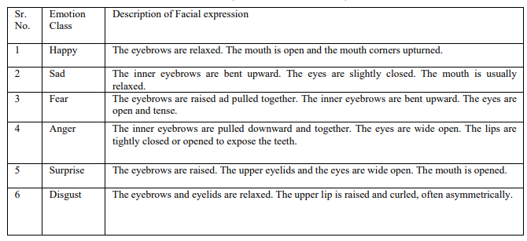

**LITERATURE SURVEY**

The paper titled “A Novel Approach for Face Expressions Recognition” focuses on a new method for face expression recognition. Haar functions are used for face, eyes and mouth detection; edge detection method for extracting the eyes correctly and Bezier curves are applied to approximate the extracted regions. Then, a set of distances for varied face types is extracted and it serves as training input for a multilayer neural network. The novel factor of this approach consists in applying Bezier curves to efficiently extract the distances between facial parts. The pre classification is done using the K-means algorithm. A two layered feed-forward neural network created is then used as a classifying tool for the input images. The consistency of the results is demonstrated by the median value. The performance achieved here is 82%. The method is not able to treat situations when the eyes are closed. Strong illumination variations affect the results. D. Drume introduced and evaluated a multi-level classification framework for the emotion classification. This framework includes three phases, face localization, facial feature extraction and training & classification. This paper uses principal component analysis at level-1 and supports vector machines at level-2 for the training and classification. Results show that this approach successfully recognizes facial emotion with 93% recognition rate. The results suggest that the method introduced is able to support the more accurate classification of emotion from the images. The Neural network classifying method is used in this work to perform facial expression recognition. The expressions classified include the six facial expressions and the neutral one. A neural network, trained using Zernike moments, was applied to the set of the Yale and JAFFE database images in order to perform face detection. Then detected faces were processed to perform the characterization phase computed through vectors of Zernike moments. At last, a back propagation neural network was trained to distinguish between the seven emotion’s states. Then method performances were evaluated on the JAFFE and YALE database.

Zhiding Yu reports image based static facial expression recognition method for the Emotion Recognition. They focus on the sub-challenge of the SFEW 2.0 dataset, where they seek to classify static images without human intervention into 7 basic emotions. The method contains a face detection module based on the ensemble of three state-of-the-art face detectors, followed by a classification module with the ensemble of multiple deep convolution neural networks (CNN). On the way to combine multiple CNN models, the author presented two schemes for learning the ensemble weights of the network responses: by minimizing the log likelihood loss, and by minimising the hinge loss. This method generates state-of-the-art results on the FER dataset. The method of two ensemble frameworks achieves the performance, 60.75% and 61.29% accuracy.

V. D. Bharate, implement the adaptive sub-layer compensation (ASLC) based facial emotions recognition method for human emotions recognition. The emotion class is recognized by using the extracted features and K nearest neighbour algorithm. The emotion recognition precision is calculated as ratio of the number of correctly classified input samples to the total number of input samples in the data set. They modified Marr Hildreth algorithm using Adaptive sub-layer compensation and hysteresis analysis to reduce negative effects of Laplacian of Gaussian (LoG), such as image degradation, unwanted details in image, and disconnected edge details from the image. By using the feature extraction method with the ASYNC method, they have achieved an overall accuracy of 86.5% for the principal component analysis and 85.1% for the Wavelet features.

D. Datcu, research aims at implementing Relevance Vector Machines (RVM) as a novel classification technique for the recognition of facial expressions in static images. The Cohn-Kanade Facial Expression Database data was selected for testing. They report 90.84% recognition rates for RVM for six universal expressions. The error rate in the case of RVM (9.16%) is compared to that of the SVM (10.15%) classifier. The important aspect is that in case of an RVM classifier the number of relevance vectors (156) is smaller than that of support vectors (276) of SVM. This effect results in a decrease of the number of kernel functions and the complexity of the model. This technique of classification not only takes less processing time but also less memory.

In this paper, M. Aziz et. al., have recognized facial expressions from the images given in the JAFFE database. They have put forward a combination of 3-different types of approach that is Scale Invariant Features Transform (SIFT), Gabor wavelets and Discrete Cosine Transform (DCT) to implement. Some pre-processing steps have been applied before extracting the features. Support Vector Machine (SVM) with radial basis kernel function is used for the classification of facial expressions. They evaluated the results on the JAFFE database and design experiments are done for person dependent and person independent methods. While implementing this method, some emotional states were misclassified with others. Sad misclassified with fear and surprise. Similarly, anger misclassified with disgust and to a little extent with sadness. Neutral is the only expression in the images that is not misclassified with any other expression.

**METHODOLOGY**

The common approach to facial emotion recognition consists of three steps: face detection and tracking, feature extraction and expression classification. Face detection stage processes the facial images, without human intervention to find the face region from the input images or sequences. After the face is positioned, the next step is to extract discriminative information caused by facial expressions. Facial expression recognition is the last stage of the system. The facial changes can be identified either as prototypic emotions or as facial action units.

Even though humans are filled with various emotions, modern psychology defines six basic facial expressions: Happiness, Sadness, Surprise, Fear, Disgust, and Anger as universal emotions. Facial muscles movements help in identifying human emotions. The facial features are the key parameters that can be considered for recognizing emotions. The facial parameters include eyebrow, mouth, nose, eyes and cheeks.

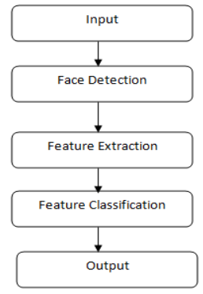

Fig. 1: Facial Emotion Recognition System Flow

**Image Acquisition (Input)** - Images used for facial expression recognition are static images. To take the images of expressions of people we use a good web camera with focal length of 5mm. The format of images is 24 bit color JPEG with resolution of 4320 x 3240 pixels. The distance between the camera and person was four feet and images of six basic expressions of each person were taken.

**Image Preprocessing** - The image preprocessing procedure comes as a very important step in the facial expression recognition task. The objective of the preprocessing phase is to take images which have normalized intensity, uniform size and shape, and represent only a face expressing certain emotion. The preprocessing procedure should also reduce the effects of illumination and lighting. Expression representation can be delicate to translation, scaling, and rotation of the head in a picture. To battle the effect of these pointless changes, the facial image may be geometrically institutionalized before classification.

**Feature Extraction -** In developing accurate facial expression recognition system feature extraction is the most important stage. Unprocessed facial images hold vast amounts of data and feature extraction is required to decrease it to smaller sets of data called features. Feature extraction changes pixel information into a more elevated representation of colour shape, motion, texture, and spatial configuration of the face or its features. The separated representation is utilized for further expression categorization. Feature extraction ordinarily decreases the information's dimensionality space. The reduction procedure ought to keep up essential data having high segregation force and high security.

**Feature Selection -** Feature selection is concerned with choosing a subset of features perfectly necessary to perform the classification task from a larger set of candidate features. The feature selection step has an effect on both the computational complexity and the quality of the classification results. It is essential that the information contained in the selected features is adequate to correctly verify the input class. Too many features may unnecessarily raise the complexity of the training and classification tasks, while a poor, inadequate selection of features may have a detrimental effect on the classification results. The process of selecting a subset of features improves the efficiency of the classifier and reduces execution time.

**Classification** - The last step of Facial Expressions Recognition systems is to recognize facial expression based on the extracted features. Classification refers to an algorithmic approach for recognizing a given expression as one of a given number of expressions. This stage is performed by a classifier. There are various classifications methods used to extract expressions. Then a near accurate face emotion is recognised and corresponding emoji is generated.

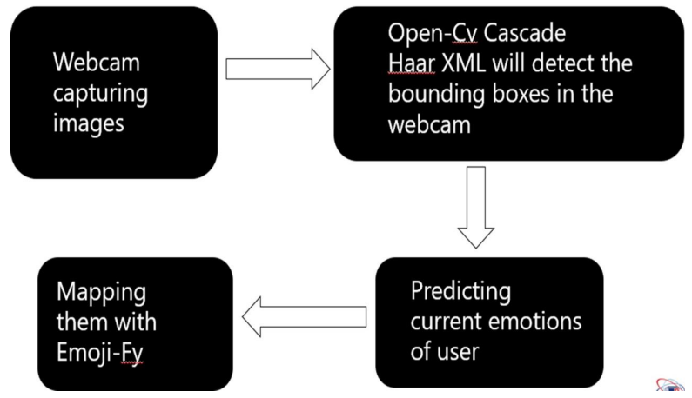

Fig. 2 : Block Diagram for generating the corresponding emoji as output

**FACILITIES REQUIRED FOR PROPOSED WORK**

**System Requirements:**

System requirements is a statement that identifies the functionality that is needed by a system in order to satisfy the customer’s requirements. System requirements are a broad and also narrow subject that could be implemented to many items. Whether discussing the system requirements for certain computers, software, or the business processes from a broad view point. Also, taking it down to the exact hardware or coding that runs the software. System requirements are the most effective way of meeting the user needs and reducing the cost of implementation. System requirements could cause a company to save a lot of money and time, and also can cause a company to waste money and time. They are the first and foremost important part of any project, because if the system requirements are not fulfilled, then the project is not complete. A System Requirements Specification (SRS) (also known as a Software Requirements Specification) is a document or set of documentation that describes the features and behaviour of a system or software application. It includes a variety of elements that attempt to define the intended functionality required by the customer to satisfy their different users.

**Tools and Libraries Required:**

OpenCV, Python, Scikit-learn, Jupyter Notebook, Database, Numpy, Dlib, Pandas

**Hardware Requirements:**

* Processor : 64-bit processor
* RAM : 8GB
* A good quality Camera or a Webcam.
* Input Device : Standard Keyboard and Mouse

**Software Requirements:**

* Operating System : Windows 7/8/10/11
* Tools : Python, Anaconda, Jupyter Notebook

**REFERENCES**

[1] https://en.wikipedia.org/wiki/Emotion#Basic_emotions.

[2] U. Hess and P. Thibault, “Darwin and Emotion Expression”, American Psychological

Association, 2009, vol. 64, no. 2, 120 128.

[3] S. M. Banu et. al., “A Novel Approach for Face Expressions Recognition”, IEEE 10th

Jubilee International Symposium on Intelligent Systems and Informatics, 2012.

[4] D. Drume and A. S. Jalal, “A Multi-level Classification Approach for Facial

Emotion Recognition”. IEEE International Conference on Computational Intelligence and

Computing Research, 2012.

[5] M. Saaidia et. al., “Facial Expression Recognition Using Neural Network Trained with

Zernike Moments”, IEEE International Conference on Artificial Intelligence with

Applications in Engineering and Technology, 2014.

[6] Zhiding Yu et. al., “Image based Static Facial Expression Recognition with Multiple Deep

Network Learning”, ACM, 2015.

[7] V. D. Bharate et. al., “Human Emotions Recognition using Adaptive Sublayer

Compensation and various Feature Extraction Mechanism”, IEEE WiSPNET, 2016

[8] M. Aziz et. al., “Facial Expression Recognition using Multiple Feature Sets'', IEEE, 2015. [9] D. Datcu, and J. M. Rothkrantz, “Facial Expression Recognition with Relevance Vector

Machines”, Interactive Collaborative Information Systems (ICIS).

[10] E. Sariyanidi, H. Gunes, et A. Cavallaro, « Automatic Analysis of Facial Affect: A

Survey of Registration, Representation, and Recognition, *IEEE Trans. Pattern Anal.*

*Mach. Intell.*, oct. 2014, doi: 10.1109/TPAMI.2014.2366127.