|  |
| --- |
|  |
| TRAVELS AGENCY |
| Project Documentation of DISM (Semester II) |

**our team members**

SHAHZINA KHAN

student 1074493

**Faculty** = Miss Aatika Liaquat

**Batch Code** = 1807E1

**Curriculum**= 6673

**Semester**= HDSE-Il

**Table of Contents: -**

1. Acknowledgment....................................................................................................... 4
2. Abstract…………………………………………………………………… 4
3. Declaration………………………………………………………………… 5
4. Certificate………………………………………………………………… 6
5. **CHAPTER I :** INTRODUCTION………………………………………………………… 8
6. Problem Statement……………………………………………… 8
7. Need of Project………………………………………………… 10
8. **CHAPTER II** :

PROJECT MAKING & BACKGROUNDS…………………….………….11

1. Project Duration……………………………………………………12
2. Task Sheet…………………………………………………………..13
3. **CHAPTER III** :

SOFTWARE & HARDWARE REQUIREMENTS…………………………..14

1. Hardware Requirements…………………………………………………………15
2. Software Requirements…………………………………………………………15
3. **CHAPTER IV** :

WORKFLOW SUBMISSION CHECKLIST…...…………………………… 16

1. Workflow Submission Checklist…………………………………………………………….….. 17
2. Screenshots…………………………………………………………….. 18
3. Application Map………………………………………………………………………20
4. **CHAPTER V**: CONCLUSION……………………………………………………………...20
5. Remarks………………………………………………………………… 22
6. Application……………………………………………………………….22
7. Problem Faced……...…………………………………………………… 22
8. Future Enhancement…..………………………………………………… 22

1- Acknowledgement:

I want to appreciate and thank all of those people who helped us during this journey of completing my project. Without everyone’s support, I could not have accomplished my work.

I express our sincere gratitude to our faculty “--Miss Aatika Liaquat--" and our coordinator for their amazing support and guidance, continuous encouragement and supervision throughout the course of the present work. It’s of no doubt that we have been very fortunate to work under such a supportive and cooperative teacher/coordinator.

And last but not the least we are extremely grateful to the whole faculty and administration of Aptech, for providing me all the facilities that were mandatory, without which this project could not be a success.

2- Abstract:

The capstone project **“Travel Agency “**, I have been working on is about the development of a Dynamic Website.

It is made by using PHP and MySQL Database Mainly. This application has as purpose to help my client in managing his work; as for any Owners well as well as Customers.

The Travels Agency will offer several features such as managing Booking, to have a view/maintain Purchase Records of buses and Proper Route and stop management. Also making the client and application easy interaction.

The project’s first stage is the requirements and specification stage. During this stage,

the client’s needs are gathered and preceded; for Travel Agency, the requirements were

expressed explicitly.

Once this phase done, comes up the feasibility study where the technical aspect is

tackled. This stage is partially driven by the application’s type to be developed, technology

enablers such as programming language, and database.

After the feasibility study done comes the design and analysis phase with the design of

database entities.

Finally comes the implementation phase with a description of all the necessary tools

used to develop the application.

3- Declaration

We are writing this to declare that all the work which is being written bellow in this Project Report entitled “—**TRAVELS AGENCY**--” is a veritable record my own work submitted to the Aptech NN, Karachi, Pakistan during the year 2020 to 2021 in the partial fulfillment of semester 1V (HDSE-II) project I also declare that I have not submitted the material being presented in this Project Report for the award of any other degree elsewhere.

Signatures:

SHAHZINA KHAN STUDENT 1074493

Certificate: -



This is to certify that,

Ms.

**SHAHZINA KHAN**

Has successfully Designed & Developed

**TRAVELS AGENCY**

Date of Issue:

**20th-may-2020**

Date of Submission:

**19-june-2020**

Authorized Signature: **Miss Aatika Liaquat**

INTRODUCTION

Problem Statement: -

INTRODUCTION:

SRC Travel Agencies is a domestic privatized transportation company that runs the vehicles all over the country. They have several branches at different locations of the country, so that they can provide the transportation facilities between the places. They want an online application to be developed, where the details of the bookings done and the customer will be updated from time to time and one can track the details of the available seats immediately.

**Existing Scenario :**

They provide different buses like Express, Luxury, and Volvo (Has two types A/C and Non A/C). The charges are different for different buses. The charges are in the below mentioned format.

Express < Luxury < Volvo (Non A/C) < Volvo (A/C)

The charges also depend on the distance the customer wants to travel.

**Functional Requirements**

A database should be maintained where the bus details along with the bus number, route, the places it covers throughout the distance and also the timings are needed to be maintained. Also the details of the customers that are entered at the time of booking the tickets are needed to be gathered in the database.

Also for canceling the ticket, there is a limit like, if cancelled before 2 days then the whole money will be returned, and if done one day before, then 15% is debited from the total amount and the remaining amount is returned and if done on that day 30% is debited from the total amount and the remaining is to be returned back. This action is also to be performed by the application alone. The application alone should be able to calculate the payments as per the service criteria and the distance. Also it has to be updated in the site.

Note :

* To book the ticket first they need to Login and only then they will be able to perform such actions. .
* The Admin maintains the list of the buses service charges etc.
* There will be an Enquiry form, Booking Form, and the also a page where the search options will be available. Also the Price list is to be maintained separately, where one can access the details of the price by entering the details of the Place of starting and Destination.
* The charges vary depending on the type of the bus opted, distance of travel which is to be calculated by the application alone.
* The price list can be updated by the Admin alone. Also the Reimbursement of the amount will also be as defined by the admin and is calculated by the application alone by considering the above parameters.
* The details of the buses and seats available are to be maintained and can be updated regularly (of course only by the admin)

Need of Project: -

Some of the benefits of Project are as under: -

* Re-enforcement of Skills happens in the experiential learning process.
* A mentor, ensuring that you do not get drifted, constantly guides you.
* It gives you a lot of confidence to face an interview as you have worked on a project. You can explain virtually everything on the subject you have learnt.
* A nice, final, black, hardbound report adds to you credentials and enhances your job prospects.
* Projects is compulsory (Sem-End Project) and is supposed to be done over and above the assignments given in your course books.
* It is advised that if a student follows the projects and submits Assignments, he would definitely have an edge over other students.
* Students need to submit their project report along with working application and source code in the stipulated time.



PROJECT MAKING & BACKGROUND

PROJECT DURATION: -

* Analysis- 3 days
* Design – 9 days
* Database –10 days
* Testing – 3 days
* Documentation -1 days

|  |  |  |  |  |
| --- | --- | --- | --- | --- |
| Analysis | Design | Database | Testing | Documentation |

|  |  |  |  |  |  |  |  |  |  |  |  |  |  |  |  |  |  |  |  |  |  |  |  |  |  |  |  |  |  |
| --- | --- | --- | --- | --- | --- | --- | --- | --- | --- | --- | --- | --- | --- | --- | --- | --- | --- | --- | --- | --- | --- | --- | --- | --- | --- | --- | --- | --- | --- |
| 1 | 2 | 3 | 4 | 5 | 6 | 7 | 8 | 9 | 10 | 11 | 12 | 13 | 14 | 15 | 16 | 17 | 18 | 19 | 20 | 21 | 22 | 23 | 24 | 25 | 26 | 27 | 28 | 29 | 30 |

TASK SHEET

|  |  |  |  |  |  |
| --- | --- | --- | --- | --- | --- |
| **No.** | **Task** | **Actual Start Date** | **Actual Days** | **Team Mate Name** | **Status** |
| 1. | Case Study | 20th may  2020 | 3 | SHAHZINA KHAN | Completed |
| 2. | UI Designing | 1th June 2020 | 6 | SHAHZINA KHAN | Completed |
| 3. | SCENARIO Making | 7th June 2020 | 2 | SHAHZINA KHAN | Completed |
| 4. | Material Searching | 10ST June 2020 | 4 | SHAHZINA KHAN | Completed |
| 5. | Database Connectivity | 14th June 2020 | 12 | SHAHZINA KHAN | Completed |
| 6. | Documentation | 19 june 2020 | 2 | SHAHZINA KHAN, | Completed |



SOFTWARE & HARDWARE REQUIREMENTS

HARDWARE REQUIREMENTS: -

* A minimum computer system that will help you access all the tools in the courses is a Pentium 166 or better.
* 64 Megabytes of RAM or better.

SOFTWARE REQUIREMENTS: -

* Xampp
* Sublime
* Browser Google



WORKFLOW SUBMISSION CHECKLIST

## 

WORKFLOW SUBMISSION CHECKLIST:-

|  |  |  |  |
| --- | --- | --- | --- |
| **S.NO** | **LIST OF ITEMS** | **Remarks** | **COMMENTS** |
| 1. | Do All Pages Linked together | **Yes** | Proper Linking. |
| 2. | Database Connected | **Yes** | Using  MYSQL |
| 3. | Page Colors As Per Common Guidelines | **Yes** | Professional Color Combination |
| 4. | All Queries Working | **Yes** | All CRUD operations working properly |
| 5. | DOCUMENTATION Included | **Yes** | All 3 word documents. |
| 6. | Project Zip File | **Yes** | Created using WinRAR |

SCREENSHOTS: -

# 

# 

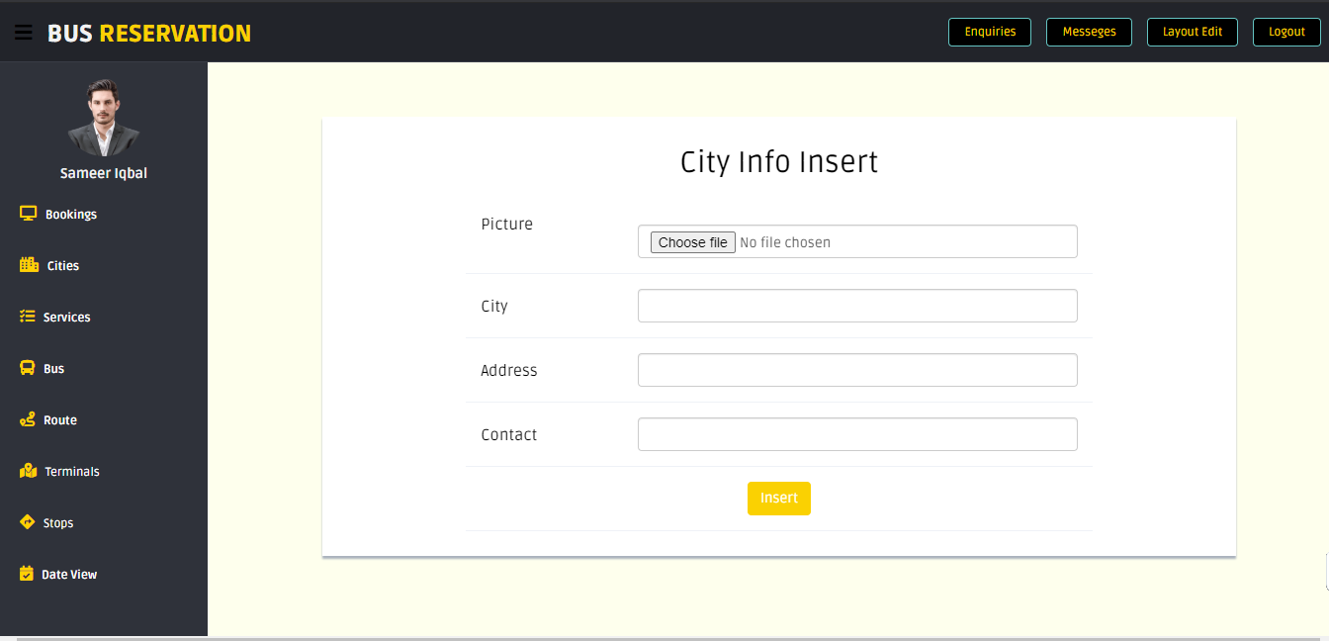

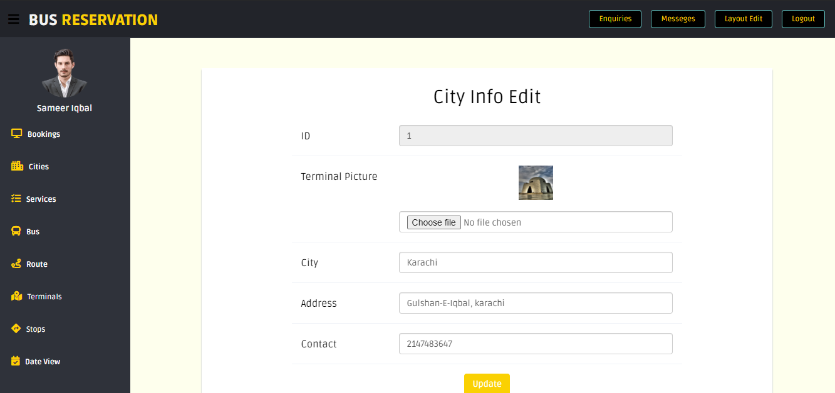

APPLICATION MAP: -

**SRCMS**

**USER**

**Login**

Route

Terminalsffbbbb

Date Schedule

Bus

Admin

Enquiry

Stops

Booking

Service



**Cities**

CONCLUSION

Remarks: -

It is very nice initiative that has made us work harder on my project and it has polished our skills now I am capable of making a PHP Application all by my own self. I am very thankful to you for giving me an incredible opportunity.

Application: -

It’s an application based on dynamic website. It provides ease for customers to book their tickets. It helps the admin to maintain proper records of buses and routes.

Problem Faced: -

The main problem we faced in the duration of project was too Slow Version issues of Xampp haunted us a big time overall it was a worst experience.

Future Enhancement: -

It is almost a perfect prototype of TRAVELS AGENCY this application can be deployed and used in real world! But there is always a place for betterment so there are our few suggestions, Deals can be added in Booking according to age. Also interaction of customer with our application is quite handy.

THANK

YOU