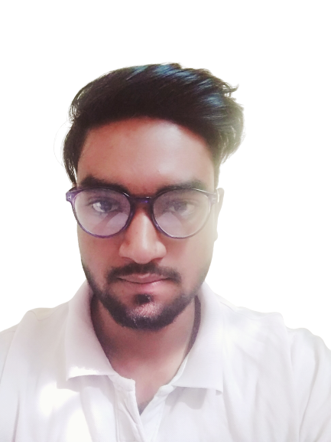

**HUNAR INTERN | 2024 – 2024**

**Data Science**

**Tasks:**

* + - * **Task 1 :- Data Cleaning.**
      * **Task 2 :- Cat And Dog Image Classifier By CNN.**
      * **Task 3 :- Breast Cancer Detection By KNN,SVM.**
      * **Task 4 :- EDA on e-Commerce Website Dataset.**
      * **Task 5 :- Happy Vs Sad Image Classification By ML.**

**SYSTEM TRON | 2024 – 2024**

**Machine learning & Artificial Intelligence**

**Tasks:**

* + - * **Task 1 :- Diabetes Prediction with Machine learning.**
      * **Task 2 :- Car Price Predictor with Machine learning.**
      * **Task 3 :- Diwali Sales Analysis.**
      * **Task 4 :- EDA on IPL Dataset.**
      * **Task 5 :- Facial Expression prediction.**

**WORK EXPERIENCE**

**DIPLOMAS Y HOBBIES**

**Formaciones :** Diplomados, Congresos, xxxxxxxxxx xxxxxx xxxxxxxxx xxxxxxxxxxxxxxxxx

**Hobbies:** xxxxxxxxxxxxxxxxxxxxxxxxxxxxxx

**AATISH KUMAR BAITHA**

**DATA SCIENTIST INTERN**

**PERSONAL DETAILS**

* **Father’s name: Puran Baitha**
* **Date of birth : 20-03-1998**
* **Gender : Male**
* **Language known : English Hindi & Nagpuri.**
* **Nationality : Indian**
* **Marital Status : Unmarried**

**MY PROJECTS**

* + - * **Weather Data Analysis.**
      * **EDA on Bollywood Movies Dataset.**
      * **EDA on Titanic Dataset.**
      * **EDA on Iris Dataset.**
      * **Apple Leaf Disease Detection By CNN.**
      * **Plant Leaf Disease Detection By CNN.**
      * **My Mood Detection By CNN.**
      * **Facial Emotion Recognition CNN.**

**SKILLS**

* **Data Science And Statistics**
* **Python And C Language**
* **Data Visualization**
* **ML , Ai And Deep Learning**
* **NumPy, Pandas, Karas**
* **Matplotlib, TensorFlow**
* **Seaborn, Scikit - Learn**
* **MS – Excel, MS - Word**
* **MY – SQL And DBMS**
* **Power – BI, MS - PowerPoint**
* **Exploratory Data Analysis**



* + - * **Masters of Technology**
      * **Jharkhand University of Technology Ranchi**
      * **2022-2024 | Data Science | with 85%**
      * **Bachelor of Technology**
      * **Dr. A P J Abdul Kalan Technical University**

**Lucknow, Uttar Pradesh**

* + - * **2016-2020 | Computer Science | with 84%**
      * **Intermediate**
      * **St. Xavier’s College Ranchi**
      * **2013-2015 | Science | with 68%**
      * **High School**
      * **Jharkhand Academic Council Ranchi**
      * **2013 | with 77%**

**EDUCATION QUALIFICATIONS**

**+91-7255006247**

[**aatishkr2023@gmail.com**](aatishkr2023@gmail.com)

**Khunti Ranchi Jharkhand, India**

### <https://www.linkedin.com/in/aatish-kumar-baitha-ba9523191>

[**https://github.com/Aatishkb**](https://github.com/Aatishkb)

[**https://computersciencedatascience.blogspot.com/**](https://computersciencedatascience.blogspot.com/)

**CONTACT**

©AZURIUS - My-resume-templates.com