STRAVA TABLEAU INSIGHTS

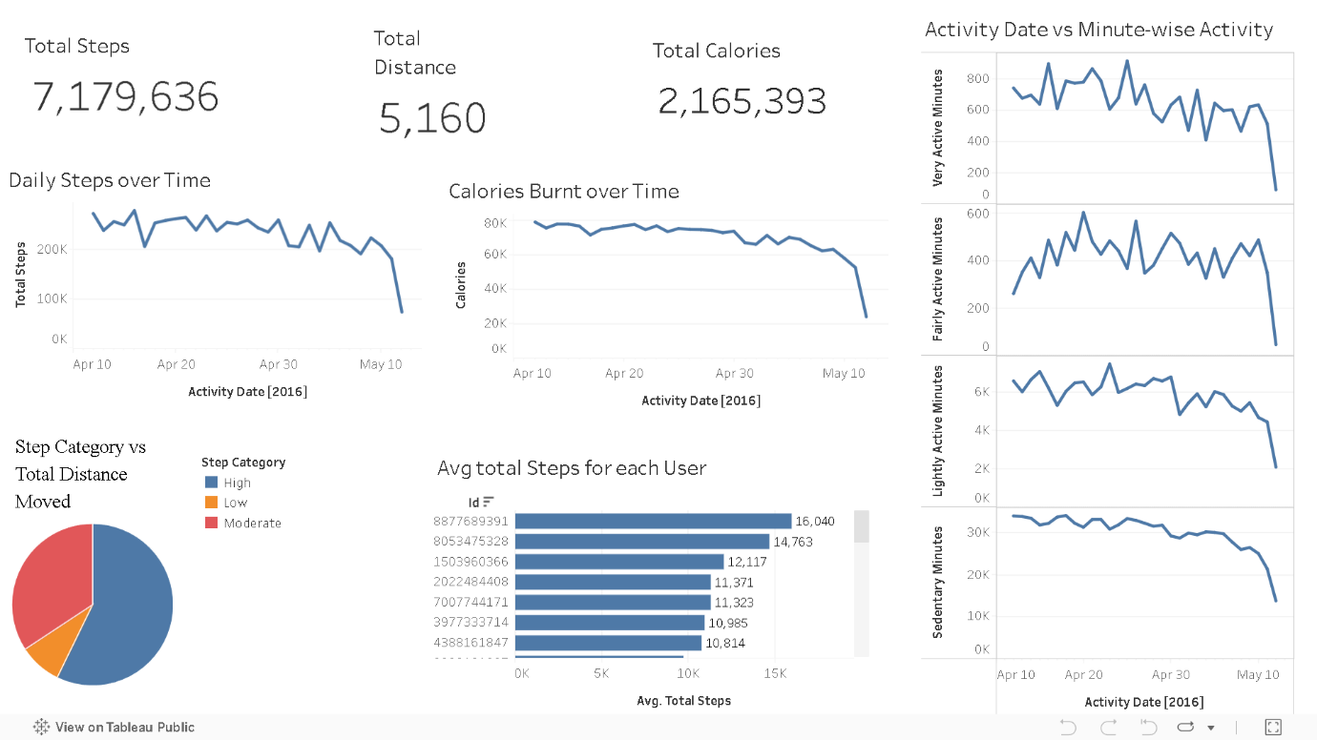
Daily_data Insights

KPI Cards
1. Total Steps: 7,179,636
2. Total Distance: 5,160
3. Total Calories Burnt: 2,165,393
Insights:
These key performance indicators highlight the overall activity volume for the logged time period. The high number of total steps and calories suggests active user participation, while distance helps contextualize step effort.

Daily Activity Trends
1. Daily Steps Over Time
2. Calories Burnt Over Time
Insights:
- Both steps and calories show a slightly declining trend toward the end of the timeline.
- Sharp drop-offs in May could indicate reduced user engagement or data incompleteness.
- There’s a strong visual correlation between daily steps and calories burned, suggesting active calories are step-driven.

Step Category vs Total Distance Pie Chart
Categories: High, Moderate, Low
Insights:
- Most of the distance is contributed by users in the “High” activity segment, indicating a small number of highly active individuals may dominate overall distance.
- The presence of “Low” users confirms varied fitness levels across the user base, useful for targeted interventions.

Avg Total Steps per User (Bar Chart)
Insights:
- Top users (IDs like 8877689391, 8053475328) have average daily steps well above 12,000, far exceeding the 10,000 steps/day benchmark.
- Distribution indicates a core group of highly consistent walkers, which may skew the dataset's average upward.

Activity Minutes Breakdown (4-Line Graphs)
Tracked by Very Active, Fairly Active, Lightly Active, and Sedentary Minutes.
Insights:
- Very Active & Fairly Active Minutes both show fluctuations but a gradual decline in recent days.
- Lightly Active Minutes are relatively stable but taper off as well.
- Sedentary Minutes dominate the time allocation (~30K minutes daily), reinforcing the importance of encouraging movement throughout the day.
- The inverse relationship between Sedentary and Active minutes is visible — as one drops, the other tends to rise.

Hourly_minute_data Insights
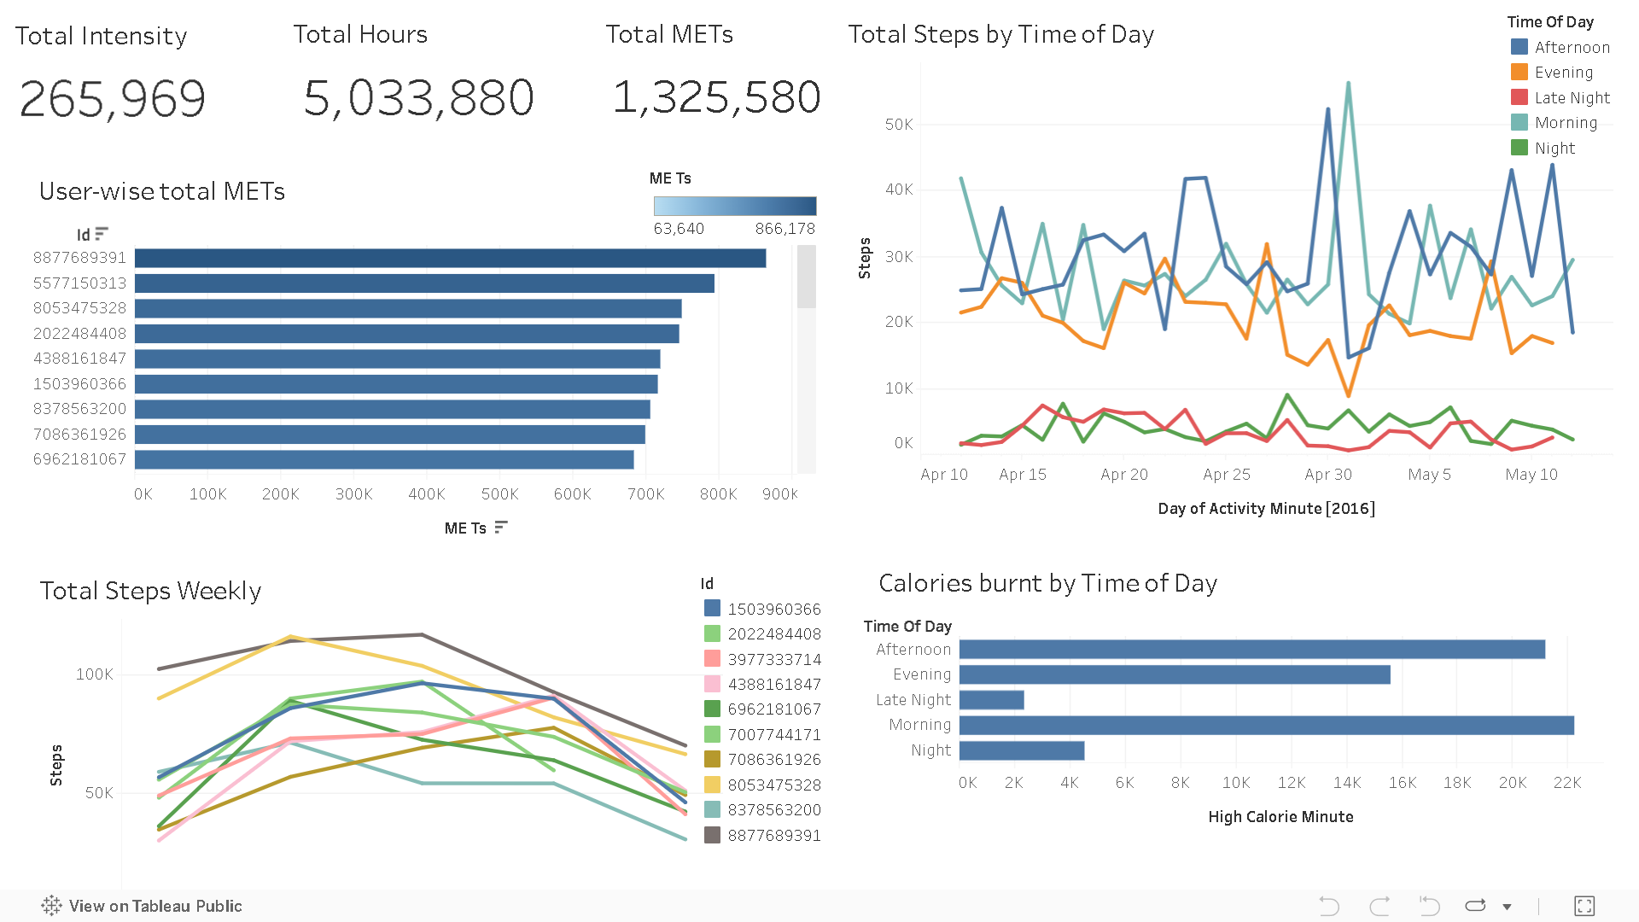

KPIs
1. Total Intensity: 265,969
2. Total Logged Hours: 5,033,880 minutes (~83,898 hours)
3. Total METs: 1,325,580
Insights:
- Indicates a highly active user base, with significant logged activity and a solid amount of metabolic energy expenditure (METs).
- The total minutes logged show consistent engagement, giving strong ground for trend and behavioral analysis.

User-wise Total METs (Bar Chart)
Insight:
- User 8877689391 has the highest METs (~866K), showing significantly higher metabolic output than others — likely a high-endurance or consistent performer.
- Other top contributors (IDs like 5577150313, 8053475328, etc.) also have strong METs but with a visible drop from the top performer.

Total Steps by Time of Day (Line Graph)
Insights:
- Morning and Afternoon show the highest step volumes — with morning spikes especially noticeable around April 30 and May 2.
- Evening activity is consistent but lower, while Night and Late Night see minimal movement.
- The dip around May 8-10 might reflect logging gaps or weekend disengagement.
- Most users prefer activity in daylight hours, suggesting that fitness programs could be best scheduled around mornings/afternoons.

Total Steps Weekly (Line Chart)
Insights:
- Weekly trends indicate peaks mid-week (possibly Tuesday–Thursday) with drop-offs toward the weekend.
- Some users (e.g., 1503960366, 2022484408) show more consistent weekly activity, while others drop sharply, may signal motivation fade or busy weekends.

Calories Burnt by Time of Day (Horizontal Bar Chart)
Insights:
- Afternoon sees the highest calorie burn, followed by Evening and Morning.
- Late Night and Night activities contribute very little, supporting the idea that most intense workouts happen during the day.

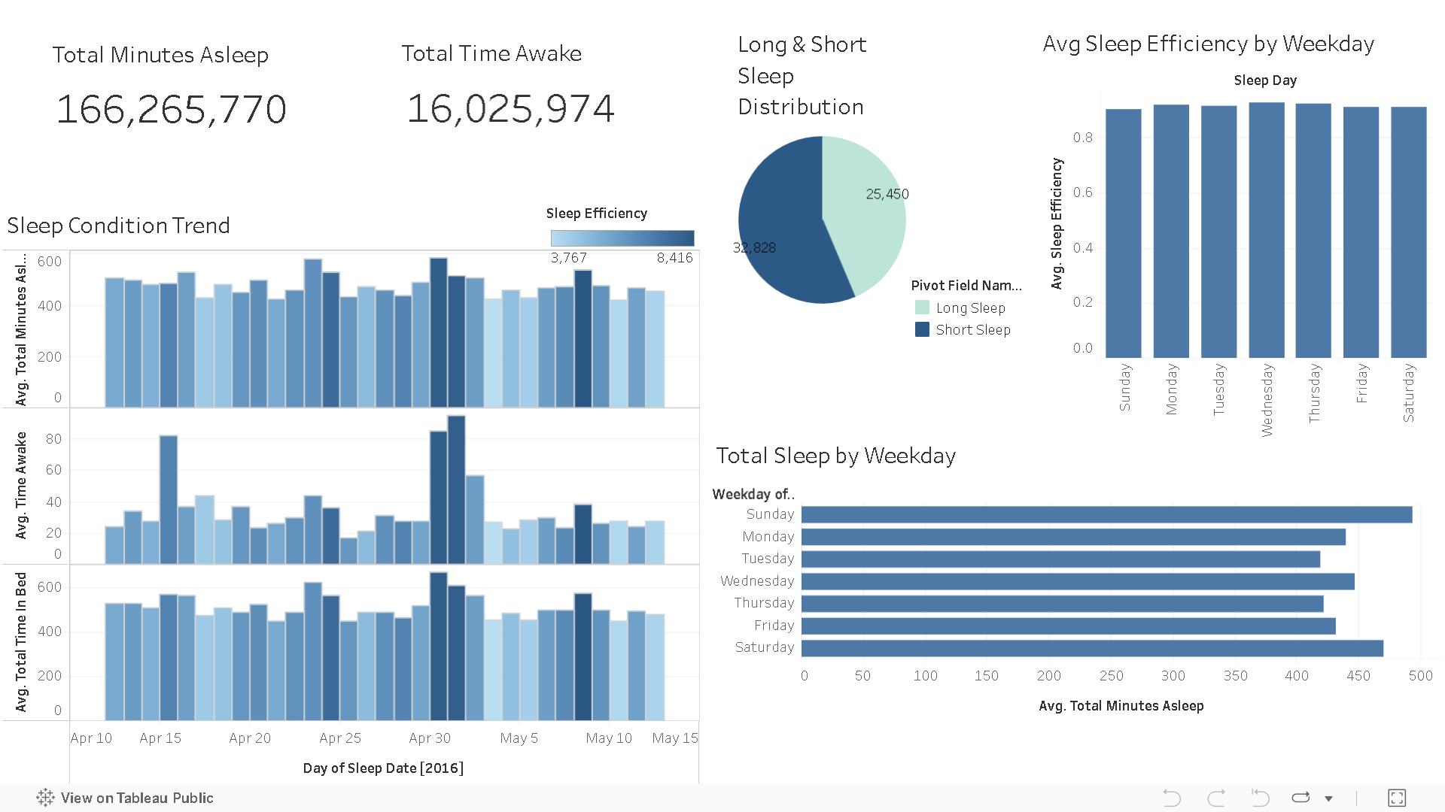
sleep_data Insights

KPIs
- Total Minutes Asleep: 166,265,770
- Total Time Awake: 16,025,974
Insights:
A 10:1 sleep-to-awake ratio during logged sleep periods indicates good overall rest quality among users. This suggests minimal restlessness or interruptions in sleep phases.

Sleep Condition Trend (Bar chart Group)
➤ Avg. Total Minutes Asleep (Bar Chart 1)
- Consistent sleep duration between 400–550 mins (6.5–9 hrs) across most dates.
- A few spikes are visible at the end of April and beginning of May, showing longer rest periods.
➤ Avg. Time Awake (Bar Chart 2)
- Notable spike around April 30–May 2, indicating restlessness or disrupted sleep.
- Other periods maintain low awake time (~20–30 mins), which is healthy.
➤ Avg. Total Time in Bed (Bar Chart 3)
- Patterns mirror asleep time with extra buffer (~30–60 mins).
- Suggests that users often spend some time in bed awake, which could be due to sleep latency or early wake-ups.

Avg Sleep Efficiency by Weekday (bar chart)
- Sleep Efficiency remains above 85% across all days, peaking on Monday and Tuesday.
- Friday & Saturday show a minor drop — potentially due to late-night activities or irregular sleep routines.
Takeaway: Weekday routines foster higher sleep efficiency, while weekends show slight dips, a common behavioral pattern.

Total Sleep by Weekday (Bar Chart)
- Users sleep the most on Sundays (avg ~490 mins).
- Fridays and Tuesdays have the lowest sleep duration, possibly due to weekend transitions or midweek stress.
Users tend to catch up on sleep over the weekend and start the week better rested. Encouraging sleep hygiene during weekdays could improve consistency.

Long & Short Sleep Distribution (Pie Chart)
- Long Sleep Instances: 33,828
- Short Sleep Instances: 25,450
~57% of recorded nights are Long Sleep, indicating good sleep duration most of the time.

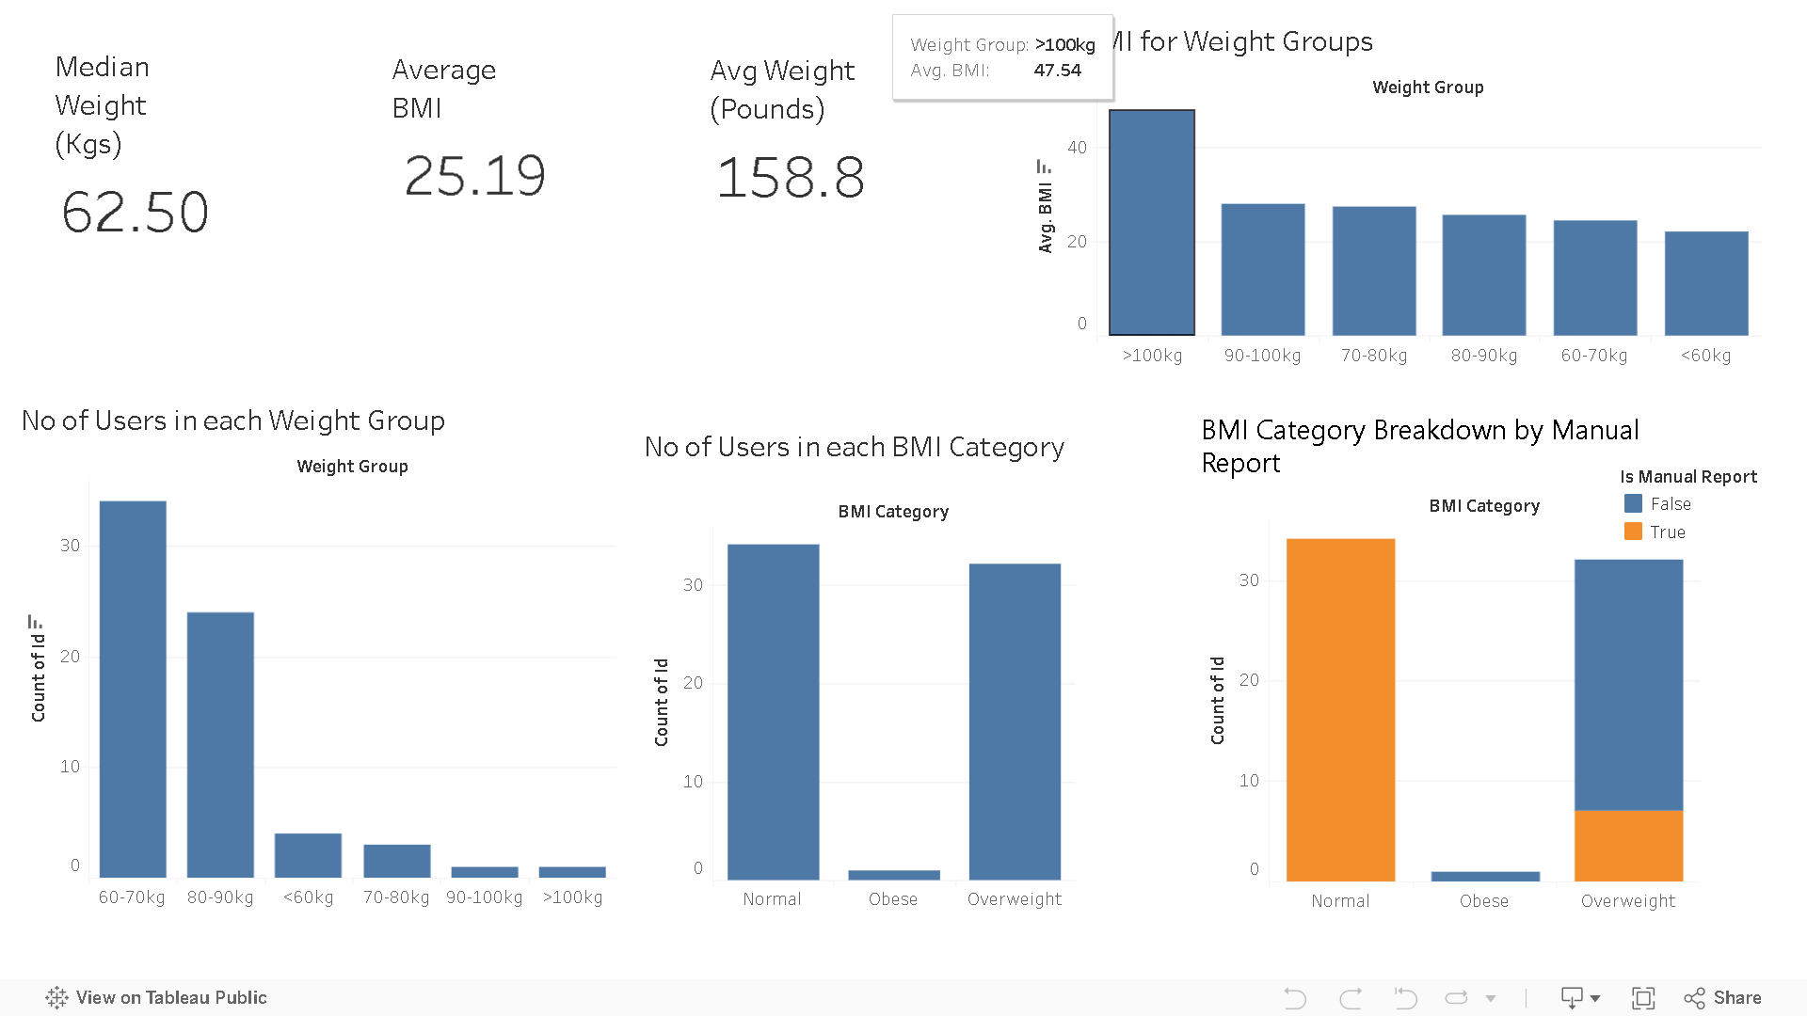
WeightLog_data Insights

Top KPIs Summary
- Median Weight: 62.50 kg
- Average Weight (lbs): 158.8 lbs
- Average BMI: 25.19
Interpretation:
- The average BMI (~25.19) places users on the border between Normal and Overweight, suggesting a need for lifestyle awareness.
- Median weight being 62.5 kg reflects a moderately healthy population, though group-wise differences exist.

BMI vs Weight Group (Bar Chart)
- The >100kg group has the highest average BMI (~47.5) — clearly falling into the obese range.
- BMI gradually decreases with lower weight groups, which is expected.
- Groups between 60–90kg maintain moderate BMI levels, aligning with healthy or slightly overweight ranges.

Number of Users per Weight Group (Bottom Left bar chart)
- 60–70kg is the most common weight group (~35 users).
- Followed by 80–90kg (~25 users).
- Very few users weigh above 100kg or below 60kg.
Interpretation:
The user base is skewed towards average weight ranges, with a healthy majority, though a notable portion is trending towards heavier segments.

No. of Users per BMI Category (Bottom Center Bar graph)
- Roughly equal number of users fall into Normal and Overweight categories.
- Very few are Obese, despite a high BMI observed for the >100kg group — indicating a small subset of extremely high-BMI users.

BMI Category Breakdown by Manual Report (Bottom Right)
- Normal BMI entries are mostly manually reported, while Overweight BMI logs are primarily auto-recorded.
- Obese users are very few and mixed in the reporting mode.
Interpretation:
- Users with normal BMI may be more health-conscious, hence more likely to log data manually.

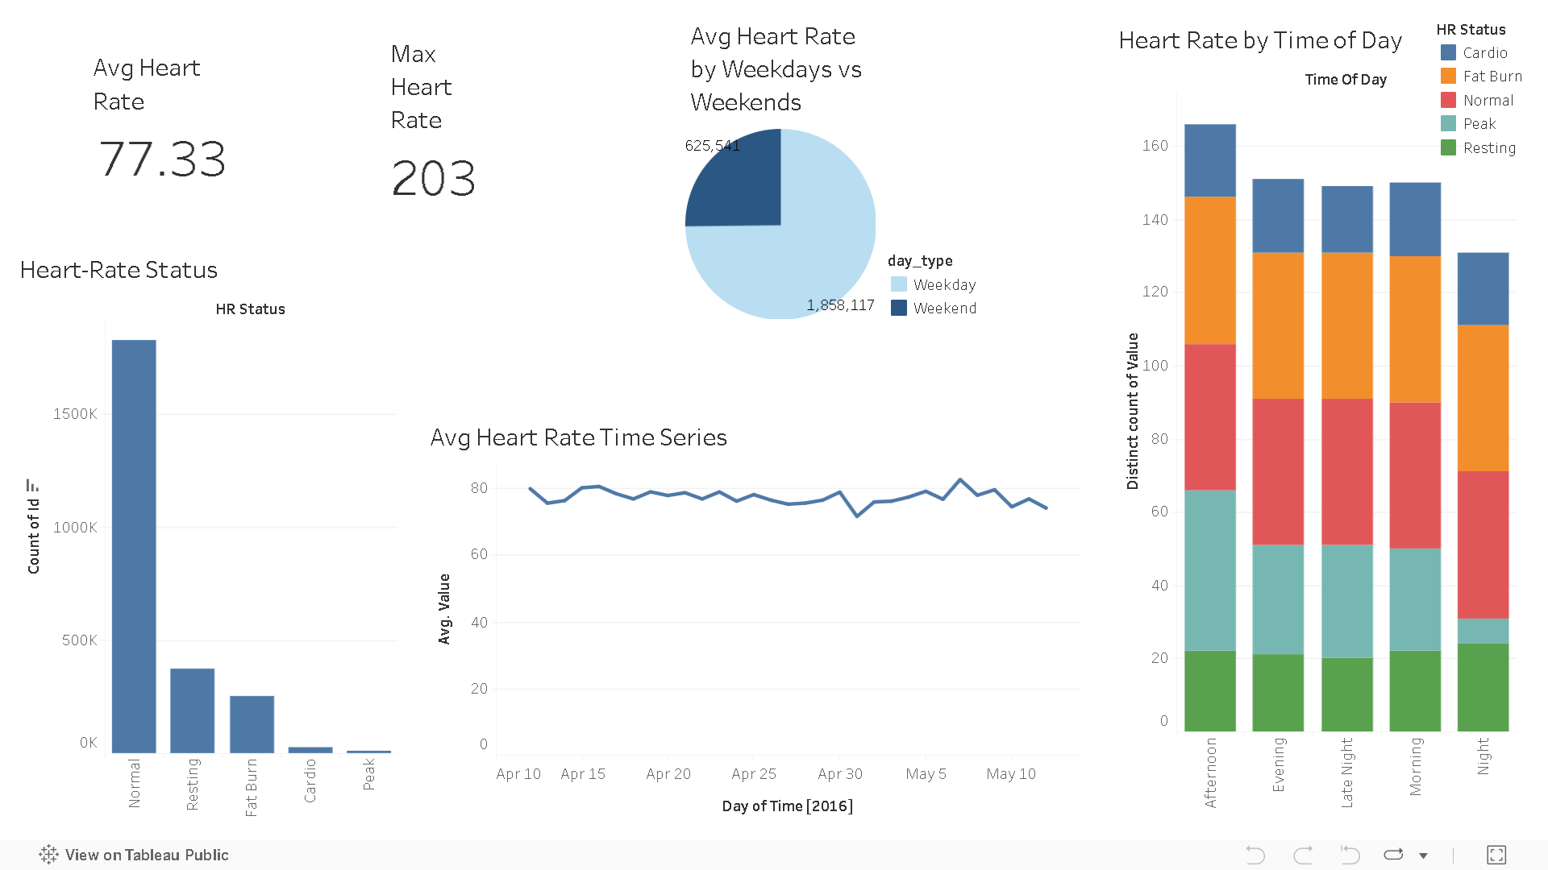
Heart rate Insights

Key Metrics Summary
- Average Heart Rate: 77.33 bpm
- Maximum Heart Rate Recorded: 203 bpm
Interpretation:
- The average heart rate (77 bpm) is within the normal resting range for adults (60–100 bpm).
- A max of 203 bpm may indicate a high-intensity workout session or possible outlier/anomalous data

The population is generally active but not highly intense in their workouts. Most heart rates stay in the resting or normal zone, with few pushing to cardio/peak levels.
Heart Rate Over Time (Time Series )
- The avg heart rate remains consistent throughout the month (~75–80 bpm).
- A minor dip around April 30 followed by a quick recovery indicates normal fluctuation, possibly affected by rest/recovery periods.
- Interpretation:
Heart rate levels show stability over time, indicating a consistent health pattern without sudden physiological stress.

Weekday vs Weekend Comparison (Pie Chart )
- Weekday readings dominate (almost 75%).
- Weekend logs are significantly lower.
Insights:
Most heart rate tracking occurs on weekdays, suggesting:
- Users may follow more structured routines on weekdays (e.g., office hours, gym workouts).
- Possible underreporting or rest days on weekends.

Heart Rate by Time of Day (Stacked Bar chart)
Insights:
- Afternoon & Evening are peak heart activity periods, likely due to workouts.
- Morning shows moderate intensity — warm-ups or walks.
- Night-time heart rate is lowest — aligns with resting phase.

