Name Aatmaj

Batch B2

Comps

16010121110

Q1 Calculate the coefficient of correlation between the indices of business activity (X) and employment (Y) from the following data.

X : 100, 102, 108, 111, 115, 116, 118.

Y : 100, 100, 104, 108, 112, 119, 120.

**CODE**

x=c(100, 102, 108, 111, 115, 116, 118)

y=c(100, 100, 104, 108, 112, 119, 120)

r=cor(x,y)

plot(x,y,main="scatter diagram",xlab=" indices of business activity ",ylab="employment ")

cat("coefficient of correlation is",r)

paste("Aatmaj", "B2 ,16010121110")

**OUTPUT**

coefficient of correlation is 0.9527625

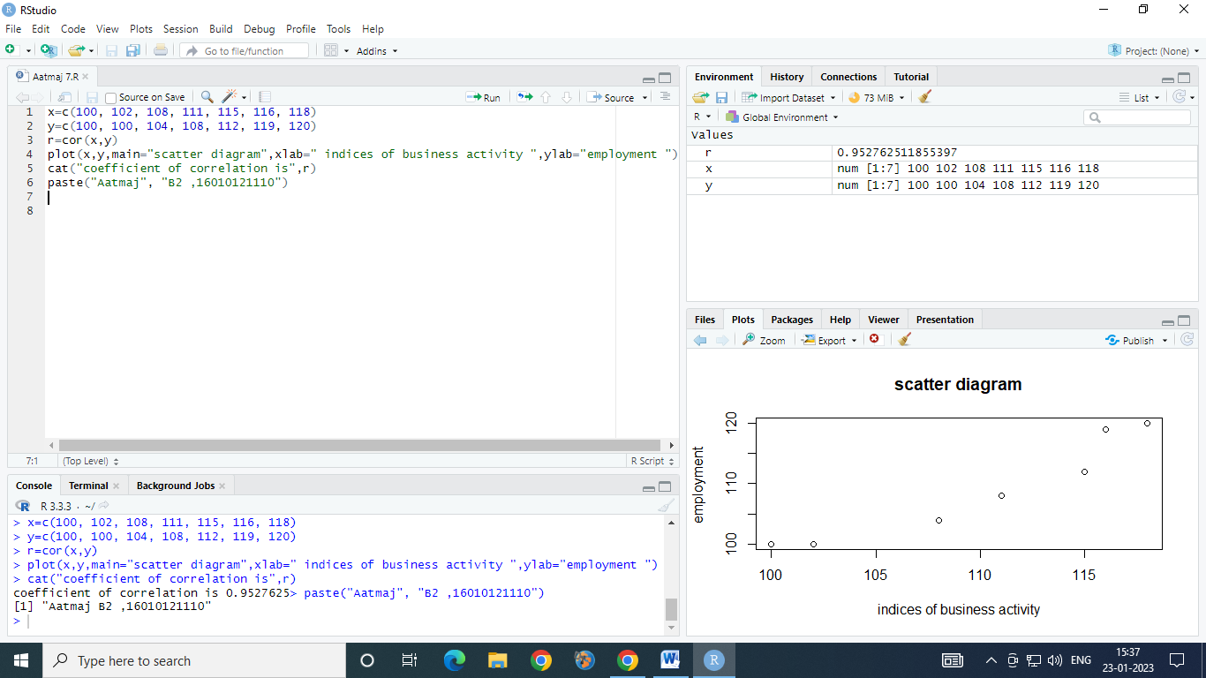

Q32 a

. Find the equations of two regression lines for the following data

X : 78, 36, 98, 25, 45, 82, 90, 62, 65, 39.

Y : 84, 51, 91, 60, 68, 62, 86, 58, 53, 47.

Estimate the value of Y when X is 50 and value of X when Y is 90.

PART 1 FIND Y WHEN X IS 50

Y ON X

**CODE :**

x=c(78, 36, 98, 25, 45, 82, 90, 62, 65, 39)

y=c(84, 51, 91, 60, 68, 62, 86, 58, 53, 47 )

r1=lm(y~x) # gives equation of of regression line of x on y(i.e.x=a+by)

co=coef(r1) # gives values of a,b

mco=matrix(co) # column matrix of a,b

a=mco[1,1]

cat ("constant term a is",a)

b=mco[2,1]

cat ("value of b is",b)

estx=fitted(r1) # gives estimated values of y for the given values of x

cat ("estimated values of x are", estx) # display estimated values of y for the given values of x

X1=50

ex=a+b*X1

cat ("estimated value of X is",ex)

plot (x,y,pch="+") # plots points corresponding to x and given value of y (+)

points(estx,y,pch="*") # plots points corresponding to x and it’s estimated value of y (*)

lines(x,y , col="green") # plots line corresponding to x and given value of y (+) using green colour

lines(estx,y , col="red")# plots line between y and estimated value of x (*) using red colour

paste("Aatmaj", "Comp ,16010121110")

**OUTPUT**

estimated value of X is 60.34237

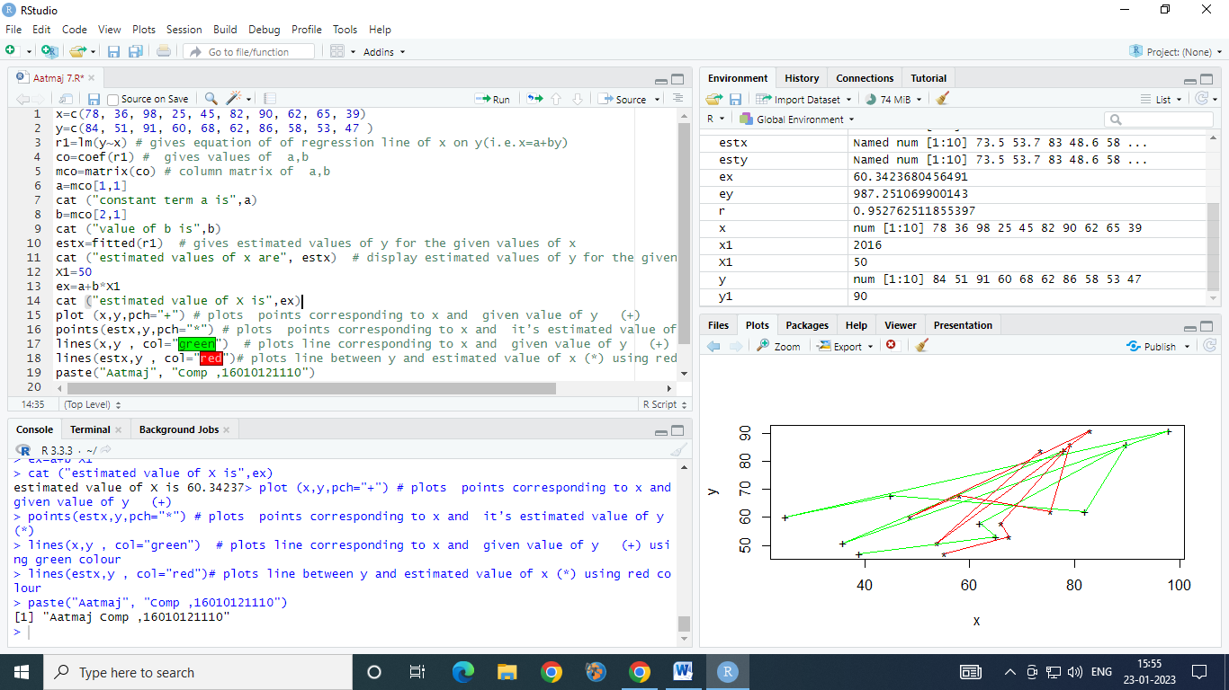

Q32 B

. Find the equations of two regression lines for the following data

X : 78, 36, 98, 25, 45, 82, 90, 62, 65, 39.

Y : 84, 51, 91, 60, 68, 62, 86, 58, 53, 47.

Estimate the value of Y when X is 50 and value of X when Y is 90.

PART 1 Y IS 90 AND X IS TO BE FOUND OUT

X ON Y

**CODE :**

x=c(78, 36, 98, 25, 45, 82, 90, 62, 65, 39)

y=c(84, 51, 91, 60, 68, 62, 86, 58, 53, 47 )

r1=lm(x~y) # gives equation of of regression line of x on y(i.e.x=a+by)

co=coef(r1) # gives values of a,b

mco=matrix(co) # column matrix of a,b

a=mco[1,1]

cat ("constant term a is",a)

b=mco[2,1]

cat ("value of b is",b)

estx=fitted(r1) # gives estimated values of y for the given values of x

cat ("estimated values of x are", estx) # display estimated values of y for the given values of x

y1=90

ex=a+b*y1

cat ("estimated value of X is",ex)

plot (x,y,pch="+") # plots points corresponding to x and given value of y (+)

points(estx,y,pch="*") # plots points corresponding to x and it’s estimated value of y (*)

lines(x,y , col="green") # plots line corresponding to x and given value of y (+) using green colour

lines(estx,y , col="red")# plots line between y and estimated value of x (*) using red colour

paste("Aatmaj", "Comp ,16010121110")

**OUTPUT**

estimated value of X is 90.53237

