**Name** Aatmaj

**Batch** B2

**Roll no** 16010121110

**Tutorial Name and date** large sampling using R software 27 march 23

**Can it be concluded that the average life span of an Indian is more than 70 years, if a random sample of 100 Indians has average life span of 71.8 years with standard deviation of 8.9 years?**

**H0** u1=u2 both have same lifespan

**Ha** u1 > u2 life span is more

**Nature of test is** one tailed

**LOS** is 5%

**Table value of Z is 1.64**

**Zcalc=** 2.022

**Zcal<table value of Z**

**H0 is** NOT accepted

**We can say that the average life span of an Indian is more than 70 years**

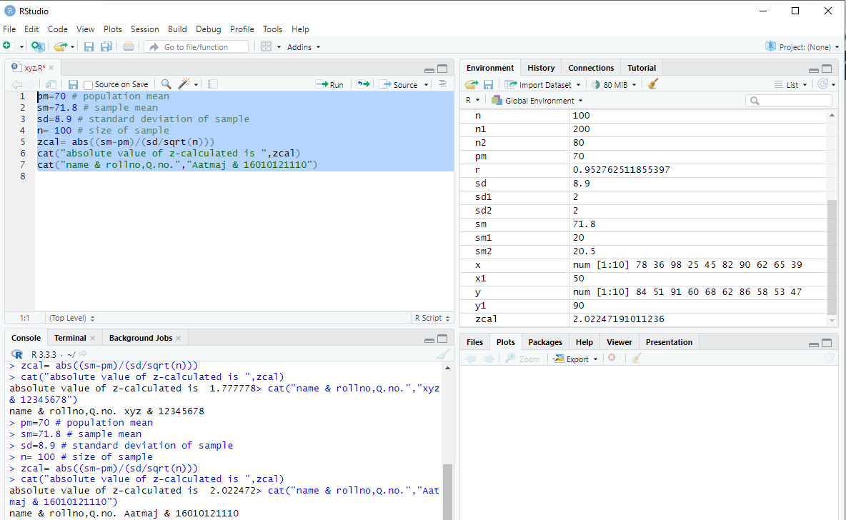

pm=70 # population mean

sm=71.8 # sample mean

sd=8.9 # standard deviation of sample

n= 100 # size of sample

zcal= abs((sm-pm)/(sd/sqrt(n)))

cat("absolute value of z-calculated is ",zcal)

cat("name & rollno,Q.no.","xyz & 12345678")

**Conclusion:**

Ho cannot be accepted as calculated value for 1 tailed id greater than table value for 95% confidence. Hence we can say that lifespan is greater.

**2) The mean breaking strength of cables supplied by a manufacturer is 1800 with S.D. 100. By a new technique in the manufacturing process it is claimed that the breaking strength of the cables has increased. In order to test the claim a sample of 50 cables is tested. It is found that the mean breaking strength is 1850. Can we support the claim at 1% LOS.**

**H0** u1=u2 both methods same

**Ha** u1 > u2 new method better

Nature of test is **one tailed**

**LOS** is 1%

**Table value of Z** is 2.33

**Zcalc**=3.535534

**Zcal<Zalpha** ie table value of Z

**H0 is NOT accepted**

**We can say that the new technique is effective**

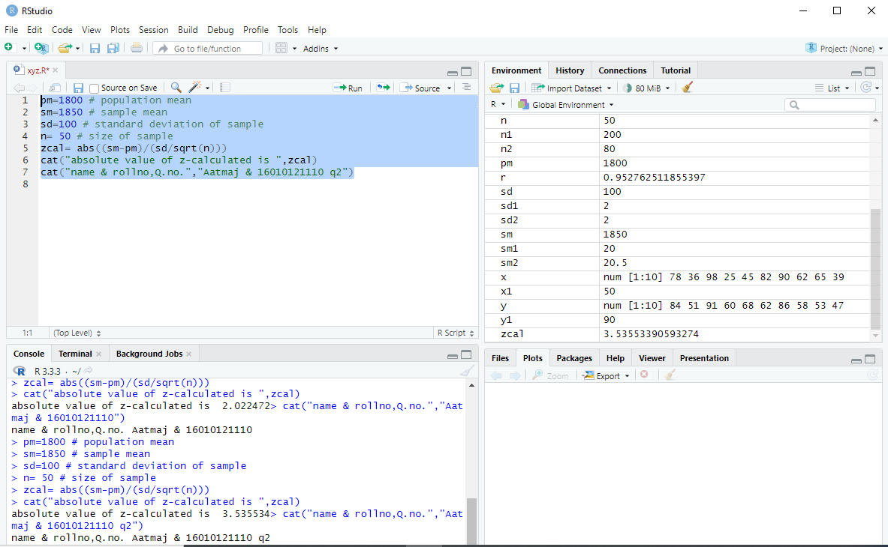

pm=1800 # population mean

sm=1850 # sample mean

sd=100 # standard deviation of sample

n= 50 # size of sample

zcal= abs((sm-pm)/(sd/sqrt(n)))

cat("absolute value of z-calculated is ",zcal)

cat("name & rollno,Q.no.","xyz & 12345678")

**Conclusion:** since the calculated value is greater than the table value we have to reject the initial assumption that the new method is same. Hence new method is better.