**Batch: C3 Roll No.: 121**

**Experiment / assignment / tutorial No. 3**

|  |
| --- |
| **Title:** Implementation of Goal based agent architecture using PROLOG. |

**Objective:** To use the concepts of knowledge engineering to design and solve moderate complex problem.

**Expected Outcome of Experiment:**

|  |  |
| --- | --- |
| **Course Outcome** | **After successful completion of the course students should be able to** |
| **CO1** | Understand the history & various application of AI and choose appropriate agent architecture to solve the given problem. |

**Books/ Journals/ Websites referred:**

1. **https://www.csupomona.edu/~jrfisher/www/prolog_tutorial/contents.html**
2. **http://www.csupomona.edu/~jrfisher/www/prolog_tutorial/pt_framer.html**
3. **http://www.doc.gold.ac.uk/~mas02gw/prolog_tutorial/prologpages/**
4. **http://classes.soe.ucsc.edu/cmps112/Spring03/languages/prolog/PrologIntro.pdf**
5. **“Prolog: Programming for Artificial Intelligence” by Ivan Bratko, Pearson education Publications**
6. **“Artificial Intelligence: a Modern Approach” by Russel and Norving, Pearson education Publications**
7. **“Artificial Intelligence” By Rich and knight, Tata Mcgraw Hill Publications**
8. **https://www.gyaanibuddy.com/assignments/assignment-detail/medical-diagnosis-in-prolog/**

**Pre Lab/ Prior Concepts:**

Agents, Agent Architecture, Programming with PROLOG

**Historical Profile:**

Knowledge is vast, uncertain and continuously changing. These properties of knowledge make it difficult to arrive at a result. A murder mystery is a kind of situation which depicts the uncertain nature of knowledge and also emphasizes the need of choosing right clauses from entire knowledgebase to make a decision. He goal based agent architecture and some knowledge engineering can help in solutioning of such problems.

The logical agents are complex but they can reason and learn from the actions and new precepts. They are less like acting and think like humans but more like acting and thinking rational agents.

Knowledge and reasoning play a crucial role in dealing with partially observable environments. A knowledge based agent can combine the general knowledge with current percept to infer the hidden aspects of the current state prior to selecting actions.

**New Concepts to be learned:**

Knowledge engineering, implementing complex agent architecture, uncertainty in knowledge.

**The Knowledge Engineering Process**

1. Identify the task
2. Assemble the relevant knowledge
3. Decide on vocabulary of predicates, functions and constants
4. Encode general knowledge about the domain
5. Encode description of specific problem instance
6. Pose queries to the inference procedure and get answers
7. Debug the knowledge base

**Algorithm for KB-Agent:**

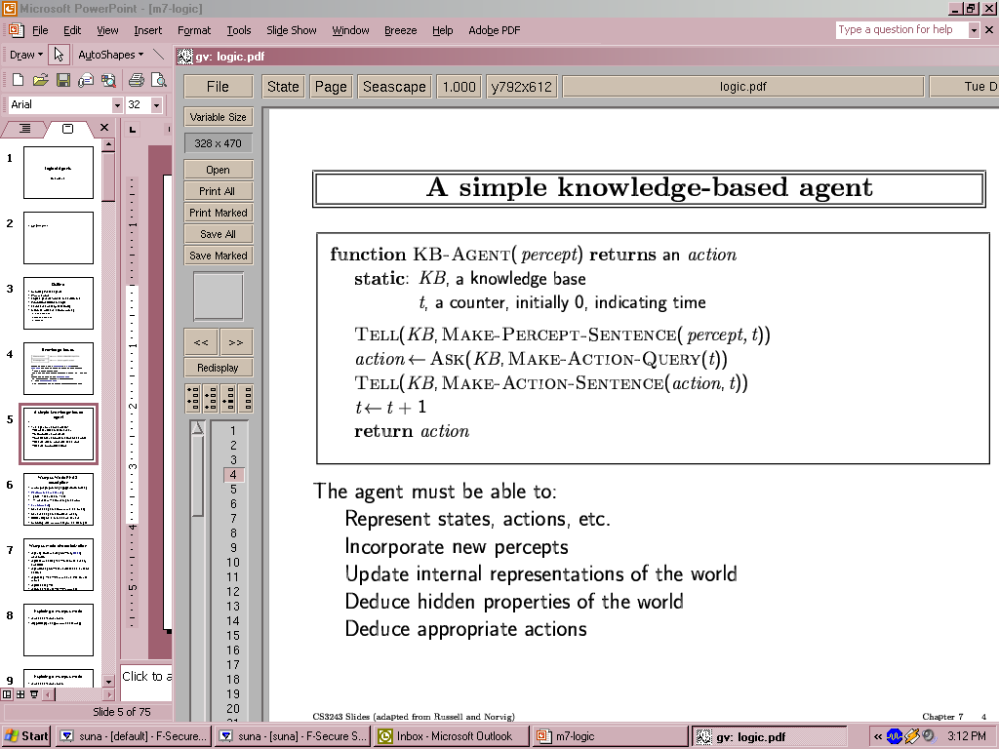

**Problem Statement:**

Medical Diagnosis - Brain

**Knowledge Engineering steps applied to chosen problem:**

* + - 1. Identifying the task:

Medical Diagnosis for the Brain

* + - 1. Assembling the relevant knowledge

First the Symptoms and Treatment part:

For Medical Diagnosis of the brain, knowledge of various symptoms and their treatments is required. Further, the knowledge of which set of symptoms together indicate the presence of a disease is also required.

If the symptom is headache, then the treatment is rest, hydration, and over-the-counter pain relievers.

If the symptom is forgetting, then the treatment involves cognitive exercises, a healthy diet, and stress management.

If the symptom is nausea, then the treatment includes anti-nausea medications, hydration, and small, bland meals.

If the symptom is dizziness, then the treatment consists of rest, hydration, and addressing underlying causes such as low blood sugar or inner ear issues.

If the symptom is fatigue, then the treatment encompasses adequate sleep, a balanced diet, and regular exercise.

If the symptom is blurred vision, then the treatment involves corrective lenses, eye exercises, and addressing underlying eye conditions.

If the symptom is mood swings, then the treatment includes counseling, therapy, lifestyle changes, and medication if necessary.

Now the Diseases part:  
If there is a headache and forgetting, then the patient is suffering from stress-related cognitive impairment.

If there is nausea, forgetting, and dizziness, but the disease is not stress-related cognitive impairment, then the disease is migraines.

If there is dizziness and blurred vision, but the disease is not stress-related cognitive impairment or migraines, then the disease is vestibular disorder.

If there is fatigue and mood swings, but the disease is not stress-related cognitive impairment, migraines, or vestibular disorder, then the disease is depression.

If there is forgetting and mood swings, but the disease is not stress-related cognitive impairment, migraines, vestibular disorder, or depression, then the disease is dementia.

If there is dizziness, blurred vision, and nausea, but the disease is not stress-related cognitive impairment, migraines, vestibular disorder, depression, or dementia, then the disease is low sugar.

* + - 1. Deciding on the vocabulary of predicates, functions and constants

Standard terminology used in Medical Science for Brain will be used.

* + - 1. Encode general knowledge about the domain

symptom('Headache').

symptom('Forgetting').

symptom('Nausea').

symptom('Dizziness').

symptom('Fatigue').

symptom('Blurredvision').

symptom('Moodswing').

treatment('Headache', 'Rest, hydration, over-the-counter pain relievers.').

treatment('Forgetting', 'Cognitive exercises, healthy diet, stress management.').

treatment('Nausea', 'Anti-nausea medications, hydration, small, bland meals.').

treatment('Dizziness', 'Rest, hydration, addressing underlying causes like low blood sugar or inner ear issues.').

treatment('Fatigue', 'Adequate sleep, balanced diet, regular exercise.').

treatment('Blurredvision', 'Corrective lenses, eye exercises, addressing underlying eye conditions.').

treatment('Moodswing', 'Counseling, therapy, lifestyle changes, medication if necessary.').

* + - 1. Encode description of specific problem instance

disease(stress_related_cognitive_impairment):-

patient('Headache', yes),

patient('Forgetting', yes).

disease(migraines):-

not(disease(stress_Related_cognitive_impairment)),

patient('Nausea', yes),

patient('Forgetting', yes),

patient('Dizziness', yes).

disease(vestibular_disorder):-

not(disease(stress_Related_cognitive_impairment)),

not(disease(migraines)),

patient('Dizziness', yes),

patient('Blurredvision', yes).

disease(depression):-

not(disease(stress_Related_cognitive_impairment)),

not(disease(migraines)),

not(disease(vestibular_disorder)),

patient('Fatigue', yes),

patient('Moodswing', yes).

disease(dementia):-

not(disease(stress_Related_cognitive_impairment)),

not(disease(migraines)),

not(disease(vestibular_disorder)),

not(disease(depression)),

patient('Forgetting', yes),

patient('Moodswing', yes).

disease(low_sugar):-

not(disease(stress_Related_cognitive_impairment)),

not(disease(migraines)),

not(disease(vestibular_disorder)),

not(disease(depression)),

not(disease(dementia)),

patient('Dizziness', yes),

patient('Blurredvision', yes),

patient('Nausea', yes).

* + - 1. Pose queries to the inference procedure and get answers

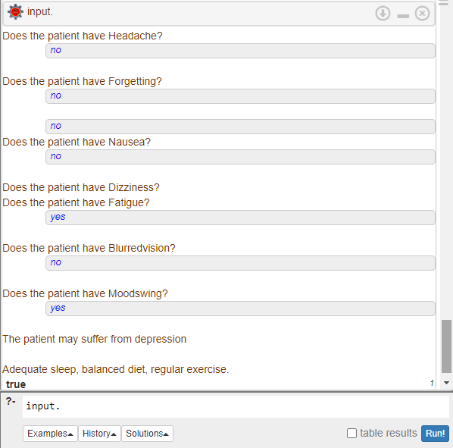

* + - 1. Debug the knowledge base

As the results provided by the machine are sufficiently accurate, debugging is not required.

**Agent Architecture** *(Justify the blocks)***:**

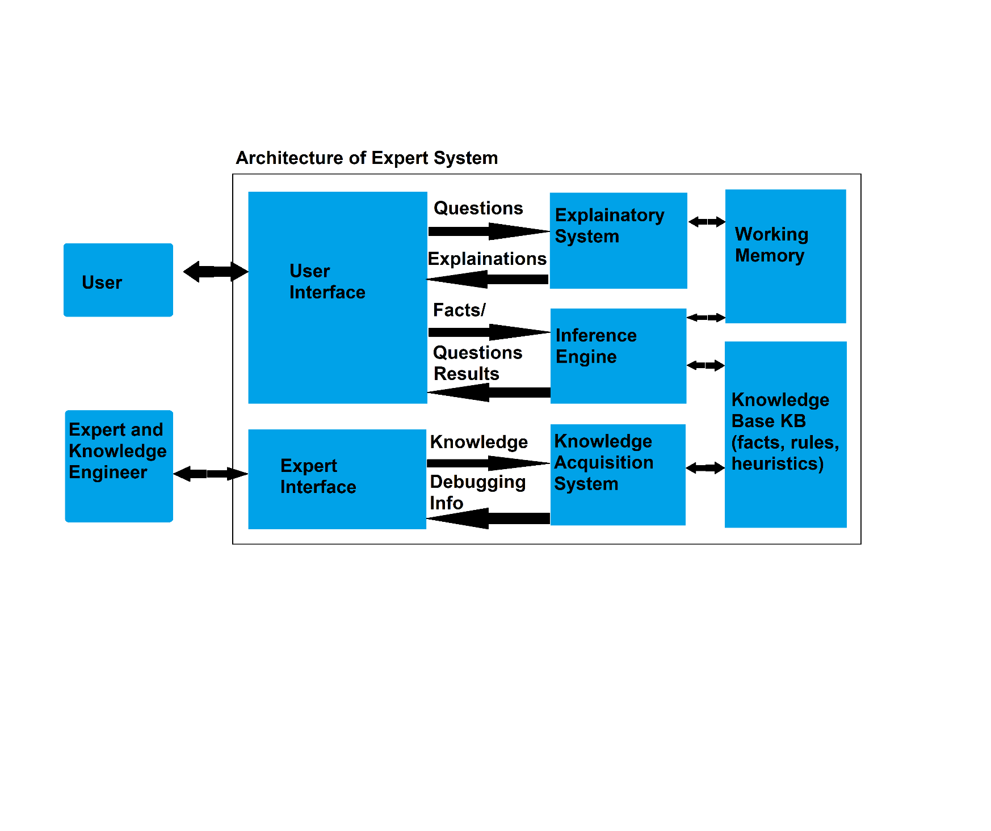

1. **User Interface**: This is where patients or medical professionals input symptoms or data related to brain health. It’s essential for collecting initial information to start the diagnosis process.
2. **Expert Interface**: Allows knowledge engineers and experts to input and update the system with new medical findings, research, and data about brain diseases, treatments, etc., ensuring that the system is current and accurate.
3. **Explanatory System**: It helps in explaining the diagnosis results in an understandable manner. For a Brain Medical Diagnosis system, it can provide insights into how certain conclusions about a patient’s brain health were reached.
4. **Inference Engine**: This is crucial for processing all collected data and applying rules and logic to diagnose potential brain issues. It performs reasoning to derive conclusions.
5. **Knowledge Acquisition System**: Helps in updating the Knowledge Base with new information without needing extensive programming skills. In terms of brain health, it ensures that new discoveries or findings are easily integrated into the system.
6. **Working Memory**: Stores temporary data which is essential for real-time processing and decision-making during diagnosis.
7. **Knowledge Base KB (facts, rules, heuristics)**: Contains all stored knowledge including symptoms, diseases descriptions, treatments etc., which is vital for making informed diagnoses.

Each of these blocks plays a crucial role in the functioning of a Brain Medical Diagnosis system, ensuring it can accurately diagnose and explain potential brain health issues. They work together to create a comprehensive, user-friendly, and up-to-date system.

**Code:**

symptom('Headache').

symptom('Forgetting').

symptom('Nausea').

symptom('Dizziness').

symptom('Fatigue').

symptom('Blurredvision').

symptom('Moodswing').

treatment('Headache', 'Rest, hydration, over-the-counter pain relievers.').

treatment('Forgetting', 'Cognitive exercises, healthy diet, stress management.').

treatment('Nausea', 'Anti-nausea medications, hydration, small, bland meals.').

treatment('Dizziness', 'Rest, hydration, addressing underlying causes like low blood sugar or inner ear issues.').

treatment('Fatigue', 'Adequate sleep, balanced diet, regular exercise.').

treatment('Blurredvision', 'Corrective lenses, eye exercises, addressing underlying eye conditions.').

treatment('Moodswing', 'Counseling, therapy, lifestyle changes, medication if necessary.').

:- dynamic patient/2.

input :-

repeat,

symptom(X),

write('Does the patient have '),

write(X),

write('? '),

read(Y),

assert(patient(X,Y)),

output.

disease(stress_related_cognitive_impairment):-

patient('Headache', yes),

patient('Forgetting', yes).

disease(migraines):-

not(disease(stress_Related_cognitive_impairment)),

patient('Nausea', yes),

patient('Forgetting', yes),

patient('Dizziness', yes).

disease(vestibular_disorder):-

not(disease(stress_Related_cognitive_impairment)),

not(disease(migraines)),

patient('Dizziness', yes),

patient('Blurredvision', yes).

disease(depression):-

not(disease(stress_Related_cognitive_impairment)),

not(disease(migraines)),

not(disease(vestibular_disorder)),

patient('Fatigue', yes),

patient('Moodswing', yes).

disease(dementia):-

not(disease(stress_Related_cognitive_impairment)),

not(disease(migraines)),

not(disease(vestibular_disorder)),

not(disease(depression)),

patient('Forgetting', yes),

patient('Moodswing', yes).

disease(low_sugar):-

not(disease(stress_Related_cognitive_impairment)),

not(disease(migraines)),

not(disease(vestibular_disorder)),

not(disease(depression)),

not(disease(dementia)),

patient('Dizziness', yes),

patient('Blurredvision', yes),

patient('Nausea', yes).

output:-

nl,

possible_diseases,

nl,

advice.

possible_diseases :- disease(X), write('The patient may suffer from '), write(X), nl.

advice :- symptom(X), patient(X, yes), treatment(X,Y), write(Y), nl.

**Team Members:**

**1. 16010121110 Aatmaj Mhatre**

**2. 16010121121 Sushant Nair**

**Post Lab Objective Questions**

**1. Which is not a Goal-based agent?**

1. Inference
2. Search
3. Planning
4. Conclusion
5. Dynamic search.

**Answer: d. Conclusion**

**2. Which were built in such a way that humans had to supply the inputs and  
interpret the outputs?**

1. Agents
2. Sensor
3. AI System
4. Actuators

**Answer: c. AI System**

**Post Lab Subjective Questions**

**Explain the role of PEAS and task environment in choosing the agent architecture. Justify your answer with an example.**

**Ans.** The following is a PEAS description for Brain Medical Diagnosis System, after which the role of PEAS and task environment in choosing the agent architecture is explained along with an example.

1. **Performance Measure**: The system’s performance could be measured by its accuracy in diagnosing brain diseases, the comprehensibility of its explanations, and its ability to keep up-to-date with the latest medical research.
2. **Environment**: The environment includes the user interface where patients or medical professionals input symptoms or data, the database of medical knowledge, and the expert interface for updating the system.
3. **Actuators**: In this case, the actuators could be the system’s modules that generate diagnoses, explanations, and updates to the knowledge base.
4. **Sensors**: The sensors would be the components of the system that receive and interpret input from the user and expert interfaces.

The PEAS components and the task environment are crucial in choosing the agent architecture because they define the agent’s goals, its capabilities, and the challenges it might face. The architecture must be designed to allow the agent to perceive its environment accurately, act upon it effectively, and maximize its performance measure.

For example, if the performance measure places a high value on the system’s ability to explain its diagnoses, the architecture might need to include a sophisticated explanatory system. If the environment includes a rapidly evolving body of medical knowledge, the architecture might need a robust knowledge acquisition system to keep the knowledge base up-to-date. The choice of sensors and actuators would depend on the specific types of input and output the system needs to handle. In all cases, the architecture should be chosen to best enable the system to achieve its performance measure given its environment, sensors, and actuators.