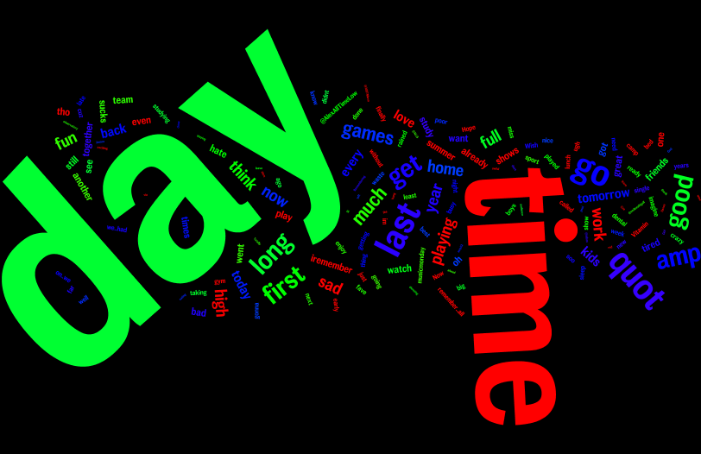

# Cluster 0 – The potential topic can be people talking about what kind of activities they did on a particular day or at particular time. Tweets are about people expressing their feelings towards a special/particular day in their lives.

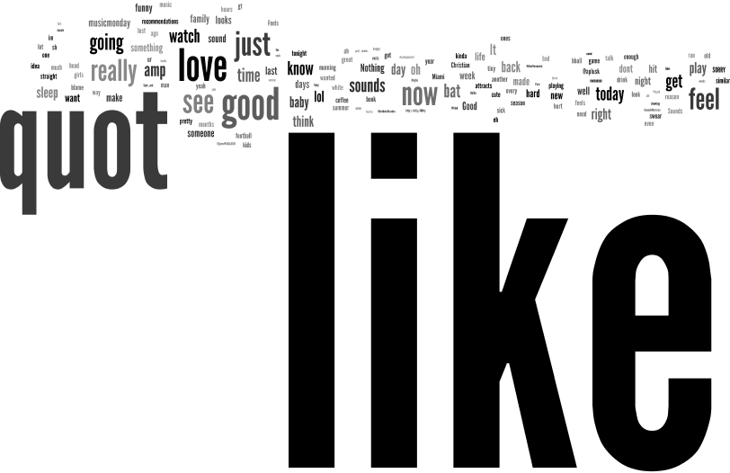

# Cluster 1 – The potential topic can be people referencing/comparing something in their life (Or an event which occurred in their life) to something else. The tweets are also showing tweeter user’s likeness to a particular thing/event.

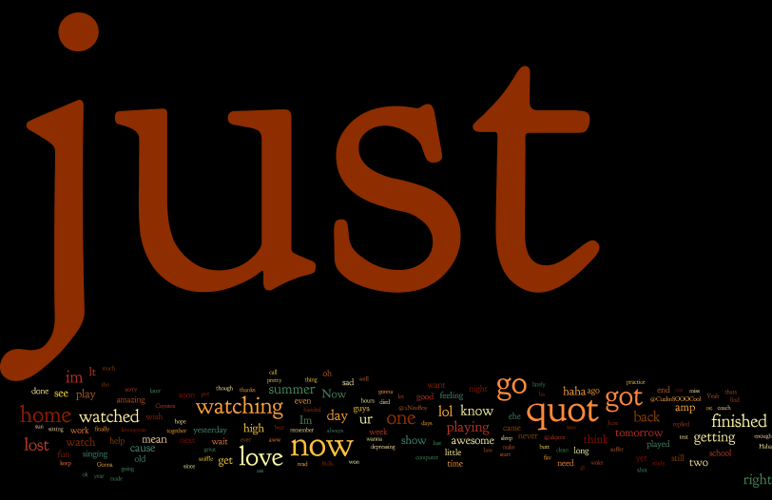

# Cluster 2 – The potential topic can be people expressing an event which they just did or finished (At the time they tweeted) Or an event or task they are doing at a particular time.

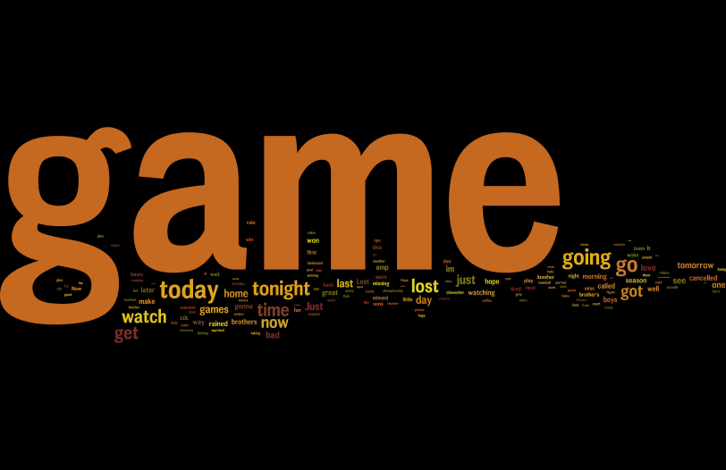

# Cluster 3 – The potential topic can be people talking about a game (related to sports) which they will be playing or watching or going.

# 

# Cluster 4 - The potential topic can be people showing their love or giving opinion to a song, book or any other literature. The tweets can also be about users playing/watching/talking about a song or a game.