# General description.

TrendEngine serves detection of change and trend in vegetation using remote sensing time series data.The process consists of three steps: acquisition, analysis and visualization of results.

TrendEngine employs Google Earth Engine Python API on the backend and allows to choose from two datasets:

- GIMMS NDVI with resolution of 8000 m

- MODIS NDVI with resolution of 250 m

An area of interest (AOI) can be described by selecting an individual geographic point or a bounding box of a polygon

on the provided map.

Results for an individual geographic point provide details and are plotted on graphs. Textual output is also provided.

Results for a polygon provide an overview. They are displayed on interactive maps with descriptive statistics.

The analysis can be performed using two algorithms:

1/ **PolyTrend** for trend detection in time series. It returns:

* the type of trend: cubic, cuadratic, linear or concealed (no net change),
* direction of change
* slope of the linear fit

Results for points contain details: a plot with the time series data and the fitted regression line.

Results for polygon provide an overview: each pixel of displayed map represents one of the values calculated by PolyTrend:

* type of trend,
* slope,
* significance
* direction

The data used is an annual NDVI composite created using the maximum value.

See: Jamali, S., Seaquist, J., Eklundh, L., Ardö, J., 2014. Automated mapping of vegetation trends with polynomials using NDVI imagery over the Sahel. Remote Sens. Environ. 141, 79–89. https://doi.org/10.1016/j.rse.2013.10.019

2/ **Detecting Breakpoints and Estimating Segments in Trend** (DBEST) describes characteristics of changes. It employs two algorithms:

A/ Generalization returns a generalized trend and f-local-change depicted on a plot.

B/ Change detection uses Seasonal Trend Decomposition (STL) based on loess to derive trend components: trend, seasonal, remainder.

TrendEngine visualizes them on plots. Additionally, textual output includes characteristics of major changes:

the start and end dates, magnitude and statistical significance. An overview of these values can be displayed on change maps if a polygon is selected.

The data is composited from bimonthly NDVI to monthly.

See: Jamali, S., Jönsson, P., Eklundh, L., Ardö, J., Seaquist, J., 2015. Detecting changes in vegetation trends using time series segmentation. Remote Sens. Environ. 156, 182–195. <https://doi.org/10.1016/j.rse.2014.09.010>

# How to use TrendEngine

**4**

**3**

**2**

**1**

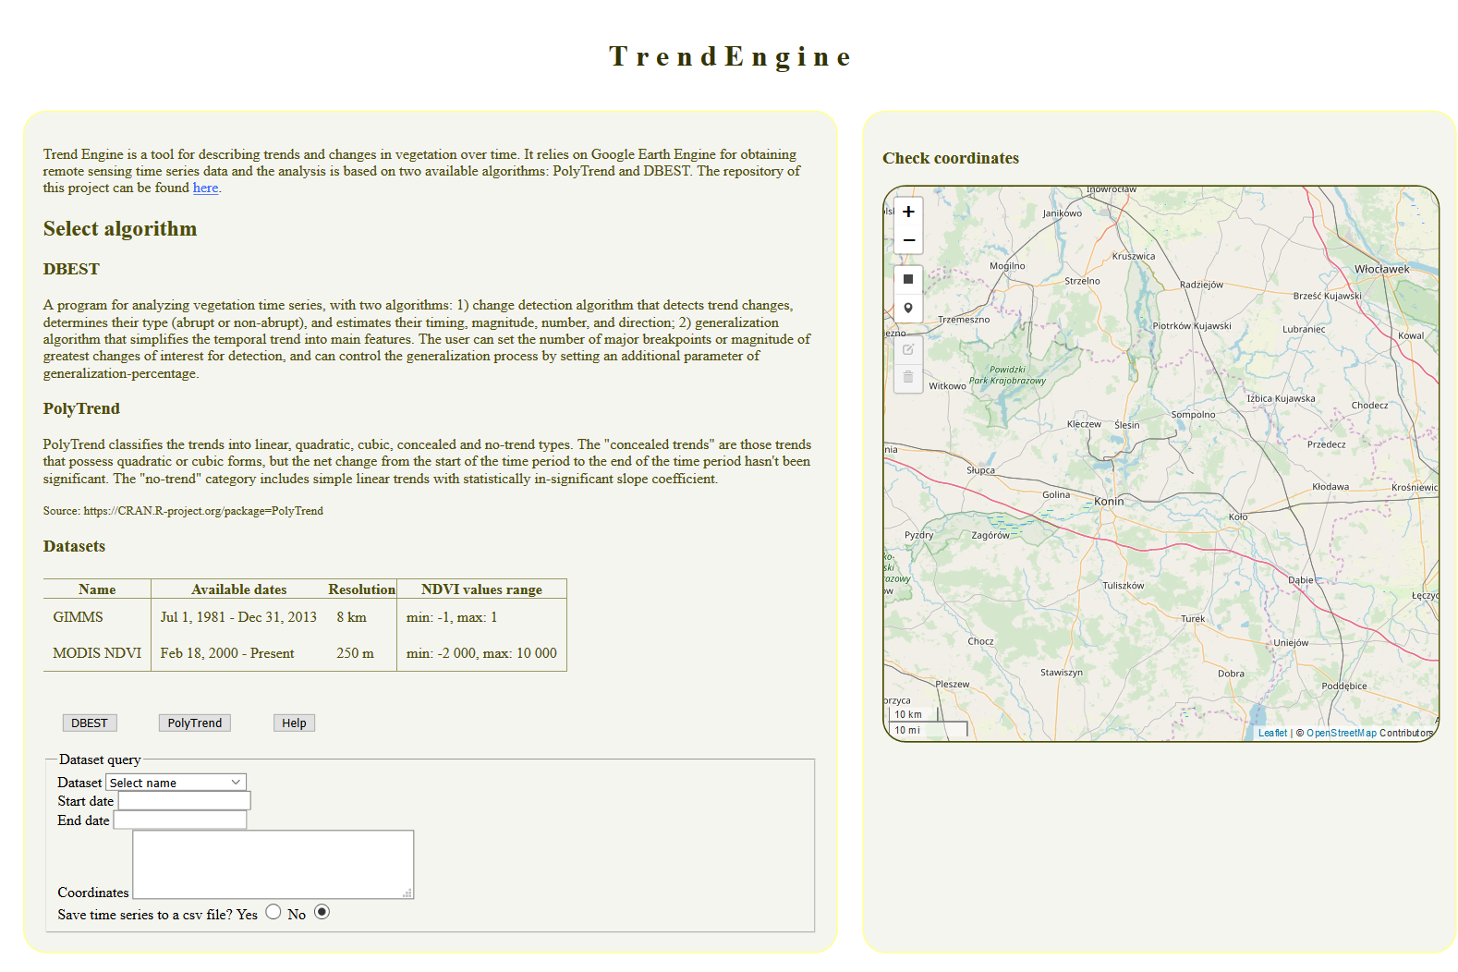

1. Read the description of available options for analysis.
2. Choose DBEST or PolyTrend.
3. Create dataset query: enter **year** when study starts and ends.
4. On the map select a point of interest or a polygon.
5. Enter DBEST or PolyTrend parameters.
6. Click Submit.

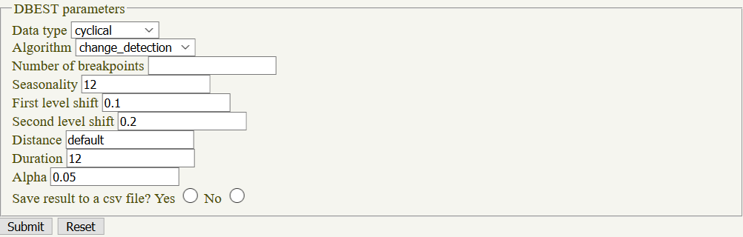 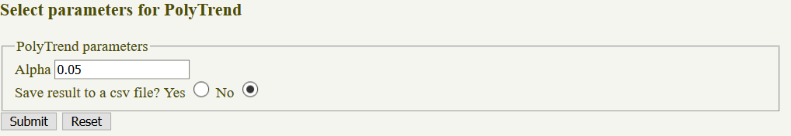

**5**

# Example analysis

**DBEST**

GIMMS, start 2000, end 2010, change detection, generalization, coordinates [18.5021859790601,52.2754870059602]

Start 2000, end 2010, change detection, coords: [[[18.498068382047347,52.17543749861391],[18.498068382047347,52.48159788567552],[19.019630670331658, 52.48159788567552], [19.019630670331658, 52.17543749861391]]]

MODIS start 2009, end 2018, coordinates [18.5021859790601,52.2754870059602]

**PolyTrend**

GIMMS start 1990, end 2010, coordinates [13.797820600569837,55.58452840614207]

MODIS start 2006, end 2018, coordinates [[[18.49257825269697,52.44396655727939],[18.49257825269697,52.480761983383694],[18.561204869576517, 52.480761983383694], [18.561204869576517, 52.44396655727939]]]

MODIS start 2006, end 2019, coordinates: [13.16048611141001,55.432788826248]

# Example use cases

The below case studies are not scientific investigations and are only meant as an example of how Trend Engine can be utilized.

## PolyTrend

Using PolyTrend we can determine in which direction changes took place (negative or positive) and how abrupt they were by assessing the slope derived from the polynomial fitting scheme. Figure and Figure 2 represent PolyTrend results based on the MODIS NDVI set for the years 2008 – 2018 for an open-pit mine area in Tomislawice, Poland.

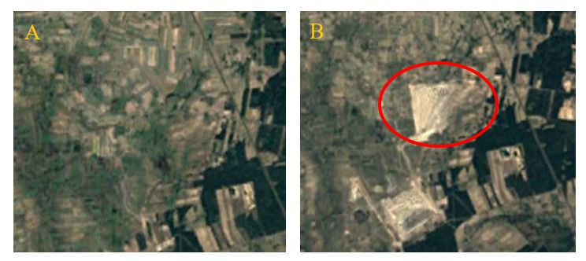

Figure 1 Tomislawice open-pit mine, A in 2009, B in 2011. Mine marked with a red circle.

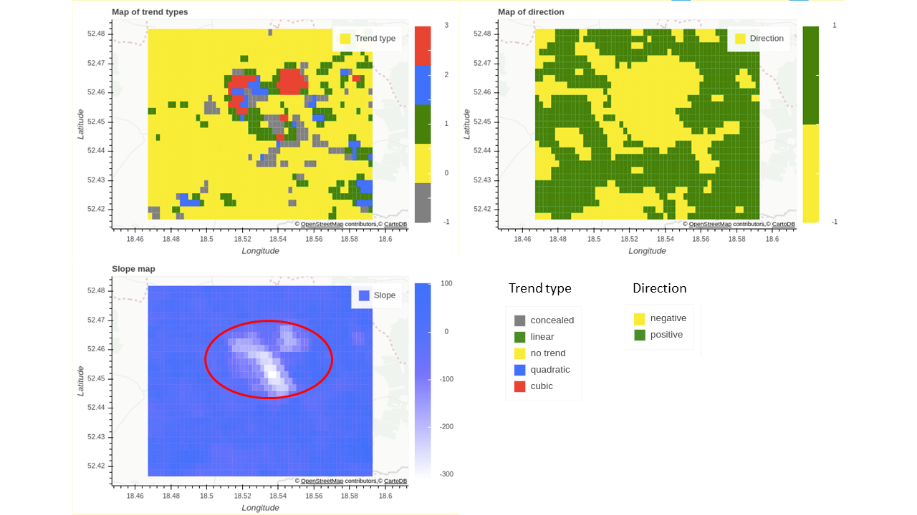

Figure 2 Output from PolyTrend analysis for an open pit mine area.

The majority of pixels display no trend. Directly inside the mining area opened in 2011 (PAK Kopalnia Węgla Brunatnego Konin S.A., n.d.) there are some higher order polynomials (Figure 2). Open pit mines are reported to have a negative influence on surrounding areas, namely vegetation state, soil condition and hydrologic balance (Pimenta et al., 2016). In this area we observe over a third of the area has undergone a negative change in NDVI values (Figure 3). This information could be used to assess and monitor the changes caused by the mining activity and plan for which areas need special attention.

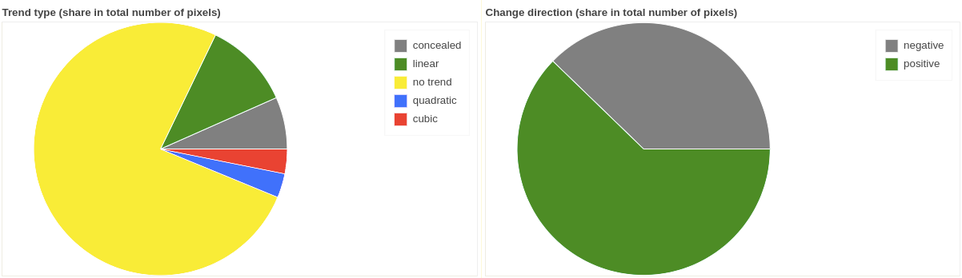

Figure 3 PolyTrend descriptive statistics visualised in pie charts (left: trend type, right direction of change).

## DBEST

DBEST’s capacity for detecting abrupt changes can be employed when dealing with forest disturbance, for instance, identifying hot spots of bark beetle (*Ips typographus*) outbreaks. Bark beetle outbreaks decimate stands of Norway spruce (*Picea abies* (L.)Karst*.*) trees very quickly and are a big problem in European forests, especially since droughts are more frequent making the trees more susceptible to infections. It is known that early detection of an outbreak can help to effectively deal with it. An example of an outbreak is Bialowieza Forest in Poland (Figure 4).

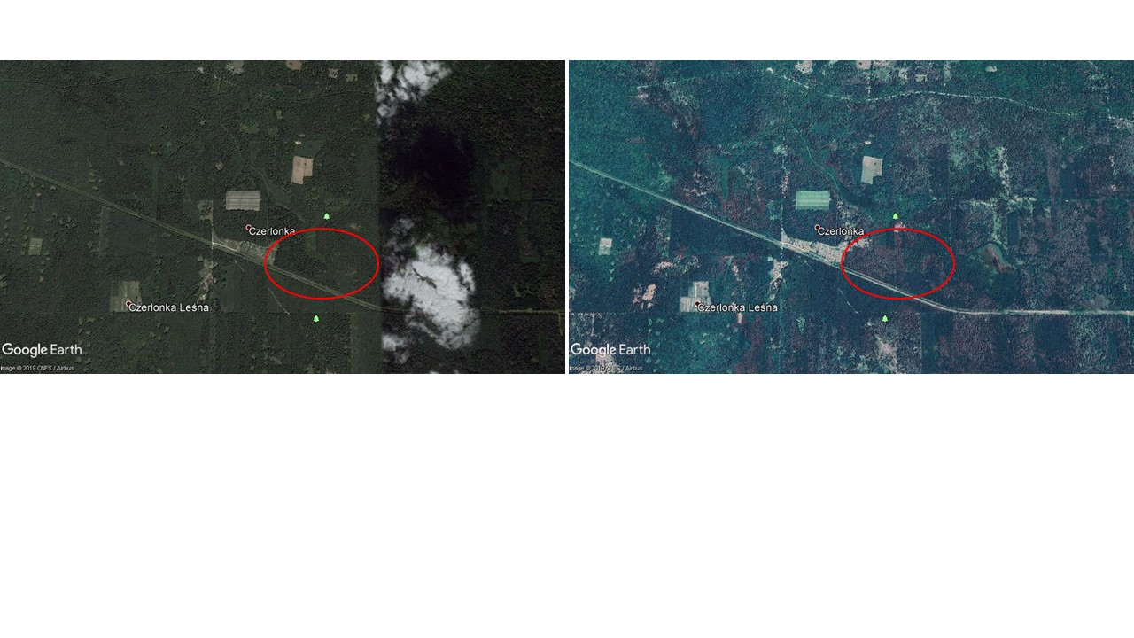

Figure 4 Satellite images of part of Bialowieza Forest in Czerlonka area, A - Sept 2010, B - Oct 2018.

Source: Google Earth.

We used MODIS NDVI images here for the dates 01.01.2005 until 31.12.2018. The overview of the area in Figure 5 shows us where the biggest changes occurred, when they were started, how long they lasted and if they were abrupt or not. In figures 4 and 5 the red circle points to an area with a big change in NDVI. These pixels can then be selected for an in-depth analysis. Running a change detection algorithm on a pixel will return the magnitude and time of the most significant change. Here, the algorithm pointed to a change in July 2016 where NDVI values dropped by 2101 units (in range -2000 to 10000, MODIS NDVI) (Figure ), which could be investigated further regarding correlation with climate data or management practice in place at that time. Based on this information foresters could assess the damage but also predict where and how fast the outbreak spreads. In areas where controversial measures like logging are taken to stop the damage, the output of Trend Engine can serve as evidence of the efficiency and/ or necessity of these measures.

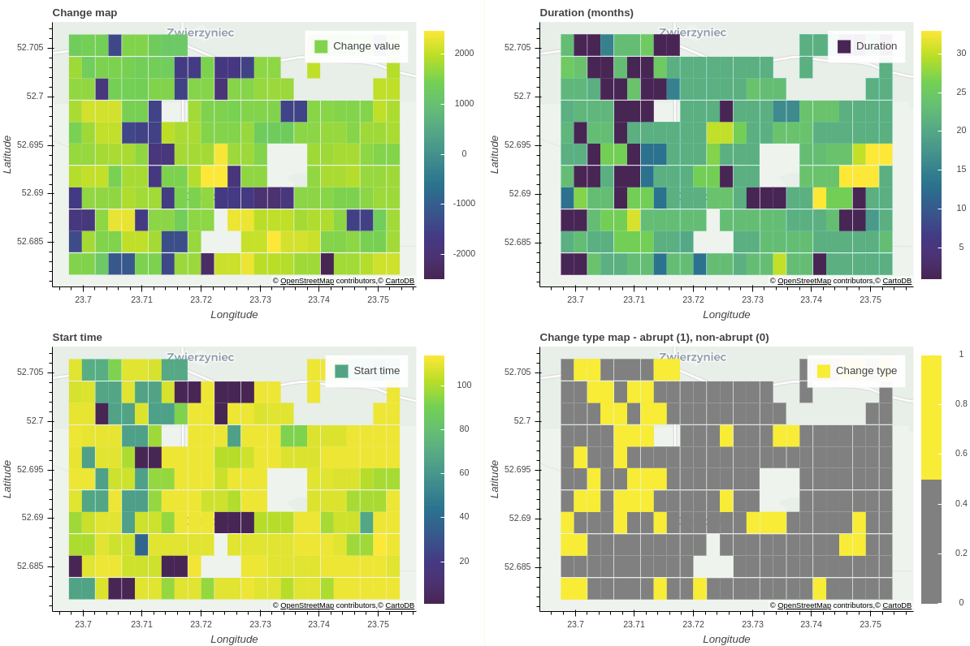

Figure 5 Czerlonka area, DBEST output maps.

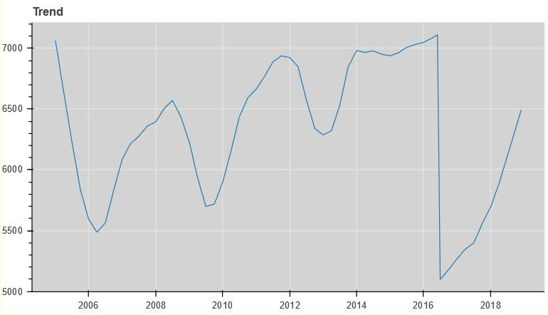

Figure 6 Trend component with clearly visible change in 2016.