**To run Trend Engine on Windows:**

1. Install Anaconda or Miniconda. See: https://docs.anaconda.com/anaconda/install/windows/
2. Open Start menu - Anaconda Prompt.
3. Make a new environment:

conda create -n trend_engine python==3.7

1. Copy the Trend-Engine folder into Documents directory.
2. In Anaconda Prompt navigate to the directory that contains the project ‘TrendEngine’, e.g. if you saved TrendEngine in Documents directory run command:

cd documents/TrendEngine



1. Install all dependencies:

pip install --file requirements.txt

1. When finished run:

python run.py

1. If everything goes well you should see:

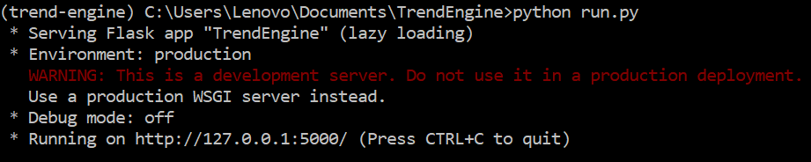

1. Open a browser (tested with Firefox and Chrome) and type in the address bar <http://127.0.0.1:5000/>