**To run Trend Engine on Windows:**

1. Download TrendEngine folder into your Documents directory and unzip.
2. Install Anaconda or Miniconda. See: https://docs.anaconda.com/anaconda/install/windows/
3. Open Start menu - Anaconda Prompt.
4. Navigate to the TrendEngine folder:

cd Documents/TrendEngine



1. In the command line of Anaconda Prompt run:

conda env create -f trend-engine.yml

1. Run command:

conda activate trend-engine



1. Run:

pip install pandas-bokeh pyspark

1. Authenticate earthengine to use your Google account:

earthengine authenticate

1. A link shows. Open the link in your browser. Authenticate via the website. Copy the code and paste into Anaconda Prompt.
2. When finished run:

python run.py

1. If everything is fine you should see this message:

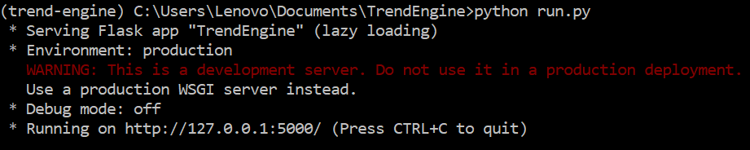

1. Open a browser (tested with Firefox and Chrome) and type in the address bar <http://127.0.0.1:5000/>