**Project Group No:**

**Hand gesture controlled wheelchair for physically challenged people.**

**Project Domain:** **Internet of Things**

**BE Project Synopsis**

**Bachelor of Engineering**

**IN**

# Electronics & Telecommunication Engineering

By

**RUTIK ANDHALKAR** [Roll No:2042082] [PRN No:123456H]

**PRATHMESH SHINDE** [Roll No:2042000] [PRN No: 123456M]

**AAVESH BAGWAN** [Roll No:2042088] [PRN No: 72027052K]

Supervisor Name

**Mr. R. S. PISKE**

# 



Department of Electronics & Telecommunication Engineering,

Vidya Pratishthan’s Kamalnayan Bajaj Institute of Engineering & Technology,

Baramati. Dist: Pune, Maharashtra

**Academic Year 2021-22**

**Project Approval Declaration**

We,

1. **RUTIK ANDHALKAR** [Roll No:2042000] [PRN No:123456H]
2. **PRATHAMESH SHINDE** [Roll No:2042000] [PRN No: 123456M]
3. **AAVESH BAGWAN** [Roll No:20420] [PRN No: 123456F]

hereby declare that we are submitting the curricular project synopsis on **Hand gesture controlled wheelchair for physically disabled people** of the broad domain **Internet of Things,** with properapproval from our project guide & head of the department for the partial fulfillment of the requirement for the award of the degree Bachelor of Engineering in the academic year 2021-22.

|  |  |
| --- | --- |
| **Mr. R. S. PISKE** | **(Dr. B. H. Patil)** |
| Guide | Head |
| Department of E&TC Engineering | Department of E&TC Engineering |

Place: Baramati

Date:28/08/2022

## Abstract

This project demonstrate that how can we design and implement the hand gesture controlled wheelchair for the physically challenged person who cannot move by himself. The main focus of this project is to detect the motion of the wrist of the hand and control the motors accordingly to move in desired direction along with some additional features such as, obstacle detection and emergency massaging system for the help of operator/patient if needed.

Previously we needed some other person to move the wheelchair in desired direction but later, we developed the “joystick controlled wheelchair” which are good in its own ways but most of the times it becomes difficult for the physically challenged person to use it efficiently to overcome this situations we have developed this “gesture controlled wheelchair” and among all the available gestures we found that this hand gesture controlled wheelchair will be the best suited for the physically challenged person.­­­

For this demonstration of the project we have used Arduino NANO, Arduino UNO, Accelerometer sensor, motors and motor driver, ultrasonic sensor for obstacle detection, transmitter and receiver, GSM module.

# Introduction

In present in the world there are around 650 million people who are physically challenged and suffering from varies challenges in the daily life some of them are by birth due to certain neural issues are physically challenged and some of them are due any accidents and due to increased rate of accidents there is high incremental rate of increase of physically challenged people. Hence it is extremely essential to build a system for them so that they can move by themselves without need of any other persons intervention and live more happily and flexibly and be self-dependent for physical movement.

Previously a concept of controlling the wheelchair by the help of the motion or gesture of body developed during world war II to assist the injured veterans it was developed by the George Klein in 1953 but this has no any major security intelligent system which will help the operator. Since then many research has been done in this area.

There are varies motion controlled wheelchairs present such as eye movement controlled wheelchair, joystick controlled wheelchair, voice controlled wheel chair, head motion controlled wheelchair, or even wheelchairs which are controlled by brain reading.

But most of them have certain issues such as eye movement controlled wheelchair will require a screen in front of eyes of operator/patient all the time which is cumbersome, the voice controlled wheelchairs has issue of understanding different voices around it which will cause a disturbance in an noisy environment. Joy stick controlled wheelchair is also not a proper solution because it is also not a convenient to move that joystick all the time, even head motion controlled wheelchair become cumbersome most of the time, and brain reading wheelchairs are also under development but they are very expensive middle class peoples simply cannot afford it and if operator or patient is away from the wheelchair he or is cannot use eye controlled wheelchair because he or she does not have that screen which detects eye motion in front of him/her and his voice will also be not reachable to the wheelchair and also if patient is using the joystick controlled wheelchair he or she does not have joystick to control it.

To overcome all above mentioned important issues we found that using hand gesture controlled wheelchair can be very useful and convenient in all the condition for the operator/ patient. In this by moving wrist of the hand of patient to the right, left, top, down, wheelchair can be moved accordingly to the right, left, forward, and backward respectively.in this we have two circuits one which is transmitter circuit which detects the motion of the hand by accelerometer and transfers the data to the receiver circuit and then receiver circuit controls the motors accordingly and then we have ultrasonic sensor at the receiver which checks for the obstacle and reports to the receiver circuit to stop the wheelchair and we have one component which GSM module help in sending message during emergency. transmitter circuit is set on the hand and receiver circuit in present at the wheelchair.

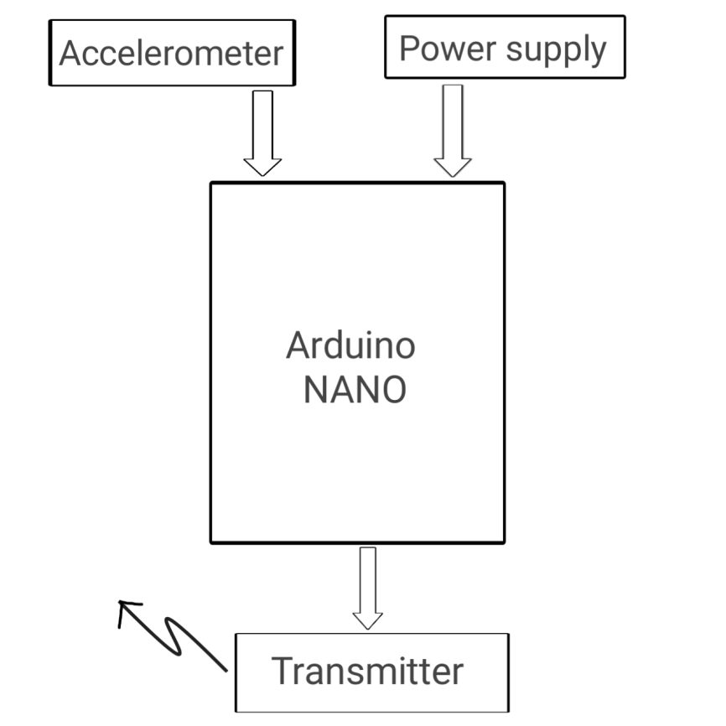

­­­­­­

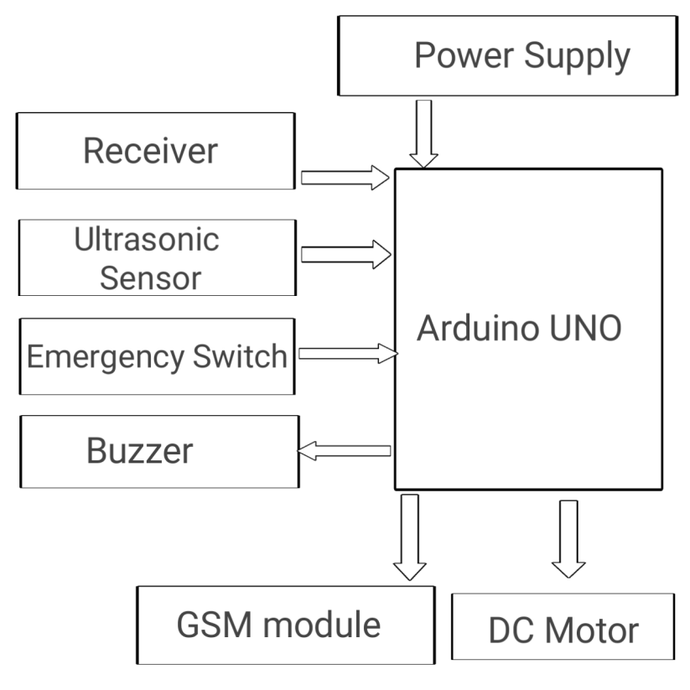

­­­

Fig: Block Diagram

# Background of the Invention/Project (Literature Review)

There are lot of research has been done in this field and lot of research is still going.

Shayban Nasif & Muhammad Abdul Goffar Khan (2017) (EEE department Rajshahi University)

"Wireless Head Gesture Controlled Wheelchair for Disable Persons". In this project they have developed wheelchair for physically challenged person.they have used acceleration sensor to detect the head gesture and RF module is used for smart wireless controlling..

Shruti Warad, Vijayalakshmi Hiremath, Preeti Dhandargi, Vishwanath Bharath, P.B.Bhagavati (2015)

Speech and flex sensor controlled wheelchair for physically disabled people. this Paper describes an intelligent motorized wheelchair for physically handicap person using dependent user speech controlled and flexes sensor technology.This project uses certain commands such as " forward backward maximum, medium, minimum and stop" to control the wheelchair Direction of the wheelchair is controlled by flex sensor application. There is wireless link between glove and wheel thats why any person can operate it without difficulty.

Chowdhury, SM Mazharul Hoque. (2019)

Jahangirnagar university. Smart wheelchair for disable people. In this they have constructed Smart wheelchair. for disable people in which the wheelchair will be controlled using certain commands. They Claims if user faces any critical situation an emergency message will deliver to them.

Mufrath Mahmood, Md.Fahim Rizwan, Masuma Sultana “Design of a low cost hand gesture controlled automated wheelchair.” IEEE Region 10 Symposium, june 2020.

In this paper they have demonstrated that how they have developed the hand gesture con- trolled wheelchair at the very low cost for affordability of the people. they have used the bluetooth control for the wheel chair as well for safety purpose they have messaging system as well build using the GSM module and they also developed the feature of GPS monitoring of the wheelchair.

1. **Problem Statement & Proposed Project**

As we know if a person is physically challenged he or she needs some other person for their mobility and this results in the over dependency of the patient over there companion. In this fast paced world everyone is busy in its own work due to this there are very few people in the world who can totally be with the patients all time and take care of them in order to bring independence in mobility of the patient we thought to design an automated wheelchair which can be controlled by the patient by itself through his/her hand gestures in this wheelchair the automation is not isolated as the luxurious thing it is to be beneficial for all common people so, how to reduce the physical strength used by old age and handicapped people to operate the wheelchair is paramount aim.

**4** **Significance & Objectives**

This Hand gesture controlled wheelchair has the capability to fill the gap between human and machine by further research we can extend this and make brain reading controlled wheelchair using artificial intelligence in a cost efficient way which will be battle winning factor for all disabled and paralyzed people.

**Objectives:**

1. To make physically challenged people independent for there mobility.
2. To demonstrate cost efficient and user friendly solution for problem.
3. To reduce the efforts of disabled person.
4. **Methodology (with flowchart)** 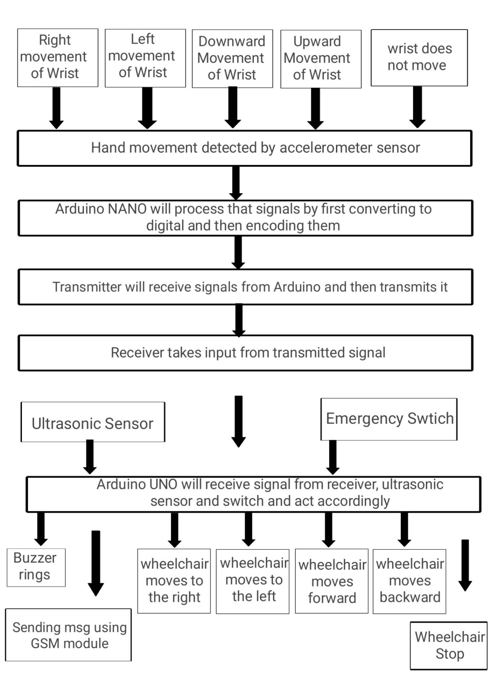

As patient moves there hand it is detected by the sensor present at the transmitter circuit it is accelerometer sensor who do it all, but this signal is analog which is then fed into the analog pin of the Arduino NANO and analog to digital converter present in the Arduino NANO converters it to the digital signal and then process it then after this by encoding the signal it is transmitted toward receiver circuit present at the wheelchair through the transmitter.

Now at the receiver side decoder decodes the signal and then fed into the Arduino UNO similiarly there are two more inputs for the Arduino UNO present one is ultrasonic sensor and second one is emergency switch(button). If there is a obstacle present then it is detected by the ultrasonic sensor and fed to the Arduino UNO and then Arduino UNO stop the wheelchair accordingly and if there is any emergency then patient will press emergency switch(button) which is essentially a button after that through Arduino UNO, GSM module will be send message to the companion of the patient.

Here we have used two motors for turning and the stability of the system both are dc motors and controlled by the Arduino UNO at the receiver circuit and we have also used the motor driver circuit.

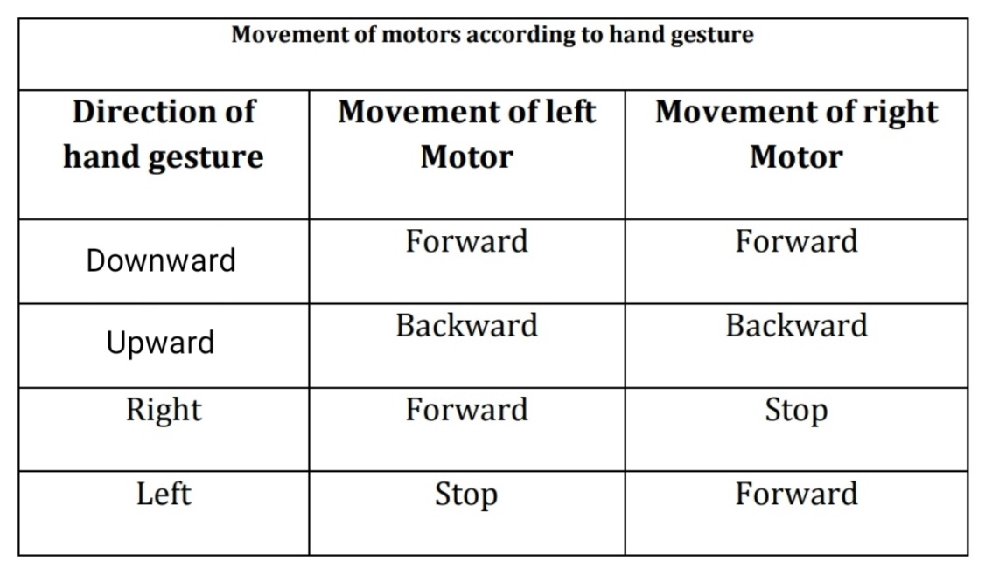

1. **Development Tools**
2. Software
3. Arduino IDE
4. Hardware
5. Arduino UNO and Arduino NANO
6. 12V Batteries
7. Trans­­­­­­­­­­­­­­­­­­­­­­­­­­­­­­­­­­­­­­­­­­­­­­­­­­­­­­­­­­­­­­­­­­­­­­­­­­­­­­­­­­­­­­­­­mitter and Receiver
8. Accelerometer sensor
9. Ultrasonic sensor
10. GSM module
11. DC motors
12. Buzzer and button.

# Proposed Project Plan

**Activity**

**Time**

**Aug 20**

**Oct. 20**

**Dec. 20**

**Jan. 21**

**Feb. 21**

**Mar. 21**

|  |  |  |  |  |  |  |
| --- | --- | --- | --- | --- | --- | --- |
| **Literature Review and Study** | Checkmark |  |  |  |  |  |
| **Collecting all the hardware required and testing them for the project.** |  | Checkmark |  |  |  |  |
| **Build a transmitter circuit of the project with all the programming of the microcontroller** |  |  | Checkmark |  |  |  |
| **Build the receiver circuit with connecting motors and check its compatibility with transmitter circuit** |  |  |  | Checkmark |  |  |
| **Build a comfortable structure and design of the wheelchair** |  |  |  |  | Checkmark |  |
| **Final Write-up & Thesis Submission** |  |  |  |  |  | Checkmark |

Table 1: Project Plan

**References :**

1. World Report on Disability, World Health Organisation 2011.
2. Shayban Nasif, Muhammed Abdul Goffar khan “Wireless head gesture controlled wheelchair for disabled person.” IEEE humanitarian technology conference December 2017.
3. Mufrath Mahmood, Md.Fahim Rizwan, Masuma Sultana “Design of a low cost hand gesture controlled automated wheelchair.” IEEE Region 10 Symposium, june 2020.
4. Pushpendra jha “Hand gesture controlled wheelchair” *international journal of scientific and technology research volume 5, issue 04, April 2016*.
5. Prof Vishal V. Pande “Hand Gesture Based Wheelchair Movement Control for Disabled person Using MEMS”. Et al int. Journal of Engineering Research and application Vol4, issue 4(Version 4). April 2014.
6. V. Sridevi, P. Ishwarya, P. Surya Chandra, N Suresh Kumar “ Automated Gesture Based Wireless Wheelchair Control by Means of Accelerometer” International Journal of Engineering and Advanced Technology (IJEAT) ISSN:2249-8958, Volume -9 Issue –1 Octomber 2019.
7. Kunal Bansod, kushal Asarkar, Mandar topre, vikrant raj “Hand Gesture Controlled Wheelchair” IRJET International Research Journal of Engineeirng and technology Volume -07 Issue- 07 July 2020.
8. Chowdhury , SM Mazharul Hoque. Smart wheelchair for disable people Diss Jahangir university 2019.
9. Speech and flex sensor-controlled wheelchair for physically disabled people presented by 1. Shruti warad 2. Vijay Laxmi Hiremath 3. Preeti Dhandargi, 4 . Vishwamath Bharath 5. P.B. Bhagavati.