Name-Aaviraj Nikumbh PRN- 24070126123 AiML B2
AIML B2

JAVA ASSIGNMENT 8
INVENTORY MANAGEMENT SYSTEM
Github-https://github.com/AaviRaj1702/Java_Files

Code used:
import java.util.*;

// Product entity class Product {
int productId; String name; double price; int quantity;

Product(int id, String name, double price, int qty) { this.productId = id; this.name = name; this.price = price;
this.quantity = qty;
}

@Override
public String toString() {
return String.format("| %-4d | %-20s | %8.2f | %-5d |", productId, name, price, quantity);
}
}

// Singleton ProductManager class ProductManager {
private static ProductManager instance = null; // single instance private ArrayList<Product> productList;
private HashMap<Integer, Product> productMap; // fast lookup

private ProductManager() { productList = new ArrayList<>(); productMap = new HashMap<>();
}

// Singleton access method
public static ProductManager getInstance() {
if (instance == null) instance = new ProductManager(); return instance;
}

void addProduct(Product p) {
if (productMap.containsKey(p.productId)) { System.out.println(" Product ID already exists!"); return;
}
productList.add(p); productMap.put(p.productId, p);
System.out.println(" Product added: " + p.name);
}

void removeProduct(int id) {
Product p = productMap.remove(id);
if (p != null) { productList.remove(p); System.out.println(" Removed: " + p.name); }
else System.out.println(" Product ID not found.");
}

void displayProducts() {
if (productList.isEmpty()) { System.out.println(" No products."); return; }
System.out.println("\n + + + +
---+");
System.out.println(" | ID | Name | Price |
Qty |");
System.out.println(" + + + +
-+");

-+");
}

for (Product p : productList) System.out.println(" " + p); System.out.println(" + + + +

void searchProduct(String keyword) { boolean found = false;
for (Product p : productList) {
if (p.name.toLowerCase().contains(keyword.toLowerCase())) { System.out.println(" Found: " + p); found = true;
}
}
if (!found) System.out.println(" No product matched: " + keyword);
}

void sortByPrice() { productList.sort(Comparator.comparingDouble(p -> p.price)); System.out.println(" Products sorted by price.");
}
}

// ─── Main
─────────────────────────────────────────────────────────────────────
public class CollectionsDesignPatternApp { public static void main(String[] args) {
Scanner sc = new Scanner(System.in);

// Both references point to same Singleton instance ProductManager pm1 = ProductManager.getInstance(); ProductManager pm2 = ProductManager.getInstance(); System.out.println("Same instance? " + (pm1 == pm2)); // true

// Seed data
pm1.addProduct(new Product(1, "Laptop", 65000, 10));
pm1.addProduct(new Product(2, "Mouse", 800, 50));
pm1.addProduct(new Product(3, "Keyboard", 1500, 30));
pm1.addProduct(new Product(4, "Monitor", 18000, 8));

while (true) {
System.out.println("\n1.Add 2.Remove 3.Display 4.Search 5.Sort ByPrice 0.Exit");
System.out.print("Choice: "); int ch;
try { ch = Integer.parseInt(sc.nextLine().trim()); }
catch (NumberFormatException e) { System.out.println("Invalid!");
continue; }

switch (ch) {
case 1:
try {
System.out.print("ID: "); int id = Integer.parseInt(sc.nextLine().trim());
System.out.print("Name: "); String nm =
sc.nextLine().trim();
System.out.print("Price: "); double pr =
Double.parseDouble(sc.nextLine().trim());
System.out.print("Qty: "); int qty = Integer.parseInt(sc.nextLine().trim());
pm1.addProduct(new Product(id, nm, pr, qty));
} catch (NumberFormatException e) { System.out.println("Invalid input."); }
break; case 2:
System.out.print("Product ID to remove: "); try {
pm1.removeProduct(Integer.parseInt(sc.nextLine().trim())); }
catch (NumberFormatException e) { System.out.println("Invalid!"); }
break;
case 3: pm1.displayProducts(); break; case 4:
System.out.print("Search keyword: "); pm1.searchProduct(sc.nextLine().trim()); break;
case 5: pm1.sortByPrice(); pm1.displayProducts(); break; case 0: System.out.println("Goodbye!"); sc.close(); return; default: System.out.println("Invalid option.");
}
}
}
}

OUTPUT:
Adding a Product
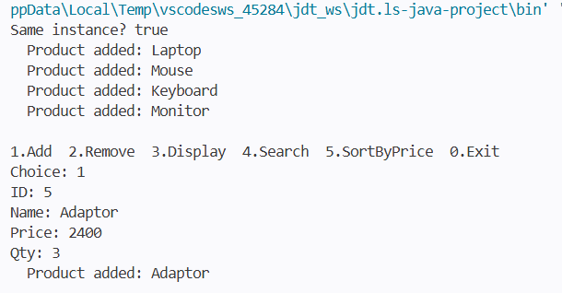
Removing a product and displaying all the products
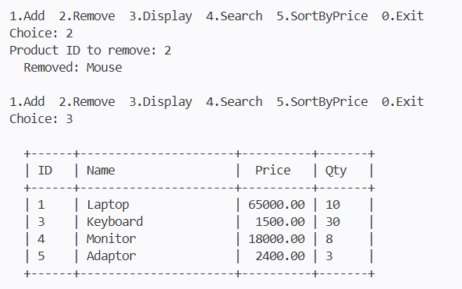
Searching for a particular product and sorting the products by price
