Name -Aaviraj Nikumbh
Prn-24070126123
AiML B2
JAVA Assignment 5
Banking Application
Code
BankAccount
public class BankAccount {
private final String accountNo;
private final String holderName;
protected double balance;

public BankAccount(String accountNo, String holderName, double openingBalance) throws BankingException {
if (accountNo == null || accountNo.isBlank()) {
throw new BankingException("Account no. cannot be empty");
}
if (holderName == null || holderName.isBlank()) {
throw new BankingException("Holder name cannot be empty");
}
if (openingBalance < 0) {
throw new BankingException("Opening balance cannot be negative");
}

this.accountNo = accountNo;
this.holderName = holderName;
this.balance = openingBalance;
}

public String getAccountNo() {
return accountNo;
}

public String getHolderName() {
return holderName;
}

public double getBalance() {
return balance;
}

public void deposit(double amount) throws BankingException {
if (amount <= 0) {
throw new BankingException("Deposit amount must be positive");
}
balance += amount;
}

public void withdraw(double amount) throws BankingException {
if (amount <= 0) {
throw new BankingException("Withdraw amount must be positive");
}
if (amount > balance) {
throw new BankingException("Insufficient balance");
}
balance -= amount;
}

public String getAccountType() {
return "Generic";
}
public String summary() {
return String.format("[%s] AccNo=%s, Holder=%s, Balance=%.2f", getAccountType(), accountNo, holderName,
balance);
}
}

CurrentAccount
public class CurrentAccount extends BankAccount {
private final double overdraftLimit;

public CurrentAccount(String accountNo, String holderName, double openingBalance, double overdraftLimit)
throws BankingException {
super(accountNo, holderName, openingBalance);
if (overdraftLimit < 0) {
throw new BankingException("Overdraft limit cannot be negative");
}
this.overdraftLimit = overdraftLimit;
}

@Override
public String getAccountType() {
return "Current";
}

@Override
public void withdraw(double amount) throws BankingException {
if (amount <= 0) {
throw new BankingException("Withdraw amount must be positive");
}
double remaining = balance - amount;
if (remaining < -overdraftLimit) {
throw new BankingException("Overdraft limit exceeded: " + overdraftLimit);
}
balance = remaining;
}
}

SavingsAccount
public class SavingsAccount extends BankAccount {
private final double minBalance;
private final double interestRate;

public SavingsAccount(String accountNo, String holderName, double openingBalance, double minBalance,
double interestRate) throws BankingException {
super(accountNo, holderName, openingBalance);

if (minBalance < 0) {
throw new BankingException("Minimum balance cannot be negative");
}
if (interestRate < 0) {
throw new BankingException("Interest rate cannot be negative");
}
this.minBalance = minBalance;
this.interestRate = interestRate;
}

@Override
public String getAccountType() {
return "Savings";
}

@Override
public void withdraw(double amount) throws BankingException {
if (amount <= 0) {
throw new BankingException("Withdraw amount must be positive");
}
double remaining = balance - amount;
if (remaining < minBalance) {
throw new BankingException("Minimum balance must be maintained");
}
balance = remaining;
}

public void applyAnnualInterest() {
balance += (balance * interestRate / 100);
}
}

BankingException
public class BankingException extends Exception{
public BankingException(String message){
super(message);
}
}

import java.util.ArrayList;

Main
public class Main {

public static void main(String[] args) {

try {
//Polymorphism
BankAccount acc1 = new SavingsAccount("SA1", "Ishan", 60000, 10000, 5);
BankAccount acc2 = new CurrentAccount("CA2", "ABC", 25000, 3000);
BankAccount acc3 = new BankAccount("BA3", "XYZ", 20000);

ArrayList<BankAccount> accounts = new ArrayList<>();
accounts.add(acc1);
accounts.add(acc2);
accounts.add(acc3);

System.out.println("----- Initial Accounts -----");
printAll(accounts);

System.out.println("\n----- Depositing 1000 in all accounts -----");
for (BankAccount acc : accounts) {
acc.deposit(1000);
}
printAll(accounts);

System.out.println("\n----- Withdraw Operations -----");

acc1.withdraw(2000);
acc2.withdraw(4000);
acc3.withdraw(500);

printAll(accounts);

} catch (BankingException e) {
System.out.println("Banking Error: " + e.getMessage());
}
}

public static void printAll(ArrayList<BankAccount> accounts) {
for (BankAccount acc : accounts) {
System.out.println(acc.summary());
}
}
}

Output
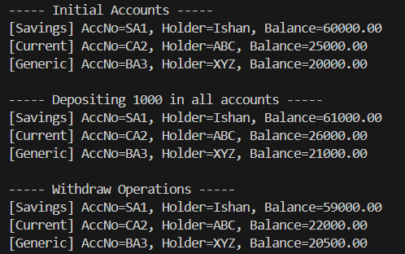
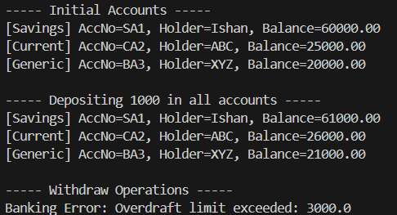

GITHUB:
https://github.com/AaviRaj1702

