Holy Sai Smart School 360 — Flow and Features
Oct 14, 2026 · @Aavoraa
Holy Sai Smart School 360 is one web app for running a school: every user signs in once, lands on a dashboard built for their role, and reaches only the modules their permissions allow.

User flow
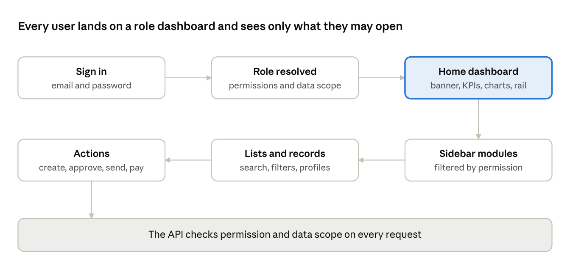
user flow · sign-in to action
After sign-in the app opens the role's home route. From there the user moves through the modules the sidebar shows them, and quick actions on the dashboard jump straight to common tasks.

Roles and home dashboards
Eleven roles ship by default. Each has a home route and a data scope, and the API checks permissions on every request.
Role | Home dashboard | Scope | What it covers
Super Admin | Owner Overview (/overview) | School | Every permission, across every campus
School Admin | Command Center | School | Full administration, users and settings
Principal | Command Center | School | Analytics, approvals, group dashboard
Management | Command Center | School | Read-only dashboards, reports and tracking
Teacher | Teacher Dashboard | Assigned classes | Attendance, academics, AI Co-Pilot; own leave and payslips
HR | Workforce | School | Employees, attendance, leave, CPD, payroll
Finance | Fee Collection | School | Fees, payments, expenses, budgets, reconciliation
Office | Admissions Dashboard | School | Admissions, fees, documents, front-office safety
Non-Teaching Staff | Staff Self-Service | Self | Own attendance, shifts, leave, payslips; gate and transport duties
Parent | Parent 360 | Own children | Tracking, academics, fees, communication
Student | My Profile | Self | Profile, timetable, homework, ideas

Features by module
The sidebar groups about 120 screens into twelve modules; a user sees an item only when they hold one of its permissions.
Module | Main features
Students | Student list and Student 360 profile, attendance, academic performance, assessments, behaviour and wellbeing, portfolio, talent discovery, early warning
Enquiries & Admissions | Leads, enquiries, counselling pipeline, applications, campus visits, conversion analytics, parent referrals, alumni, vendors
Academics | Curriculum, classes, subjects, timetable, lesson plans, homework, question bank, report cards, Cambridge objectives
Parent Experience | Parent directory, communication, PTM, circulars, events, acknowledgements
GPS & Safety | Smart gate and gate log, pickup authorisation, visitors, live student and bus tracking, GPS devices, routes, boarding, emergency alerts, safeguarding, infirmary, counselling
Fee Management | Fee structures, collection, student accounts, payments, receipts, concessions, scholarships, expenses, reimbursements, budgets, reconciliation, reports
Staff | Employee directory, staff attendance, shifts, leave, overtime, allowances, workload, CPD, payroll, payslips
Facilities & Assets | Assets, facilities, maintenance, inventory, documents, certificates, compliance calendar, audit trail
Innovation | Innovation lab, ideas, projects, mentors, milestones, competitions, achievements; students submit their own ideas
Intelligence | AI Teacher Co-Pilot, School Knowledge AI, analytics, reports
Group | Campuses, group dashboard, campus comparison, transfers, group policies
Users & Settings | Report centre, users and roles, system settings

Platform features
These features apply across every module.
- Access control: role-based permissions are checked by the API on every request. Data is scoped by role, so a teacher sees only assigned classes and a parent only their own children.
- Sign-in: email and password with rate-limited login, refresh tokens and password change.
- Dashboards: each role dashboard opens with the campus banner and greeting. Below are headline KPIs, attendance trends, a risk breakdown and top performers. A side rail holds quick actions, recent notifications and upcoming events.
- Notifications and tasks: live badges in the sidebar for alerts and pending tasks.
- Navigation: sidebar sections with direct links to key pages, automatic breadcrumbs, and a top bar with search, academic year and campus switchers.
- Mobile: a bottom navigation set per role (for example Home, Track, Academics and Fees for parents). Tables stack into cards below 768px.
- Design system: one brand magenta (#8F0A40) with gold accents, plus muted module hues behind icons only. Status colours carry meaning, and light and dark themes are supported.

