Github Repo Link: https://github.com/Aavu/DSP-Assignment1

Question 1:

The length of y when the length of ‘x’ is 200 and the length of ‘h’ is 100 will be 299.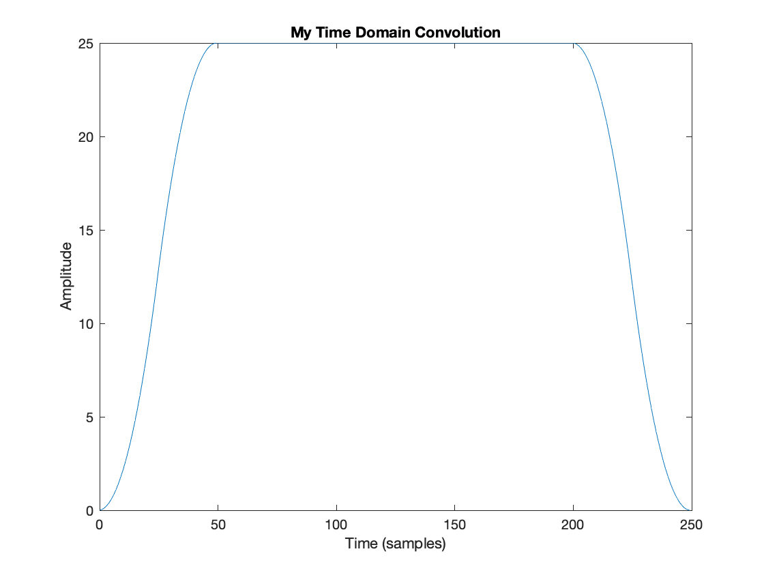

Question 2:

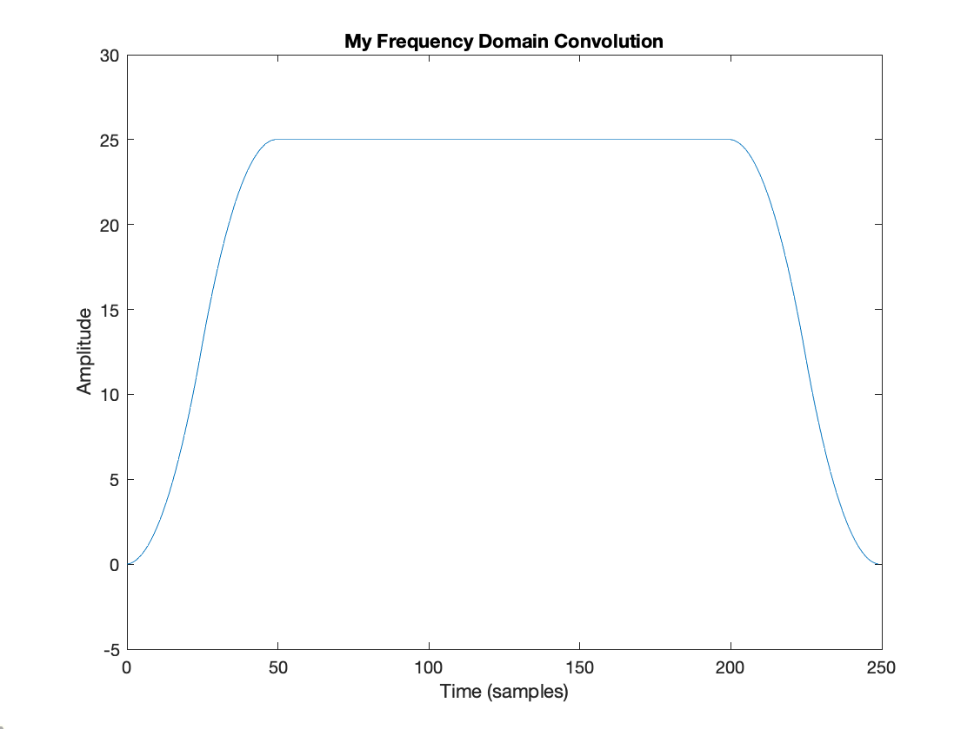

Question 3:

m = 1.0e-18 \* [0 -0.1730]’

mabs = 1.0e-15 \* [0 0.7296]’

stdev = 1.0e-15 \* [0 0.9944]’

Time (s) = [192.4593 0.0752 0.0889]’

The frequency domain convolution is the most time efficient method. This is because, in the frequency domain, convolution operation is just element wise multiplication. The Fast Fourier Transform exploits the symmetry property in the calculation of the nth root of unity, thus only O(nlogn) butterfly computations are required. The time domain convolution function from problem 1 was thousands of times slower than the version that used the Fourier space to compute the convolution in problem 2. This makes sense since the time domain convolution is the least time efficient method as the computations require each overlap to be computed and takes O(n^2) to complete.