Raghavasimhan Sankaranarayanan

Punahamoa Walker

**MUSI6202 Assignment 3**

Question 1:

The dither noise distributions generated in this section are shown below. The magnitude spectrum is also included. This is plotted assuming that the sampling frequency is 96kHz. The word length, w is 4

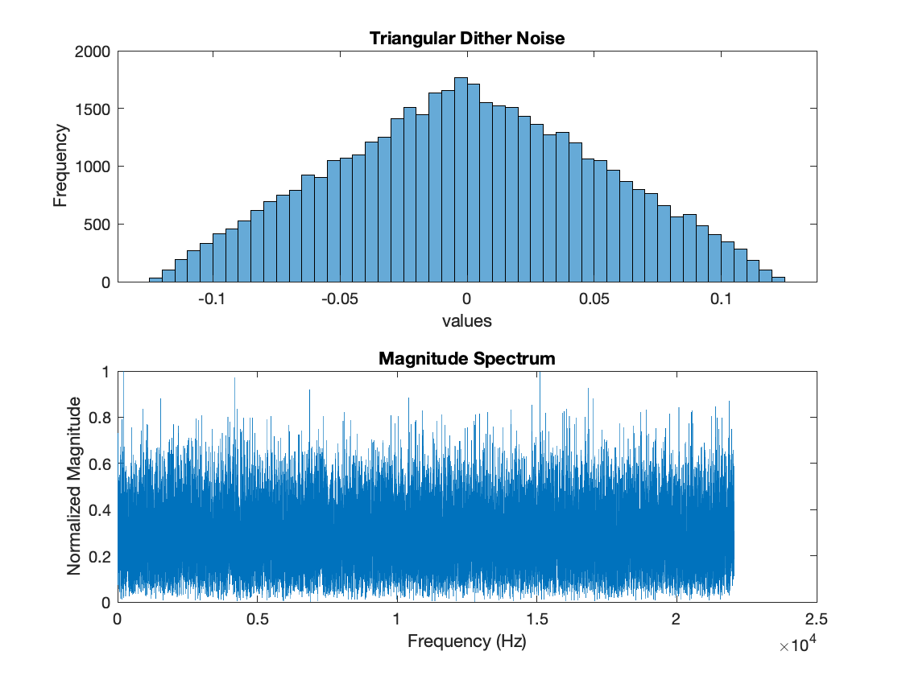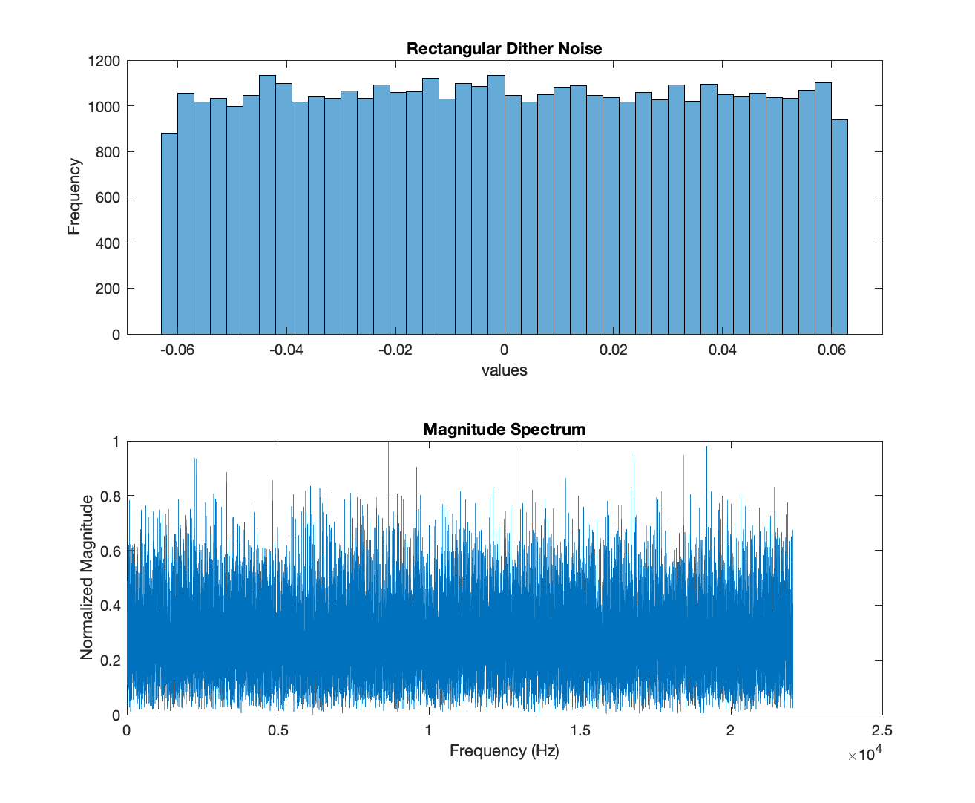

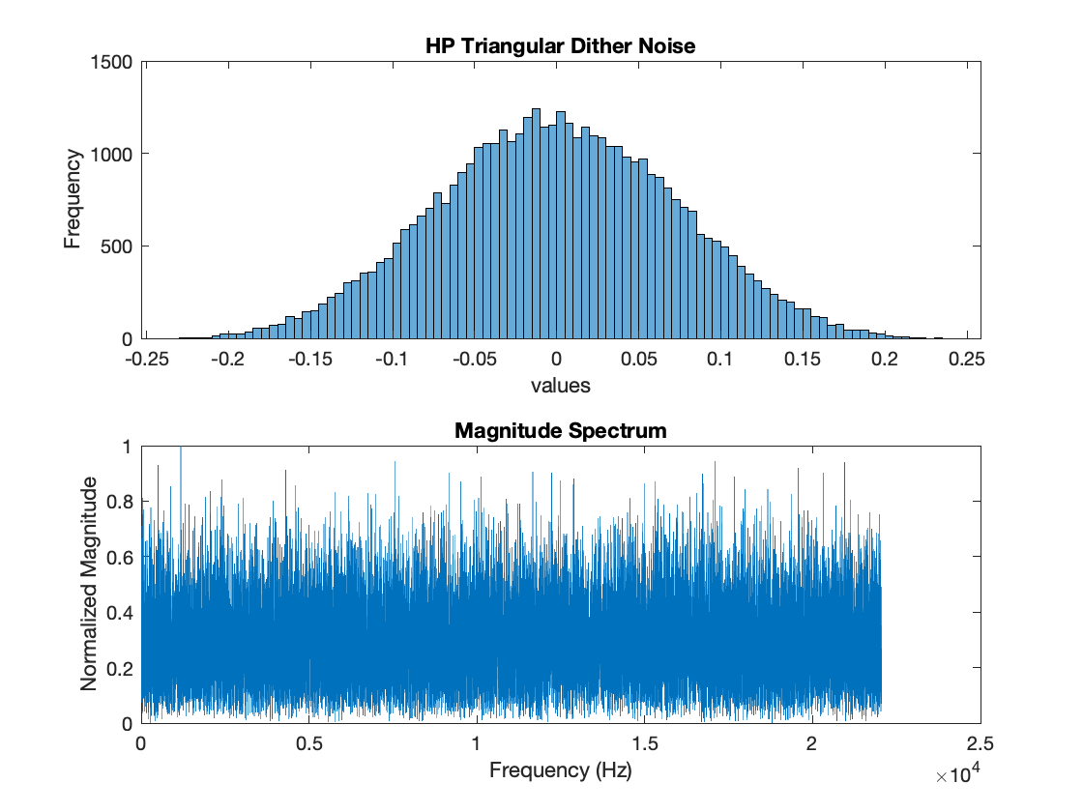

Question 2:

We wrote a function which will quantize an input and another which will add dither noise and then quantize the input.

Question 3:

We wrote a function which adds dither, quantizes and then noise shapes an input audio signal. The magnitude spectrum of the error of a 440Hz sine wave being input into this function is shown below. The word length is 4, sampling frequency is 96kHz and the dither noise is triangular.

Question 4:

A recording of a flute was input to all the functions we have written in this assignment with either a word length of 4 or 8. These images are included on the following pages.

When a word length of 8 is used, myQuantize sounds fairly similar to the original audio file with possibly a little more white noise. When myDither is used, the output sounds more similar to myQuantize. Using myShapeNoise, white noise is still present but it sounds quieter perceptually. Though the total power of the error signal is the same, the noise shaper filters the error so that it is more present in a less sensitive part of our hearing range.

When a word length of 4 is used, myQuantize produces an output with very prominent harmonics. This manifests as an irritating ringing. This occurs since the quantization error is correlated with the input signal and can no longer be assumed as white noise. Using myDither reduces the impact of the harmonics but increases the amount of white noise which is heard. myNoiseShape counteracts the white noise by shifting it’s power to higher frequencies. This makes the perceived effect of the white noise less.

