**Image-Acquisition-from-Web-Camera**

**Aim**

Aim:

To write a python program using OpenCV to capture the image from the web camera and do the following image manipulations. i) Write the frame as JPG

ii) Display the video

iii) Display the video by resizing the window

iv) Rotate and display the video

**Software Used**

Anaconda - Python 3.7

**Algorithm**

Step 1: Import Opencv Package.

Step 2: Capture the Video from the WebCamera.

Step 3: Write the image to a file.

Step 4: Show the image or the live camera.

Step 5: End the program.

**Program:**

### Developed By:Aavula Tharun

### Register No:212221240003

## i) Write the frame as JPG file

import cv2

video = cv2.VideoCapture(0)

while(True):

t,frame = video.read()

cv2.imwrite("Newpicture.jpg",frame)

result=False

if cv2.waitKey(1) == ord('b'):

break

video.release()

cv2.destroyAllWindows()

## ii) Display the video

import cv2

pic = cv2.VideoCapture(0)

while True:

t,frame = pic.read()

cv2.imshow('frame',frame)

if cv2.waitKey(1) == ord('b'):

break

pic.release()

cv2.destroyAllWindows()

## iii) Display the video by resizing the window

import numpy as np

import cv2

im = cv2.VideoCapture(0)

while True:

ret,frame = im.read()

width = int(im.get(3))

height = int(im.get(4))

image = np.zeros(frame.shape,np.uint8)

smallerFrame = cv2.resize(frame,(0,0),fx = 0.5,fy=0.5)

image[:height//2,:width//2] = smallerFrame

image[height//2:, :width // 2] = smallerFrame

image[:height//2, width//2:] = smallerFrame

image[height//2:, width//2:] = smallerFrame

cv2.imshow('frame',image)

if cv2.waitKey(1) == ord('b'):

break

im.release()

cv2.destroyAllWindows()

## iv) Rotate and display the video

import numpy as np

import cv2

im = cv2.VideoCapture(0)

while True:

ret,frame = im.read()

width = int(im.get(3))

height = int(im.get(4))

image = np.zeros(frame.shape,np.uint8)

smallerFrame = cv2.resize(frame,(0,0),fx = 0.5,fy=0.5)

image[:height//2,:width//2] = cv2.rotate(smallerFrame,cv2.ROTATE_180)

image[height//2:, :width // 2] = smallerFrame

image[:height//2, width//2:] = smallerFrame

image[height//2:, width//2:] = cv2.rotate(smallerFrame,cv2.ROTATE_180)

cv2.imshow('frame',image)

if cv2.waitKey(1) == ord('b'):

break

im.release()

cv2.destroyAllWindows()

**Output**

**i) Write the frame as JPG image**

[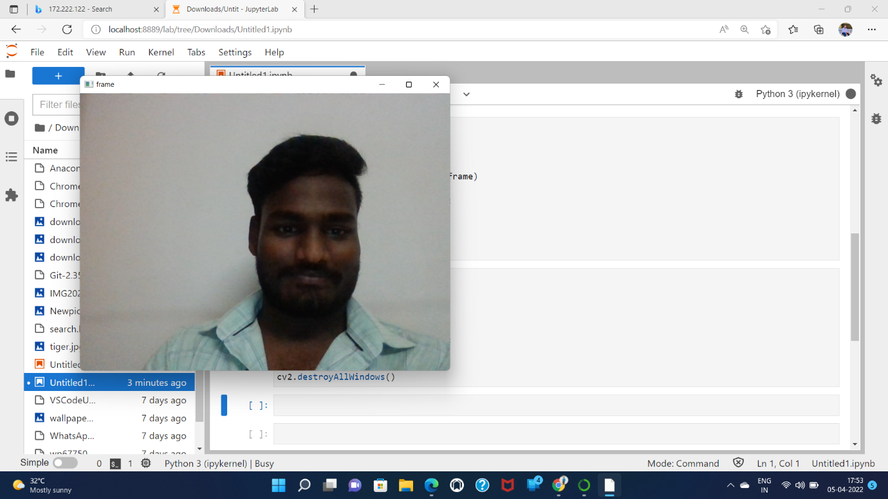](https://github.com/AavulaTharun/Image-acquisition-from-web-camera/blob/main/1.png)

**ii) Display the video**

[](https://github.com/AavulaTharun/Image-acquisition-from-web-camera/blob/main/2.png)

**iii) Display the video by resizing the window**

[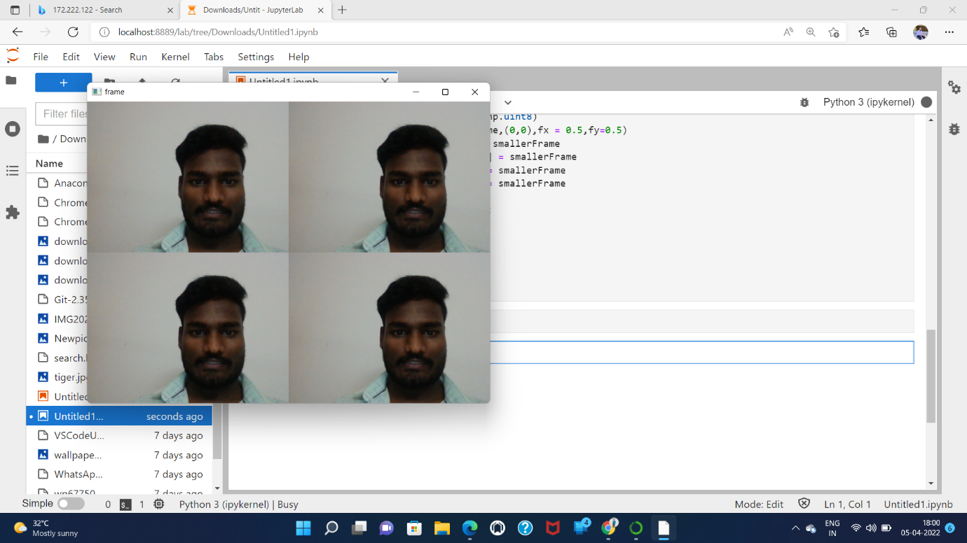](https://github.com/AavulaTharun/Image-acquisition-from-web-camera/blob/main/3.png)

**iv) Rotate and display the video**

[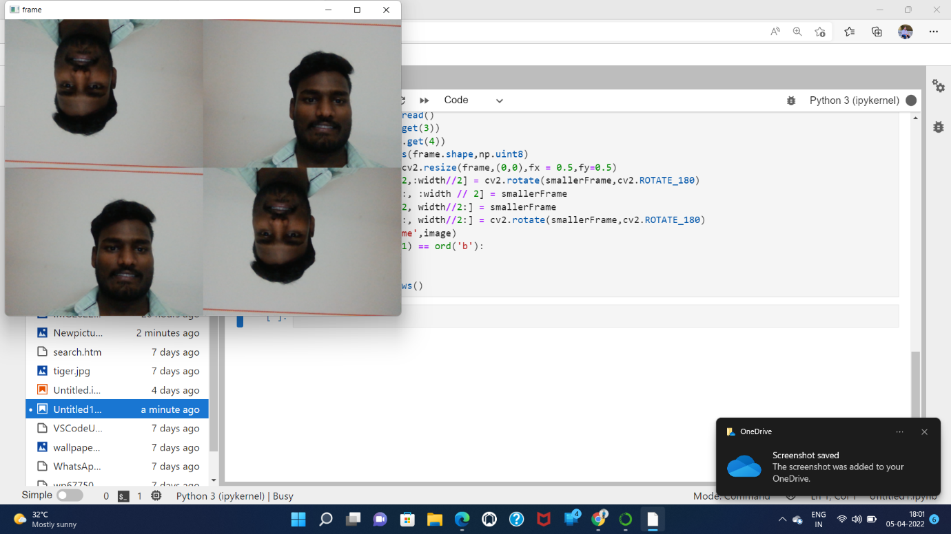](https://github.com/AavulaTharun/Image-acquisition-from-web-camera/blob/main/4.png)

**Result:**

Thus the image is accessed from webcamera and displayed using openCV.