


INSTITUTE FOR

ADVANCED COMPUTING

AND SOFTWARE

DEVELOPMENT AKURDI,

PUNE

Documentation On

“SCRAP TREADING SYSTEM”

PG-DAC SEPT 2021

Submitted By:

Group No: 57

Kazi Aayaj Shabbir (219086)

Shaikh Omair Shaikh Mujahed (219174)

Mr. Prashant Karhale

Centre Coordinator

Mr. Kashinath Patil

Project Guide

IACSD Student’s Online Portal

Table of Contents

1. Introduction 3

Problem Statement 3

Aim & Objectives 3

2. Overall Description 4

Proposed Methodology 4

Operating Environment 4

Design and Implementation Constraints 5

3. Requirements Specification 6

External Interface Requirements 6

4. System Diagram 7

Activity Diagram 7

Data Flow Diagram 10

Class Diagram 12

Use Case Diagram 13

ER Diagram 15

5. Table Structure 17

Course 17

Subject 17

Admin Student 17

Student 17

Admin Faculty 18

Faculty 18

Assignments 18

Notes 19

Classroom 19

Daily Schedule 19

Placements 19

Announcement 20

Contact Number 20

User 20

6. Conclusion 21

Future Scope 21

7. References 22

1

IACSD Student’s Online Portal

List of Figures

Figure 1 Admin Activity Diagram 7

Figure 2 Student Activity Diagram 8

Figure 3 Faculty Activity Diagram 9

Figure 4 Level 0 Data Flow Diagram 10

Figure 5 Level 1 Data Flow Diagram 10

Figure 6 Level 2 Data Flow Diagram for Admin 10

Figure 7 Level 2 Data Flow Diagram Course 11

Figure 8 Class Diagram 12

Figure 9 Use Case Diagram for Student 13

Figure 10 Use Case Diagram for Faculty 13

Figure 11 Use Case Diagram for Admin 14

Figure 12 ER (MySQL Auto Generated) 15

Figure 13 ER Diagram 16

2

IACSD Student’s Online Portal

1. INTRODUCTION.

Introduction:

This system allows the Users to easily Buy or Sell the Scrap whenever they need with use of this system. This document is meant to delineate the features of Scrap Trading System Portal, so as to serve as a guide to the developers on one hand and software validation document for complete functionality of listing and booking car. In this system, Tourism and Travelling facilities also provide. The prospective client on the other.

Problem Statement:

An existing system need physically meet to trade Scrap. The seller has to go in the merchant’s shop where seller has to show Scrap and then buyer will tell the amount and then they can negotiate accordingly. In the existing system seller have to take the scrap to buyer’s shop.

Aims and Objective:

The Scrap Treading System is a platform through which we will connect scrap dealer/merchants with people who are possessing scrap in house and want to sell it at reasonable price. At this platform we will take description, type, quantity, photos of scrap from seller and put a post on website where other people [buyers/dealer] can explore it and can put bid for it. Then seller will decide who to sell according to various factors like price, pick up time, ease of transport, etc.

Simple database is maintained.

Easy operations for the operator of the system.

User interfaces are user accommodating and attractive; it takes very less time for the operator to use the system.

The aim is to design a college website which implant update information of the college that should improve expertness of college record management.

3

IACSD Student’s Online Portal

2.OVERALL DESCRIPTION.

Proposed Methodology:

The main page of the website will contain various available post of scrap to be sold. Through this page anybody who is visiting this website will get to see these posts which will be ordered according to latest uploaded post in ascending manner. Various filters will be provided for sorting all post as buyer’s requirement. Filtering conditions like weight, price, type, material, locations etc. This page will also contain approximate current rates of different types of scrap material. The page will also provide Calculator as feature to the users to make their job easy. For bidding user (buyer) must login first. If a user is not registered on the website, then they have to register first using register option. After successful login user can bid for scraps. Buyers or users may filter scraps according to various filtering conditions like weight, price, type, material, locations etc. For uploading post to sell scrap Sellers also have to login first. If a seller is not registered on the website, then they have to register first using register option.

Operating Environment:

Server Side:

Processor: Intel® Xeon® processor 3500 series

HDD: Minimum 500GB Disk Space

RAM: Minimum 4 GB

OS: Windows 10, Linux 6

Database: MySQL

Client Side (minimum requirement):

Processor: Intel Dual Core

HDD: Minimum 80GB Disk Space

RAM: Minimum 2GB

OS: Windows 7, Linux

4

IACSD Student’s Online Portal

Design and Implementation Constraints:

- The application will use JavaScript, ReactJS and CSS as main web technologies.

- HTTP and FTP protocols are used as communication protocols. FTP is used to upload the web application in live domain and the client can access it via HTTP protocol.

- SMTP protocol is used for Email communication.

- Several types of validations make this web application a secured one and SQL Injections can also be prevented.

- Since Scrap Treading System is a web-based application, internet connection must be established.

- The Scrap Treading System will be used on PCs and will function via internet or intranet in any web browser.

5

IACSD Student’s Online Portal

- Requirements Specification.

External Interface Requirements:

User Interfaces:

- All the users will see the same page when they enter in this website. This page asks the users a username and a password.

- After being authenticated by correct username and password, user will be redirect to their corresponding profile where they can do various activities.

- The user interface will be simple and consistence, using terminology commonly understood by intended users of the system. The system will have simple interface, consistence with standard interface, to eliminate need for user training of infrequent users.

Hardware Interfaces:

- No extra hardware interfaces are needed.

- The system will use the standard hardware and data communication resources.

This includes, but not limited to, general network connection at the server/hosting site, network server and network management tools.

Application Interfaces:

Web Browser:

The system is a web-based application; clients need a modern web browser such as Mozilla

Firebox, Internet Explorer, Opera, and Chrome. The computer must have an Internet

connection in order to be able to access the system.

Communications Interfaces:

- This system uses communication resources which includes but not limited to, HTTP protocol for communication with the web browser and web server and TCP/IP network protocol with HTTP protocol.

- This application will communicate with the database that holds all the booking information. Users can contact with server side through HTTP protocol by means of a function that is called HTTP Service. This function allows the application to use the data retrieved by server to fulfil the request fired by the user.

6

IACSD Student’s Online Portal

- System Diagrams.

- Activity Diagram:

Admin Activity:

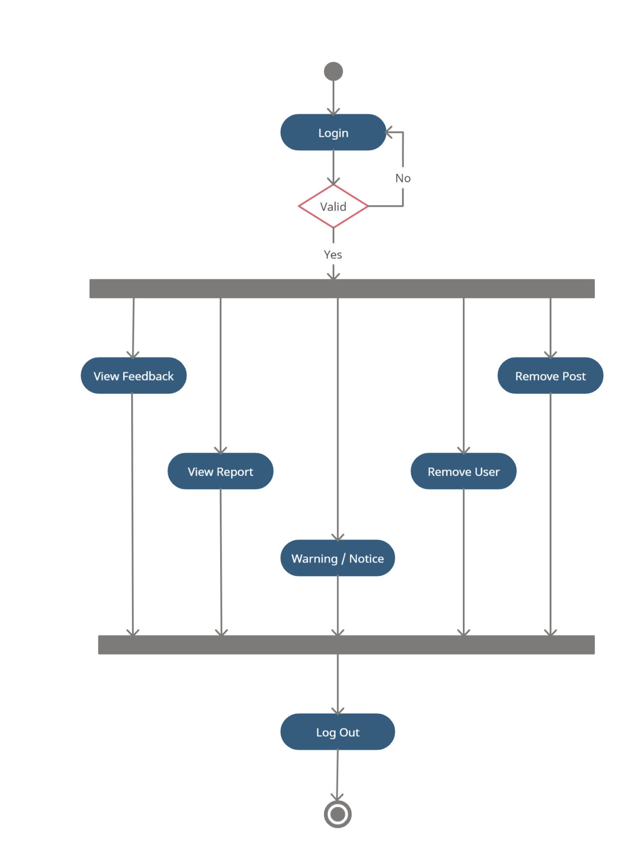
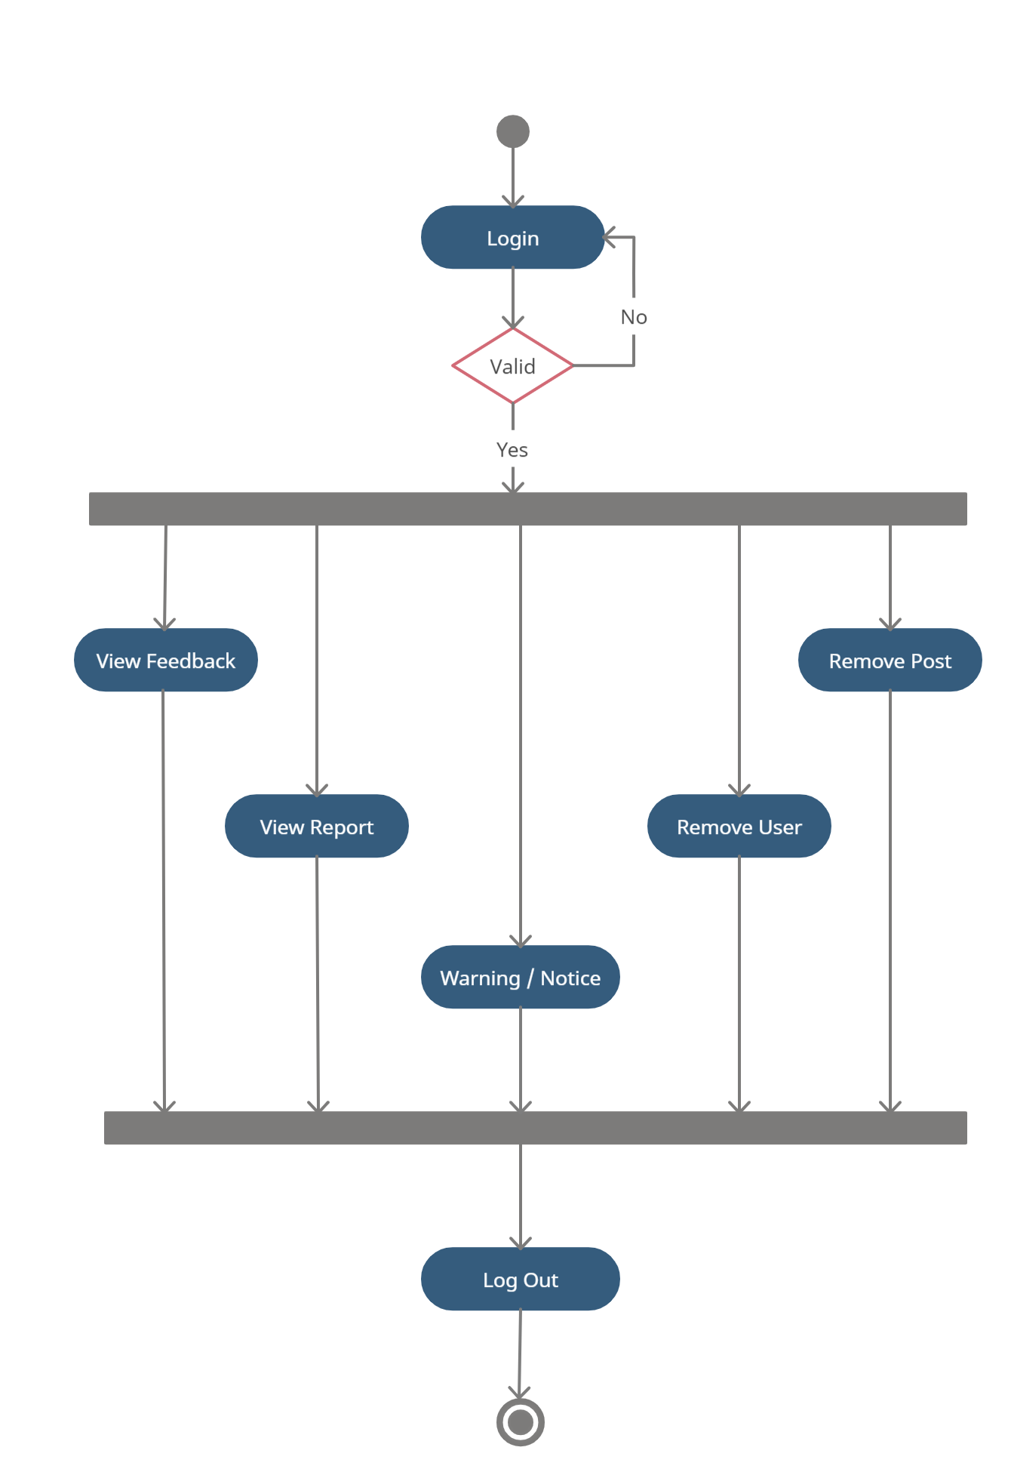

7

IACSD Student’s Online Portal

User Activity:

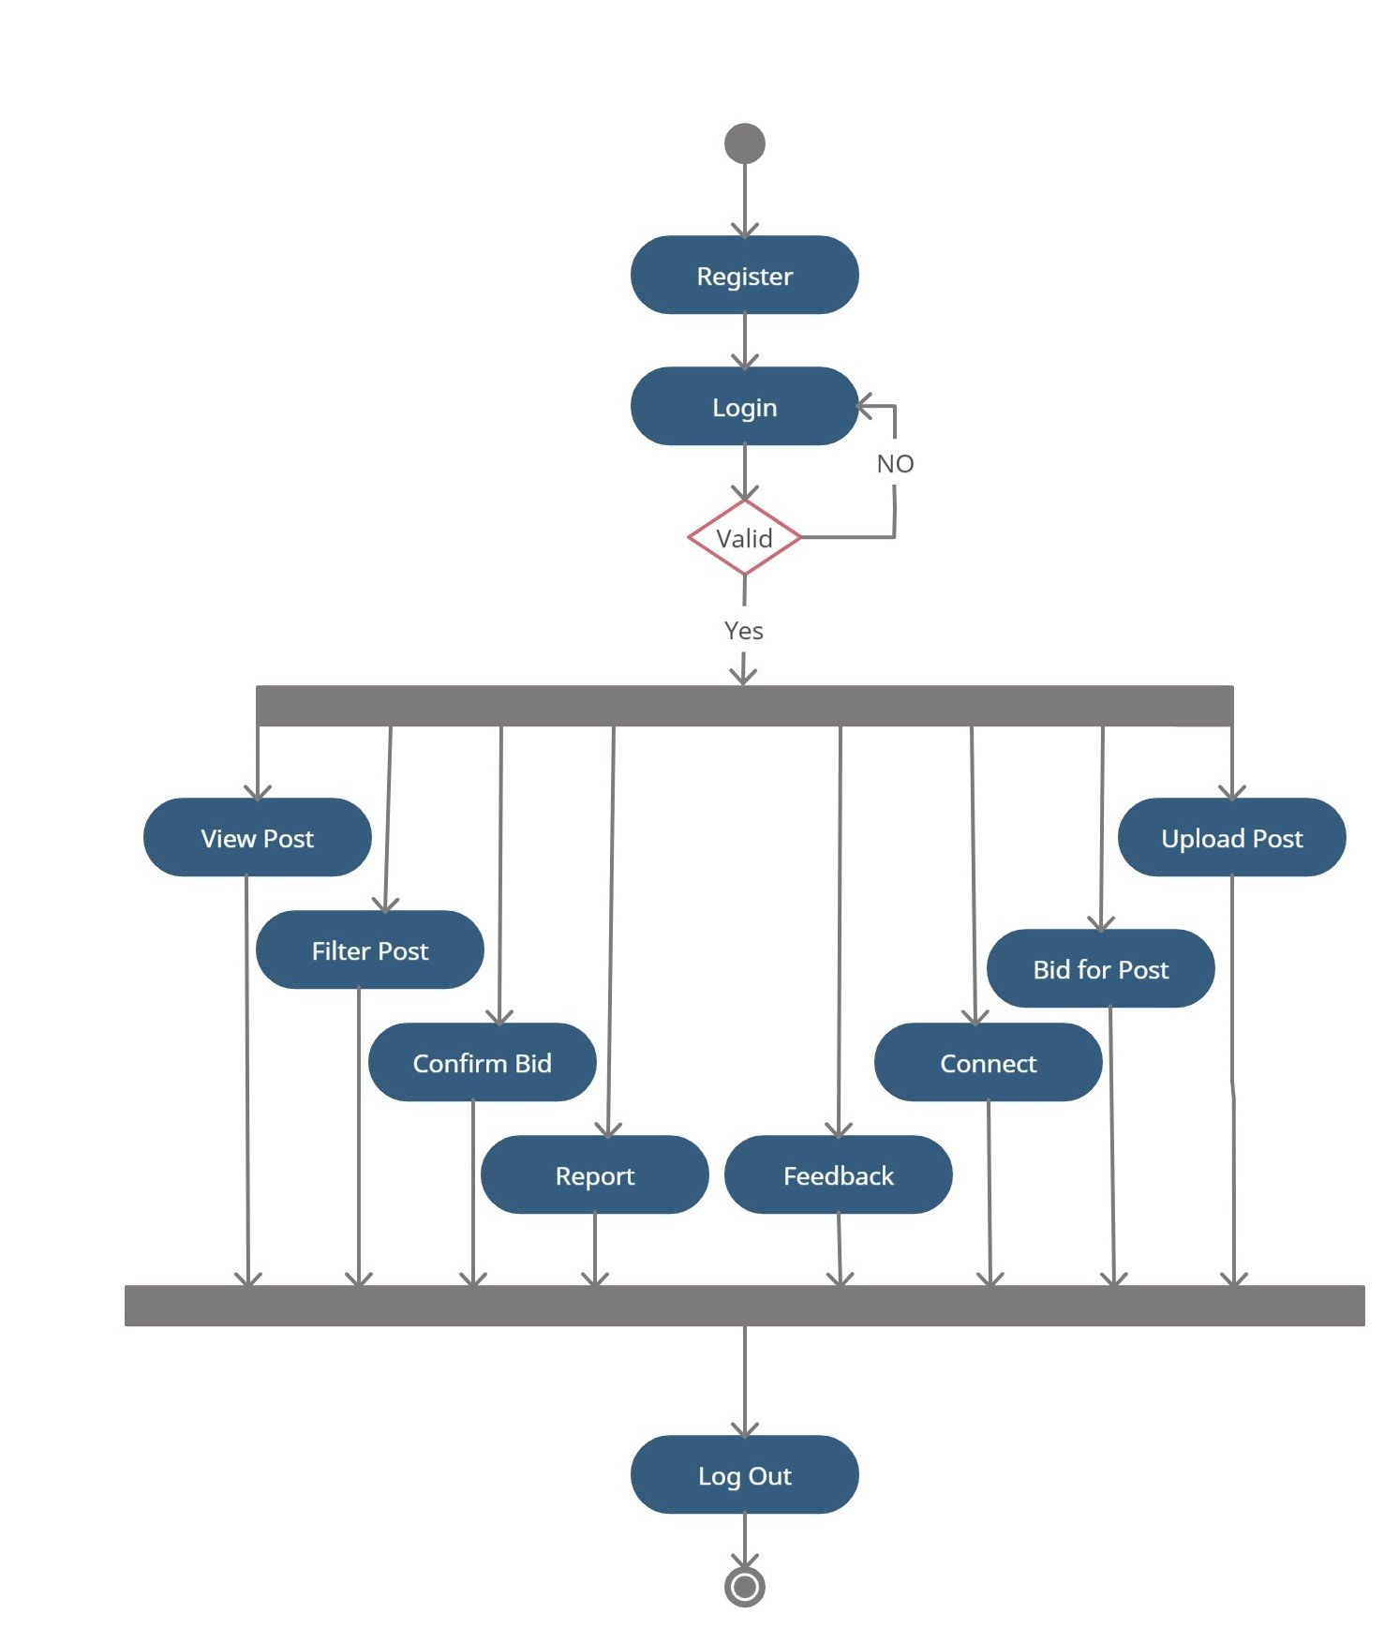

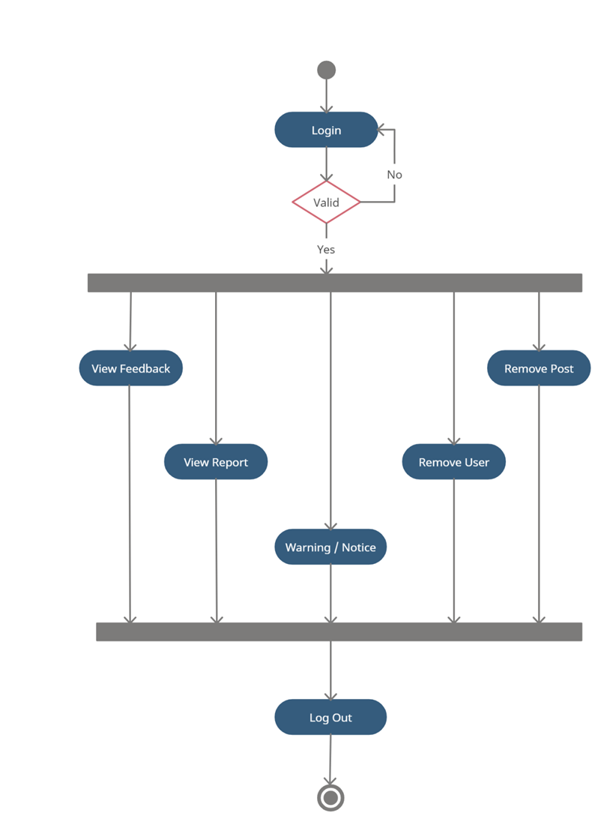

8

IACSD Student’s Online Portal

9

IACSD Student’s Online Portal

- Data Flow diagram:

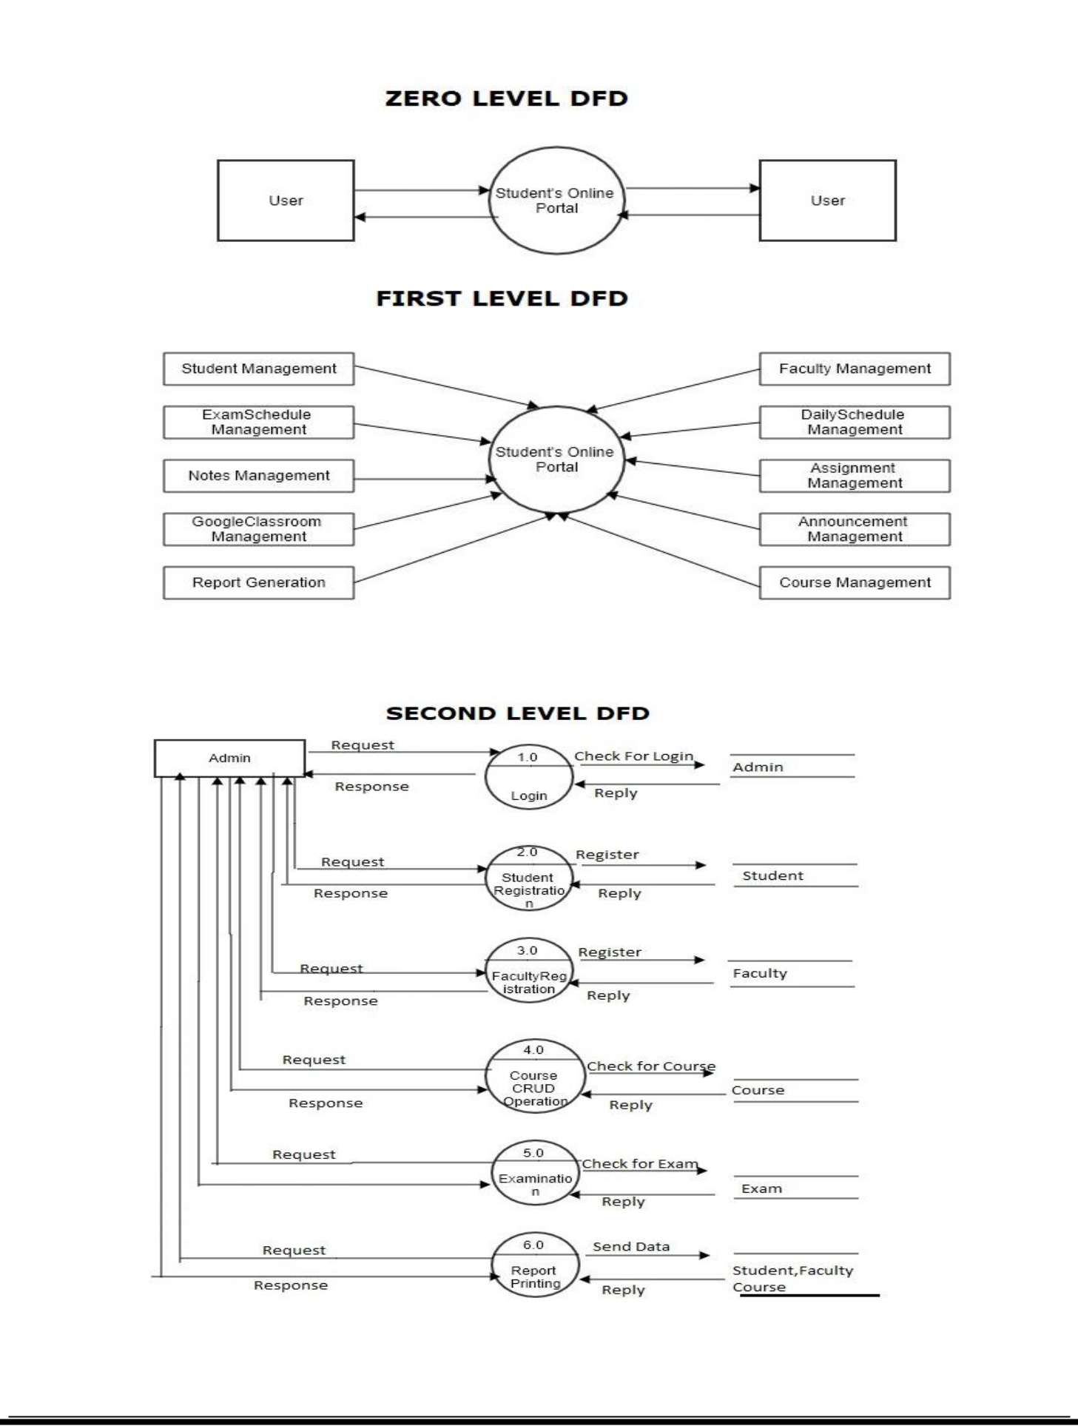

10

IACSD Student’s Online Portal

11

IACSD Student’s Online Portal

- Class Diagram:

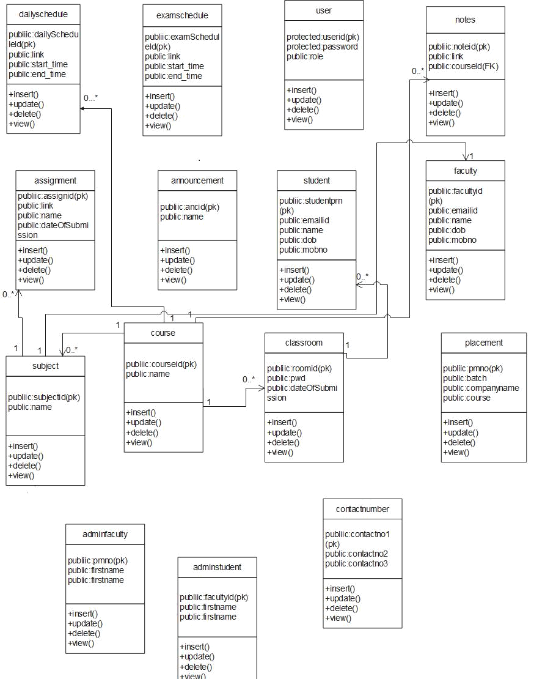

12

IACSD Student’s Online Portal

- Use Case Diagram:

Admin Use-case:

User Use-case:

13

IACSD Student’s Online Portal

Admin Use-case:

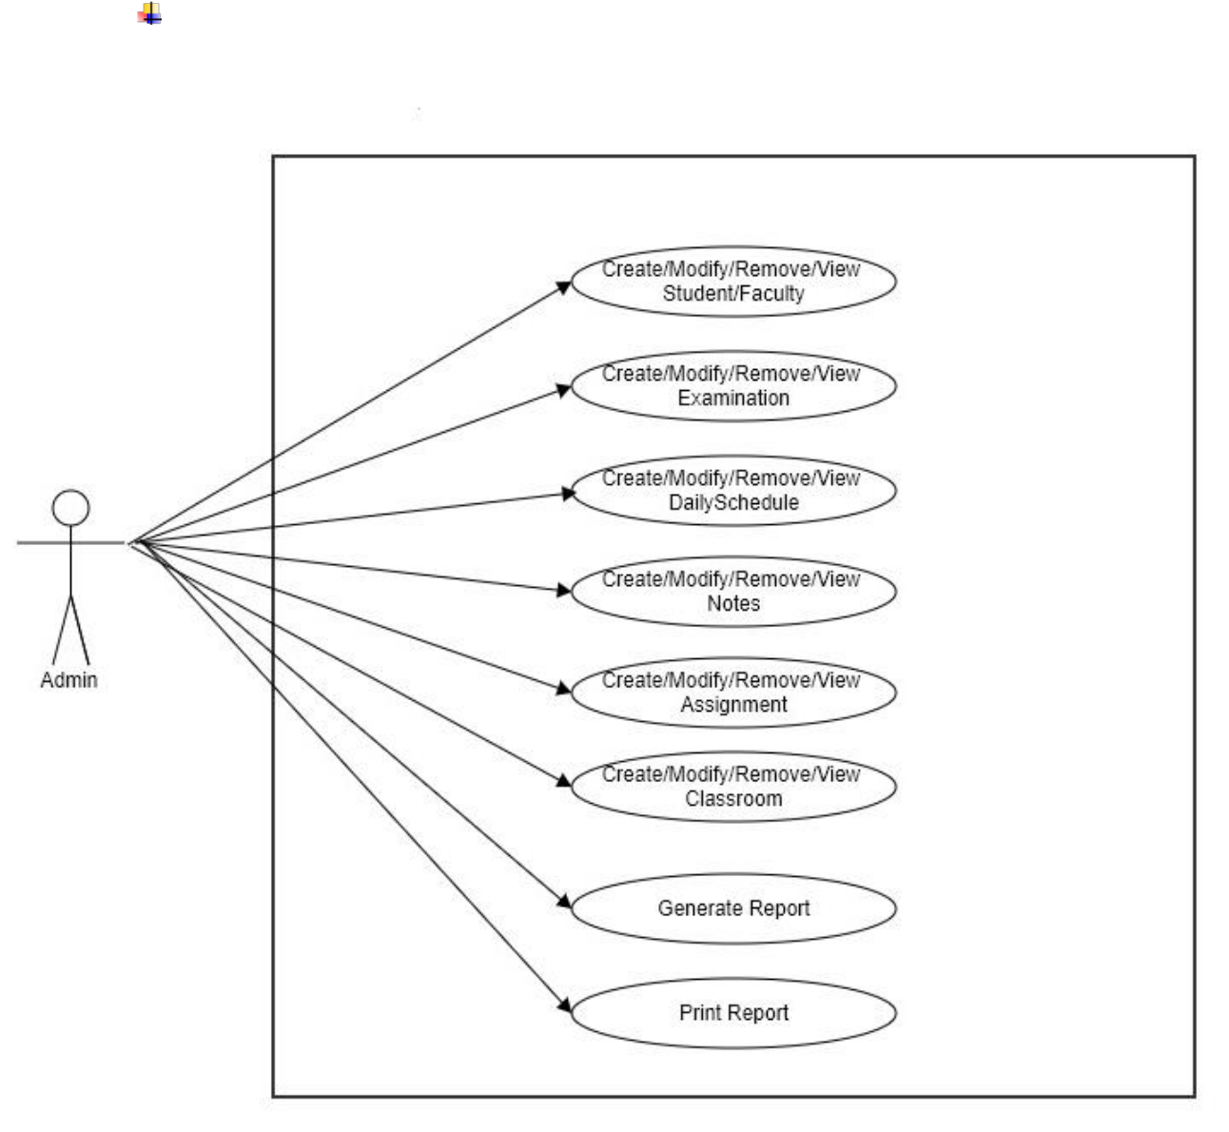

14

IACSD Student’s Online Portal

- ER Diagram:

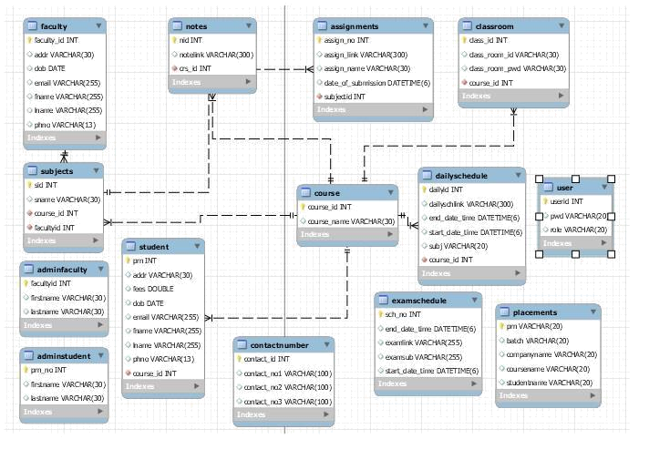

15

IACSD Student’s Online Portal
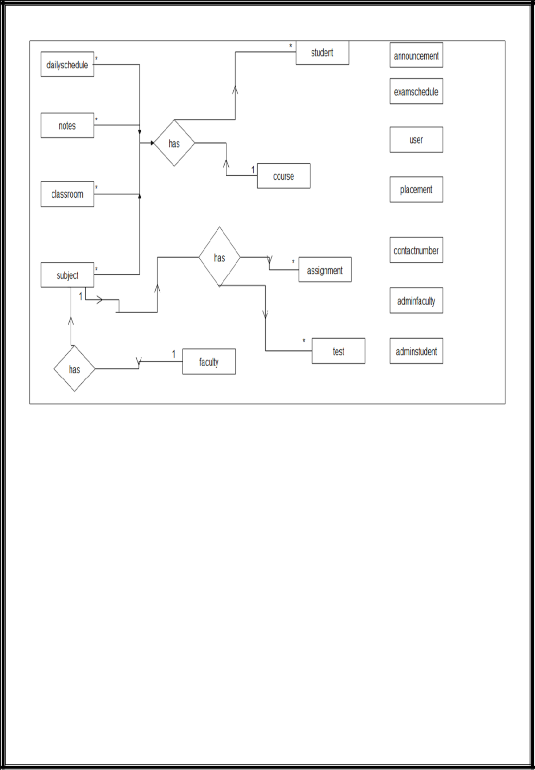

16

IACSD Student’s Online Portal

- Table Structure.

- Course:

 |  | Field |  |  |  | Type |  |  |  | Null |  |  |  |  | Key |  |  |  | Default |  |  |  |  |  | Extra
 |  | courseId |  |  |  | int(11) |  |  |  | NO |  |  |  |  | PRI |  |  |  | NULL |  |  |  |  |  | auto_increment
 |  | courseName |  |  |  | varchar(30) |  |  |  | YES |  |  |  |  |  |  |  |  | NULL
• Subject:
 |  | Field |  |  |  |  | Type |  |  |  | Null |  |  | Key |  |  |  |  |  | Default |  |  |  |  | Extra
 |  | subjectId |  |  |  |  | int(10) |  |  |  | NO |  |  | PRI |  |  |  |  |  | NULL |  |  |  |  | auto_increment
 |  | subjectName |  |  |  |  | varchar(30) |  |  |  | YES |  |  |  |  |  |  |  |  | NULL
 |  | courseId |  |  |  |  | int(10) |  |  |  | NO |  |  | MUL |  |  |  |  |  | NULL
 |  | facultyId |  |  |  |  | int(10) |  |  |  | NO |  |  | MUL |  |  |  |  |  | NULL

- Admin Student:

 |  | Field |  |  |  | Type |  |  |  | Null |  |  |  | Key |  |  |  |  |  |  | Default |  |  |  |  |  | Extra
 |  | prn_no |  |  |  | int |  |  |  | YES |  |  |  | PRI |  |  |  |  |  |  | NULL |  |  |  |  |  | auto_increment
 |  | firstname |  |  |  | varchar(30) |  |  |  | NO |  |  |  |  |  |  |  |  |  |  | NULL
 |  | lastname |  |  |  | varchar(30) |  |  |  | NO |  |  |  |  |  |  |  |  |  |  | NULL
• Student:
 |  | Field |  |  |  |  | Type |  |  | Null |  |  | Key |  |  |  |  |  |  | Default |  |  |  |  |  | Extra
 |  | pid |  |  |  |  | int(11) |  |  | NO |  |  | PRI |  |  |  |  |  | NULL |  |  |  |  |  |  |  | auto_increment
 |  | fname |  |  |  |  | varchar(30) |  |  | YES |  |  |  |  |  |  |  |  | NULL
 |  | lname |  |  |  |  | varchar(30) |  |  | YES |  |  |  |  |  |  |  |  | NULL
 |  | phno |  |  |  |  | varchar(30) |  |  | YES |  |  |  |  |  |  |  |  | NULL
 |  | dob |  |  |  |  | datetime |  |  | YES |  |  |  |  |  |  |  |  | NULL
 |  | email |  |  |  |  | varchar(30) |  |  | YES |  |  |  |  |  |  |  |  | NULL

17

IACSD Student’s Online Portal

address | varchar(50) | YES |  | NULL
coursename | int(11) | NO | MUL | NULL
courseFees | double | YES |  | NULL

- Admin Faculty:

 |  |  | Field |  |  |  |  |  |  | Type |  |  |  |  |  |  |  | Null |  |  |  |  |  |  |  | Key |  |  |  |  |  |  |  |  |  | Default |  |  |  |  |  |  |  |  | Extra
 |  |  | facultyid |  |  |  |  |  |  | int |  |  |  |  |  |  |  | NO |  |  |  |  |  |  |  | PRI |  |  |  |  |  |  |  |  |  | NULL |  |  |  |  |  |  |  |  | auto_increment
 |  |  | firstname |  |  |  |  |  |  | varchar(30) |  |  |  |  |  |  |  | YES |  |  |  |  |  |  |  |  |  |  |  |  |  |  |  |  |  | NULL
 |  |  | lastname |  |  |  |  |  |  | varchar(30) |  |  |  |  |  |  |  | YES |  |  |  |  |  |  |  |  |  |  |  |  |  |  |  |  |  | NULL
•
• |  | Faculty:
 |  |  | Field |  |  |  |  |  | Type |  |  |  |  |  |  |  | Null |  |  |  |  |  |  |  | Key |  |  |  |  |  |  |  |  |  | Default |  |  |  |  |  |  |  | Extra
 |  |  | facultyid |  |  |  |  |  | int(11) |  |  |  |  |  |  |  | NO |  |  |  |  |  |  |  | PRI |  |  |  |  |  |  |  |  | NULL |  |  |  |  |  |  |  |  |  |  | auto_increment
 |  |  | fname |  |  |  |  |  | varchar(30) |  |  |  |  |  |  |  | YES |  |  |  |  |  |  |  |  |  |  |  |  |  |  |  |  | NULL
 |  |  | lname |  |  |  |  |  | varchar(30) |  |  |  |  |  |  |  | YES |  |  |  |  |  |  |  |  |  |  |  |  |  |  |  |  | NULL
 |  |  | phno |  |  |  |  |  | varchar(30) |  |  |  |  |  |  |  | YES |  |  |  |  |  |  |  |  |  |  |  |  |  |  |  |  | NULL
 |  |  | dob |  |  |  |  |  | datetime(6) |  |  |  |  |  |  |  | YES |  |  |  |  |  |  |  |  |  |  |  |  |  |  |  |  | NULL
 |  |  | email |  |  |  |  |  | varchar(30) |  |  |  |  |  |  |  | YES |  |  |  |  |  |  |  |  |  |  |  |  |  |  |  |  | NULL
 |  |  | address |  |  |  |  |  | varchar(50) |  |  |  |  |  |  |  | YES |  |  |  |  |  |  |  |  |  |  |  |  |  |  |  |  | NULL
 |  |  | faculty |  |  |  |  |  | int |  |  |  |  |  |  |  | YES |  |  |  |  |  |  |  | MUL |  |  |  |  |  |  |  |  | NULL
•
• |  | Assignment:
 |  |  | Field |  |  |  |  |  |  |  |  |  |  | Type |  |  |  |  |  |  |  | Null |  |  |  |  |  |  | Key |  |  |  |  |  |  |  |  | Default |  |  |  |  |  | Extra
 |  |  | assign_no |  |  |  |  |  |  |  |  |  |  | int |  |  |  |  |  |  |  | NO |  |  |  |  |  |  | PRI |  |  |  |  |  |  |  | NULL |  |  |  |  |  | auto_increment
 |  |  | assign_link |  |  |  |  |  |  |  |  |  |  | varchar(300) |  |  |  |  |  |  |  | YES |  |  |  |  |  |  |  |  |  |  |  |  |  |  | NULL
 |  |  | assign_name |  |  |  |  |  |  |  |  |  |  | varchar(30) |  |  |  |  |  |  |  | YES |  |  |  |  |  |  |  |  |  |  |  |  |  |  | NULL
 |  |  | date_of_submission |  |  |  |  |  |  |  |  |  | datetime(6) |  |  |  |  |  |  |  |  | YES |  |  |  |  |  |  |  |  |  |  |  |  |  |  | NULL
 |  |  | subjectid |  |  |  |  |  |  |  |  |  |  | int |  |  |  |  |  |  |  | NO |  |  |  |  |  |  | MUL |  |  |  |  |  |  |  | NULL

18

 |  | IACSD |  |  |  |  |  |  |  |  |  |  |  |  |  |  |  |  |  | Student’s Online Portal
 |  | • Notes:
 |  |  |  | Field |  |  |  |  | Type |  |  | Null |  |  |  | Key |  |  | Default |  |  | Extra
 |  |  |  | nid |  |  |  | int |  |  |  | NO |  |  |  | PRI |  |  | NULL |  |  | auto_increment
 |  |  |  | notelink |  |  |  | varchar(300) |  |  |  | YES |  |  |  |  |  |  | NULL
 |  |  |  | crs_id |  |  |  | int |  |  |  | YES |  |  |  | MUL |  |  | NULL

- Classroom:

 |  |  | Field |  |  |  |  |  |  |  | Type |  |  |  |  |  |  |  |  | Null |  |  |  |  |  |  |  | Key |  |  |  |  |  |  | Default |  |  |  |  |  | Extra
 |  |  | class_id |  |  |  |  |  |  |  | int |  |  |  |  |  |  |  |  | NO |  |  |  |  |  |  |  | PRI |  |  |  |  |  |  | NULL |  |  |  |  |  | auto_increment
 |  |  | class_room_id |  |  |  |  |  |  | varchar(30) |  |  |  |  |  |  |  |  |  | YES |  |  |  |  |  |  |  |  |  |  |  |  |  |  | NULL
 |  |  | class_room_pwd |  |  |  |  |  |  | varchar(30) |  |  |  |  |  |  |  |  |  | YES |  |  |  |  |  |  |  |  |  |  |  |  |  |  | NULL
 |  |  | course_id |  |  |  |  |  |  |  | int |  |  |  |  |  |  |  |  | NO |  |  |  |  |  |  |  | MUL |  |  |  |  |  |  | NULL
•
• | Daily Schedule:
 |  |  | Field |  |  |  |  | Type |  |  |  |  |  |  |  |  | Null |  |  |  |  |  |  |  |  | Key |  |  |  |  |  |  |  | Default |  |  |  |  |  |  | Extra
 |  |  | dailyId |  |  |  |  | int(10) |  |  |  |  |  |  |  |  | NO |  |  |  |  |  |  |  |  | PRI |  |  |  |  |  |  |  | NULL |  |  |  |  |  |  | auto_increment
 |  |  | startDateTime |  |  |  |  | datetime |  |  |  |  |  |  |  |  | YES |  |  |  |  |  |  |  |  |  |  |  |  |  |  |  |  | NULL
 |  |  | endDateTime |  |  |  |  | datetime |  |  |  |  |  |  |  |  | YES |  |  |  |  |  |  |  |  |  |  |  |  |  |  |  |  | NULL
 |  |  | dailySchLink |  |  |  |  | varchar(300) |  |  |  |  |  |  |  |  | YES |  |  |  |  |  |  |  |  |  |  |  |  |  |  |  |  | NULL
 |  |  | courseId |  |  |  |  | int(10) |  |  |  |  |  |  |  |  | NO |  |  |  |  |  |  |  |  | MUL |  |  |  |  |  |  |  | NULL
 |  |  | subjectName |  |  |  |  | varchar(30) |  |  |  |  |  |  |  |  | YES |  |  |  |  |  |  |  |  |  |  |  |  |  |  |  |  | NULL
•
• |  | Placements:
 |  |  | Field |  |  |  |  |  | Type |  |  |  |  |  |  |  |  | Null |  |  |  |  |  |  |  |  | Key |  |  |  |  |  |  |  |  | Default |  |  |  |  |  |  | Extra
 |  |  | prn |  |  |  |  |  | varchar(20) |  |  |  |  |  |  |  |  | NO |  |  |  |  |  |  |  |  | PRI |  |  |  |  |  |  |  |  | NULL
 |  |  | batch |  |  |  |  |  | varchar(20) |  |  |  |  |  |  |  |  | YES |  |  |  |  |  |  |  |  |  |  |  |  |  |  |  |  |  | NULL
 |  |  | companyname |  |  |  |  |  | varchar(20) |  |  |  |  |  |  |  |  | YES |  |  |  |  |  |  |  |  |  |  |  |  |  |  |  |  |  | NULL

19

IACSD Student’s Online Portal

coursename | varchar(20) | YES |  | NULL
studentname | varchar(20) | YES |  | NULL

- Announcement:

 | Field |  |  | Type |  |  | Null |  |  | Key |  |  | Default |  |  | Extra
 | ansm_id |  |  | int |  |  | NO |  |  | PRI |  |  | NULL |  |  | auto_increment
 | ansm_name |  |  | varchar(500) |  |  | YES |  |  |  |  |  | NULL

- Contact Number:

 | Field |  |  | Type |  |  | Null |  |  | Key |  |  | Default |  |  | Extra
 | contact_no1 |  |  | int |  |  | NO |  |  | PRI |  |  | NULL |  |  | auto_increment
 | contact_no2 |  |  | varchar(100) |  |  | YES |  |  |  |  |  | NULL
 | contact_no3 |  |  | varchar(100) |  |  | YES |  |  |  |  |  | NULL
 | contact_no4 |  |  | varchar(100) |  |  | YES |  |  |  |  |  | NULL

• User:

 | Field |  |  | Type |  |  | Null |  |  | Key |  |  | Default |  |  | Extra
 | userid |  |  | int |  |  | NO |  |  | PRI |  |  | NULL
 | password |  |  | varchar(30) |  |  | YES |  |  |  |  |  | NULL

20

IACSD Student’s Online Portal

- CONCLUSION

- Conclusion:

This project aid in automating the existing manual system. This is a paperless work. It can be monitored and guarded remotely. It cut down the man power required and provides accurate information. All years together huddled information can be saved and can be accessed at any time. For this reason, the data stored in the repository helps in taking decision by management. So, it is improved to have a Web Based system. All the stakeholders, faculty and authority can get the required information without delay. This system is crucial in the colleges and universities.

- Future Scope:

This project can be enhanced further by adding payable additional courses, online feedback system, online payment facility for the members to reduce the extra work of the admin. The software is flexible enough to be modified and implemented as per future requirements. We have tried our best to present this free and user–friendly website to Institutes.

21

IACSD Student’s Online Portal

- REFERENCES.

- References:

http://www.ijcstjournal.org/volume-7/issue-1/IJCST-V7I1P4.pdf
https://bootstrapmade.com/mentor-free-education-bootstrap-theme/
https://www.javatpoint.com/java-mail-api-tutorial
https://angular.io/docs
https://javaee.github.io/javaee-spec/javadocs/
https://www.w3schools.com/

22

