Computing Systems Worksheet 1 Introduction to VRA
Roz Wyatt-Millington
25 September 2023
This Lab introduces you to the VMWare vRealize Automation system (VRA). You will deploy an Ubuntu Desktop client and start to understand how to manipulate stuff using the command line. This version of worksheet does not contain any spaces for answering questions — that is in your printed lab book.
Note: An operating system is a suite of programs that enables users to make efficient use of the computer. It co-ordinates the computer’s hardware, controlling such components as the disks, screen, keyboard, memory and processor. Operating systems generally include software that allows users to carry out a range of monitoring, management and maintenance tasks. In addition, software is included which facilitates communication of the computer with other computers.

Document conventions
- Information for you to read and understand is in this font.
- Information output by the PC or when discussing commands is shown in this font.
- Commands that you need to type into terminal is shown in this font.
- A control Character is indicated by prefixing a ^ character e.g. ^C means Control-C. To generate this on keyboard, hold down "Ctrl" and press "c".

References
Canonical (2023) The leading operating system for PCs, IoT devices, servers and the cloud | Ubuntu.
Available from: <https://ubuntu.com/>.
Tanenbaum, A. S., Feamster, N. & Wetherall, D. J. (2021) Computer Networks. Pearson.

Introduction to Linux
The majority of the practical work for this module will involve using Linux — in this module mainly Ubuntu 22.04 LTS ((Canonical, 2023)) which is a flavour published by Canonical using the Linux Kernel 5.4. Before we delve into using Linux first off it is worth talking about its story.
The story of Linux began in Finland when Linus B. Torvalds, then a student, bought himself a PC equipped with a 386 processor in order to study how it worked. Since MS-DOS did not fully exploit the properties of the 386, Linus used another commercial operating system, MINIX, developed mainly by Andrew Tanenbaum (the first author of the key networks text for this module (Tanenbaum et al., 2021)). MINIX is a miniature UNIX system released in 1987 - UNIX at the time being the common operating system for many workstations as Windows was not the predominant operating system for PCs that it has become.
Driven by limitations of the system, Linus started to rewrite parts of the software in order to add functionality and features, using Free Software from the “Gnu’s Not Unix” (GNU) project such as the compiler (GCC) and debugger (gdb). He broadcast the results freely on the Internet under the title of Linux. The first version became available in August 1991. The free software foundation include reference to GNU in the name i.e. Gnu/Linux. Right at the beginning just a few enthusiasts noticed the system and became interested. Over the years the number of developers has continued to grow and today there are thousands of developers sponsored by over a thousand companies working on the kernel alone.
Nowadays, Linux is a Unix compatible operating system conforming to POSIX (Portable Operating System Interface) specifications and equipped with certain extensions. This makes it easy to transport computer code from applications written for other UNIX systems.
Linux code is entirely original and not in any way proprietary. The source programs are distributed freely under the GNU General Public Licence (GPL). However, large establishments requiring Linux tend to pay a fee to guarantee support through companies such as Red Hat or SUSE. However many many free distributions (distros) are available including Ubuntu, Debian, Fedora to name but three.
GUI interfaces are available, but certain system maintenance functions oare still most easily performed using the Linux Shell and every prospective system engineer should have some idea of how it can be used. The history of Linux and UNIX is an interesting area for investigation via the Internet.

The VMware vRealize Automation system
In this lab you will learn how to use the VRA system provided by the BEEC Network Systems team to create your own virtual machine running Ubuntu which you will be using in this module alongside the Remote access Linux servers that are also run by the school. The remote servers more like standard lab computers in the way they work in that they are configured in such a way that most users are constrained in what they can do.
2.1 Why so complicated?
As is common in most organisations, Leeds Beckett’s computer labs are configured in such a way that most users are constrained in what they can do. There are good security reasons for this. The VRA system allows us to free up some of these constraints within a contained environment. This module introduces you to the system which you will use in other modules in your studies. Within the VRA you can have superuser access (elevated privileges) which enables you to configure your system, create user accounts and do other administrator" tasks. However it is in an isolated network so although you can install applications, the virtual machines are constrained in how they can access the network.
A consequence of this freedom is that there is little protection against your mistakes – there are many ways to lose data accidentally and you will be responsible for your own data.

Tasks
As you work through the tasks, THINK about what you are doing. Do not just follow the instructions without considering what you are doing and what you can learn from it. In most Labs there are further topics to explore after you have completed the exercises of the worksheets.

Access the VRA & create your Virtual machine
To access the VRA on campus, we can go directly to them on a PC running a standard Leeds Beckett desktop. Once you have logged in (remember this can take some time if you have not used the PC before), open you web browser (Edge, Chrome or Firefox) and go to the following link: https://vra-stu.aet.leedsbeckett.ac.uk/
DO NOT DO THIS IF YOU ARE NOT ON A LEEDS BECKETT STANDARD LAB PC - you will need to use the Student VPN in this case.
This will open a website which will look something like Figure 1. Click on the button to go to the login page as shown in Figure 2.
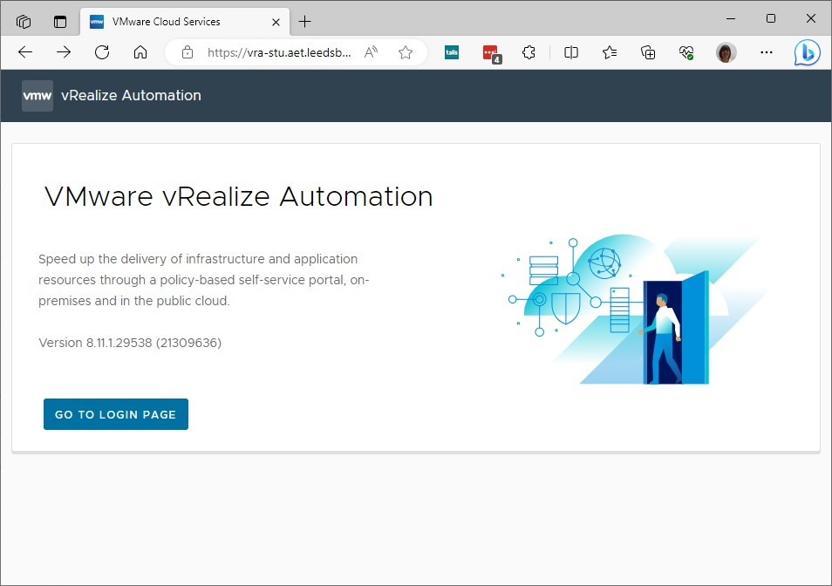
Figure 1 Initial VRA site
Enter your university login details — your username is ‘cxxxxxxx’ and your password is your standard LBU password that you use to access everything. On successful login you will get to the Services screen as shown in Figure 3 — click on the Service Broker link.
This will open the Overview of your Service Broker. To get to the screen shown in Figure 4 click on the Catalog link in the left-hand menu and scroll until you can see the Basic Ubuntu Desktop. Hit the REQUEST link to open up a page as shown in Figure 5 and ensure you select the BEC Student General
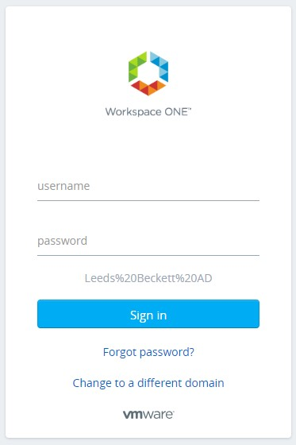
Figure 2 VRA Login
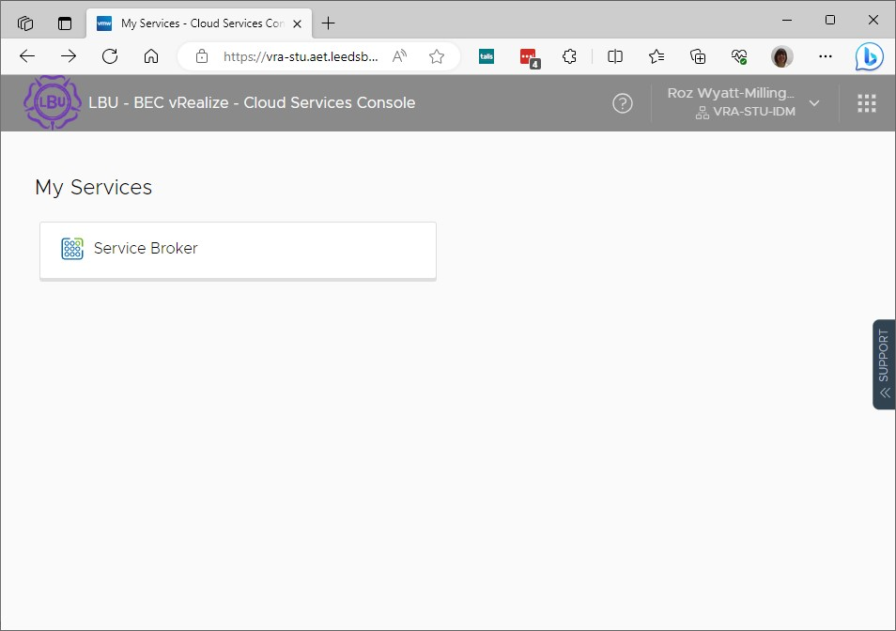
Figure 3 My Services on VRA
Project (as we want to create an x86 virtual machine). You can name the deployment whatever you want. Hit SUBMIT button
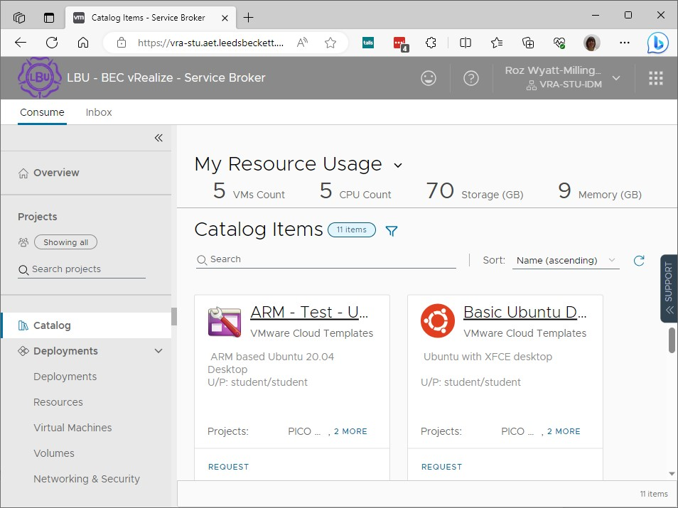
Figure 4 VRA Catalog
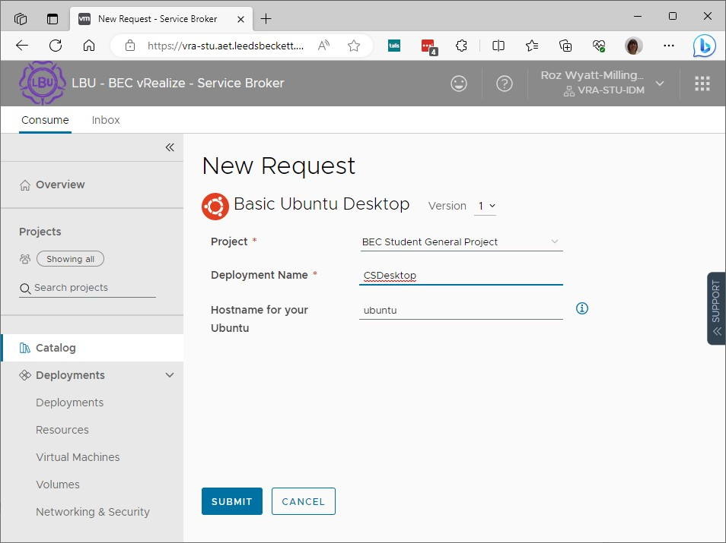
Figure 5 VRA New Request
This will take you to the Deployments page — Figure 6 shows a small part of mine as I have a number of test deployments. This was taken while my new virtual machine was being created — if you click on the name you will open a screen with more information about this deployment and can see how far you are through the tasks required. At this point it is a case of waiting till the deployment has
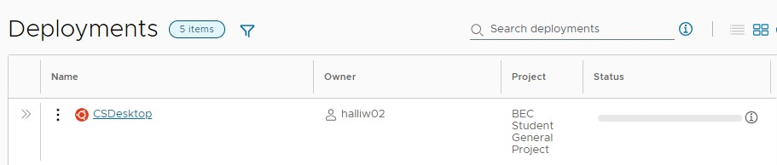
Figure 6 VRA Deployment
been created — once this has happened, you should end up with a screen that looks something like Figure 7. Now click on the ACTIONS drop-down menu on right (highlighted in red on figure) and select ‘Connect to Remote Console’. This will open a new window and you may see below the address bar a pop-up that says something like shown in Figure 8. Click on the ‘accept the certificate’ link
which will open another tab as shown in Figure 9. You will need to click on the Advanced button to see everything and then hit the ‘Continue to vmhci...’ link at bottom. This will go to a login screen but you can ignore this and close this tab down and go back to the VMware Cloud Services tab. If you now refresh the window (F5) you should now see the Ubuntu XFCE login screen as shown in Figure 10. The password for the user ‘student’ is ‘student’ (this is the case for many of the machine templates on the VRA) so now login.
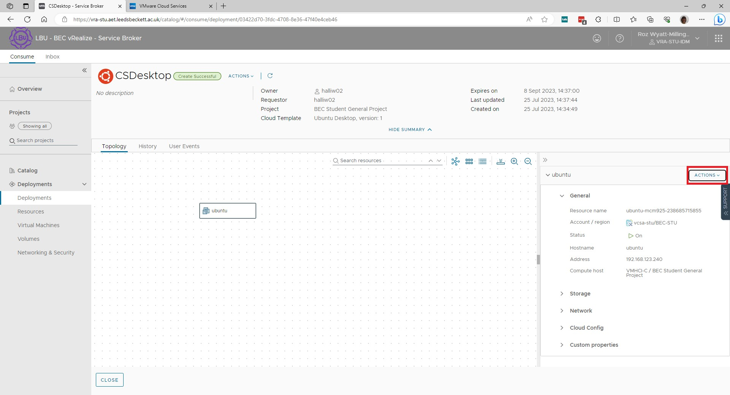
Figure 7 VRA Successful Creation
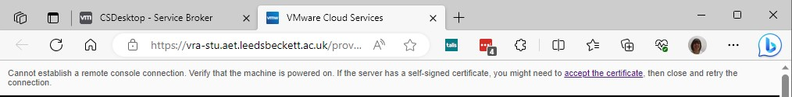
Figure 8 VMware Cloud Services error
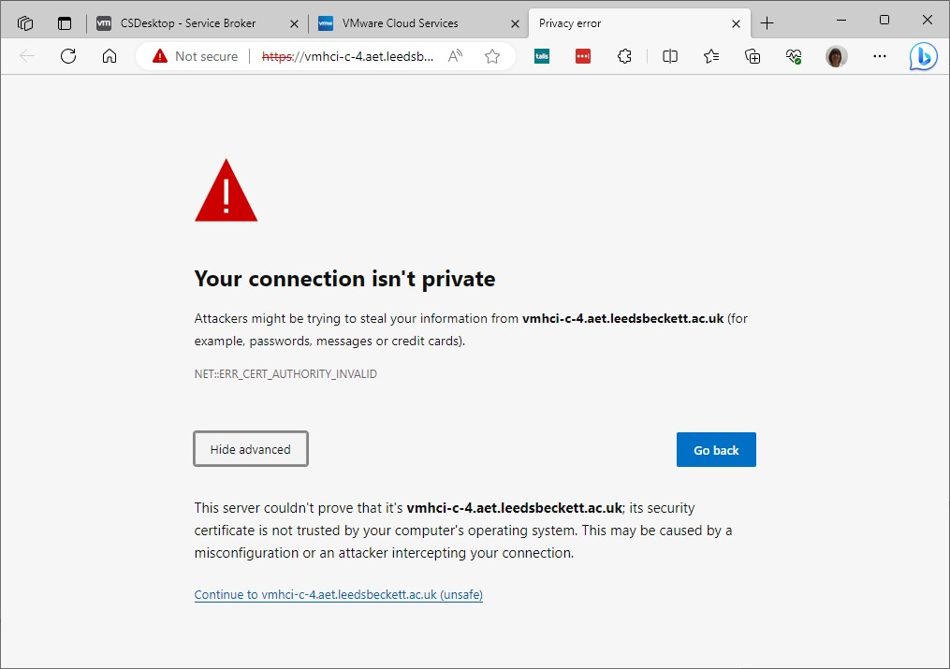
Figure 9 Accept Certificate
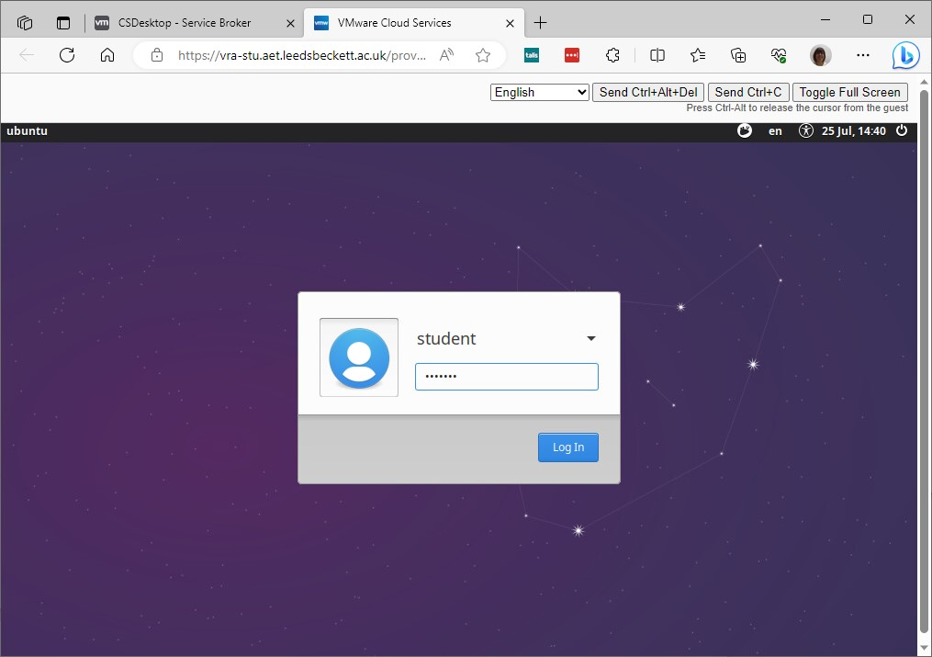
Figure 10 Remote Login Screen

Initial commands
Firstly we need to open a shell or terminal window by going to Applications > Utilities > Terminal to open a Terminal window.
Note: the terms shell and terminal are used interchangeably - more correctly, a terminal provides some kind of screen or window and also connects to the keyboard and maybe the mouse. Usually it sends the keystrokes and mouse actions to a shell program and displays the output of that shell program. A terminal can also connect with other programs.
You should see a new window with prompt something like this: student@ubuntu:~$
The ‘$’ indicates that you do not have root privileges as is usual on Linux machines. On these IMS machines you can however use the sudo command to run commands as the ‘super-user’ or as we are about to do actually become the root user on the system.
Open another terminal window. You should have two identical windows — you can switch between them using the mouse. You will now arrange for one of your terminals to have root permissions (remember this is the Linux equivalent of Administrator access in Windows).
In one of your terminals at the ‘$’ prompt type: sudo su
When prompted (asked) type in the password for student user given above. This user has been created as part of the administrator user group so can get root access.
Note: You may expect something (e.g. a large dot or a *) to appear for each character of your password as you type. In this case you will see nothing. Just type carefully and understand that the operating system is accepting your key strokes. The normal behaviour of characters appearing as you type is called echoing.
You could also have typed the following to get temporary root access: sudo -i
You should notice that the prompt in the terminal window has changed to: root@ubuntu:/home/student#
The terminal prompt is ‘#’ for root and ‘$’ for other users — this is important as you need to know when you are a root user! Notice also that the active window has a flashing cursor. To get out of root access you simply type at the ‘#’ > exit
You will notice the prompt has gone back to ‘$’ indicating you are in a user shell.

Obtaining help on commands in Linux
Open a Linux terminal — you should see the expected prompt on the screen:
student@ubuntu`:~$``
The ‘$’ indicates you are in normal user mode and the ~ indicates that your current directory/folder is your Home directory.
To get help about Linux commands you can use the ‘manual’ command — that is for the command dir you would type man dir at the $. This brings up the Linux manual pages for ‘dir’ which you can scroll through using your mouse wheel, the up/down arrow keys or space-bar (which jumps a page down). To quit the manual you need to type ‘q’. You can also use the ‘information’ command by typing info dir at the $.
Try both these commands out and use the space below to discuss the different levels of information contained in the two approaches to help files.
Info provides more detailed and interconnected information with separate sections for
various aspects of the command.
Man is more straightforward, with consolidated sections like description and example.
Info allows more interactive navigation with hyperlinks, creating a hierarchical structure.
Man relies on basic scrolling and 'q' for quitting
Info might be more user-friendly for those who prefer a structured, interactive interface.
Man is often preferred for quick reference and reading in a terminal environment.

You have to read the provided information carefully to understand what it means! It gives you some information in English but a lot of extra information which can be confusing. You may have to scroll down, until you find the item you are after. Items in square brackets [ ] are optional – “may be left out”. The “–” symbol is used to show switches — that is something that gives additional information to the command as opposed to parameter(s) which tell the command the objects it needs to act on.

Create and save some files
echo – a simple command (+ file creation using redirection)
Type echo My name is Roz
You will see on the screen:
student@ubuntu:~$ echo My name is Roz My name is Roz student@ubuntu:~$
The first line is what you typed. The second line is the output from the command and the third line is the prompt waiting for you to type your next command. echo is the command and ‘My name is Roz’ are the parameters. echo can have any number of parameters. Some commands can have only one or two.
We can use echo it as a simple of way of creating a file by piping the output (using >) to a text file.
Type echo My name is Roz > first.txt You will see on the screen:
student@ubuntu:~$ echo My name is Roz > first.txt student@ubuntu:~$
Naming conventions in most operating systems are similar with a file consisting of a name followed by an extension which is usually to do with the file type — they are separated by a ‘.’ (full stop or period). So for the file created above “first” is the filename with “txt” indicating a simple text file being the extension. A file also has a pathname which gives the entire path of the file form the root directory to the file including sub-directory names — this is unique on the system. For this file the simple path (provided you didn’t change directory) will be ~/first.txt (or in full /home/student/first.txt). As an offline challenge, can you find out the maximum filename length and which characters are allowed in filenames in Ubuntu?
In Ubuntu (and many other Linux systems), the maximum filename length is 255 characters. This limit
includes the entire path, so the combination of the filename and its path cannot exceed this length.
Regarding allowed characters in filenames, Linux systems are more permissive compared to some
other operating systems. I can use any character in a filename except for the following special
characters:
1. / (forward slash): Used as a directory separator.
2. NULL (character with ASCIl value 0): Represents the end of a string in C programming.
To check the file has been created we can type ls -l (that is the letter ell not one. 1 does not look much different to l in many fonts - you need to remember this)
This will bring up a list of the files and directories/folders in the current location with their creation times. You should be able to see first.txt with a recent creation time in the list.
To see the contents of the file type: less first.txt less is a command that takes one parameter which is the name of the file and causes the operating system to list, on the screen, one page at a time, the contents of the files specified. To quit this command type q (this or CTRL-C (^C) will get you out of many Linux commands).
Why less and not more? Can you find out (after the lab)?
1. "less" allows both forward and backward scrolling using the arrow keys, making it more flexible
for navigating through a file.
2. less" supports searching within the file. You can search for specific patterns or text using the '/
key followed by the search term.
3. "less" provides more interactive navigation features, making it easier to move around within a
file.
4. "less" can display the contents of a file one screen at a time, similar to "more," but it also
supports additional features for controlling the output.
5. "less" has more command-line options, allowing users to customize its behavior according to
their preferences
You can also edit your file on the command line by typing:
nano ~/first.txt
This should open the file you just created. To exit it you need to press CTRL-x on your keyboard (noted as ^X at bottom of file). Note that ^stands for the CTRL key by convention.
You can also use gedit ~/first.txt to open the GUI text editor to see and edit your file — note it is likely that gedit will not be installed so use sudo apt install gedit to install . This is an application with its own help system which you can explore. When you exit from gedit you find that you can save the edited file without changing its name or save it with a new name or exit without saving it.
To copy files on the command line the cp command is used. Now let us try this by typing cp first.txt second.2 at the $ in a terminal window. student@ubuntu:~$ cp first.txt second.2\ **student@ubuntu**:~$`
This will create an exact copy of first.txt in a file called second.2 — you can check this by using the ls -l command to see it has been created and then nano or gedit commands to open the second.2 file. Create r more copies of your file ls lists the files in the current directory. Make sure you can see the names of the file you have just created (you may see the names of other files as well). There is also a graphical file manager (similar to Windows Explorer) which you can use to view lists of files etc.). You can access this by selecting it on the left-hand icon menu (the icon that looks like a filing cabinet) or by going to Applications > Accessories > Files.
Note: the terms “folder” and “directory” mean exactly the same thing iand are used interchangeably.
Looking at ls -l we can see there is a switch -l. In fact for this command there are a whole series of switches that do different things. Using the manual page when needs (man ls) which you can open in another terminal window answer the following questions:
- What is displayed when you do not specify any switches — i.e. ls. Try it and describe the results below:
When you use the ls command without specifying any switches in the terminal, it displays the list of files and directories in the current directory in a simple, one-column format. Each entry represents a file or directory, and directories are not distinguished from regular files.
- Which switch forces the system to display just directories (and not their contents)? Try using it.
The switch that forces the system to display just directories (and not their contents) is -d. When you use the -d switch with the ls command, it will list only the names of directories in the specified location.
- Which switch displays all of the files and sub-directories on a drive? Try using it.
To display all files and sub-directories in a drive, you can use the -a option with the ls command. The -a option stands for "all" and includes hidden files and directories in the listing.
There are two wildcard characters that can be used indicate a set of files instead of a single file. You can use:
- * instead of ANY series of valid characters for the name and extension.
- ? instead of ANY SINGLE character (but it must be a character, not a space).
There are times when these wildcards can be useful in any operating system – for example, when you are “searching” for file whose name you have forgotten but know the letter its name starts with or the extension. So, for example:
ls * lists all files in the current directory and in all sub-directories ls *.txt lists all files in the current directory with the .txt extension ls f* lists all files starting with ‘f’
ls *.t* lists all files whose extension begins with ‘t’ ls ?????.* lists files with only 5 characters in their name Try some of these to see what happens.

Create, use and remove sub-directories
As you would expect, you can create a folder structure using Linux on the command line as well as using the Linux File Manager in the GUI. The commands you need are mkdir to make a directory; cd to change directory; rmdir to remove an empty directory and rm to remove files.
Type mkdir six
This “makes a directory” with the name six. Repeat this with 2 more directories called seven and eight. Check what you have done by typing ls. You should see the sub-directories you have created listed among the files. Use the command mv <file> six/<file> to move some of your text files created earlier in the six sub-directory.
Linux sub-directories have no simple way of tracing their “parent” directories. Therefore, every subdirectory maintains two special sub-directories called “.” for the sub-directory itself and “..” for the next directory ‘up’ the tree towards the root directory. Also, “/” is the name of the root directory so you can always “change back to” the root by typing cd / — note the space between the command and the directory name (this is essential in Linux, but not in other systems). Further, you have seen that “~” represents your Home directory. You can use cd ~ to get to your Home directory.
Type ls–R
This produces a display of all files and sub-directories on the disk. You can read the display and check that it is as you expect.
Type ls–R>~/<filename> where <filename> is the name of a text file such as output.txt. The text file will contain the output from the ls command (re-directed into the file) and will be stored in your Home directory.
To remove a file permanently from the system use the command rm <file> — make sure that the <file > is something unimportant as you can not retrieve it once removed.
To remove empty directories from the system, you can use the command rmdir <dirname> — check you can only remove empty directories by trying to remove the six directory that you earlier put files in. Can you find out how to remove non-empty directories? Hint: look at manual for rm command. Now remove all the files and directories you have created in this lab.

Review
This lab has been mainly about learning the basics of the command line in Linux and how to manipulate files and directories with it. You will learn a lot more about this in the Operating Systems in Practice at Level 5.

All screenshots in this section taken on 25 July 2023
replace my name with your first name
nano is a commonly used command line text editor with vim being another common text editor
Only ones you have created

