THIRANEX INTERNSHIP
REAL-WORLD DATA PROJECT
Big Mart Sales Prediction
Business-oriented exploratory analysis and machine learning

Training records | 8,523
Test records | 5,681
Best model | Random Forest • R² 0.6052

Prepared for Task 4 submission

1. Executive Summary
This project applies a complete data analytics and machine learning workflow to the Big Mart Sales dataset. The objective is to understand the factors associated with item-level outlet sales and build a model that can predict sales for unseen test records. The workflow covers data inspection, cleaning and preprocessing, exploratory data analysis, categorical encoding, model training, evaluation, business interpretation, and prediction export.
Three regression approaches were evaluated: Linear Regression, Decision Tree, and Random Forest. Random Forest produced the strongest validation performance, with an R² score of 0.605245, MAE of 723.545222, and RMSE of 1035.825057. The final model was used to generate predictions for all 5,681 test records.

2. Business Problem and Objective
Retail businesses need reliable estimates of product sales to support inventory planning, outlet-level decisions, product strategy, and resource allocation. The business problem addressed here is to predict Item Outlet Sales from available item and outlet characteristics.

Project objectives
- Inspect and prepare the Big Mart sales data for analysis.
- Identify useful patterns across item, outlet, location, pricing, visibility, and fat-content attributes.
- Compare multiple regression models using MAE, RMSE, and R².
- Select the best-performing model based on validation performance.
- Generate sales predictions for the unseen test dataset.
- Translate analytical results into practical business insights.

3. Dataset Overview
Dataset characteristic | Value
Training records | 8,523
Test records | 5,681
Input features | 11
Target variable | Item_Outlet_Sales
Prediction output | 5,681 test-record predictions
The main variables represent product attributes (such as item type, fat content, visibility, weight, and MRP) and outlet attributes (such as outlet type, size, location type, identifier, and establishment year). The training dataset contains the target Item_Outlet_Sales, while the test dataset is used for final prediction.

4. Data Preparation and Preprocessing
The dataset was inspected for structure, data types, missing values, and categorical inconsistencies before modeling. The preprocessing workflow prepared numerical and categorical variables for machine learning and kept the transformation steps together with the model through a preprocessing/model pipeline.
- Checked the dataset shape and feature structure.
- Inspected missing values and variable distributions.
- Prepared numerical variables for modeling.
- Encoded categorical variables so they could be used by regression algorithms.
- Separated predictors (X) from the target variable (y).
- Split the training data into 80% training and 20% validation sets using random_state=42.

5. Exploratory Data Analysis
Exploratory analysis was used to understand how item and outlet characteristics vary and how they relate to sales. The following charts are taken from the completed project notebook.
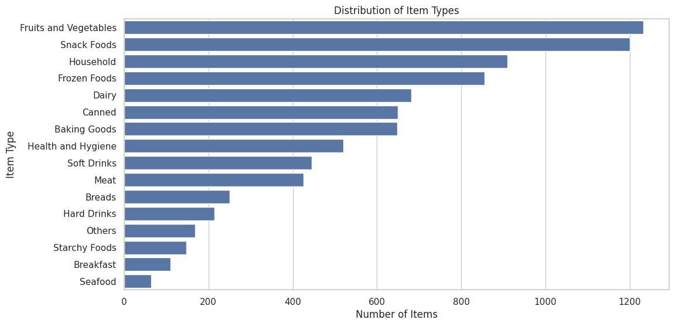
Figure 1. Distribution of item types across the dataset.
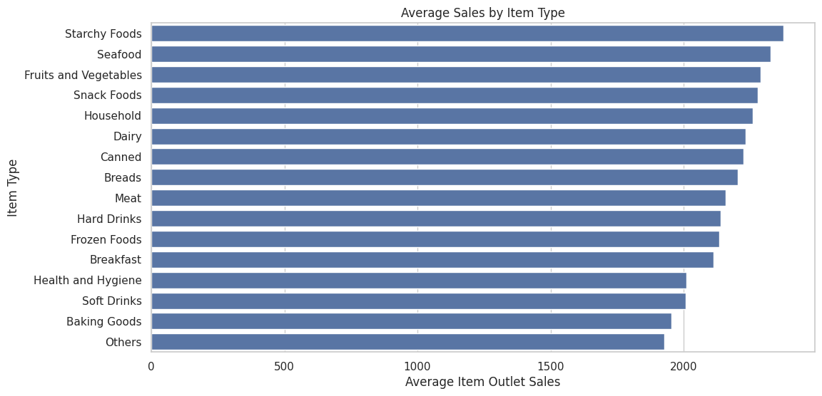
Figure 2. Average Item Outlet Sales by item type.
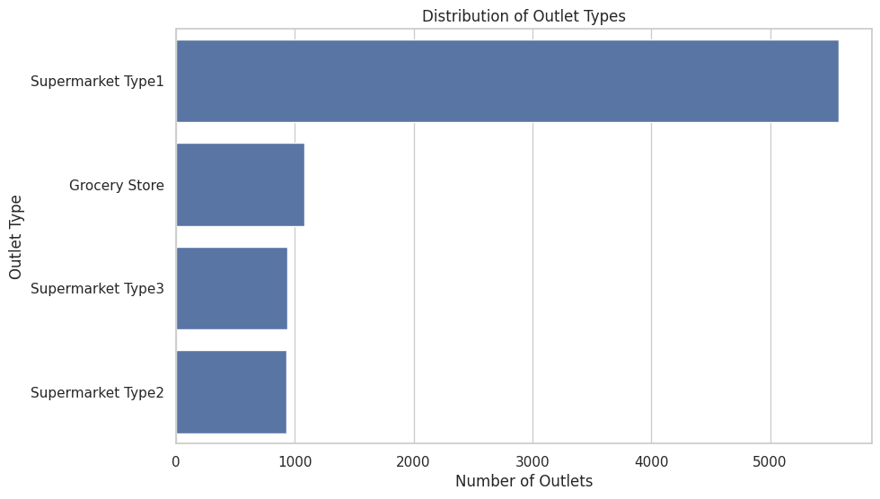
Figure 3. Distribution of outlet types.
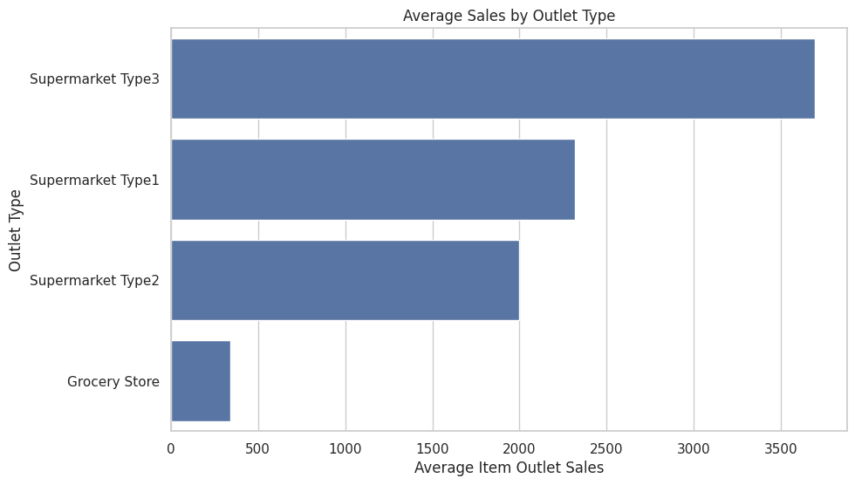
Figure 4. Average Item Outlet Sales by outlet type.
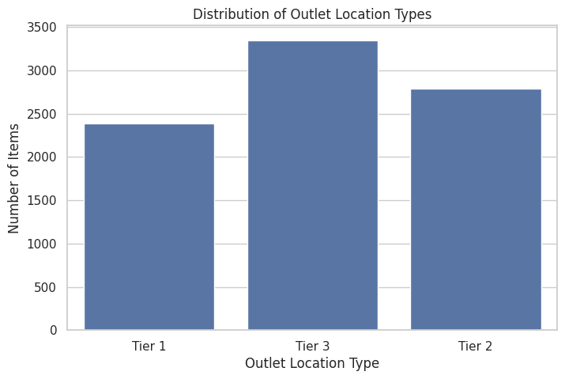
Figure 5. Distribution by outlet location type.
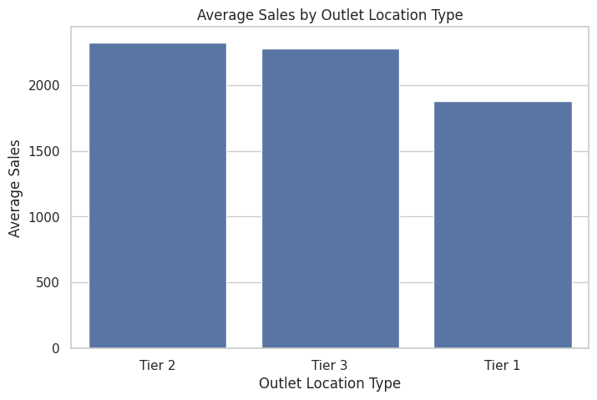
Figure 6. Average sales by outlet location type.

5.1 Key categorical insights
- Supermarket Type3 had the highest average sales among the outlet types observed in the analysis.
- Starchy Foods had the highest average sales among the item types in the analysis.
- Tier 2 had the highest average sales among the outlet location types.
- Regular fat-content items had the highest average sales among the fat-content categories.
These results describe observed differences in average sales between groups. They should be interpreted as associations in the dataset rather than proof that a single category causes higher sales.

5.2 Numerical relationships and distributions
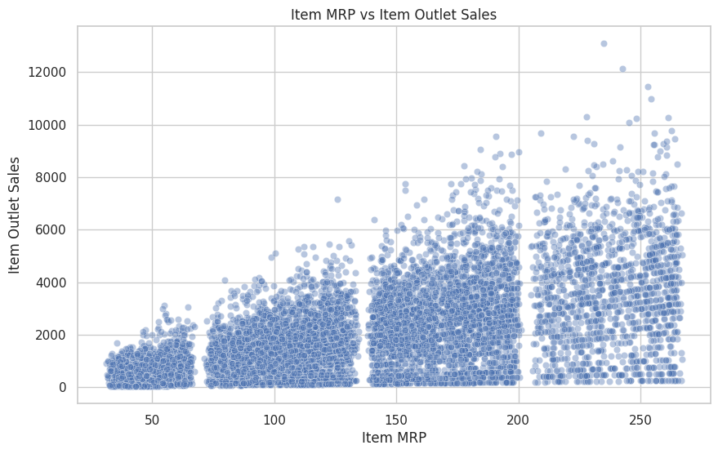
Figure 7. Relationship between Item MRP and Item Outlet Sales.
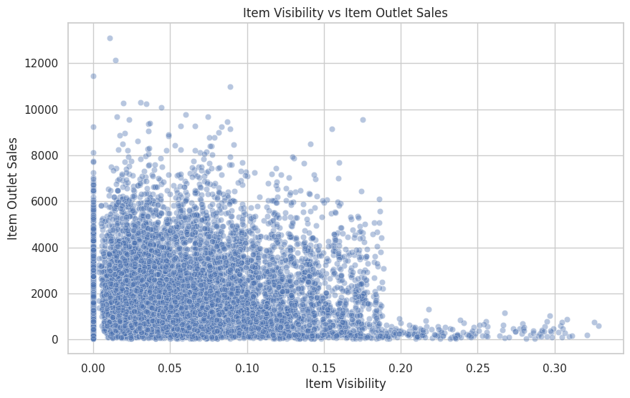
Figure 8. Relationship between Item Visibility and Item Outlet Sales.
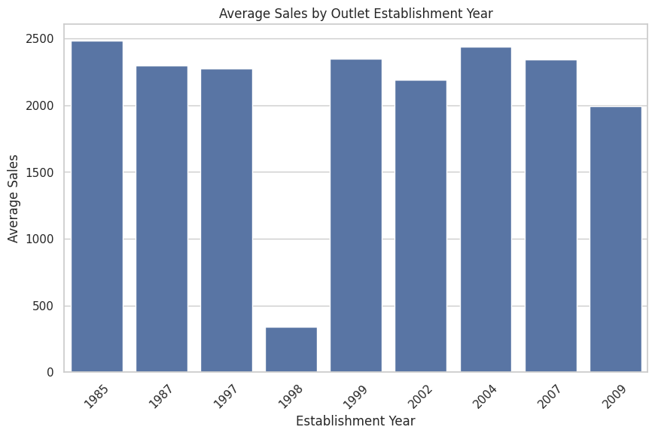
Figure 9. Average sales by outlet establishment year.
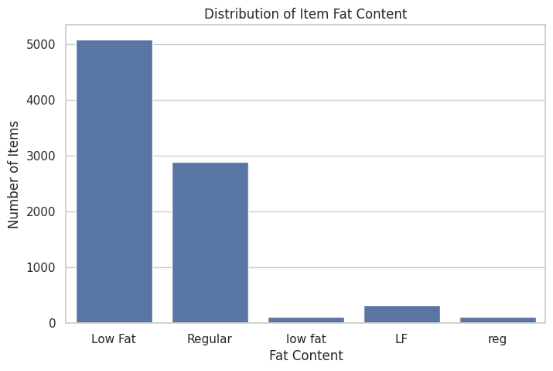
Figure 10. Distribution of item fat-content categories.
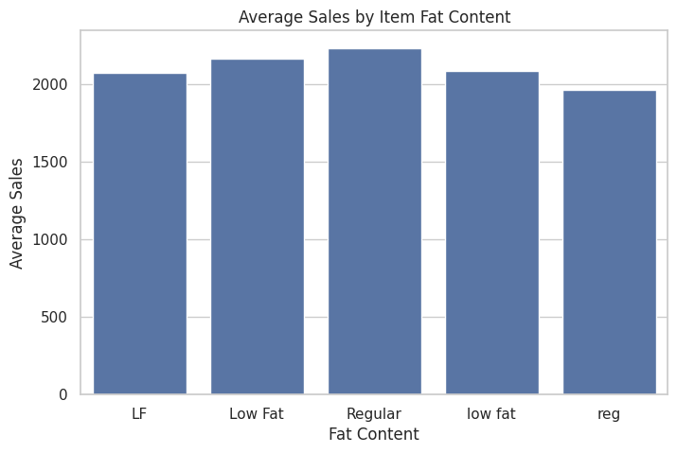
Figure 11. Average sales by item fat-content category.
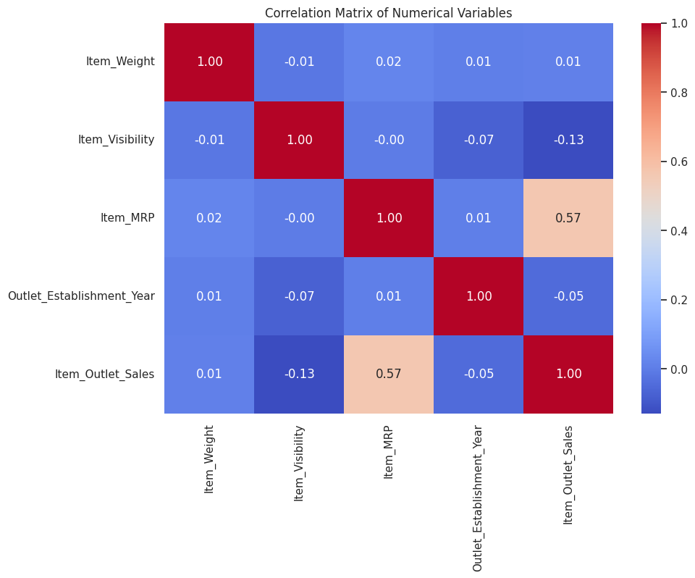
Figure 12. Correlation matrix of numerical variables.

5.3 Additional findings
- The highest Item MRP observed in the project analysis was 266.89.
- Average Item Outlet Sales across the training data was 2181.29.
- The MRP-versus-sales and visibility-versus-sales plots were used to visually inspect relationships between numerical variables and the target.

6. Machine Learning Approach
The project treats sales prediction as a regression problem. Three models were trained and evaluated on the validation set:
- Linear Regression
- Decision Tree
- Random Forest
Model performance was compared using Mean Absolute Error (MAE), Root Mean Squared Error (RMSE), and R². Lower MAE/RMSE indicate smaller prediction errors, while a higher R² indicates that the model explains a larger share of the variation in the validation target.
Model | MAE | RMSE | R² Score
Linear Regression | 939.175117 | 1267.551306 | 0.408865
Decision Tree | 739.328842 | 1065.904694 | 0.581985
Random Forest | 723.545222 | 1035.825057 | 0.605245
Random Forest is the selected model because it achieved both the highest R² score and the lowest MAE and RMSE among the three evaluated models.
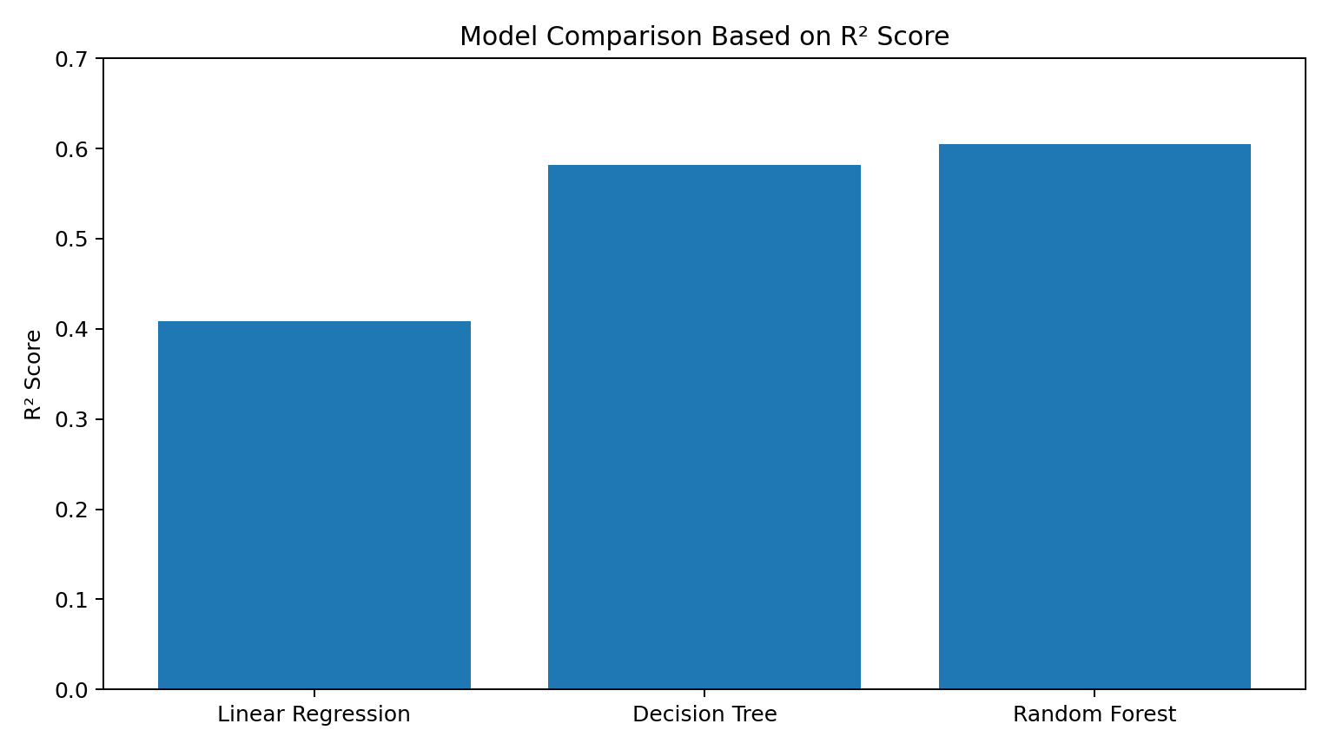
Figure 13. Validation comparison using R².
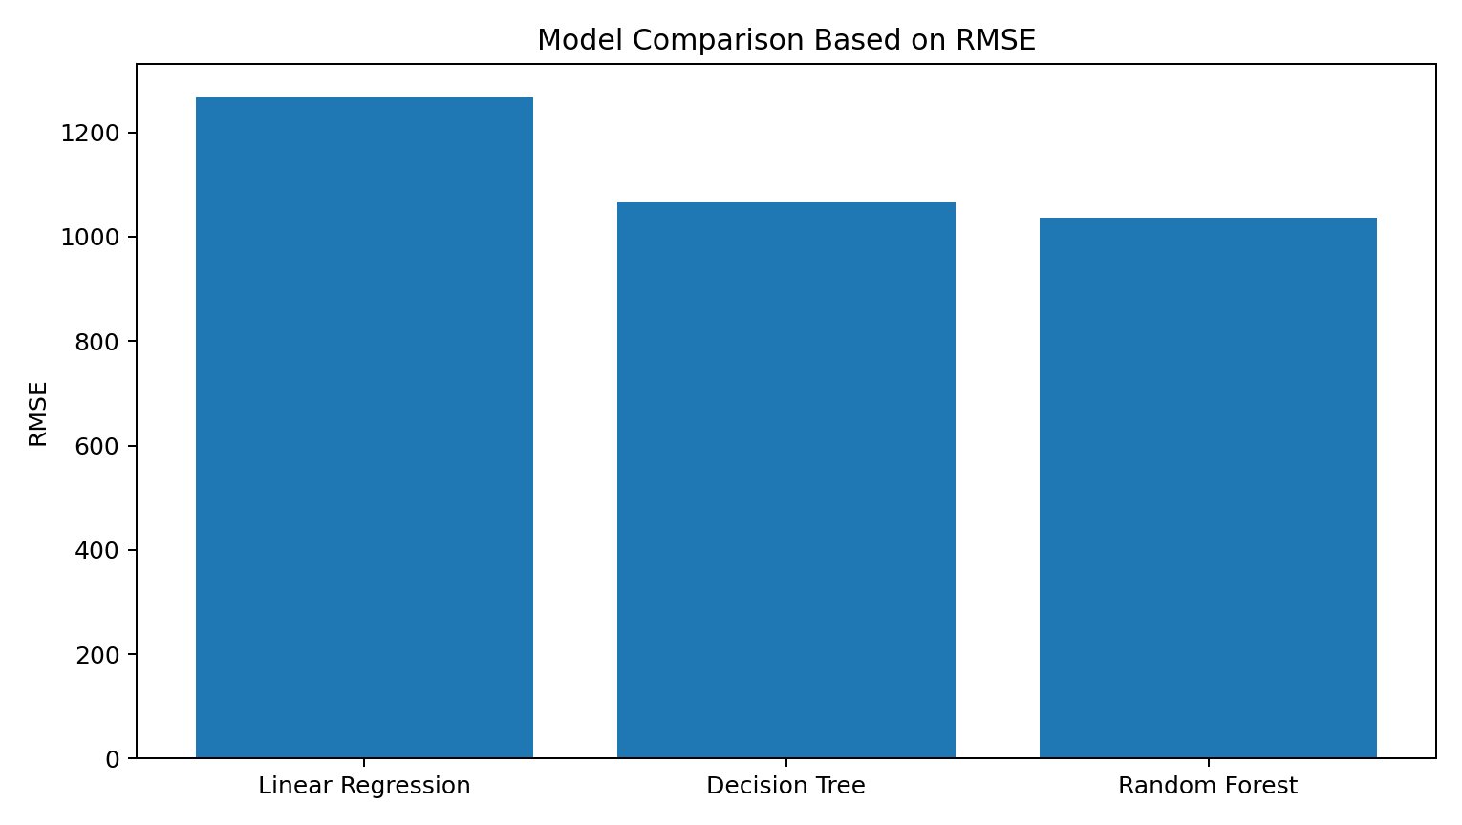
Figure 14. Validation comparison using RMSE.

7. Prediction Output
After selecting Random Forest as the best-performing model, predictions were generated for the 5,681 records in the test dataset. The prediction file contains the original test-record fields together with the predicted sales column `Predicted_Item_Outlet_Sales`.
Prediction output statistic | Value
Number of predictions | 5,681
Minimum predicted sales | 51.28
Maximum predicted sales | 7002.06
Mean predicted sales | 2172.17
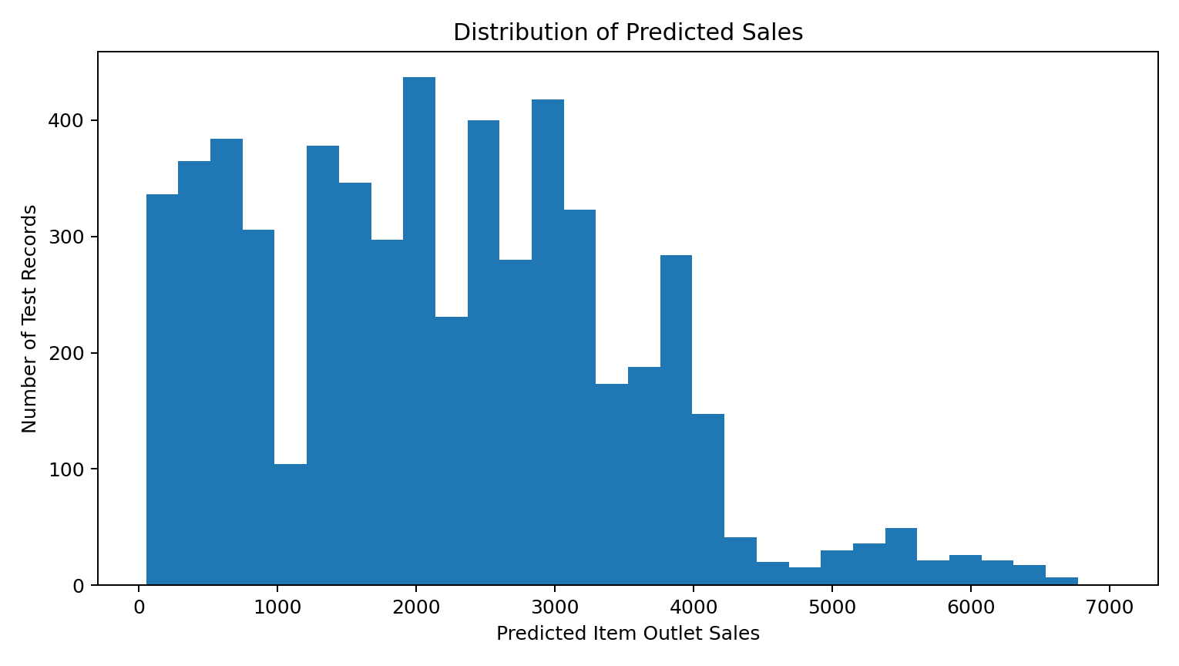
Figure 15. Distribution of predicted sales for the test records.

8. Business Insights and Recommendations
Prioritize high-performing outlet formats: Supermarket Type3 showed the highest average sales in the project analysis. Outlet-level planning can use this pattern as a signal for further investigation into assortment, store scale, customer traffic, and inventory practices.
Use outlet location as a segmentation variable: Tier 2 recorded the highest average sales among the three location types. Future decisions can compare demand patterns and operating conditions by location tier rather than applying one strategy to every outlet.
Review product-level demand patterns: Starchy Foods showed the highest average sales among item types. Product-category performance can be monitored to improve assortment and replenishment decisions.
Consider pricing and visibility together: The project explored Item MRP and Item Visibility against sales. These variables can be incorporated into forecasting and promotion analysis rather than evaluated independently.
Use the Random Forest model as the current baseline: Random Forest produced the strongest validation performance in this project. It can serve as the baseline model for future experiments with hyperparameter tuning, additional feature engineering, and more robust validation.

9. Limitations and Future Improvements
- The reported model performance is based on a single 80/20 validation split.
- The R² of 0.605245 indicates useful predictive signal, but a substantial portion of sales variation remains unexplained.
- Future work could use cross-validation and systematic hyperparameter tuning.
- Additional feature engineering and outlier/error analysis could be explored.
- Model explainability techniques could be added to quantify the contribution of individual predictors.
- Business validation should be performed before using predictions for operational decisions.

10. Conclusion
The Big Mart Sales Prediction project demonstrates an end-to-end real-world data science workflow. The analysis identified meaningful differences in average sales across outlet types, item categories, location tiers, and fat-content groups, while the numerical analysis examined pricing, visibility, and outlet establishment patterns. Among the tested regression models, Random Forest delivered the best validation results with an R² of 0.605245, MAE of 723.545222, and RMSE of 1035.825057. The final model was then used to produce 5,681 test-set sales predictions.

11. Tools and Technologies
- Python
- Pandas
- NumPy
- Matplotlib
- Seaborn
- Scikit-learn
- Google Colab / Jupyter Notebook
- Google Drive

Appendix A. Project Output Files
The completed project workflow produced the following key deliverables:
- Big Mart Sales Prediction notebook (including the corrected feature-importance cell).
- Model evaluation results comparing Linear Regression, Decision Tree, and Random Forest.
- bigmart_sales_predictions.csv containing 5,681 test-set predictions.
- This final Task 4 report with charts, analysis, model comparison, and business interpretation.

