Netflix Content Exploratory Data Analysis
Thiranex Internship — Task 3
Visual EDA Report

This report presents the charts from the completed Netflix EDA notebook, together with concise explanations of what each visualization shows.

1. Project Objective
The objective of this project is to explore the Netflix Movies and TV Shows dataset, identify meaningful patterns and trends, examine relationships between variables, and communicate the findings through clear visualizations.

2. Dataset Overview
The dataset contains Netflix title information such as content type, title, director, cast, country, date added, release year, rating, duration, genres, and description. The analysis focuses on descriptive exploration rather than predictive modeling.

3. Movies vs TV Shows
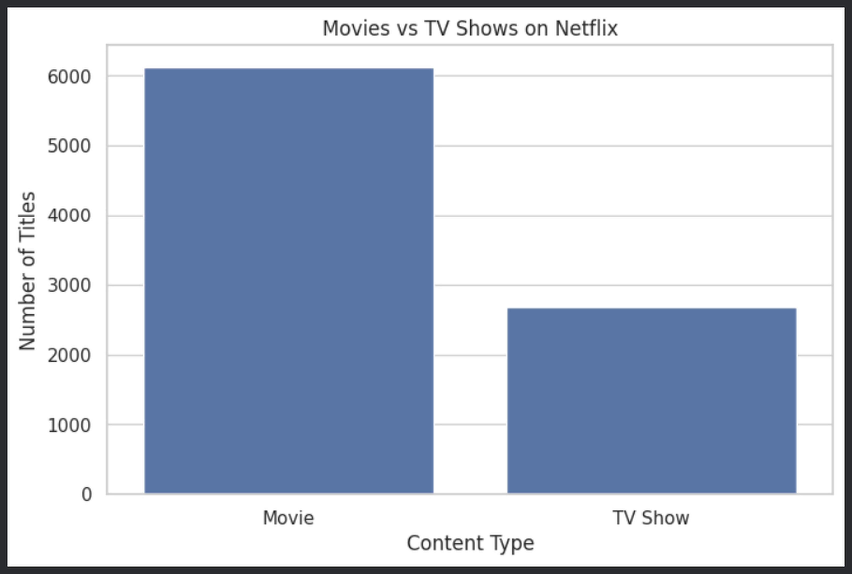
Explanation: The bar chart compares the number of Movies and TV Shows in the dataset. Movies clearly form the larger category, indicating that the Netflix catalog represented here contains substantially more movies than television series.

4. Percentage of Content Type
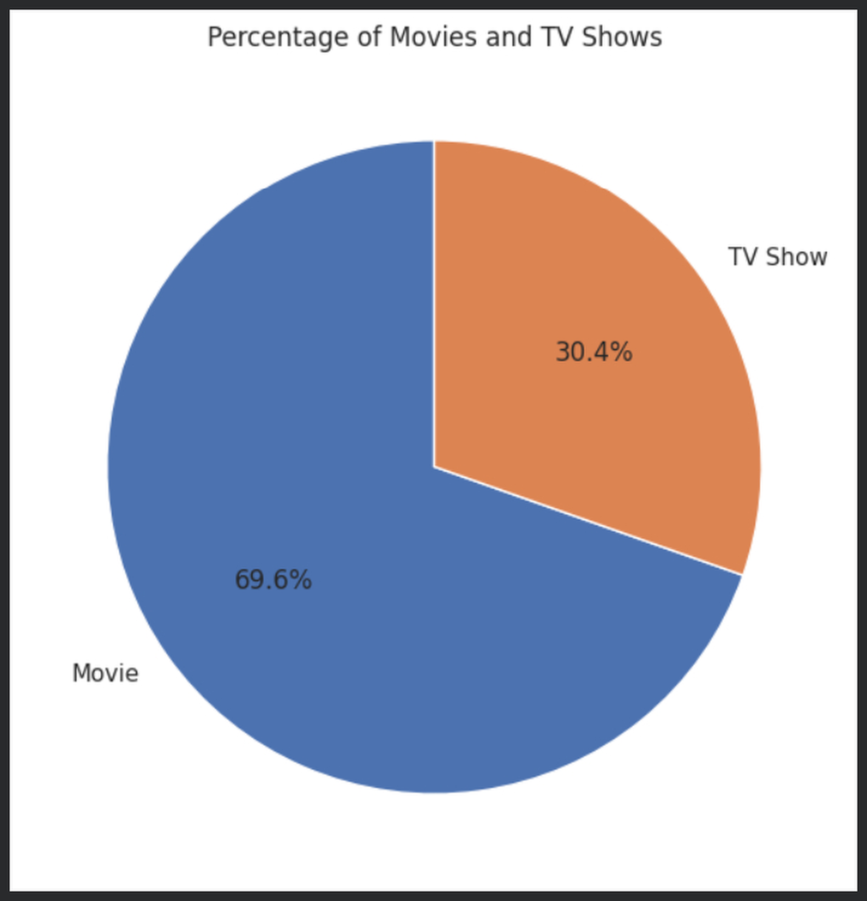
Explanation: The pie chart shows the share of each content type. Movies account for the majority of the catalog, while TV Shows make up the smaller share. This confirms the difference observed in the count comparison.

5. Netflix Titles by Release Year
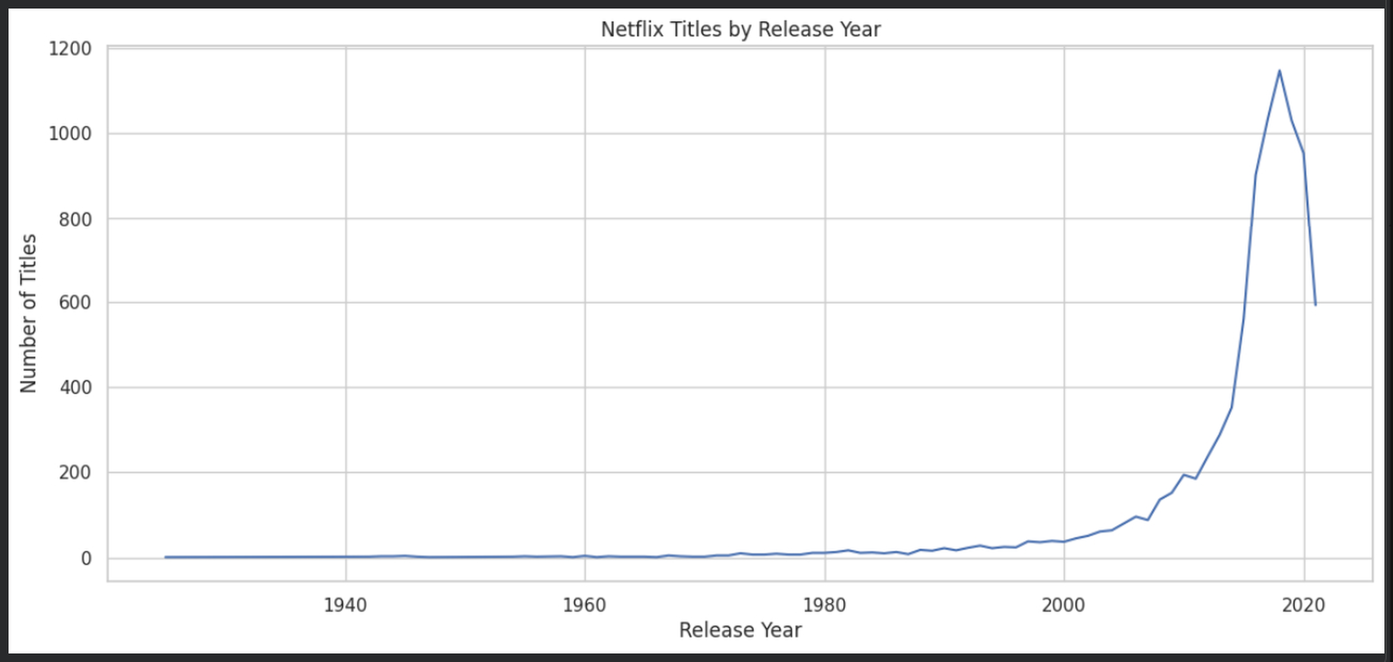
Explanation: The release-year trend shows how the number of titles varies across years. The distribution becomes much larger in recent years, indicating that the dataset has a strong concentration of modern Netflix-era content.

6. Distribution of Movie Durations
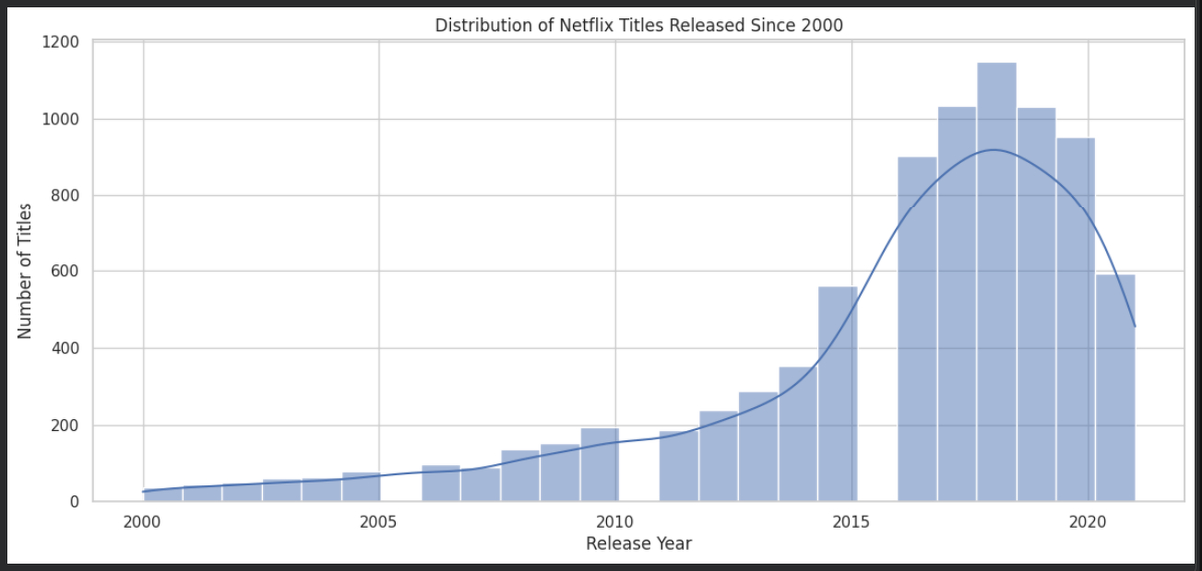
Explanation: The histogram shows the distribution of movie lengths in minutes. Most observations are concentrated around the typical feature-film range, with many movies falling approximately between 80 and 120 minutes. A smaller number of movies have substantially longer runtimes.

7. Netflix Titles Added by Year
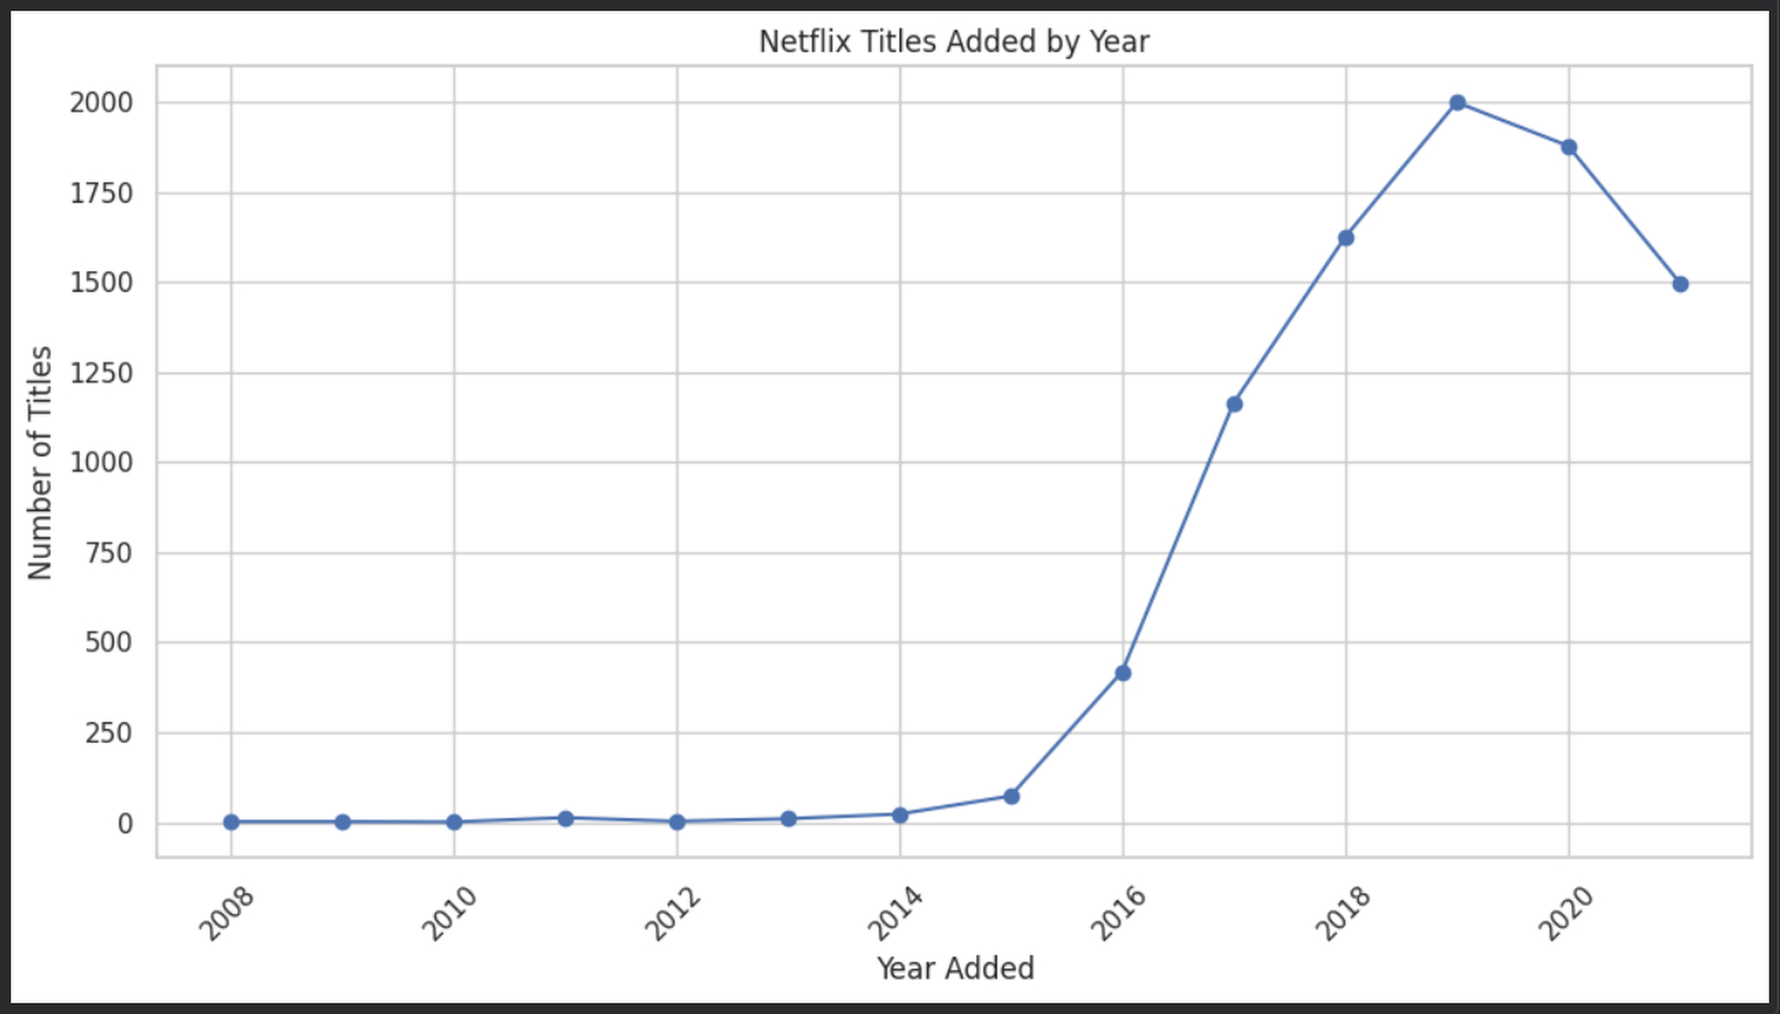
Explanation: This time-series visualization shows the number of titles added to Netflix each year. The catalog grows substantially over the later years, showing a clear expansion in the number of titles being added.

8. Top 10 Years with the Most Netflix Content Added
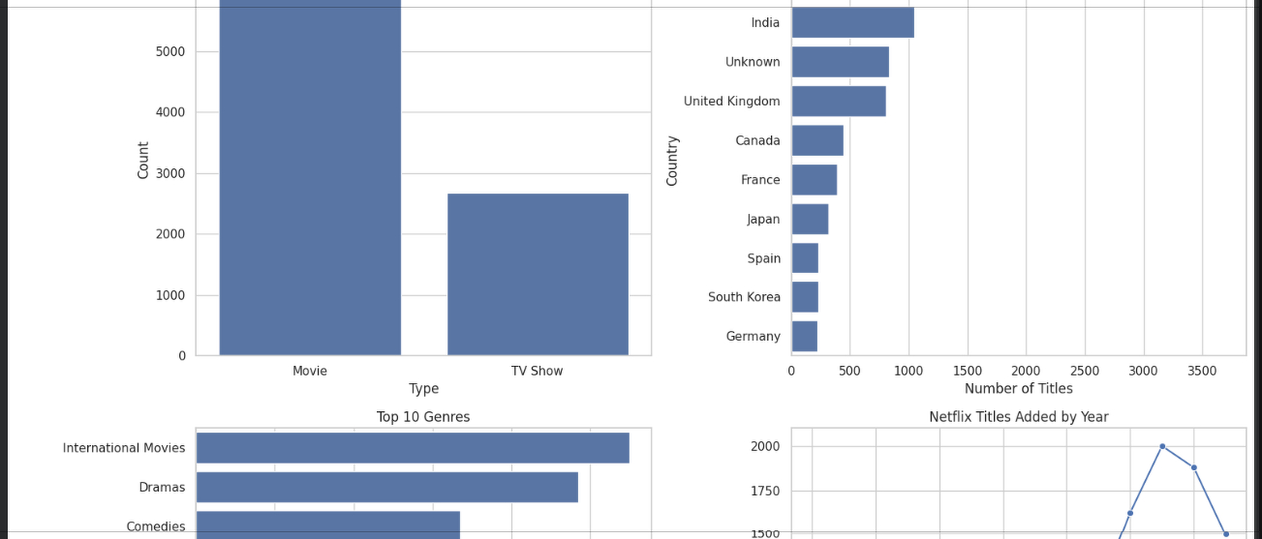
Explanation: The ranking identifies the years with the largest numbers of titles added. 2019 appears as the highest year in the displayed analysis, followed by 2020 and 2021, highlighting a period of strong catalog expansion.

9. Distribution of Content Ratings
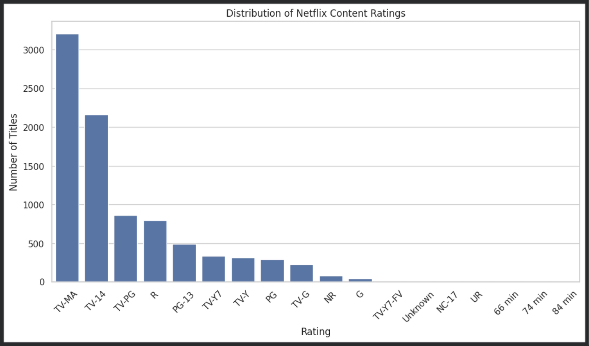
Explanation: The rating chart compares the frequency of Netflix audience/content ratings. TV-MA and TV-14 are among the most common categories, showing that mature and teen-oriented classifications form a substantial part of the catalog.

10. Top 10 Countries by Number of Netflix Titles
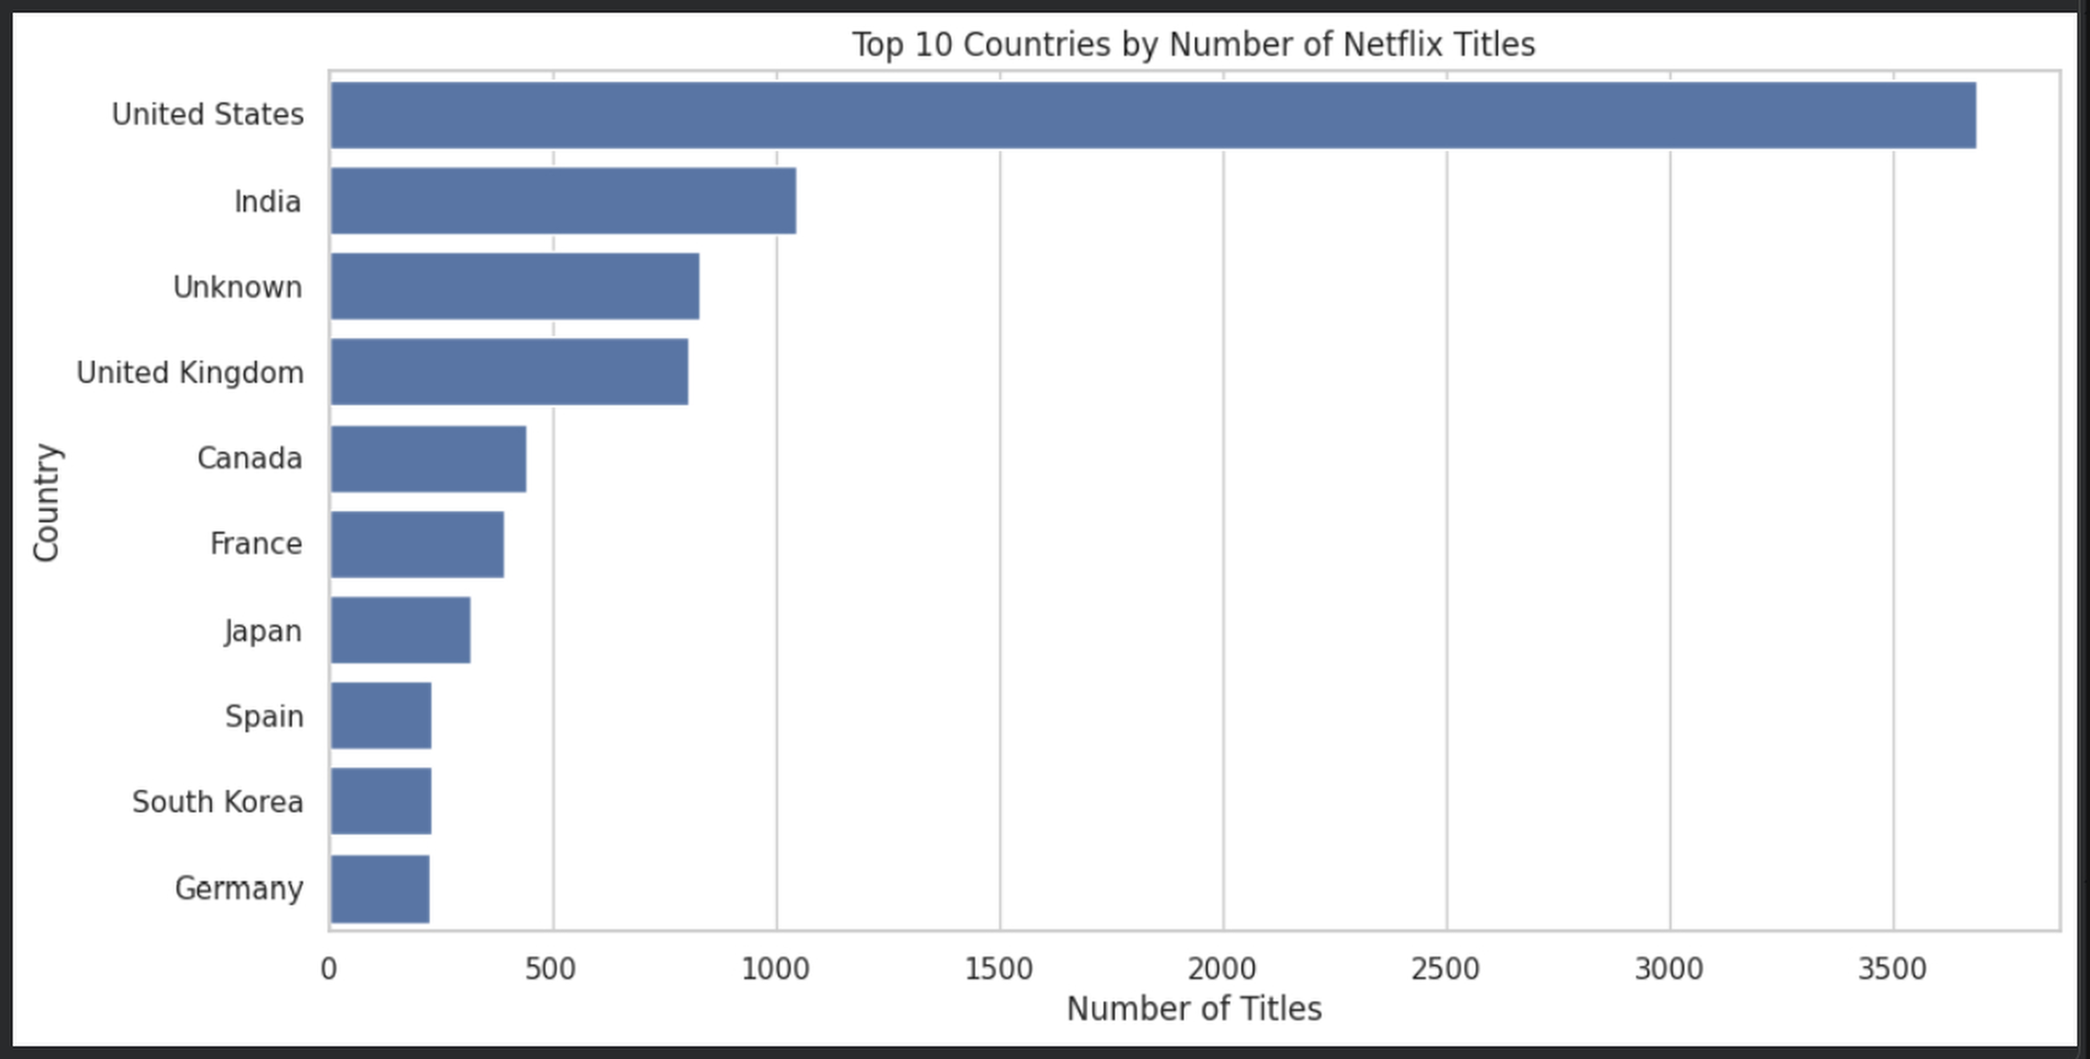
Explanation: The country ranking shows where the titles in the dataset are associated with the highest numbers of productions. The United States leads by a large margin, with India and the United Kingdom also having strong representation.

11. Top 10 Genres on Netflix
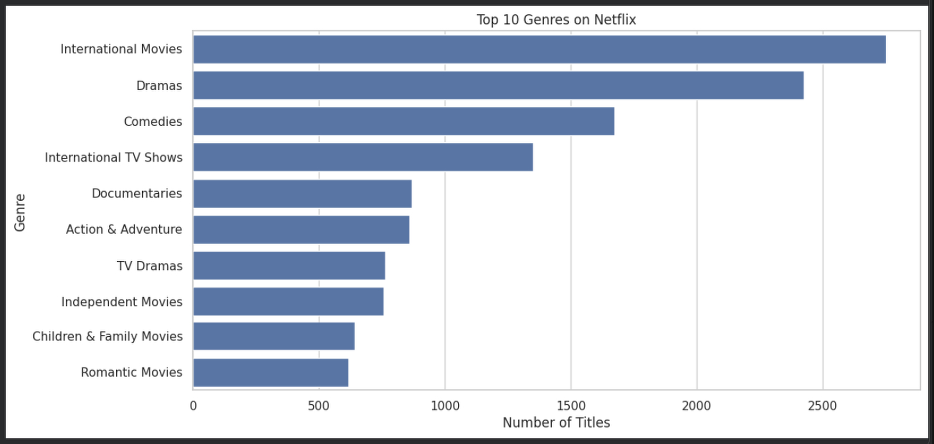
Explanation: The genre chart ranks the most frequent categories. International Movies, Dramas, and Comedies are prominent, demonstrating the variety of content available across different styles and audiences.

12. Top 10 Directors by Number of Netflix Titles
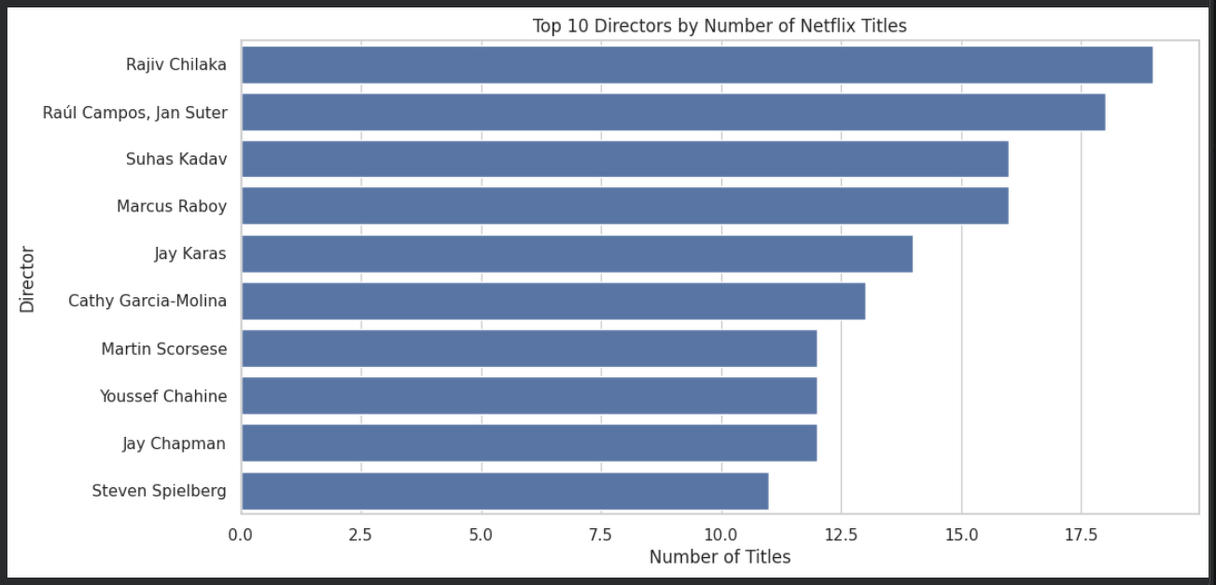
Explanation: The director chart identifies filmmakers who have multiple titles represented in the dataset. The visualization helps highlight directors with comparatively high representation within Netflix's catalog.

13. Movies vs TV Shows by Release Year
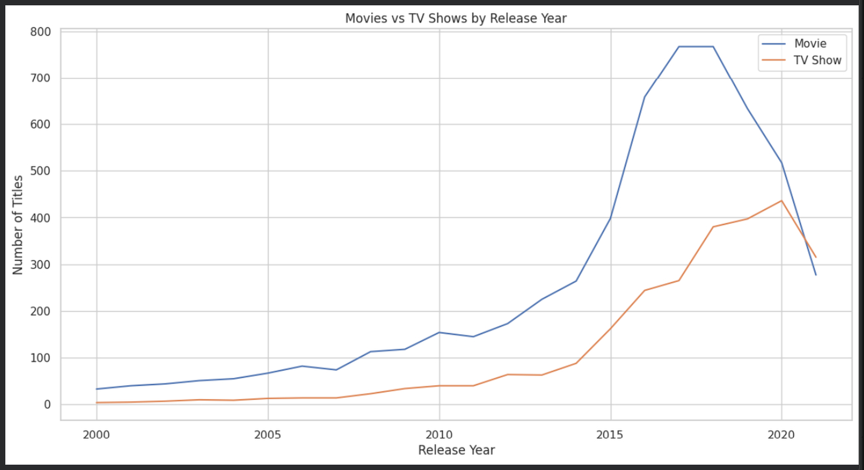
Explanation: This comparison tracks Movies and TV Shows across release years. Movies remain more numerous across the displayed period, while both content types show stronger representation in more recent years.

14. Correlation Matrix of Numerical Variables
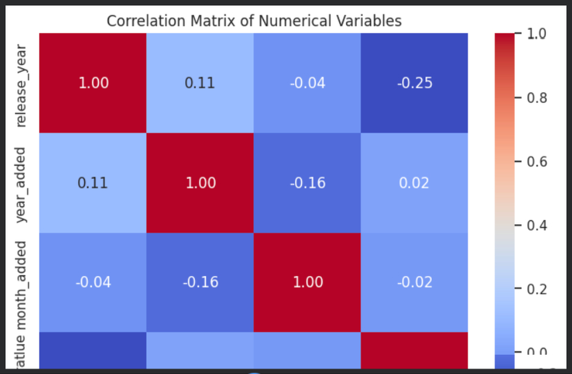
Explanation: The heatmap summarizes relationships among release year, year added, month added, and extracted duration. The strongest visible positive relationship is between release year and year added, indicating that newer releases tend to be associated with later additions to Netflix.

15. Top 10 Genres — Alternative View
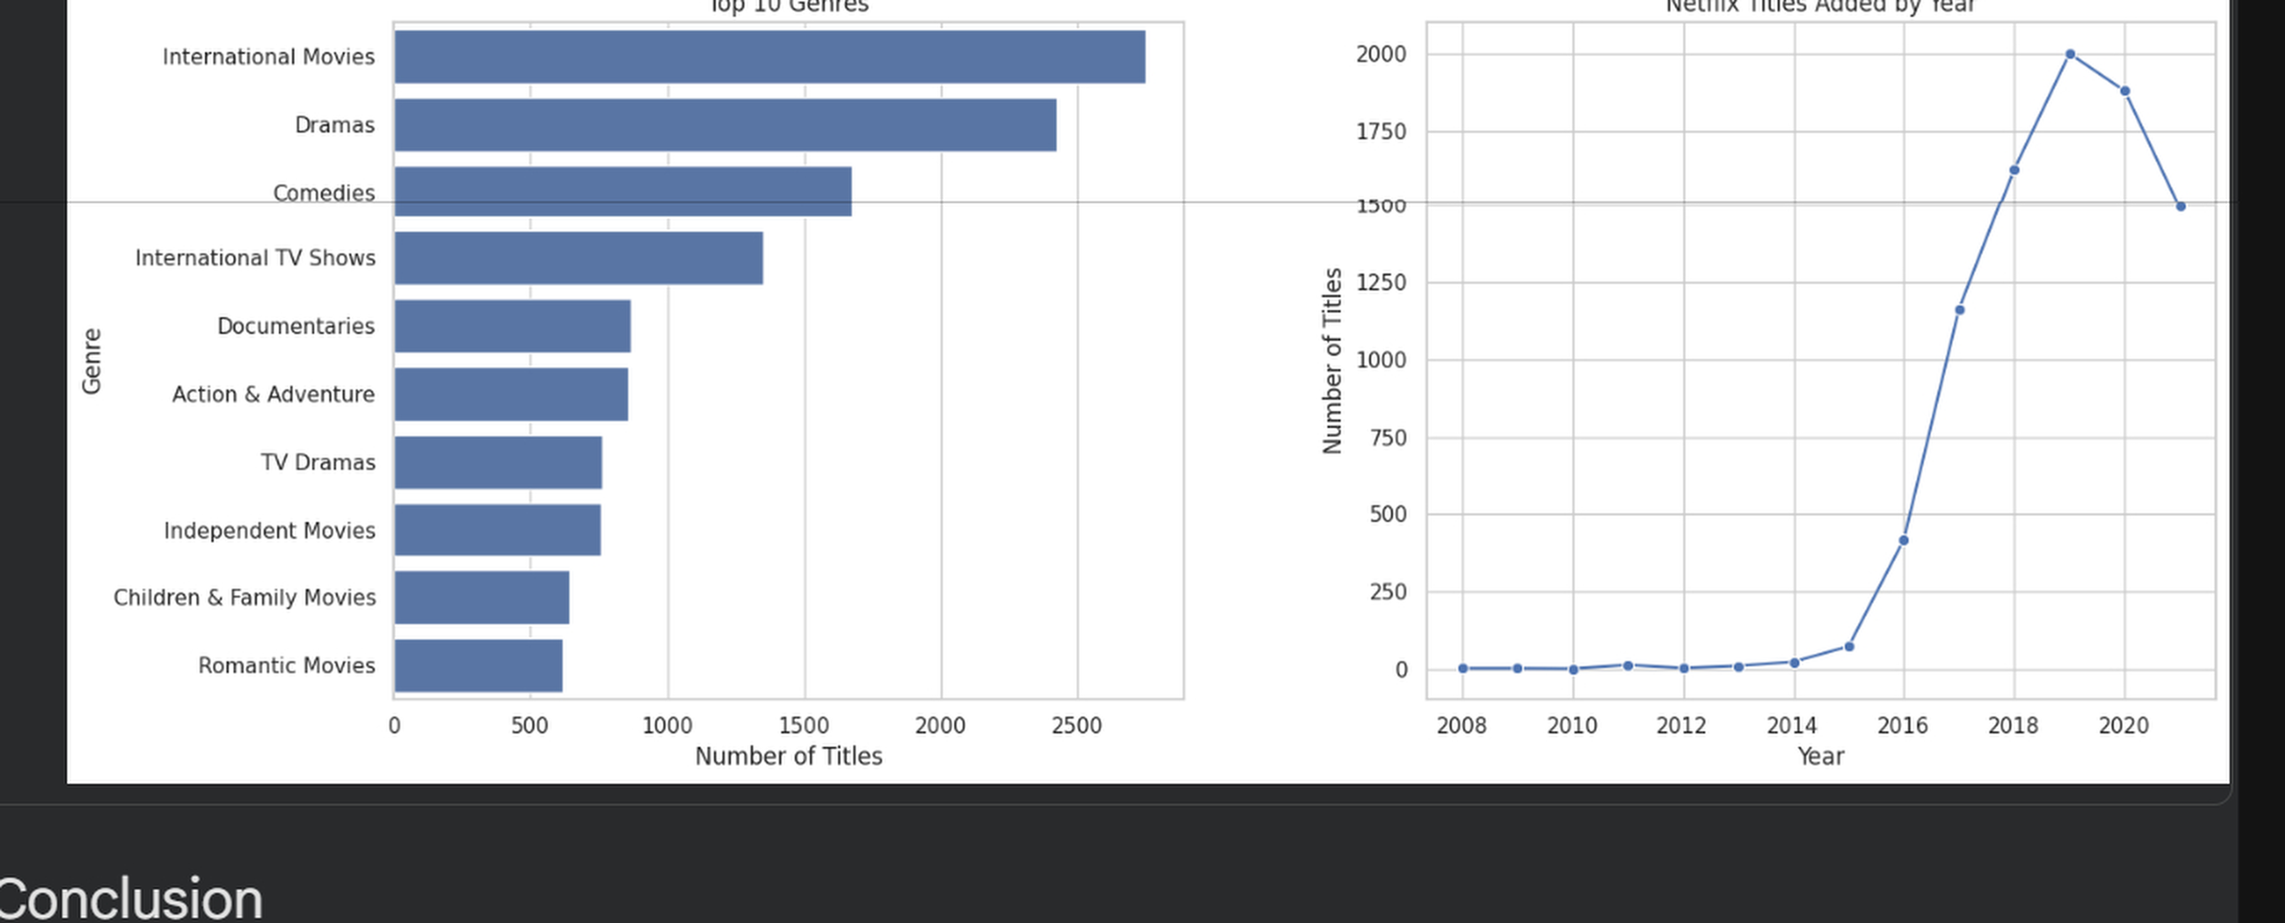
Explanation: This alternative genre ranking provides another view of the most frequent genre categories. It reinforces the prominence of International Movies, Dramas, and Comedies while showing the relative frequency of other major categories.

16. Top Movie Durations
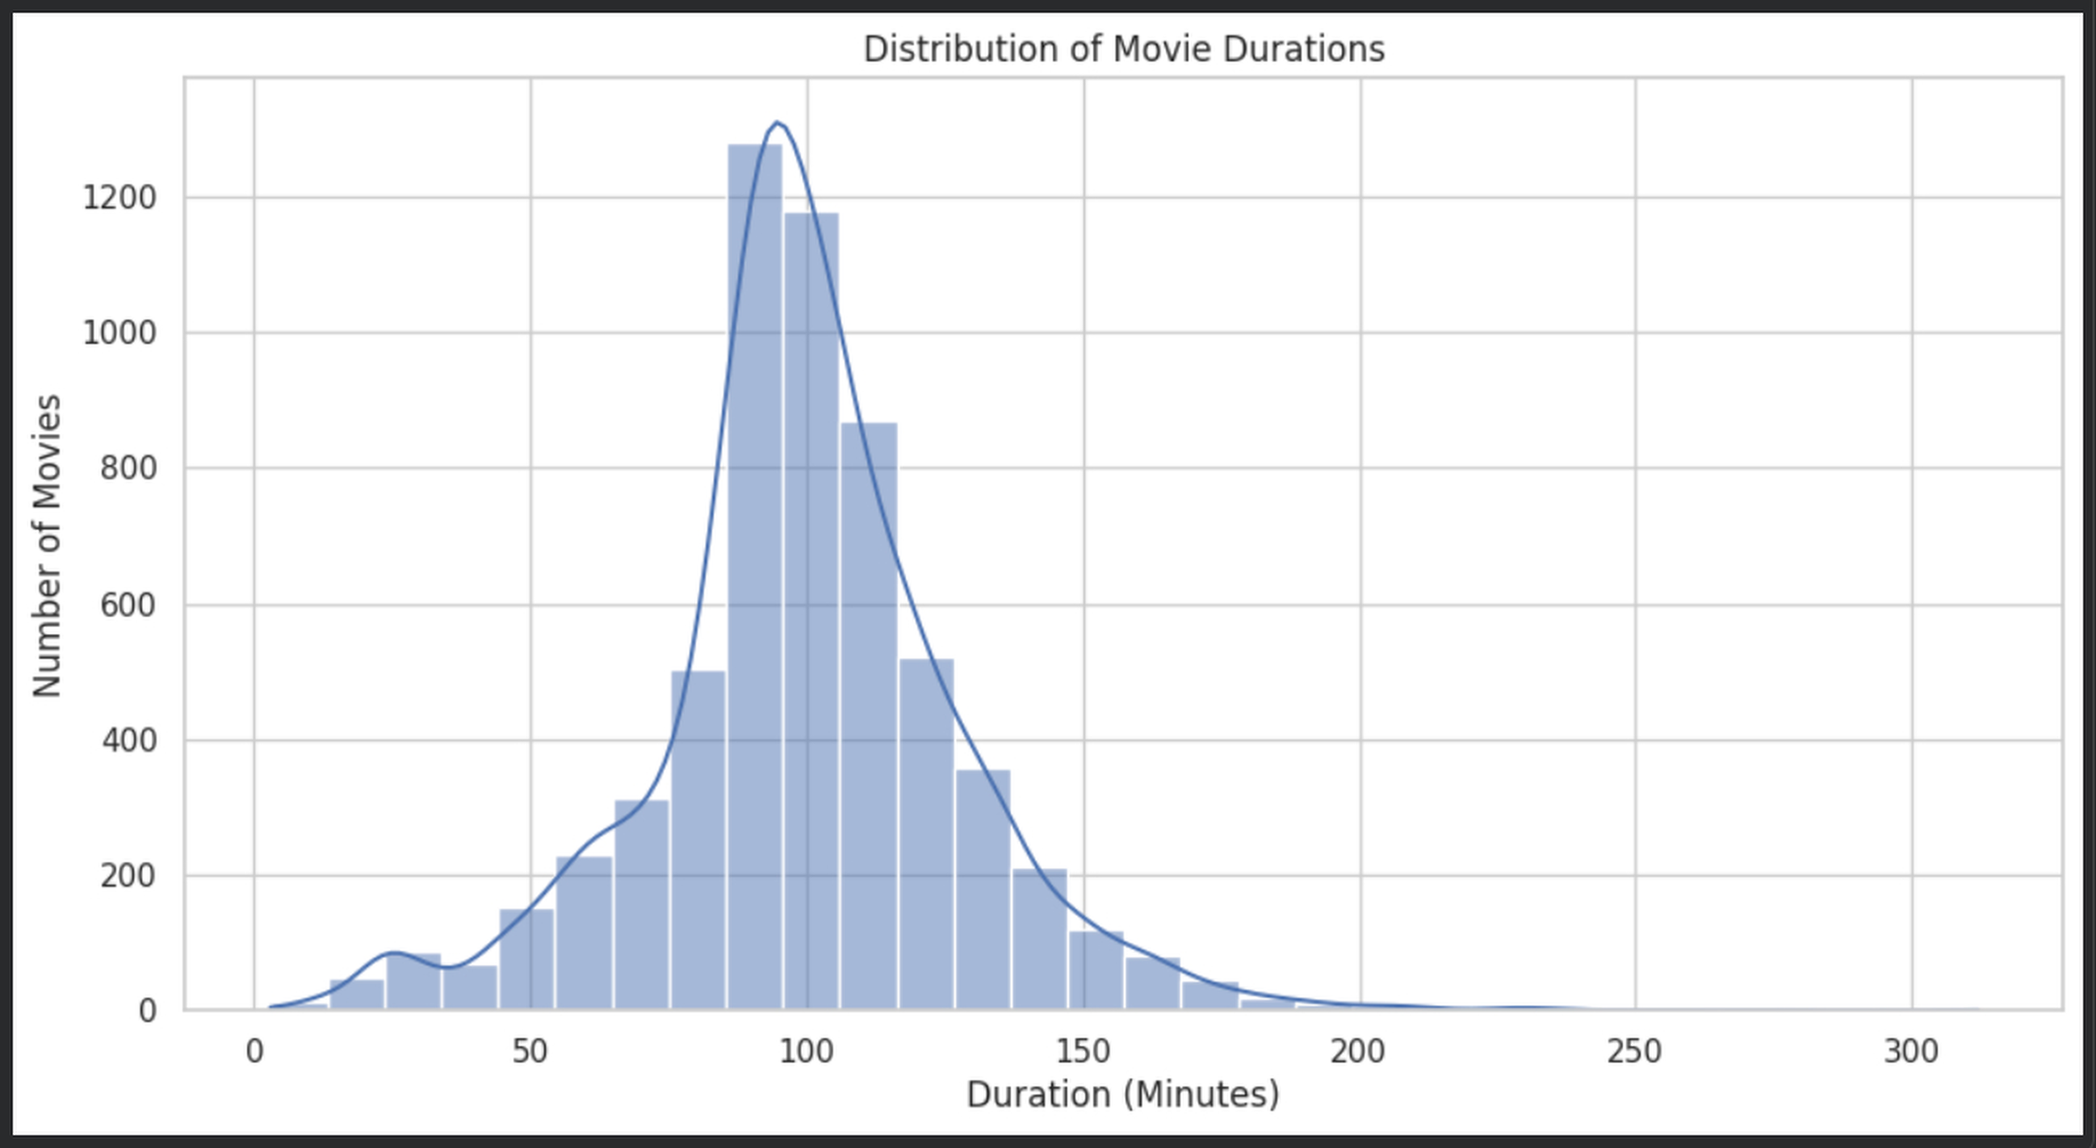
Explanation: This visualization provides an additional view of movie duration values. It helps identify the runtime ranges that occur most frequently and complements the overall duration distribution shown earlier.

17. Final EDA Dashboard
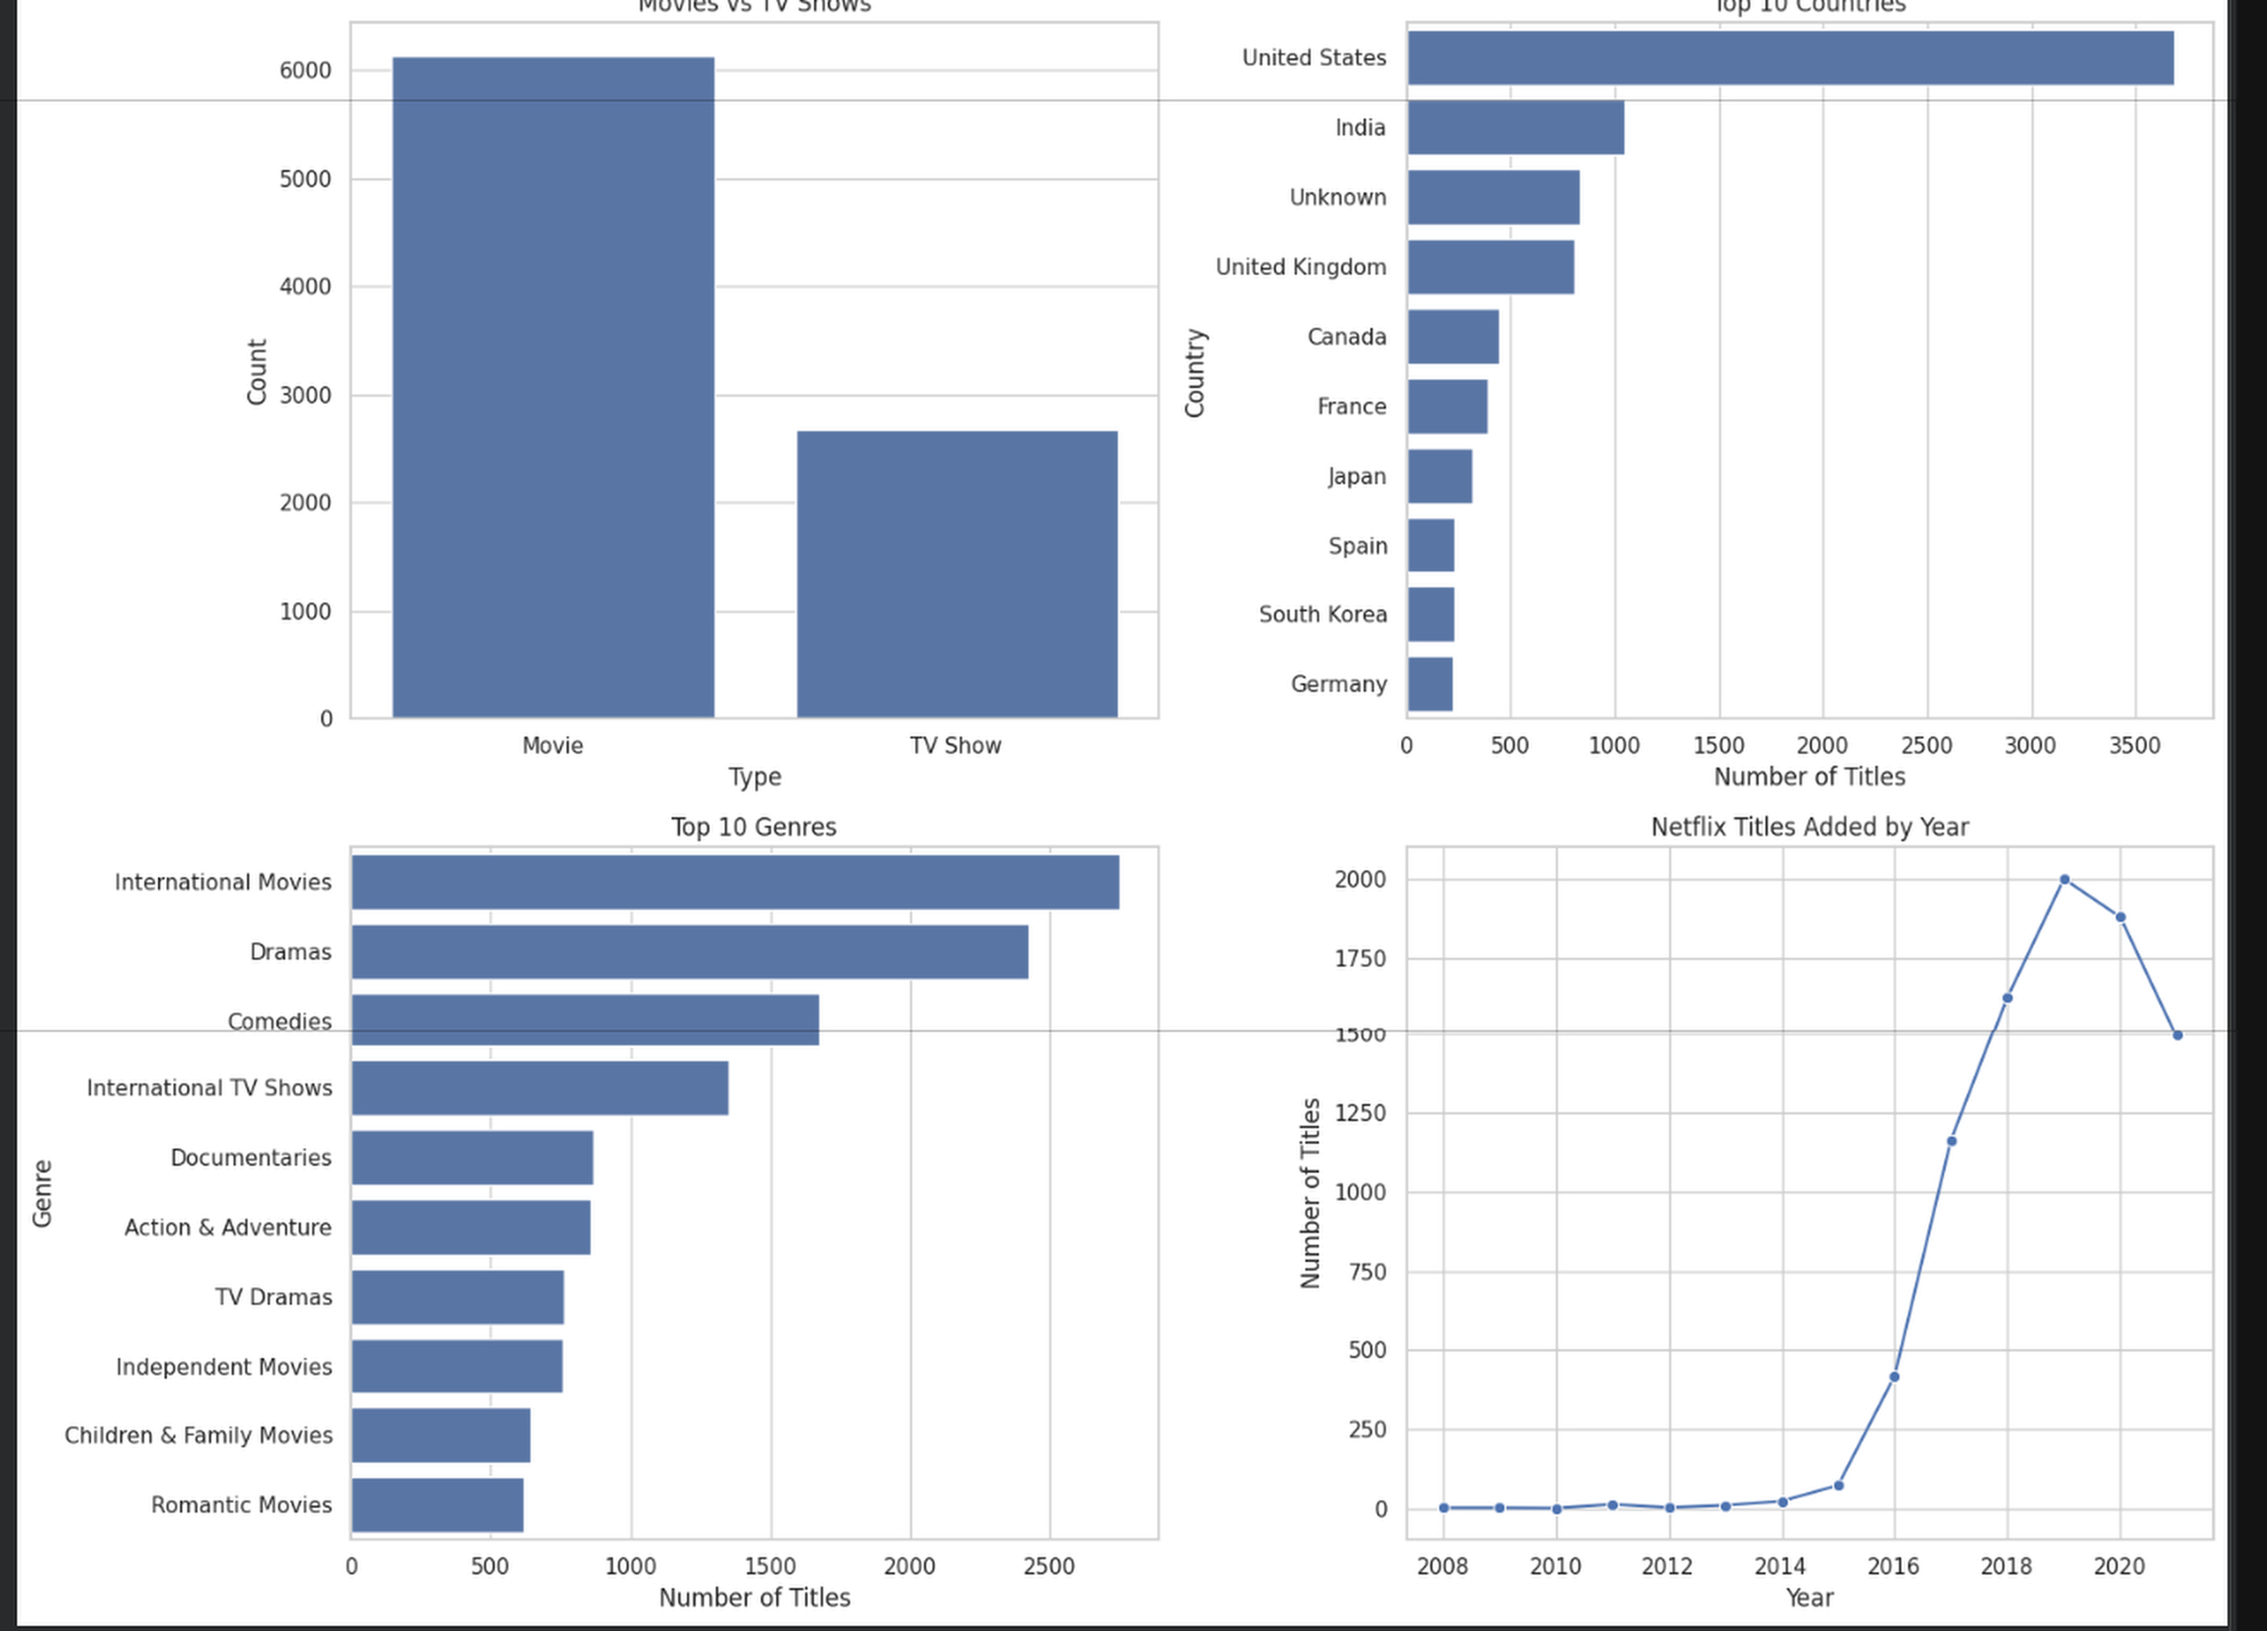
The final dashboard combines several of the most important EDA visuals into one view. It summarizes content type, geographic distribution, genre frequency, and the pattern of titles added over time, making the major findings easier to review together.

18. Key Insights
- Movies make up the majority of the analyzed Netflix catalog.
- The dataset is strongly concentrated around modern release years.
- Netflix's additions increased substantially during the later years represented in the data.
- 2019 is the highest year in the displayed top-years ranking for titles added.
- The United States has the largest country-level representation, followed by India and the United Kingdom.
- International Movies, Dramas, and Comedies are among the most frequent genres.
- TV-MA and TV-14 are among the most common content ratings.
- Most movie durations are concentrated around the typical feature-film range.
- Release year and year added show a clear positive relationship in the correlation analysis.
- The overall catalog demonstrates substantial geographic and genre diversity.

19. Conclusion
The EDA successfully converts the Netflix title dataset into a set of clear visual findings. The charts reveal how the catalog is distributed by content type, how Netflix additions changed over time, which countries and genres are most represented, how movie durations are distributed, and how selected numerical variables relate to one another.
Together, these visualizations demonstrate the value of exploratory data analysis for discovering patterns, communicating results, and developing analytical thinking from a real-world dataset.

20. Project Details
Internship | Thiranex Internship — Task 3
Project | Netflix Content Exploratory Data Analysis
Report Type | Visual EDA Report
Analysis Type | Exploratory Data Analysis

