YUVA VIRTUAL DATA SCIENCE WITH PYTHON INTERNSHIP
Week 2 Report
Exploratory Data Analysis and Visualization of the Titanic Dataset

Prepared by
Mohammed Aayan

Python • Pandas • NumPy • Matplotlib • Seaborn

1. Introduction
This report documents the exploratory data analysis and visualization performed on the Titanic dataset during Week 2 of the Yuva Virtual Data Science with Python internship. The analysis focuses on understanding the structure and distribution of passenger information, exploring relationships between passenger characteristics and survival, identifying patterns and anomalies, and communicating findings through clear visualizations.

2. Objective
The main objective was to perform a detailed exploratory analysis of the cleaned Titanic dataset and use visualizations to identify meaningful patterns, relationships, differences between groups, and potential anomalies. The analysis also introduced derived variables such as family size and age groups to support deeper interpretation.

3. Dataset and Final Data Quality
The analysis started from the cleaned Titanic dataset prepared during Week 1. After duplicate removal and final missing-value handling, the final analytical dataset contained 765 rows and 16 columns. The final quality check showed zero missing values and zero duplicate rows. Two derived features, family_size and age_group, were added during the exploratory analysis.
Metric | Result
Final observations | 765
Final variables | 16
Survivors | 320
Non-survivors | 445
Overall survival rate | 41.29%
Average age | 29.36 years
Median age | 28 years
Average fare | 26.59
Median fare | 15.90
Missing values | 0
Duplicate rows | 0

4. Exploratory Analysis Methodology
- Inspected dataset structure, columns, data types, missing values, duplicates, and unique values.
- Calculated descriptive statistics for numerical variables to understand central tendency and spread.
- Performed univariate analysis to study individual variable distributions.
- Performed bivariate analysis to compare survival with gender, class, age, fare, and other variables.
- Created family_size and age_group features for additional analysis.
- Used multivariate visualizations and a numerical correlation heatmap to explore combined relationships.
- Examined numerical variables for potential anomalies using the IQR approach.
- Performed a final data-quality check before saving the EDA dataset.

5. Univariate Analysis
Univariate analysis examines individual variables to understand their frequency, distribution, spread, and dominant categories before interpreting relationships between variables.
Figure 1. Overall Passenger Survival Distribution
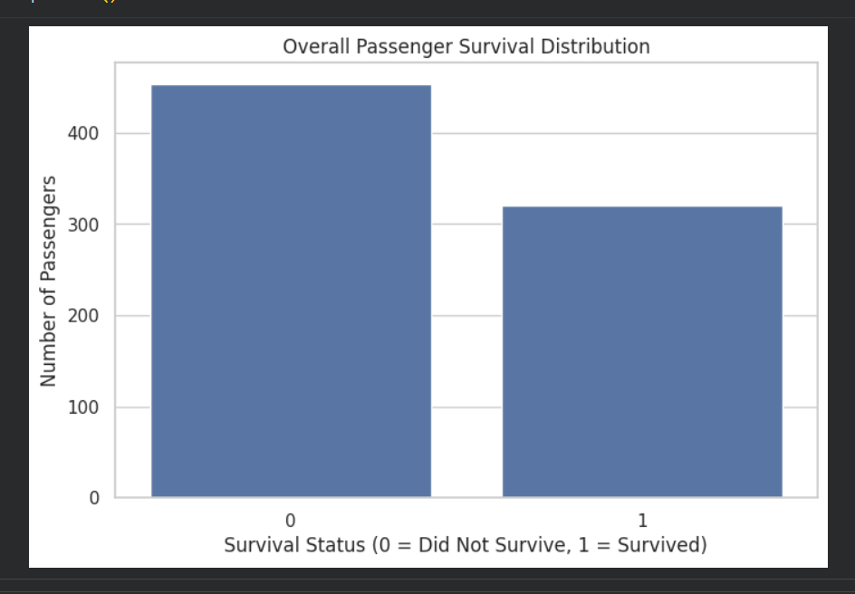
Interpretation: The chart shows that non-survivors form the larger group. After duplicate removal, 320 passengers survived while 445 did not, giving an overall survival rate of about 41.3%.

Figure 2. Distribution of Passenger Age
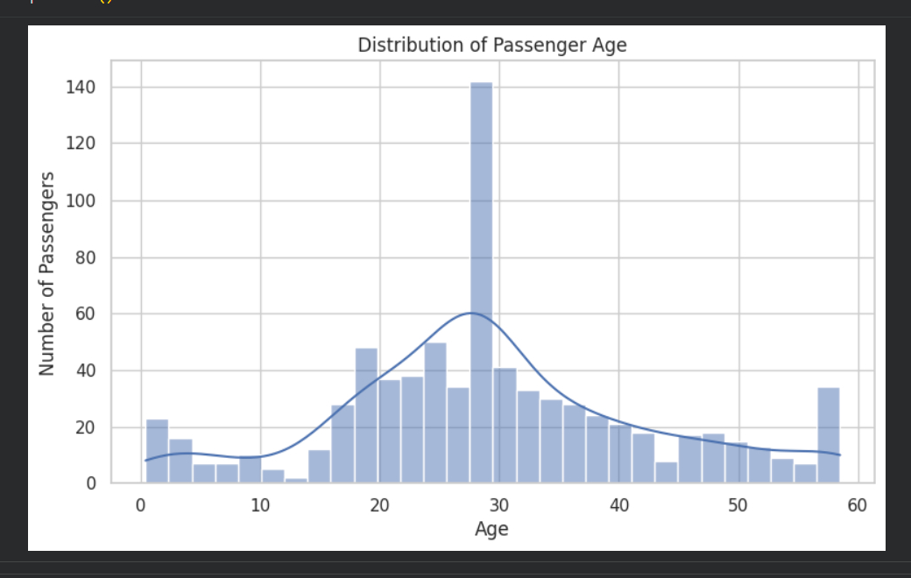
Interpretation: Passenger ages are concentrated around young-adult and adult ranges, with a visible concentration near the late twenties. The distribution is spread across children through older passengers.

Figure 3. Passenger Age Distribution and Spread
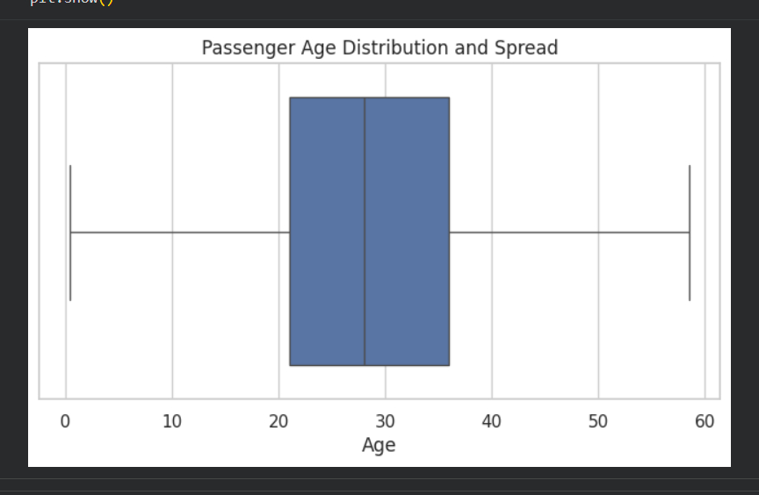
Interpretation: The boxplot summarizes the center and spread of age. The median is about 28 years, while the middle half of passengers lies around the mid-twenties to upper-thirties range.

Figure 4. Distribution of Passenger Fare
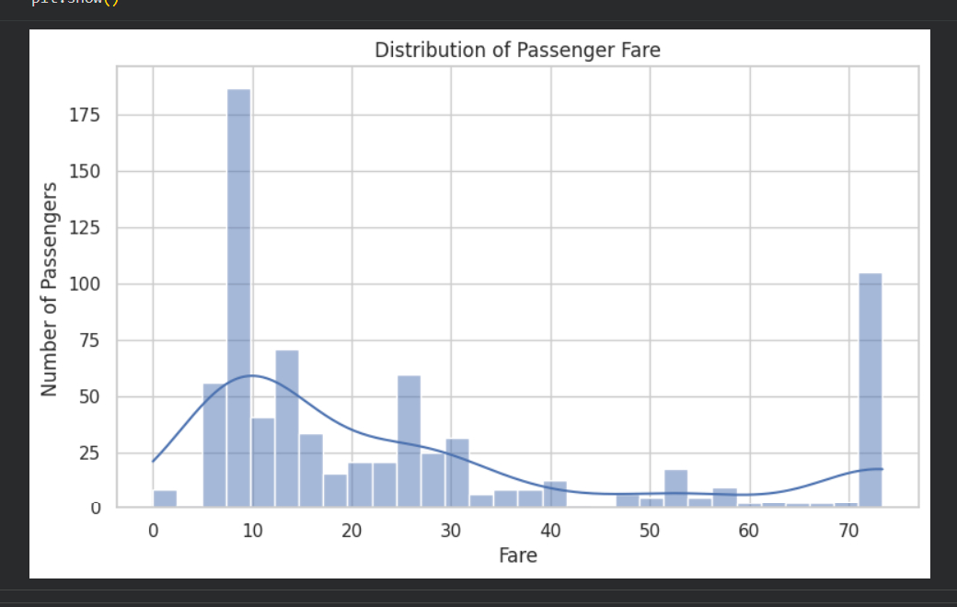
Interpretation: Fare values are strongly right-skewed. Most passengers paid relatively low fares, while a smaller number paid substantially higher amounts.

Figure 5. Passenger Fare Distribution and Spread
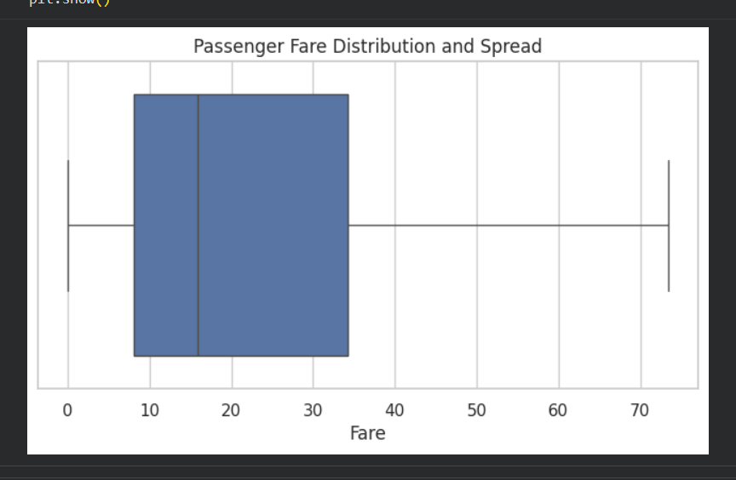
Interpretation: The fare boxplot confirms the skewed distribution and shows the broad spread of ticket prices. Higher fares are associated with a small number of passengers.

Figure 6. Passenger Distribution by Class
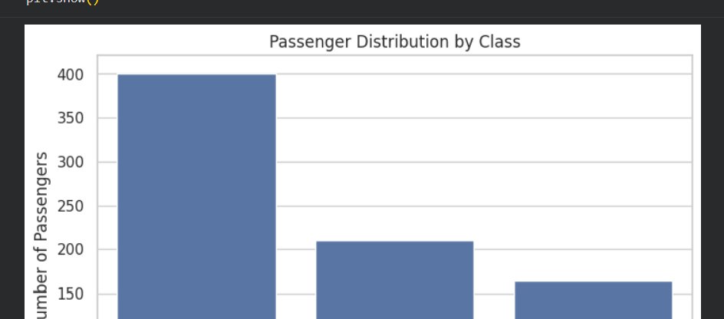
Interpretation: Third-class passengers are the largest group, followed by second class and first class. This uneven class distribution is important when comparing survival rates.

Figure 7. Passenger Distribution by Gender
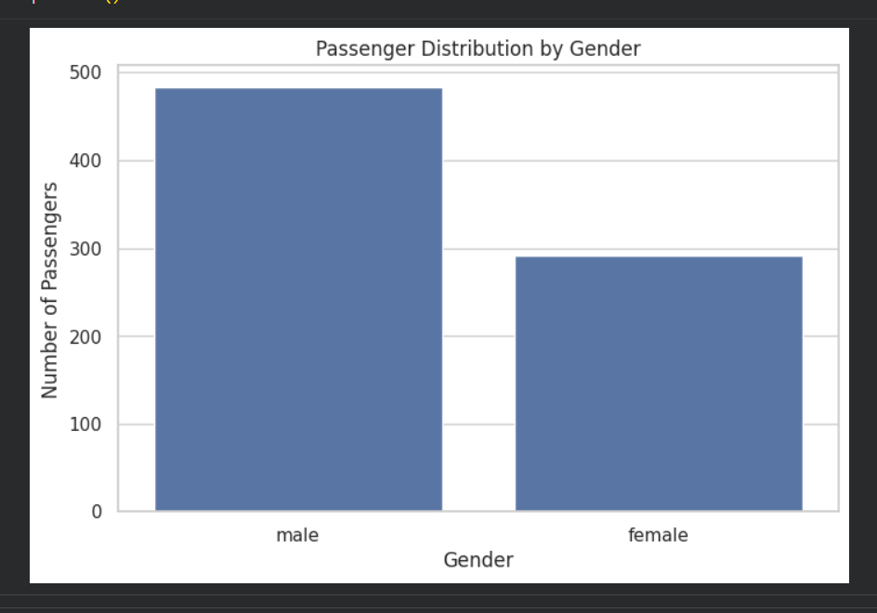
Interpretation: Male passengers outnumber female passengers in the cleaned dataset. This imbalance should be considered when interpreting survival comparisons by gender.

Figure 8. Passenger Distribution by Port of Embarkation
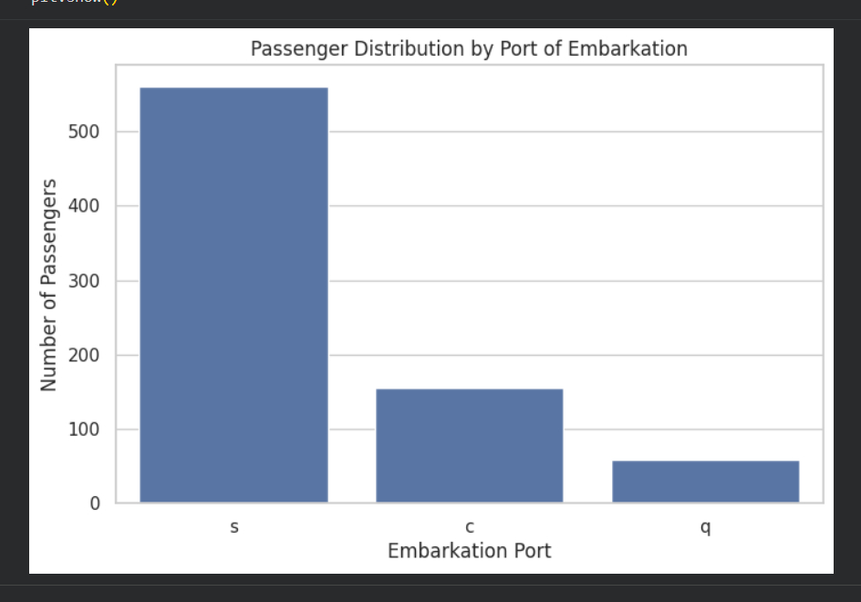
Interpretation: Southampton is the dominant embarkation port, followed by Cherbourg and Queenstown. The distribution is therefore heavily concentrated in Southampton.

6. Survival Analysis
Survival was treated as the central outcome. These visualizations compare survival across important passenger characteristics and reveal substantial differences between groups.
Figure 9. Passenger Survival by Gender
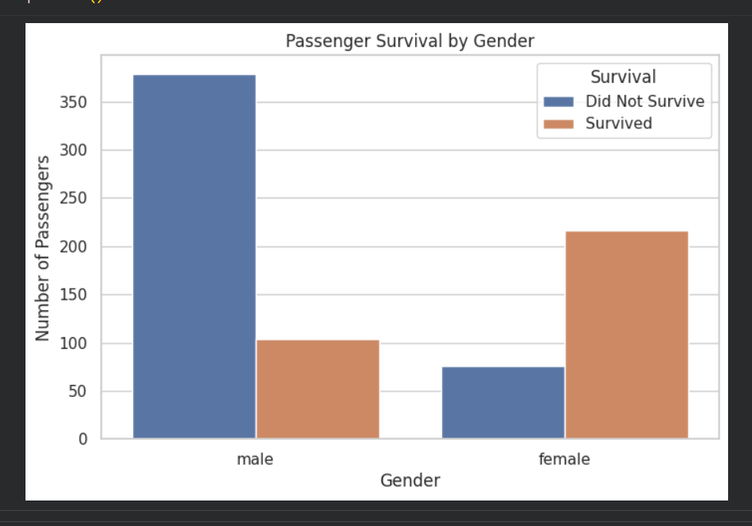
Interpretation: Female passengers have a much higher survival rate than male passengers. In the completed analysis, female survival was about 74.0%, compared with about 21.5% for males.

Figure 10. Passenger Survival by Class
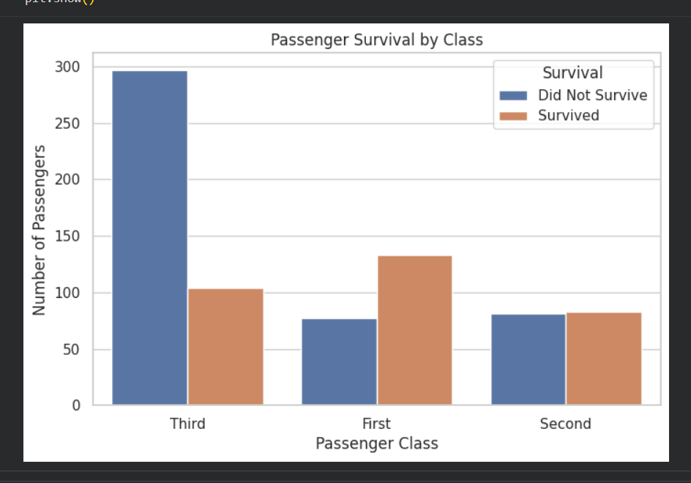
Interpretation: Survival varies substantially by passenger class. First-class passengers have the highest survival rate, followed by second class, while third class has the lowest.

Figure 11. Age Distribution by Survival Status
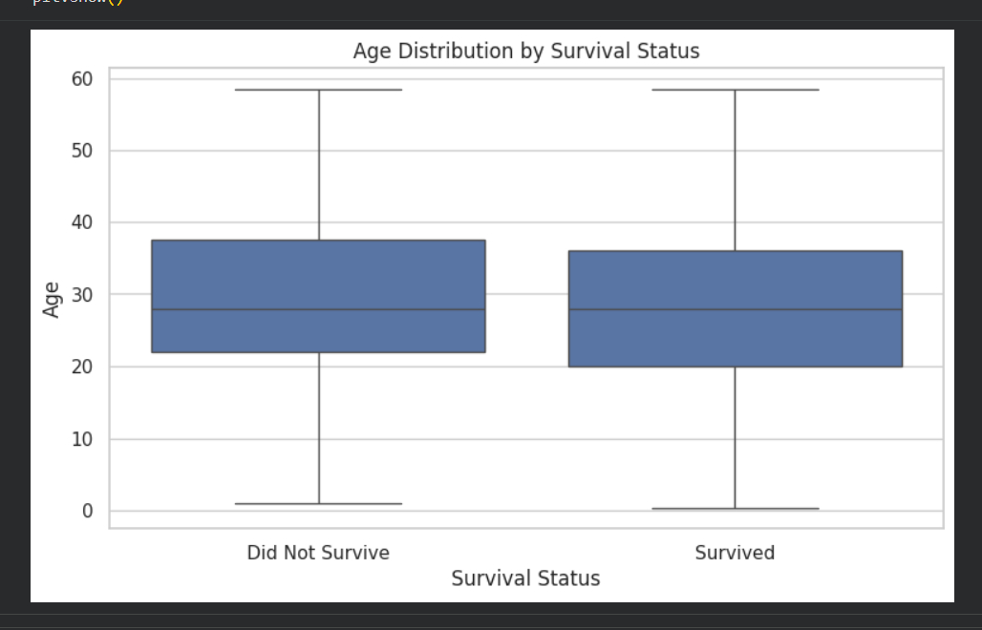
Interpretation: The age boxplots show broadly similar central age ranges for survivors and non-survivors, although the distributions differ somewhat in spread.

Figure 12. Fare Distribution by Survival Status
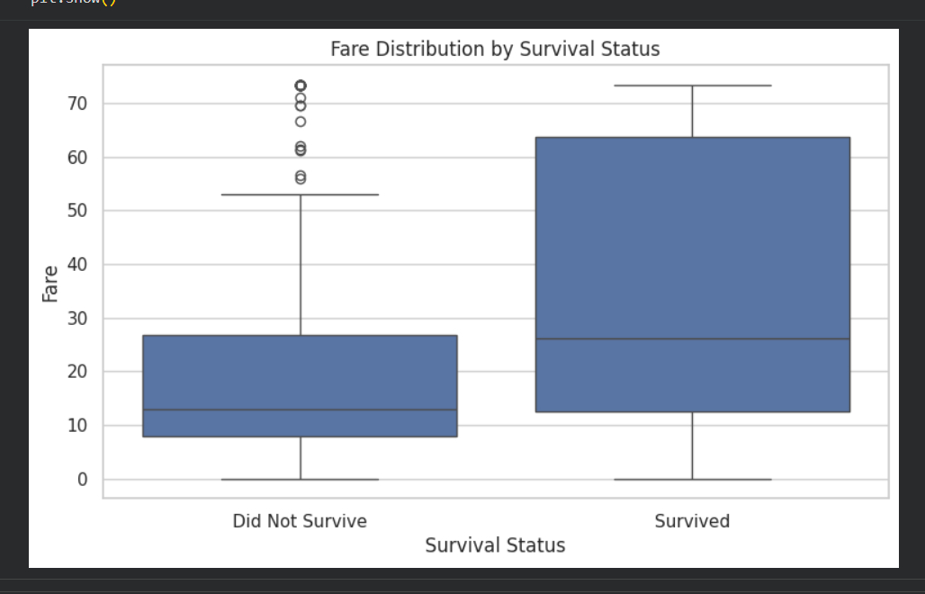
Interpretation: Survivors tend to have higher fare values than non-survivors. This pattern is consistent with the relationship between fare, passenger class, and access to resources.

Figure 13. Relationship Between Passenger Age and Fare
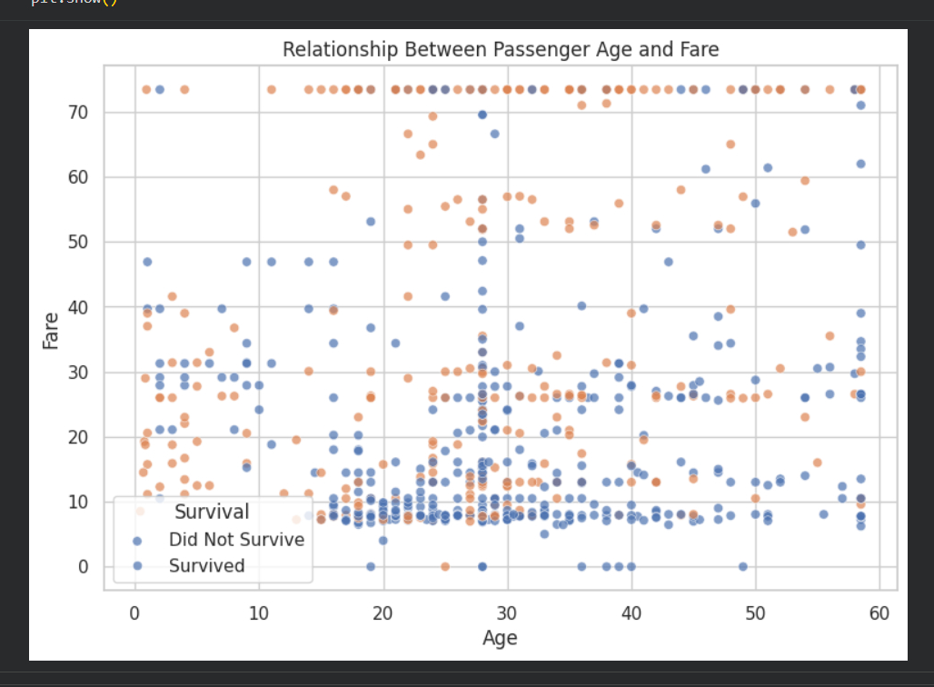
Interpretation: The scatter plot shows a wide range of fares across ages. Higher fares are more concentrated among certain passengers, while survival status is distributed across the age-fare space.

7. Family and Demographic Analysis
Family-related and demographic variables were examined to determine whether travelling arrangements and passenger composition were associated with different survival outcomes.
Figure 14. Distribution of Passenger Family Size
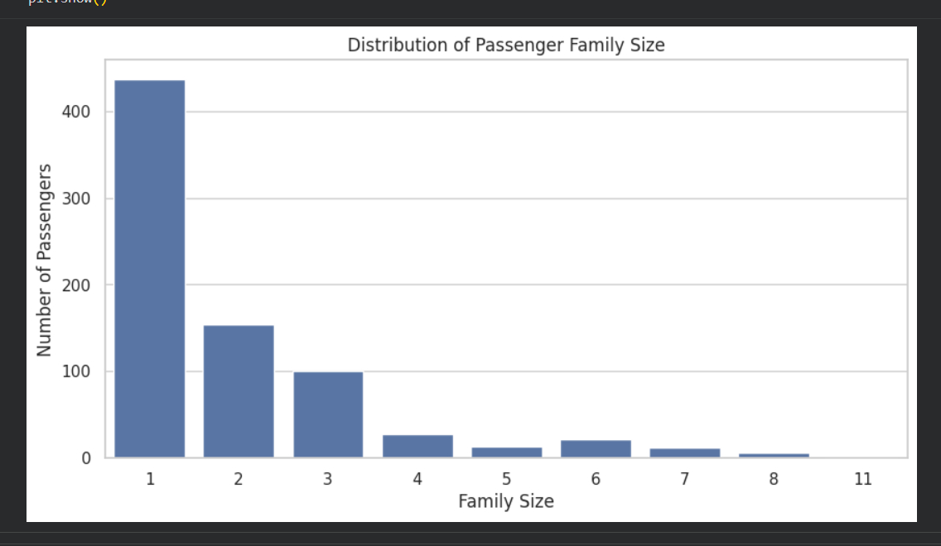
Interpretation: Most passengers travelled alone or in relatively small family groups. Large family sizes are much less common.

Figure 15. Survival Rate by Family Size
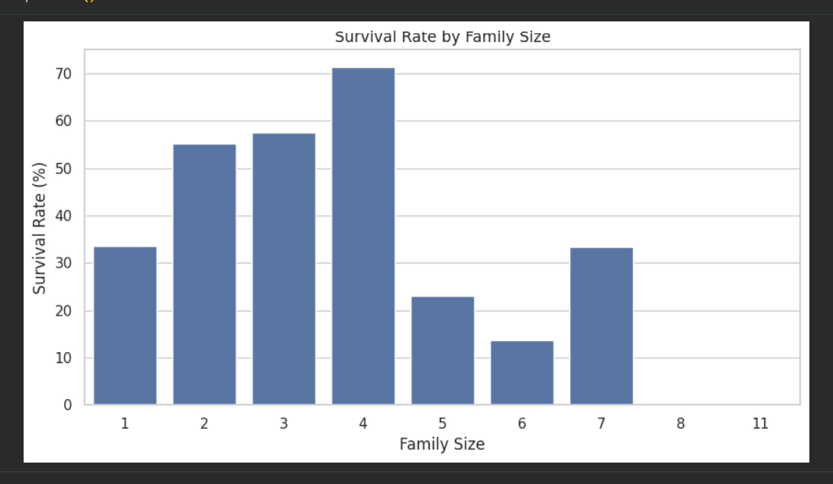
Interpretation: Moderate family sizes show relatively higher survival in this dataset, while very large families show lower survival. The pattern suggests that family size may influence outcomes, although small groups are more common.

Figure 16. Passenger Distribution by Class and Gender
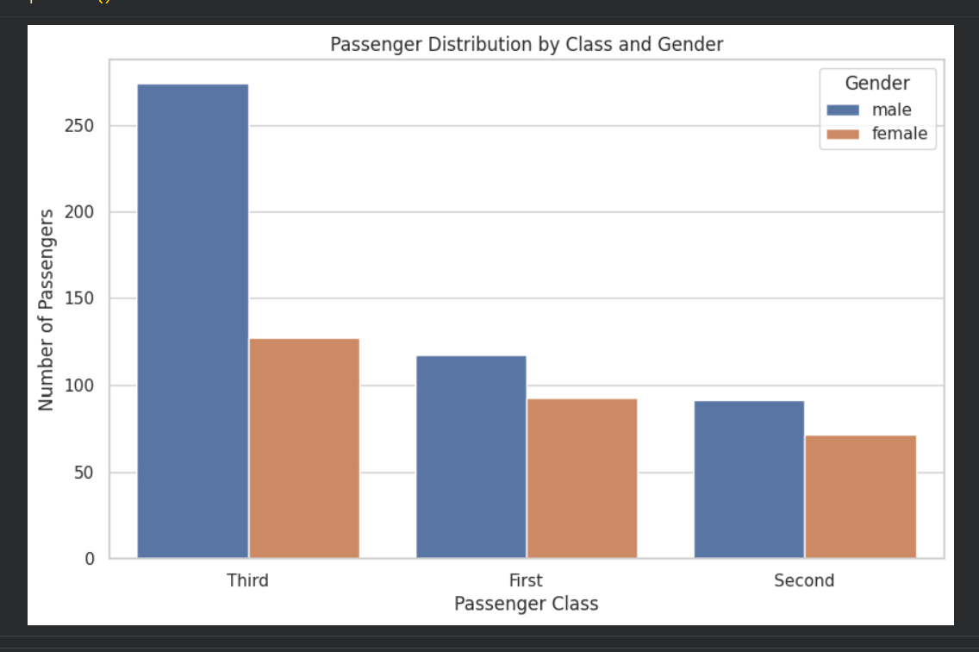
Interpretation: The grouped counts show that males are numerous in every class, while the composition differs by class. Third class contains the largest overall number of passengers.

Figure 17. Survival Rate by Passenger Class and Gender
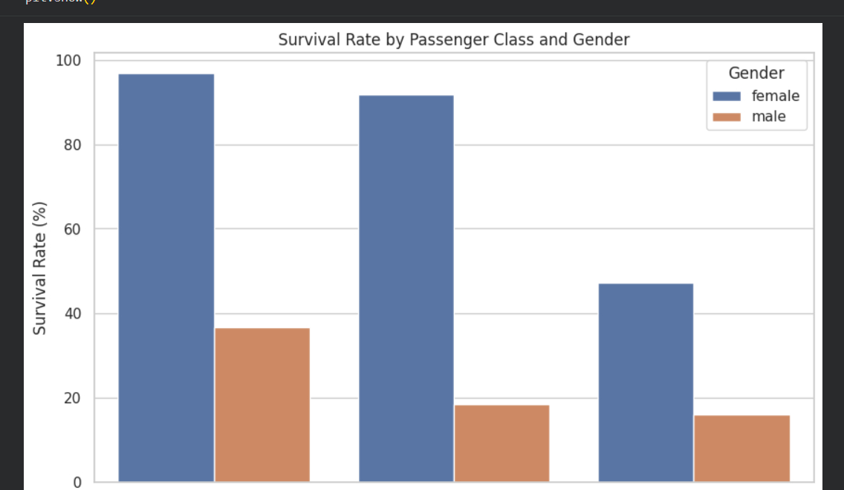
Interpretation: Gender differences remain strong within every class. Female survival is especially high in first and second class, while male survival is much lower across all three classes.

Figure 18. Survival Rate by Age Group
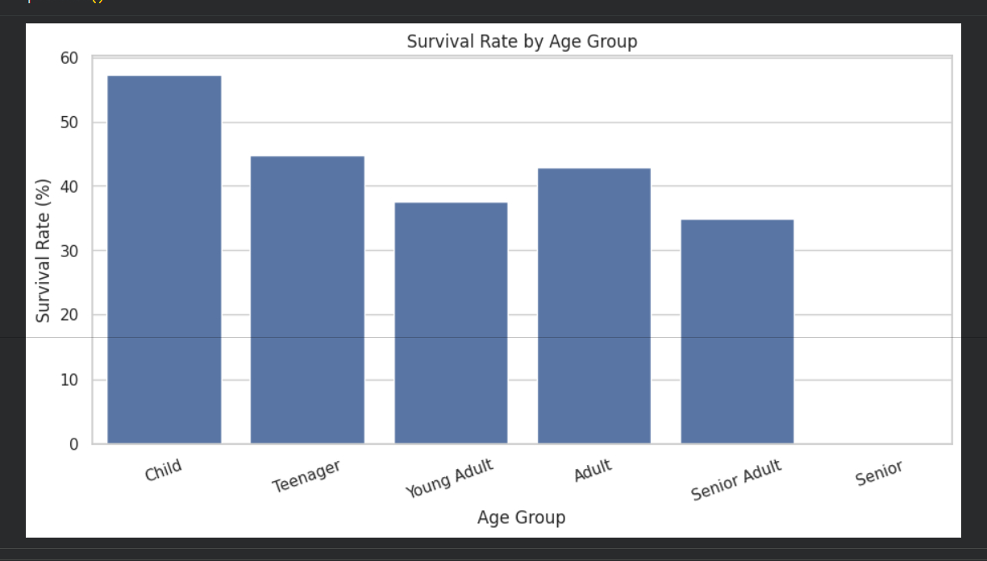
Interpretation: Children have the highest survival rate among the displayed age groups at about 57.4%. Young adults and senior adults have lower survival rates.

8. Multivariate and Correlation Analysis
The final group combines multiple dimensions and numerical relationships to provide a broader view of the factors visible in the dataset.
Figure 19. Correlation Matrix of Numerical Variables
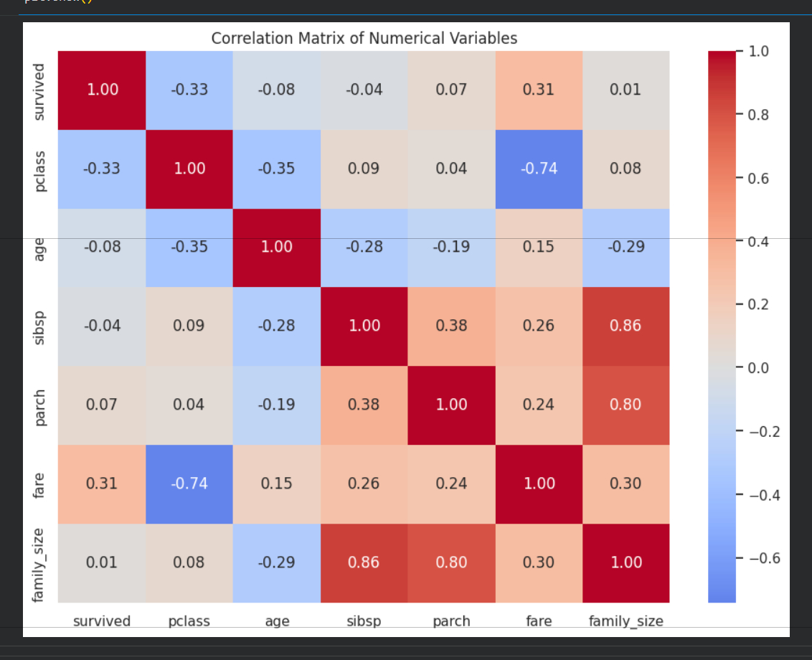
Interpretation: The heatmap shows relationships among numerical variables. Passenger class is negatively related to fare and survival coding, while family-size components are positively related to family size.

Figure 20. Survival Rate by Port of Embarkation
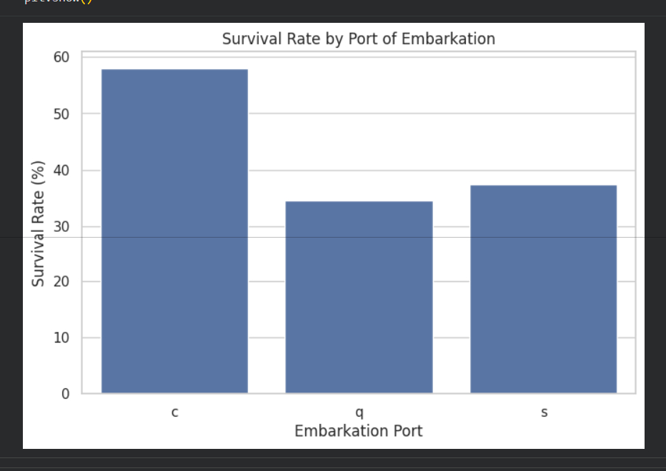
Interpretation: Cherbourg has the highest survival rate among the three embarkation ports at about 58.1%. Southampton and Queenstown have lower rates.

Figure 21. Survival Rate by Number of Siblings/Spouses
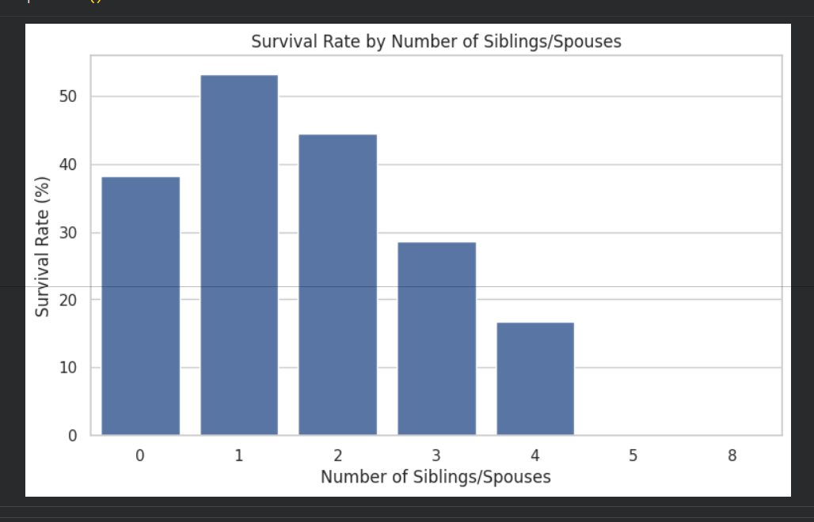
Interpretation: Passengers travelling with one sibling or spouse show a higher survival rate than those travelling alone. Survival generally falls for larger sibling/spouse counts.

Figure 22. Survival Rate by Number of Parents/Children
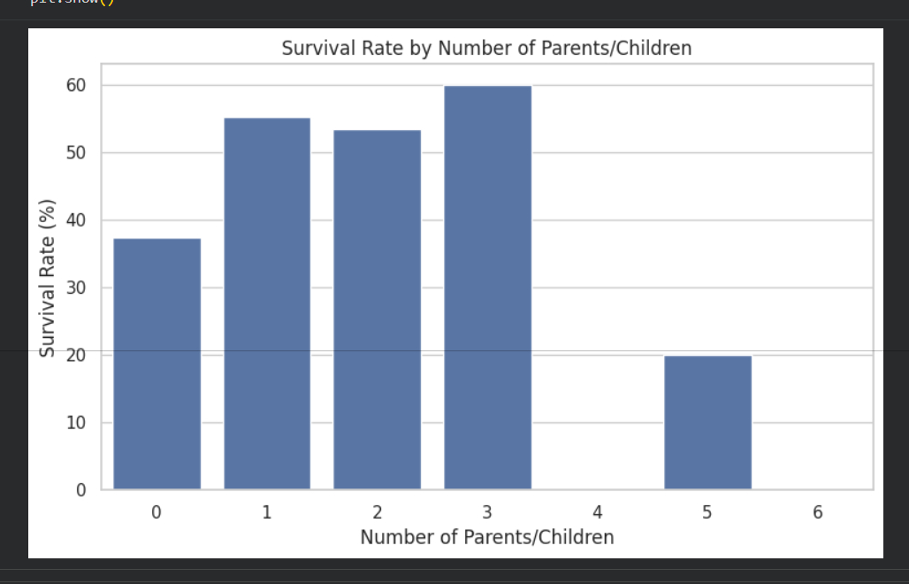
Interpretation: Passengers travelling with one to three parents or children generally show higher survival rates than passengers travelling with none, while very large counts are uncommon and less stable.

9. Key Findings
- The final dataset contains 765 observations and 16 variables, with no remaining missing values or duplicate rows.
- The overall survival rate is 41.29%, meaning non-survival is more common than survival in the analyzed data.
- Gender is one of the strongest visible differences: female survival is approximately 73.97%, compared with approximately 21.53% for males.
- Passenger class is strongly associated with survival: first class has the highest survival rate (63.33%), followed by second class (50.61%) and third class (25.94%).
- Fare is strongly right-skewed, and survivors generally show higher fare values than non-survivors.
- The combination of class and gender shows that female survival remains high in first and second class, while male survival is substantially lower in every class.
- Children have the highest survival rate among the displayed age groups at approximately 57.35%.
- Moderate family sizes show comparatively higher survival rates, while very large family groups have much lower observed survival.
- Cherbourg has the highest observed survival rate among embarkation ports, at approximately 58.06%.
- Passengers travelling with one sibling/spouse or one to three parents/children generally show higher survival than passengers travelling alone, while very large group sizes are uncommon.

10. Interpretation and Discussion
The visual exploration indicates that survival was not evenly distributed across the passenger population. The clearest differences appear by gender and passenger class. The fare analysis also supports a relationship between economic position and survival, because higher fares are more common among survivors and fare is connected to class. Family-related variables show that travelling arrangements may matter, but some large-family categories contain relatively few observations and should therefore be interpreted cautiously.
The analysis also demonstrates the importance of using multiple views of the same dataset. Count plots show group sizes, survival-rate plots show proportional differences, boxplots reveal distribution and spread, scatter plots show relationships between numerical variables, and the correlation heatmap provides a compact overview of linear relationships among numerical features.

11. Transformations and Aggregations
- Family size was derived as sibsp + parch + 1 to represent the total travelling family group size.
- Age was grouped into Child, Teenager, Young Adult, Adult, Senior Adult, and Senior categories for grouped survival analysis.
- Survival rates were calculated by grouping passengers by gender, class, family size, age group, embarkation port, siblings/spouses, and parents/children.
- Numerical correlation analysis was performed on relevant numerical variables to identify positive and negative relationships.
- Final data-quality checks confirmed that the analytical dataset contained no missing values or duplicate rows.

12. Conclusion
The Week 2 exploratory analysis provided a detailed view of the Titanic dataset and demonstrated how visualization can turn raw passenger records into interpretable patterns. The strongest visible differences were associated with gender and passenger class, while fare, family size, age group, and embarkation also showed meaningful variation in survival. The completed EDA produced a clean analytical dataset with 765 rows and 16 variables and established a strong foundation for subsequent machine-learning tasks.

13. Final Output
The completed Week 2 work consists of the executed Python notebook, the final titanic_eda.csv dataset, and this report. All visual figures included in this report are cropped directly from the visualization output contained in the PDF supplied for this project.

End of Week 2 Report

