WEEK 4
Supervised Learning Model Implementation
Breast Cancer Classification Using Machine Learning
Yuva Virtual Data Science with Python Internship
Problem Type: Binary Classification
Primary Model: Logistic Regression
Comparison Model: Random Forest
Prepared by: Mohammed Aayan

1. Introduction
Supervised learning is a machine learning approach in which a model learns patterns from labeled data and uses those patterns to make predictions on previously unseen observations. Classification is a supervised learning problem where the objective is to assign observations to predefined categories.
This project focuses on developing a binary classification model for breast cancer diagnosis using the Breast Cancer Wisconsin (Diagnostic) dataset. The dataset contains numerical measurements derived from breast cell nuclei, along with a diagnosis indicating whether a case is benign or malignant. The objective is to build a predictive system capable of distinguishing between these two classes based on the available diagnostic features.
The project follows a complete supervised learning workflow, beginning with dataset inspection and data quality assessment. Exploratory Data Analysis (EDA) is performed to understand feature distributions and relationships with the target variable. The data is then prepared through target encoding, feature selection, and appropriate preprocessing.
Logistic Regression is implemented as the primary classification model because it is a suitable and interpretable algorithm for binary classification. Random Forest is additionally implemented as a comparison model to evaluate whether a tree-based ensemble approach can provide improved predictive performance.

2. Objectives
- Acquire and inspect the public Breast Cancer Wisconsin (Diagnostic) dataset.
- Assess data quality through missing-value, duplicate, type, and target-distribution checks.
- Perform exploratory analysis to understand important diagnostic feature patterns.
- Prepare the data through target encoding, feature selection, and feature scaling.
- Implement Logistic Regression as the primary supervised classification model.
- Implement Random Forest as a comparison model.
- Validate the models using stratified 5-fold cross-validation.
- Evaluate performance using Accuracy, Precision, Recall, F1 Score, and ROC-AUC.
- Analyze confusion matrices, ROC curves, feature importance, errors, strengths, limitations, and possible improvements.

3. Dataset Description
The project uses the Breast Cancer Wisconsin (Diagnostic) dataset, a publicly available binary classification dataset. The original UCI-style data contains 569 observations and 32 columns: an identifier, a diagnosis label, and 30 numerical diagnostic measurements.
Property | Value
Records | 569
Columns | 32
Predictive features | 30
Target classes | 2
Target encoding | B = 0, M = 1
The diagnosis variable contains two classes: B (Benign) and M (Malignant). For modeling, B was encoded as 0 and M as 1. The ID column was excluded because it is an identifier rather than a meaningful predictive feature.

4. Data Quality Assessment
The dataset was checked before model development to identify issues that could affect reliability. The analysis found no missing values and no duplicate records. All 30 modeling features are numerical, making them suitable for scaling and classification.
Check | Result
Rows | 569
Columns | 32
Missing values | 0
Duplicate rows | 0
Unique IDs | 569

4.1 Target Distribution
The dataset contains 357 benign cases (62.74%) and 212 malignant cases (37.26%). The classes are not perfectly balanced, so stratified splitting and class-aware evaluation are appropriate.
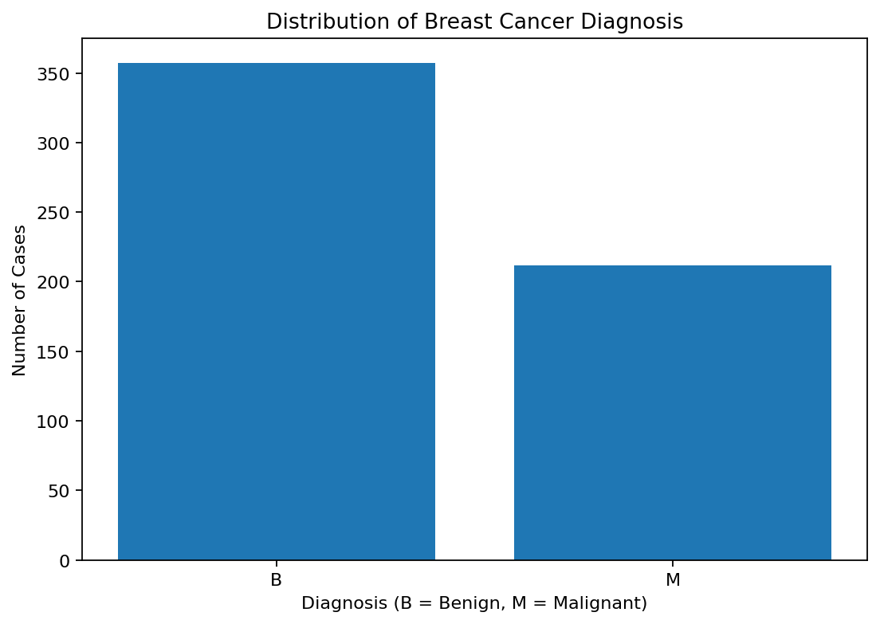
Figure 1. Distribution of benign and malignant cases.

5. Exploratory Data Analysis
EDA was performed to understand diagnostic measurements and identify patterns associated with diagnosis. Boxplots compare selected measurements between benign and malignant cases, while correlation analysis examines relationships among the numerical features.
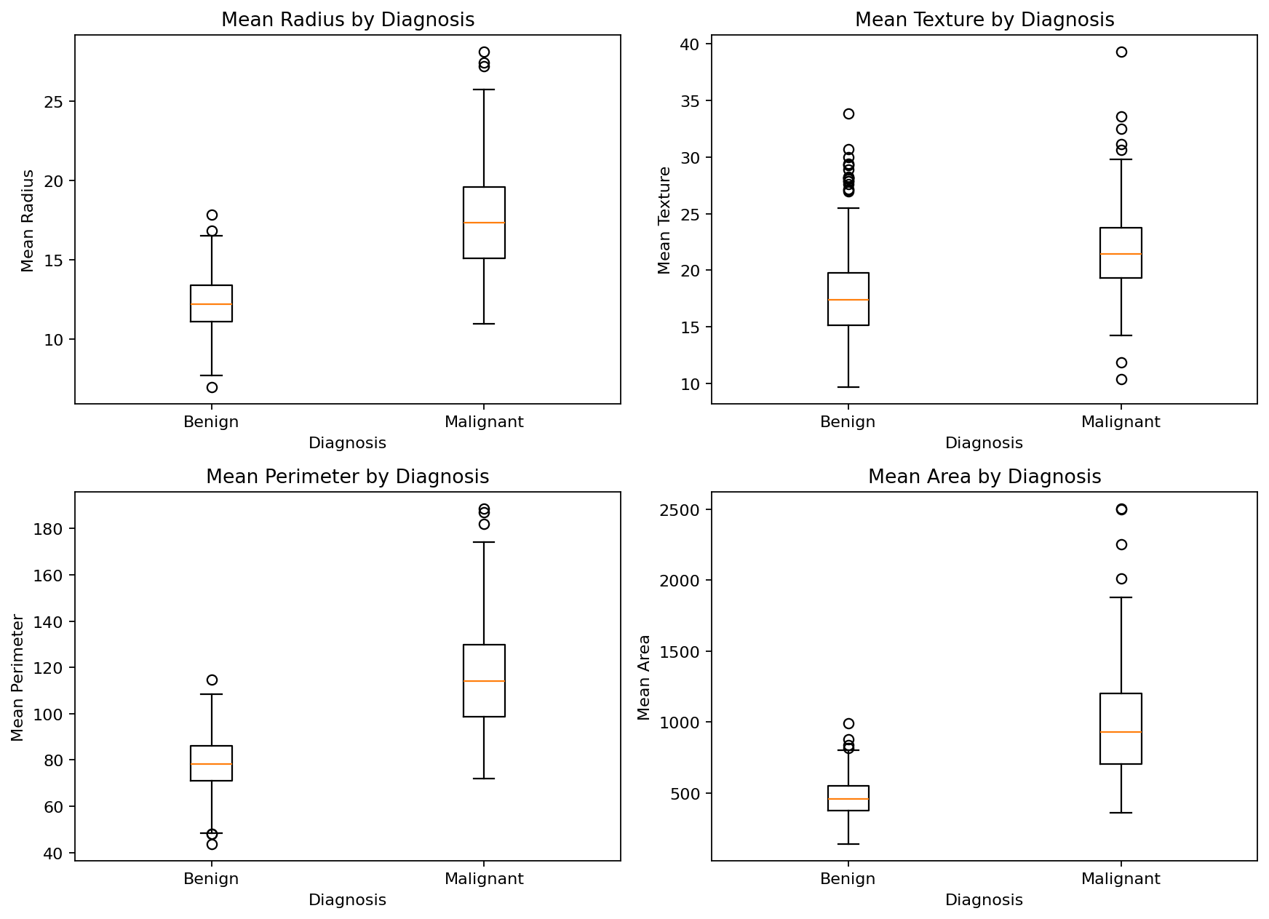
Figure 2. Selected diagnostic feature distributions by diagnosis.
The selected feature distributions show visible differences between benign and malignant observations, particularly for measurements describing cell size and shape. These differences support the use of supervised classification.
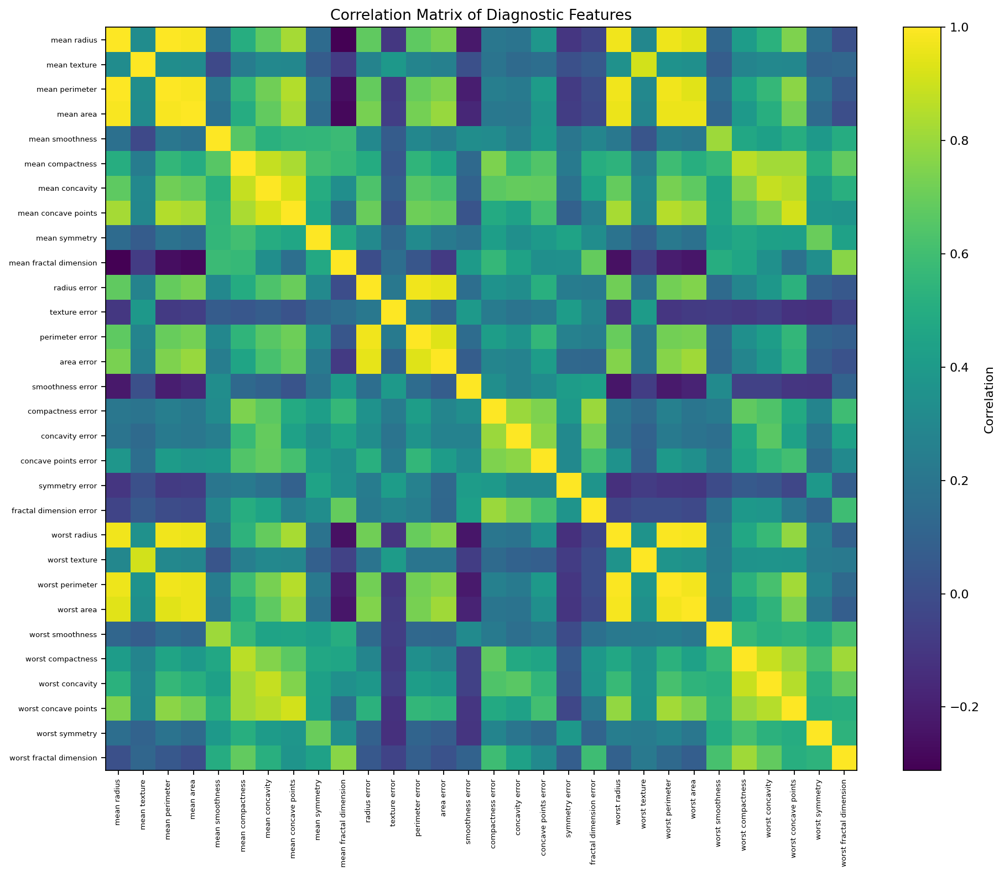
Figure 3. Correlation matrix of diagnostic features.
Several groups of measurements, including radius, perimeter, and area, are strongly correlated because they describe related properties of the same cell structures. This correlation is considered during interpretation rather than treating every variable as independent.

6. Data Preprocessing and Feature Engineering

6.1 Target Encoding
The diagnosis label was converted to a binary numerical target: Benign (B) = 0 and Malignant (M) = 1. This makes the target compatible with the classification algorithms.

6.2 Feature Selection
All 30 numerical diagnostic measurements were retained as predictors. The ID column was removed because it is an identifier and does not provide meaningful predictive information. The original Diagnosis column was also excluded from the feature matrix after creating the numerical Target variable.

6.3 Feature Scaling
StandardScaler was used inside a Pipeline for Logistic Regression. Standardization places features on comparable scales and prevents variables with larger numeric ranges from disproportionately influencing the optimization process. Keeping the scaler inside the pipeline also prevents information leakage during cross-validation.

6.4 Train-Test Split
The dataset was divided into 80% training data and 20% testing data using random_state=42 and stratification. Stratification preserves the class proportions across the two subsets.
X_train, X_test, y_train, y_test = train_test_split(
X, y, test_size=0.20, random_state=42, stratify=y
)

7. Model Selection and Rationale

7.1 Logistic Regression
Logistic Regression was selected as the primary model because the task is binary classification and the model provides an interpretable probability-based baseline. Its probability estimates also support ROC-AUC analysis.

7.2 Random Forest
Random Forest was selected as a comparison model because it can capture nonlinear relationships and feature interactions. It also provides model-specific feature importance estimates for interpretation.

8. Model Training
Both models were trained on the same training subset. Logistic Regression used StandardScaler inside a pipeline and max_iter=5000. Random Forest used 300 trees, random_state=42, class_weight='balanced', and parallel processing.
LogisticRegression(max_iter=5000, random_state=42)
RandomForestClassifier(n_estimators=300, random_state=42,
class_weight='balanced', n_jobs=-1)

9. Model Validation and Evaluation
The held-out test set was evaluated using Accuracy, Precision, Recall, F1 Score, and ROC-AUC. Multiple metrics were used because accuracy alone does not show how different types of classification errors are distributed. Recall is especially informative for the malignant class because it measures the proportion of malignant cases correctly identified.
Model | Accuracy | Precision | Recall | F1 Score | ROC-AUC
Logistic Regression | 0.9649 | 0.9750 | 0.9286 | 0.9512 | 0.9960
Random Forest | 0.9649 | 1.0000 | 0.9048 | 0.9500 | 0.9970
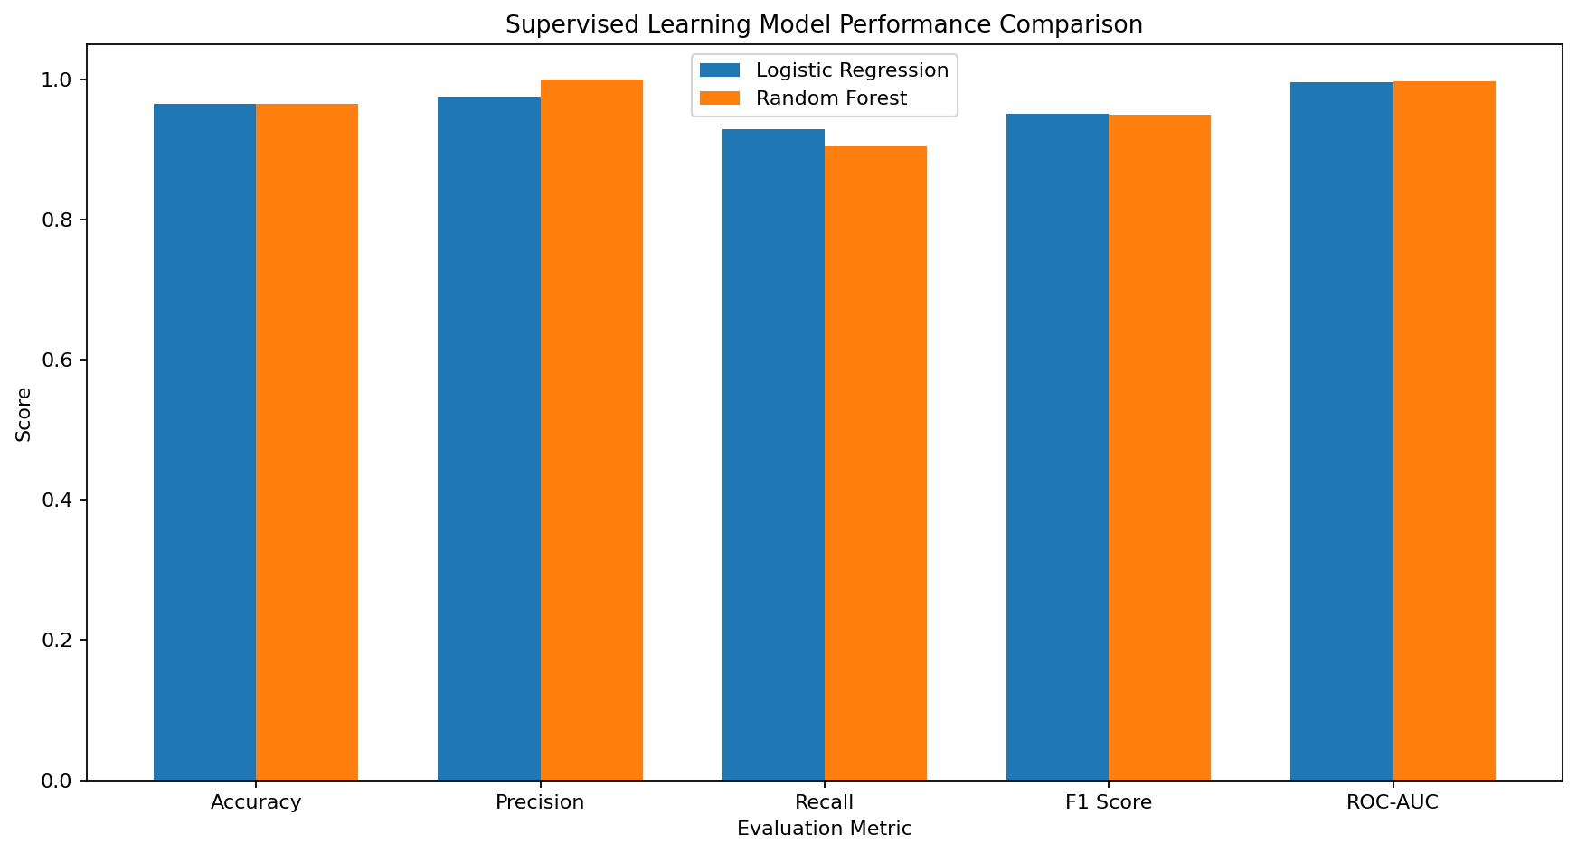
Figure 4. Test-set performance comparison.

9.1 Logistic Regression Results
Logistic Regression achieved 0.9649 accuracy (96.49%), 0.9750 precision, 0.9286 recall, 0.9512 F1 Score, and 0.9960 ROC-AUC. It correctly identified 39 of 42 malignant test cases, with 3 false negatives and 1 false positive.

9.2 Random Forest Results
Random Forest achieved 0.9649 accuracy (96.49%), 1.0000 precision, 0.9048 recall, 0.9500 F1 Score, and 0.9970 ROC-AUC. It correctly identified 38 of 42 malignant test cases and produced no false positives, but it had 4 false negatives.
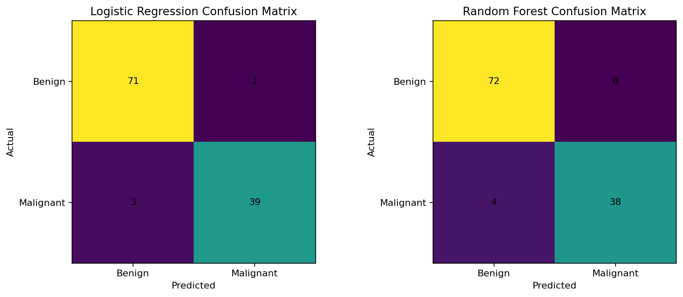
Figure 5. Confusion matrices for both models.

10. ROC-AUC Analysis
Logistic Regression obtained a ROC-AUC of 0.9960, while Random Forest obtained 0.9970. Both values indicate strong separation between the two classes on the held-out test set. Random Forest was marginally higher in ROC-AUC, while Logistic Regression was stronger in recall and F1 Score.
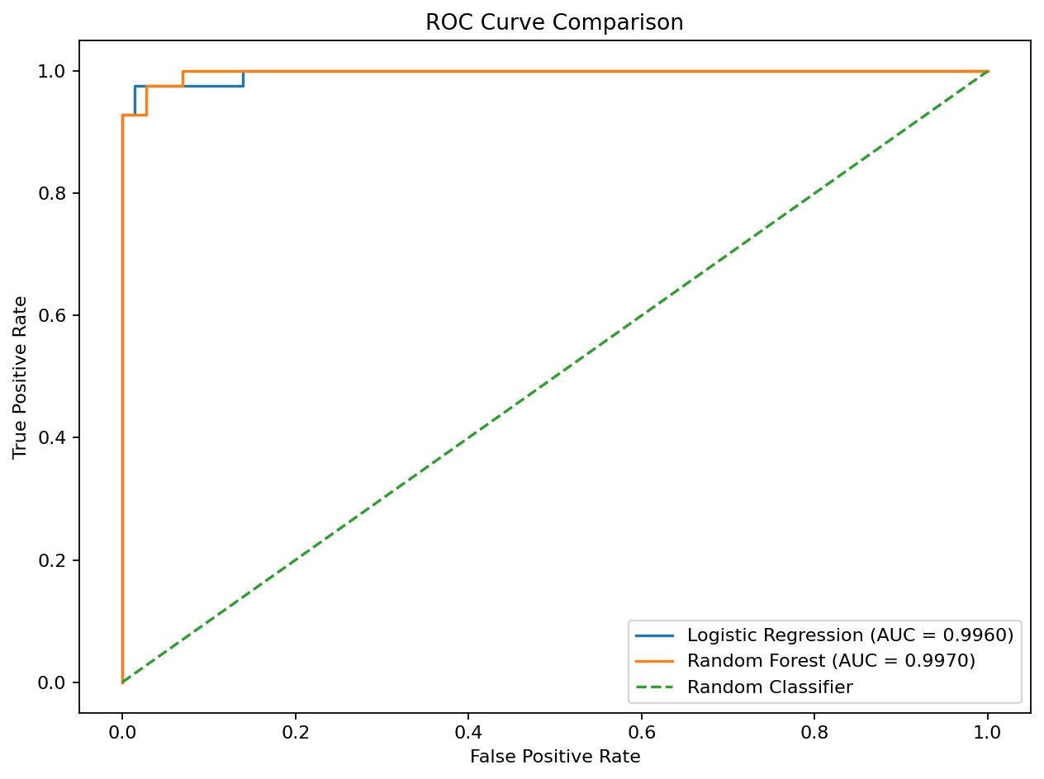
Figure 6. ROC curve comparison.

11. Cross-Validation
Five-fold Stratified Cross-Validation was used to assess consistency across multiple train-validation partitions. Stratification preserves the class distribution in each fold.
Model | Mean CV Accuracy | CV Std
Logistic Regression | 0.9737 | 0.0166
Random Forest | 0.9613 | 0.0089
Logistic Regression achieved a mean cross-validation accuracy of 0.9737 with a standard deviation of 0.0166. Random Forest achieved 0.9613 with a standard deviation of 0.0089. Logistic Regression therefore had the higher mean validation accuracy.
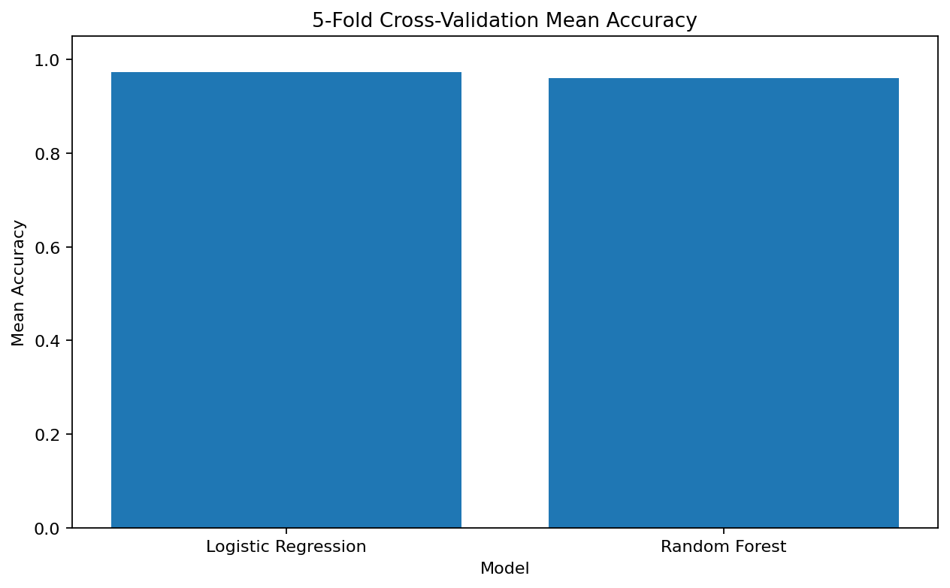
Figure 7. Mean accuracy from 5-fold stratified cross-validation.

12. Feature Importance and Interpretation
Random Forest feature importance was used to identify the measurements that contributed most to the ensemble's predictions. These are model-specific importance values and should not be interpreted as medical causation.
Feature | Importance
worst perimeter | 0.1435
worst area | 0.1408
worst concave points | 0.1046
mean concave points | 0.0996
worst radius | 0.0750
mean radius | 0.0566
mean perimeter | 0.0514
mean concavity | 0.0482
worst concavity | 0.0391
mean area | 0.0383
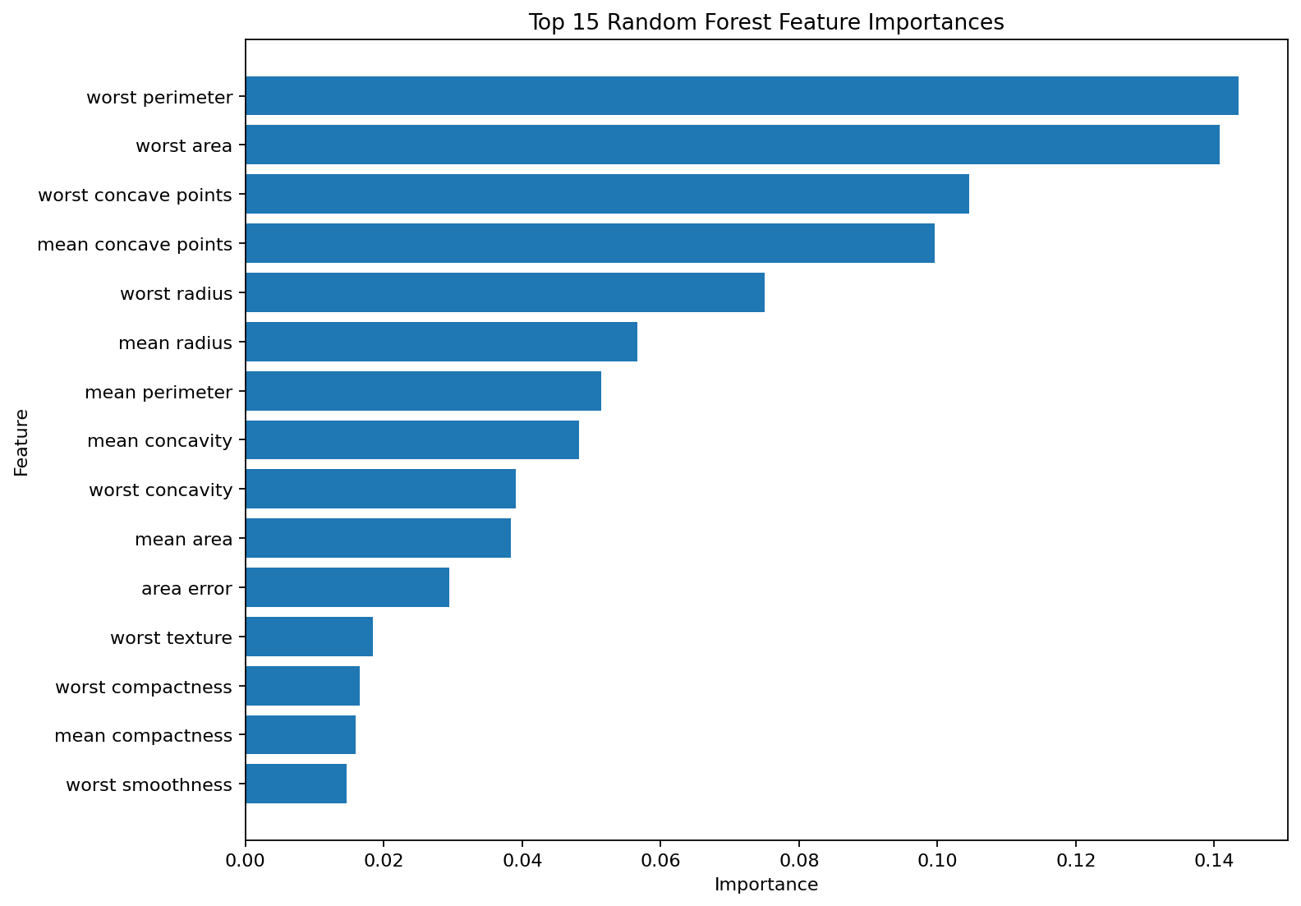
Figure 8. Top 15 Random Forest feature importances.
The leading features are largely measurements describing cell size, perimeter, area, and concavity. This is consistent with the EDA, which showed that structural diagnostic measurements contain useful information for separating the two classes.

13. Error Analysis
On the 114-case test set, both models made four incorrect predictions, resulting in the same test accuracy of 96.49%. Logistic Regression produced 1 false positive and 3 false negatives, whereas Random Forest produced 0 false positives and 4 false negatives.
The distribution of errors affects the model choice. Logistic Regression identified one additional malignant case, resulting in higher recall (92.86% versus 90.48%) and a slightly higher F1 Score (0.9512 versus 0.9500). Random Forest achieved perfect malignant-class precision on the test set.

14. Overall Model Comparison
Criterion | Logistic Regression | Random Forest
Test Accuracy | 0.9649 | 0.9649
Test Precision | 0.9750 | 1.0000
Test Recall | 0.9286 | 0.9048
Test F1 Score | 0.9512 | 0.9500
Test ROC-AUC | 0.9960 | 0.9970
Mean 5-Fold CV Accuracy | 0.9737 | 0.9613
The models achieved identical test accuracy, but their strengths differed. Logistic Regression had higher recall, F1 Score, and mean cross-validation accuracy, while Random Forest had higher precision and a marginally higher ROC-AUC. Based on balanced classification performance and validation consistency, Logistic Regression is selected as the preferred model for this project.

15. Strengths and Limitations

15.1 Strengths
- Uses a public, established diagnostic classification dataset.
- Includes a complete preprocessing and modeling workflow.
- Uses stratified train-test splitting and stratified cross-validation.
- Uses a pipeline to reduce preprocessing leakage risk.
- Evaluates two complementary supervised learning approaches.
- Uses multiple performance metrics, confusion matrices, ROC analysis, and feature importance.

15.2 Limitations
- The dataset is relatively small compared with modern clinical datasets.
- Evaluation is based on one held-out test split plus cross-validation and is not clinical validation.
- Correlated features may reduce the independent contribution of some variables.
- Random Forest feature importance is model-specific and does not establish causation.
- External validation on an independent population was not performed.
- This is an educational machine-learning project and is not intended for medical diagnosis or clinical decision-making.

16. Possible Improvements
- Perform systematic hyperparameter tuning using GridSearchCV or RandomizedSearchCV.
- Evaluate additional models such as Support Vector Machines and Gradient Boosting.
- Investigate feature selection or PCA for dimensionality reduction.
- Use repeated or nested cross-validation for more robust estimates.
- Evaluate probability calibration when probability estimates are important.
- Validate the final model on an independent external dataset before any real-world deployment.

17. Reproducibility and Outputs
The project was implemented in Python using pandas, NumPy, Matplotlib, Seaborn, and scikit-learn. The original UCI/WDBC files wdbc.data and wdbc.names were used in the Colab workflow. The project generates dataset, prediction, model-comparison, and feature-importance outputs for the GitHub repository.
Python | pandas | NumPy | Matplotlib | Seaborn | scikit-learn

18. Conclusion
This project successfully implemented a supervised learning workflow for breast cancer diagnosis using the Wisconsin Diagnostic Breast Cancer dataset. The process covered data inspection, quality assessment, exploratory analysis, target encoding, feature selection, preprocessing, model training, validation, and performance evaluation.
Logistic Regression was implemented as the primary classification model, while Random Forest was used as a comparison model. The models were evaluated using Accuracy, Precision, Recall, F1 Score, ROC-AUC, confusion matrices, ROC curves, and 5-fold stratified cross-validation. These evaluation techniques provided a comprehensive assessment of predictive performance and helped identify the stronger model for the classification task.
Feature analysis was also performed to understand which measurements contributed most to the predictions. The results demonstrate how supervised machine learning can be applied to distinguish benign and malignant cases using numerical diagnostic features.
Overall, the project demonstrates a complete and reproducible machine learning pipeline in Python, from raw data preparation to model evaluation and prediction generation. The analysis also highlights the importance of appropriate preprocessing, model validation, multiple evaluation metrics, and feature interpretation when developing classification models. While the models provide useful predictive performance on this dataset, further improvements could be explored through hyperparameter tuning, feature selection, ensemble methods, and additional validation on independent datasets.

19. Final Key Results
Item | Result
Dataset | 569 × 32
Predictive features | 30
Train/Test split | 80% / 20%
Logistic Regression test accuracy | 0.9649 (96.49%)
Random Forest test accuracy | 0.9649 (96.49%)
Logistic Regression ROC-AUC | 0.9960
Random Forest ROC-AUC | 0.9970
Logistic Regression mean CV accuracy | 0.9737 (97.37%)
Random Forest mean CV accuracy | 0.9613 (96.13%)
Preferred model | Logistic Regression

