WEEK 5 PROJECT REPORT
Deep Learning Application in Data Science
Fashion-MNIST Image Classification Using Convolutional Neural Networks
Yuva Virtual Data Science with Python Trainee Internship
Framework: TensorFlow / Keras
Task Type: Multiclass Image Classification
Prepared by: Mohammed Aayan
2026

Executive Summary
This project applies deep learning to multiclass image classification using the Fashion-MNIST dataset. A baseline multilayer perceptron (MLP) was first established, followed by convolutional neural network (CNN) experiments. The best-performing configuration was the CNN without data augmentation, which achieved 91.91% test accuracy, 92.00% weighted precision, 91.91% weighted recall, and 91.93% weighted F1-score on 10,000 held-out test images. Two augmentation configurations were also evaluated. In the tested setup, heavy augmentation achieved 87.03% accuracy and light augmentation achieved 82.84%, so neither improved the final model. The project therefore treats augmentation as a controlled experiment rather than assuming that additional regularization will always improve performance.
The analysis goes beyond a single accuracy value by examining class-wise performance, confusion patterns, incorrect predictions, confidence, learning behavior, and generalization. The largest classification difficulty was associated with visually similar upper-body clothing categories, particularly Shirt, T-shirt/top, Pullover, and Coat. These findings provide practical evidence for where future model improvements should be concentrated.

1. Introduction
Deep learning provides a way to learn hierarchical representations directly from data. For image problems, convolutional neural networks are especially useful because convolutional filters can learn local visual patterns such as edges, shapes, textures, and increasingly complex structures. This project demonstrates a complete deep learning workflow: dataset inspection, preprocessing, baseline modeling, CNN architecture design, training, evaluation, controlled experiments, error analysis, and critical interpretation.

2. Problem Statement
The task is to classify grayscale images of clothing items into one of ten Fashion-MNIST categories. The input is a 28×28 grayscale image and the output is one of ten mutually exclusive class labels. The problem is formulated as supervised multiclass classification.

2.1 Objectives
- Understand and apply fundamental deep learning concepts using TensorFlow/Keras.
- Build a baseline neural network and establish a measurable reference point.
- Design and train a CNN suitable for small grayscale images.
- Evaluate the model using accuracy, precision, recall, F1-score, loss, and confusion analysis.
- Investigate the effect of data augmentation through controlled experiments.
- Analyze errors, difficult classes, generalization behavior, and practical limitations.
- Document the complete workflow with reproducible code and evidence.

3. Dataset Description
Fashion-MNIST is a benchmark image dataset containing grayscale images of ten clothing categories. Each image has a spatial resolution of 28×28 pixels. The classification problem contains ten classes: T-shirt/top, Trouser, Pullover, Dress, Coat, Sandal, Shirt, Sneaker, Bag, and Ankle boot.
Property | Value
Image size | 28 × 28 pixels
Channels | 1 (grayscale)
Classes | 10
Training data | 60,000 images
Test data | 10,000 images
Task | Multiclass classification
Output | 10-class softmax probabilities

4. Data Preparation and Preprocessing
The images were converted into a numerical representation suitable for neural-network training. Pixel values were normalized to the [0, 1] range by dividing the original 0–255 intensities by 255. The image tensors were also reshaped to include an explicit channel dimension, producing the CNN input shape 28×28×1. The training data was further divided into training and validation portions, while the official test set was kept separate for final evaluation.
# Load Fashion-MNIST
from tensorflow.keras.datasets import fashion_mnist
(X_train, y_train), (X_test, y_test) = fashion_mnist.load_data()
# Normalize pixel values
X_train = X_train.astype("float32") / 255.0
X_test = X_test.astype("float32") / 255.0
# Add channel dimension
X_train = X_train[..., np.newaxis]
X_test = X_test[..., np.newaxis]

5. Baseline Model: Multilayer Perceptron
A dense neural network was used as the baseline. The images were flattened before being passed through fully connected layers. The purpose of the baseline was not to maximize performance but to establish a quantitative reference against which convolutional modeling could be compared.
Model | Accuracy | Precision | Recall | F1-score
Baseline MLP | 89.29% | 89.36% | 89.29% | 89.31%
CNN without augmentation | 91.91% | 92.00% | 91.91% | 91.93%
CNN + heavy augmentation | 87.03% | 88.23% | 87.03% | 87.30%
CNN + light augmentation | 82.84% | 83.44% | 82.84% | 82.42%

The CNN without augmentation improved accuracy by 2.62 percentage points over the MLP baseline (91.91% versus 89.29%). This provides evidence that convolutional feature extraction was useful for this image task.
baseline_model = keras.Sequential([
layers.Flatten(input_shape=(28, 28, 1)),
layers.Dense(128, activation="relu"),
layers.Dropout(0.3),
layers.Dense(64, activation="relu"),
layers.Dense(10, activation="softmax")
])
baseline_model.compile(
optimizer="adam",
loss="sparse_categorical_crossentropy",
metrics=["accuracy"]
)

6. CNN Architecture Design
The CNN was designed to preserve spatial structure while progressively learning higher-level visual features. Three convolutional blocks were used. Batch Normalization was included to stabilize intermediate activations, ReLU was used as the nonlinear activation, and MaxPooling reduced spatial resolution. Dropout was included as regularization. Global Average Pooling reduced the feature maps to a compact representation before the final dense classifier and softmax output.
Component | Purpose
Conv2D | Learn local spatial features such as edges and shapes.
Batch Normalization | Stabilize activations and support training.
ReLU | Introduce non-linearity.
MaxPooling | Reduce spatial dimensions and computational cost.
Dropout | Reduce reliance on individual activations.
Global Average Pooling | Convert feature maps into a compact representation.
Dense + Softmax | Map learned representation to ten class probabilities.

cnn_model = keras.Sequential([
layers.Input(shape=(28, 28, 1)),
layers.Conv2D(32, (3, 3), padding="same"),
layers.BatchNormalization(),
layers.ReLU(),
layers.MaxPooling2D((2, 2)),
layers.Dropout(0.25),
layers.Conv2D(64, (3, 3), padding="same"),
layers.BatchNormalization(),
layers.ReLU(),
layers.MaxPooling2D((2, 2)),
layers.Dropout(0.25),
layers.Conv2D(128, (3, 3), padding="same"),
layers.BatchNormalization(),
layers.ReLU(),
layers.GlobalAveragePooling2D(),
layers.Dense(128, activation="relu"),
layers.Dropout(0.40),
layers.Dense(10, activation="softmax")
])

7. Training Configuration
The CNN was trained using the Adam optimizer and sparse categorical cross-entropy because the target labels are integer class indices. Accuracy was tracked during training and validation. Early stopping and learning-rate reduction were used where applicable to avoid unnecessary training and to support convergence.
Setting | Configuration
Optimizer | Adam
Loss | Sparse categorical cross-entropy
Output activation | Softmax
Batch size | 128
Validation | Held-out validation subset
Final evaluation | 10,000-image test set
Metrics | Accuracy, Precision, Recall, F1-score

8. Final Model Evaluation
The selected final model was the CNN without data augmentation. On the held-out test set it achieved 91.91% accuracy, corresponding to 9,191 correct predictions out of 10,000 and 809 incorrect predictions. The weighted precision was 92.00%, weighted recall was 91.91%, and weighted F1-score was 91.93%. The recorded test loss was 0.2287.
Metric | Final CNN
Accuracy | 91.91%
Precision (weighted) | 92.00%
Recall (weighted) | 91.91%
F1-score (weighted) | 91.93%
Test loss | 0.2287
Correct predictions | 9,191 / 10,000
Incorrect predictions | 809 / 10,000

9. Controlled Data Augmentation Experiments
Two additional experiments were performed to test whether image augmentation would improve generalization. The important methodological point is that the augmentation configurations were evaluated empirically rather than assumed to be beneficial.
The heavy-augmentation configuration achieved 87.03% accuracy, while the lighter augmentation configuration achieved 82.84%. Both were below the 91.91% achieved by the CNN without augmentation. Under the tested hyperparameters and transformations, additional augmentation therefore did not improve this particular setup.
This result should not be interpreted as evidence that augmentation is universally harmful. It indicates that the specific transformations, their strength, and the associated training configuration were not beneficial for this experiment. A future study could tune augmentation strength, learning rate, dropout, and training duration.

10. Class-wise Performance
Class | Accuracy
T-shirt/top | 87.10%
Trouser | 98.40%
Pullover | 89.40%
Dress | 90.80%
Coat | 84.10%
Sandal | 96.60%
Shirt | 78.80%
Sneaker | 98.60%
Bag | 99.10%
Ankle boot | 96.20%

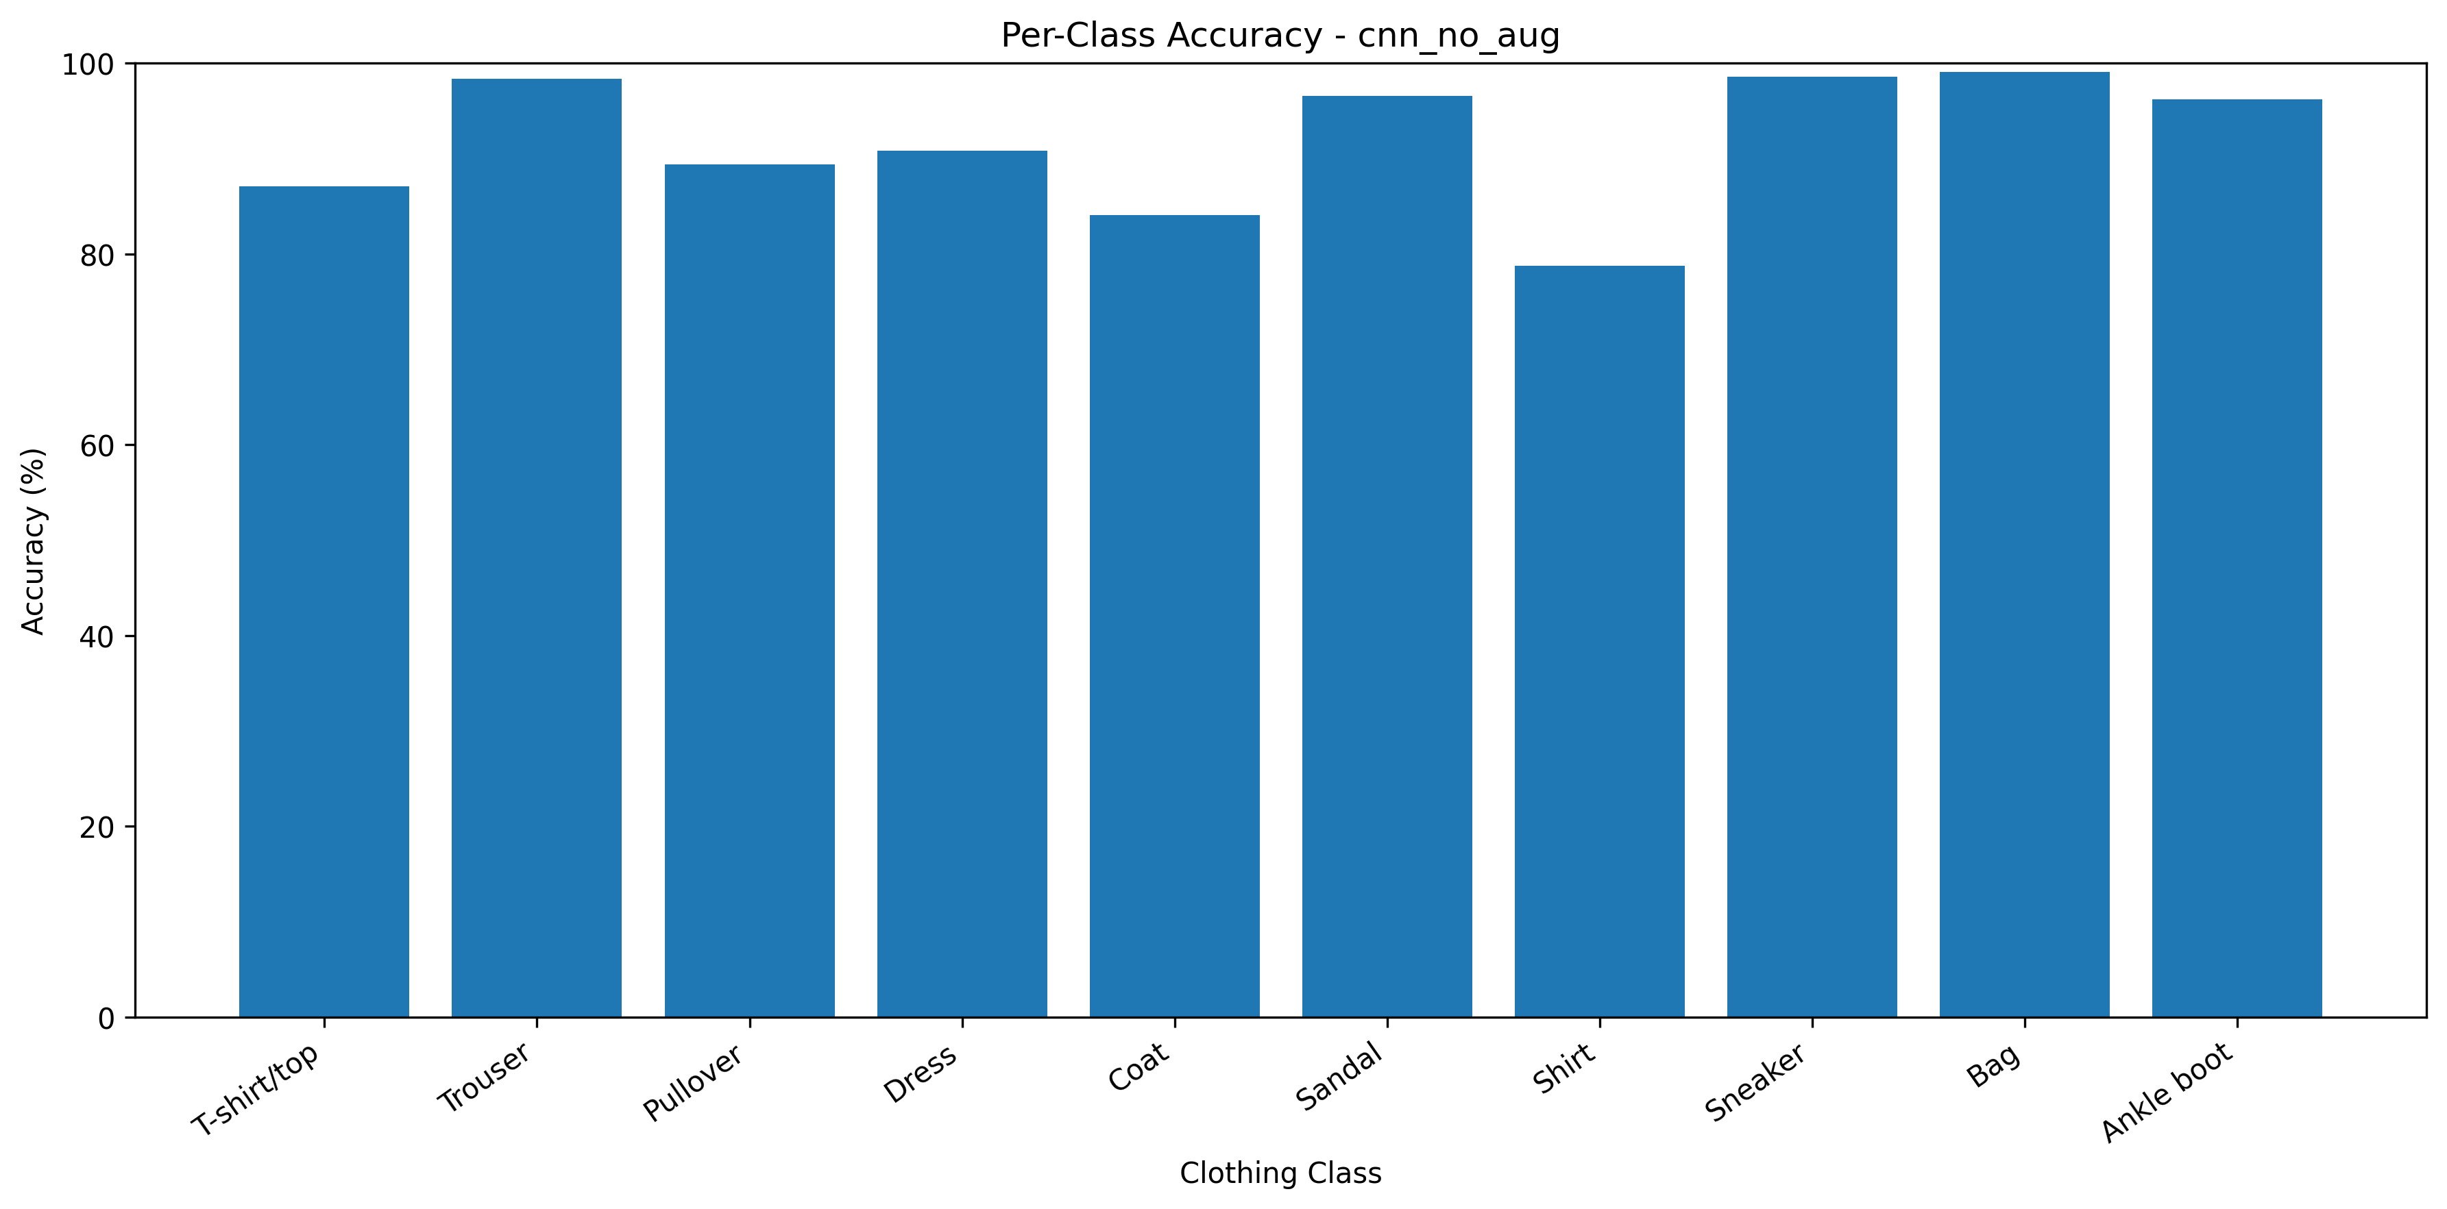
Figure 6. Per-class accuracy of the analyzed CNN output.
Class-wise analysis shows that performance is not uniform across all clothing categories. The exported final results show particularly strong performance for visually distinctive categories such as Bag and Trouser, while Shirt is more difficult. This pattern is consistent with the visual similarity among several upper-body clothing classes.

11. Confusion Matrix and Error Analysis
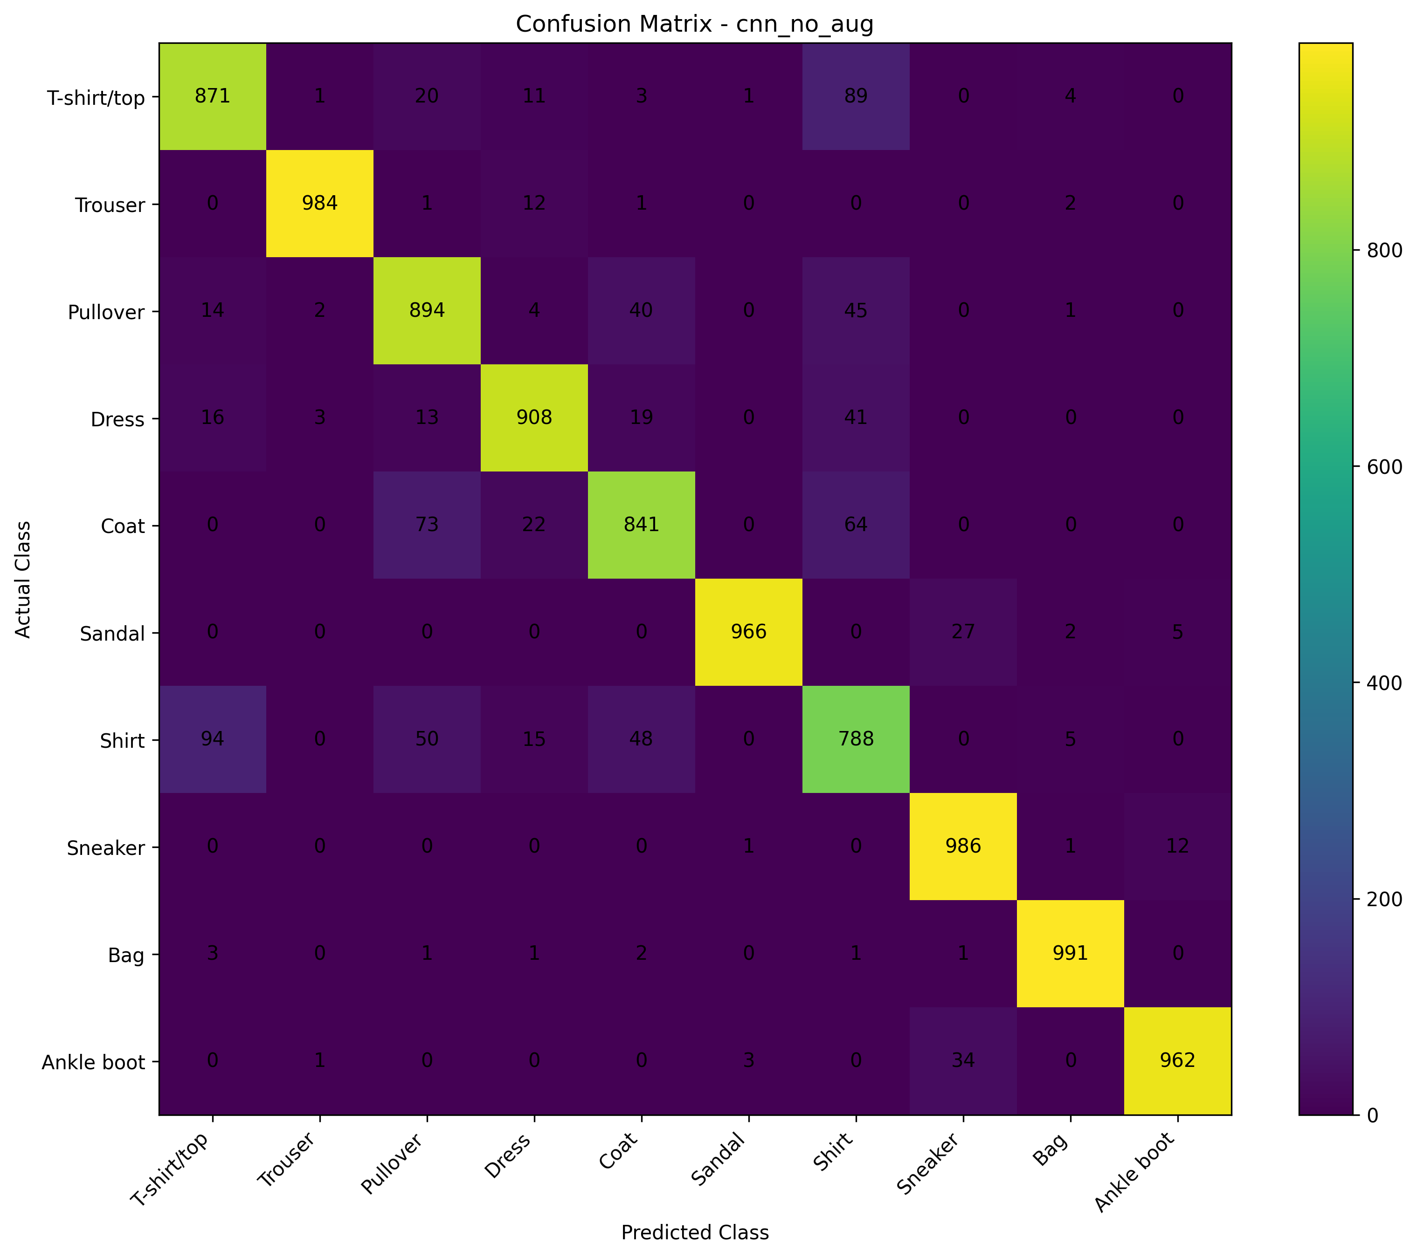
Figure 7. Confusion matrix associated with the final CNN analysis.
Actual | Predicted | Count
Shirt | T-shirt/top | 94
T-shirt/top | Shirt | 89
Coat | Pullover | 73
Coat | Shirt | 64
Shirt | Pullover | 50
Shirt | Coat | 48
Pullover | Shirt | 45
Dress | Shirt | 41
Pullover | Coat | 40
Ankle boot | Sneaker | 34

The most frequent errors occur between visually similar upper-body categories. In the final CNN results, examples include Shirt being confused with T-shirt/top, Pullover, and Coat. Such errors are plausible because the images are small grayscale representations and may contain limited texture and shape information. The confusion analysis is therefore more informative than accuracy alone because it identifies the specific classes where the model's representation is less discriminative.

12. Critical Analysis

12.1 Why CNN outperformed the MLP
The CNN improved test accuracy from 89.29% for the MLP to 91.91%, a gain of 2.62 percentage points. The principal architectural difference is that the CNN processes images using convolutional filters, allowing the model to learn spatially local patterns before classification. The MLP instead flattens the image and treats the pixels as a long vector, which does not explicitly preserve two-dimensional locality.

12.2 Why augmentation did not improve this experiment
Both tested augmentation configurations reduced test accuracy relative to the CNN without augmentation. A likely explanation is that the transformations introduced additional variation that was not useful under the tested training schedule and regularization settings. This is an experimental interpretation rather than a universal rule. More systematic hyperparameter tuning would be required to determine whether a different augmentation policy could outperform the baseline CNN.

12.3 Generalization and limitations
The final CNN achieves strong benchmark performance for a compact image classifier, but it still produces 809 errors on the 10,000-image test set. The concentration of errors in visually similar classes indicates that accuracy alone does not fully describe model behavior. The 28×28 grayscale resolution also limits the amount of visual detail available to the model.

13. Challenges and Resource Considerations
- Training time can increase substantially when multiple CNN configurations are trained without hardware acceleration.
- Experimentation must balance model complexity against available computational resources.
- Augmentation and regularization require tuning; adding more techniques does not guarantee better results.
- Small grayscale images can make visually similar clothing categories difficult to distinguish.
- Controlled experiments are important because changing several hyperparameters at once makes causal interpretation difficult.

14. Strengths of the Solution
- Uses a CNN architecture appropriate for image classification.
- Includes a baseline model for quantitative comparison.
- Uses a held-out test set for final evaluation.
- Reports multiple evaluation metrics rather than accuracy alone.
- Includes controlled augmentation experiments.
- Includes class-wise and confusion-based error analysis.
- Uses Batch Normalization, Dropout, and Global Average Pooling in the CNN design.
- Produces reproducible outputs including predictions, metrics, plots, and the trained model.

15. Proposed Improvements
- Perform systematic hyperparameter tuning for learning rate, dropout rate, filter counts, and batch size.
- Tune augmentation strength rather than applying a fixed transformation policy.
- Use learning-rate schedules and compare several training schedules under the same evaluation protocol.
- Investigate class-specific errors using targeted visual inspection and feature representations.
- Evaluate transfer learning with a suitable pretrained image model if the project scope and computational resources permit.
- Use more advanced CNN architectures and compare parameter count, training time, and accuracy.
- Calibrate prediction probabilities so confidence better reflects empirical correctness.
- Use explainability techniques such as saliency or Grad-CAM in future work to inspect which image regions influence predictions.

16. Key Code Segments

16.1 CNN compilation
cnn_model.compile(
optimizer=keras.optimizers.Adam(learning_rate=0.001),
loss="sparse_categorical_crossentropy",
metrics=["accuracy"]
)

16.2 Model training
history = cnn_model.fit(
X_train,
y_train,
validation_data=(X_val, y_val),
epochs=...,
batch_size=128,
callbacks=callbacks
)

16.3 Multiclass evaluation
pred_prob = cnn_model.predict(X_test)
pred = np.argmax(pred_prob, axis=1)
accuracy = accuracy_score(y_test, pred)
precision = precision_score(
y_test, pred, average="weighted"
)
recall = recall_score(
y_test, pred, average="weighted"
)
f1 = f1_score(
y_test, pred, average="weighted"
)

16.4 Confusion matrix
cm = confusion_matrix(y_test, pred)
sns.heatmap(
cm,
annot=True,
fmt="d",
xticklabels=class_names,
yticklabels=class_names
)

17. Reproducibility and Output Artifacts
The project generated machine-readable CSV outputs, graphical analysis files, model artifacts, and summary information. The final result package contains model comparison data, predictions, class-level analysis, confusion-pair information, architecture information, and supporting plots. These artifacts allow the numerical claims in this report to be traced back to the executed project outputs.

18. Results Summary
The experiments demonstrate a clear progression from a dense baseline to convolutional modeling. The baseline MLP reached 89.29% accuracy, while the selected CNN reached 91.91%, representing a 2.62 percentage-point improvement. Heavy and light augmentation configurations produced lower accuracies of 87.03% and 82.84%, respectively. Therefore, the final model selection was based on the measured results rather than on the assumption that a more complex training pipeline must perform better.
Experiment | Accuracy | Interpretation
Baseline MLP | 89.29% | Reference model
CNN without augmentation | 91.91% | Selected final model
CNN + heavy augmentation | 87.03% | Lower than baseline CNN
CNN + light augmentation | 82.84% | Lowest tested configuration

19. Conclusion
This project successfully demonstrated a practical deep learning workflow for Fashion-MNIST multiclass classification. A baseline MLP achieved 89.29% test accuracy, while the CNN without augmentation achieved 91.91%, showing the value of convolutional feature extraction for image data. The project also evaluated two augmentation configurations. Neither improved the selected CNN, which provided an important experimental insight: regularization and augmentation must be tuned to the data and training configuration rather than added automatically. Detailed class-wise and confusion analysis identified visually similar upper-body categories as an important source of errors. Overall, the work demonstrates model design, training, evaluation, experimentation, and critical interpretation rather than relying on a single performance number.

Appendix A. Final Model Configuration
Layer / Stage | Configuration
Input | 28 × 28 × 1
Conv Block 1 | 32 filters, 3×3, BatchNorm, ReLU, MaxPool, Dropout
Conv Block 2 | 64 filters, 3×3, BatchNorm, ReLU, MaxPool, Dropout
Conv Block 3 | 128 filters, 3×3, BatchNorm, ReLU
Feature aggregation | Global Average Pooling
Dense | 128 units, ReLU
Regularization | Dropout
Output | 10 units, Softmax
Optimizer | Adam
Loss | Sparse categorical cross-entropy

