WEEK 6 INTEGRATIVE CAPSTONE PROJECT
Customer Churn Prediction and Customer Segmentation Using Data Science
An end-to-end Python data science workflow using the Telco Customer Churn dataset
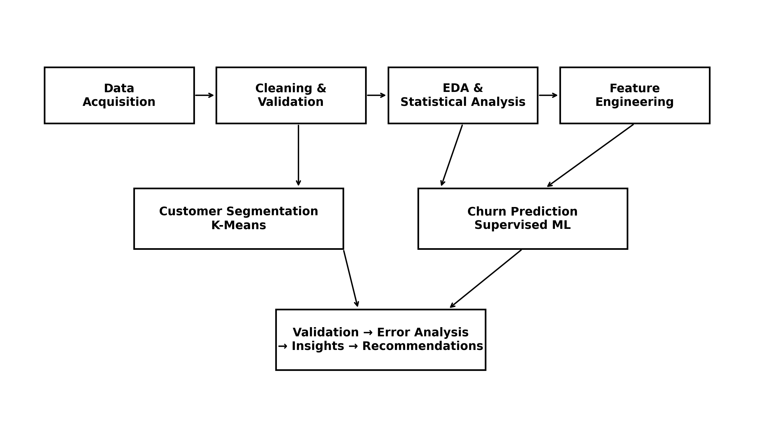
Figure 1. End-to-end project workflow used in the capstone.
Internship Deliverable Report
2026

Contents
Executive Summary
1. Problem Statement and Objectives
2. Dataset and Data Acquisition
3. Data Cleaning and Validation
4. Exploratory Data Analysis
5. Feature Engineering
6. Customer Segmentation using K-Means
7. Churn Prediction using Supervised Machine Learning
8. Model Validation, Tuning and Threshold Analysis
9. Error Analysis and Model Interpretation
10. Key Insights and Evidence-Based Recommendations
11. Challenges, Limitations and Technical Improvements
12. Critical Discussion and Reflection
13. Conclusion
14. Reproducibility and Project Files
Appendix A. Representative Python Code Examples
Appendix B. Key Numerical Results

Executive Summary
This capstone develops an end-to-end data science solution for customer churn analysis and prediction using the Telco Customer Churn dataset. The project integrates data acquisition, cleaning, exploratory data analysis (EDA), feature engineering, unsupervised customer segmentation, supervised churn prediction, model validation, error analysis, and evidence-based recommendations. The workflow was designed to demonstrate the complete lifecycle expected from an applied Python data science project rather than stopping after a single model result.
The raw dataset contains 7,043 customers and 21 columns. The initial inspection found no duplicate rows or missing values according to pandas; however, TotalCharges was stored as text and contained 11 blank-string entries. Investigation showed that all 11 affected records had zero tenure, so the values were converted to numeric and represented as 0.0 after validation. The final cleaned dataset retained all 7,043 records with zero missing values and zero duplicates.
EDA showed an overall churn rate of 26.54%. Important descriptive patterns included a 52.94% churn rate among customers with 0–6 months of tenure, compared with 9.51% for customers with 49–72 months. Month-to-month contracts had a 42.71% churn rate, while one-year and two-year contracts had 11.27% and 2.83%, respectively. Churn was also higher among fiber-optic customers (41.89%) and electronic-check users (45.29%) in this dataset. Statistical association testing and numerical distribution tests reinforced the importance of several of these variables, while the report explicitly treats them as associations rather than causal effects.
For customer segmentation, K-Means was evaluated from K=2 to K=10 using Silhouette, Davies-Bouldin, and Calinski-Harabasz criteria. Silhouette and Calinski-Harabasz both selected K=2, while Davies-Bouldin preferred K=8; K=2 was retained because two independent criteria agreed and the resulting segments were clearly interpretable. The two clusters represented a higher-tenure/higher-service group and a lower-tenure/lower-service group with different observed churn rates.
For churn prediction, a dummy baseline, Logistic Regression, and Random Forest were compared. Five-fold stratified cross-validation and hyperparameter tuning were used to reduce dependence on a single split. The tuned Logistic Regression achieved test recall of 78.88% and F1 of 62.77%, while the threshold-adjusted Logistic Regression at 0.52 achieved F1 of 62.88%. The tuned Random Forest achieved 77.08% accuracy and 61.50% F1. Error analysis identified 79 false negatives and 271 false positives for the tuned Logistic Regression and showed that prediction difficulty was higher for some tenure, contract, internet-service, and payment-method groups. Concrete future improvements include probability calibration, cost-sensitive threshold selection, nonlinear boosting models, feature selection, explainable AI, interaction analysis, segment-specific modeling, and alternative clustering methods.

1. Problem Statement and Objectives

1.1 Problem Statement
Telecommunication businesses need to understand which customer characteristics and service patterns are associated with customer churn and how machine learning can support proactive retention analysis. The capstone addresses this problem by analyzing customer demographic, service, contract, tenure, and billing information to discover churn patterns, create meaningful customer segments, and predict churn using supervised learning.

1.2 Project Objectives
- Acquire and validate a publicly available customer churn dataset.
- Clean and preprocess the dataset while documenting the reason for each transformation.
- Perform descriptive and statistical EDA to identify important patterns and relationships.
- Engineer interpretable features that summarize service adoption and customer lifecycle.
- Use K-Means clustering to identify customer segments without using the churn target.
- Build and compare supervised churn classifiers using appropriate evaluation metrics.
- Validate model stability using stratified cross-validation and hyperparameter tuning.
- Analyze errors and feature contributions to understand where the model succeeds and fails.
- Translate evidence into practical recommendations, limitations, and a concrete improvement roadmap.

1.3 Success Criteria
The project is considered successful when it provides a coherent data pipeline, uses actual evidence from the dataset, justifies technical choices, evaluates models using multiple metrics, analyzes errors rather than only headline scores, and clearly communicates limitations and next-step improvements.

2. Dataset and Data Acquisition
The project uses the Telco Customer Churn dataset containing 7,043 customer records and 21 original columns. The dataset describes customer demographics, household relationships, tenure, subscribed communication and entertainment services, contract and billing characteristics, and churn status.

2.1 Dataset Characteristics
Item | Value
Rows | 7,043
Columns | 21
Target | Churn
No Churn | 5,174 (73.46%)
Churn | 1,869 (26.54%)
Numerical Variables | 4
Categorical Variables | 17
The customerID column is treated as an identifier and excluded from modeling because it does not represent a behavioral or service attribute. The Churn column is the supervised target. The analysis retains the original descriptive variables while creating additional analytical features later.

2.2 Main Variable Groups
Group | Representative variables
Customer profile | gender, SeniorCitizen, Partner, Dependents
Relationship / lifecycle | tenure
Core services | PhoneService, MultipleLines, InternetService
Additional services | OnlineSecurity, OnlineBackup, DeviceProtection, TechSupport
Entertainment services | StreamingTV, StreamingMovies
Contract & billing | Contract, PaperlessBilling, PaymentMethod
Charges | MonthlyCharges, TotalCharges
Target | Churn

2.3 Data Source
Dataset source: IBM Telco Customer Churn sample data. The project notebook records the source and loads the CSV locally from Google Drive for analysis. The public source should be retained with the GitHub project for reproducibility.

3. Data Cleaning and Validation
Cleaning was performed as a separate stage before EDA and modeling. The objective was not to maximize the number of transformations, but to correct confirmed data-quality issues while preserving valid observations.

3.1 Initial Inspection
Check | Result
Raw shape | 7,043 × 21
Missing values before cleaning | 0 pandas NaN values
Duplicate rows before cleaning | 0
Problematic column | TotalCharges stored as object
Blank TotalCharges values | 11 blank strings

3.2 TotalCharges Investigation
TotalCharges represented a monetary amount but was stored as object. Converting the column directly with errors='coerce' produced 11 missing numeric values. These records were then inspected against customer tenure. All 11 affected customers had tenure = 0, so they represent newly activated customers with no recorded accumulated charge in the supplied data. The project therefore retained those observations and represented TotalCharges as 0.0 after numeric conversion.

3.3 Cleaning Logic
# Clean text whitespace and convert TotalCharges
for col in clean_df.select_dtypes(include="object").columns:
clean_df[col] = clean_df[col].astype(str).str.strip()
clean_df["TotalCharges"] = pd.to_numeric(
clean_df["TotalCharges"], errors="coerce"
)
clean_df["TotalCharges"] = clean_df["TotalCharges"].fillna(0.0)
The final validation reported 7,043 rows, 21 columns, zero missing values, zero duplicate rows, and TotalCharges with float64 type. Numerical ranges were also checked: tenure 0–72 months, MonthlyCharges 18.25–118.75, and TotalCharges 0.0–8684.80.

4. Exploratory Data Analysis
EDA was designed to answer two questions: (1) what is the structure of the customer base, and (2) which variables show meaningful differences across churn status? The analysis combines counts, rates, distributions, correlation analysis, chi-square association testing, and Mann-Whitney tests.

4.1 Overall Churn Distribution
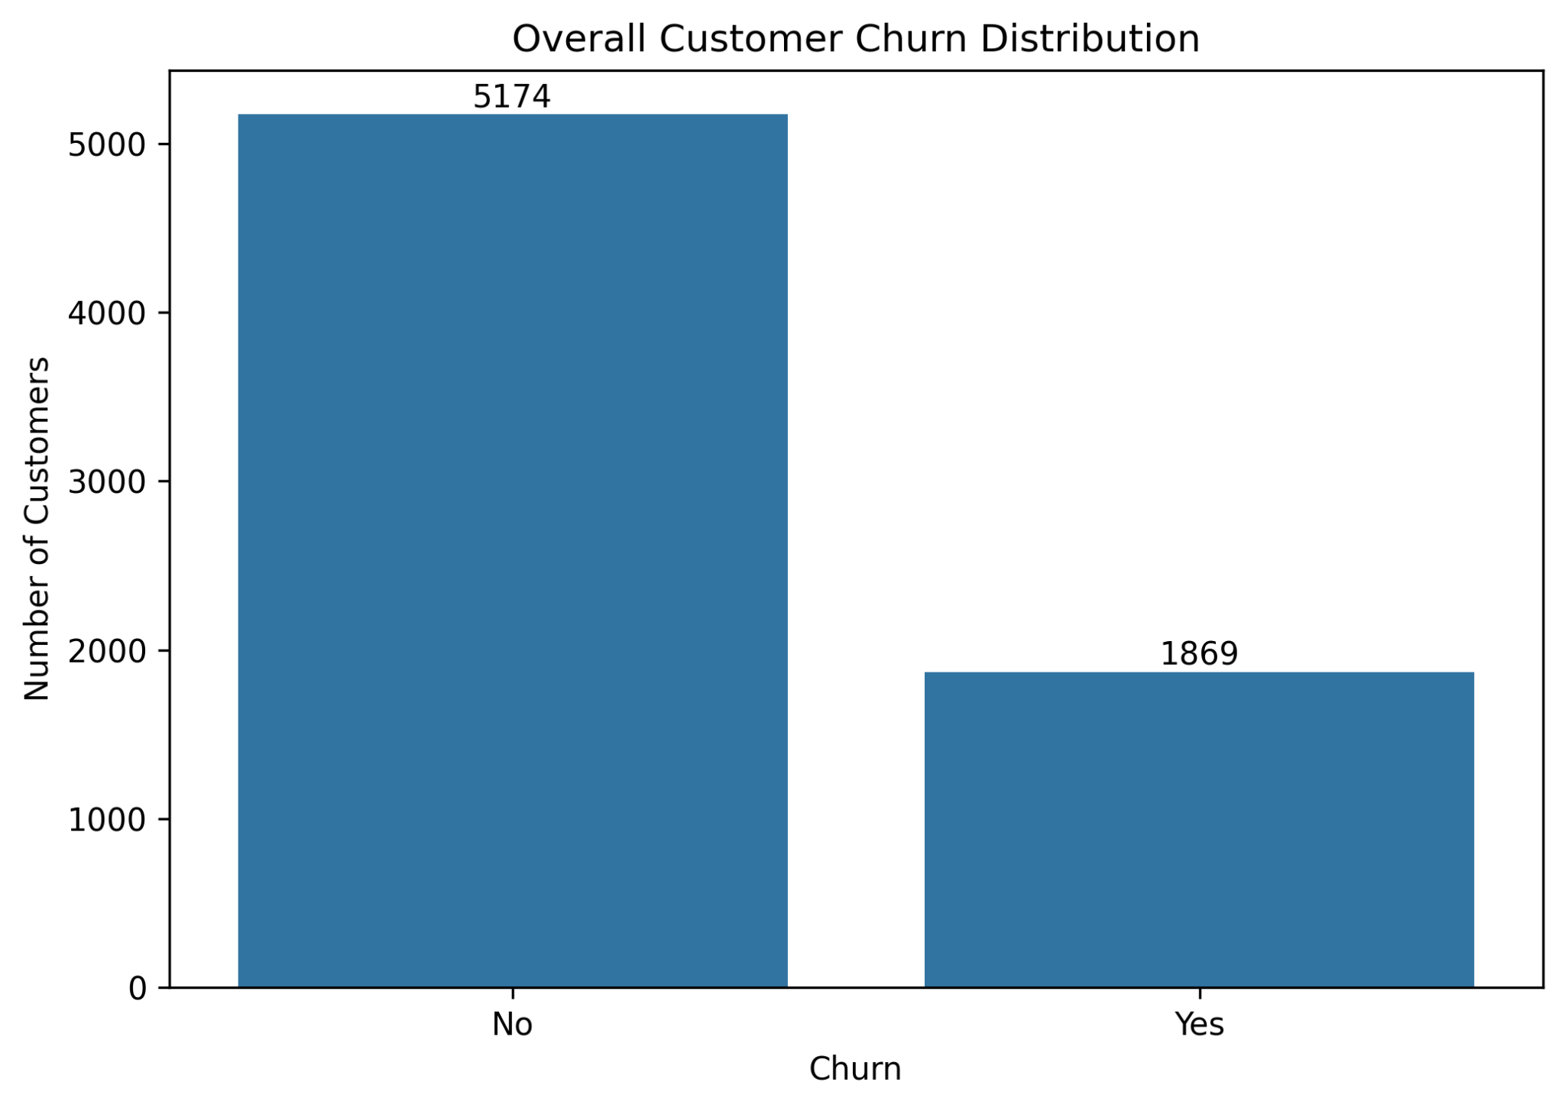
Figure 2. Overall churn distribution: 5,174 non-churners and 1,869 churners.
The churn class represents 26.54% of the dataset, while 73.46% of customers did not churn. This class imbalance means accuracy alone is insufficient for evaluating the predictive models; recall, precision, F1, ROC-AUC and PR-AUC are therefore reported.

4.2 Contract and Internet Service
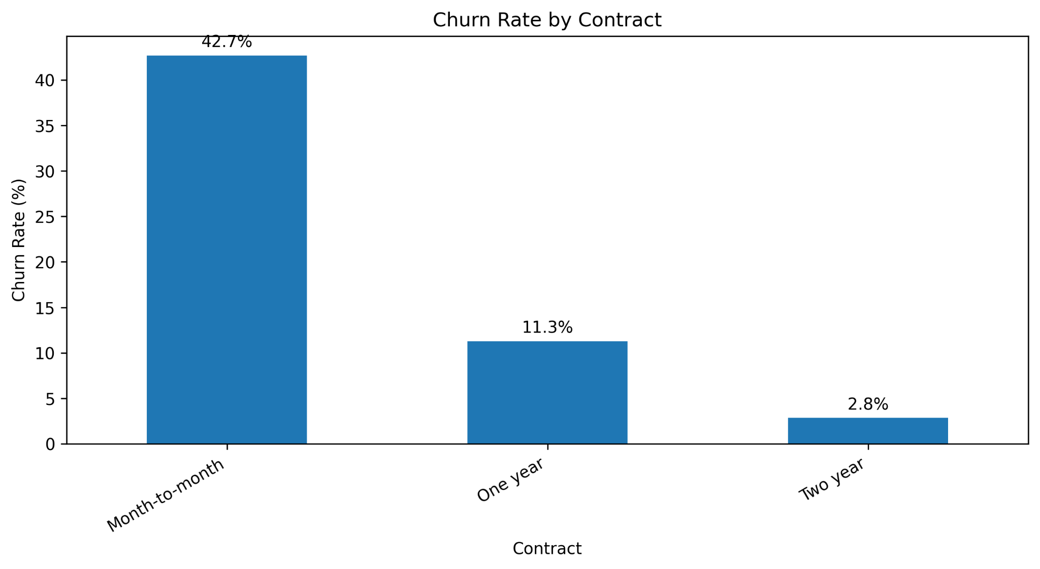
Figure 3. Observed churn rate by contract type.
Month-to-month customers show an observed churn rate of 42.71%, compared with 11.27% for one-year contracts and 2.83% for two-year contracts. Contract type also had the strongest categorical association with churn, with Cramer's V = 0.4101. This pattern is descriptive and does not prove that contract type causes churn.
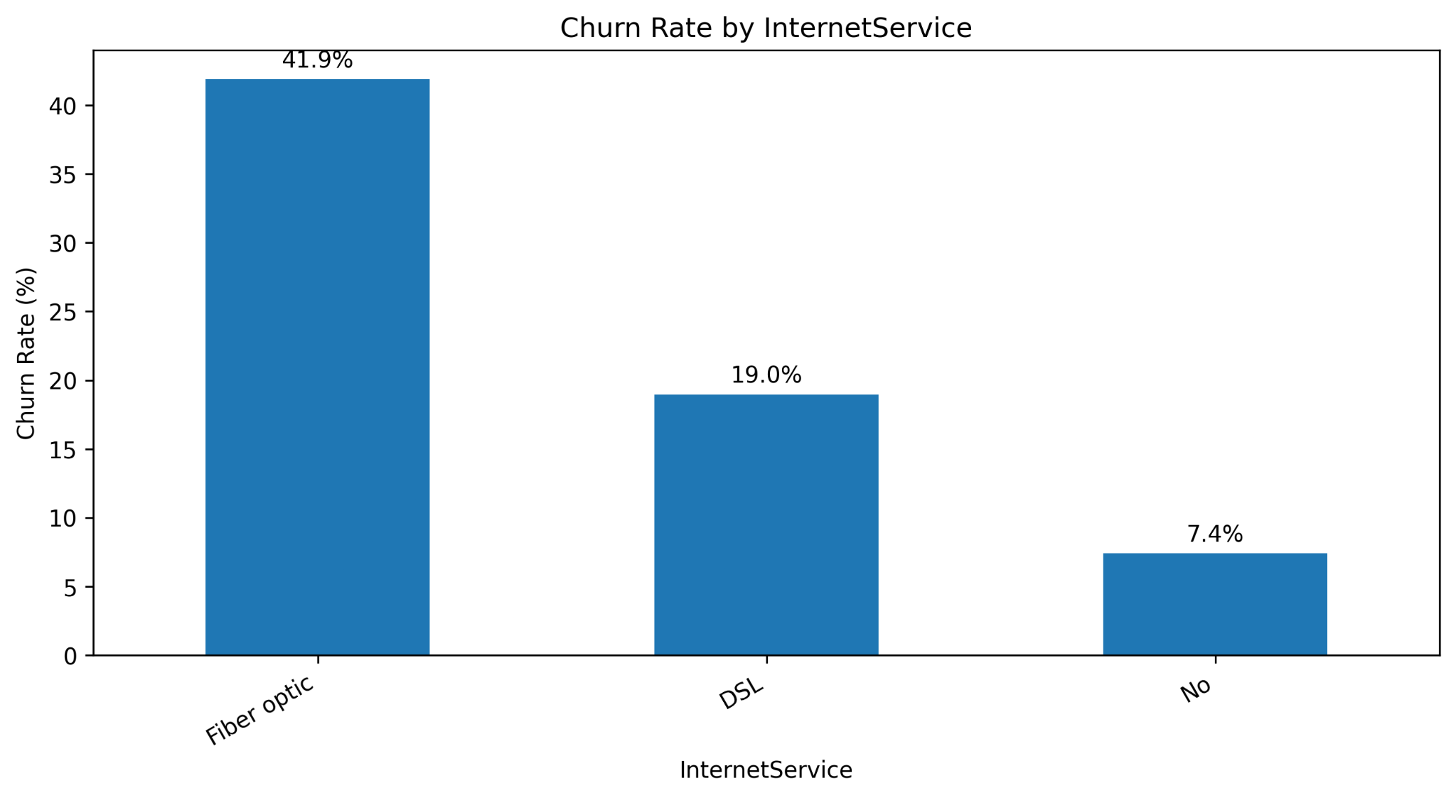
Figure 4. Observed churn rate by internet service type.
Fiber optic customers show 41.89% churn, DSL customers 18.96%, and customers without internet service 7.40%. InternetService had Cramer's V = 0.3225, placing it among the stronger categorical associations.

4.3 Payment Method
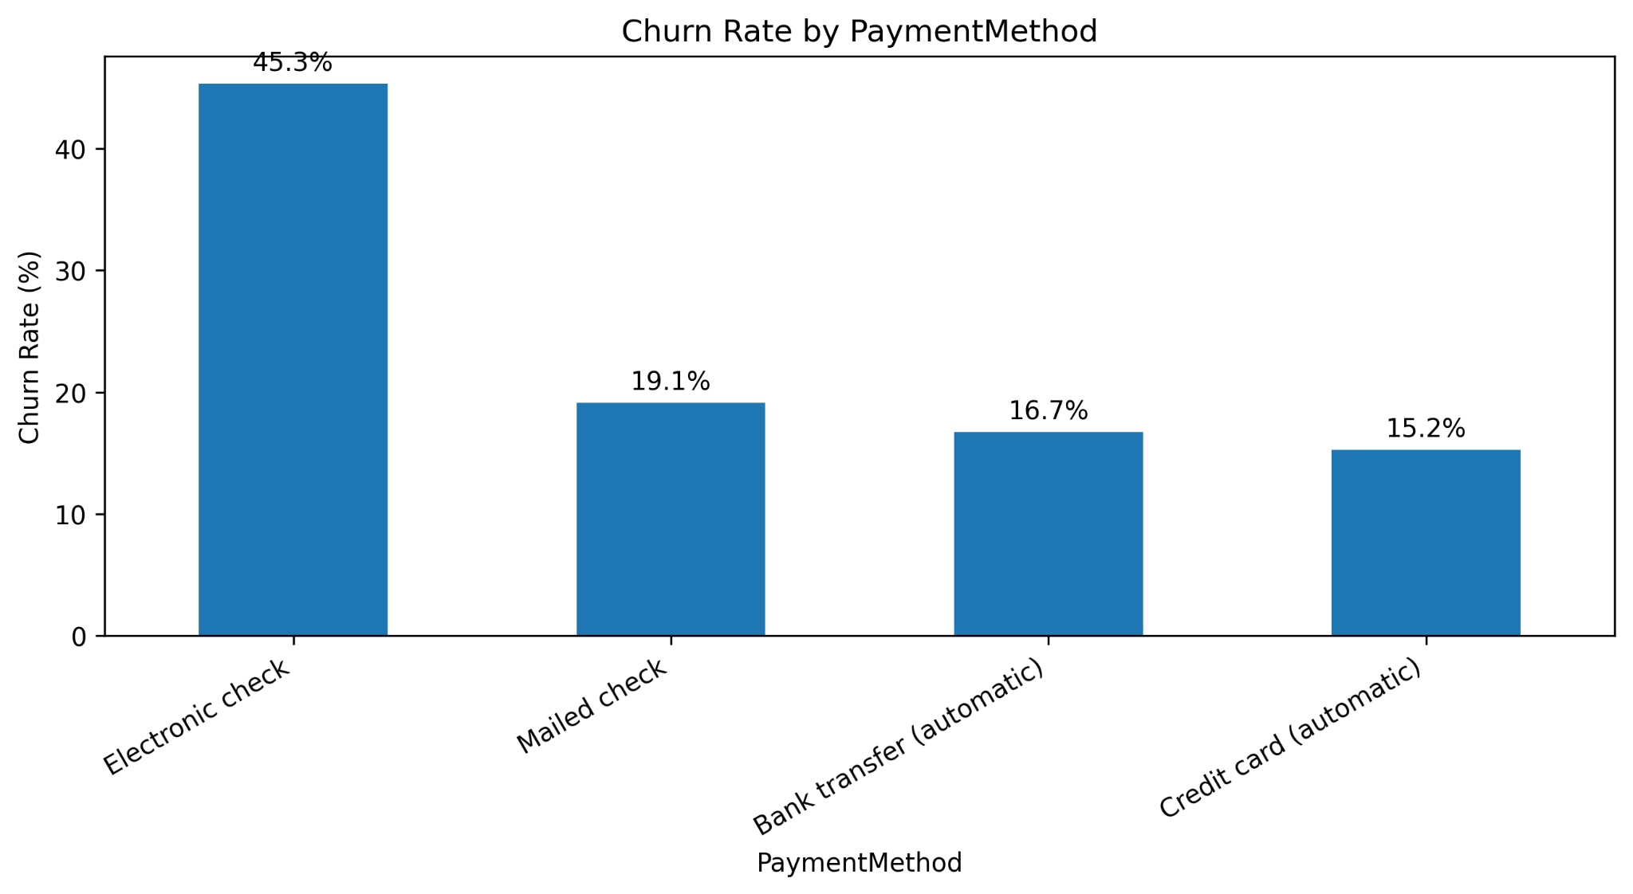
Figure 5. Observed churn rate by payment method.
Electronic-check customers show a 45.29% churn rate, compared with 19.11% for mailed checks, 16.71% for automatic bank transfer, and 15.24% for automatic credit card. Payment method had Cramer's V = 0.3034. The interpretation is that payment method separates groups with different observed churn rates; it is not treated as a causal mechanism.

4.4 Tenure and Customer Lifecycle
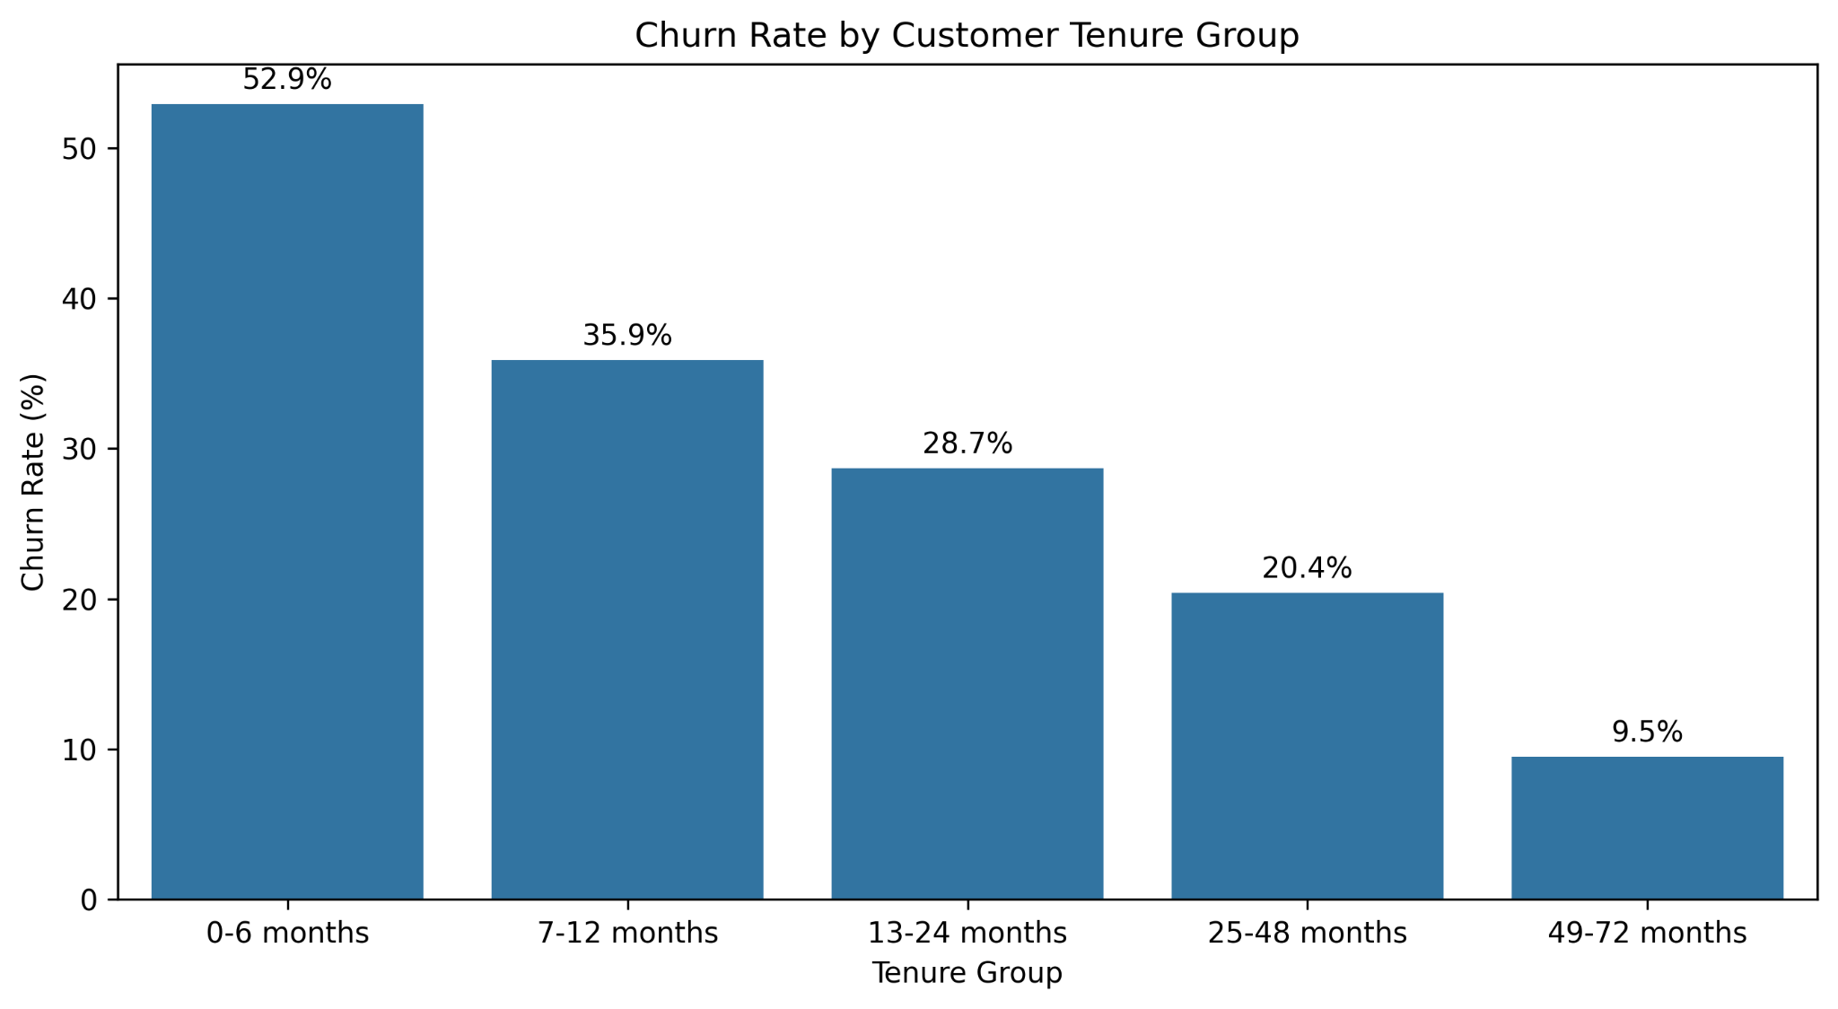
Figure 6. Observed churn rate by tenure group.
The strongest lifecycle pattern is the decline in observed churn across tenure groups: 52.94% for 0–6 months, 35.89% for 7–12 months, 28.71% for 13–24 months, 20.39% for 25–48 months, and 9.51% for 49–72 months. The mean tenure is 17.98 months for churned customers versus 37.57 months for non-churned customers; the median difference is even larger, at 10 versus 38 months.

4.5 Service Adoption
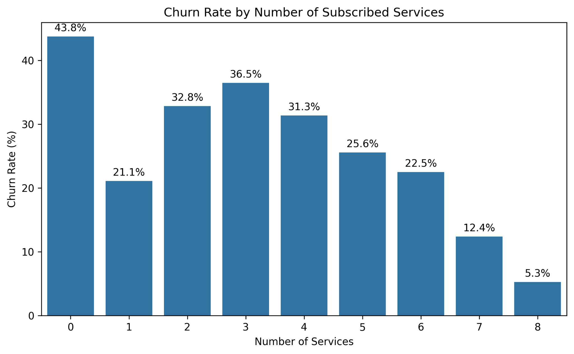
Figure 7. Observed churn rate by number of subscribed services.
Service count shows a non-monotonic pattern: customers with zero services have 43.75% churn, one service 21.11%, two services 32.83%, three services 36.48%, and eight services 5.29%. The small zero-service group (80 customers) should not be overinterpreted, while the much lower rate at eight services is consistent with a highly engaged customer profile in this dataset.

4.6 Numerical Distributions and Churn Differences
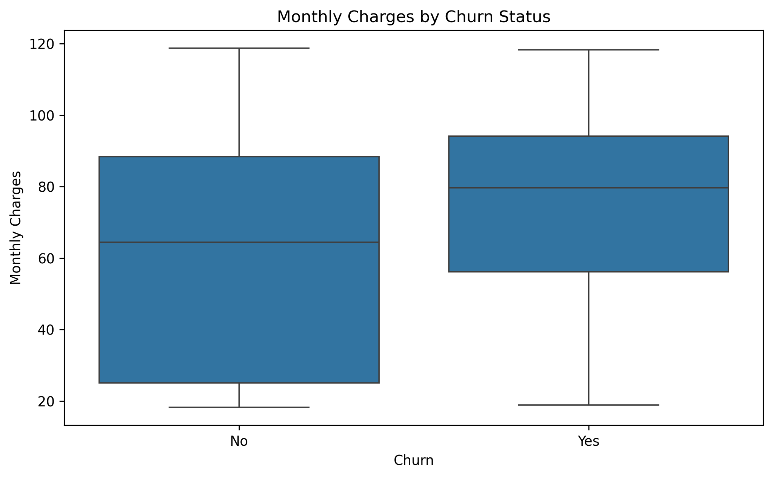
Figure 8. Monthly charges by churn status.
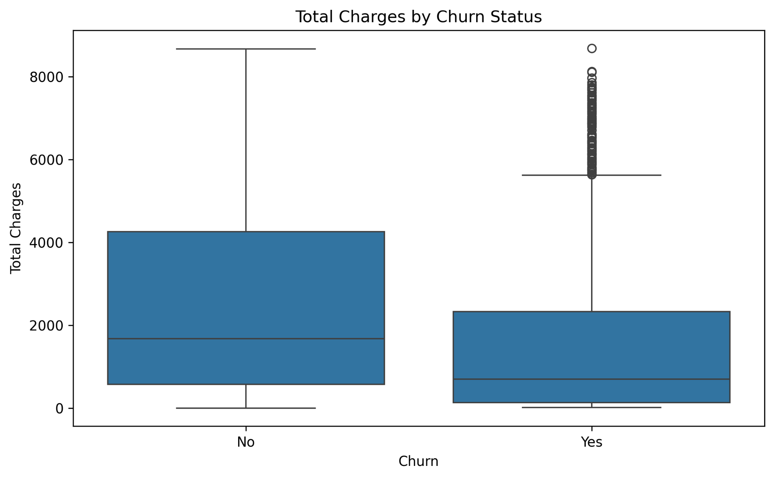
Figure 9. Total charges by churn status.
Metric | No churn | Churn
Mean tenure | 37.57 | 17.98
Median tenure | 38.00 | 10.00
Mean monthly charges | 61.27 | 74.44
Median monthly charges | 64.43 | 79.65
Mean total charges | 2549.91 | 1531.80
Median total charges | 1679.53 | 703.55
Churned customers have higher average and median monthly charges but much lower tenure and accumulated total charges. This combination is consistent with shorter-tenure customers who may have higher monthly service costs but have not yet accumulated high lifetime charges.

4.7 Correlation Analysis
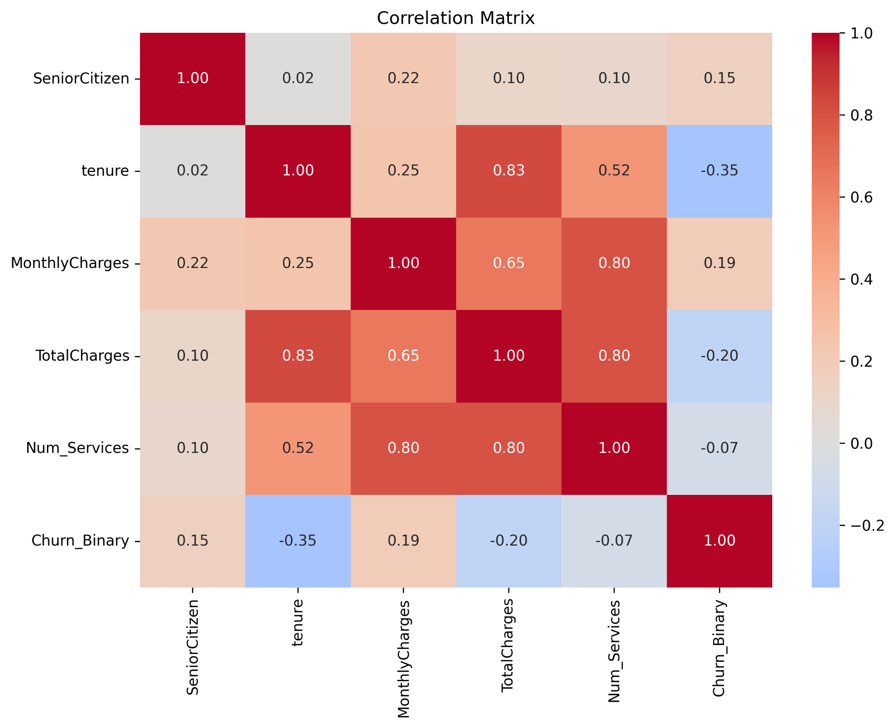
Figure 10. Correlation matrix for numerical variables and churn.
The strongest numerical relationships include tenure with TotalCharges (0.826), MonthlyCharges with Num_Services (0.802), and TotalCharges with Num_Services (0.796). Churn has correlation -0.352 with tenure, 0.193 with MonthlyCharges, and -0.198 with TotalCharges. Because correlation can reflect overlapping information, it is used as diagnostic evidence rather than as a causal claim.

4.8 Statistical Association Tests
Feature | Cramer V
Contract | 0.41
OnlineSecurity | 0.35
TechSupport | 0.34
InternetService | 0.32
PaymentMethod | 0.30
OnlineBackup | 0.29
DeviceProtection | 0.28
All of the above categorical associations were reported with p-values below 0.001 in the analysis output. For numerical variables, the Mann-Whitney tests also returned p < 0.001 for tenure, MonthlyCharges, and TotalCharges. These tests indicate that the groups differ in the sample; they do not identify a causal mechanism.

5. Feature Engineering
Feature engineering converts raw service and lifecycle variables into compact variables that can be used consistently by the downstream analyses. The approach emphasizes interpretability and avoids using target-derived information for clustering.
Feature | Definition | Purpose
Num_Services | Number of service fields equal to Yes | Service breadth
SecuritySupport_Count | Count of four security/support services set to Yes | Protection/support adoption
Streaming_Count | Count of two streaming services set to Yes | Entertainment adoption
Tenure_Group | Five tenure lifecycle bands | Interpretability
Is_New_Customer | 1 if tenure <= 6 months else 0 | Early-lifecycle flag
Above_Median_MonthlyCharge | 1 if MonthlyCharges > 70.35 else 0 | Simple charge threshold
Churn_Binary | No=0, Yes=1 | Model target
The feature-engineered dataset contains 28 columns. The churn modeling dataset uses 23 pre-encoding predictors after excluding customerID, Churn, Churn_Binary, Tenure_Group, and Above_Median_MonthlyCharge. Churn is used as the target only in supervised learning and is excluded from clustering features to prevent target leakage.

5.1 New-Customer Evidence
Customer group | Customers | Churn rate (%)
New (0–6 months) | 1481 | 52.94
Existing (>6 months) | 5562 | 19.51
This feature compresses the strongest EDA lifecycle pattern into a binary modeling signal while preserving the original continuous tenure variable for the model.

6. Customer Segmentation using K-Means
Customer segmentation was performed without using Churn. Seven numerical variables were standardized before clustering: SeniorCitizen, tenure, MonthlyCharges, TotalCharges, Num_Services, SecuritySupport_Count, and Streaming_Count. Standardization is necessary because K-Means is distance-based and otherwise high-scale variables such as TotalCharges would dominate the distance calculation.

6.1 Choosing the Number of Clusters
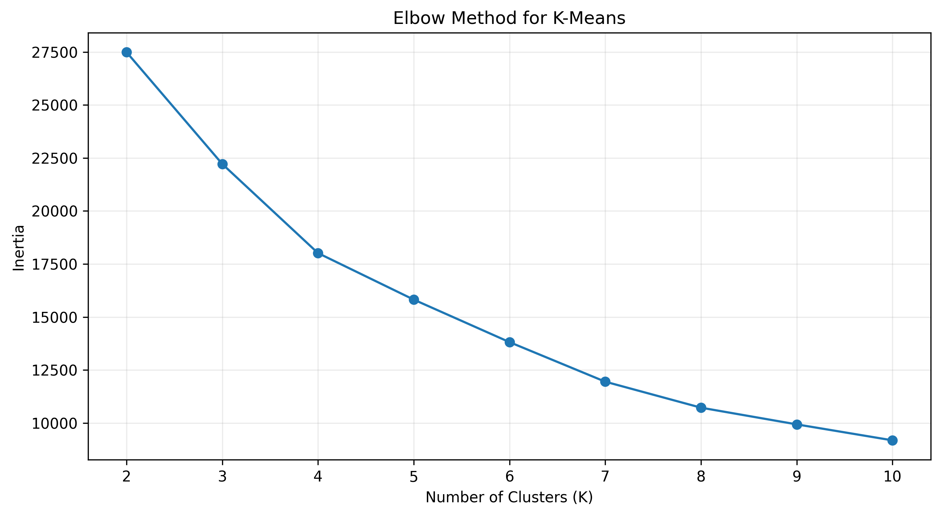
Figure 11. Elbow curve for K=2 to K=10.
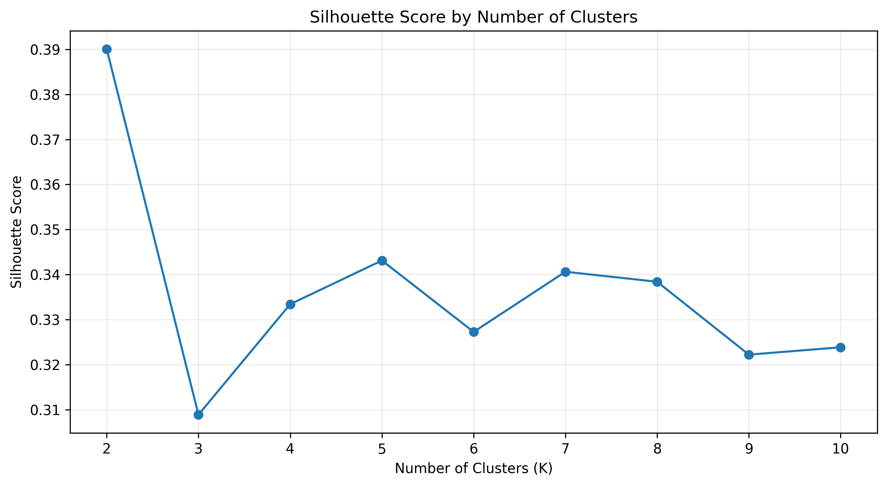
Figure 12. Silhouette score across candidate cluster counts.
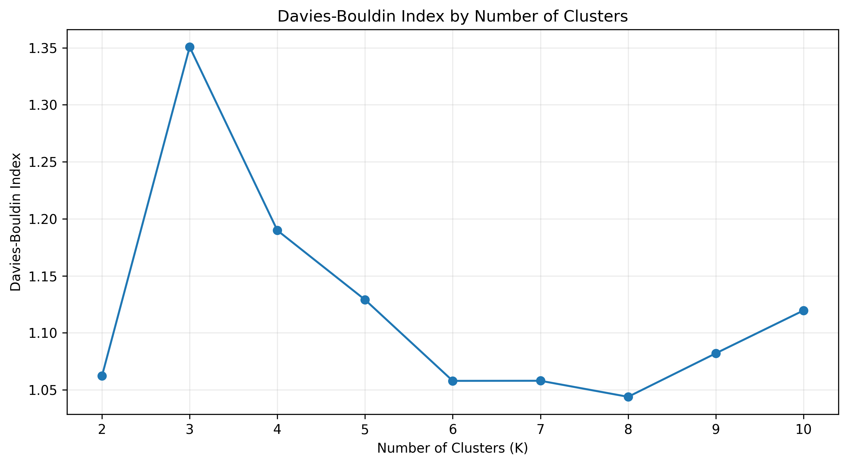
Figure 13. Davies-Bouldin index across candidate cluster counts.
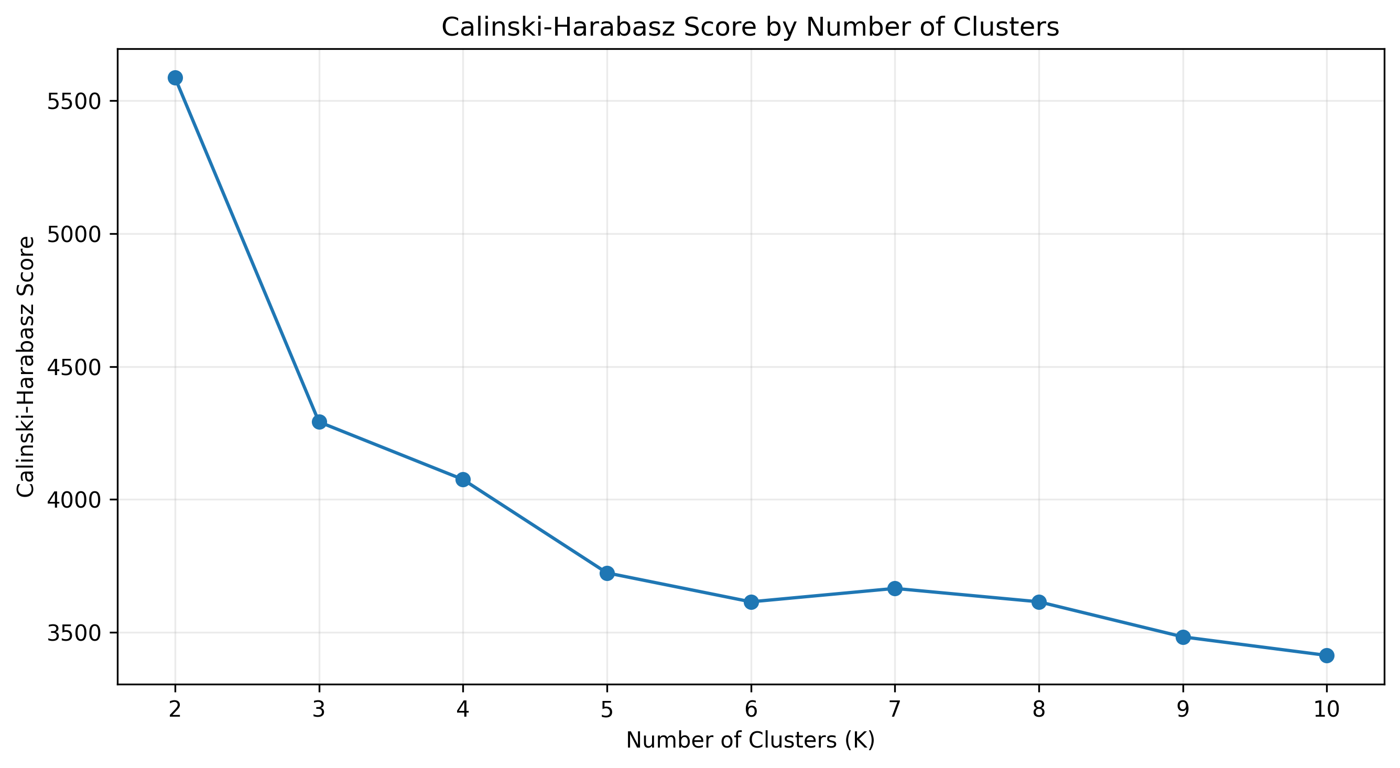
Figure 14. Calinski-Harabasz score across candidate cluster counts.
Silhouette selected K=2 with score 0.3901, while Calinski-Harabasz also selected K=2 with 5586.3037. Davies-Bouldin preferred K=8 with index 1.0439. Because two metrics independently supported K=2 and the resulting clusters were large enough to interpret, K=2 was retained. The disagreement is documented rather than hidden.

6.2 Cluster Profiles
Cluster | Customer_Count | Percentage | Churn_Rate_Percent | tenure | MonthlyCharges | TotalCharges | Num_Services | SecuritySupport_Count | Streaming_Count
0 | 2873 | 40.79 | 21.34 | 49.45 | 89.31 | 4410.58 | 5.43 | 2.36 | 1.49
1 | 4170 | 59.21 | 30.12 | 20.60 | 47.85 | 811.65 | 1.94 | 0.51 | 0.28
Cluster 0 contains 2,873 customers (40.79%) with mean tenure 49.45 months, mean MonthlyCharges 89.31, mean TotalCharges 4,410.58, and mean service count 5.43. Cluster 1 contains 4,170 customers (59.21%) with mean tenure 20.60 months, mean MonthlyCharges 47.85, mean TotalCharges 811.65, and mean service count 1.94. The profiles therefore differ strongly in customer lifecycle, billing scale, and service adoption.

6.3 Cluster Visualization
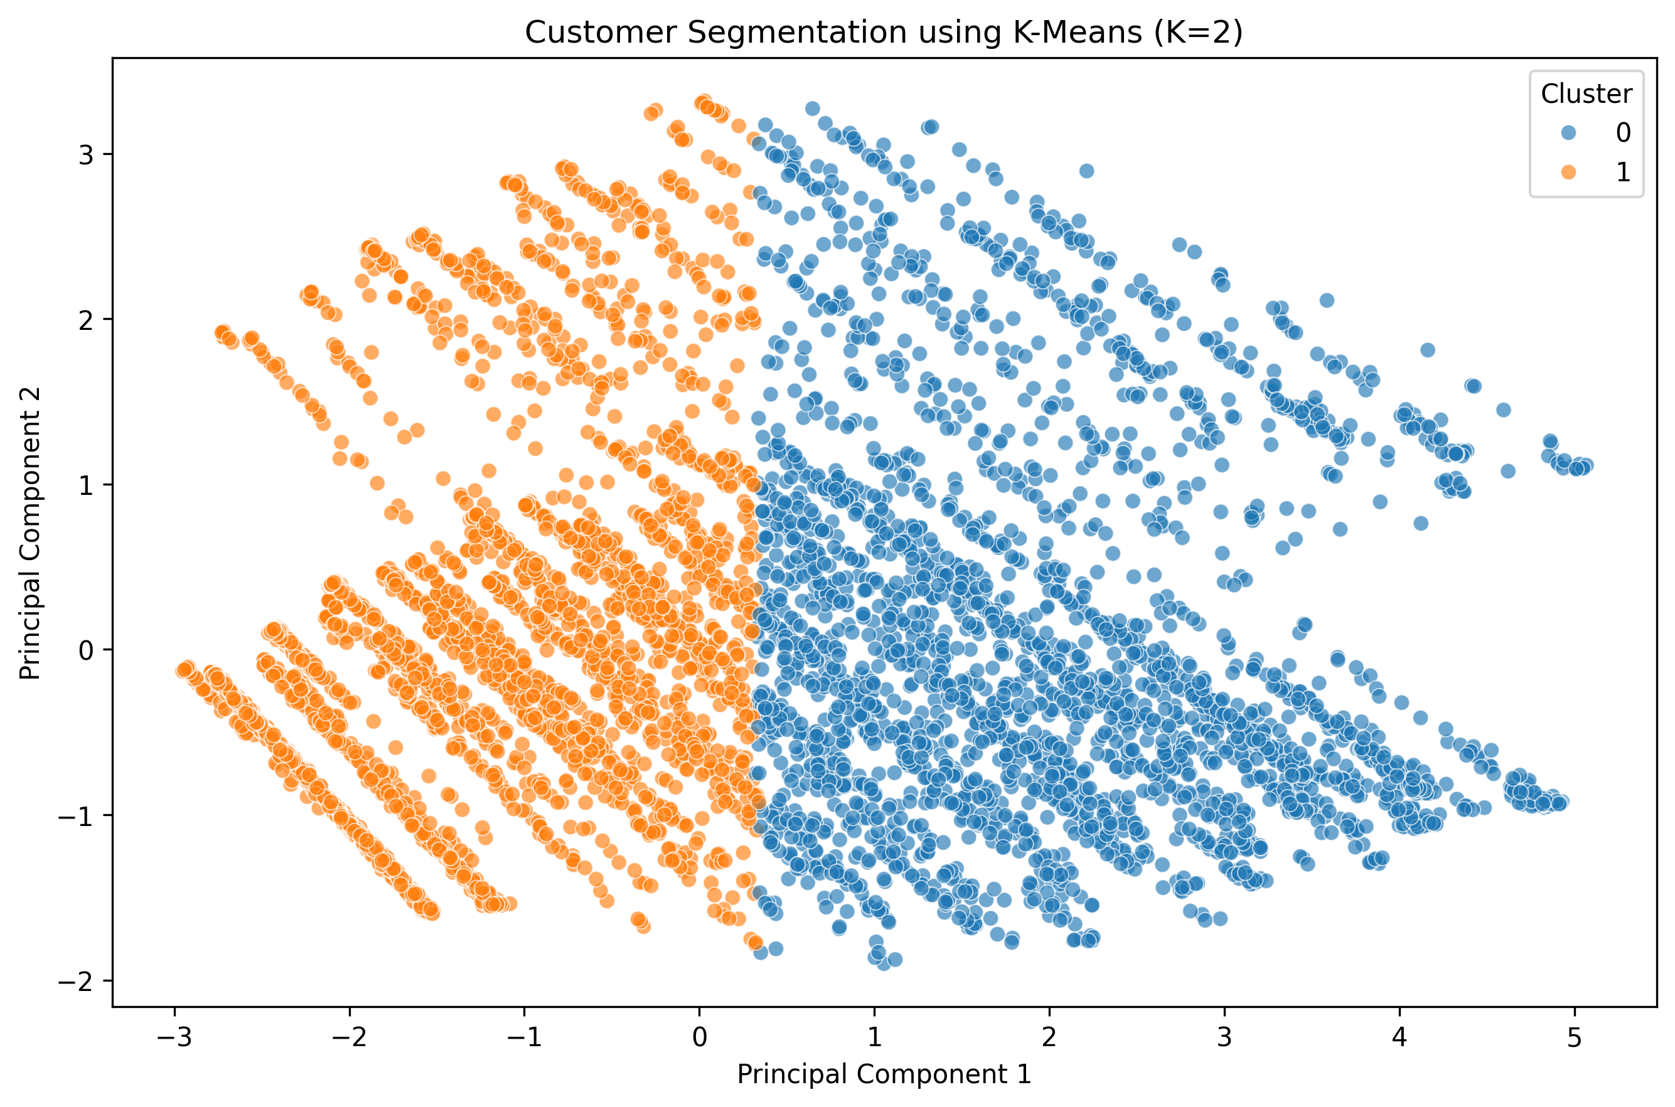
Figure 15. PCA projection of the two K-Means clusters; the first two components explain 75.39% of variance.
Cluster 0 has an observed churn rate of 21.34%, while Cluster 1 has 30.12%. Because churn was not used in clustering, this difference is a post-clustering descriptive finding and demonstrates that segmentation can add a customer-profile perspective to the supervised problem.

7. Churn Prediction using Supervised Machine Learning
The supervised-learning task predicts Churn_Binary. The model design uses a stratified 80/20 train-test split, which preserved the 26.54% churn rate in both training and testing sets. The preprocessing pipeline standardizes numerical features and one-hot encodes categorical features. Using a Pipeline and ColumnTransformer ensures that preprocessing is fitted within the training folds rather than leaking test information.

7.1 Models
Model | Purpose | Key configuration
Dummy Baseline | Reference point using majority class | Most frequent
Logistic Regression | Interpretable linear baseline for binary churn | max_iter=2000
Random Forest | Nonlinear ensemble for interaction-like patterns | n_estimators=300 in initial comparison

7.2 Initial Test Results
Model | Accuracy | Precision | Recall | F1 | ROC-AUC | PR-AUC
Dummy Baseline | 0.7346 | 0.0000 | 0.0000 | 0.0000 | 0.5000 | 0.2654
Logistic Regression | 0.8027 | 0.6611 | 0.5267 | 0.5863 | 0.8458 | 0.6525
Random Forest | 0.7786 | 0.6062 | 0.4733 | 0.5315 | 0.8188 | 0.6078
The dummy baseline achieves 73.46% accuracy only by predicting the majority class and therefore has zero recall for churn. This demonstrates why accuracy alone would be misleading. Logistic Regression and Random Forest both improve substantially over the baseline on churn-focused metrics.

8. Model Validation, Tuning and Threshold Analysis

8.1 Five-Fold Stratified Cross-Validation
Model | Accuracy Mean | Accuracy Std | Precision Mean | Precision Std | Recall Mean | Recall Std | F1 Mean | F1 Std | ROC-AUC Mean | ROC-AUC Std | PR-AUC Mean | PR-AUC Std
Logistic Regression | 0.8078 | 0.0138 | 0.6713 | 0.0308 | 0.5398 | 0.0403 | 0.5979 | 0.0335 | 0.8481 | 0.0113 | 0.6635 | 0.0154
Random Forest | 0.7858 | 0.0131 | 0.6235 | 0.0338 | 0.4876 | 0.0283 | 0.5470 | 0.0282 | 0.8227 | 0.0125 | 0.6143 | 0.0289
Five-fold validation showed Logistic Regression with mean F1 0.5979 ± 0.0335 and mean ROC-AUC 0.8481 ± 0.0113; Random Forest achieved mean F1 0.5470 ± 0.0282 and mean ROC-AUC 0.8227 ± 0.0125. The relatively small fold-to-fold standard deviations indicate that the results are not being driven entirely by one train/validation partition.

8.2 Hyperparameter Tuning
Model | Best parameters | Best CV F1
Tuned Logistic Regression | C=0.01; class_weight='balanced' | 0.6360
Tuned Random Forest | n_estimators=250; max_depth=None; min_samples_leaf=3; class_weight='balanced' | 0.6293
The tuning procedure explicitly tested both regularization strength and class weighting for Logistic Regression, and tree count, depth, leaf size, and class weighting for Random Forest. The use of class_weight=balanced reflects the minority churn class and was evaluated rather than assumed to help.

8.3 Tuned Test Results and Threshold Analysis
Model | Accuracy | Precision | Recall | F1_Score | ROC_AUC | PR_AUC | FN | FP | Error_Total
Tuned Logistic Regression | 0.7516 | 0.5212 | 0.7888 | 0.6277 | 0.8451 | 0.6537 | 79 | 271 | 350
Tuned Random Forest | 0.7708 | 0.5548 | 0.6898 | 0.6150 | 0.8367 | 0.6444 | 116 | 207 | 323
Tuned Logistic Regression (Threshold=0.52) | 0.7587 | 0.5314 | 0.7701 | 0.6288 | 0.8451 | 0.6537 | 86 | 254 | 340
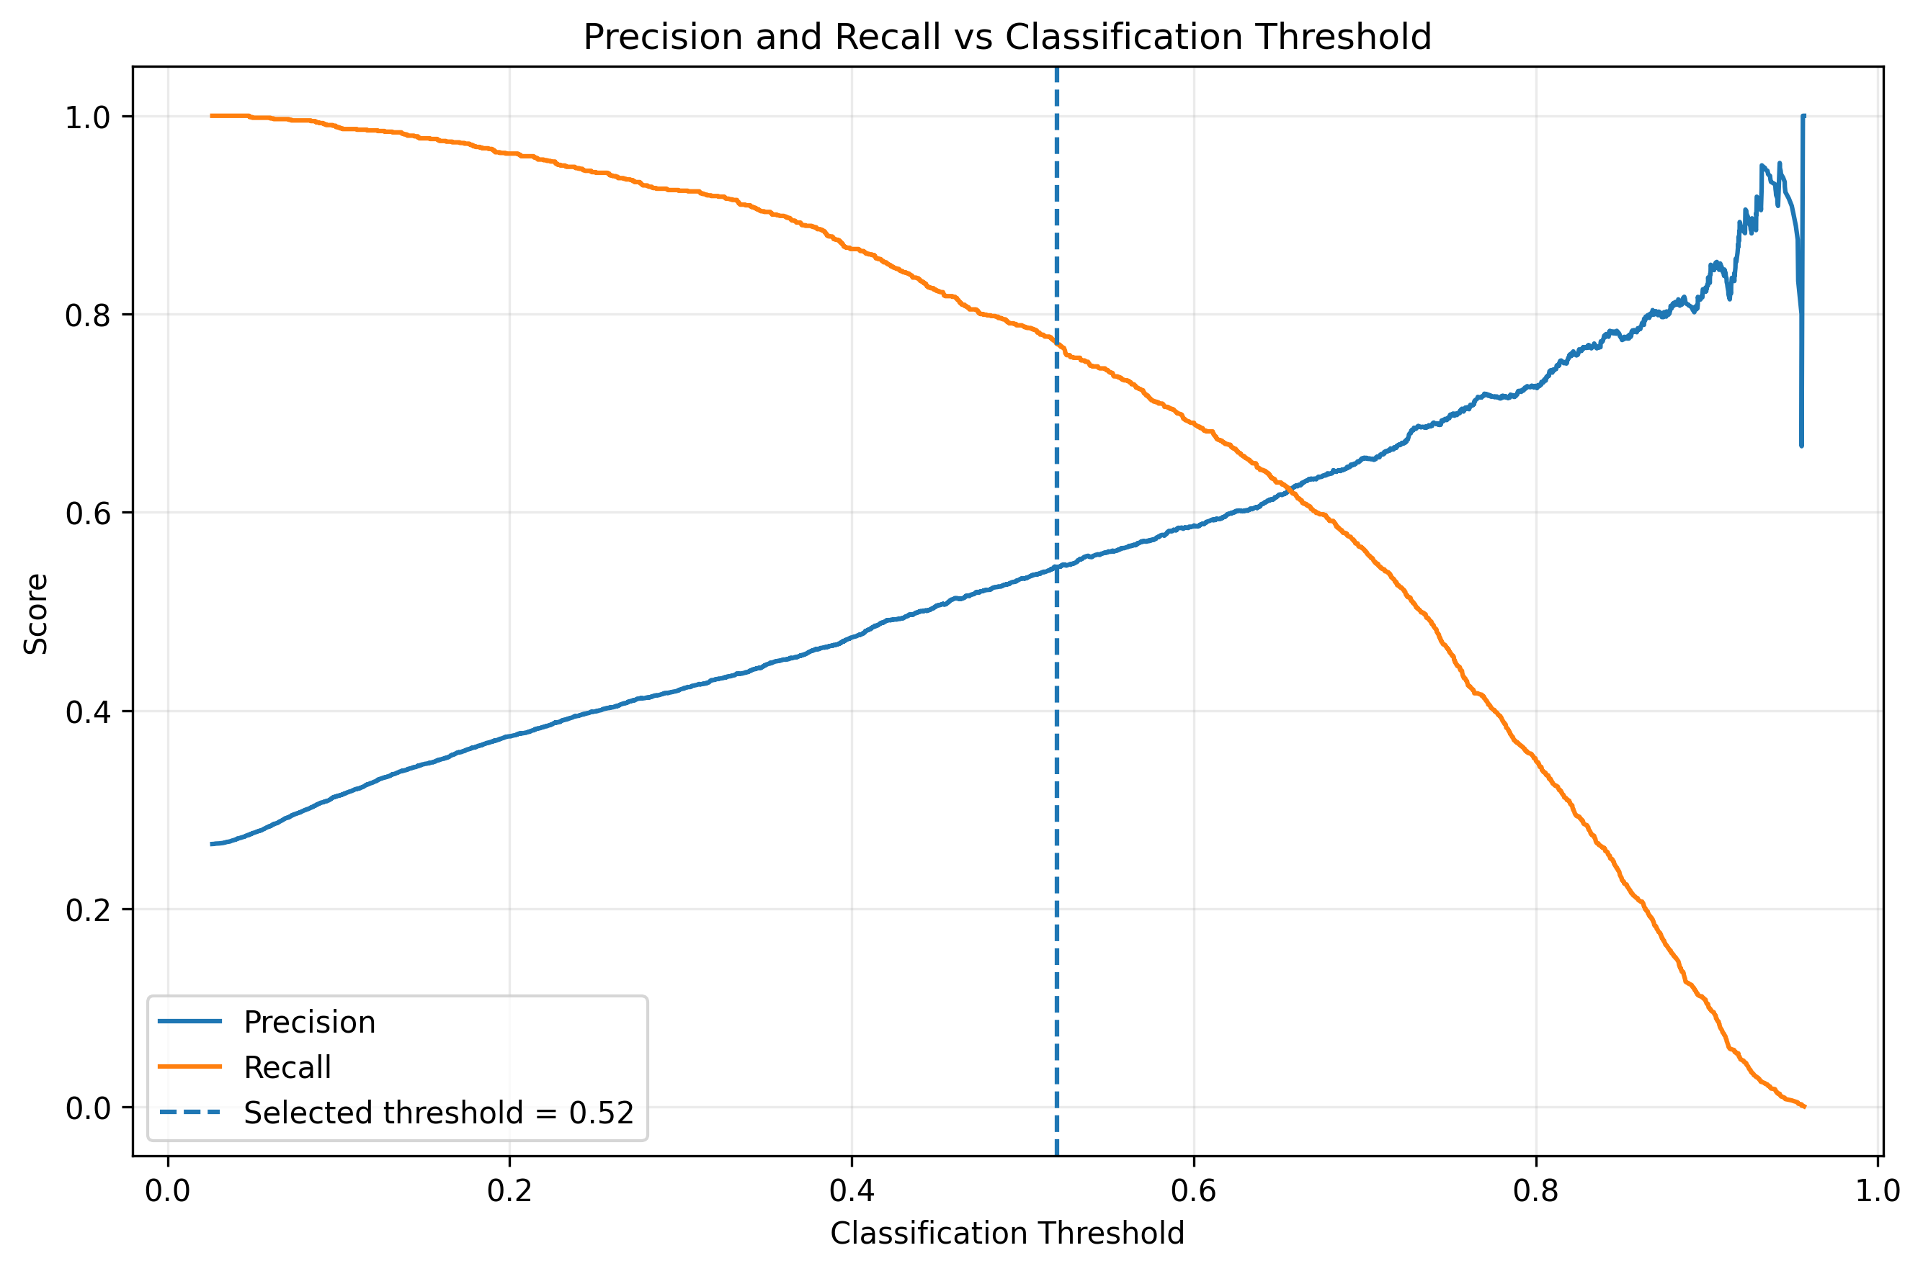
Figure 16. Precision and recall across Logistic Regression decision thresholds, with the selected threshold of 0.52.
The default tuned Logistic Regression produced recall 78.88% and F1 62.77%. The threshold selected from out-of-fold training predictions was 0.52, producing test F1 62.88%, precision 53.14%, recall 77.01%, and accuracy 75.87%. This is a small F1 change, so the main value of the analysis is demonstrating that the classification threshold is a decision parameter rather than an immutable model property.

9. Error Analysis and Model Interpretation
Error analysis goes beyond headline metrics by examining the actual customers behind incorrect predictions. For the tuned Logistic Regression at the default 0.50 threshold, the test set contained 295 true positives, 764 true negatives, 271 false positives, and 79 false negatives. The total error count was 350.
Prediction type | Count
True Negative | 764
True Positive | 295
False Positive | 271
False Negative | 79

9.1 False-Negative and False-Positive Profiles
Prediction_Type | Customers | Mean_Tenure | Median_Tenure | Mean_MonthlyCharges | Mean_TotalCharges | Mean_Num_Services | New_Customer_Percent
False Negative | 79 | 30.53 | 31.00 | 60.31 | 2491.16 | 3.48 | 24.05
False Positive | 271 | 19.53 | 16.00 | 76.72 | 1693.79 | 3.22 | 31.00
True Negative | 764 | 43.87 | 49.00 | 55.36 | 2773.34 | 3.45 | 7.07
True Positive | 295 | 12.69 | 5.00 | 76.10 | 1108.70 | 2.86 | 52.20
False negatives had mean tenure 30.53 months and mean MonthlyCharges 60.31, making them less similar to the strongest simple churn pattern than the true positives. False positives had mean tenure 19.53 months and mean MonthlyCharges 76.72, which makes them look more like the observed churn profile even though they did not churn. This helps explain why the model can flag plausible churn-like customers who ultimately remain.

9.2 Error Rates Across Customer Groups
Tenure_Group | Customers | Errors | Error_Rate_Percent
0-6 months | 311 | 103 | 33.12
13-24 months | 206 | 72 | 34.95
25-48 months | 304 | 79 | 25.99
49-72 months | 450 | 46 | 10.22
7-12 months | 138 | 50 | 36.23
Prediction difficulty is highest in several shorter-tenure groups: error rates were 33.12% for 0–6 months, 36.23% for 7–12 months, and 34.95% for 13–24 months, compared with 10.22% for 49–72 months. The pattern is consistent with the model having more difficulty distinguishing customers in the high-churn early lifecycle.

9.2.1 Contract Error Rates
Contract | Customers | Errors | Error_Rate_Percent
Month-to-month | 773 | 292 | 37.77
One year | 300 | 49 | 16.33
Two year | 336 | 9 | 2.68
Month-to-month customers had a 37.77% error rate, versus 16.33% for one-year and 2.68% for two-year contracts. This suggests that the broad month-to-month risk pattern is useful but not sufficient to separate individual outcomes perfectly.
InternetService | Customers | Errors | Error_Rate_Percent
DSL | 484 | 107 | 22.11
Fiber optic | 613 | 217 | 35.40
No | 312 | 26 | 8.33
PaymentMethod | Customers | Errors | Error_Rate_Percent
Bank transfer (automatic) | 300 | 50 | 16.67
Credit card (automatic) | 309 | 56 | 18.12
Electronic check | 474 | 172 | 36.29
Mailed check | 326 | 72 | 22.09
Fiber-optic customers had a 35.40% error rate and electronic-check users had a 36.29% error rate. These groups both show high observed churn and high prediction difficulty, reinforcing that strong group-level association does not automatically produce perfect individual-level classification.

9.3 Feature Interpretation
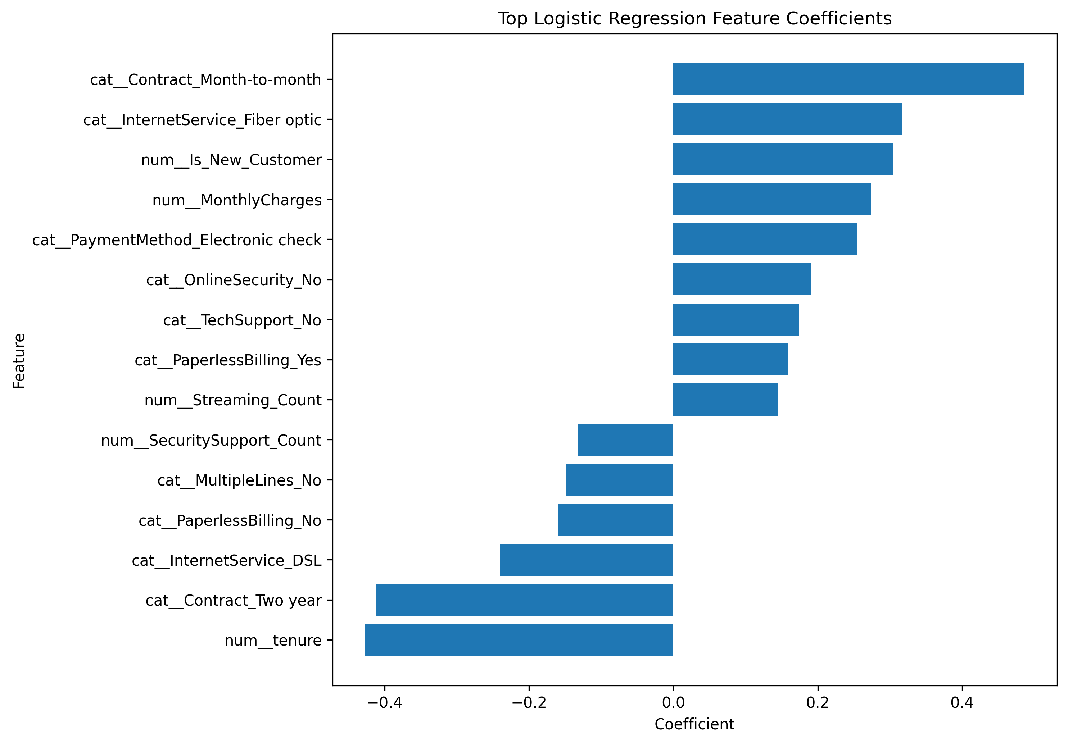
Figure 17. Top Logistic Regression coefficients by absolute magnitude.
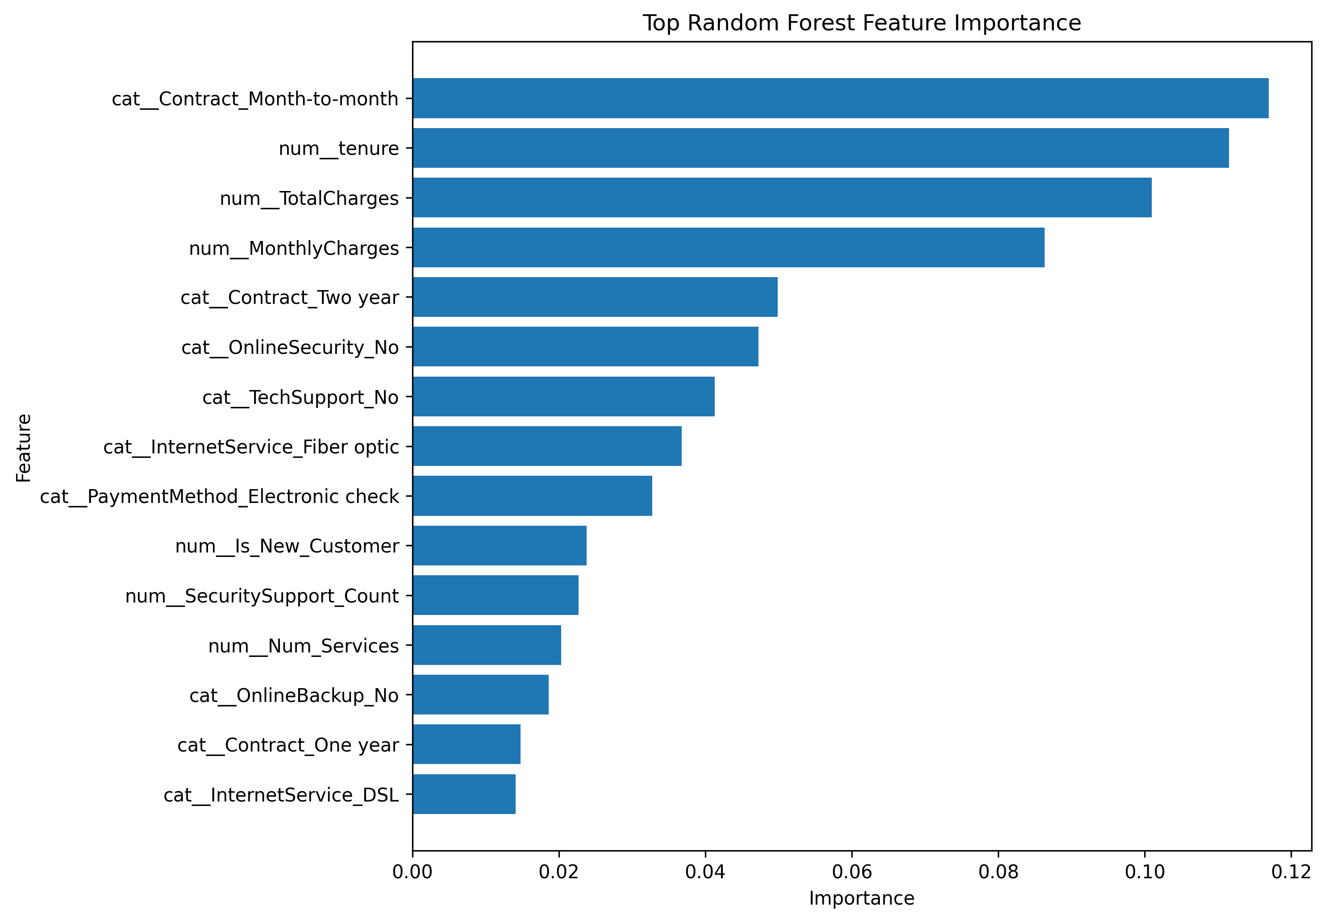
Figure 18. Top Random Forest feature importances.
The two model families highlight a similar core set of predictors. Logistic Regression assigns positive coefficients to month-to-month contract, fiber optic service, new-customer status, higher monthly charges, and electronic check, while longer tenure and two-year contracts have negative coefficients. Random Forest likewise ranks month-to-month contract, tenure, TotalCharges, MonthlyCharges, two-year contract, OnlineSecurity, TechSupport, InternetService, and PaymentMethod among its most important features. These outputs should be interpreted as model associations and predictive contribution, not causal effects.

10. Key Insights and Evidence-Based Recommendations

10.1 Key Findings
Overall churn: 26.54% of customers churned. Churn is a substantial outcome class, so model evaluation should not rely on accuracy alone. Caution: This describes the observed dataset and is not a population estimate.
Customer lifecycle: Mean tenure is 17.98 months for churned customers versus 37.57 months for non-churned customers. Shorter-tenure customers show a stronger association with churn. Caution: This is an association and does not prove that tenure causes churn.
New customers: Customers in the 0-6 month group have a 52.94% churn rate, compared with 19.51% for customers with more than six months. The first six months are an important customer lifecycle segment. Caution: This is a descriptive comparison.
Contract: Month-to-month churn = 42.71%, one-year = 11.27%, two-year = 2.83%. Contract type is strongly associated with observed churn. Caution: The analysis does not establish a causal effect of contract type.
Internet service: Fiber optic churn = 41.89%, DSL = 18.96%, no internet = 7.40%. Internet service type separates customer groups with materially different observed churn rates. Caution: Service type may interact with contract, pricing, tenure, and other characteristics.
Payment method: Electronic-check churn = 45.29%, automatic bank transfer = 16.71%, automatic credit card = 15.24%. Payment method is a strong descriptive separator in this dataset. Caution: Payment method should not be interpreted as a direct cause without controlled analysis.
Charges: Mean monthly charges are 74.44 for churned customers and 61.27 for non-churned customers. Churned customers have higher average monthly charges but shorter average tenure. Caution: Charges are related to subscribed services and customer tenure.
Customer segmentation: K-Means produced two segments with different tenure, service adoption, charges, and observed churn. Unsupervised segmentation adds a descriptive customer-profile layer to the churn model. Caution: Churn was not used when creating the clusters.
Model errors: The tuned Logistic Regression produced 79 false negatives and 271 false positives on the test set. The model still has uncertainty for a meaningful subset of customers. Caution: The appropriate error balance depends on the operational cost of each error.

10.2 Recommendations

R1 — Early lifecycle
Use stronger onboarding and early-tenure engagement for customers within their first six months.
Potential action: Provide structured onboarding, service education, and early support check-ins.
Evidence: 0-6 month churn rate = 52.94%.
Trade-off: Requires additional support or engagement resources.

R2 — Contract
Analyze month-to-month customers as a distinct retention segment.
Potential action: Evaluate contract education and retention offers for eligible customers.
Evidence: Month-to-month churn rate = 42.71%.
Trade-off: Incentives may affect short-term revenue or margin.

R3 — Payment experience
Investigate customer and billing characteristics associated with electronic-check users.
Potential action: Study billing communication, payment experience, and voluntary payment-method changes.
Evidence: Electronic-check churn rate = 45.29%.
Trade-off: Any payment-method change requires careful communication.

R4 — Support and security
Evaluate support and security-service adoption as part of retention analysis.
Potential action: Test targeted service education, support availability, or suitable bundles.
Evidence: Customers without OnlineSecurity and TechSupport show substantially higher observed churn.
Trade-off: Additional services can increase customer cost.

R5 — Predictive deployment
Use churn probabilities and validated thresholds rather than treating every prediction equally.
Potential action: Define risk bands and choose thresholds using explicit operational costs.
Evidence: The final model generates both false positives and false negatives.
Trade-off: Higher recall can increase the number of customers flagged for outreach.

11. Challenges, Limitations and Technical Improvements

11.1 Challenges Encountered
Challenge | Evidence
Mixed data types | 11 blank TotalCharges strings
Class imbalance | 26.54% churn
Conflicting clustering metrics | K=2 vs K=8 disagreement
Feature redundancy | High correlations among lifecycle/service variables
Classification errors | 350 tuned-Logistic errors

11.2 Limitations
Limitation_ID | Area | Limitation | Evidence | Implication
L1 | Predictive performance | The final tuned Logistic Regression has a test F1 of approximately 0.63, so predictions are useful but not error-free. | Test F1 = 0.6277 | Predictions should be treated as risk estimates rather than certain outcomes.
L2 | False negatives | 79 actual churners were classified as non-churners. | 79 false negatives | Potential churn cases can remain undetected.
L3 | False positives | 271 non-churners were classified as churners. | 271 false positives | A churn-focused intervention could also reach customers who would otherwise remain.
L4 | Threshold dependence | Changing the classification threshold changes the precision-recall trade-off. | Threshold analysis performed | The operational threshold should depend on the relative cost of false negatives and false positives.
L5 | Correlation | Tenure, TotalCharges, and service-related variables contain overlapping information. | Strong feature correlations observed | Model coefficients should be interpreted in the context of correlated predictors.
L6 | Cluster interpretation | The two-cluster solution is useful for broad customer profiling but does not capture every possible customer subgroup. | K=2 selected while Davies-Bouldin preferred K=8. | Additional segmentation approaches could reveal more granular customer groups.

11.3 Concrete Improvement Plan
Improvement_ID | Technique | Current_Limitation | Implementation | Expected_Benefit | Trade_Off
IM1 | Probability calibration | Predicted probabilities are not automatically guaranteed to represent well-calibrated real-world probabilities. | Evaluate calibration curves and Brier score and, if necessary, use calibrated classifiers. | More reliable probability estimates for risk prioritization. | Adds validation and model-complexity requirements.
IM2 | Cost-sensitive threshold selection | F1-based threshold selection does not explicitly represent the operational cost of errors. | Define costs for false positives and false negatives and select the threshold that minimizes expected cost. | Aligns the classification decision rule with the actual intervention objective. | Requires reliable estimates of intervention and missed-churn costs.
IM3 | Advanced nonlinear models | The tested Logistic Regression captures primarily linear effects in the transformed feature space. | Compare methods such as Gradient Boosting, XGBoost, LightGBM, or HistGradientBoosting using stratified CV. | May capture nonlinear relationships and feature interactions. | Higher complexity and potentially lower interpretability.
IM4 | Feature selection | Several features contain overlapping information. | Use permutation importance, mutual information, regularization, or recursive feature elimination. | Can reduce redundancy and simplify the model. | Removing features may discard useful interaction information.
IM5 | Explainable predictions | Global feature importance does not explain every individual customer prediction. | Use SHAP or local explanation methods for selected models. | Allows analysts to understand why an individual customer received a high-risk prediction. | Additional computational and interpretational complexity.
IM6 | Segment-specific modeling | The two customer clusters have noticeably different profiles and churn rates. | Evaluate model performance and thresholds separately for each customer segment. | May reveal segment-specific patterns hidden by a single global model. | Smaller segment sample sizes can increase model variance.
IM7 | Interaction analysis | The current analysis mainly evaluates individual feature contributions. | Test interactions such as contract × tenure, internet service × charges, and tenure × services. | May reveal combinations of factors associated with churn. | Too many interaction terms can increase complexity and overfitting risk.
IM8 | Alternative clustering methods | K-Means assumes distance-based spherical-style clusters and the metrics did not agree on one K. | Compare K-Means with hierarchical clustering or density-based methods using suitable validation metrics. | May discover customer structures not represented by K-Means. | Different algorithms require different assumptions and tuning.
The improvement plan is intentionally specific. It does not merely state that the model can be improved; it identifies the current limitation, the implementation route, the expected benefit, and the trade-off. The strongest next steps are probability calibration, cost-sensitive threshold selection, stronger nonlinear models, feature selection, explainable predictions, interaction analysis, segment-specific modeling, and alternative clustering algorithms.

11.4 Further Analysis
Area | Why | Proposed_Method
Threshold optimization | False negatives and false positives may have different costs. | Select the threshold using explicit operational costs.
Probability calibration | Predicted probabilities may be used to prioritize outreach. | Evaluate calibration curves and Brier score.
Interaction effects | Contract, tenure, service type, and charges may interact. | Test interactions or nonlinear models using cross-validation.
Explainability | Operational users may need explanations for predictions. | Evaluate permutation importance or SHAP.
Segment-specific analysis | The two customer clusters have different profiles. | Test segment-specific thresholds or models.
Cost-sensitive modeling | Missed churn and unnecessary outreach can have different costs. | Define a cost matrix and compare models using expected cost.

12. Critical Discussion and Reflection
The project demonstrates that customer churn is not captured by one variable or one model. The EDA stage revealed strong group-level patterns, but the error analysis showed that individual prediction remains uncertain, especially in groups that resemble the typical churn profile. This distinction is important: a variable can be highly associated with churn at the group level while still being insufficient to classify every customer correctly.
The clustering stage also illustrates the importance of methodological judgment. K=2 was not selected because every metric agreed; Davies-Bouldin preferred K=8. Instead, the choice relied on two criteria supporting K=2 plus the interpretability and size of the resulting segments. Reporting the disagreement strengthens the methodological transparency of the project.
Model validation similarly shows why a single test score is insufficient. The tuned Logistic Regression improved minority-class recall through class weighting but reduced accuracy and precision. Threshold analysis demonstrated that changing the operating point changes the balance between false positives and false negatives. A real deployment would therefore require an explicit decision cost framework rather than an arbitrary threshold.
The project also has a meaningful computational advantage: the selected methods are lightweight enough to train on a standard CPU environment. This makes the workflow reproducible without requiring specialized hardware, while future experiments with boosting, explainability, or calibration can be added incrementally.

13. Conclusion
This capstone successfully implemented a complete Python data science pipeline for customer churn analysis, segmentation, and prediction. The project moved from raw public data through validation, EDA, feature engineering, unsupervised clustering, supervised classification, cross-validation, hyperparameter tuning, threshold analysis, error analysis, and actionable recommendations.
The strongest evidence from the dataset points to customer lifecycle, contract structure, internet service, payment method, service adoption, and monthly charges as important churn-related dimensions. The modeling results demonstrate that useful predictive signal exists, while the error analysis shows that a meaningful number of customers remain difficult to classify. The final report therefore presents the project not as a perfect predictor, but as a structured decision-support workflow with explicit uncertainty, limitations, and improvement paths.

14. Reproducibility and Project Files
The project is organized to preserve raw data, cleaned data, EDA evidence, segmentation results, model-validation outputs, error-analysis outputs, insights, and reflection materials. The notebook contains the executable workflow, while the generated CSV and PNG files provide evidence that can be reused in the report or reviewed independently.
Stage | Output location
Raw data | week-6/Telco-Customer-Churn.csv
Cleaning | week-6/Telco-Customer-Churn-Cleaned.csv
EDA | week-6/EDA_Outputs/
Feature engineering | week-6/Feature_Engineering_Outputs/
Segmentation | week-6/Segmentation_Outputs/
Prediction | week-6/Churn_Prediction_Outputs/
Validation | week-6/Model_Validation_Outputs/
Error analysis | week-6/Error_Analysis_Outputs/
Insights | week-6/Insights_Outputs/
Reflection | week-6/Reflection_Outputs/
Recommended GitHub capstone folder: Week-6-Integrative-Capstone-Project/. The final repository should include the notebook, final report, README, cleaned/derived datasets that are practical to publish, and selected evidence outputs. The raw dataset may also be kept if the dataset license/source permits redistribution; otherwise, the README should link to the public source and document the expected download path.

Appendix A. Representative Python Code Examples

A.1 Data Cleaning
# Convert monetary column safely and preserve validated rows
clean_df["TotalCharges"] = pd.to_numeric(
clean_df["TotalCharges"], errors="coerce"
)
clean_df["TotalCharges"] = clean_df["TotalCharges"].fillna(0.0)
assert clean_df["TotalCharges"].isna().sum() == 0
assert clean_df.duplicated().sum() == 0

A.2 K-Means Model Selection
for k in range(2, 11):
model = KMeans(n_clusters=k, random_state=42, n_init=20)
labels = model.fit_predict(X_scaled)
silhouette = silhouette_score(X_scaled, labels)
db = davies_bouldin_score(X_scaled, labels)
ch = calinski_harabasz_score(X_scaled, labels)

A.3 Leakage-Safe Supervised Preprocessing
preprocessor = ColumnTransformer([
("num", Pipeline([
("imputer", SimpleImputer(strategy="median")),
("scaler", StandardScaler())
]), numeric_features),
("cat", Pipeline([
("imputer", SimpleImputer(strategy="most_frequent")),
("onehot", OneHotEncoder(handle_unknown="ignore"))
]), categorical_features)
])

A.4 Tuned Logistic Regression
logistic_pipeline = Pipeline([
("preprocessor", preprocessor),
("classifier", LogisticRegression(
C=0.01,
class_weight="balanced",
max_iter=2000,
random_state=42
))
])

A.5 Threshold Decision Rule
probability = tuned_logistic.predict_proba(X_test)[:, 1]
prediction = (probability >= 0.52).astype(int)
These excerpts are representative sections of the notebook and are included to make the reasoning and implementation explicit. The complete executable workflow remains in the Week 6 notebook.

Appendix B. Key Numerical Results

B.1 Final Predictive Results
Model | Accuracy | Precision | Recall | F1_Score | ROC_AUC | PR_AUC | TN | FP | FN | TP
Tuned Logistic Regression | 0.7516 | 0.5212 | 0.7888 | 0.6277 | 0.8451 | 0.6537 | 764 | 271 | 79 | 295
Tuned Random Forest | 0.7708 | 0.5548 | 0.6898 | 0.6150 | 0.8367 | 0.6444 | 828 | 207 | 116 | 258
Tuned Logistic Regression (Threshold=0.52) | 0.7587 | 0.5314 | 0.7701 | 0.6288 | 0.8451 | 0.6537 | 781 | 254 | 86 | 288

B.2 Clustering Metric Comparison
Criterion | Preferred_K | Value | Interpretation
Silhouette Score | 2 | 0.3901 | Prefers stronger within-cluster cohesion and separation.
Davies-Bouldin Index | 8 | 1.0439 | Prefers lower average similarity between clusters.
Calinski-Harabasz Score | 2 | 5586.3037 | Prefers strong between-cluster separation relative to within-cluster dispersion.

B.3 Top Predictive Features
Logistic Regression top coefficients:
Feature | Coefficient | Absolute_Coefficient
cat__Contract_Month-to-month | 0.4862 | 0.4862
num__tenure | -0.4266 | 0.4266
cat__Contract_Two year | -0.4115 | 0.4115
cat__InternetService_Fiber optic | 0.3172 | 0.3172
num__Is_New_Customer | 0.3039 | 0.3039
num__MonthlyCharges | 0.2735 | 0.2735
cat__PaymentMethod_Electronic check | 0.2547 | 0.2547
cat__InternetService_DSL | -0.2397 | 0.2397
cat__OnlineSecurity_No | 0.1901 | 0.1901
cat__TechSupport_No | 0.1742 | 0.1742
cat__PaperlessBilling_No | -0.1592 | 0.1592
cat__PaperlessBilling_Yes | 0.1589 | 0.1589
Random Forest top feature importances:
Feature | Importance
cat__Contract_Month-to-month | 0.1169
num__tenure | 0.1115
num__TotalCharges | 0.1009
num__MonthlyCharges | 0.0864
cat__Contract_Two year | 0.0499
cat__OnlineSecurity_No | 0.0473
cat__TechSupport_No | 0.0413
cat__InternetService_Fiber optic | 0.0368
cat__PaymentMethod_Electronic check | 0.0327
num__Is_New_Customer | 0.0238
num__SecuritySupport_Count | 0.0227
num__Num_Services | 0.0203

Sources and Notes
Primary dataset: IBM Telco Customer Churn sample data. The project uses the public CSV representation of the dataset. All numerical results, charts, and model outputs in this report are based on the analysis files produced during the Week 6 workflow.
Interpretation note: descriptive differences, statistical associations, model coefficients, feature importances, and cluster-level churn rates are presented as evidence of patterns in the supplied dataset. They are not treated as proof of causation.

