YUVA VIRTUAL DATA SCIENCE WITH PYTHON INTERNSHIP
WEEK 3 REPORT
Customer Segmentation Using K-Means Clustering
Unsupervised Learning and Clustering Analysis
Prepared by Mohammed Aayan

1. Introduction
This project applies unsupervised learning to segment customers into meaningful groups using the Mall Customers dataset. The purpose of clustering is to discover structure in customer data without using a predefined target label. K-Means clustering was selected because the dataset contains numerical variables that can be represented in a feature space and grouped according to similarity.
The analysis focuses on Age, Annual Income (k$), and Spending Score (1–100). CustomerID is treated only as an identifier and is excluded from the clustering model. Gender is retained for descriptive and post-clustering analysis rather than being used as a numerical distance feature.

2. Objectives
- Prepare and inspect a publicly available customer dataset for clustering.
- Select meaningful numerical features for customer segmentation.
- Apply feature scaling so that distance calculations are not dominated by feature magnitude.
- Use the Elbow Method and Silhouette Score to evaluate candidate values of K.
- Apply K-Means clustering using the selected number of clusters.
- Profile each cluster using customer counts, age, income, spending score, and gender composition.
- Visualize the resulting customer segments and discuss their potential business implications.

3. Dataset Description
The analyzed dataset contains 200 customer records and 5 original customer attributes, with the final clustered file containing an additional Cluster column. The numerical variables have the following observed ranges: Age 18–70, Annual Income 15–137 k$, and Spending Score 1–99.
Statistic | Value
Records | 200
Original attributes | 5
Missing values | 0
Duplicate rows | 0
Average Age | 38.85
Average Income (k$) | 60.56
Average Spending Score | 50.20

Gender distribution contains 112 female customers (56.00%) and 88 male customers (44.00%).

4. Data Quality Assessment
The dataset was checked for missing values, duplicate records, data types, and unique-value counts before clustering. The uploaded final clustered dataset contains zero missing values and zero duplicate rows. Because the clustering variables are numerical and complete, no missing-value imputation was required for the final clustering matrix.
missing_values = df.isnull().sum()
duplicate_count = df.duplicated().sum()
print(missing_values)
print("Duplicate rows:", duplicate_count)

5. Exploratory Data Analysis

5.1 Age Distribution
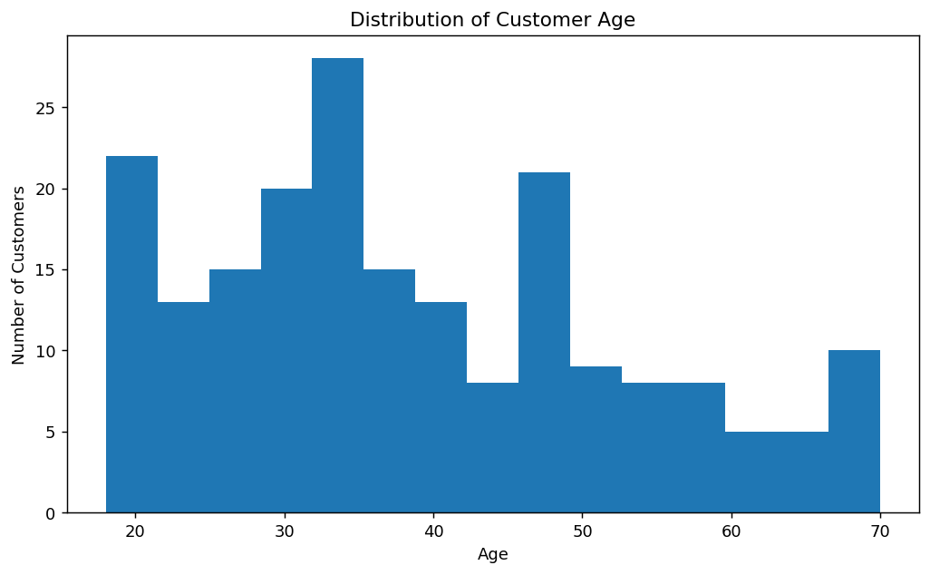
Figure 1. Distribution of customer age.
The average customer age is 38.85 years, while the median is 36.00 years. The distribution shows customers across a broad age range rather than a single demographic group. This variability makes age useful for distinguishing customer segments, although it should be interpreted together with income and spending behavior.

5.2 Annual Income Distribution
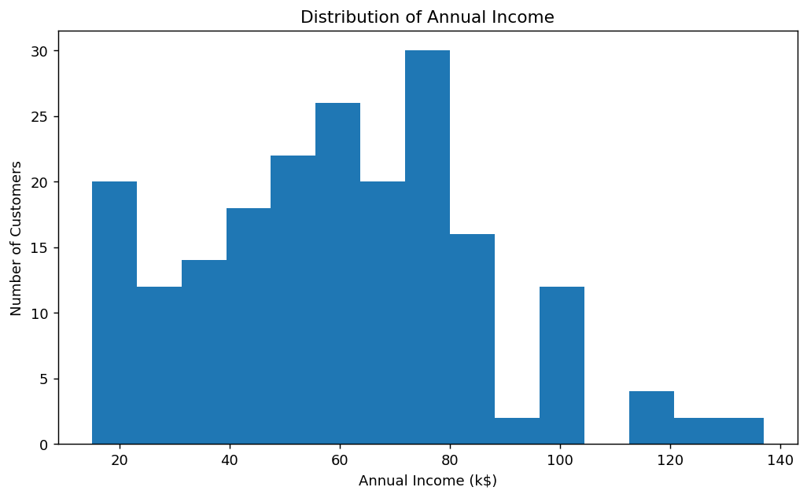
Figure 2. Distribution of annual income.
Annual income ranges from 15 k$ to 137 k$, with an average of 60.56 k$. The wide range indicates substantial variation in purchasing capacity, making income an important segmentation variable.

5.3 Spending Score Distribution
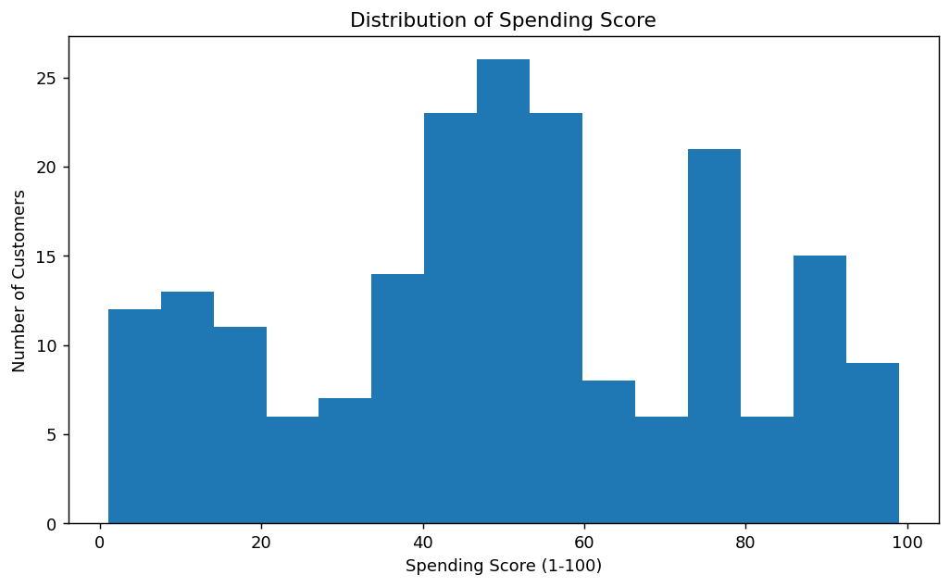
Figure 3. Distribution of spending score.
Spending Score ranges from 1 to 99, with an average of 50.20. The spread of scores indicates that customers differ considerably in observed spending behavior, which is especially useful for segmentation.

5.4 Income and Spending Relationship
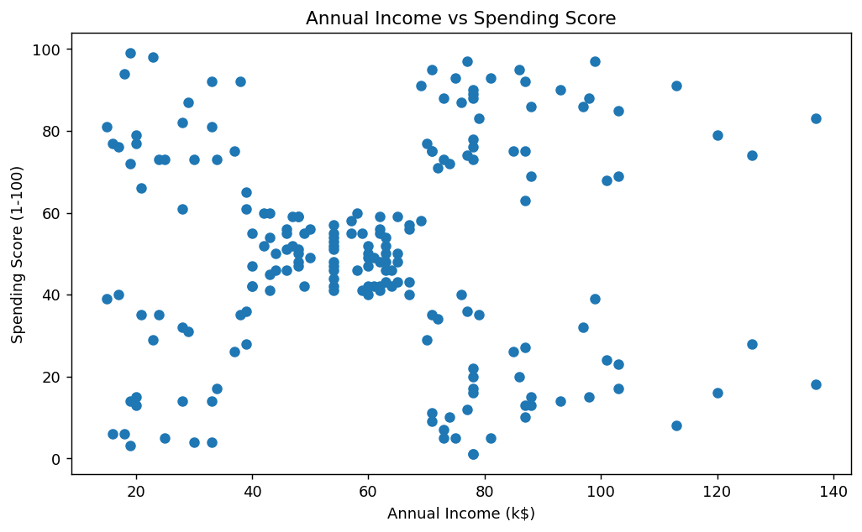
Figure 4. Annual income versus spending score before clustering.
The scatter plot indicates that income alone does not determine spending behavior. Customers with similar income levels can have noticeably different spending scores. This supports using both income and spending score together rather than relying on a single feature.

6. Feature Selection and Preprocessing
Age, Annual Income (k$), and Spending Score (1–100) were selected because they describe three complementary aspects of customer segmentation: demographic age, purchasing capacity, and observed spending behavior. CustomerID was excluded because it is an identifier and has no meaningful behavioral distance. Gender was retained for later descriptive analysis but was not encoded into the primary K-Means feature matrix.
clustering_features = [
"Age",
"Annual Income (k$)",
"Spending Score (1-100)"
]
X = df[clustering_features].copy()

6.1 Outlier Assessment
Feature | Q1 | Q3 | IQR | Lower Bound | Upper Bound | Potential Outliers
Age | 28.75 | 49.0 | 20.25 | -1.62 | 79.38 | 0
Annual Income (k$) | 41.5 | 78.0 | 36.5 | -13.25 | 132.75 | 2
Spending Score (1-100) | 34.75 | 73.0 | 38.25 | -22.62 | 130.38 | 0

Potential IQR outliers were assessed but not automatically removed. In customer segmentation, an unusually high income or spending score can represent a genuine customer segment rather than a data-entry error. Removing such observations could therefore eliminate meaningful business groups. The observations were retained and standardized before clustering.

6.2 Feature Scaling
scaler = StandardScaler()
X_scaled = scaler.fit_transform(X)
StandardScaler was applied because K-Means relies on distance calculations. The selected features are measured on different numerical ranges, so scaling prevents a feature from receiving disproportionate influence simply because its raw numbers are larger. The scaled matrix is used for model fitting, while original units are retained for cluster interpretation.

7. Determining the Number of Clusters

7.1 Elbow Method
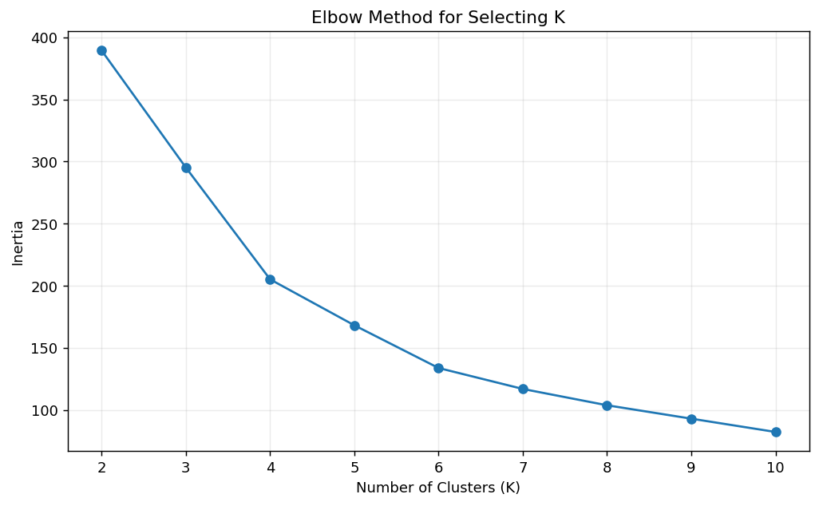
Figure 5. Elbow Method using K values from 2 to 10.
The Elbow Method evaluates the reduction in within-cluster variation, represented by inertia, as K increases. Inertia decreases as more clusters are introduced, but the practical objective is to identify a point where additional clusters provide diminishing improvement.

7.2 Silhouette Score
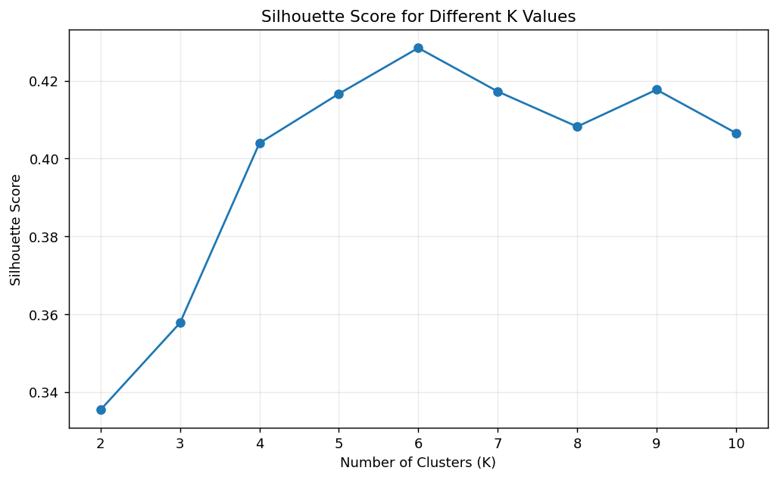
Figure 6. Silhouette scores for K values from 2 to 10.
K | Silhouette Score
2.0 | 0.3355
3.0 | 0.3578
4.0 | 0.404
5.0 | 0.4166
6.0 | 0.4284
7.0 | 0.4172
8.0 | 0.4082
9.0 | 0.4177
10.0 | 0.4066

The highest silhouette score among the tested values occurs at K=6, with a score of 0.4284. Silhouette analysis provides quantitative evidence for selecting the number of clusters, while the Elbow Method provides a complementary view of within-cluster compactness. Based on these evaluations, K=6 was selected for the final model.

8. K-Means Clustering
final_kmeans = KMeans(
n_clusters=best_k,
random_state=42,
n_init=10
)
cluster_labels = final_kmeans.fit_predict(X_scaled)
df_clustered["Cluster"] = cluster_labels
The final K-Means model was fitted with K=6, random_state=42, and n_init=10. The random state makes the result reproducible, while multiple initializations reduce dependence on a single starting set of centroids. The resulting clustering achieved a silhouette score of 0.4284.

9. Cluster Distribution
Cluster | Customer Count | Percentage
0 | 45 | 22.50%
1 | 39 | 19.50%
2 | 33 | 16.50%
3 | 39 | 19.50%
4 | 23 | 11.50%
5 | 21 | 10.50%

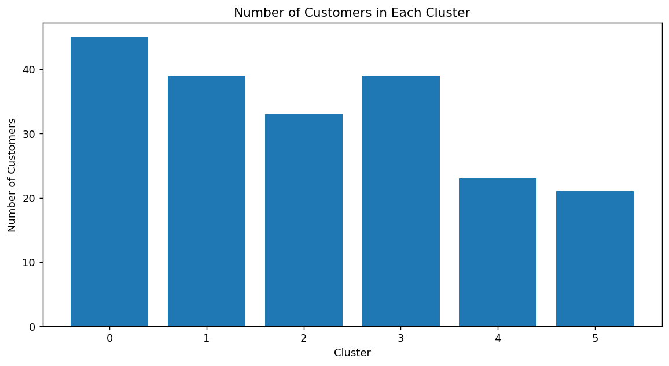
Figure 7. Number of customers assigned to each cluster.
The largest segment is Cluster 0 with 45 customers (22.50%), while the smallest is Cluster 5 with 21 customers (10.50%). The distribution is not perfectly equal, which is expected because K-Means forms groups according to similarity rather than forcing equal group sizes.

10. Detailed Cluster Profiles
Table: Mean customer characteristics by cluster
Cluster | Customer Count | Age | Annual Income (k$) | Spending Score (1-100)
0.0 | 45.0 | 56.33 | 54.27 | 49.07
1.0 | 39.0 | 26.79 | 57.1 | 48.13
2.0 | 33.0 | 41.94 | 88.94 | 16.97
3.0 | 39.0 | 32.69 | 86.54 | 82.13
4.0 | 23.0 | 25.0 | 25.26 | 77.61
5.0 | 21.0 | 45.52 | 26.29 | 19.38

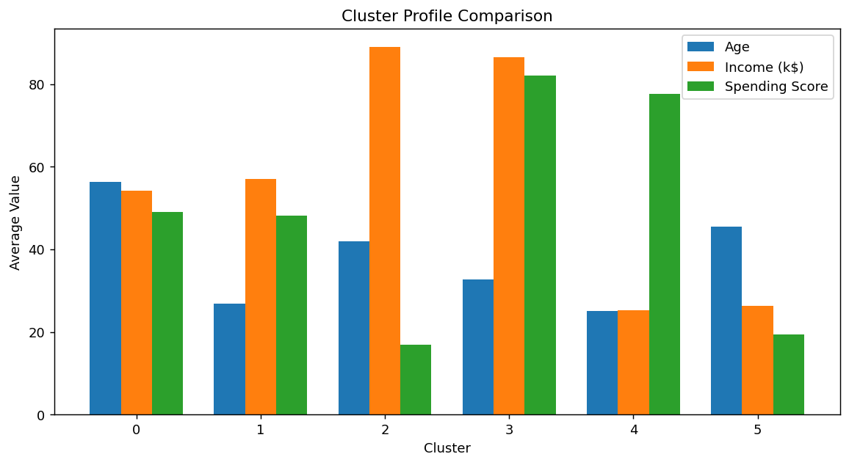
Figure 8. Average feature values across clusters.

11. Cluster-by-Cluster Interpretation

11.1 Cluster 0 — Mature Moderate Customers
This cluster contains 45 customers (22.50% of the dataset). The average age is 56.33 years, average annual income is 54.27 k$, and average spending score is 49.07.
Compared with the full dataset, age is 17.48 units above the overall average; income is 6.29 units below the overall average; spending score is 1.13 units below the overall average.
Business interpretation: This segment represents relatively older customers with moderate income and moderate spending. Marketing can emphasize convenience, retention, and products aligned with established customer needs rather than aggressive acquisition offers.
Gender composition: Female 57.78%, Male 42.22%. Gender is reported as a descriptive characteristic and was not used as the numerical distance feature for K-Means.

11.2 Cluster 1 — Young Moderate Customers
This cluster contains 39 customers (19.50% of the dataset). The average age is 26.79 years, average annual income is 57.10 k$, and average spending score is 48.13.
Compared with the full dataset, age is 12.06 units below the overall average; income is 3.46 units below the overall average; spending score is 2.07 units below the overall average.
Business interpretation: These younger customers show moderate income and spending. They may respond to engagement campaigns, introductory offers, and products that encourage longer-term customer relationships.
Gender composition: Female 64.10%, Male 35.90%. Gender is reported as a descriptive characteristic and was not used as the numerical distance feature for K-Means.

11.3 Cluster 2 — High-Income Low-Spending Customers
This cluster contains 33 customers (16.50% of the dataset). The average age is 41.94 years, average annual income is 88.94 k$, and average spending score is 16.97.
Compared with the full dataset, age is 3.09 units above the overall average; income is 28.38 units above the overall average; spending score is 33.23 units below the overall average.
Business interpretation: This segment combines the highest average income among the six groups with a low spending score. It may represent an opportunity for targeted conversion strategies, premium recommendations, personalized offers, or campaigns designed to increase engagement.
Gender composition: Female 42.42%, Male 57.58%. Gender is reported as a descriptive characteristic and was not used as the numerical distance feature for K-Means.

11.4 Cluster 3 — High-Income High-Spending Customers
This cluster contains 39 customers (19.50% of the dataset). The average age is 32.69 years, average annual income is 86.54 k$, and average spending score is 82.13.
Compared with the full dataset, age is 6.16 units below the overall average; income is 25.98 units above the overall average; spending score is 31.93 units above the overall average.
Business interpretation: This is a high-income, high-spending segment. It is potentially the strongest value segment for premium offerings, loyalty programs, personalized recommendations, and customer-retention strategies.
Gender composition: Female 53.85%, Male 46.15%. Gender is reported as a descriptive characteristic and was not used as the numerical distance feature for K-Means.

11.5 Cluster 4 — Young High-Spending Customers
This cluster contains 23 customers (11.50% of the dataset). The average age is 25.00 years, average annual income is 25.26 k$, and average spending score is 77.61.
Compared with the full dataset, age is 13.85 units below the overall average; income is 35.30 units below the overall average; spending score is 27.41 units above the overall average.
Business interpretation: These customers have relatively low average income but high spending behavior. Promotions, affordability-focused products, and engagement strategies could be useful, while businesses should consider the sustainability of high spending relative to income.
Gender composition: Female 56.52%, Male 43.48%. Gender is reported as a descriptive characteristic and was not used as the numerical distance feature for K-Means.

11.6 Cluster 5 — Low-Income Low-Spending Customers
This cluster contains 21 customers (10.50% of the dataset). The average age is 45.52 years, average annual income is 26.29 k$, and average spending score is 19.38.
Compared with the full dataset, age is 6.67 units above the overall average; income is 34.27 units below the overall average; spending score is 30.82 units below the overall average.
Business interpretation: This group has both low average income and low spending. Broad premium marketing may be less effective; value-oriented products and cost-sensitive promotions may be more appropriate.
Gender composition: Female 61.90%, Male 38.10%. Gender is reported as a descriptive characteristic and was not used as the numerical distance feature for K-Means.

12. Cluster Visualization
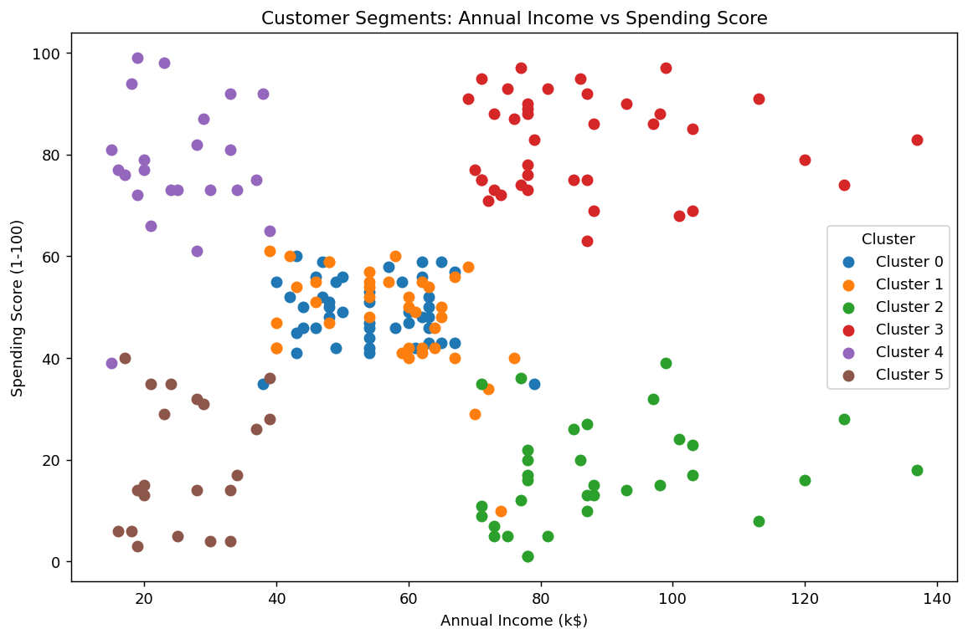
Figure 9. Final customer clusters using annual income and spending score.
The income-versus-spending visualization shows how the six groups separate into distinct behavioral regions. In particular, high-income customers are divided into low-spending and high-spending groups, while lower-income customers are also divided according to spending behavior. This demonstrates why combining multiple variables is more informative than segmenting customers using income alone.

13. Transformations and Aggregations
Two main transformations were used in the clustering workflow. First, StandardScaler transformed the selected numerical features to comparable standardized scales for distance-based K-Means calculations. Second, cluster labels produced by K-Means were added to the original dataset so that each customer could be associated with a segment.
cluster_profile = (
df_clustered
.groupby("Cluster")[clustering_features]
.mean()
.round(2)
)
Grouped aggregation was used to calculate mean age, mean annual income, and mean spending score for each cluster. These averages summarize the central characteristics of each segment and make cluster-to-cluster comparisons easier. Customer counts and percentages were also calculated to understand the size of each segment.

14. Business and Research Implications
The segmentation provides a simple framework for differentiated customer strategies. The high-income/high-spending segment can be prioritized for retention and premium services, while the high-income/low-spending segment can be studied for barriers to conversion or engagement. The young/high-spending group may be relevant for campaigns aimed at maintaining engagement, whereas the low-income/low-spending segment may be more responsive to value-oriented strategies.
These interpretations are descriptive rather than causal. The clustering identifies groups with similar observed characteristics; it does not prove that income, age, or any other feature causes a particular spending behavior. Business decisions should therefore combine these segments with additional information such as purchase history, product categories, customer tenure, or campaign response when available.

15. Limitations
- The dataset contains only a small number of customer attributes, so the clusters may not capture all dimensions of customer behavior.
- K-Means assumes that cluster structure can be represented effectively using distance to centroids; different algorithms could produce different groupings.
- The selected K is supported by Elbow and Silhouette analysis, but cluster validity also depends on the practical purpose of segmentation.
- The dataset is observational and clustering results should not be interpreted as causal relationships.
- Gender was used only for post-clustering descriptive analysis and therefore does not influence the K-Means distance calculations.

16. Conclusion
The project successfully applied K-Means clustering to segment 200 customers into 6 groups using Age, Annual Income, and Spending Score. Feature scaling was applied to make the distance calculations comparable, and K values from 2 to 10 were evaluated using the Elbow Method and Silhouette Score. K=6 produced the highest tested silhouette score of 0.4284.
The resulting clusters show meaningful differences in age, income, and spending behavior. The detailed cluster profiles provide interpretable customer segments that can support differentiated marketing and customer-management strategies. The analysis also demonstrates the importance of combining quantitative cluster evaluation with practical interpretation rather than selecting a clustering solution without justification.

17. Final Outputs
- Yuva_Week3_Mall_Customer_Clustering.ipynb — completed Google Colab notebook.
- Mall_Customers.csv — source dataset used for the analysis.
- Mall_Customers_Clustered.csv — final dataset containing the assigned Cluster labels.
- Yuva_Week3_Mall_Customer_Clustering_Report.docx — this detailed report.

Appendix A — Key Code Snippets
The following snippets summarize the core implementation used in the notebook.
# Feature selection
clustering_features = [
"Age",
"Annual Income (k$)",
"Spending Score (1-100)"
]
X = df[clustering_features].copy()
# Scaling
scaler = StandardScaler()
X_scaled = scaler.fit_transform(X)
# Evaluate K values
for k in range(2, 11):
kmeans = KMeans(n_clusters=k, random_state=42, n_init=10)
labels = kmeans.fit_predict(X_scaled)
score = silhouette_score(X_scaled, labels)
# Final clustering
final_kmeans = KMeans(
n_clusters=best_k,
random_state=42,
n_init=10
)
cluster_labels = final_kmeans.fit_predict(X_scaled)
df_clustered["Cluster"] = cluster_labels
# Cluster profiling
cluster_profile = (
df_clustered
.groupby("Cluster")[clustering_features]
.mean()
.round(2)
)

