YUVA VIRTUAL DATA SCIENCE WITH PYTHON TRAINEE
WEEK 1 PROJECT REPORT
Data Acquisition, Cleaning, and Preprocessing

Project: Titanic Dataset Analysis
Python • Pandas • NumPy • Matplotlib • Seaborn • Scikit-learn • Google Colab

1. Introduction
This project was completed for Week 1 of the Yuva Virtual Data Science with Python Trainee internship. The task focuses on acquiring a public dataset, understanding its structure, identifying data-quality issues, cleaning the data, checking inconsistencies and outliers, and preparing the data for subsequent analysis.

2. Objective
- Acquire and inspect a publicly available dataset using Python.
- Understand the dataset dimensions, columns, and data types.
- Identify and handle missing values and duplicate records.
- Check categorical variables for consistency.
- Detect numerical outliers using the IQR method.
- Treat extreme values while retaining useful observations.
- Prepare a cleaned dataset suitable for further data-science work.

3. Dataset and Initial Inspection
The Titanic dataset was loaded using Seaborn's built-in dataset loader. The initial dataset contained 891 rows and 15 columns. The notebook used head(), shape, columns, and info() to inspect the data before cleaning.
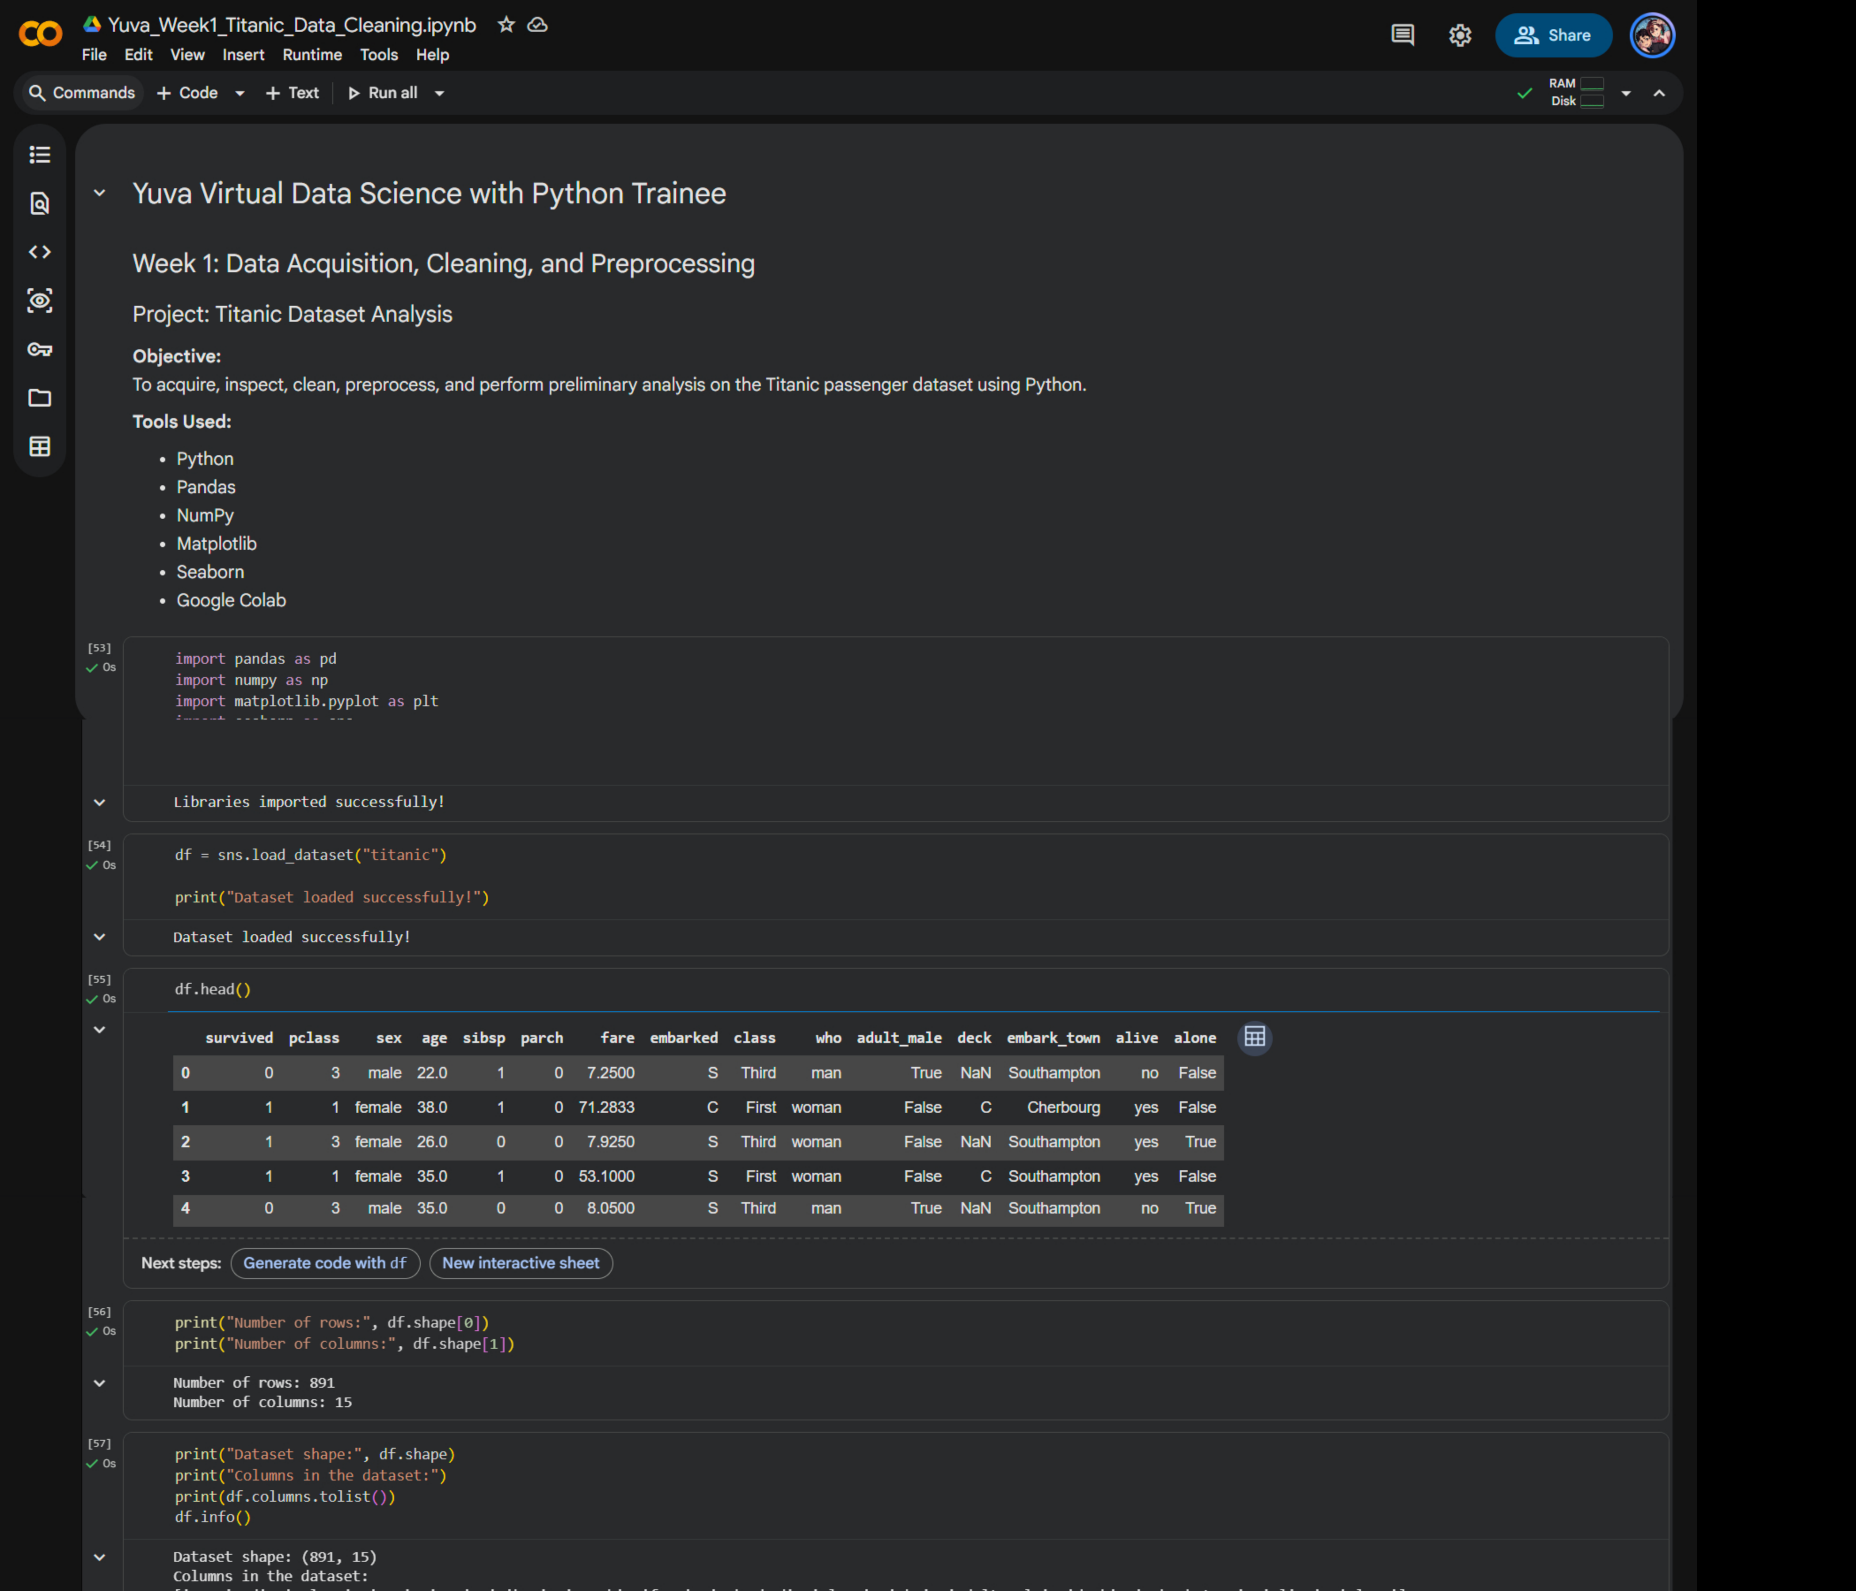
Figure 1. Google Colab evidence showing project setup, dataset loading, sample records, dimensions, and initial schema.

4. Missing Value Analysis
Missing values were quantified using Pandas isnull().sum() and converted into percentages. The notebook identified 177 missing values in age (19.87%), 2 in embarked (0.22%), 688 in deck (77.22%), and 2 in embark_town (0.22%) before cleaning.
Column | Missing before cleaning | Treatment shown in notebook
age | 177 (19.87%) | Median imputation
embarked | 2 (0.22%) | Mode imputation
deck | 688 (77.22%) | Column removed
embark_town | 2 (0.22%) | Not explicitly imputed; later represented as 'nan' during text standardization
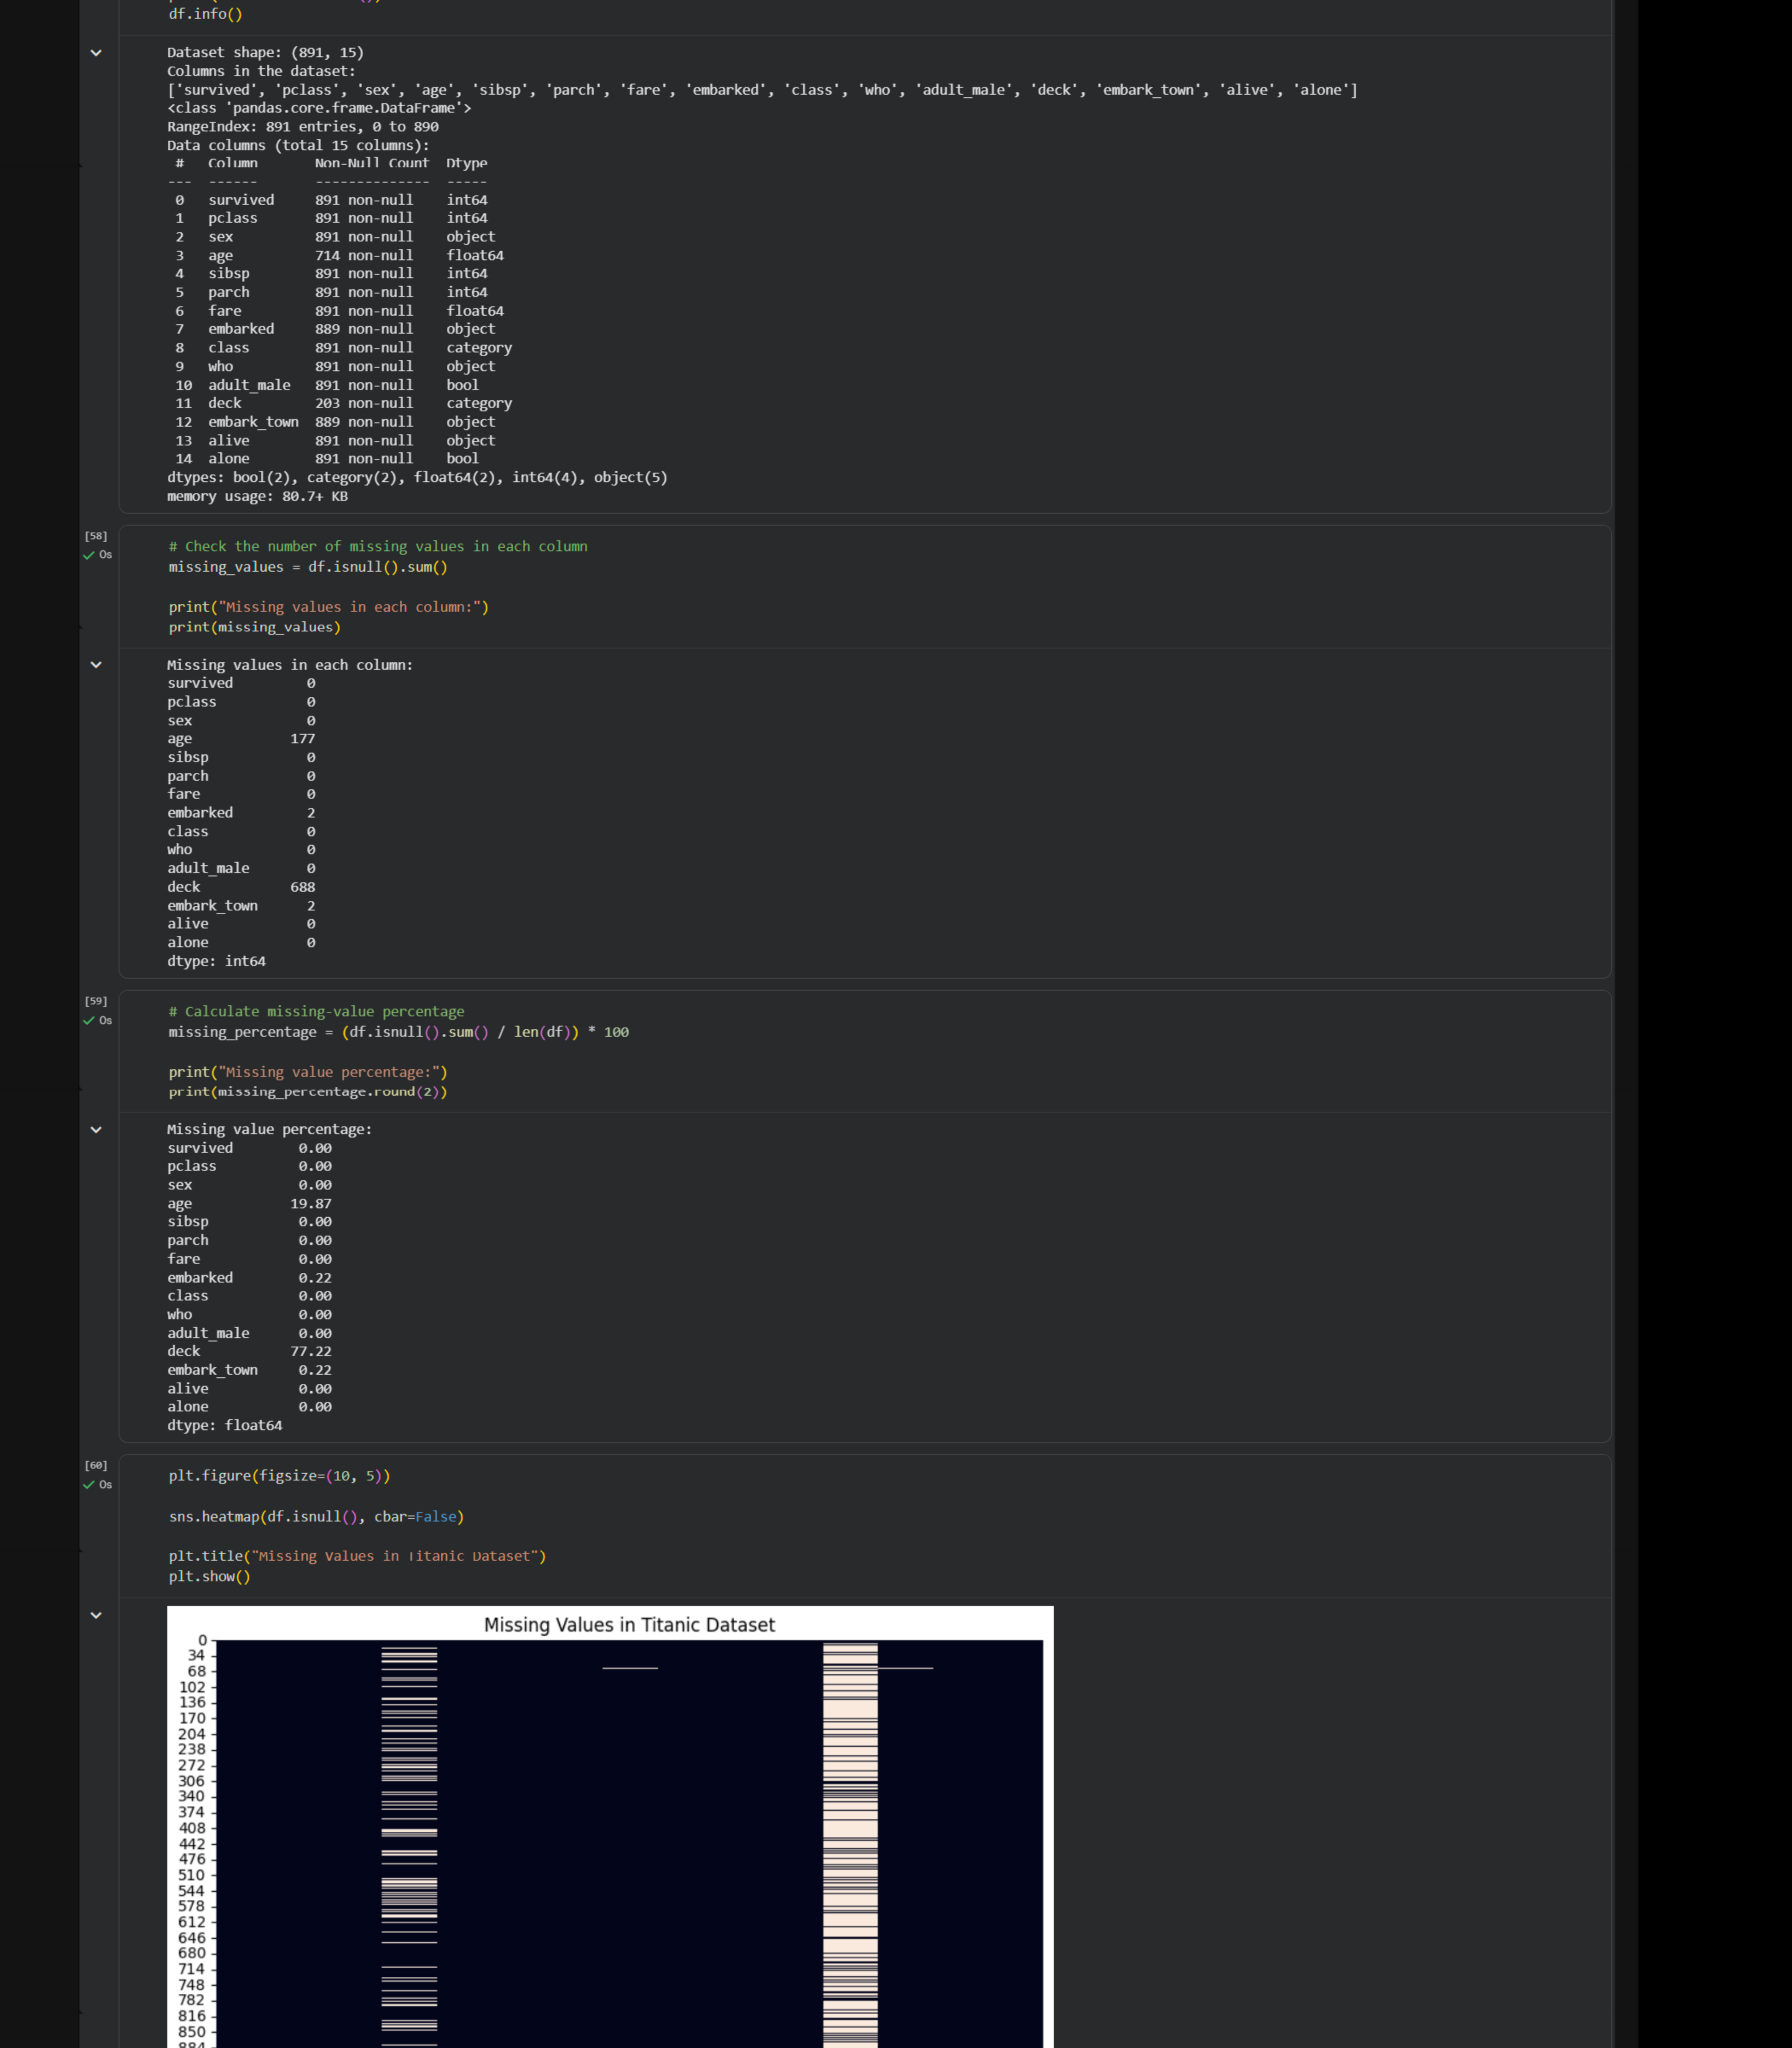
Figure 2. Missing-value counts, percentages, and heatmap from the completed Colab notebook.

5. Missing Value Treatment
The age column was filled using its median, which is a robust measure for numerical imputation. The embarked column was filled using its mode. The deck column was removed because 688 of the original 891 records were missing that attribute. The notebook output confirms that age and embarked had zero null values after their respective treatments.
A data-quality note is important for the final report: embark_town originally had two missing values. The categorical-standardization code converted missing entries to the literal string 'nan'. Therefore, a future refinement should explicitly impute or remove those two values rather than treating the text 'nan' as a valid category.

6. Duplicate Detection
Duplicate rows were checked using duplicated().sum(). The notebook found 116 duplicate rows. These rows were removed using drop_duplicates(), leaving 775 rows and 14 columns in the working dataset. A subsequent check confirmed zero duplicate rows remaining.
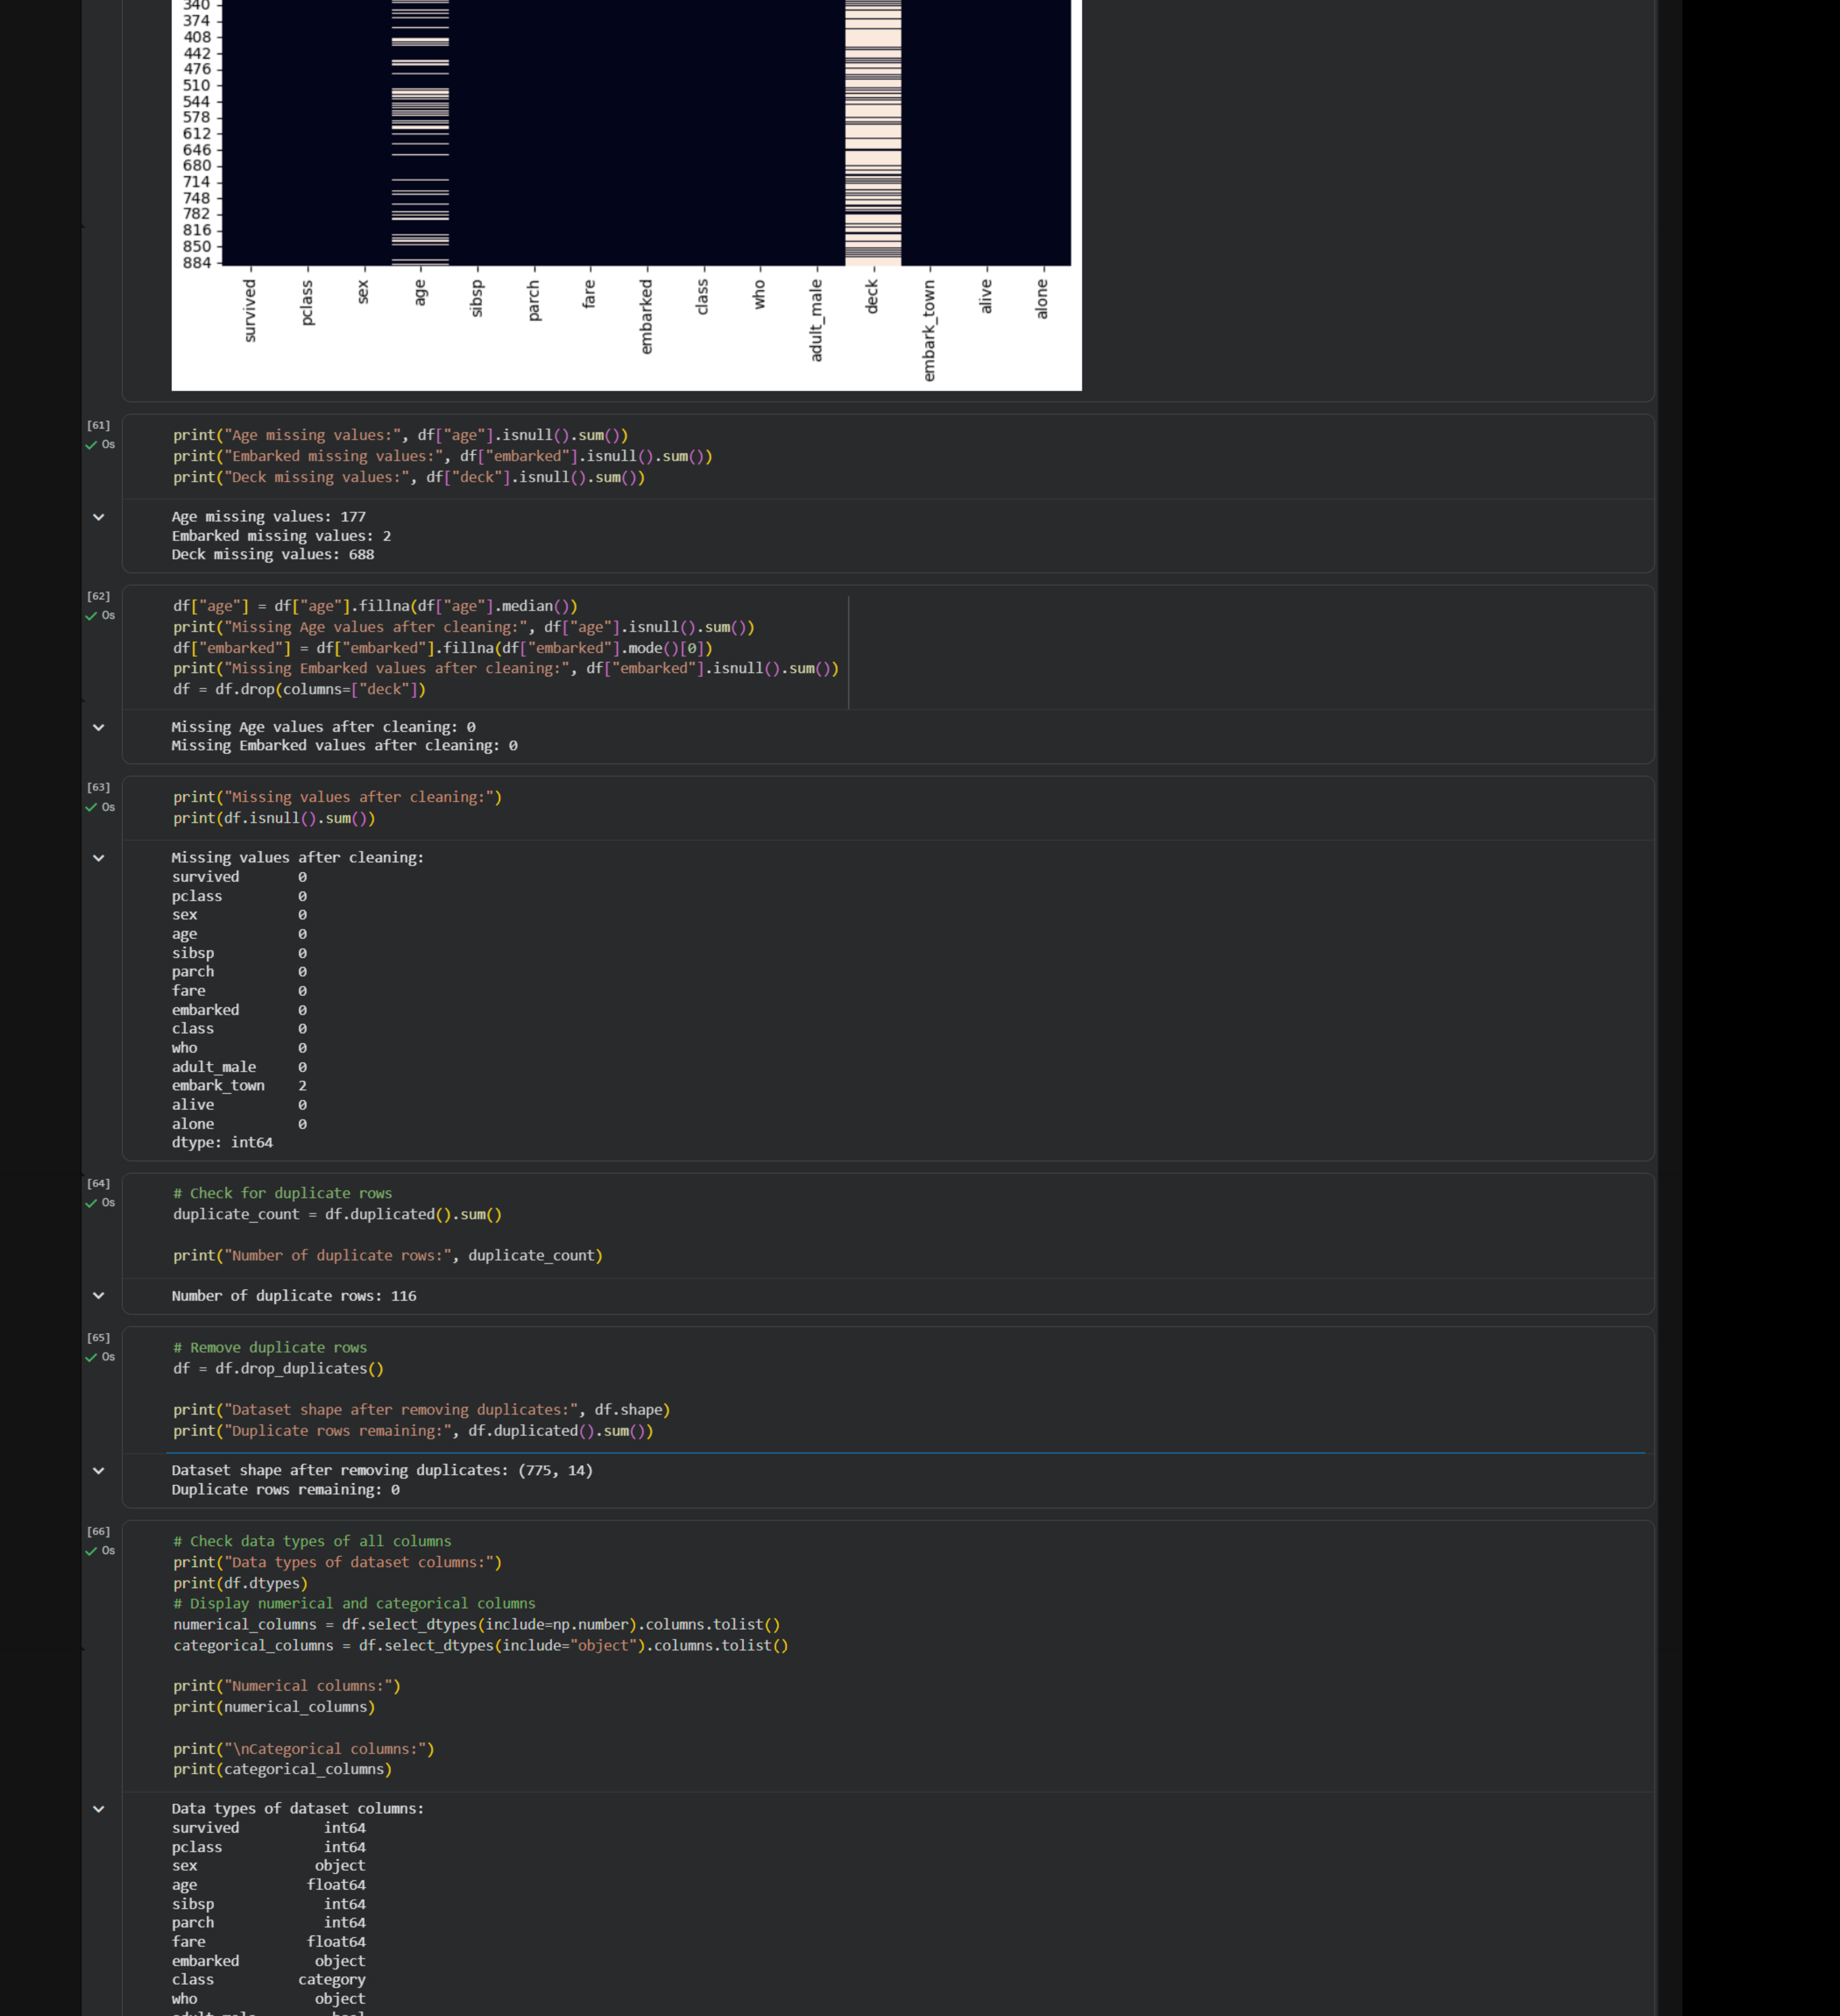
Figure 3. Duplicate detection/removal and data-type inspection evidence.

7. Data Type and Categorical Consistency Checks
The notebook inspected data types and separated numerical and categorical variables. The numerical columns identified were survived, pclass, age, sibsp, parch, and fare. The object-type categorical columns identified were sex, embarked, who, embark_town, and alive. Unique values and frequency counts were then reviewed.
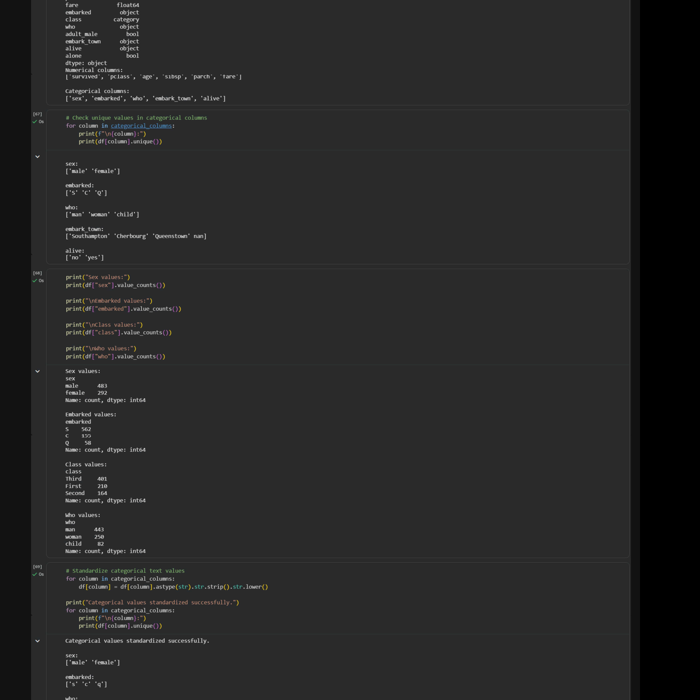
Figure 4. Categorical unique-value checks, frequency counts, text standardization, and statistical summary evidence.

8. Statistical Summary
After duplicate removal, the numerical summary was calculated for 775 observations. The notebook reports a mean age of approximately 29.58 years and a median age of 28 years. Fare has a mean of approximately 34.88 before the displayed IQR treatment. The maximum observed age was 80 years and the maximum fare was 512.3292 before capping.

9. Outlier Detection Using IQR
Potential outliers were identified for age, fare, sibsp, and parch using the Interquartile Range (IQR) rule. The notebook reported 27 potential outliers for age, 102 for fare, 39 for sibsp, and 15 for parch. Boxplots were generated to visually inspect the distributions and extreme observations.
Variable | Potential outliers identified
age | 27
fare | 102
sibsp | 39
parch | 15
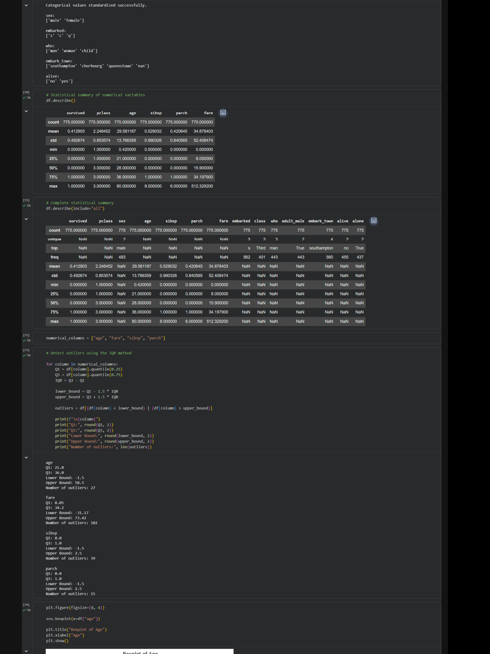
Figure 5. Numerical/statistical summary and IQR-based outlier detection output, including the Age boxplot.

10. Outlier Treatment
For the continuous variables age and fare, the notebook applied IQR capping. Values below the calculated lower bound or above the upper bound were clipped to the respective bounds. This method reduces the influence of extreme observations while preserving the passenger records.
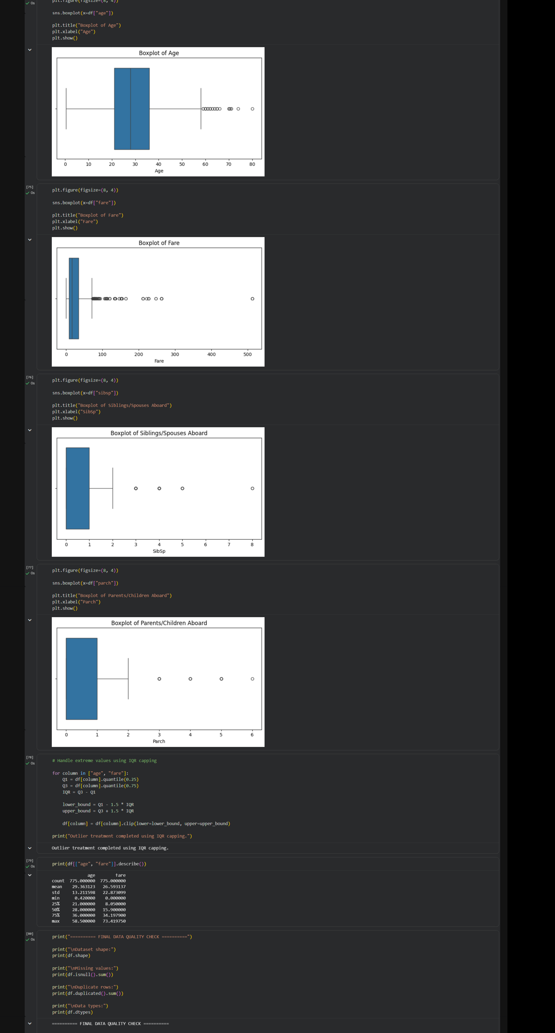
Figure 6. Boxplots for age, fare, sibsp, and parch, followed by IQR capping and the final data-quality-check cell.

11. Cleaning Summary
Data-quality issue | Action | Outcome
Age missingness | Median imputation | 177 missing values addressed
Embarked missingness | Mode imputation | 2 missing values addressed
Deck missingness | Column removal | Highly incomplete attribute removed
Duplicate rows | drop_duplicates() | 116 duplicates removed; 775 rows remained
Categorical formatting | strip() + lower() | Text representation standardized
Numerical outliers | IQR analysis + capping for age/fare | Extreme continuous values capped

12. Conclusion
The Week 1 data acquisition, inspection, and cleaning workflow was implemented in Google Colab using Python. The Titanic dataset was inspected from its original 891-row, 15-column form, missing values were analyzed and treated where specified, 116 duplicate records were removed, categorical values were reviewed and standardized, and potential outliers were identified with the IQR method. IQR capping was applied to age and fare to reduce the effect of extreme values while retaining records. The resulting working dataset contained 775 rows and 14 columns. The notebook provides a strong foundation for subsequent exploratory analysis and machine-learning work. One remaining data-quality consideration is the two original embark_town missing values, which should be handled explicitly before treating that feature as fully clean.

13. Evidence and Reproducibility
All figures in this report were cropped from the user's exported Google Colab notebook PDF. The evidence shows the executed code and outputs used during the Week 1 workflow. The source file was a one-page rendered Colab notebook containing the project setup, data inspection, missing-value analysis, duplicate handling, categorical checks, statistical summary, IQR outlier analysis, boxplots, and outlier capping. fileciteturn0file0L1-L2

14. References
- Seaborn — statistical data visualization and example datasets.
- Pandas — data manipulation and analysis.
- NumPy — numerical computing.
- Matplotlib — visualization.
- Scikit-learn — preprocessing utilities.

