Week 3 – Statistical Analysis & Predictive Modeling
Telco Customer Churn Analysis using R

Virtual R Data Analyst Internship
Dataset: Telco Customer Churn | Records: 7,043 | Target: Churn

Statistical testing • Correlation analysis • Logistic regression • Cross-validation • Model evaluation

1. Executive Summary
This Week 3 project extends the earlier Telco Customer Churn analysis from descriptive visualization to statistical inference and predictive modeling. The analysis uses 7,043 customer records and a binary Churn outcome. Data quality checks found no missing values and no duplicate records in the cleaned dataset.
The statistical analysis found strong evidence of differences in monthly charges between churned and retained customers, and strong associations between churn and both contract type and internet service. Correlation testing also showed a strong relationship between tenure and total charges.
A logistic regression model was evaluated using an 80/20 train-test split and 5-fold cross-validation. The final test-set accuracy was 79.82%, with sensitivity/recall of 51.21%, specificity of 90.14%, precision of 65.19%, F1 score of 0.5736, and ROC-AUC of 0.8338. The cross-validation ROC score was approximately 0.8412.
The results indicate that the model separates churn and non-churn customers reasonably well, while its lower sensitivity shows that a substantial portion of actual churners are still missed. This distinction is important because accuracy alone would not fully describe the usefulness of a churn-detection model.

2. Objectives
- Prepare and validate the Telco Customer Churn dataset for statistical analysis.
- Describe the distributions of important numerical variables.
- Test hypotheses concerning churn and customer characteristics.
- Measure correlations between important numerical variables.
- Check distributional assumptions and potential multicollinearity.
- Build a binary logistic regression model for churn prediction.
- Use an 80/20 train-test split and 5-fold cross-validation.
- Evaluate the classifier with a confusion matrix, accuracy, sensitivity, specificity, precision, recall, F1 and ROC-AUC.
- Identify practical strengths and improvement areas for the predictive model.

3. Dataset and Data Preparation
The project uses the Telco Customer Churn dataset containing customer demographic, service, contract, billing and churn information. The cleaned Week 3 dataset contains 7,043 rows and 21 original variables.
Data-quality check | Result
Rows | 7,043
Original variables | 21
Missing values after cleaning | 0
Duplicate rows | 0
Churn = No | 5,174 (73.46%)
Churn = Yes | 1,869 (26.54%)
Total Charges was converted to numeric form and missing numeric values were handled during preprocessing. Categorical variables were converted to factors, and the target variable Churn was represented as a binary outcome for logistic regression.

4. Descriptive Statistical Analysis
The main numerical variables examined were tenure, monthly charges and total charges. Their overall means were approximately 32.37 months, 64.76 monetary units per month and 2,279.73 total charges respectively.
Variable | Mean | Interpretation
Tenure | 32.37 months | Average customer relationship duration
Monthly Charges | 64.76 | Average recurring monthly charge
Total Charges | 2,279.73 | Cumulative charges across the customer relationship
The churn distribution is imbalanced toward non-churn customers: 73.46% are classified as No and 26.54% as Yes. This imbalance makes sensitivity, specificity, precision and F1 important alongside accuracy.

5. Hypothesis Testing

5.1 Monthly Charges and Churn – Welch t-test
A Welch two-sample t-test was used to compare monthly charges between customers who churned and those who did not. The mean monthly charge was 61.27 for customers who did not churn and 74.44 for customers who churned. The test returned t = -18.408, df = 4135.8, p < 2.2 × 10⁻¹⁶.
Interpretation: the observed difference in average monthly charges is statistically significant. The group means also show a practically visible difference of about 13.18 charge units per month. This provides evidence that monthly billing level is associated with churn at the univariate level.

5.2 Contract Type and Churn – Chi-square Test
The chi-square test of independence between contract type and churn returned χ² = 1184.6 with 2 degrees of freedom and p < 2.2 × 10⁻¹⁶.
Contract | No Churn | Churn | Observed churn rate
Month-to-month | 2,220 | 1,655 | 42.70%
One year | 1,307 | 166 | 11.27%
Two year | 1,647 | 48 | 2.83%
The observed rates differ substantially across contract categories. The result supports a strong statistical association between contract type and churn in this dataset. This is an association, not proof that contract type alone causes churn.

5.3 Internet Service and Churn – Chi-square Test
The chi-square test for internet service and churn returned χ² = 732.31 with 2 degrees of freedom and p < 2.2 × 10⁻¹⁶.
Internet service | No Churn | Churn | Observed churn rate
DSL | 1,962 | 459 | 18.96%
Fiber optic | 1,799 | 1,297 | 41.89%
No internet service | 1,413 | 113 | 7.40%
Fiber-optic customers show a markedly higher observed churn rate than the other two categories. The statistical test confirms that internet service and churn are not independent in this dataset.

6. Correlation and Assumption Analysis
Pearson correlation tests were used to quantify linear relationships among the main numerical variables.
Variable pair | Pearson r | Interpretation
Tenure – Total Charges | 0.8262 | Strong positive relationship
Tenure – Monthly Charges | 0.2479 | Weak-to-moderate positive relationship
Monthly Charges – Total Charges | 0.6512 | Moderate-to-strong positive relationship
All three correlation tests returned p < 2.2 × 10⁻¹⁶. The strongest relationship is between tenure and total charges, which is expected because total charges accumulate over time. This relationship is relevant to regression interpretation because highly related predictors can make individual coefficients less stable or harder to interpret.

6.1 Normality Checks
Shapiro-Wilk tests were applied to samples of the numerical variables. Tenure produced W = 0.90292 and monthly charges produced W = 0.92325, with p < 2.2 × 10⁻¹⁶ for both. Thus, normality is rejected for these variables. The large sample size also means the Shapiro-Wilk test is highly sensitive to deviations from normality.

6.2 Multicollinearity Check
Variance Inflation Factors (VIF/GVIF) were examined for the predictors in the final logistic regression model.
Variable | GVIF | Df | Adjusted GVIF
tenure | 16.252 | 1 | 4.031
monthly_charges | 8.632 | 1 | 2.938
total_charges | 20.832 | 1 | 4.564
contract | 1.539 | 2 | 1.114
internet_service | 6.230 | 2 | 1.580
payment_method | 1.343 | 3 | 1.050
senior_citizen | 1.125 | 1 | 1.061
partner | 1.373 | 1 | 1.172
dependents | 1.283 | 1 | 1.133
paperless_billing | 1.114 | 1 | 1.056
The adjusted GVIF values for tenure (4.03) and total charges (4.56) are the largest in the final model. They indicate moderate collinearity rather than an extreme problem under a commonly used threshold of 5. Because total charges are cumulative and strongly correlated with tenure, their individual regression coefficients should be interpreted with caution.

7. Statistical Visualizations
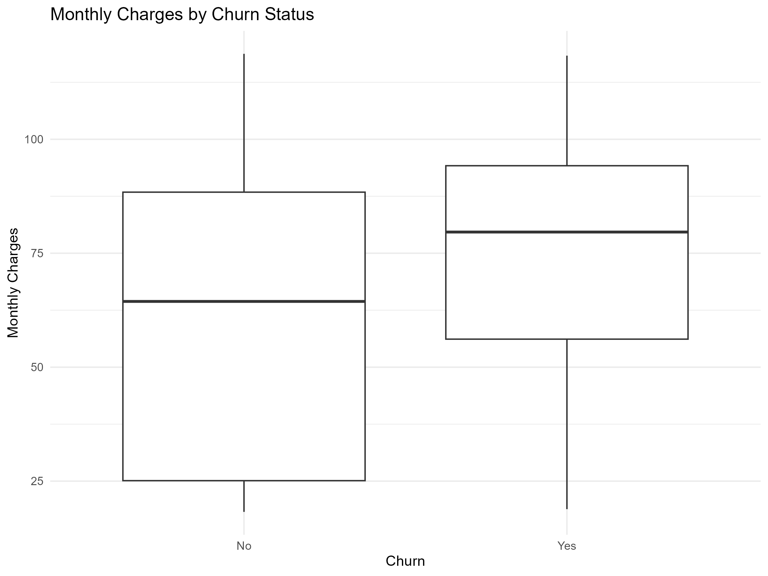
Figure 1. Monthly charges by churn status
The boxplot visually supports the statistical finding that churned customers tend to have higher monthly charges.
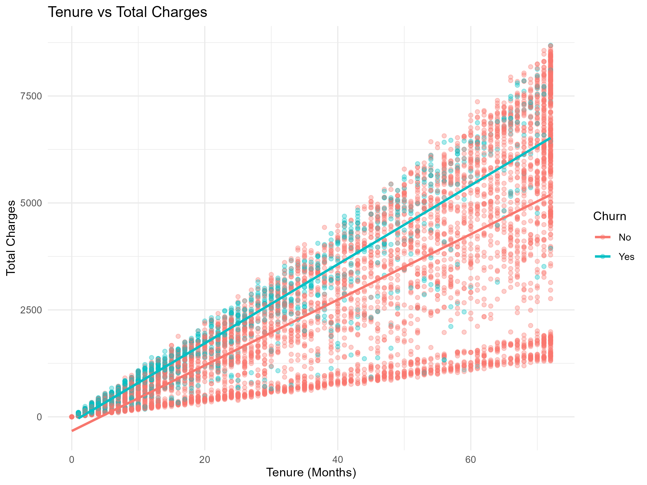
Figure 2. Tenure versus total charges
The strong upward relationship is consistent with the Pearson correlation of 0.8262.
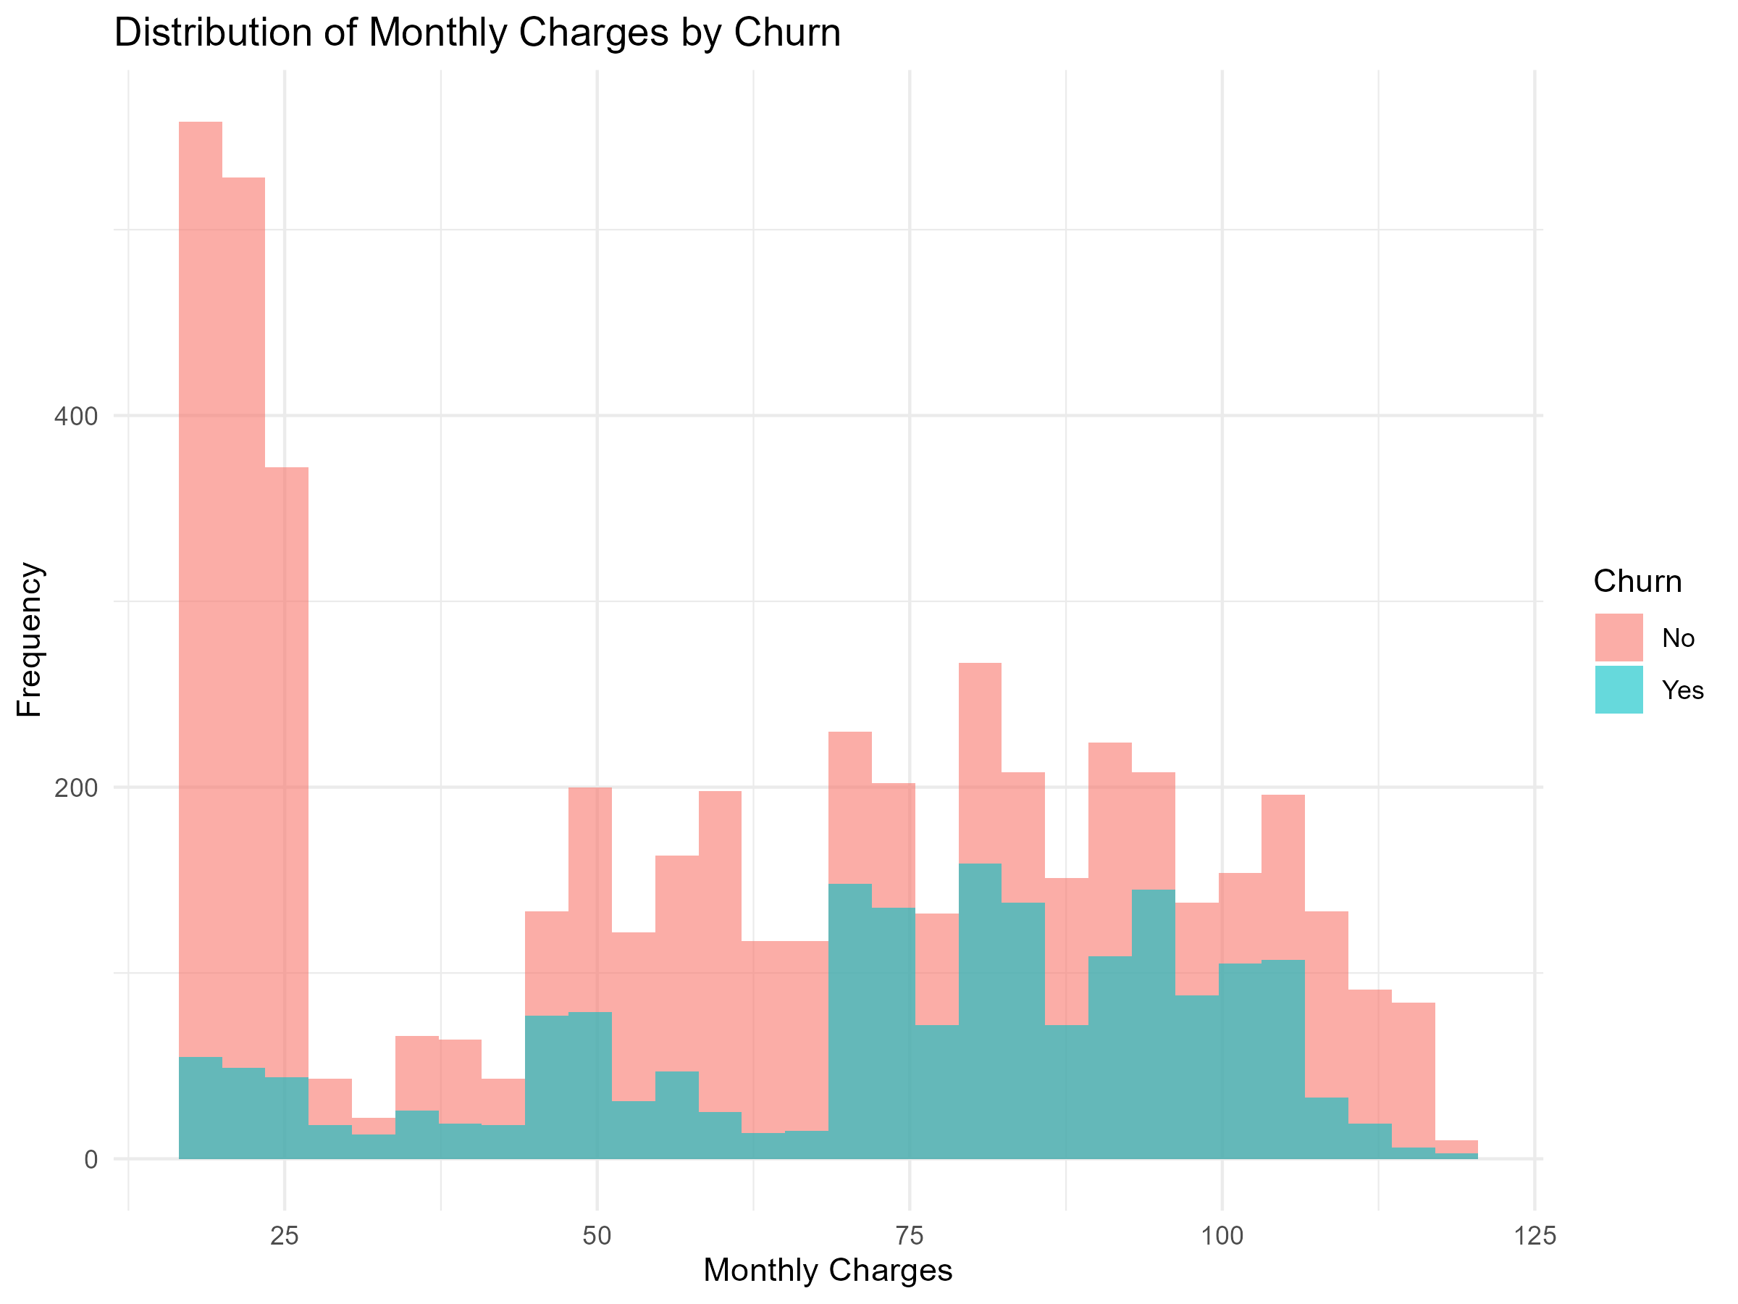
Figure 3. Monthly charges distribution
The distribution shows the spread and non-normal shape of monthly charges.
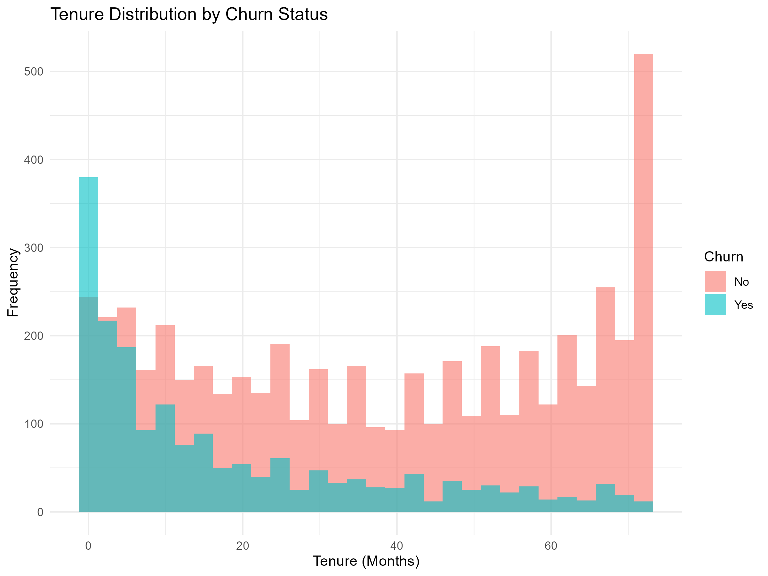
Figure 4. Tenure distribution
The tenure distribution shows that customer relationship duration is not normally distributed.

8. Predictive Modeling – Logistic Regression
Binary logistic regression was selected because the target variable has two outcomes: Churn = No and Churn = Yes. The final model uses tenure, monthly charges, total charges, contract, internet service, payment method, senior citizen status, partner status, dependents status and paperless billing.
An 80/20 stratified train-test split was used. The training set contains 5,636 observations and the test set contains 1,407 observations. Stratification helps preserve the class distribution across the two partitions.

8.1 Cross-validation
Five-fold cross-validation was performed on the training data using ROC as the optimization metric. The mean cross-validation ROC score was approximately 0.8412, with ROC standard deviation approximately 0.0083. The test-set AUC of 0.8338 is close to the cross-validation result, suggesting that the observed discrimination was reasonably consistent between the validation procedure and held-out test data.

8.2 Final Model Performance
Metric | Value
Accuracy | 0.7982 (79.82%)
Sensitivity / Recall | 0.5121 (51.21%)
Specificity | 0.9014 (90.14%)
Precision | 0.6519 (65.19%)
F1 Score | 0.5736
ROC-AUC | 0.8338
Kappa | 0.4438
AIC | 5962.58
The model has substantially higher specificity (90.14%) than sensitivity (51.21%). In practical terms, the model is better at identifying customers who remain than at capturing all customers who actually churn. The precision of 65.19% means that among customers predicted as churners, about two-thirds were actual churners in the test set.

9. Confusion Matrix and Classification Diagnostics
 | Actual Churn = Yes | Actual Churn = No
Predicted Yes | 191 | 102
Predicted No | 182 | 932
There were 373 actual churners in the test set. The model correctly identified 191 of them and missed 182. Among 1,034 non-churners, 932 were correctly identified and 102 were classified as churners. These counts explain why sensitivity is much lower than specificity.
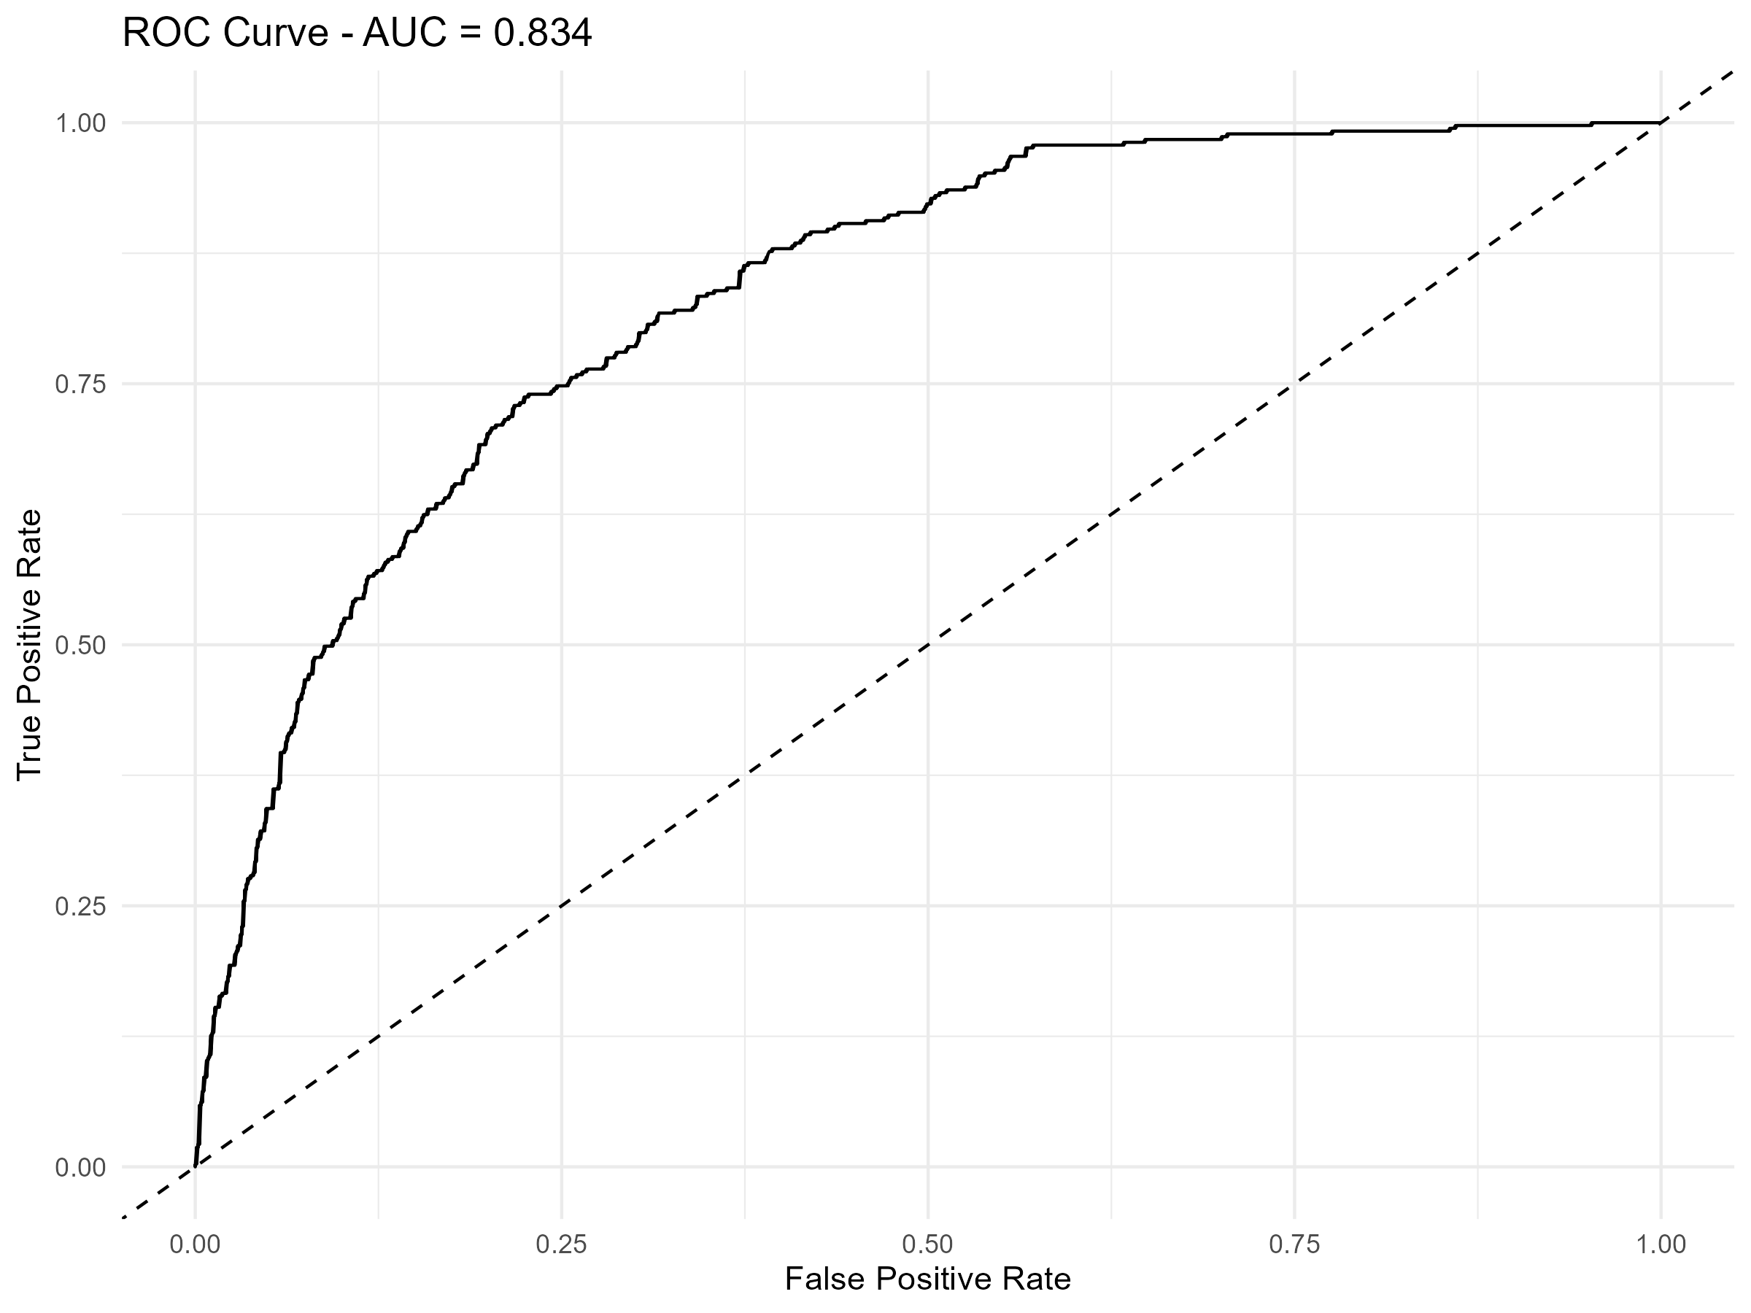
Figure 5. ROC curve for the final logistic regression model
The ROC curve has an AUC of 0.8338. AUC summarizes ranking/discrimination across classification thresholds rather than relying on only one probability cutoff.
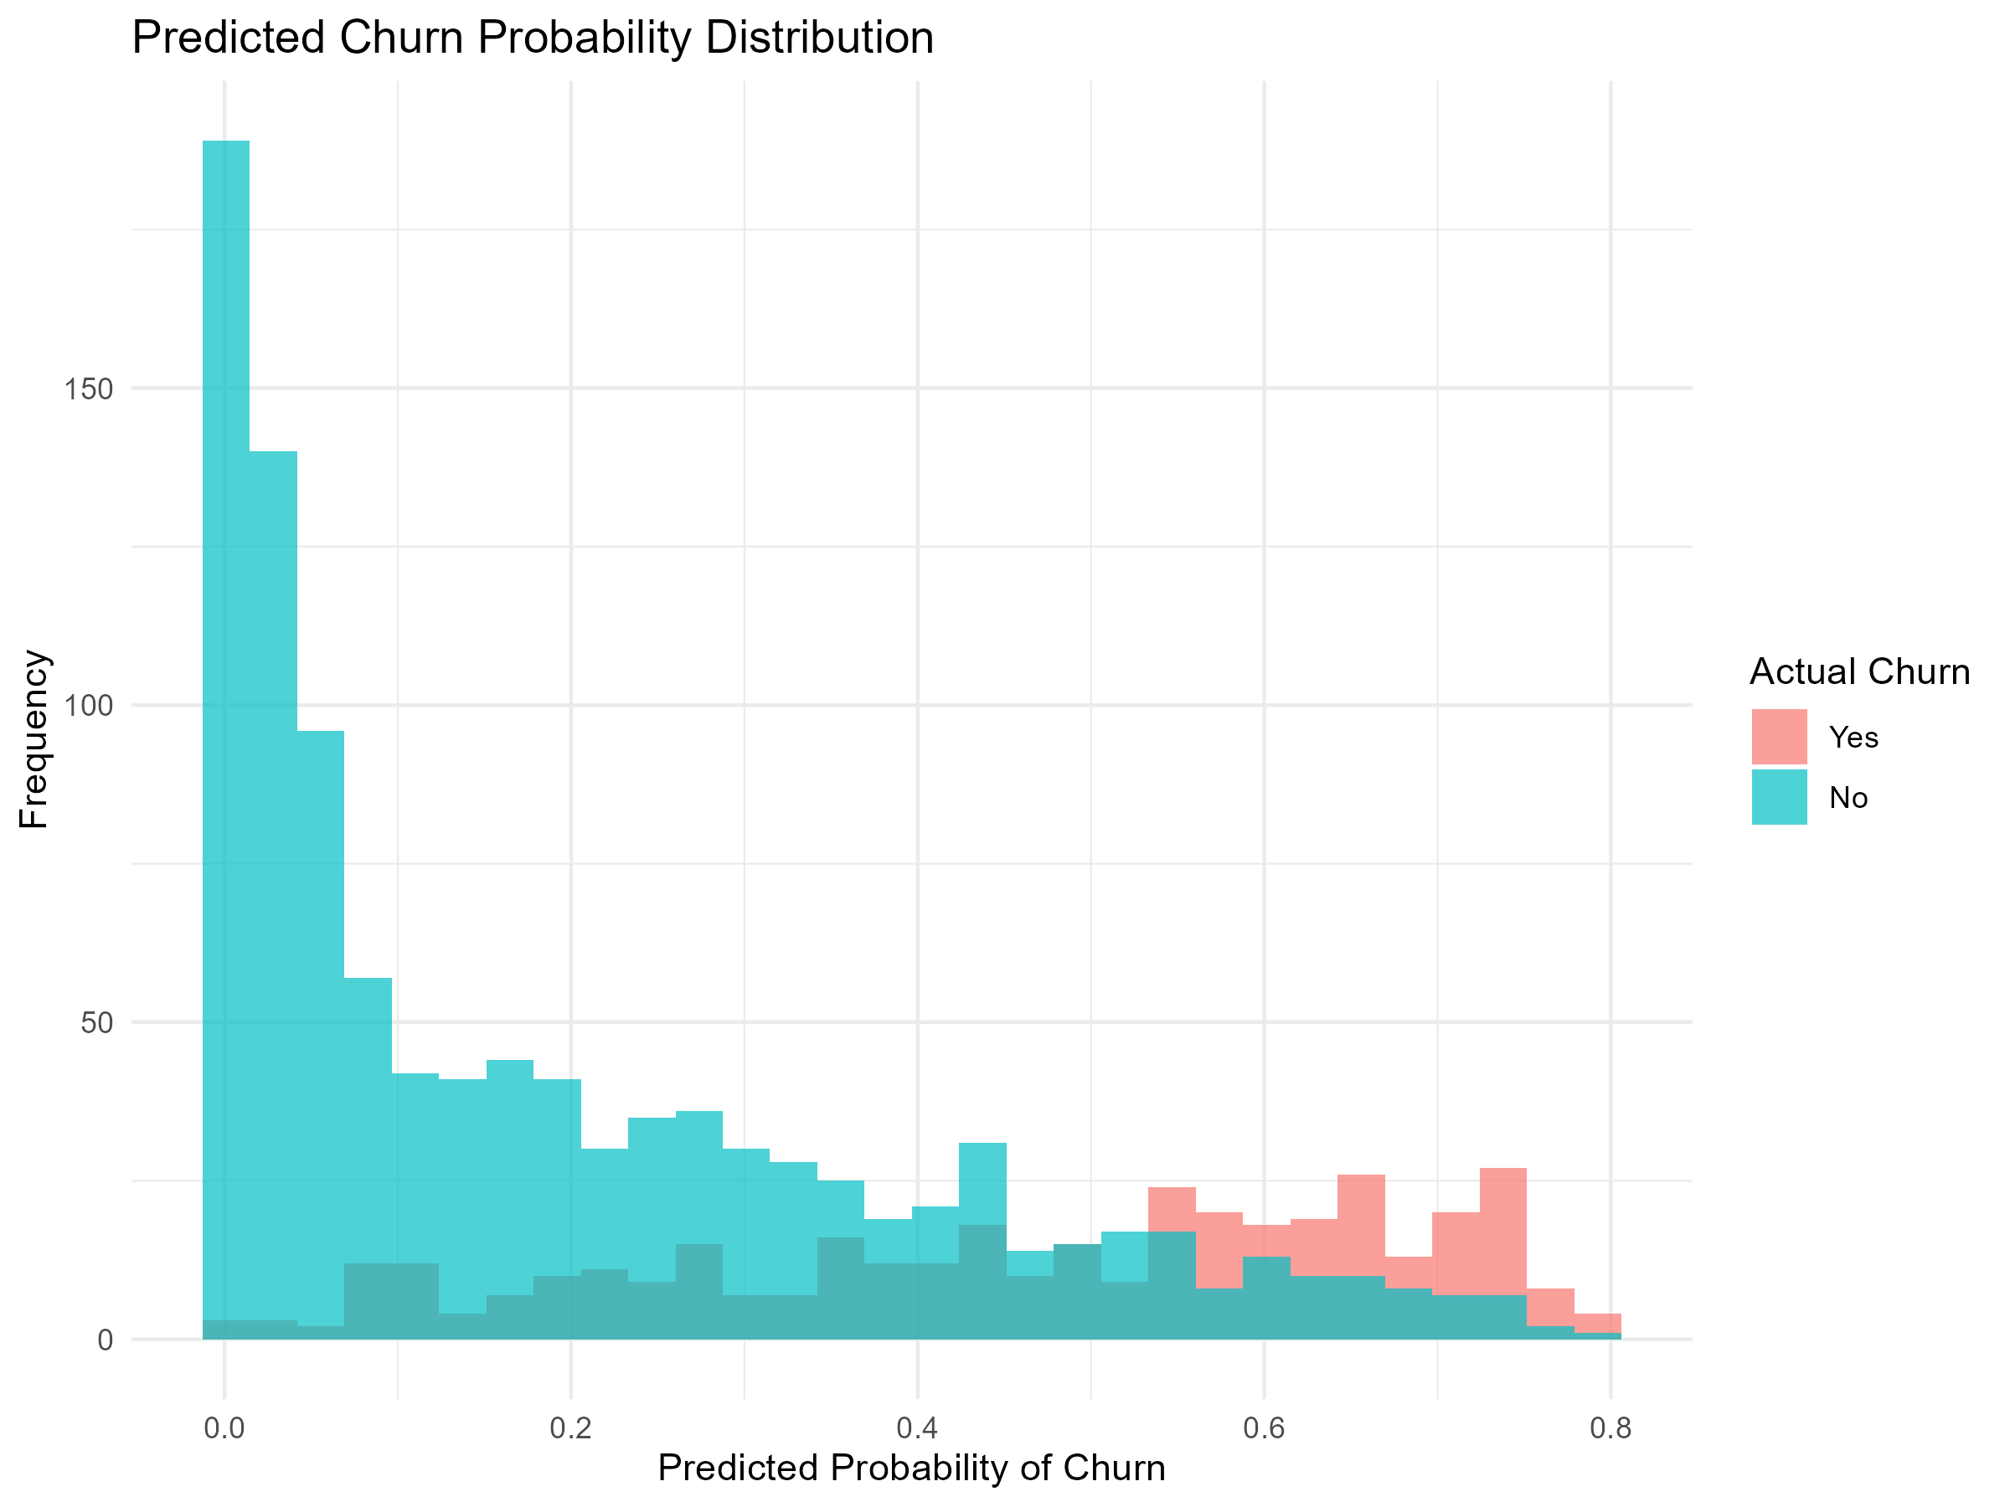
Figure 6. Predicted churn probabilities
The predicted probability visualization shows how the model assigns different churn probabilities to customers. Probability-based outputs can be useful when different operational thresholds are considered.
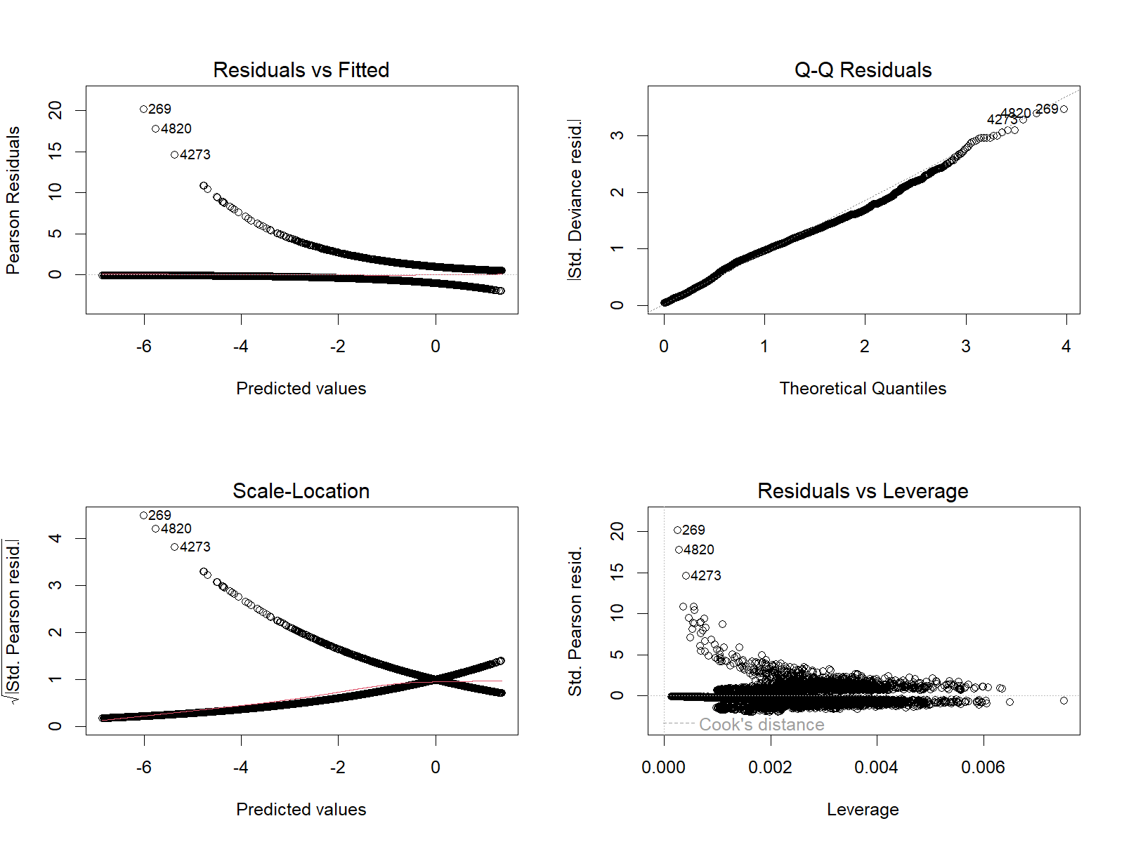
Figure 7. Model diagnostics
The diagnostic plots provide additional checks of the fitted logistic model and help identify patterns that may indicate model limitations or observations requiring further investigation.

10. Key Statistical and Predictive Insights
- Churn represents 26.54% of the dataset, so class imbalance should be considered when evaluating the classifier.
- Monthly charges are significantly higher for churned customers in the univariate comparison: 74.44 versus 61.27.
- Contract type has a strong association with churn; observed churn ranges from 2.83% for two-year contracts to 42.70% for month-to-month contracts.
- Internet service is also strongly associated with churn, with the highest observed churn rate among fiber-optic customers at 41.89%.
- Tenure and total charges have a strong positive correlation (r = 0.8262), reflecting the cumulative nature of total charges.
- The final classifier reaches 79.82% accuracy and 0.8338 ROC-AUC, but sensitivity is only 51.21%, so many actual churners are missed.
- Specificity is 90.14%, indicating stronger identification of non-churn customers than churn customers at the selected classification threshold.
- Tenure and total charges have the highest adjusted GVIF values, so coefficient-level interpretations should account for their shared information.

11. Model Strengths and Improvement Areas

11.1 Strengths
- Uses a clear binary classification framework appropriate for the Churn target.
- Includes both statistical hypothesis testing and predictive modeling rather than relying only on descriptive plots.
- Uses an independent test set and 5-fold cross-validation.
- Reports multiple classification metrics rather than accuracy alone.
- Includes ROC-AUC and diagnostic visualizations.
- Checks multicollinearity before interpreting the regression model.

11.2 Improvement Areas
- Sensitivity of 51.21% indicates that the current probability threshold misses many actual churners.
- Threshold tuning could be explored if the business objective prioritizes detecting more potential churners.
- Class-weighted logistic regression or resampling methods could be evaluated for the class imbalance.
- Alternative models such as random forest, gradient boosting or other tree-based classifiers could be compared using the same train/test framework.
- Feature engineering could derive variables such as average charge per tenure period or service-bundle indicators.
- Tenure and total charges could be handled carefully because of their strong relationship and cumulative construction.

12. Business Interpretation
The statistical evidence highlights several customer characteristics associated with churn. Month-to-month contracts have a much higher observed churn rate than one- and two-year contracts, while fiber-optic customers also show a higher observed churn rate than the other internet-service categories. Churned customers have higher average monthly charges in the univariate analysis.
For a retention workflow, the model's probability output can be used to prioritize customers for additional review. However, the selected threshold should be aligned with the relative costs of false positives and false negatives. Because the current model misses a substantial number of actual churners, changing the threshold or comparing alternative models would be appropriate before using predictions operationally.

13. Conclusion
Week 3 successfully extended the Telco Customer Churn project from visualization into statistical inference and predictive modeling. The hypothesis tests demonstrated statistically significant relationships between churn and monthly charges, contract type and internet service. Correlation and multicollinearity analysis identified the strong relationship between tenure and total charges as an important modeling consideration.
The final logistic regression achieved 79.82% test accuracy and an ROC-AUC of 0.8338. Its 90.14% specificity was substantially higher than its 51.21% sensitivity, showing that the model's performance depends on which type of classification error is prioritized. The combination of statistical testing, cross-validation, multiple evaluation metrics and diagnostics provides a stronger analytical foundation than accuracy alone.

14. Project Outputs and Reproducibility
The Week 3 analysis produced cleaned data, statistical result tables, model coefficients, cross-validation results, test-set predictions, model performance metrics, ROC-AUC results, VIF results and seven visualization files. The R script used for the analysis is maintained separately in the Week-3/R-Script folder.
- Cleaned dataset: Telco_Customer_Churn_Week3_Cleaned.csv
- Model summary: Final_Model_Summary.csv
- Performance metrics: Model_Performance_Metrics.csv
- Cross-validation results: Cross_Validation_Results.csv
- Correlation matrix: Correlation_Matrix.csv
- VIF results: VIF_Results.csv
- ROC-AUC result: ROC_AUC.csv
- Test predictions: Test_Set_Predictions.csv
- Seven PNG visualizations embedded in this report

Appendix A – Main Statistical Results
Analysis | Result
Welch t-test: Monthly Charges vs Churn | t = -18.408, p < 2.2e-16
Chi-square: Contract vs Churn | χ² = 1184.6, df = 2, p < 2.2e-16
Chi-square: Internet Service vs Churn | χ² = 732.31, df = 2, p < 2.2e-16
Tenure vs Total Charges | r = 0.8262, p < 2.2e-16
Tenure vs Monthly Charges | r = 0.2479, p < 2.2e-16
Monthly Charges vs Total Charges | r = 0.6512, p < 2.2e-16
5-fold CV ROC | ≈ 0.8412
Test ROC-AUC | 0.8338
Test Accuracy | 0.7982
Test Sensitivity | 0.5121
Test Specificity | 0.9014

