VIRTUAL R DATA ANALYST INTERNSHIP
WEEK 2 PROJECT REPORT
Data Visualization and Insight Communication
Telco Customer Churn Analysis
Tools: R, RStudio, tidyverse, ggplot2, janitor, skimr
Dataset: Telco Customer Churn — 7,043 customer records

1. Executive Summary
This Week 2 project analyzes customer churn using the Telco Customer Churn dataset in R. The dataset contains 7,043 customer records and 21 original variables covering demographics, services, account characteristics, tenure, billing, and churn status. The project focuses on visual storytelling: each chart was selected to answer a specific analytical question and is followed by its key finding and business interpretation.
The overall observed churn rate is 26.54%. The strongest differences appear across contract type and customer tenure. Month-to-month customers have a churn rate of 42.71%, compared with 11.27% for one-year contracts and 2.83% for two-year contracts. The 0–12 month tenure group has the highest churn rate at 47.44%.
Billing and service variables provide additional signals. Churned customers have an average monthly charge of $74.44, compared with $61.27 for customers who stayed. Fiber optic customers have the highest churn rate among internet-service groups, while electronic-check users have the highest churn rate among payment methods. These findings are descriptive associations and should be investigated further rather than interpreted as proof of causation.

2. Dataset and Analytical Approach
The analysis used the Telco Customer Churn dataset and applied the same cleaning principles used for the project workflow. Column names were standardized with janitor, TotalCharges was converted to numeric form, zero-tenure missing charge values were handled, categorical variables were converted to factors, and tenure groups were created. Churn rates were calculated as the percentage of customers with Churn = Yes within each category.
Measure | Value
Dataset records | 7,043
Original variables | 21
Visualizations | 9
Visualization library | ggplot2
Overall churn rate | 26.54%

3. Visualization 1 — Customer Churn Distribution

Purpose
Establish the overall distribution of customers who stayed and customers who churned.

Why this chart was selected
A bar chart is the most direct method for comparing counts across the two categorical churn outcomes.
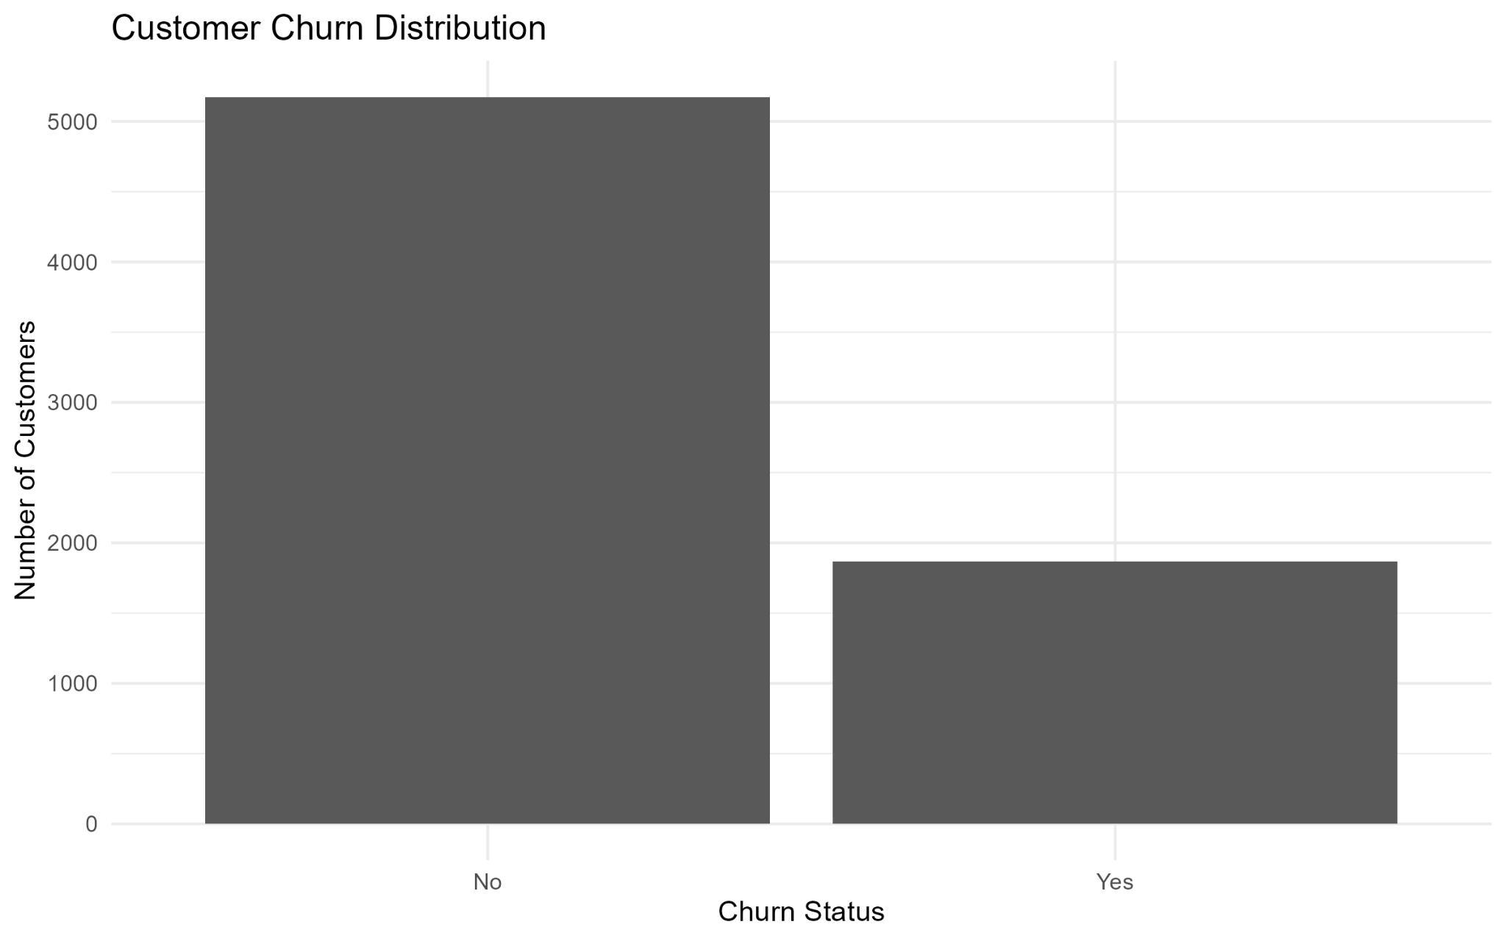

Key insight
Most customers stayed, but 26.54% churned, showing that churn represents a substantial share of the customer base.

Business interpretation
This chart provides the baseline for all later segment comparisons and confirms that churn is a meaningful business issue.

R Code Used
ggplot(data, aes(x = churn)) + geom_bar()

4. Visualization 2 — Churn Rate by Contract Type

Purpose
Compare churn rates across different contract commitments.

Why this chart was selected
A percentage bar chart provides a direct comparison of churn rates without being affected by different category sizes.
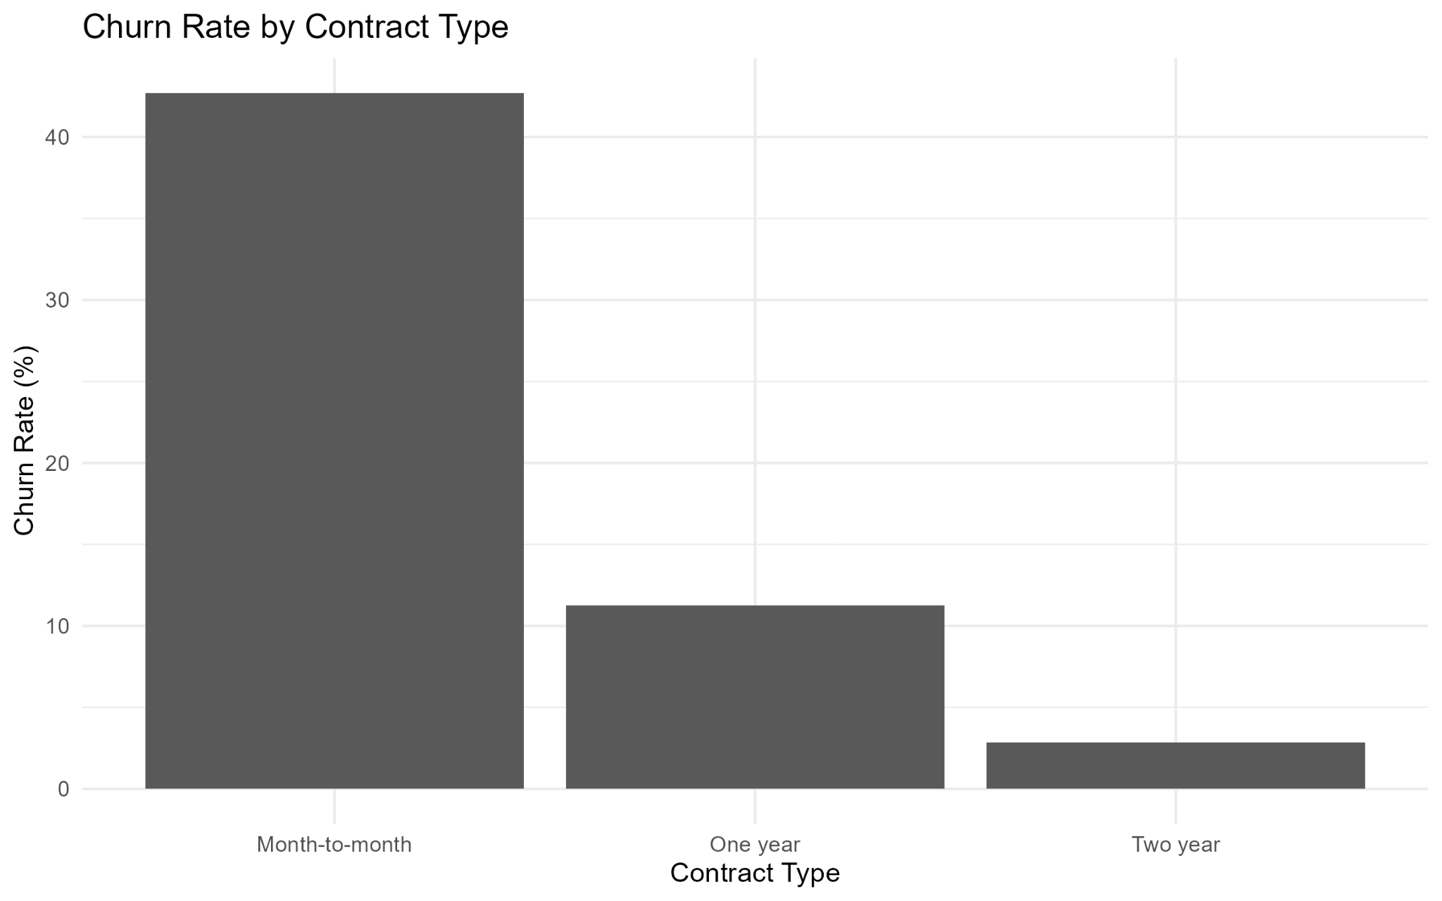

Key insight
Month-to-month customers have a 42.71% churn rate, versus 11.27% for one-year and 2.83% for two-year contracts.

Business interpretation
Contract commitment is strongly associated with retention. Month-to-month customers should receive particular attention in retention initiatives.

R Code Used
data %>% count(contract, churn) %>% group_by(contract) %>% mutate(churn_rate = n / sum(n) * 100) %>% filter(churn == "Yes") %>% ggplot(aes(contract, churn_rate)) + geom_col()

5. Visualization 3 — Tenure Distribution by Churn Status

Purpose
Compare how tenure is distributed between customers who churned and those who stayed.

Why this chart was selected
A histogram is appropriate for the continuous tenure variable and shows where each churn group is concentrated across the lifecycle.
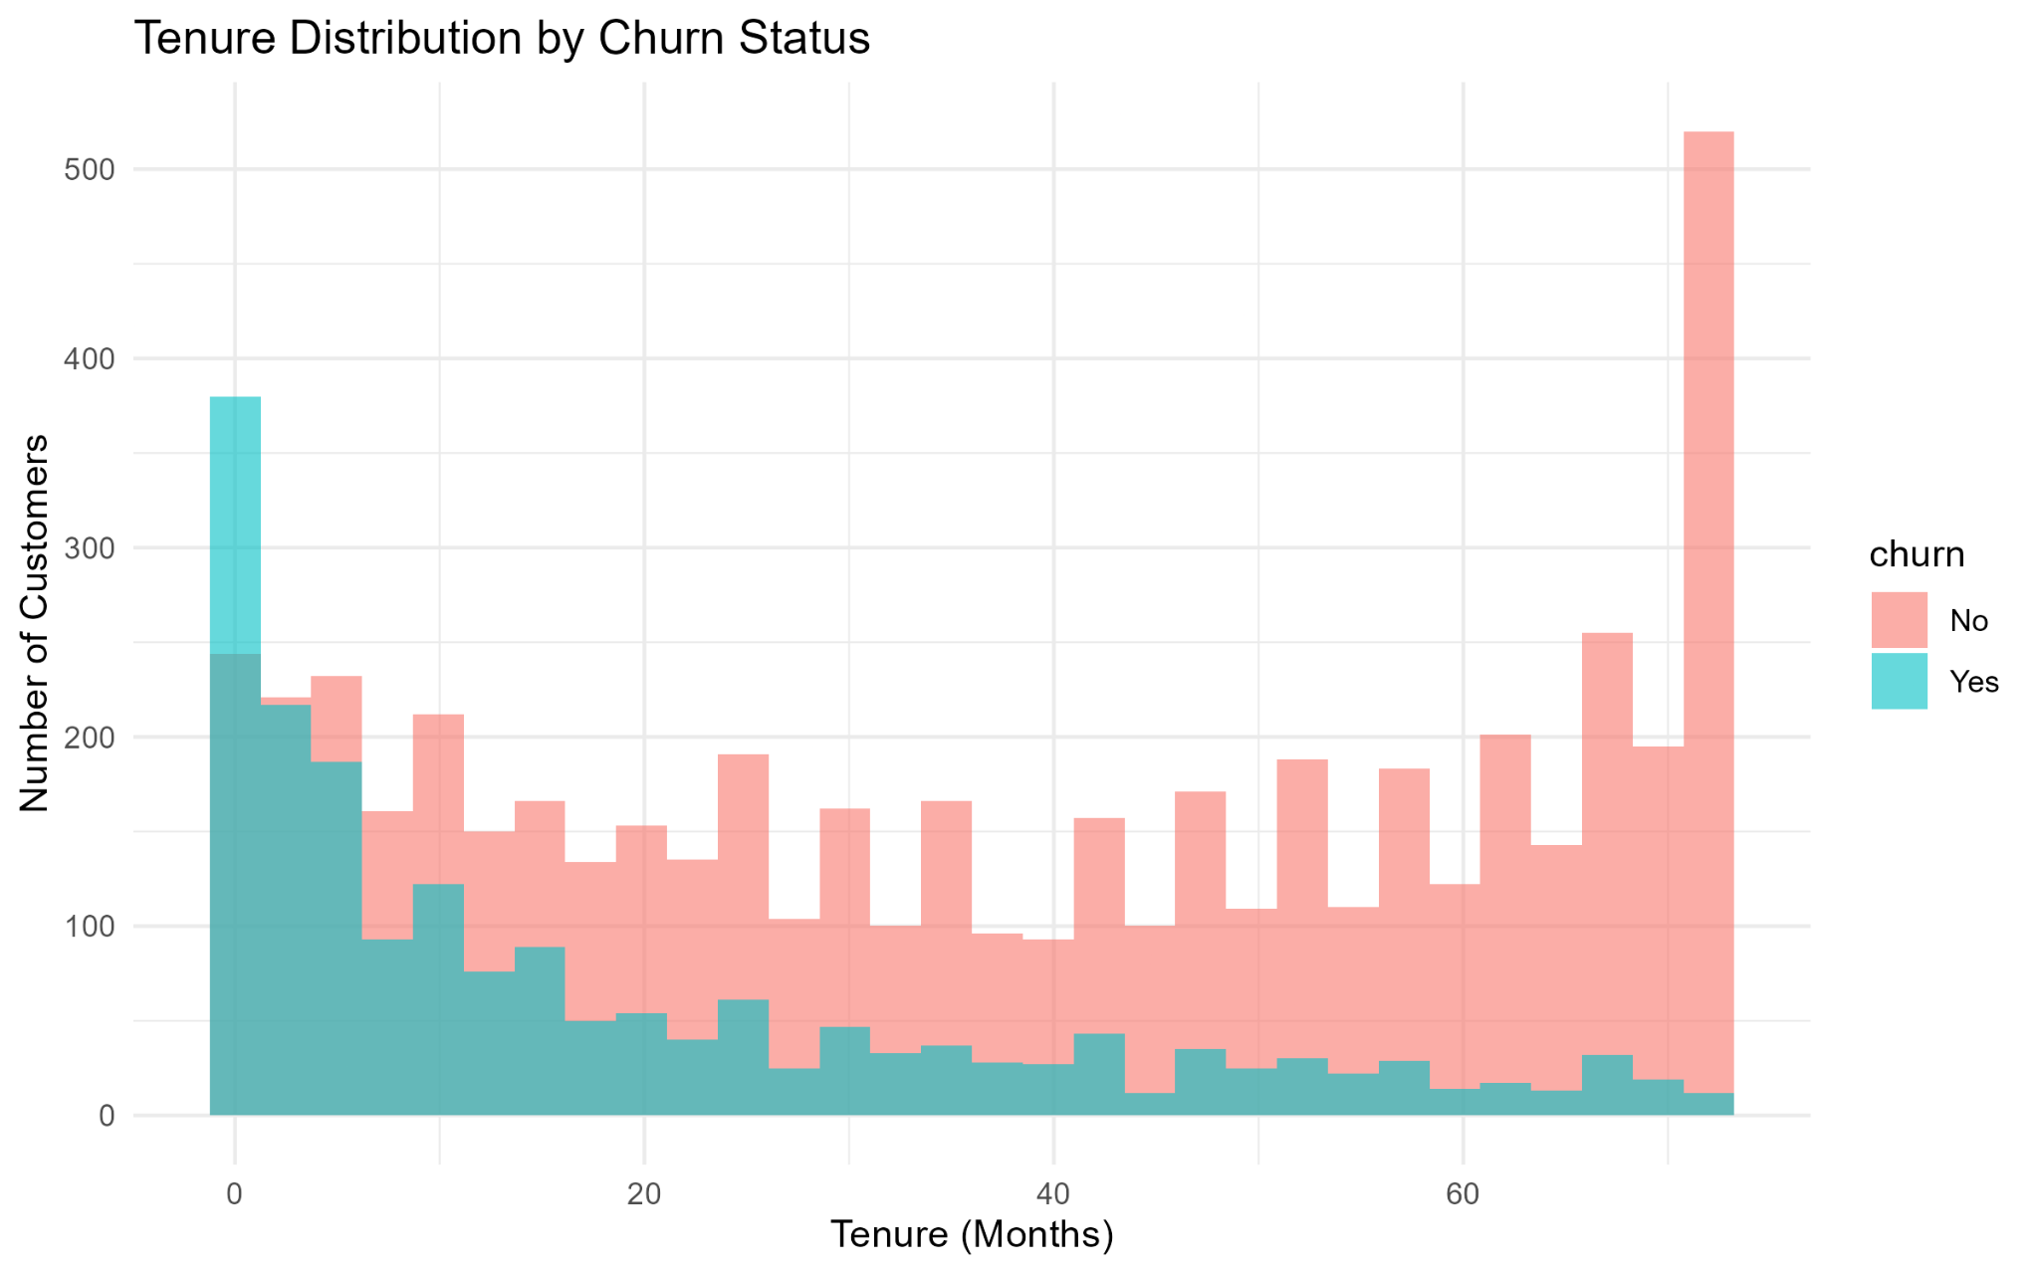

Key insight
Churned customers are concentrated more heavily at lower tenure values, while retained customers extend much further into the long-tenure range.

Business interpretation
The early customer lifecycle is a critical retention window, making onboarding and early customer experience important areas for investigation.

R Code Used
ggplot(data, aes(x = tenure, fill = churn)) + geom_histogram(bins = 30, position = "identity", alpha = 0.6)

6. Visualization 4 — Monthly Charges by Churn Status

Purpose
Examine whether monthly charge levels differ between churned and retained customers.

Why this chart was selected
A boxplot shows the median, spread, and distribution of monthly charges for each churn group.
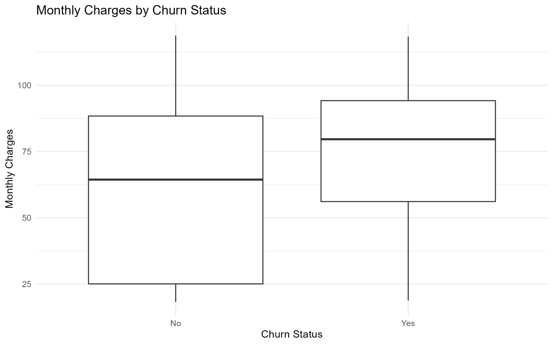

Key insight
Average monthly charges are $74.44 for churned customers versus $61.27 for retained customers, with a higher central charge level for the churned group.

Business interpretation
Higher monthly charges may identify customers who warrant closer review of pricing, plan value, and service combinations.

R Code Used
ggplot(data, aes(x = churn, y = monthly_charges)) + geom_boxplot()

7. Visualization 5 — Tenure vs Total Charges

Purpose
Examine the relationship between customer tenure and accumulated total charges.

Why this chart was selected
A scatter plot is appropriate for two numerical variables and reveals direction, spread, and group-level patterns.
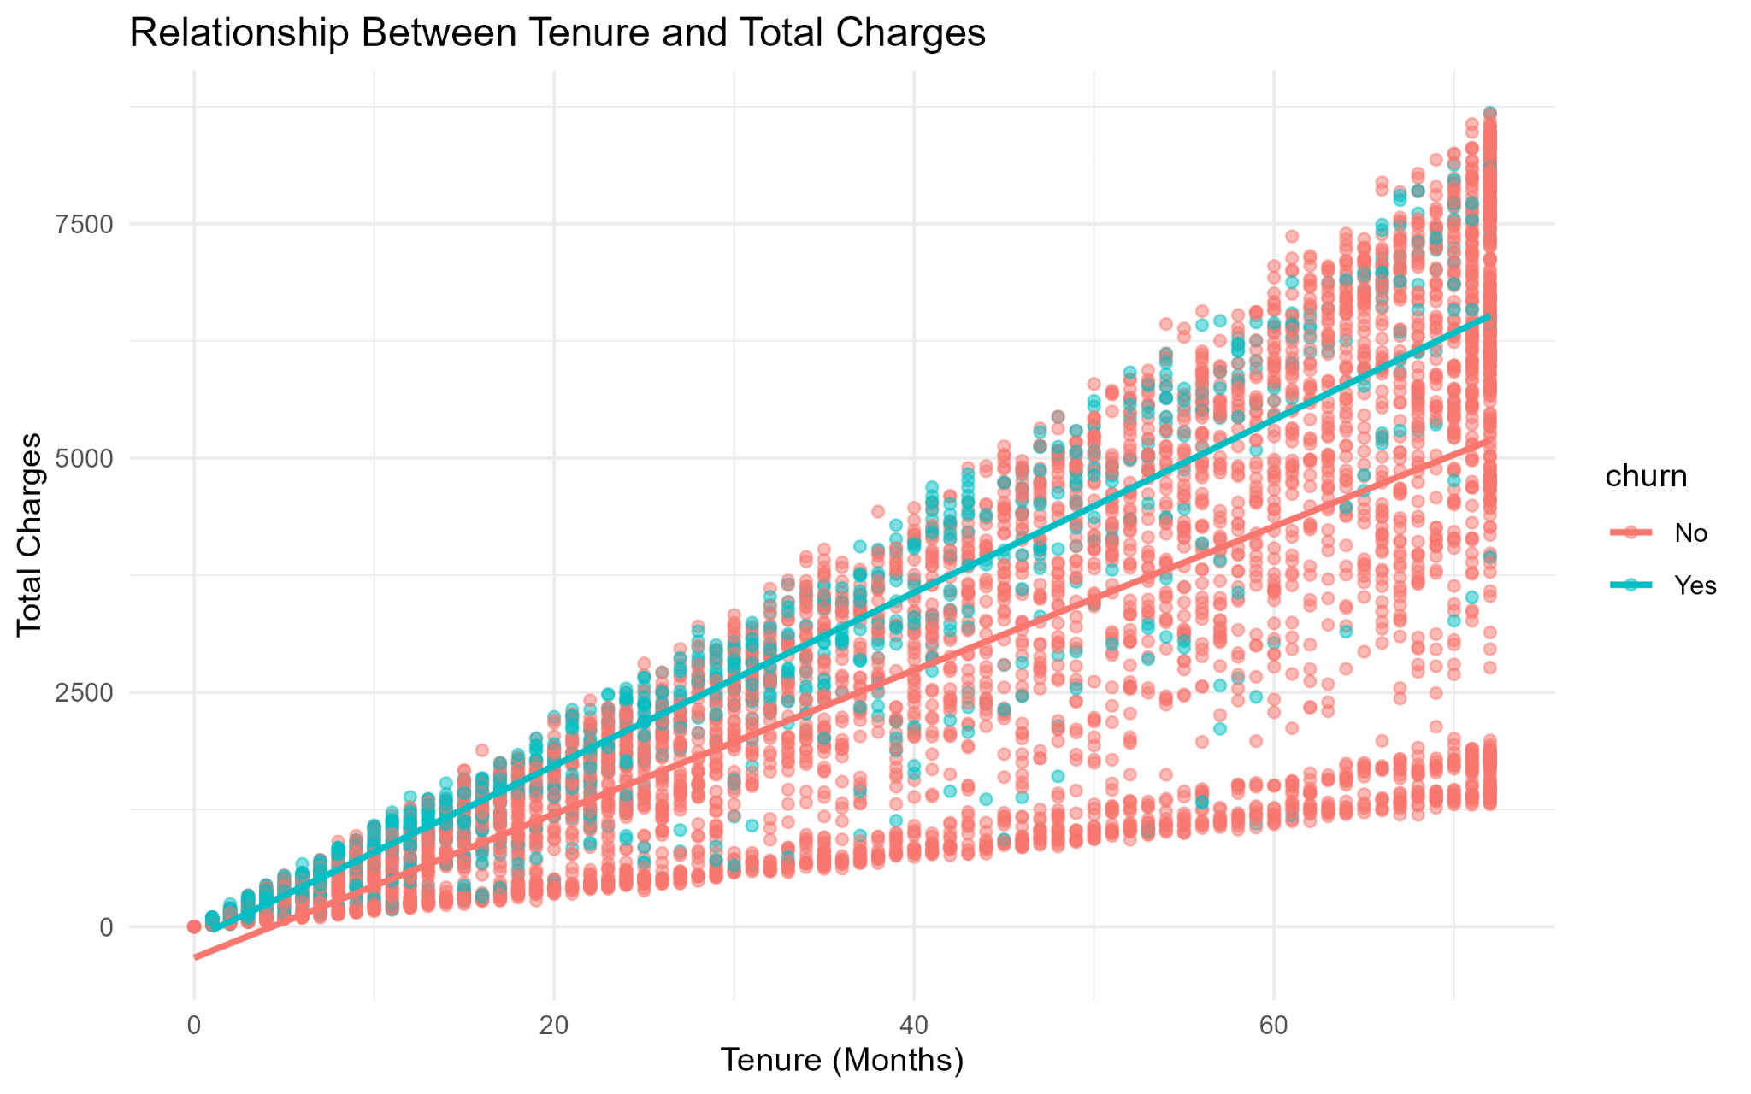

Key insight
Total charges increase strongly as tenure increases, producing a clear upward relationship across the customer base.

Business interpretation
Longer customer relationships are associated with greater accumulated charges. Reducing early churn can therefore protect future customer value.

R Code Used
ggplot(data, aes(x = tenure, y = total_charges, color = churn)) + geom_point(alpha = 0.5) + geom_smooth(method = "lm", se = FALSE)

8. Visualization 6 — Churn Rate by Internet Service

Purpose
Compare churn rates across internet-service categories.

Why this chart was selected
A category-level percentage bar chart provides an easy comparison on a common churn-rate scale.
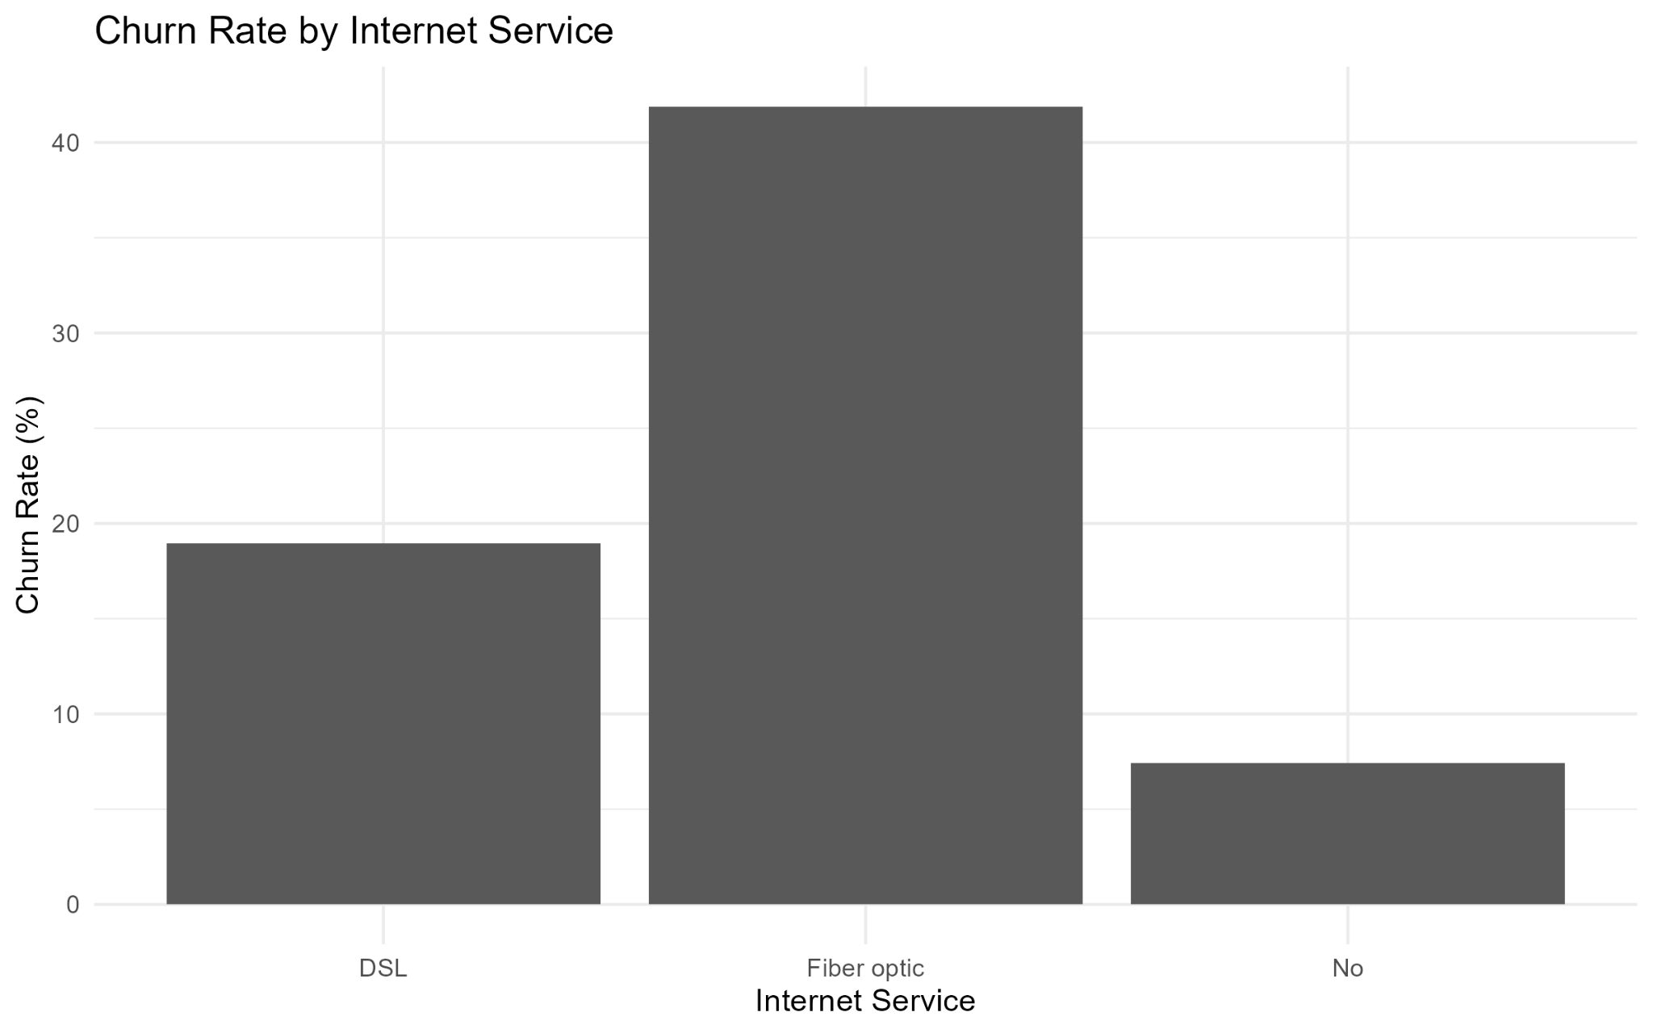

Key insight
Fiber optic has the highest churn rate at 41.89%, compared with 18.96% for DSL and 7.40% for customers without internet service.

Business interpretation
The fiber-optic segment warrants deeper investigation of pricing, service quality, support, and competitive alternatives; the chart alone does not establish causation.

R Code Used
data %>% count(internet_service, churn) %>% group_by(internet_service) %>% mutate(churn_rate = n / sum(n) * 100) %>% filter(churn == "Yes") %>% ggplot(aes(internet_service, churn_rate)) + geom_col()

9. Visualization 7 — Churn Rate by Payment Method

Purpose
Identify differences in churn across payment methods.

Why this chart was selected
A horizontal bar chart keeps long payment-method labels readable and makes ranking straightforward.
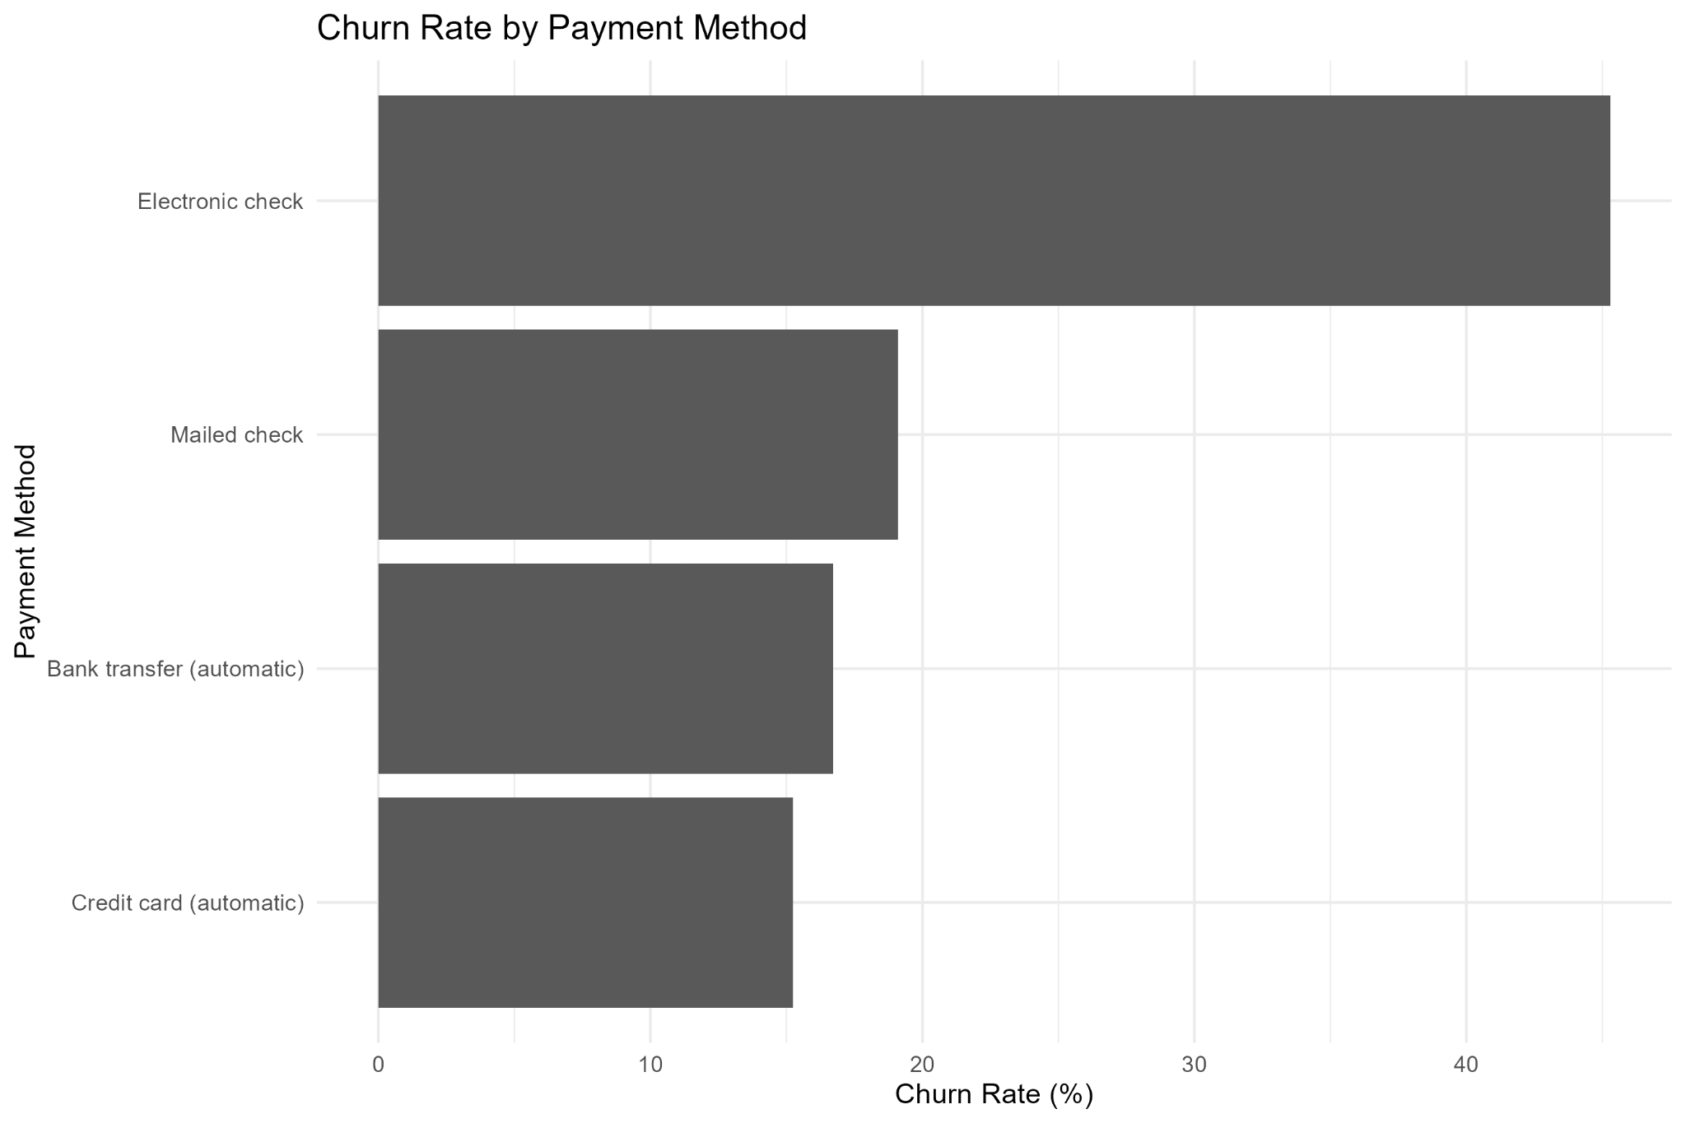

Key insight
Electronic check has the highest churn rate at 45.29%, while automatic payment methods show lower observed churn rates.

Business interpretation
Payment method is a useful segmentation signal. Electronic-check customers could be examined alongside tenure and contract type to understand the pattern.

R Code Used
data %>% count(payment_method, churn) %>% group_by(payment_method) %>% mutate(churn_rate = n / sum(n) * 100) %>% filter(churn == "Yes") %>% ggplot(aes(reorder(payment_method, churn_rate), churn_rate)) + geom_col() + coord_flip()

10. Visualization 8 — Churn Rate by Customer Tenure Group

Purpose
Convert continuous tenure into practical customer-lifecycle groups.

Why this chart was selected
Tenure bands are easier for a business audience to interpret and identify a specific high-risk lifecycle stage.
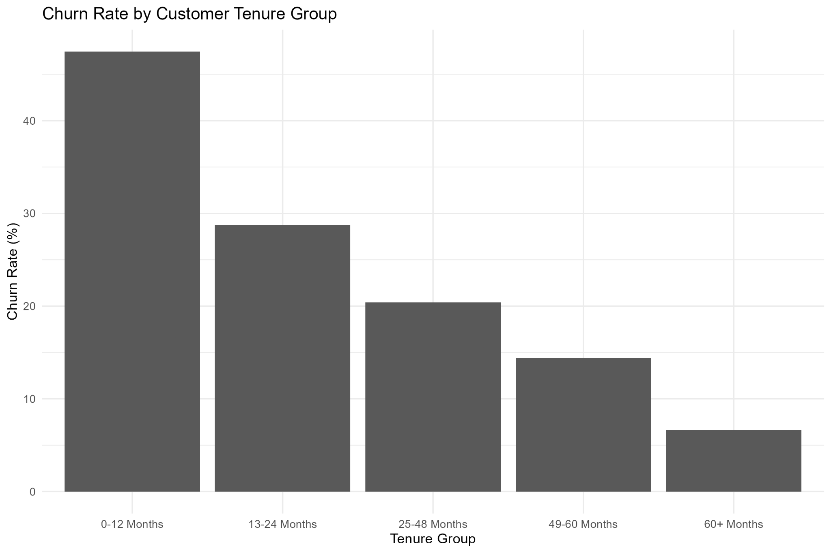

Key insight
The 0–12 month group has the highest churn rate at 47.44%, followed by progressively lower rates in the longer-tenure groups.

Business interpretation
The first year is the strongest visible retention window, suggesting that early engagement should receive focused attention.

R Code Used
data %>% count(tenure_group, churn) %>% group_by(tenure_group) %>% mutate(churn_rate = n / sum(n) * 100) %>% filter(churn == "Yes") %>% ggplot(aes(tenure_group, churn_rate)) + geom_col()

11. Visualization 9 — Churn Rate by Senior Citizen Status

Purpose
Compare churn rates between senior and non-senior customers.

Why this chart was selected
A two-category bar chart gives a direct comparison of the observed rates.
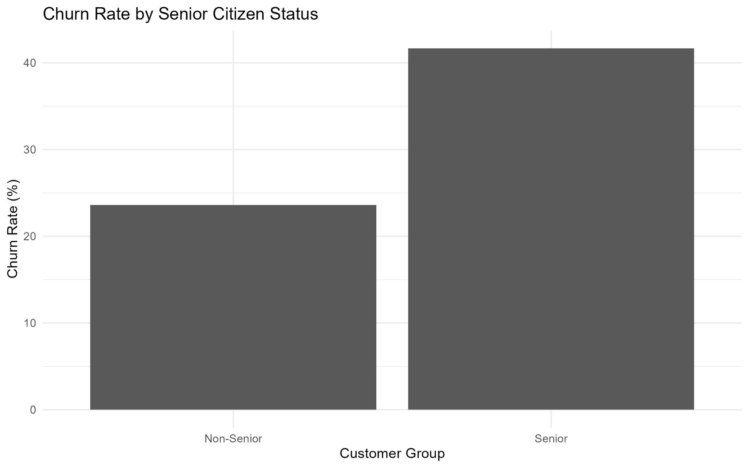

Key insight
Senior customers have a churn rate of 41.68%, compared with 23.61% for non-senior customers.

Business interpretation
Senior status may help identify a higher-risk segment, but it should be combined with other customer characteristics before decisions are made.

R Code Used
data %>% count(senior_citizen, churn) %>% group_by(senior_citizen) %>% mutate(churn_rate = n / sum(n) * 100) %>% filter(churn == "Yes") %>% ggplot(aes(senior_citizen, churn_rate)) + geom_col()

12. Overall Analytical Interpretation
The nine visualizations provide a consistent view of churn across customer lifecycle, contractual, billing, service, payment, and demographic dimensions. The strongest patterns are the high churn among month-to-month customers and newer customers. Billing and service variables add further segmentation signals, particularly higher monthly charges, fiber-optic service, and electronic-check payment.
These results should be treated as descriptive evidence. The visualizations reveal associations that can guide further investigation, but they do not prove that any single factor directly causes churn.

13. Recommendations for Further Analysis
- Investigate why month-to-month customers churn at much higher rates and evaluate retention or contract-conversion strategies.
- Analyze the first-year customer lifecycle in finer intervals to identify when churn risk is greatest.
- Examine fiber-optic customers by monthly charges, contract, technical support, and service combinations.
- Investigate electronic-check users alongside contract type and tenure to determine whether the payment-method pattern persists after segmentation.
- Use multivariable statistical or machine-learning models later to identify factors associated with churn while considering multiple variables together.
- Measure future retention initiatives using changes in churn rates across defined customer segments.

14. Conclusion
This Week 2 project demonstrates how R and ggplot2 can transform customer-level data into clear, decision-oriented visual insights. Nine visualizations were selected for specific analytical questions and presented with their purpose, selection rationale, actual chart, R code, key finding, and business interpretation. The strongest evidence points to month-to-month and short-tenure customers as important retention-risk segments, while service, payment, and billing variables provide additional areas for investigation.

15. Project Files
- R script: Week2_Telco_Visualization.R
- Dataset: Telco_Customer_Churn_Week2.csv
- Cleaned dataset: Telco_Customer_Churn_Week2_Cleaned.csv
- Screenshots: 9 generated PNG visualizations
- Report: Week2_Telco_Churn_Visualization_Report.docx

