WEEK 4
Comprehensive Telco Customer Churn Analysis
Data Analysis, Statistical Testing & Predictive Modeling using R

Virtual R Data Analyst Internship
Prepared by Aayan

1. Executive Summary
Week 4 consolidates the customer churn work into a complete analytical workflow. The analysis covers data preparation, exploratory visualization, statistical testing, correlation and multicollinearity assessment, logistic regression, train-test evaluation, 5-fold cross-validation, and model diagnostics.
The dataset contains 7,043 customer records. Overall churn is 26.54%, with 1,869 customers classified as churned and 5,174 as non-churned. Strong descriptive differences are visible across contract type, tenure, internet service, payment method, and senior status.
A logistic regression model was evaluated using an 80/20 train-test split and 5-fold cross-validation. On the test set, the model achieved 79.82% accuracy and an ROC-AUC of 0.834. Specificity was 90.14%, while sensitivity was 51.21%, indicating that the model identifies non-churn customers more effectively than churn customers at the selected classification threshold.

2. Project Objectives
- Prepare and validate the customer churn dataset.
- Explore major patterns and differences in customer churn.
- Apply hypothesis tests to selected customer variables.
- Examine correlations and potential multicollinearity.
- Build a logistic regression model for churn classification.
- Evaluate the model using a holdout test set and 5-fold cross-validation.
- Interpret model performance, limitations, and practical implications.

3. Dataset and Data Preparation
The analysis uses the Telco Customer Churn dataset. The target variable is Churn, with values Yes and No. The data contains customer demographic information, services, contract information, payment method, tenure, monthly charges, and total charges.
Item | Value
Customer records | 7,043
Churned customers | 1,869
Non-churned customers | 5,174
Overall churn rate | 26.54%
Missing values after cleaning | 0
Duplicate rows | 0
The data preparation process included cleaning column names, converting Total Charges to numeric values, handling missing Total Charges values, converting categorical variables to factors, and creating derived variables required for the analysis.

4. Exploratory Data Analysis
The exploratory analysis focuses on the distribution of churn and customer characteristics associated with it. The charts below are included to make the report reproducible and to connect numerical results with visual evidence.

4.1 Customer Churn Distribution
This chart shows the overall distribution of churn. Of 7,043 customers, 1,869 churned and 5,174 did not churn, giving an overall churn rate of 26.54%. The target is therefore imbalanced toward non-churn customers, which is important when interpreting accuracy and classification results.
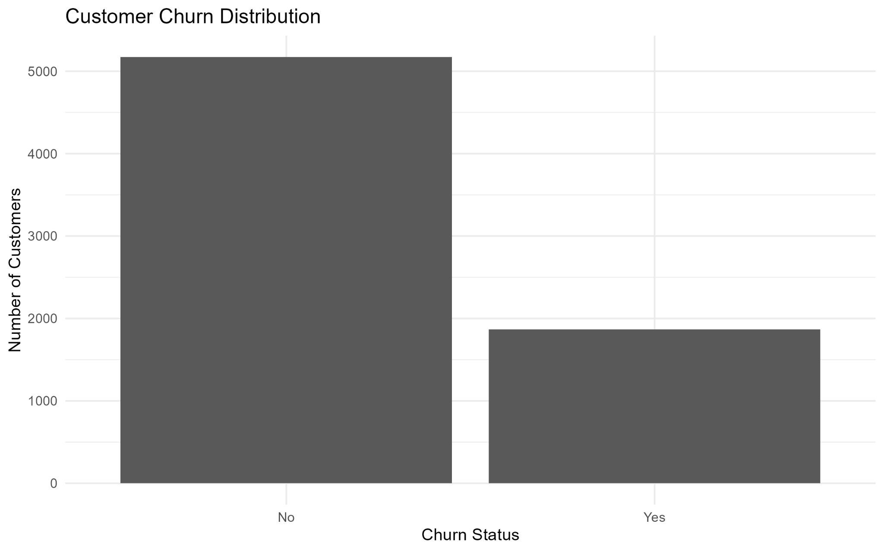

4.2 Churn Rate by Contract Type
Month-to-month customers have a 42.7% churn rate, compared with 11.3% for one-year contracts and 2.8% for two-year contracts. This is one of the clearest segmentation patterns in the analysis and indicates that contract duration is strongly associated with churn.
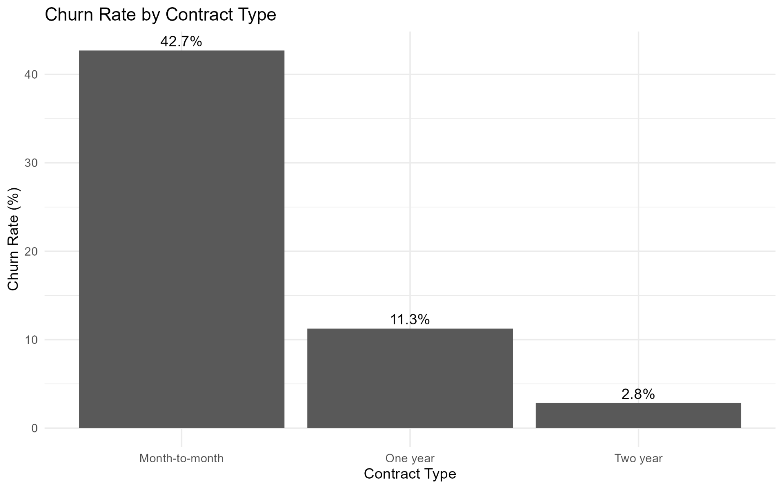

4.3 Tenure Distribution by Churn Status
Churned customers are concentrated more heavily at shorter tenure, while non-churn customers are distributed across longer periods. This supports the statistical finding that tenure is strongly related to customer retention.
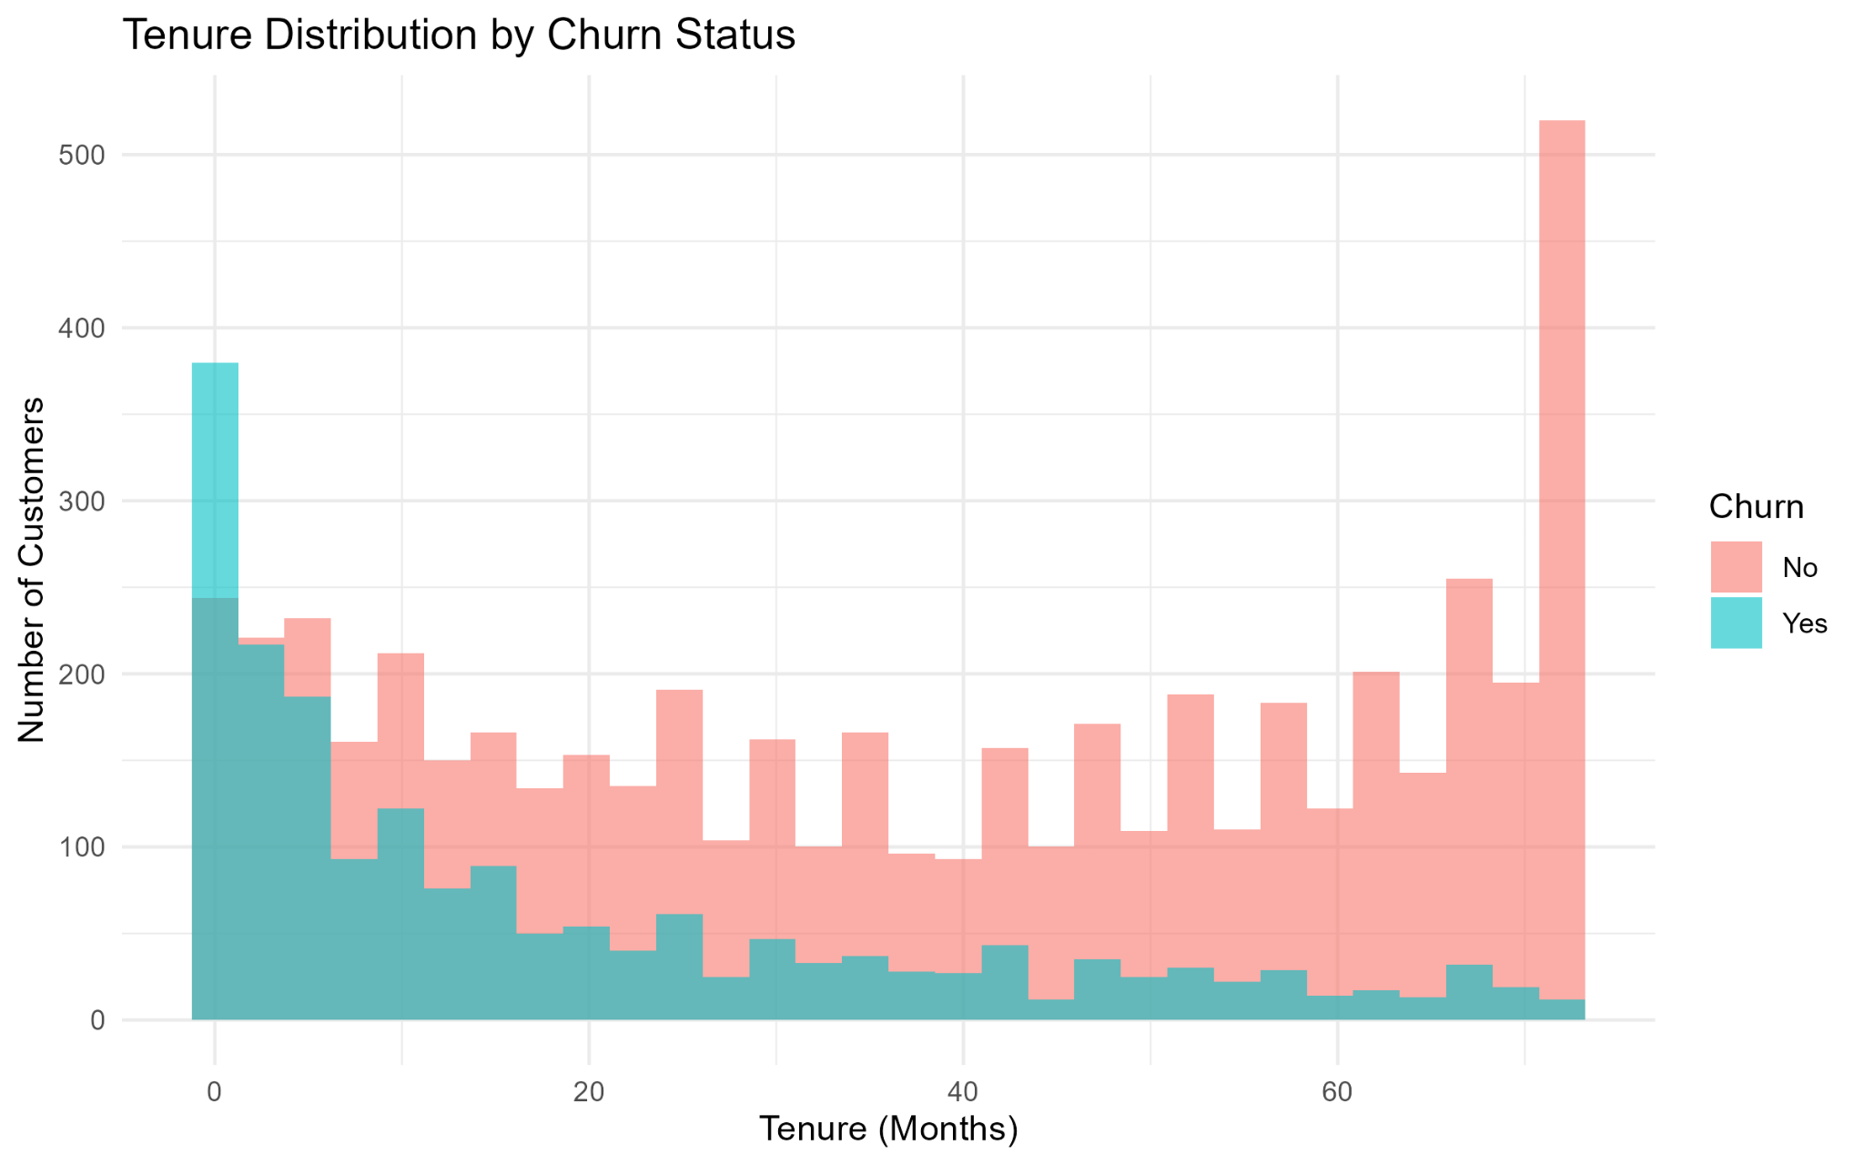

4.4 Monthly Charges by Churn Status
The median monthly charge is higher for customers who churned than for customers who remained. The distributions also overlap substantially, so monthly charges alone do not fully separate churners from non-churners.
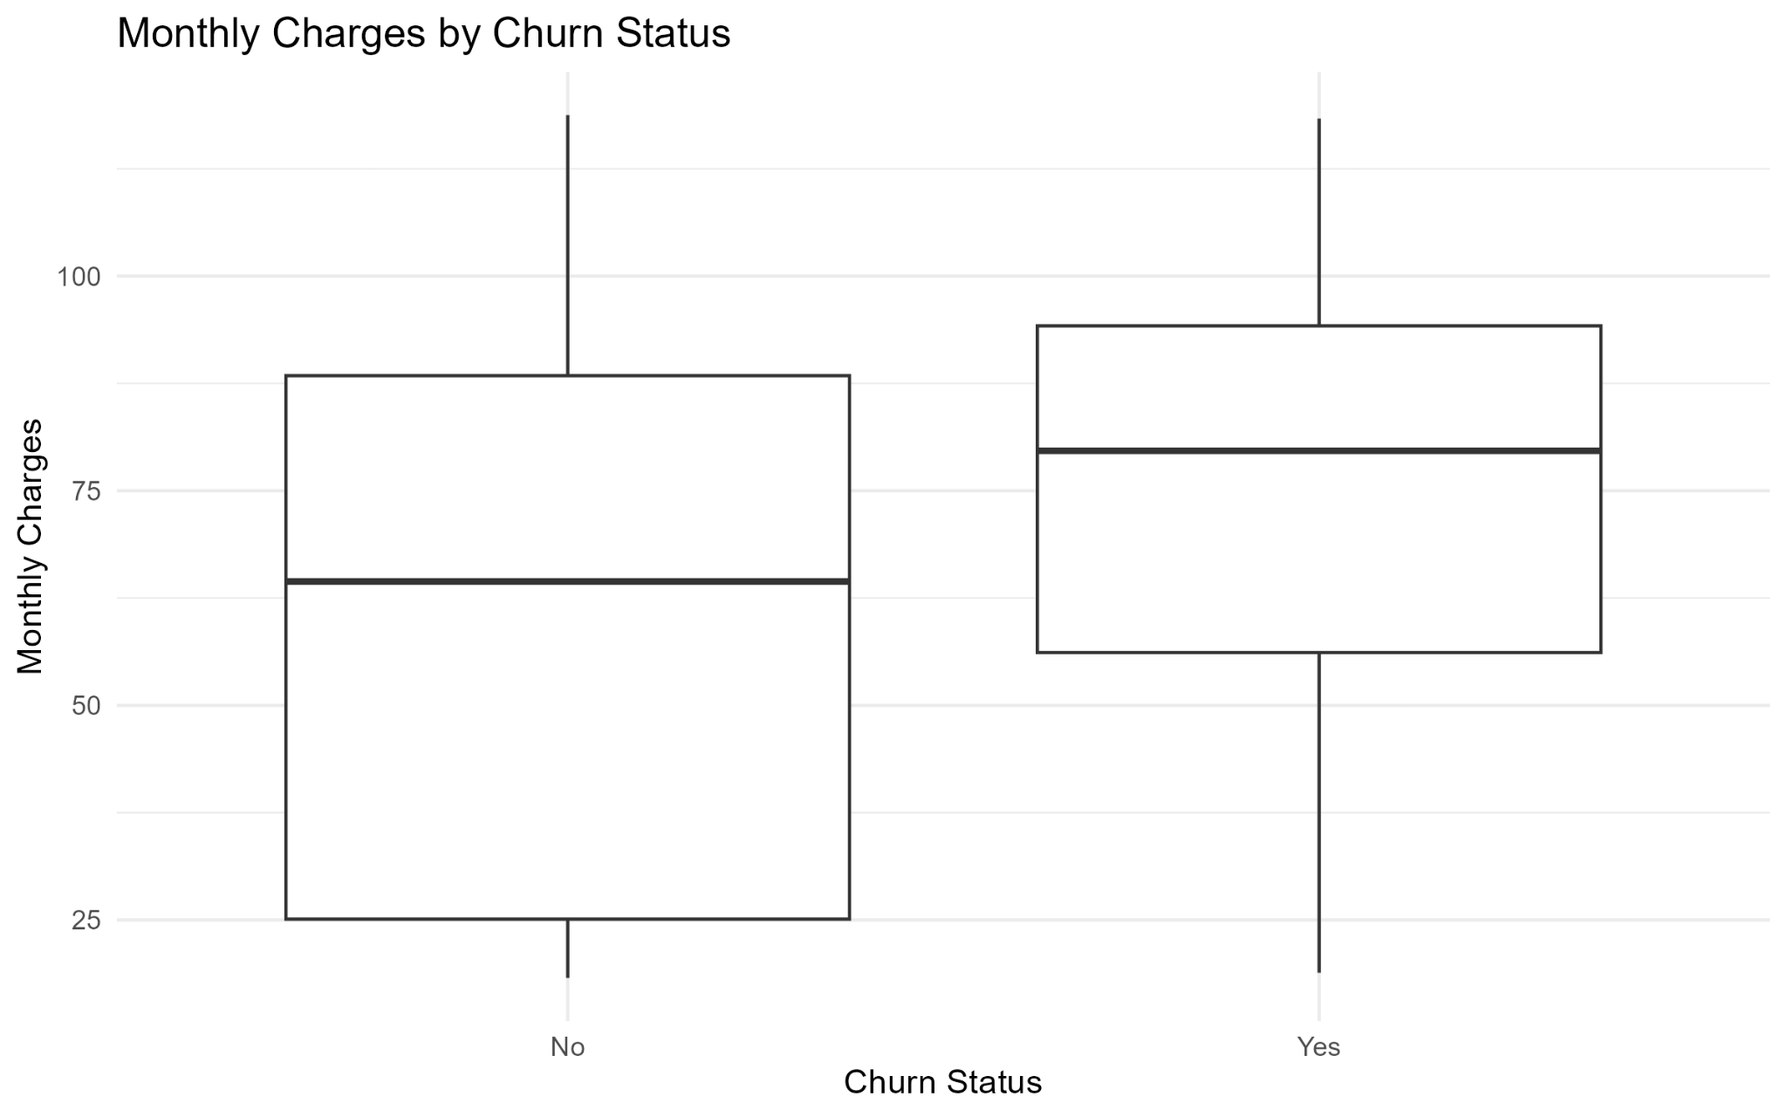

4.5 Relationship Between Tenure and Total Charges
Total charges increase strongly with tenure. The correlation between tenure and total charges is approximately 0.83. The relationship also explains why these variables require attention for multicollinearity when used together in a regression model.
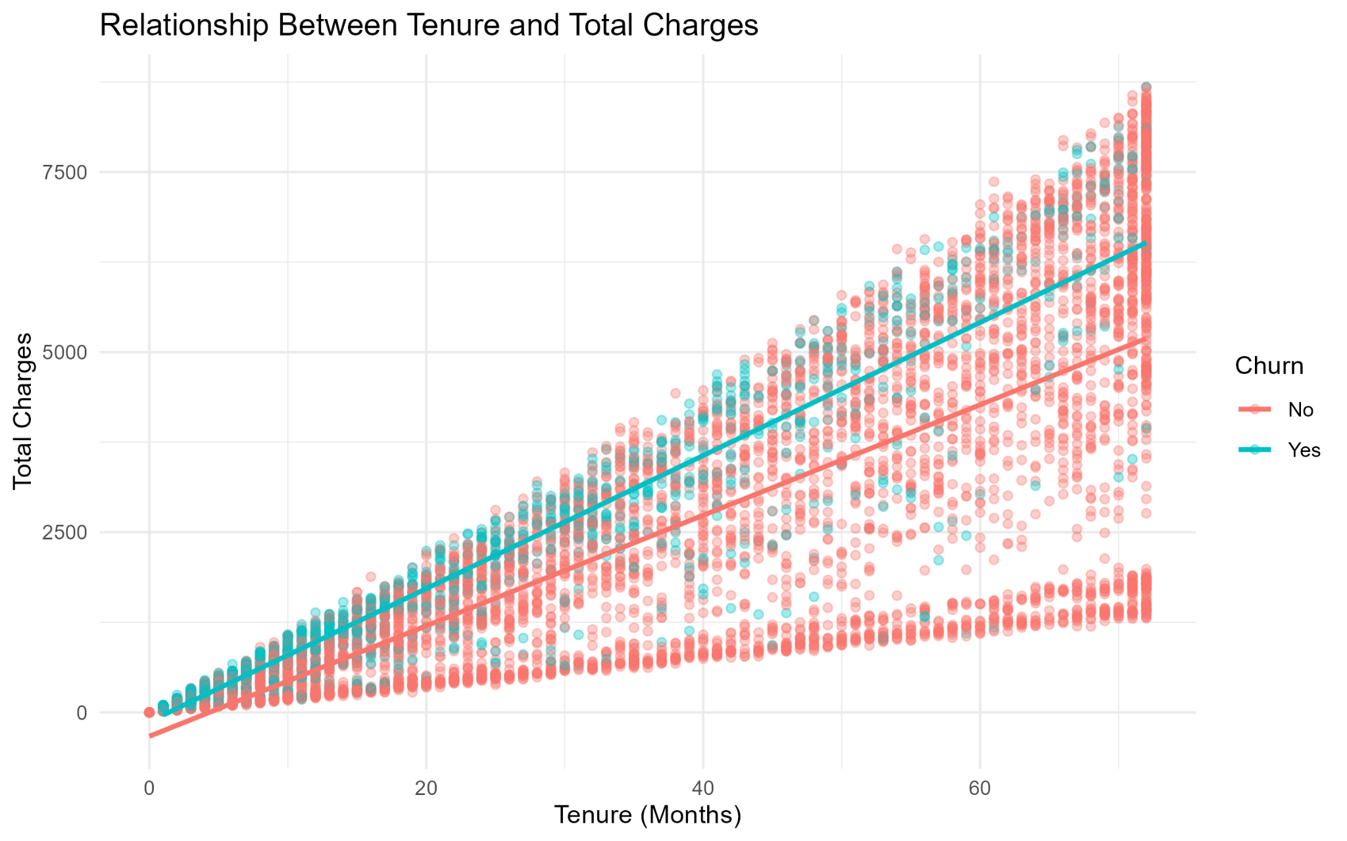

4.6 Churn Rate by Internet Service
Fiber optic customers have a 41.9% churn rate, compared with 19.0% for DSL and 7.4% for customers without internet service. Internet service type is therefore an important segmentation variable in the analysis.
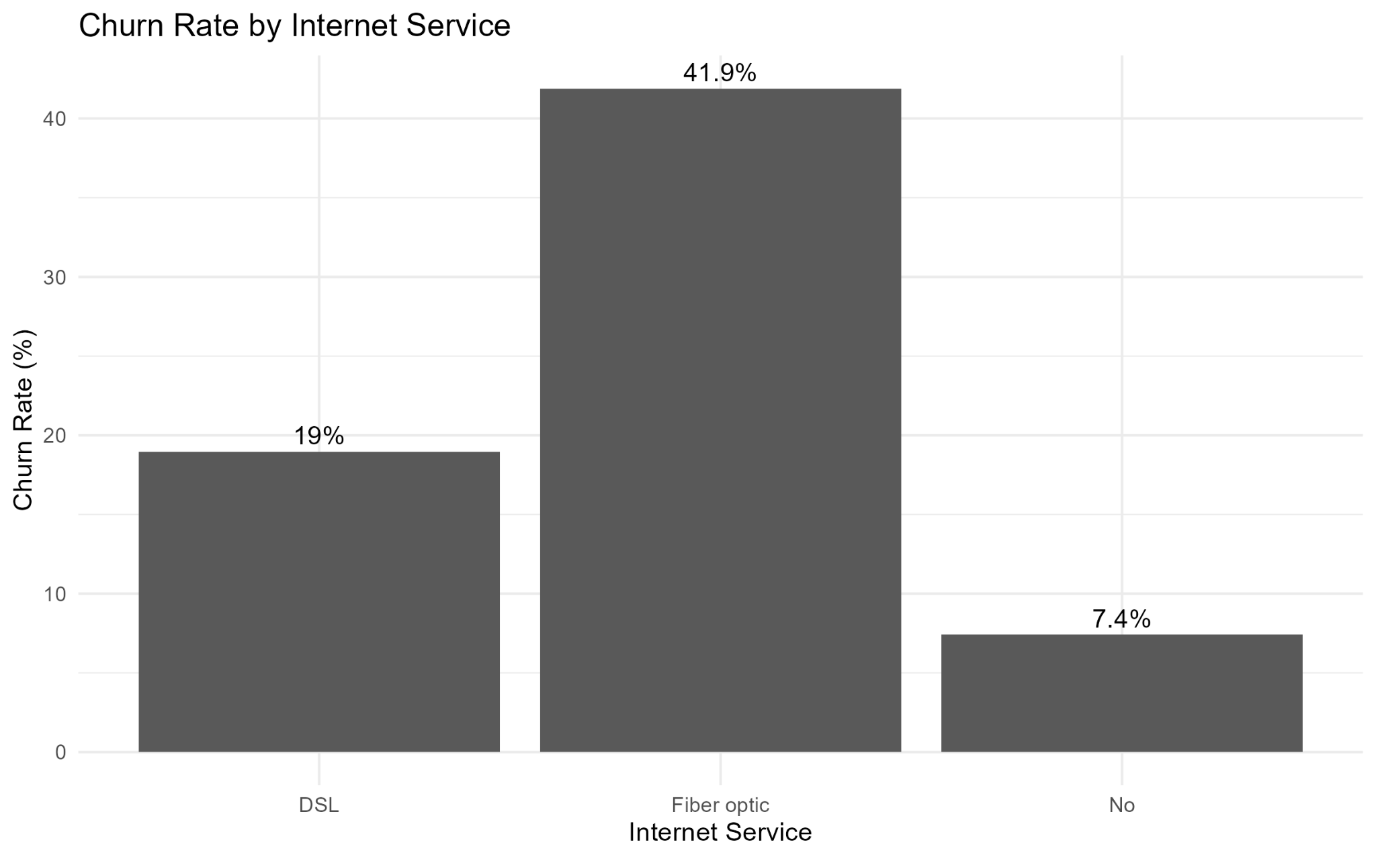

4.7 Churn Rate by Payment Method
Electronic check has the highest observed churn rate at 45.3%, while mailed check, automatic bank transfer, and automatic credit card payment have lower observed rates. Payment method is also statistically associated with churn in the multivariable model.
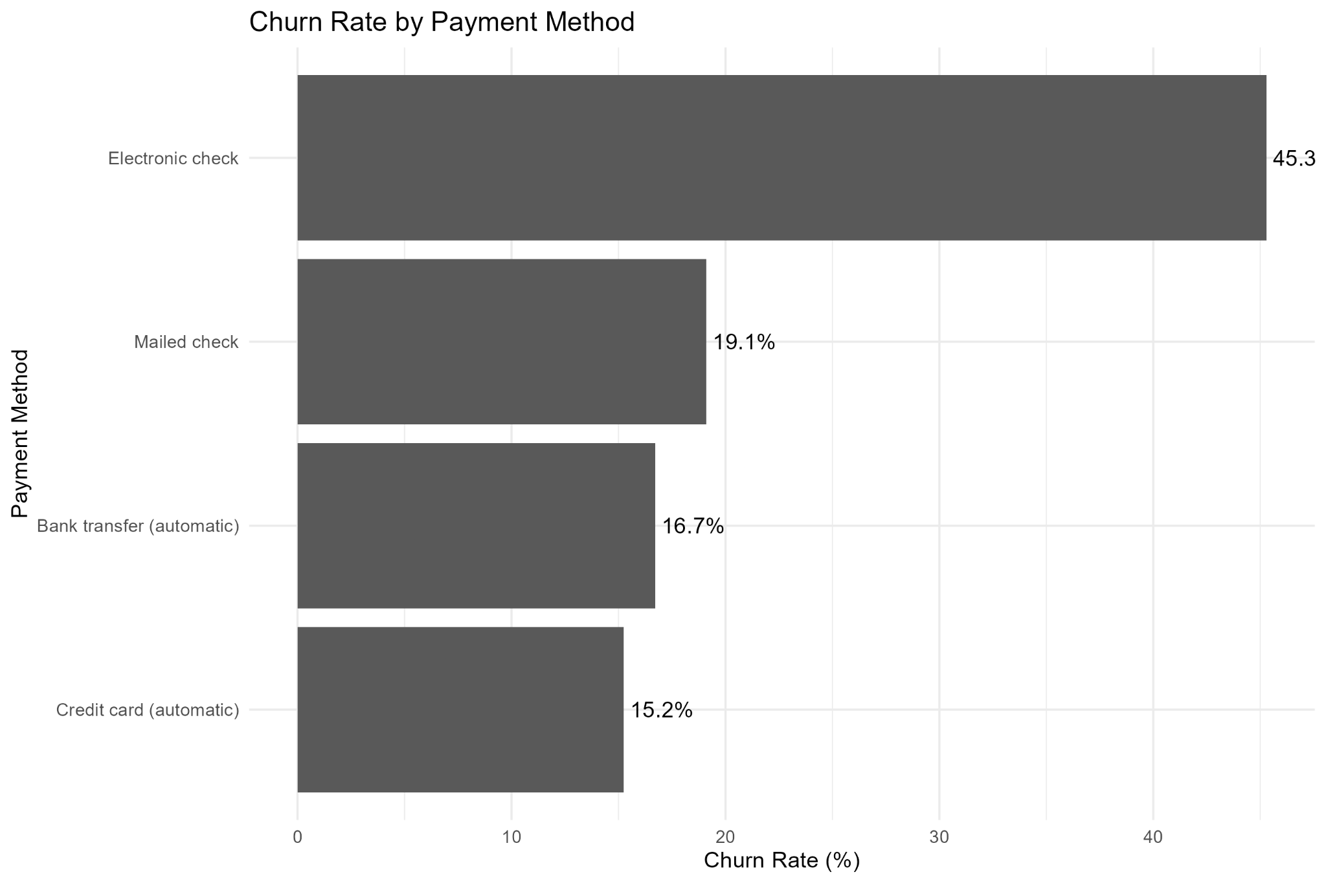

4.8 Churn Rate by Customer Tenure Group
The 0–12 month group has the highest churn rate at 47.4%. Churn declines across the longer-tenure groups, reaching 6.6% among customers with 60+ months of tenure. This highlights the early customer period as an important part of churn analysis.
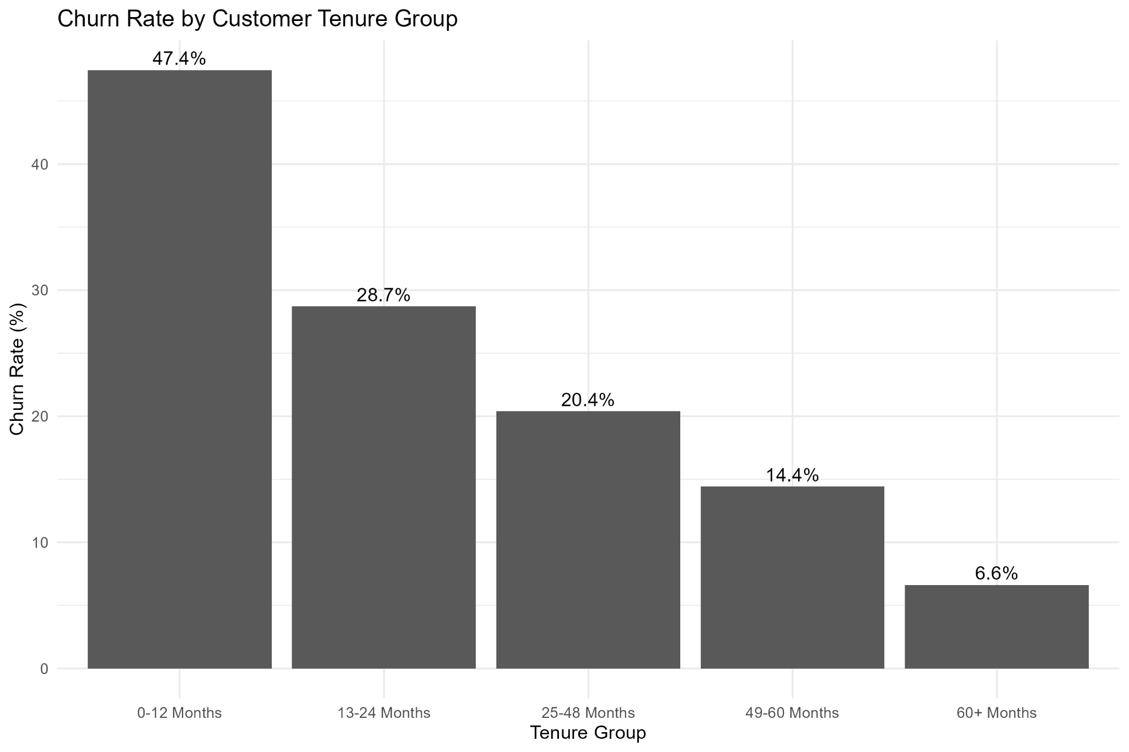

4.9 Churn Rate by Senior Citizen Status
The observed churn rate is 41.7% for senior customers and 23.6% for non-senior customers. Senior status also remains statistically significant in the logistic regression model.
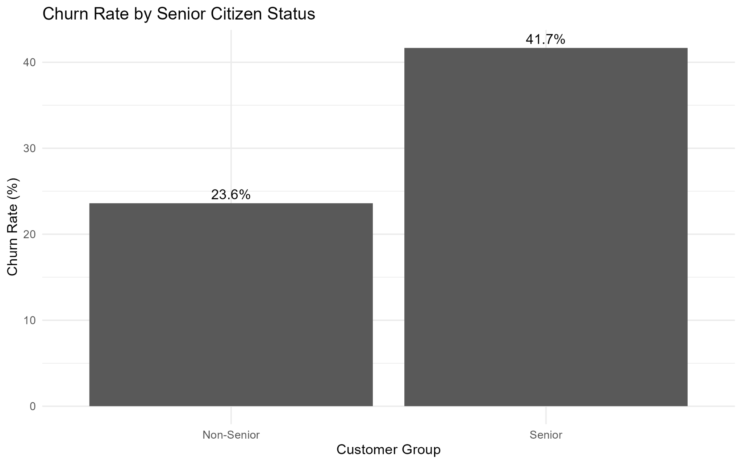

5. Statistical Analysis

5.1 Welch Two-Sample t-Test
A Welch two-sample t-test was used to compare monthly charges between customers who churned and those who did not. The result was statistically significant (t = -18.408, df ≈ 4135.8, p < 2.2e-16). Mean monthly charges were approximately 61.27 for non-churn customers and 74.44 for churned customers. The test supports a difference in average monthly charges between the two churn groups.

5.2 Chi-Square Tests
Contract type and churn were significantly associated (χ² = 1184.6, df = 2, p < 2.2e-16). Internet service and churn were also significantly associated (χ² = 732.31, df = 2, p < 2.2e-16). These results are consistent with the descriptive churn-rate charts.

5.3 Correlation Analysis
The strongest numerical relationship is between tenure and total charges (r = 0.826). Monthly charges and total charges have a correlation of approximately 0.651, while tenure and monthly charges have a correlation of approximately 0.248. The strong tenure-total-charges relationship is expected because total charges accumulate over the customer's tenure.

5.4 Normality and Multicollinearity
Shapiro-Wilk tests for tenure and monthly charges produced p-values below 2.2e-16, indicating departure from normality. Because the analysis uses a large dataset and logistic regression rather than a normal-error linear model, normality of these raw predictors is not treated as a requirement for the classification model.
VIF analysis identified the main multicollinearity concern around tenure and total charges. Their adjusted VIF values were approximately 4.03 and 4.56. This is below a commonly used threshold of 5, but still indicates that the related predictors should be interpreted with caution because of their strong correlation.

5.5 Correlation Visualization
The correlation heatmap provides a visual summary of the relationships among the three numerical variables.
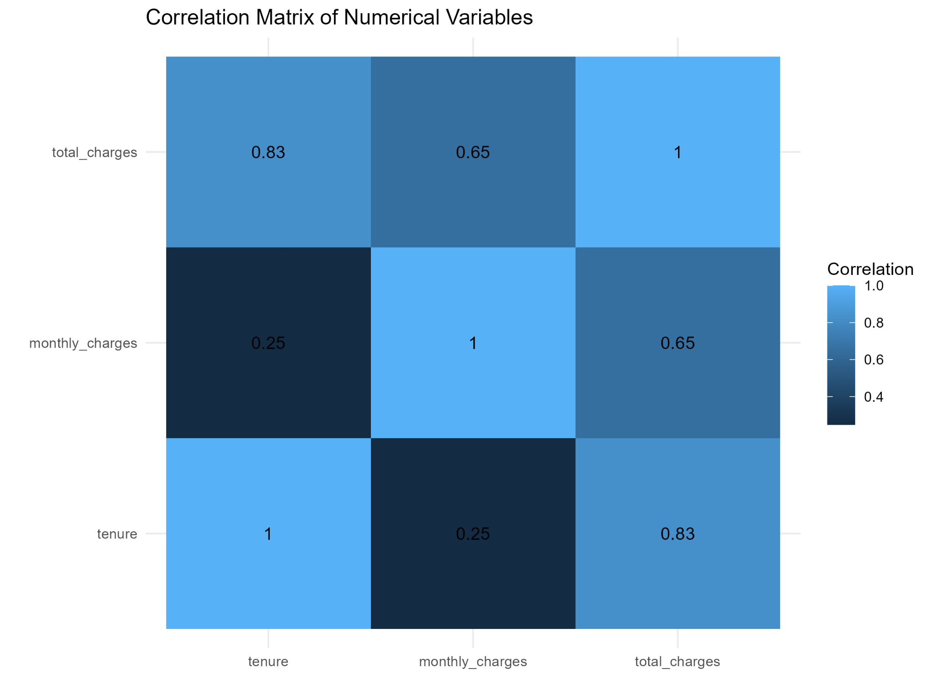

6. Predictive Modeling

6.1 Logistic Regression
A logistic regression model was used because the target variable is binary: customers either churned or did not churn. Predictors included tenure, monthly charges, total charges, contract, internet service, payment method, senior citizen status, partner, dependents, and paperless billing.
Several predictors were statistically significant in the fitted model. Contract type showed strong differences relative to month-to-month contracts, with one-year and two-year contracts having lower estimated odds of churn. Fiber optic internet service showed higher estimated odds relative to the reference category, while electronic check, senior status, and paperless billing were also significant in the fitted model. Monthly charges were significant in the univariate comparison but were not statistically significant in the multivariable logistic model (p ≈ 0.129), illustrating how relationships can change after accounting for other predictors.

6.2 Train-Test Split and Cross-Validation
An 80/20 split was used, producing 5,636 training observations and 1,407 test observations. Five-fold cross-validation was applied to the training data. The cross-validation ROC was approximately 0.841, while the held-out test AUC was approximately 0.834. The closeness of these values provides evidence that the model's ranking performance was reasonably consistent across validation and test evaluation.

7. Model Evaluation

7.1 Confusion Matrix
The confusion matrix shows the classification behavior at the selected probability threshold. There were 191 true positives, 102 false positives, 182 false negatives, and 932 true negatives.
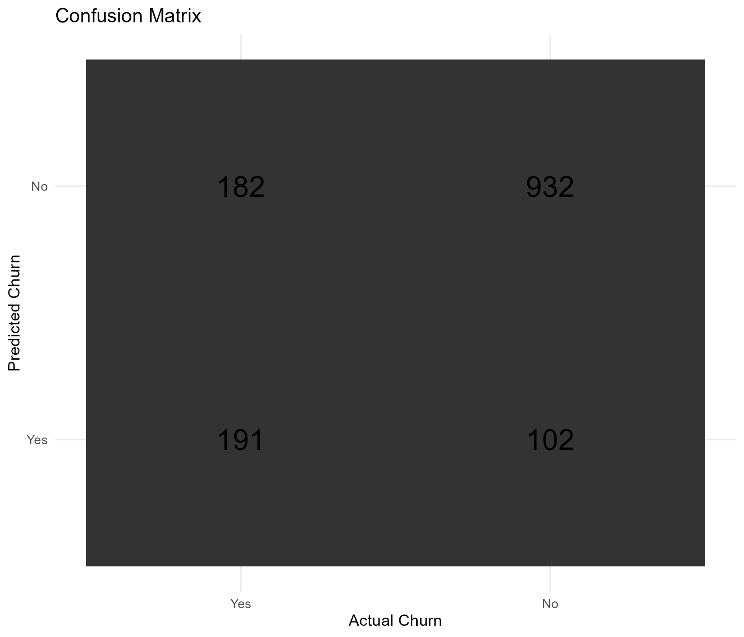

7.2 Performance Metrics
Metric | Test Result
Accuracy | 79.82%
Sensitivity / Recall | 51.21%
Specificity | 90.14%
Precision | 65.19%
F1-score | 57.36%
ROC-AUC | 0.8338
Kappa | 0.4438
The model has high specificity but lower sensitivity. In practical terms, it correctly identifies a large proportion of customers who do not churn, while a substantial number of actual churners remain classified as non-churners. Therefore, accuracy alone should not be used to assess this model.

7.3 ROC Curve
The ROC curve summarizes the trade-off between true-positive and false-positive rates across classification thresholds. The test AUC of 0.834 indicates useful discriminatory ability.
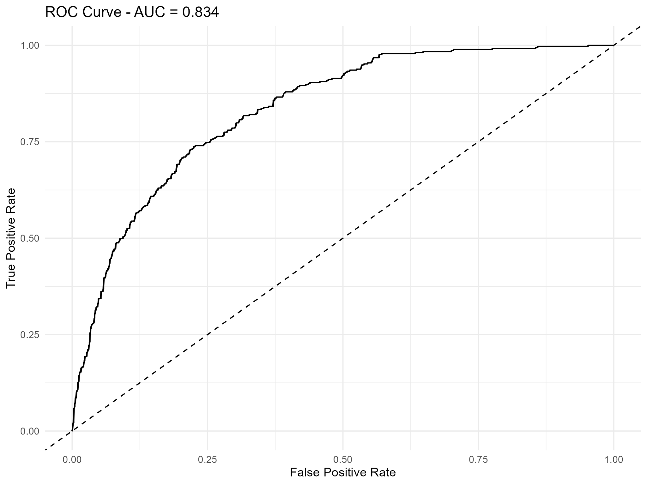

7.4 Predicted Probability Distribution
The predicted probability distribution shows separation between the observed churn groups but also substantial overlap. This overlap is consistent with the false-positive and false-negative classifications in the confusion matrix.
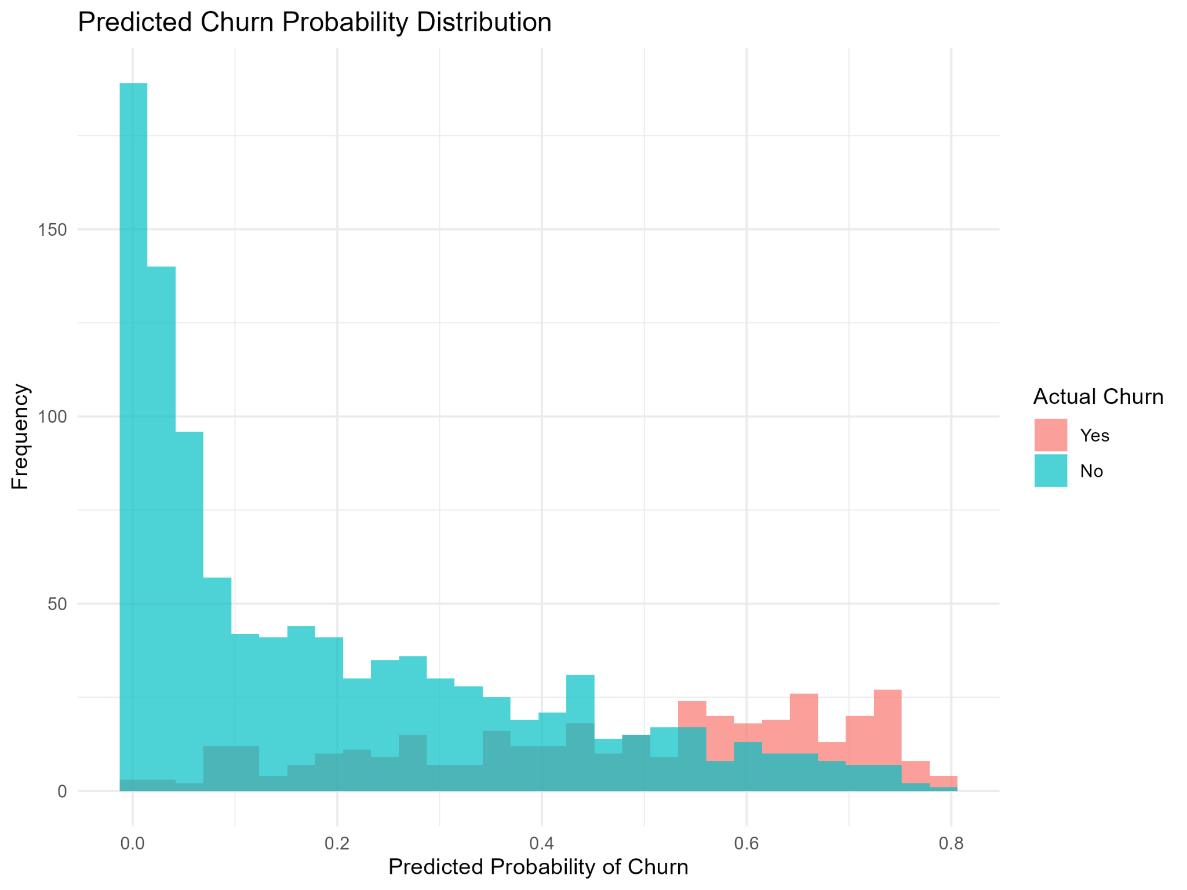

7.5 Model Performance Visualization
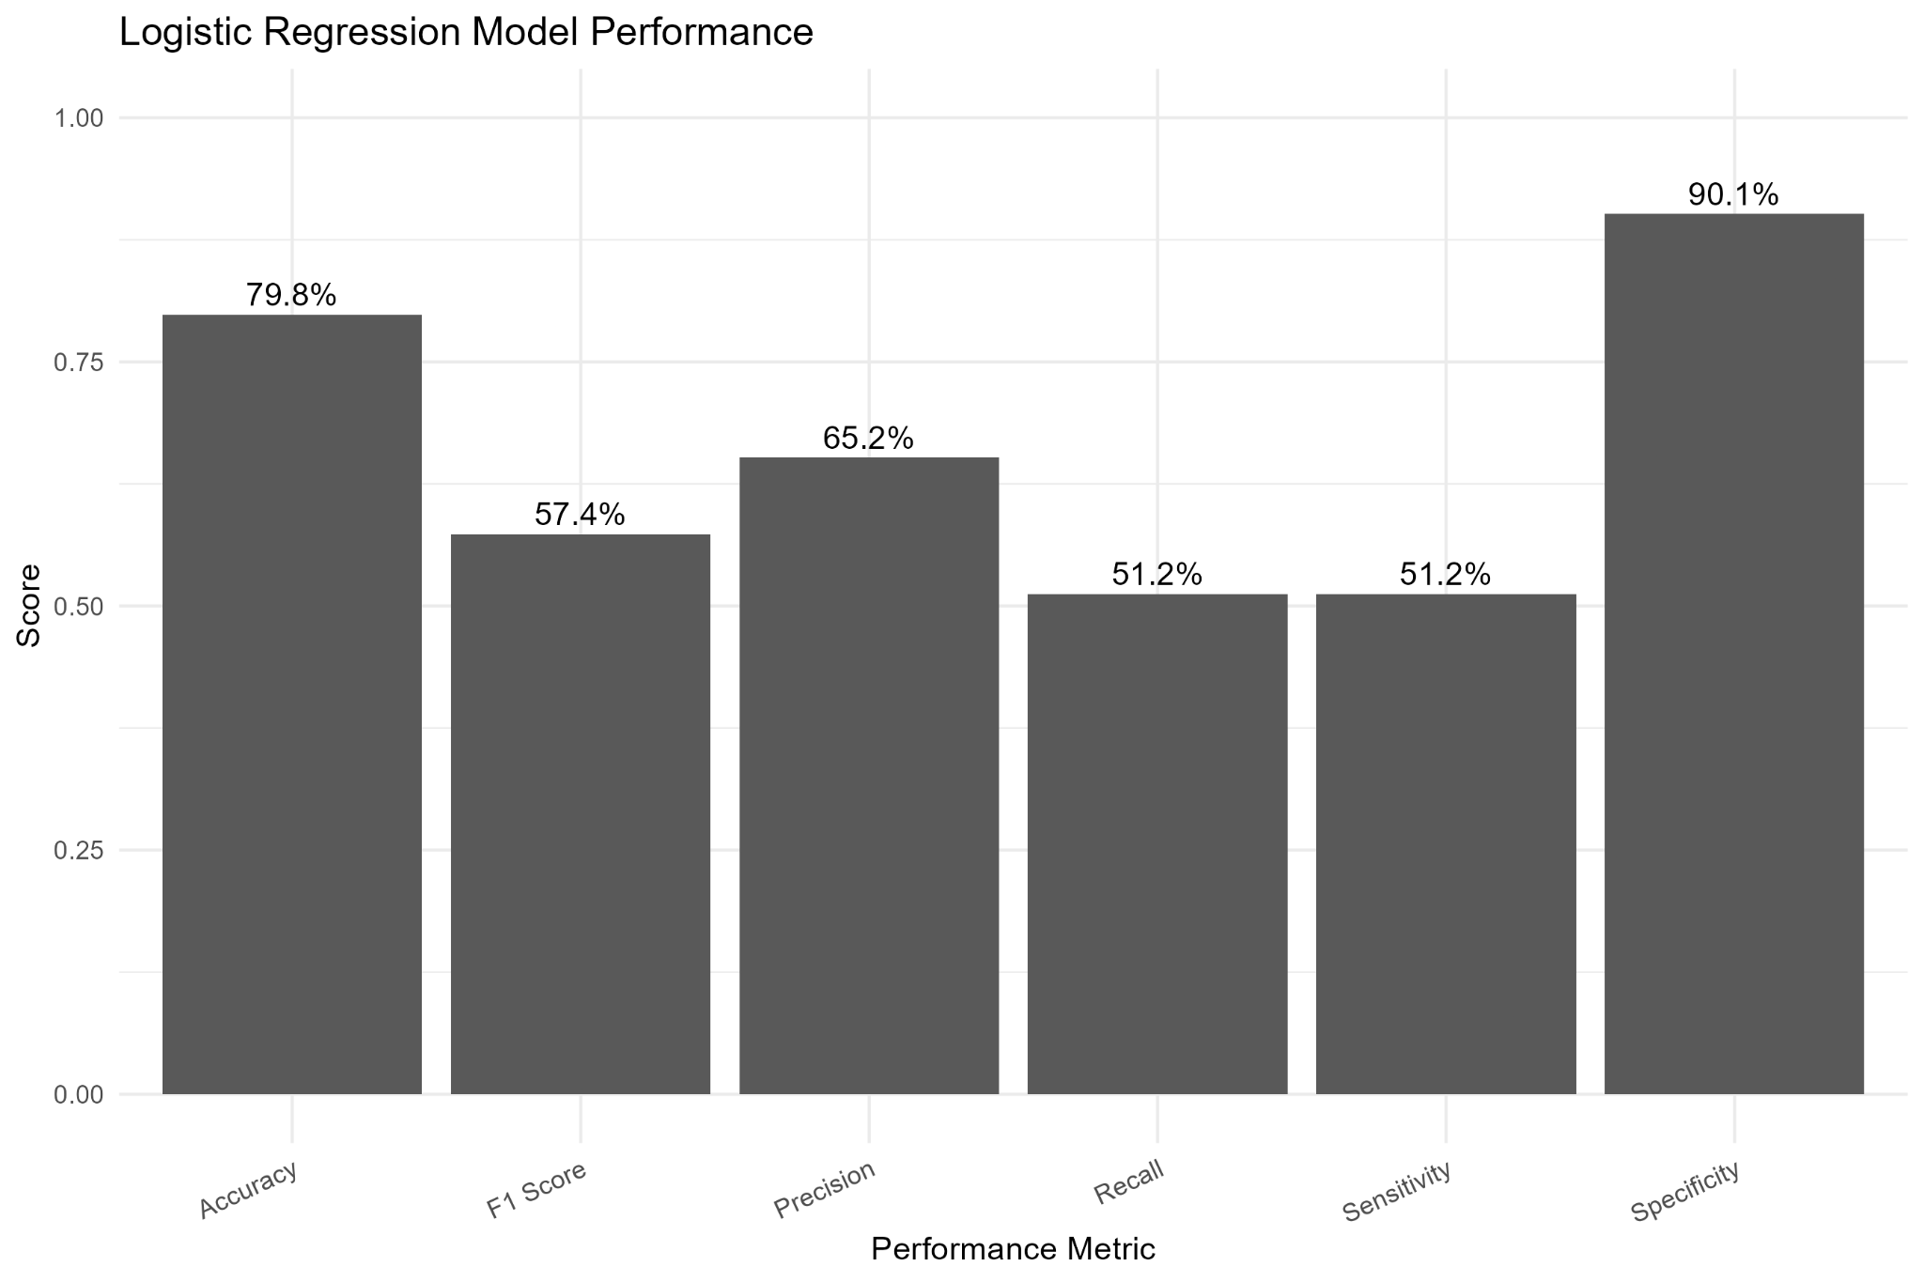

8. Model Diagnostics
The diagnostic plots examine residual behavior, Q-Q residual patterns, scale-location behavior, and residual leverage. Several observations have relatively large residuals and some observations show higher leverage characteristics. These cases should be investigated in future model refinement.
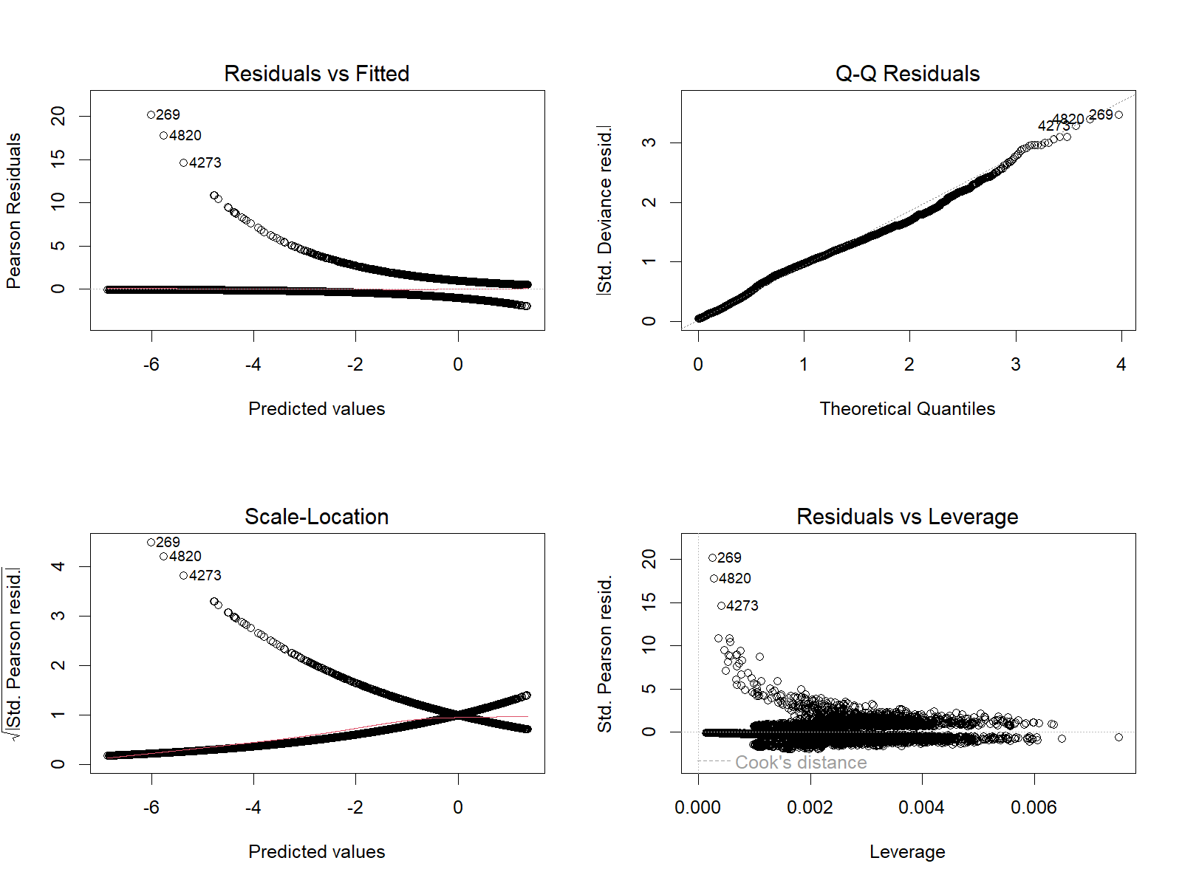

9. Key Findings
- Overall churn is 26.54%, with 1,869 churned customers out of 7,043.
- Contract type is strongly associated with churn: 42.7% for month-to-month, 11.3% for one-year, and 2.8% for two-year contracts.
- Customers in the first 12 months show the highest tenure-group churn rate at 47.4%.
- Fiber optic customers have a 41.9% churn rate, compared with 19.0% for DSL and 7.4% for no internet service.
- Electronic check customers have a 45.3% observed churn rate.
- Senior customers show a 41.7% churn rate compared with 23.6% among non-seniors.
- Tenure and total charges have a strong positive correlation of approximately 0.83.
- The logistic regression model achieved a test AUC of 0.834 and 79.8% accuracy.
- Specificity (90.1%) is substantially higher than sensitivity (51.2%), so the model is better at identifying non-churn than churn at the selected threshold.

10. Practical Interpretation
The analysis identifies customer groups that can be examined more closely in retention planning. The strongest descriptive differences occur among month-to-month customers, customers with short tenure, fiber optic users, electronic-check users, and senior customers.
These findings should be treated as associations in observational customer data rather than proof that a single factor causes churn. A practical retention workflow could use the model's predicted probabilities to prioritize customers for further review, while considering an appropriate probability threshold for the business objective.

11. Model Strengths and Improvement Areas

Strengths
- Uses a complete train-test evaluation rather than reporting only training performance.
- Includes 5-fold cross-validation.
- Reports multiple classification metrics instead of accuracy alone.
- Includes ROC-AUC and a confusion matrix.
- Checks correlation and multicollinearity before interpreting the regression model.
- Includes model diagnostic plots.

Improvement Areas
- Sensitivity is 51.2%, so many actual churners are missed at the current classification threshold.
- The tenure-total-charges relationship creates moderate multicollinearity and should be monitored.
- Influential observations visible in diagnostics should be investigated.
- Alternative models such as decision trees, random forests, gradient boosting, or regularized logistic regression could be compared.
- Threshold tuning could be evaluated if the business objective places greater importance on detecting potential churners.
- Class imbalance could be addressed through class weighting or resampling if appropriate.

12. Conclusion
Week 4 demonstrates an end-to-end customer churn analytics workflow in R. The analysis combines data preparation, visual exploration, statistical testing, predictive modeling, validation, and diagnostics.
The results show clear differences in churn across contract type, tenure, internet service, payment method, and customer characteristics. The logistic regression model provides useful discrimination with a test AUC of 0.834, while its lower sensitivity indicates an opportunity for further model and threshold improvement.

13. Reproducibility and Project Outputs
The Week 4 project includes the dataset, R script, visualization outputs, statistical/model output files, report, and README. The workflow is designed to be rerun in RStudio using the provided script and project structure.

