VIRTUAL R DATA ANALYST INTERNSHIP
WEEK 1 TASK REPORT
Data Cleaning and Preliminary Analysis with R

Telco Customer Churn Analysis

Project Detail | Value
Dataset | Telco Customer Churn
Rows analyzed | 7,043
Columns analyzed | 21
Analysis tool | R / RStudio
Key packages | tidyverse, janitor, skimr, ggplot2
Task duration | Week 1

Prepared as part of the Virtual R Data Analyst Internship

1. Introduction
This report presents the Week 1 data cleaning and preliminary analysis performed on the Telco Customer Churn dataset using R and RStudio. The purpose of this task was to prepare the raw customer dataset for reliable analysis by checking its structure, identifying missing and blank values, removing duplicate records, correcting data types, standardizing column names, and producing initial descriptive statistics and visualizations.
The analysis also explores customer churn patterns across contract types, monthly charges, and customer tenure. These preliminary findings provide a foundation for the more advanced visual analysis and statistical modeling activities planned for subsequent internship tasks.

2. Objectives
- Load and inspect the Telco Customer Churn dataset in R.
- Understand the dataset structure, dimensions, variables, and basic distributions.
- Identify and handle missing or blank values.
- Detect and remove duplicate records.
- Convert TotalCharges into a numeric variable and handle its blank entries appropriately.
- Standardize variable names and categorical data types.
- Calculate descriptive statistics for important numerical variables.
- Examine churn distribution and churn rates by contract type.
- Create clear exploratory visualizations for preliminary insight generation.

3. Dataset Description
The dataset contains 7,043 customer records and 21 variables. It includes customer demographic information, service subscriptions, account details, tenure, monthly charges, total charges, and the target variable Churn. The dataset is suitable for customer retention analysis because it combines categorical and numerical attributes with an explicit churn outcome.
Variable Group | Examples | Purpose
Customer information | customerID, gender, SeniorCitizen | Basic customer characteristics
Household information | Partner, Dependents | Customer relationship context
Services | PhoneService, InternetService, TechSupport | Subscribed services
Account information | Contract, PaymentMethod, PaperlessBilling | Billing and contract behavior
Numerical measures | tenure, MonthlyCharges, TotalCharges | Usage, duration and financial measures
Outcome | Churn | Indicates whether the customer left

4. Data Cleaning Methodology
Data loading: The CSV file was loaded into R using read.csv() after setting the working directory.
Initial inspection: names(), str(), summary(), head(), dim(), and skim() were used to understand the dataset.
Missing and blank values: Missing values were counted by column and blank character values were identified using trimws(). Blank strings were converted to NA.
Duplicate handling: Duplicate records were checked using duplicated() and removed with distinct().
Data type correction: TotalCharges was converted from character to numeric. Blank TotalCharges values associated with zero-tenure customers were represented as 0.
Name standardization: janitor::clean_names() was used to standardize variable names into consistent snake_case format.
Categorical conversion: Relevant categorical variables, including gender, contract, payment method, and churn, were converted to factors.

5. Data Quality Validation
The final validation confirmed that the cleaned dataset retained all 7,043 customer records and 21 variables. The analysis produced zero missing values across the final working dataset and zero duplicate rows.
Quality Check | Result | Status
Rows | 7,043 | Passed
Columns | 21 | Passed
Missing values | 0 | Passed
Duplicate rows | 0 | Passed

6. Preliminary Analysis and Key Findings
Overall churn counts were 5,174 customers who did not churn and 1,869 customers who churned. This corresponds to a churn rate of approximately 26.54%.
Contract Type | Customers | Churned | Churn Rate
Month-to-month | 3,875 | 1,655 | 42.71%
One year | 1,473 | 166 | 11.27%
Two year | 1,695 | 48 | 2.83%
The contract-level analysis shows a strong difference in churn behavior. Month-to-month customers have the highest churn rate, while customers on two-year contracts have the lowest churn rate. This suggests that contract commitment is an important variable to investigate further in customer retention analysis.
Average monthly charges were approximately 61.27 for customers who stayed and 74.44 for customers who churned. Thus, the churned group had higher average monthly charges in this dataset.
Average tenure was approximately 37.57 months for customers who stayed and 17.98 months for customers who churned. This indicates that tenure is another useful variable for deeper churn analysis.

7. Summary Statistics
Variable | Mean | Median | Standard Deviation
tenure | 32.37 | 29.00 | 24.56
MonthlyCharges | 64.76 | 70.35 | 30.09
TotalCharges | 2279.73 | 1394.55 | 2266.79

8. Visualizations
The following six visualizations were generated with ggplot2 to communicate the main patterns identified during preliminary analysis.
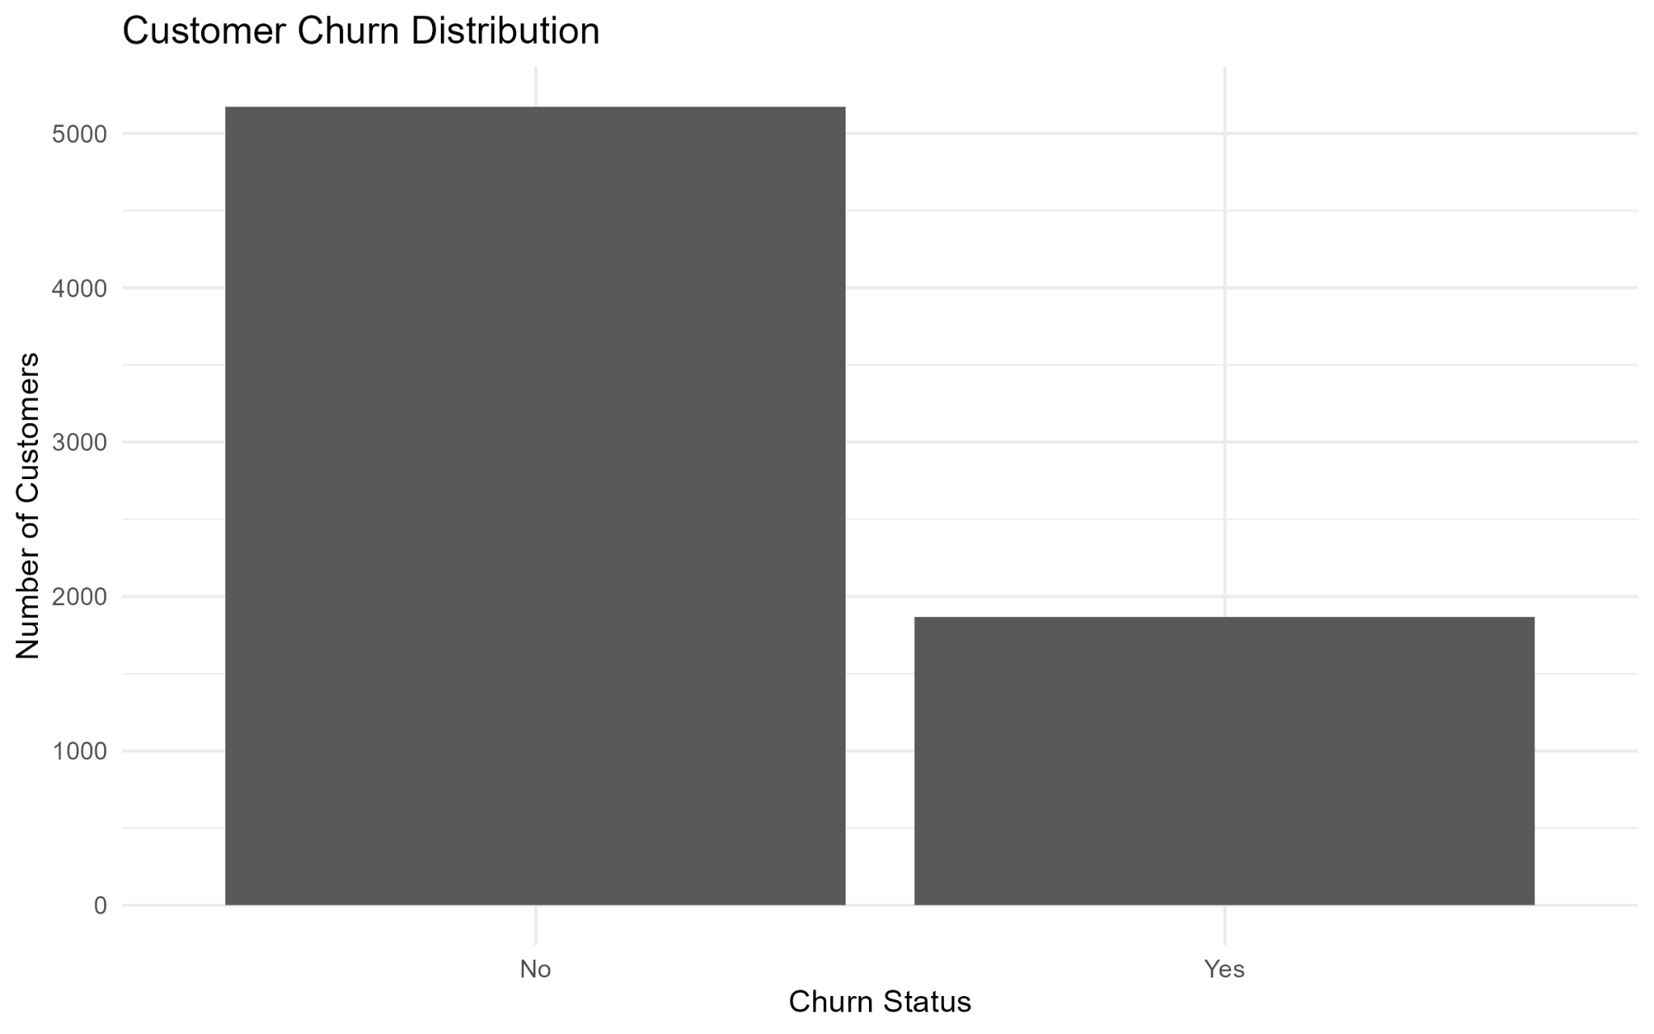
Figure 1. Customer Churn Distribution
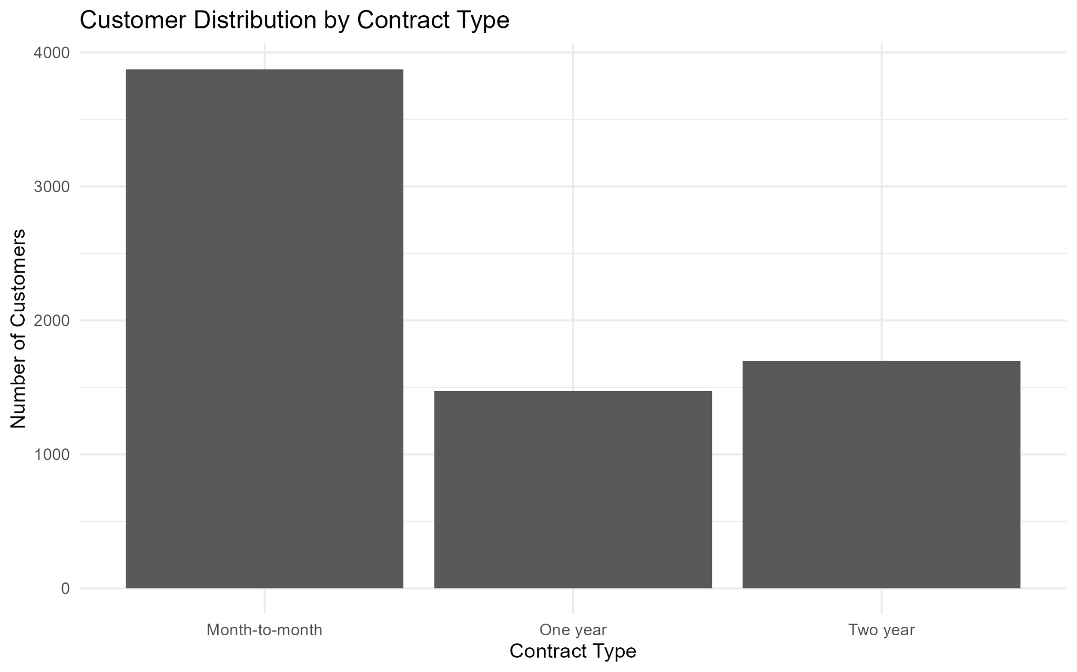
Figure 2. Customer Distribution by Contract Type
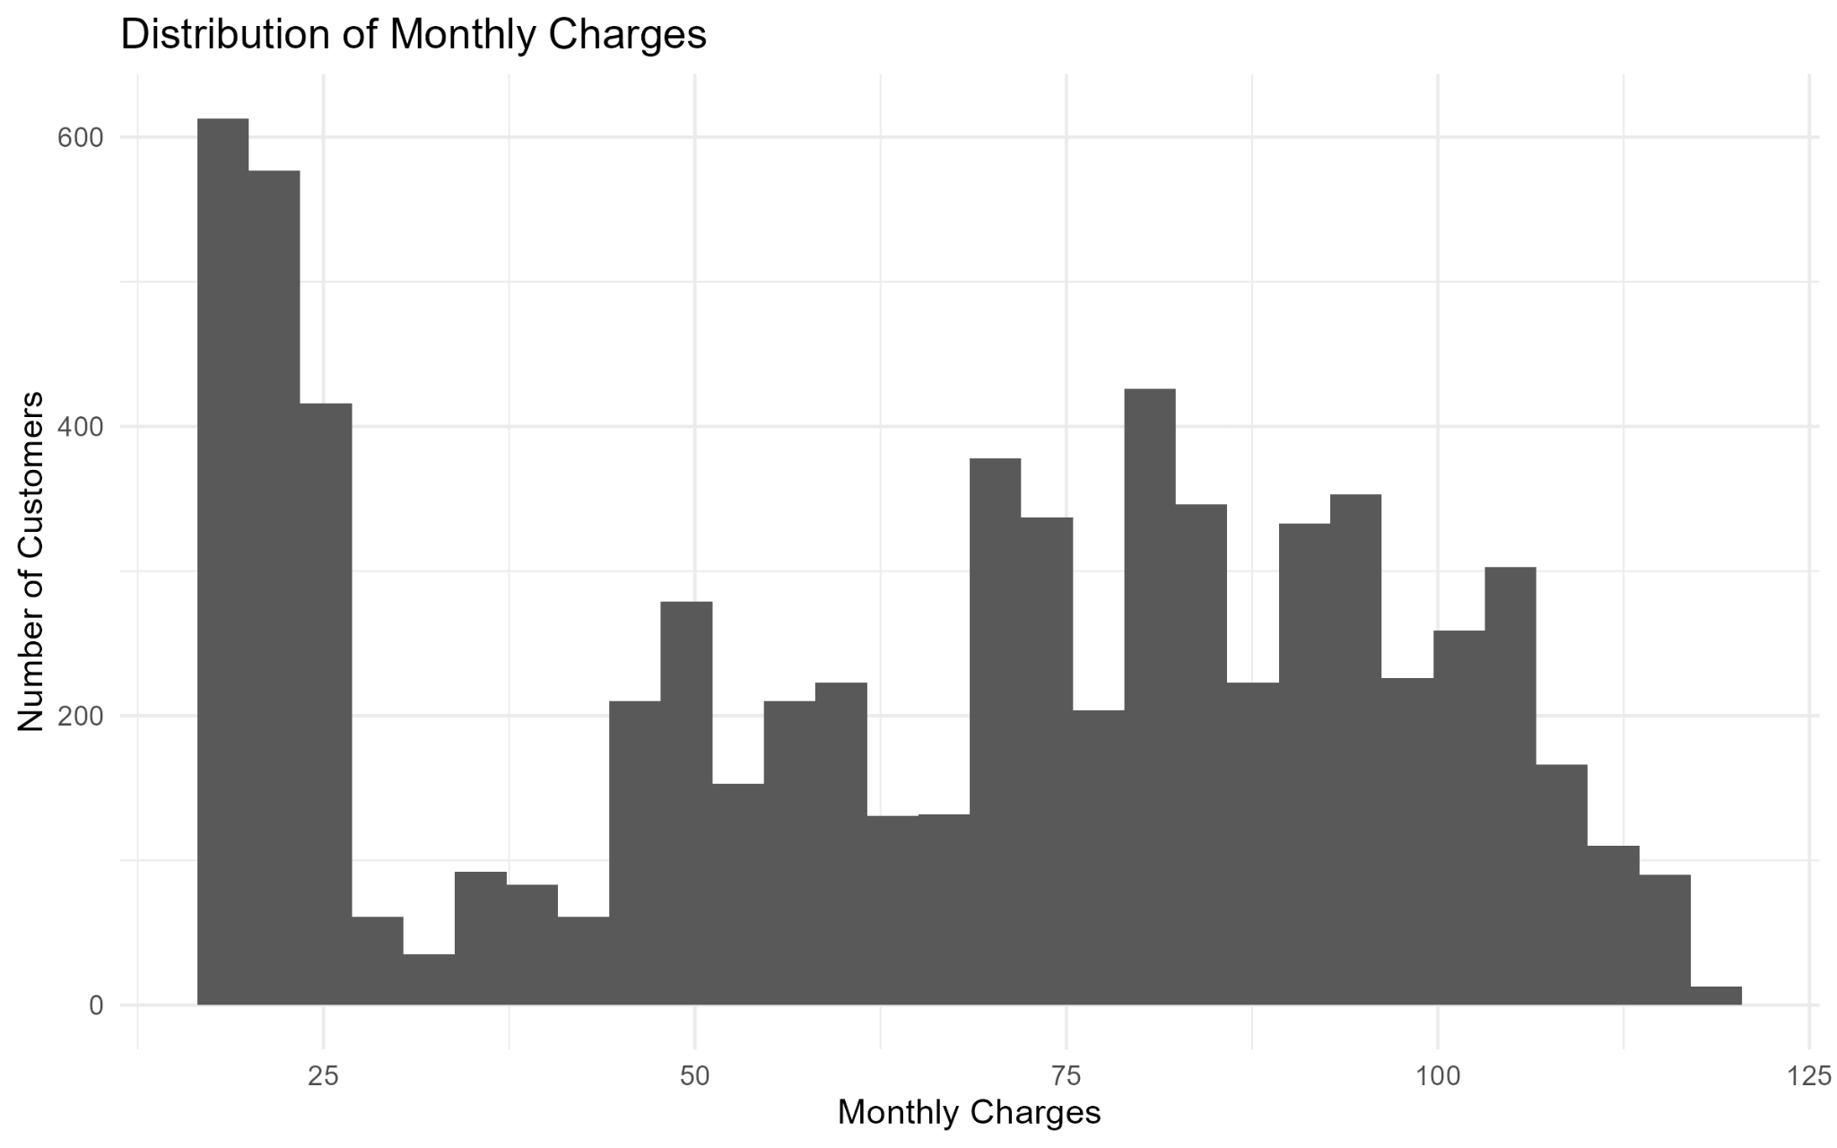
Figure 3. Distribution of Monthly Charges
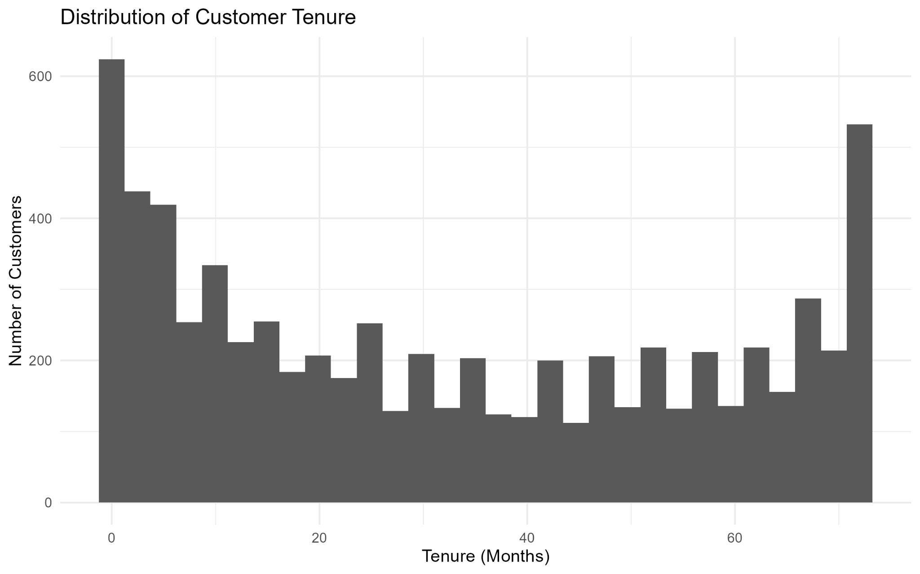
Figure 4. Distribution of Customer Tenure
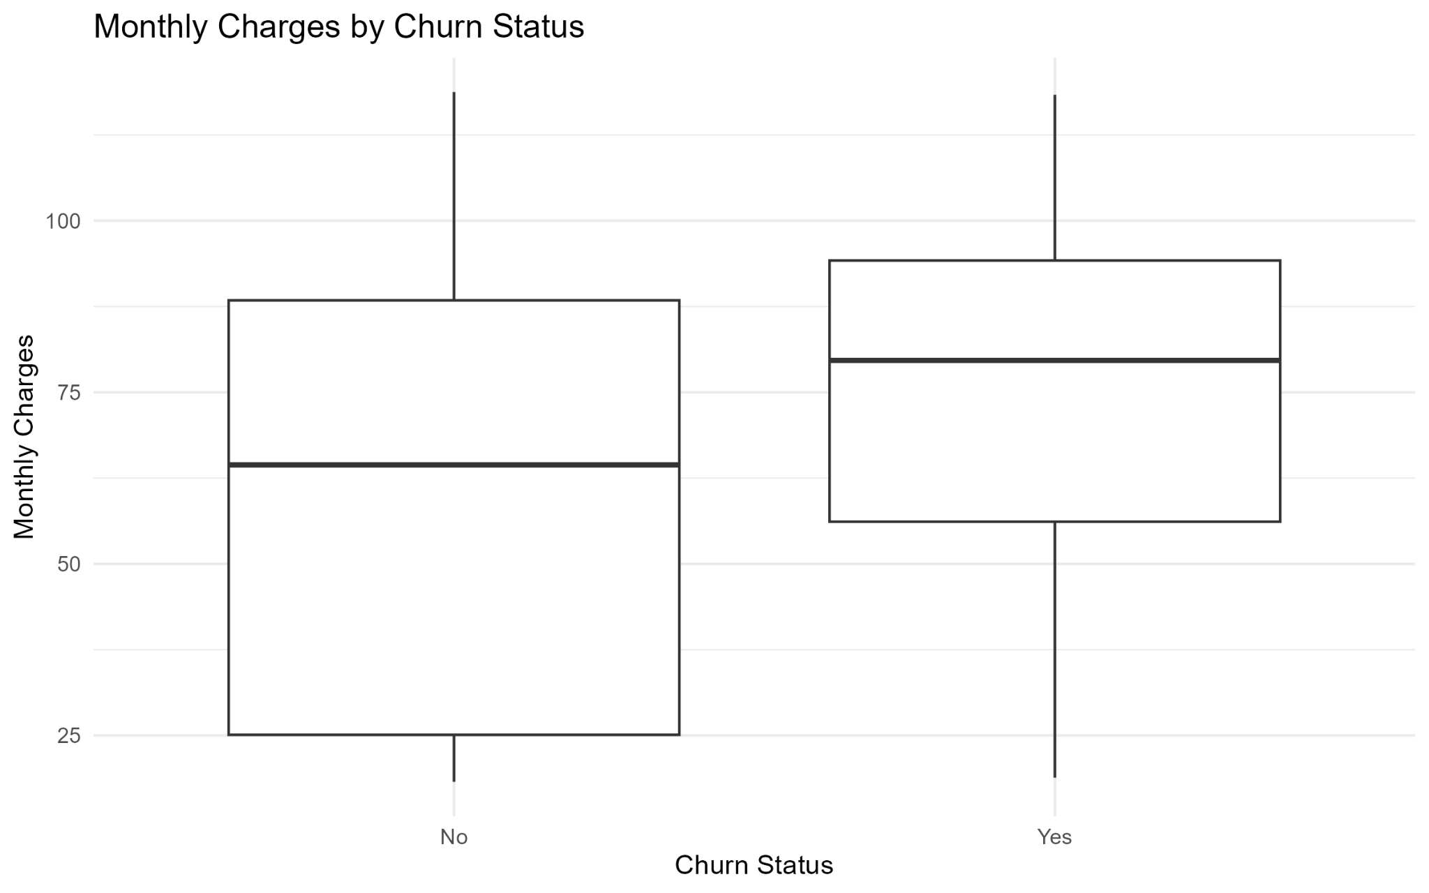
Figure 5. Monthly Charges by Churn Status
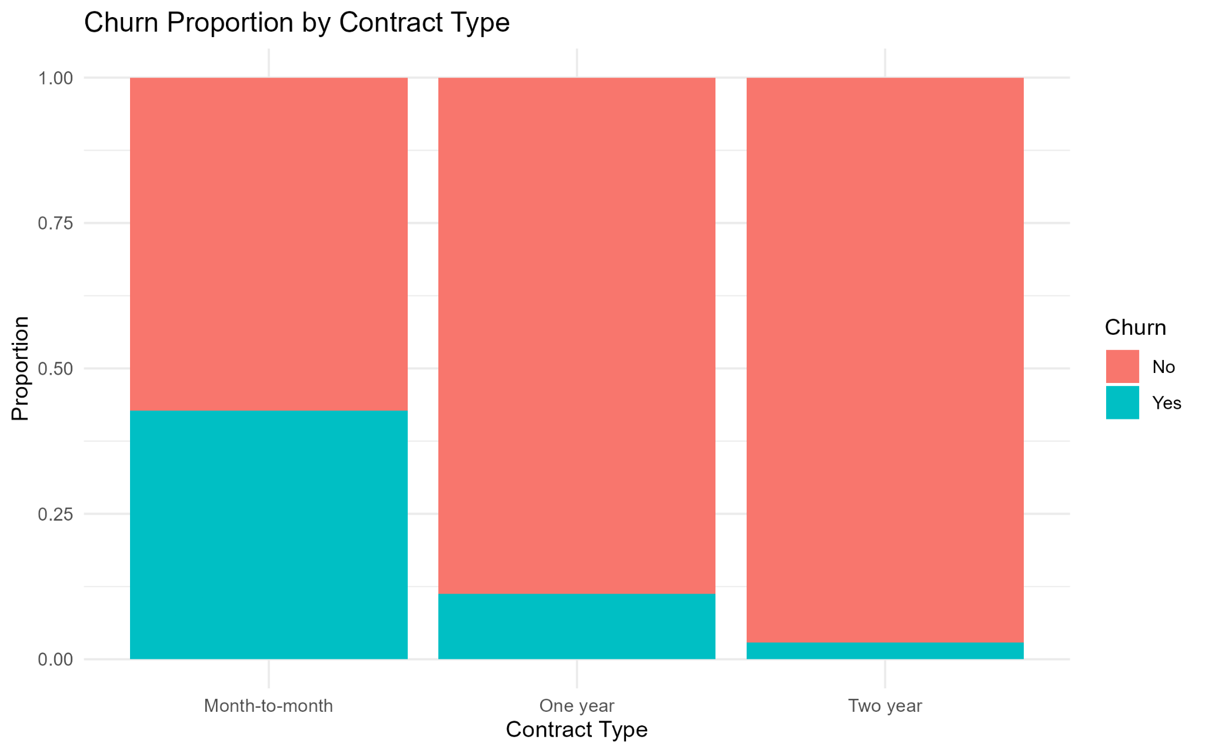
Figure 6. Churn Proportion by Contract Type

9. Key Insights
- The dataset contains 7,043 customers across 21 variables after cleaning.
- The final working dataset contains no missing values and no duplicate rows.
- Approximately 26.54% of customers in the dataset have churned.
- Month-to-month contracts show substantially higher churn than one-year and two-year contracts.
- Customers who churned have higher average monthly charges than customers who stayed.
- Customer tenure differs between churned and retained customers, making tenure a useful candidate for further analysis.
- The distributions of monthly charges and tenure show substantial variation across the customer base, supporting additional segmentation and predictive analysis.

10. Conclusion
Week 1 successfully established a clean and analysis-ready Telco Customer Churn dataset. The workflow covered data inspection, missing and blank value handling, duplicate removal, data-type correction, variable-name standardization, factor conversion, descriptive statistics, and exploratory visualization. The preliminary results indicate that contract type, monthly charges, and tenure are meaningful variables for understanding churn behavior. The cleaned dataset and documented workflow provide a reliable base for the next stage of the internship, where visualization, insight communication, statistical analysis, and predictive modeling can be developed further.

11. Submission Description (200+ Words)
For Week 1 of the Virtual R Data Analyst Internship, I completed a data cleaning and preliminary analysis project using the Telco Customer Churn dataset in RStudio. The objective was to transform the raw customer data into a reliable and analysis-ready dataset while developing an initial understanding of customer churn patterns. I began by loading and inspecting the dataset using functions such as head(), dim(), names(), str(), summary(), and skim(). I then checked for missing values and blank entries, converted blank strings to missing values, and verified the quality of the data. Duplicate records were identified and removed. The TotalCharges variable was converted from character to numeric, and zero-tenure customers with blank total charges were handled appropriately. Variable names were standardized with the janitor package, and categorical variables were converted into factors for analysis. I calculated descriptive statistics for tenure, monthly charges, and total charges, and performed frequency and proportion analysis for customer demographics, contract type, and churn. I also compared average monthly charges and average tenure between customers who churned and those who stayed. Six ggplot2 visualizations were created to communicate churn distribution, contract distribution, monthly charge distribution, tenure distribution, monthly charges by churn status, and churn proportions by contract type. The final validation confirmed 7,043 rows, 21 columns, zero missing values, and zero duplicate rows. The analysis showed that month-to-month customers have a much higher churn rate than customers on longer contracts, while churned customers also have higher average monthly charges. These findings provide useful preliminary insights and establish a strong foundation for the next stages of data visualization, statistical analysis, and predictive modeling.

12. Appendix — R Analysis Code
library(tidyverse)
library(janitor)
library(skimr)

setwd("D:/Virtual R Data Analyst Intern/Week-1/Dataset")
data <- read.csv("WA_Fn-UseC_-Telco-Customer-Churn.csv")

data <- data %>%
mutate(
across(where(is.character), ~na_if(trimws(.), ""))
) %>%
distinct()

names(data)[names(data) == "TotalCharges"] <- "total_charges"
data$total_charges <- as.numeric(data$total_charges)

data$total_charges <- ifelse(
is.na(data$total_charges) & data$tenure == 0,
0,
data$total_charges
)

data <- clean_names(data)

data <- data %>%
mutate(
gender = as.factor(gender),
partner = as.factor(partner),
dependents = as.factor(dependents),
phone_service = as.factor(phone_service),
multiple_lines = as.factor(multiple_lines),
internet_service = as.factor(internet_service),
online_security = as.factor(online_security),
online_backup = as.factor(online_backup),
device_protection = as.factor(device_protection),
tech_support = as.factor(tech_support),
streaming_tv = as.factor(streaming_tv),
streaming_movies = as.factor(streaming_movies),
contract = as.factor(contract),
paperless_billing = as.factor(paperless_billing),
payment_method = as.factor(payment_method),
churn = as.factor(churn)
)

summary_stats <- data %>%
summarise(
mean_tenure = mean(tenure, na.rm = TRUE),
median_tenure = median(tenure, na.rm = TRUE),
sd_tenure = sd(tenure, na.rm = TRUE),
mean_monthly_charges = mean(monthly_charges, na.rm = TRUE),
median_monthly_charges = median(monthly_charges, na.rm = TRUE),
sd_monthly_charges = sd(monthly_charges, na.rm = TRUE),
mean_total_charges = mean(total_charges, na.rm = TRUE),
median_total_charges = median(total_charges, na.rm = TRUE),
sd_total_charges = sd(total_charges, na.rm = TRUE)
)

table(data$gender)
table(data$contract)
table(data$internet_service)
table(data$churn)
prop.table(table(data$churn)) * 100

monthly_by_churn <- data %>%
group_by(churn) %>%
summarise(average_monthly_charges = mean(monthly_charges, na.rm = TRUE))

tenure_by_churn <- data %>%
group_by(churn) %>%
summarise(average_tenure = mean(tenure, na.rm = TRUE))

contract_churn_rate <- data %>%
group_by(contract) %>%
summarise(
customers = n(),
churned = sum(churn == "Yes"),
churn_rate = churned / customers * 100
)

ggplot(data, aes(x = churn)) +
geom_bar() +
labs(title = "Customer Churn Distribution",
x = "Churn Status", y = "Number of Customers") +
theme_minimal()

ggplot(data, aes(x = contract)) +
geom_bar() +
labs(title = "Customer Distribution by Contract Type",
x = "Contract Type", y = "Number of Customers") +
theme_minimal()

ggplot(data, aes(x = monthly_charges)) +
geom_histogram(bins = 30) +
labs(title = "Distribution of Monthly Charges",
x = "Monthly Charges", y = "Number of Customers") +
theme_minimal()

ggplot(data, aes(x = tenure)) +
geom_histogram(bins = 30) +
labs(title = "Distribution of Customer Tenure",
x = "Tenure (Months)", y = "Number of Customers") +
theme_minimal()

ggplot(data, aes(x = churn, y = monthly_charges)) +
geom_boxplot() +
labs(title = "Monthly Charges by Churn Status",
x = "Churn Status", y = "Monthly Charges") +
theme_minimal()

ggplot(data, aes(x = contract, fill = churn)) +
geom_bar(position = "fill") +
labs(title = "Churn Proportion by Contract Type",
x = "Contract Type", y = "Proportion", fill = "Churn") +
theme_minimal()

nrow(data)
ncol(data)
colSums(is.na(data))
sum(duplicated(data))

