Motion Capture & Sports Analysis System(SRS)
Introduction
a) Purpose
The purpose of this Software Requirements Specification (SRS) document is to provide a detailed description of the requirements for the system “Virtual Coach”. This document defines the overall structure, functionalities, constraints, and performance expectations of the system. It serves as a reference for developers, designers, testers, and stakeholders to ensure that the system is developed according to specified requirements.
b) Scope
The scope of this document is to describe the working and features of the “Virtual Coach” system, which is an AI-based application designed to analyze cricket player posture using video input. The system utilizes computer vision and machine learning techniques to evaluate player performance and provide feedback.
Problem Description
The purpose of this SRS is to clearly define all requirements of the Virtual Coach system so that it can be designed and implemented effectively.
Intended Audience:
- Developers and programmers
- System designers
- Testing and QA team
- Project guide and evaluators
- End users (players and trainers)
This document helps all stakeholders understand the system functionality and ensures smooth development.
Scope
a) Product Name: Virtual Coach
b) What the system will do:
- Accept video input (live or recorded)
- Detect body joints using pose estimation
- Analyze posture and movement
- Provide feedback and suggestions
- Generate performance scores
- Store user data and history
What the system will NOT do:
- Replace human coaches completely
- Work without video input
- Support other sports (initial version limited to cricket)

c) Application, Benefits, Objectives:
- Helps players improve performance
- Provides affordable coaching solution
- Reduces injury risk through posture correction
- Accessible to users without professional coaching

Overall Description
Product Perspective
The Virtual Coach system is a mobile-based AI application that processes video input and provides posture analysis. It consists of multiple modules working together in a pipeline.
System Architecture
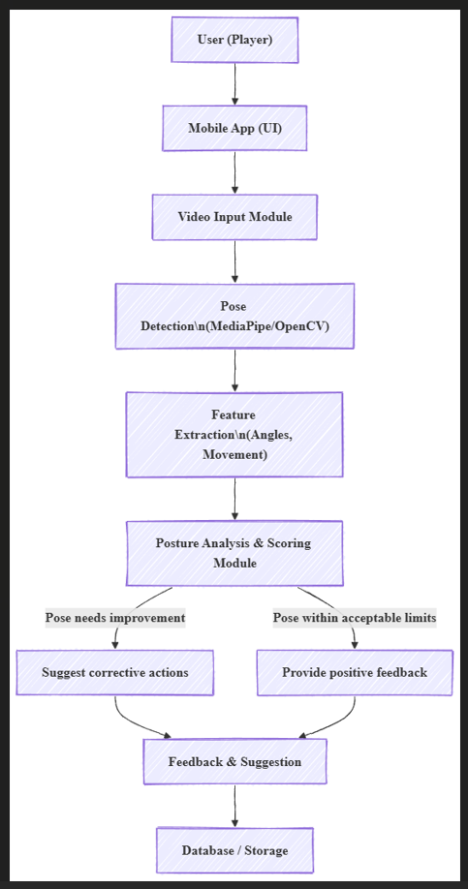

Hardware Requirements
- PC/Laptop (Intel i5 or higher)
- Minimum 8 GB RAM with 4GB graphics
- Android smartphone with camera
- Internet connection

Software Requirements
- OS: Windows / Linux / macOS
- Language: Python
- Android Studio (for mobile app)
- Libraries: OpenCV, MediaPipe
- ML Frameworks: TensorFlow / PyTorch
- Database: Firebase / MySQL
Product Functions
The major functions of the system are:
- Video Capture/Input
Accepts live or recorded cricket videos.
- Pose Detection
Detects body joints like elbows, knees, shoulders.
- Feature Extraction
Calculates joint angles and movement patterns.
- Posture Analysis
Compares posture with ideal standards.
- Performance Scoring
Generates score based on accuracy.
- Feedback System
Provides suggestions and injury alerts.
- Data Storage
Stores user performance history.

1. System Workflow
The system workflow explains how the motion capture system processes player movement data using computer vision and artificial intelligence techniques. The system begins with video input which may come from a live camera feed or uploaded video file. The video is divided into multiple frames which are processed sequentially.
Each frame is analyzed using pose detection algorithms such as MediaPipe or deep learning models. These algorithms detect human body joints including shoulders, elbows, hips, knees and ankles. Once joints are detected, the system tracks their movement across frames to understand motion patterns.
Using the coordinates of these joints, the system calculates metrics such as joint angles, body posture, speed of movement, acceleration and movement efficiency. The results are then visualized through graphs, skeleton overlays and analytical reports that help coaches and athletes evaluate performance.
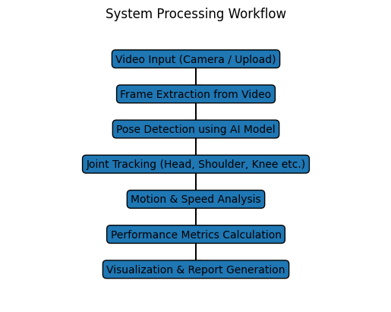
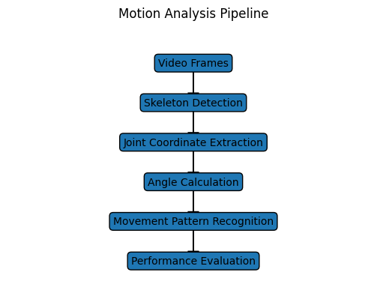
2. External Interfaces
The system interacts with various external components that provide inputs and receive outputs from the analysis system.
Input Interfaces include video capture devices such as webcams, mobile cameras, or sports cameras. The system can also accept prerecorded video files in formats such as MP4 or AVI. In advanced setups, motion sensors or wearable devices may also provide additional motion data.
User Inputs include player details such as name, age, and sport category. Users can also select the type of analysis required such as speed analysis, posture analysis, or movement pattern evaluation.
Output Interfaces provide processed information such as skeleton tracking visualization, movement heatmaps, analytical graphs, and performance reports. These outputs help coaches analyze strengths and weaknesses of athletes.
3. Functional Requirements
The functional requirements describe the core features and capabilities of the motion capture system.
• The system shall allow users to upload or capture video recordings.
• The system shall detect and track human body joints using AI models.
• The system shall compute joint angles and body posture.
• The system shall analyze player speed, acceleration and motion patterns.
• The system shall store analysis results in the database.
• The system shall generate visual reports and performance metrics.
• The system shall allow users to download reports for further study.

4. Performance Requirements
The performance requirements define the efficiency and operational capabilities of the system.
The system should support at least 50 concurrent users accessing the platform. The video processing module should handle approximately 30 frames per second to maintain smooth motion tracking. The response time for analysis results should remain below one second for optimal user experience.
The system must also efficiently process large video files without significant delays. GPU acceleration may be used to improve processing speed and maintain high performance during intensive analysis.

5. Design Constraints
The design of the system is influenced by certain technological and hardware constraints. The system relies on libraries such as OpenCV for image processing and MediaPipe for real-time pose detection. Machine learning models implemented using TensorFlow or similar frameworks may be used for advanced analytics.
The system requires a camera device for capturing player motion and may benefit from GPU hardware for faster computation. The architecture is implemented as a web-based platform to ensure accessibility from multiple devices including laptops, tablets and smartphones.

6. Database Design
The database manages all the stored information related to players, videos and analysis results.
Entities involved in the system include Player, Video and Analysis. The Player entity stores personal details of athletes. The Video entity stores uploaded recordings associated with players. The Analysis entity contains computed metrics, graphs and generated reports.
The relationship between these entities follows a structured hierarchy. A single player may upload multiple videos, and each video may generate multiple analysis results. This relational structure ensures efficient data management and easy retrieval of historical performance data.

7. System Attributes
Reliability: The system should achieve approximately 90 percent accuracy in detecting body joints and motion patterns.
Availability: The application should remain accessible to users at all times through an online interface.
Security: Secure login authentication and encrypted data storage must be implemented to protect user data.
Maintainability: Modular system design allows easy updates and debugging.
Portability: The system should operate across different operating systems and browsers.

8. User Interface Design
The user interface of the motion capture system is designed to provide simple navigation and clear visualization of sports analytics. The interface includes pages such as login, dashboard, video upload, analysis viewer and report generation.
The dashboard allows users to manage player profiles, view uploaded videos and monitor recent analysis results. The analysis interface displays skeleton tracking over video frames along with performance graphs and movement statistics.
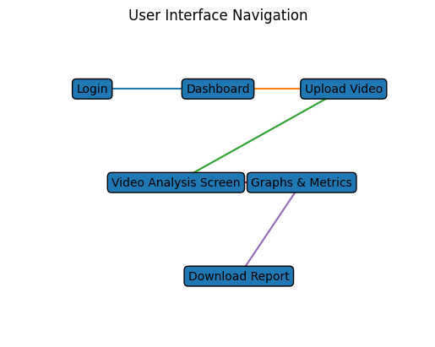

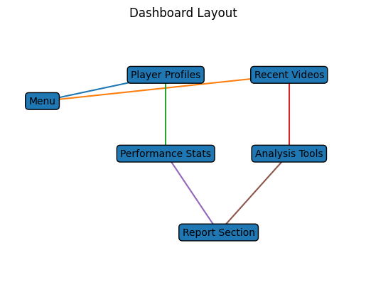

Software Design Document:
a>Structural Design:
1>CLASS DIAGRAM:
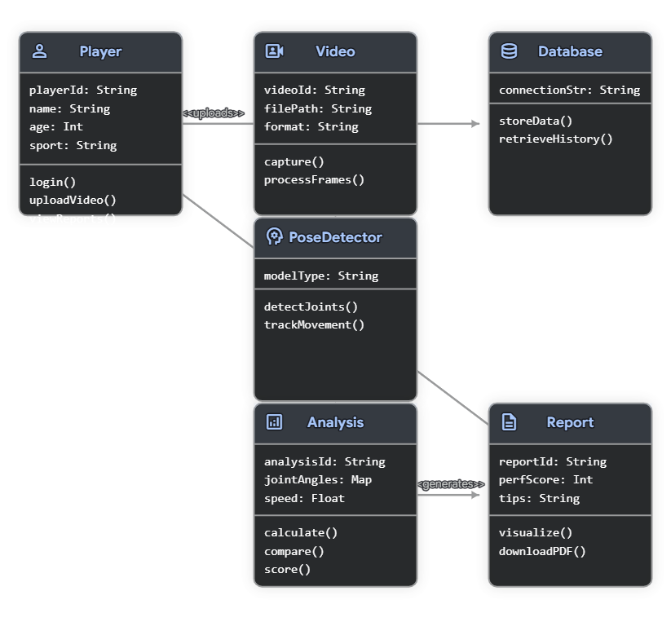

2>OBJECT DIAGRAM:
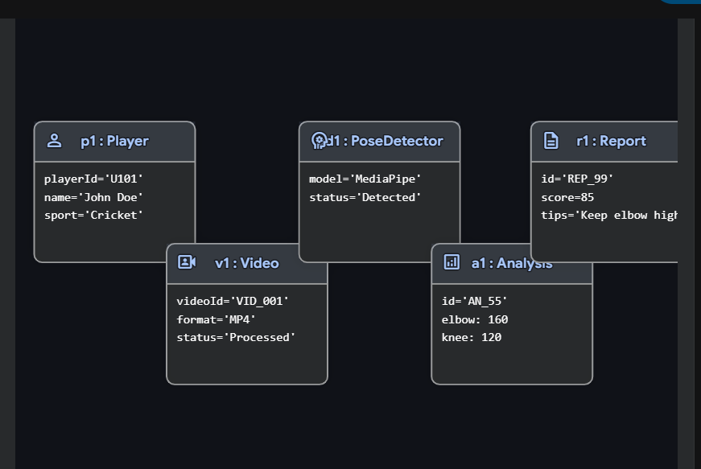

B> Data design
1>DATA FLOW DIAGRAM:
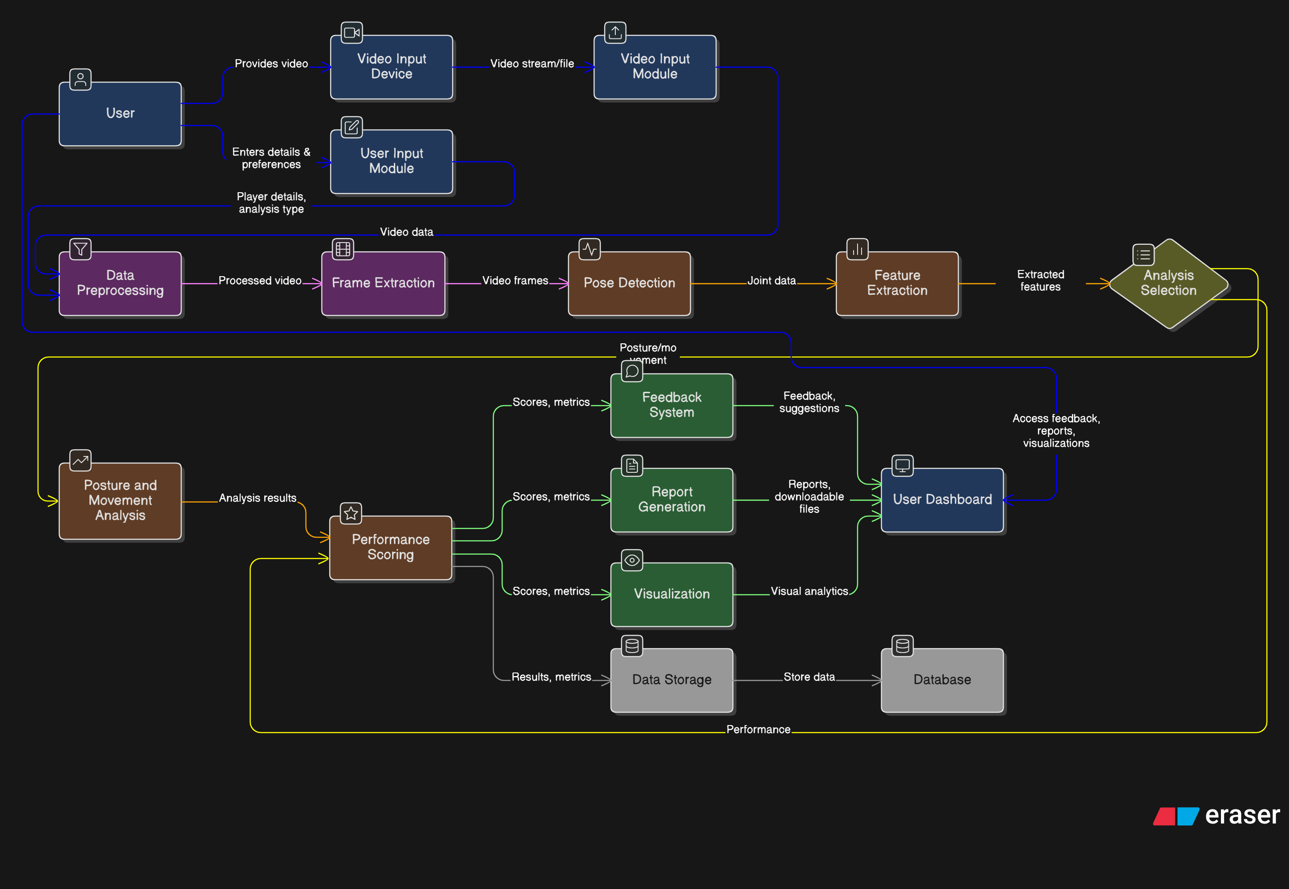
4.3. Behavioural Design
a. Sequence Diagram
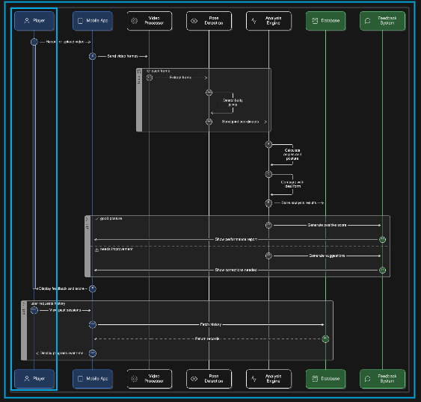
b. Collaboration diagram
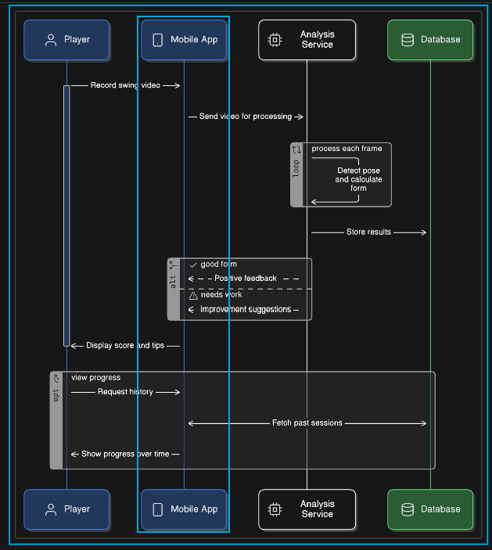
c. Activity Diagram
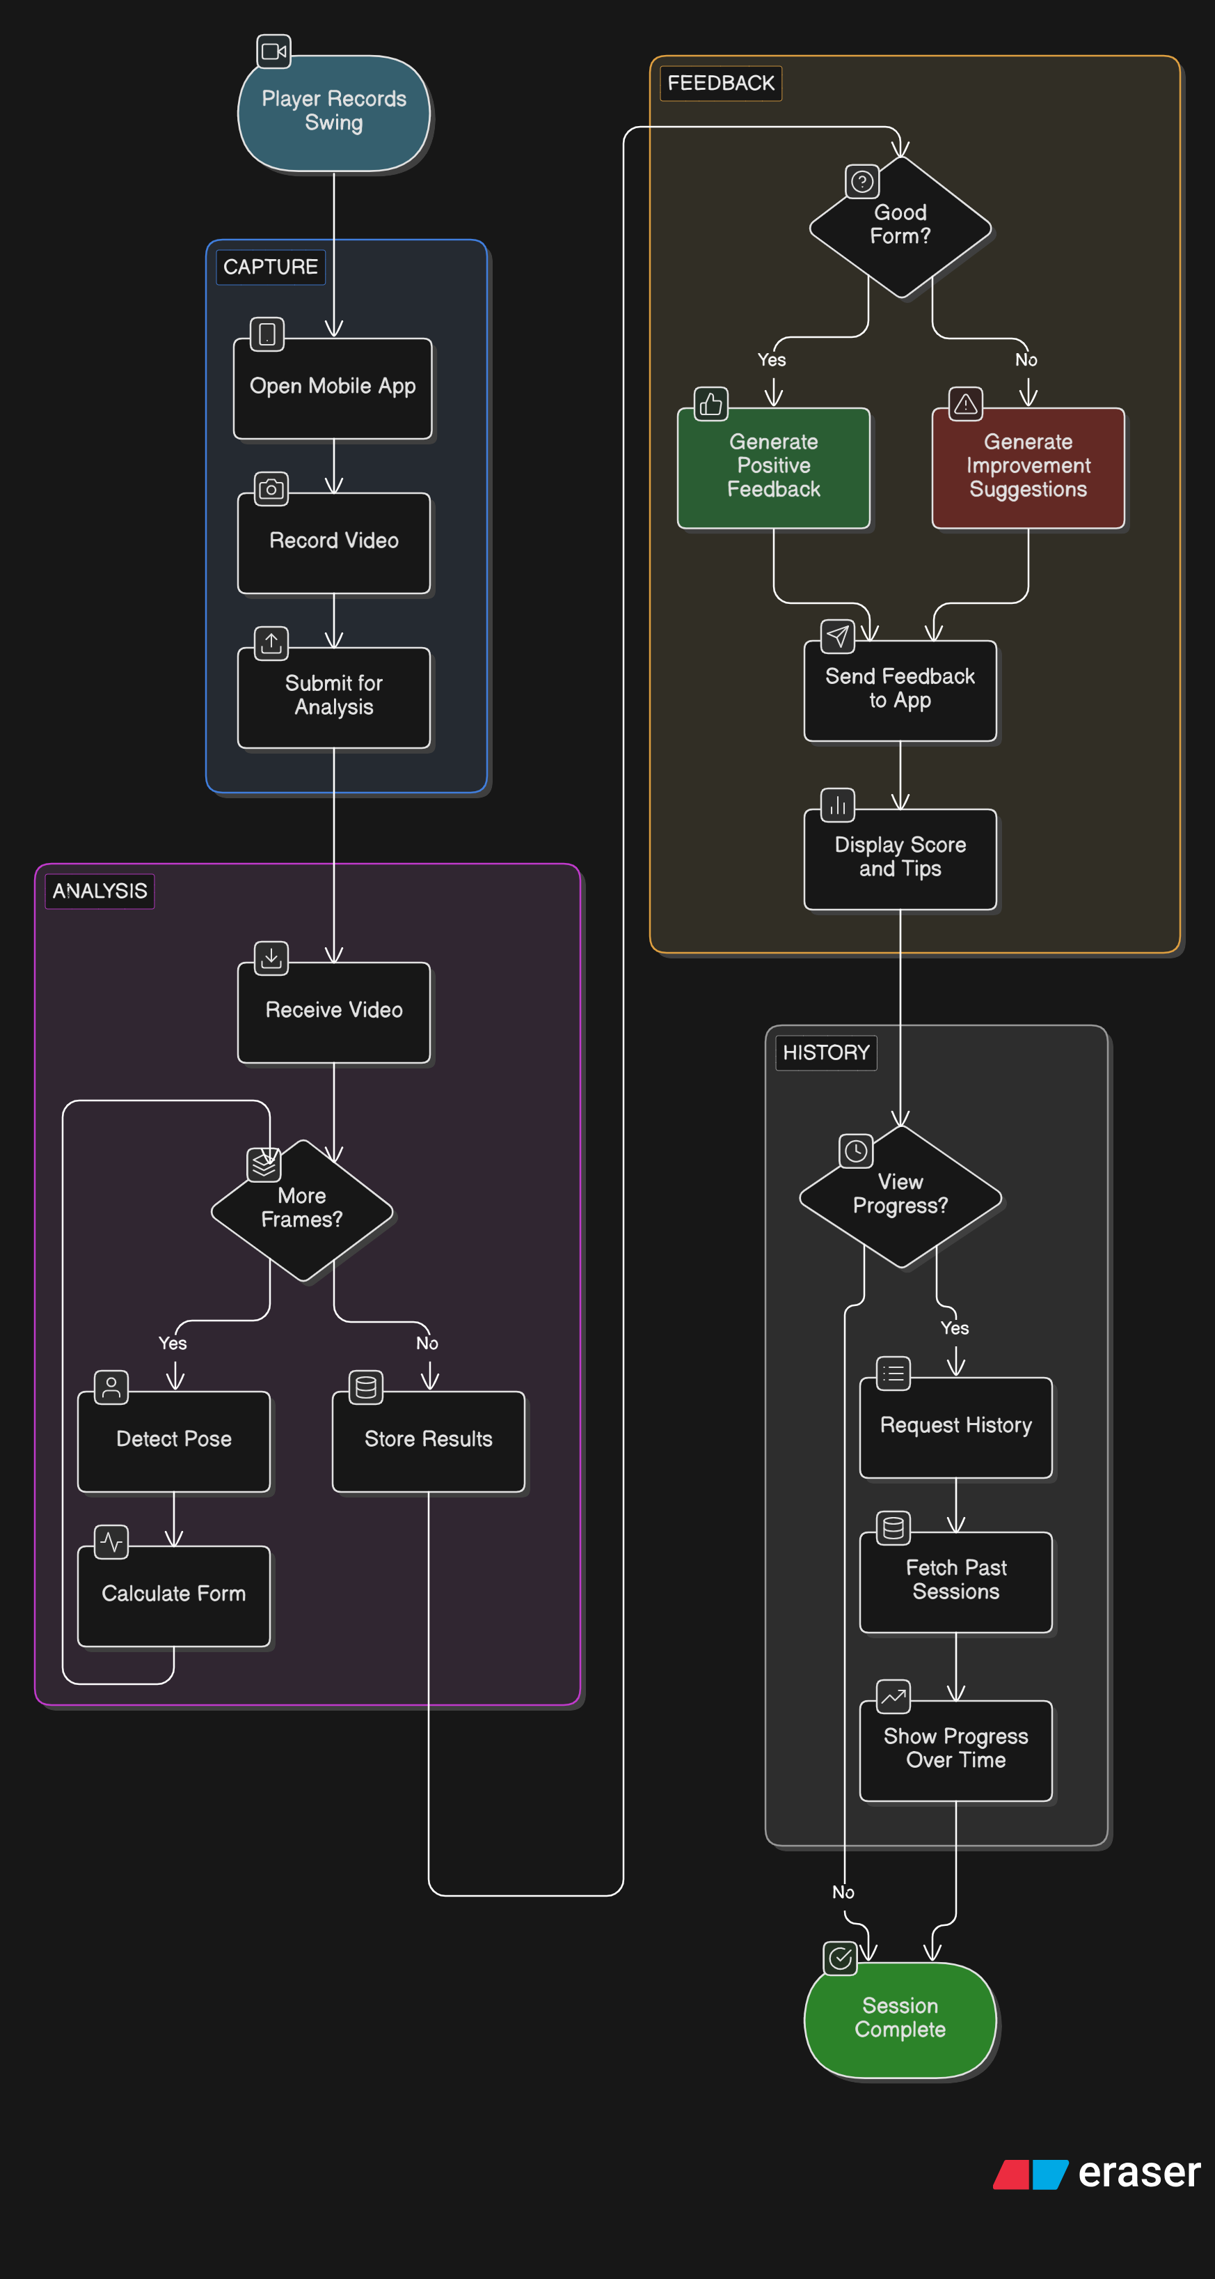
d. State-chart diagram
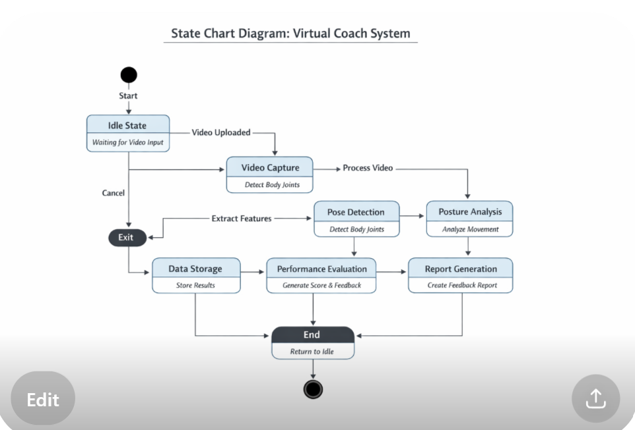
4.3. Implementation Design
a. Component Diagram
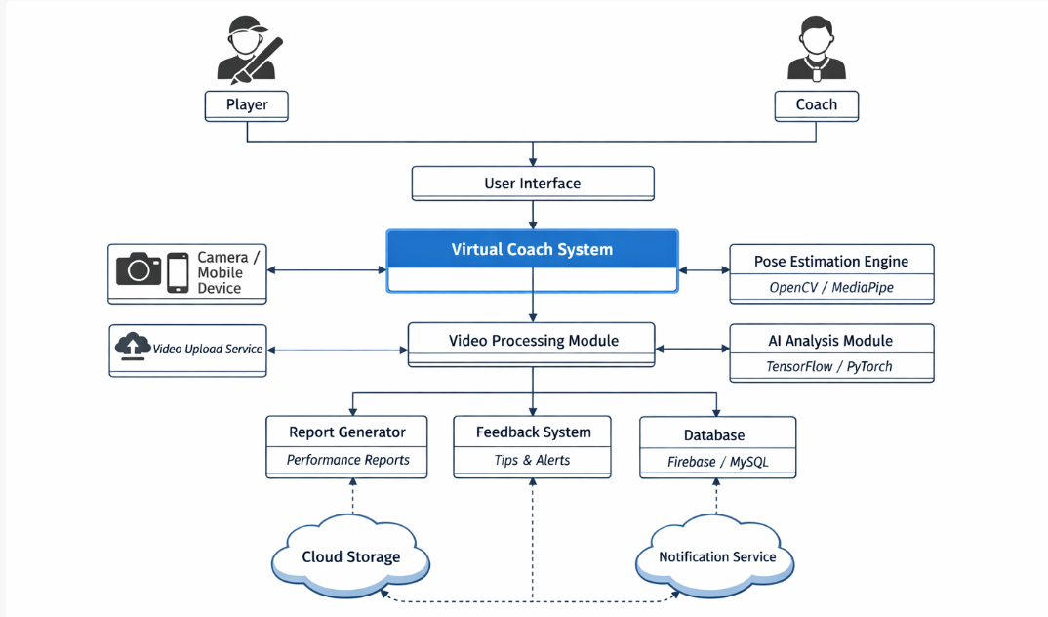
4.4. Environment Design
a. Deployment Diagram
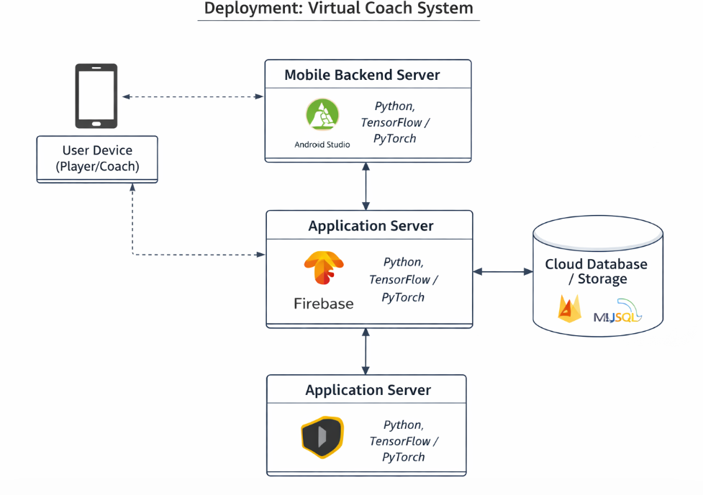
References:

[1] Z. Cao, T. Simon, S. E. Wei, and Y. Sheikh,
“Realtime Multi-Person 2D Pose Estimation using Part Affinity Fields,”
CVPR, 2017.
[2] J. Shotton et al.,
“Real-Time Human Pose Recognition in Parts from Single Depth Images,”
CVPR, 2011.
[3] T. Pfister, J. Charles, and A. Zisserman,
“Flowing ConvNets for Human Pose Estimation in Videos,”
ICCV, 2015.
[4] K. Simonyan and A. Zisserman,
“Two-Stream Convolutional Networks for Action Recognition in Videos,”
NIPS, 2014.
[5] G. Varol, I. Laptev, and C. Schmid,
“Long-Term Temporal Convolutions for Action Recognition,”
TPAMI, 2018.
[6] Google Research,
“MediaPipe: A Framework for Building Perception Pipelines,”
[7] A. Toshev and C. Szegedy,
“DeepPose: Human Pose Estimation via Deep Neural Networks,”
CVPR, 2014.
[8] S. Wei et al.,
“Convolutional Pose Machines,”
CVPR, 2016.
[9] Z. Fang et al.,
“RMPE: Regional Multi-person Pose Estimation,”
ICCV, 2017.
[10] D. Tran et al.,
“Learning Spatiotemporal Features with 3D Convolutional Networks,”
ICCV, 2015.
[11] J. Carreira and A. Zisserman,
“Quo Vadis, Action Recognition? A New Model and the Kinetics Dataset,”
CVPR, 2017
[12] H. K. K. et al.,
“Human Activity Recognition Using Machine Learning Techniques,”
IEEE Access, 2019.
[13] M. Andriluka et al.,
“2D Human Pose Estimation: New Benchmark and State of the Art Analysis,”
CVPR, 2014.
[14] B. Xiao, H. Wu, and Y. Wei,
“Simple Baselines for Human Pose Estimation and Tracking,”
ECCV, 2018.
[15] N. Neverova et al.,
“ModDrop: Adaptive Multi-Modal Gesture Recognition,”
TPAMI, 2016.

