NAME | AAYANSH SINGH
BRANCH | CSE
SECTION | A
UNI ROLL | 202401100200005

Part 1: Run and Assess the Python Application

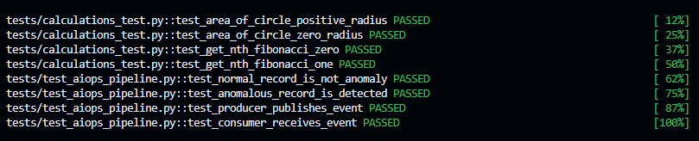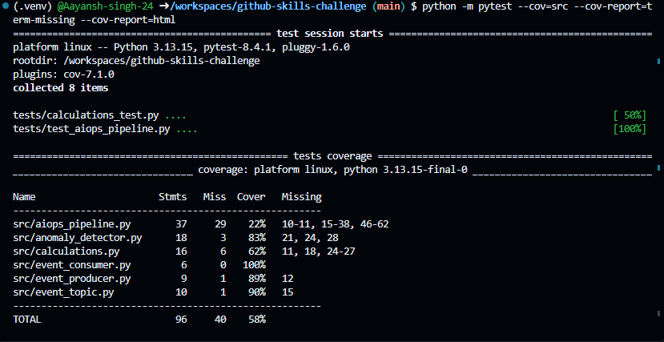

Part 2: Configure Continuous Integration

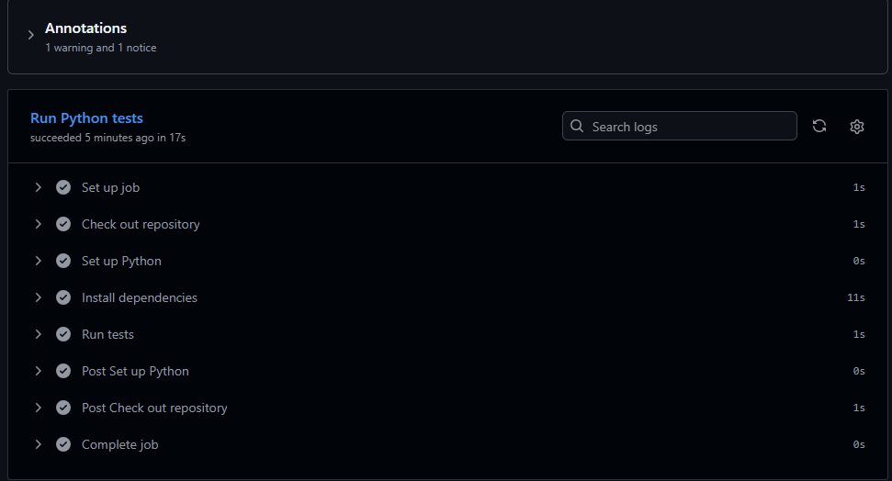

Part 3: Configure Test Coverage Automation

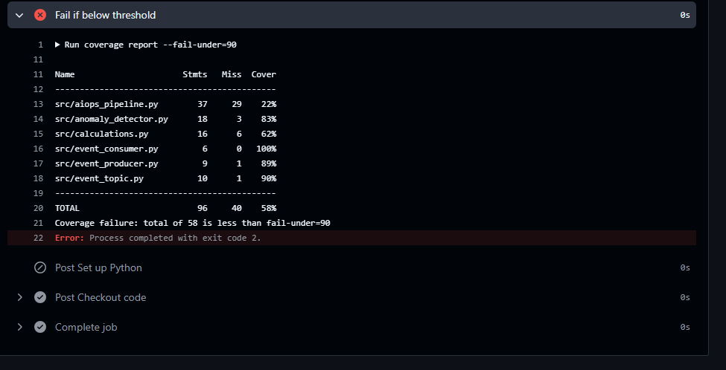

After fix:-
