Analysis of Algorithm (CSN13400)
ASSIGNMENT-6
Name : Om Upadhyay | Date :27/09/2026
Reg_No.: 20253004

Q1. You are working for a retail company, and you have been provided with sales data for various products. Each product has a unique identifier (ID) which ranges from 0 to 1000. Your task is to analyse the sales data to understand which products are the most popular based on the frequency of sales. By using an efficient algorithm, you need to sort the product IDs based on the frequency of sales such that:
• Products with higher sales frequency come first.
• If two products have the same sales frequency, the product with the smaller ID comes first.
#include <stdio.h>
#include <stdlib.h>
#include <time.h>
#define N 1000
int main(){
int freq[N+1]={0};
int count[N+1]={0};
int *bucket[N+1]={NULL};
srand(time(NULL));
for(int i=0;i<=N;i++)
freq[i]=rand()%100+1;
for(int i=0;i<=N;i++)
if(freq[i]>0)
count[freq[i]]++;
for(int i=1;i<=N;i++)
if(count[i]>0)
bucket[i]=malloc(count[i]*sizeof(int));
int index[N+1]={0};
for(int i=0;i<=N;i++){
if(freq[i]>0){
int f=freq[i];
bucket[f][index[f]++]=i;
}
}
printf("Product ID\tFrequency\n");
for(int f=N;f>=1;f--){
if(count[f]>0){
for(int j=0;j<count[f];j++){
int id=bucket[f][j];
printf("%d\t\t%d\n",id,f);
}
}
}
for(int i=1;i<=N;i++)
free(bucket[i]);
return 0;
}
A1. CODE:

OUTPUT:

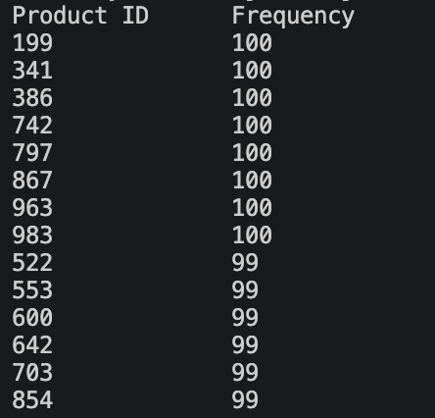

Q2. You are given an array of 10000 integers where each integer is represented as a 32-bit unsigned binary number. You need to sort the array based on the binary representation of the numbers in lexicographical order. Use a suitable sorting algorithm to implement this efficiently. (All integers fit within 32-bit unsigned integers). Calculate the required time in milliseconds and compare with any two existing sorting based-approaches.
A2. CODE:
#include <stdio.h>
#include <stdlib.h>
#include <time.h>
#define N 10000
void radixSort(unsigned int a[], int n) {
unsigned int *b=malloc(n*sizeof(unsigned int));
for(int bit=0;bit<32;bit++){
int count[2]={0,0};
for(int i=0;i<n;i++){count[(a[i]>>bit)&1]++;}
int pos[2]={0,count[0]};
for(int i=0;i<n;i++){
int x=(a[i]>>bit)&1;
b[pos[x]++]=a[i];
}
for(int i=0;i<n;i++){
a[i]=b[i];
}
}
free(b);
}
int main() {
unsigned int a[N];
srand(time(NULL));
for(int i=0;i<N;i++){
a[i]=((unsigned int)rand()<<16) | rand();
}
clock_t start = clock();
radixSort(a, N);
clock_t end = clock();
printf("Time: %.3f ms\n",(double)(end-start)*1000/CLOCKS_PER_SEC);
printf("First 10 elements:\n");
for(int i=0;i<10;i++)
printf("%u ",a[i]);
return 0;
}

OUTPUT:

Q3. You are tasked with analyzing the performance of a network by sorting and categorizing latency measurements. You have an array of n latency measurements in milliseconds, each ranging from 0 to 1000 milliseconds. Your goal is to use a fast-sorting algorithm to efficiently categorize these measurements into specific time ranges and then provide the following information:
• Categorized Latency Ranges: Divide the latencies into predefined sub-intervals such as: [0, 100), [100,200), [200,300), and so on up to [900, 1000]. Each sub-interval represents a time range.
• Count of Measurements in Each Sub-interval: Determine how many measurements fall into each of these time ranges.
• Sorted List of Measurements in Each Sub-interval: For each sub-interval, provide a sorted list of latencies that fall into that range.
• Median Latency for Each Sub-interval: Calculate the median latency for each subinterval. The median is the middle value when the latencies in that subinterval are sorted.
#include <stdio.h>
#include <stdlib.h>
#include <time.h>
int main() {
int n=20;
int a[20];
int c[1001]={0};
srand(time(0));
for(int i=0;i<n;i++){
a[i]=rand()%1001;
c[a[i]]++;
}
printf("Random data: ");
for(int i=0;i<n;i++)
printf("%d ",a[i]);
for(int r=0;r<10;r++){
int l=r*100;
int u=(r==9) ? 1000:l+99;
int b[20];
int k=0;
for(int x=l;x<=u;x++)
while(c[x]--){
b[k++]=x;
}
printf("\n\n[%d,%d] Count=%d\nSorted: ",l,u,k);
for(int i=0;i<k;i++){printf("%d ",b[i]);}
if(k==0)
printf("\nMedian: none");
else if(k%2)
printf("\nMedian: %d",b[k/2]);
else
printf("\nMedian: %.2f",(b[k/2-1]+b[k/2])/2.0);
}
printf("\n");
return 0;
}
A3. CODE:

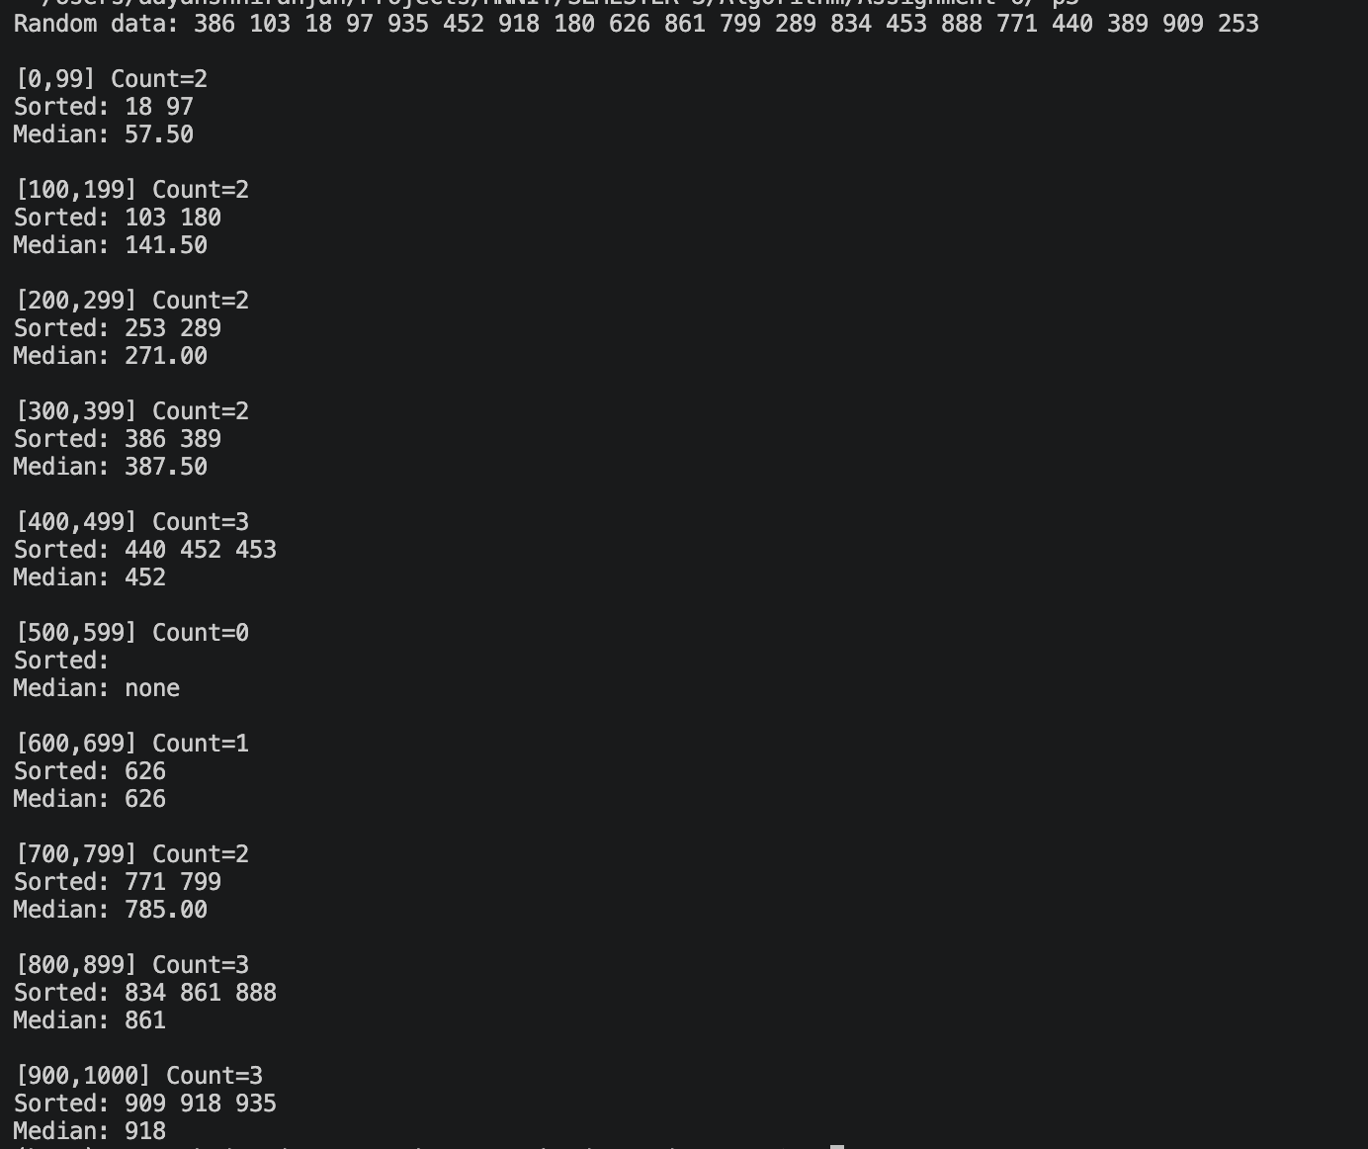
OUTPUT:

