**Sprint Review Meeting Report**

**Sprint 1**

**When to be held**

* At the end of this sprint.

**Participant Involved**

* Scrum Master (Gee Chun Seng)
* Team members (Goh Weng Yong, Chua Wei Han, Eng Yee Jei, Hamish Then Jin Jiat)
* Product owner & other stakeholders

**Purpose**

* To allows the scrum master and the team members to do a demonstration of the system to the product owner and stakeholders.
* The product owner and stakeholders will test the system and provide feedback to the scrum master and the team members.
* The system is also being demonstrated to the owners and stakeholders to check the feasibility of the system and requirement fulfilment.
* This meeting report also allows product owner and stakeholders to keep track of the development status of their system.

**Module Involved**

1. Payment Module
2. Order Module
3. Staff Maintenance Module
4. Seat Reservation Module
5. Food Menu Maintenance Module

**Review User Stores Session**

**Payment Module**

|  |  |  |
| --- | --- | --- |
| **User Story** | **Status** | **Satisfied/Dissatisfied** |
| Generate receipt | Started | Satisfied |
| Calculate payment amount | Started | Satisfied |

**Order Module**

|  |  |  |
| --- | --- | --- |
| **User Story** | **Status** | **Satisfied/Dissatisfied** |
| Add order item | Started | Satisfied |
| Cancel order item | Started | Satisfied |

**Staff Maintenance Module**

|  |  |  |
| --- | --- | --- |
| **User Story** | **Status** | **Satisfied/Dissatisfied** |
| Delete staff details | Started | Satisfied |
| Update staff details | Started | Satisfied |
| Retrieve staff details | Started | Satisfied |
| Add new staff details | Started | Satisfied |

**Seat Reservation Module**

|  |  |  |
| --- | --- | --- |
| **User Story** | **Status** | **Satisfied/Dissatisfied** |
| Search seat | Started | Satisfied |
| Check seat | Started | Satisfied |
| Add seat | Started | Satisfied |

**Food Menu Maintenance Module**

|  |  |  |
| --- | --- | --- |
| **User Story** | **Status** | **Satisfied/Dissatisfied** |
| Search food details | Started | Satisfied |
| Update food | Started | Satisfied |
| Display food menu | Started | Satisfied |
| Delete food | Started | Satisfied |
| Add new food | Started | Satisfied |

**Customer Feedback 1**

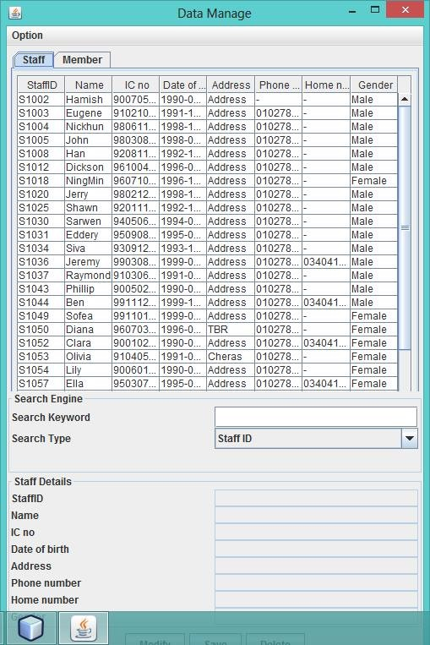

Customer complaint that this screen is plain and dull. They say the screen is not interesting enough to catch their attention when they are checking the information on the table. They suggested to enlarge the screen size so that it is more pleasing for their eye as it will display more information on the table. Besides, they also suggested that the table legend should be bolded to attract user’s attention.

Moreover, customer also suggested it should provide guidance and help on the screen in order to guide them when they have confusion or encountered problem.