**Time Complexity in the Real-World: Teaching of Algorithms in Computer Science**

Aayesha Islam

June 10th, 2024

**I. Introduction**

Algorithms and their complexities are foundational elements of computer science, driving innovations and efficiency across various fields. An algorithm is essentially a step-by-step procedure for solving a problem or performing a task, and its complexity refers to the resources it requires, such as time and space (Phalke et al., 2022). The concept of time complexity is crucial as it allows computer scientists to measure and compare the performance of different algorithms systematically. Understanding time complexity allows prediction and knowledge of how an algorithm’s execution time increases with the size of its input, thus assisting in selecting the most efficient algorithm for a given problem (Papadimitriou, 2014). Time complexity is typically expressed using Big O notation, which provides a high-level understanding of an algorithm’s performance (Phalke et al., 2022).

Understanding these complexities is not just an academic exercise; it has practical implications in developing efficient software and optimizing computational resources. Despite its importance, the teaching and understanding of time complexity in algorithms present significant challenges. This paper examines the fundamental concepts of time complexity, reviews real-world applications, and explores the instructional methods used to teach these concepts effectively in computer science education.

***Figure 1: Key Terms Defined***

|  |  |  |
| --- | --- | --- |
| Term | Definition | Example |
| Algorithm | A set of well-defined instructions for solving a problem or completing a task. | A recipe is an algorithm for cooking a dish. |
| Time Complexity | A measure of the amount of time (resources) an algorithm takes to execute as the size of its input increases. | Searching a phonebook for a name might take longer (more time) as the number of entries increases. |
| Big O Notation | A mathematical notation used to express the upper bound of an algorithm's time complexity. | An algorithm with Big O notation of O(n) means its execution time grows linearly with the input size (n). |

**II. Foundations and History of Complexity Theory**

The study of algorithms and computational complexity has a rich history, originating with early contributions such as Euclid's algorithm for finding the greatest common divisor and Al Khwarizmi's codification of arithmetic algorithms (Papadimitriou, 2014). These early works laid the groundwork for understanding algorithm efficiency and the eventual adoption of the decimal system, which spurred significant scientific and social advancements (Papadimitriou, 2014).

In the 1960s, the formalization of computational complexity theory was advanced by Hartmanis and Stearns, who introduced a classification scheme for computational problems based on their difficulty. Their work established foundational concepts and theorems that continue to shape the field, such as the speed-up theorem, which highlights the variability in algorithm efficiency across different problem instances (Hartmanis & Stearns, 1965).

Hartmanis and Stearns' work emphasized the importance of computational models, such as the Turing machine, in formalizing the study of algorithm complexity (Hartmanis & Stearns, 1965). By establishing rigorous definitions and providing proofs for key theorems, they created a systematic framework that has guided further research in the field (Hartmanis & Stearns, 1965). These models helped create a clear and organized way to study how complex computer programs can be. Their work included defining different categories of complexity (called complexity classes) and exploring how efficiently computers can solve certain problems (Hartmanis & Stearns, 1965). The exploration of complexity classes P and NP, as well as the ongoing investigation into the P vs. NP problem shows the importance of understanding computational complexity in both theoretical research and practical applications (Papadimitriou, 2014).

***Figure 2: Venn diagram representing P vs NP hierarchy***

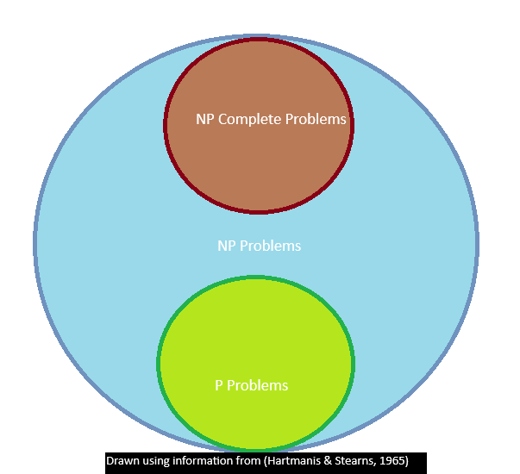

**III. Teaching Algorithm Design and Analysis**

Effective teaching of algorithm design and analysis requires strategies that promote problem-solving and algorithmic thinking (Naragund & Handur, 2013). Active learning methodologies can be particularly beneficial in achieving these goals. These methodologies include Manifold Problem Assignment, Inspection of Algorithms, Technique-Based Learning, Identification and Designing Method, and Realization of Algorithms (Naragund & Handur, 2013).

***Figure 3: Teaching Methodology Classification***

|  |  |
| --- | --- |
| Term | Definition |
| Manifold Problem Assignment | A teaching method involving diverse problem sets designed to enhance problem-solving skills and expose students to various algorithmic challenges. |
| Inspection of Algorithms | A method where students analyze and critique existing algorithms to understand their structure, efficiency, and potential improvements. |
| Technique-Based Learning | A process where students identify appropriate algorithms and design new ones to solve specific problems, fostering creativity and innovation. |
| Realization of Algorithms  Information: (Naragund & Handur, 2013) | Practical implementation and testing of algorithms by students to ensure they work correctly and efficiently in real-world scenarios. |

These methods engage students in active problem-solving, algorithm analysis, and implementation using various design techniques. The positive impact of these methodologies on student learning outcomes, is evidenced by student feedback and performance (Naragund & Handur, 2013).

While there is a trend towards more practical subjects in computer science education, a strong foundation in theoretical concepts remains crucial (Hynek, 2019). Algorithmic complexity should be taught with practical examples, and the course structure must utilize real-world scenarios to demonstrate the usefulness of theoretical principles (Hynek, 2019). Examples include finding subsequences with maximal sum, calculating the Fibonacci sequence, and solving the N-queens problem (a puzzle about placing N chess queens on an N×N chessboard without them attacking each other). By contrasting different time complexities and showcasing the impact on efficiency, these examples bridge the gap between theory and practice (Hynek, 2019). This approach fosters a deeper understanding of theoretical concepts and their practical applications in algorithm design.

**IV. Algorithmic Thinking and Evaluation in the Real-World**

In today's digital age, algorithmic thinking emerges as a fundamental skill, focusing on logical solutions and problem decomposition (Park & Jun, 2023). Consider its application in e-commerce platforms, where efficient algorithms are needed for tasks like product recommendation systems and inventory management. Here, algorithmic thinking involves understanding complex customer preferences, exploring efficient solutions for personalized recommendations, and articulating step-by-step processes to optimize user experience and increase sales. Evaluation standards specifically for algorithmic thinking skills contribute to the understanding and improvement of algorithms, impacting time complexity considerations in software development and the digital marketplace (Park & Jun, 2023). In the case of e-commerce, the effectiveness of recommendation algorithms directly influences user engagement and conversion rates, demonstrating the importance of algorithmic thinking in driving business success.

The role of Big O notation in evaluating and comparing algorithm performance cannot be overstated (Shabbir et al., 2023). Big O notation provides a framework for understanding the efficiency of algorithms, crucial for computer science education and career development (Shabbir et al., 2023). In the context of e-commerce platforms, where vast datasets are processed daily, the efficiency of sorting algorithms directly influences the speed and accuracy of search processes. For instance, efficient sorting algorithms ensure that product listings are presented to users in a timely manner, enhancing the overall user experience and increasing the likelihood of purchase (Shabbir et al., 2023). This nuanced understanding is invaluable for e-commerce businesses aiming to optimize algorithmic performance and provide seamless user experiences. By incorporating knowledge from real-world examples, educators can enhance students' understanding of time complexity and algorithmic efficiency, empowering them to apply these concepts effectively in both theoretical analyses and practical scenarios (Naragund & Handur, 2013).

**V. Conclusion**

Teaching time complexity in computer science education presents unique challenges, but through innovative strategies, these can be addressed. Striving for a student-centered approach, as outlined in modern teaching concepts, can enhance understanding and engagement. Shifting from traditional teacher-centered methods to practices that prioritize students' active participation and individual learning needs can stimulate their interest and potential. This includes incorporating interactive simulations and real-world case studies, such as applications in search engines and e-commerce, to illustrate the relevance of time complexity in everyday technology. Future teaching approaches should incorporate a combination of online and offline methods to accommodate different learning styles and levels of preparation. This can include providing varied learning materials for pre-class preparation and using practical examples during class to clarify complex algorithmic concepts and spur algorithmic thinking. Hierarchical experiments tailored to students' skill levels and group work to foster collaboration can further enhance learning outcomes. Encouraging autonomous learning through modern communication tools and a comprehensive assessment plan that evaluates multiple aspects of student performance can ensure a holistic development of their algorithmic skills.

References

Phalke, S., Vaidya, Y., & Metkar, S. (2022). Big-O Time Complexity Analysis Of Algorithm. *2022 International Conference on Signal and Information Processing (IConSIP)*, 1–5.

<https://doi.org/10.1109/ICoNSIP49665.2022.10007469>

Papadimitriou, C. (2014). Algorithms, complexity, and the sciences. *Proceedings of the National Academy of Sciences of the United States of America, 111(45)*, 15881–15887.

<http://www.jstor.org/stable/43279180>

Hartmanis, J., & Stearns, R. E. (1965). On the Computational Complexity of Algorithms. *Transactions of the American Mathematical Society, 117*, 285–306.<https://doi.org/10.2307/1994208>

Naragund, J. G., & Handur, V. S. (2013). Educationally effective teaching of design and analysis of algorithms. *Innovation and Technology in Education (MITE)*, 57-62.<https://doi.org/10.1109/mite.2013.6756305>

Hynek, J. (2019). A Practical Approach to the Time Complexity of Algorithms. *2019 29th Annual Conference of the European Association for Education in Electrical and Information Engineering (EAEEIE*), 1–5. <https://doi.org/10.1109/eaeeie46886.2019.9000428>

Park, H. and Jun, W. (2023). A Study of Development of Algorithm Thinking Evaluation Standards, *International Journal of Applied Engineering and Technology 5(2),* 53-58

<https://romanpub.com/resources/ijaet%20v5-2-2023-08.pdf>.

Shabbir, A., Majeed, A., Iftikhar, M., Raja Hashim Ali, Arshad, U., Muhammad Zeeshan Shabbir, Ali Zeeshan Ijaz, Ali, N., & Aftab, A. (2023). A Review of Algorithms’s Complexities on Different Valued Sorted and Unsorted Data. *2023 International Conference on IT and Industrial Technologies (ICIT)*, 1–6.<https://doi.org/10.1109/icit59216.2023.10335840>