NAME: AAYESHA MOINUDDIN HOTE

PRN: 2030331245002

CLASS: THIRD YEAR

SUB: CP

TOPIC: FIND FIRST AND LAST OF SORTED ARRAY PROGRAM

ALGORITHM: 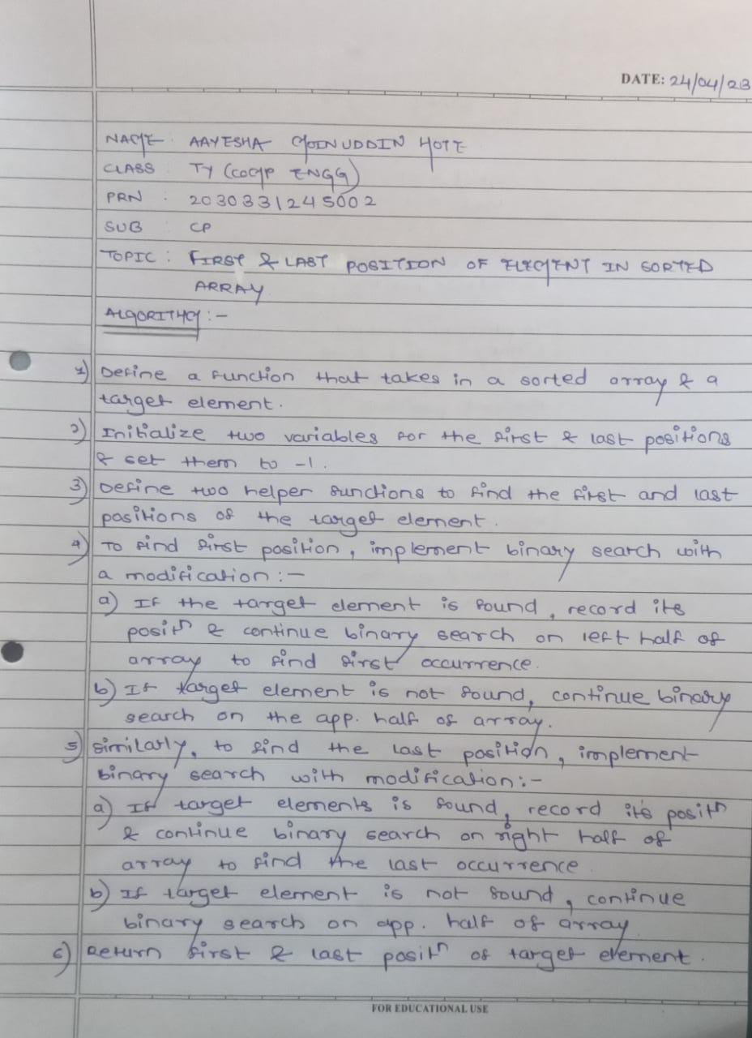

FLOWCHART:

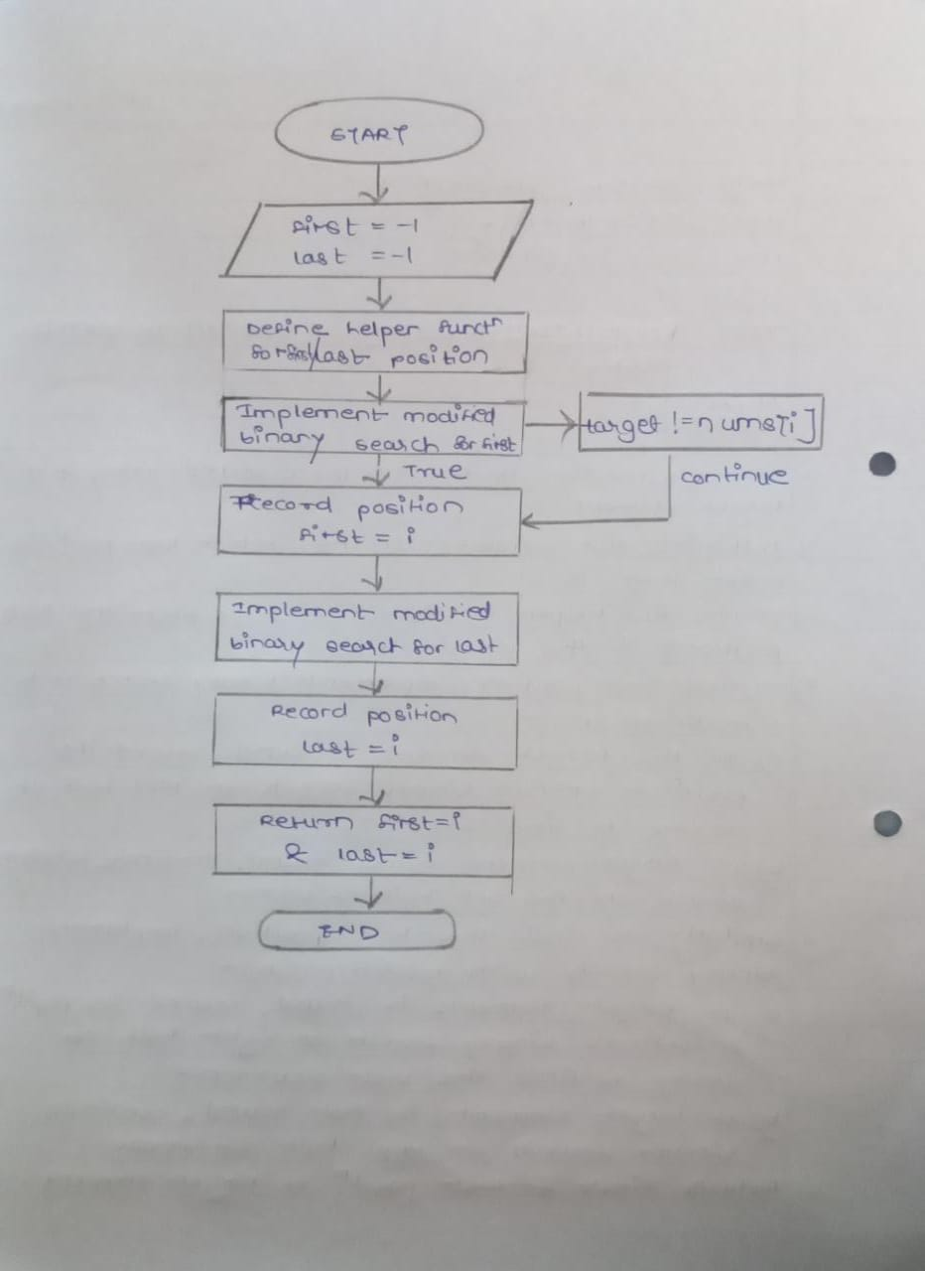

INPUT AND OUTPUT:

