Sr. No. | Title | Page No.
1 | Problem Statement & Software Requirements Specification(SRS) | 1
2 | Data Flow Diagram (DFD) & Structured Chart | 4
3 | Use Case Diagram | 6
4 | Class Diagram & Object Diagram | 7
5 | State Chart & Activity Diagrams | 9
6 | Sequence Diagram & Collabration Diagram | 12
7 | Component & Deployment Diagrams | 14
8 | Function Point (FP) Analysis | 16
9 | Project Scheduling | 18
10 | Testing Strategy & Test Cases | 20
11 | Conclusion | 22

1. PROBLEM STATEMENT AND SOFTWARE REQUIREMENTS SPECIFICATION (SRS)
1.1 Problem Statement
The financial services industry requires an efficient, secure, and scalable loan management system to streamline the process of loan applications, approvals, and repayment tracking. Traditional banking systems often suffer from:
- Manual processing delays: Paper-based loan applications take weeks to process
- Lack of transparency: Customers cannot track their application status in real-time
- Security vulnerabilities: Legacy systems lack modern encryption and authentication
- Limited accessibility: Services are restricted to banking hours and physical locations
- Data inconsistency: Multiple databases and systems lead to data synchronization issues
1.2 Project Overview
Nexa Bank Loan Management System is a comprehensive web-based platform designed to:
- Enable customers to apply for various loan products online
- Provide real-time eligibility assessment and approval workflow
- Manage loan disbursement and payment tracking
- Ensure regulatory compliance and audit trails
- Offer secure authentication with 2FA support
- Provide admin dashboards for loan management

- Architecture: The system follows a hybrid web architecture integrating modern authentication services with a structured backend and relational database.

1.3 Software Requirements Specification (SRS)
1.3.1 Functional Requirements
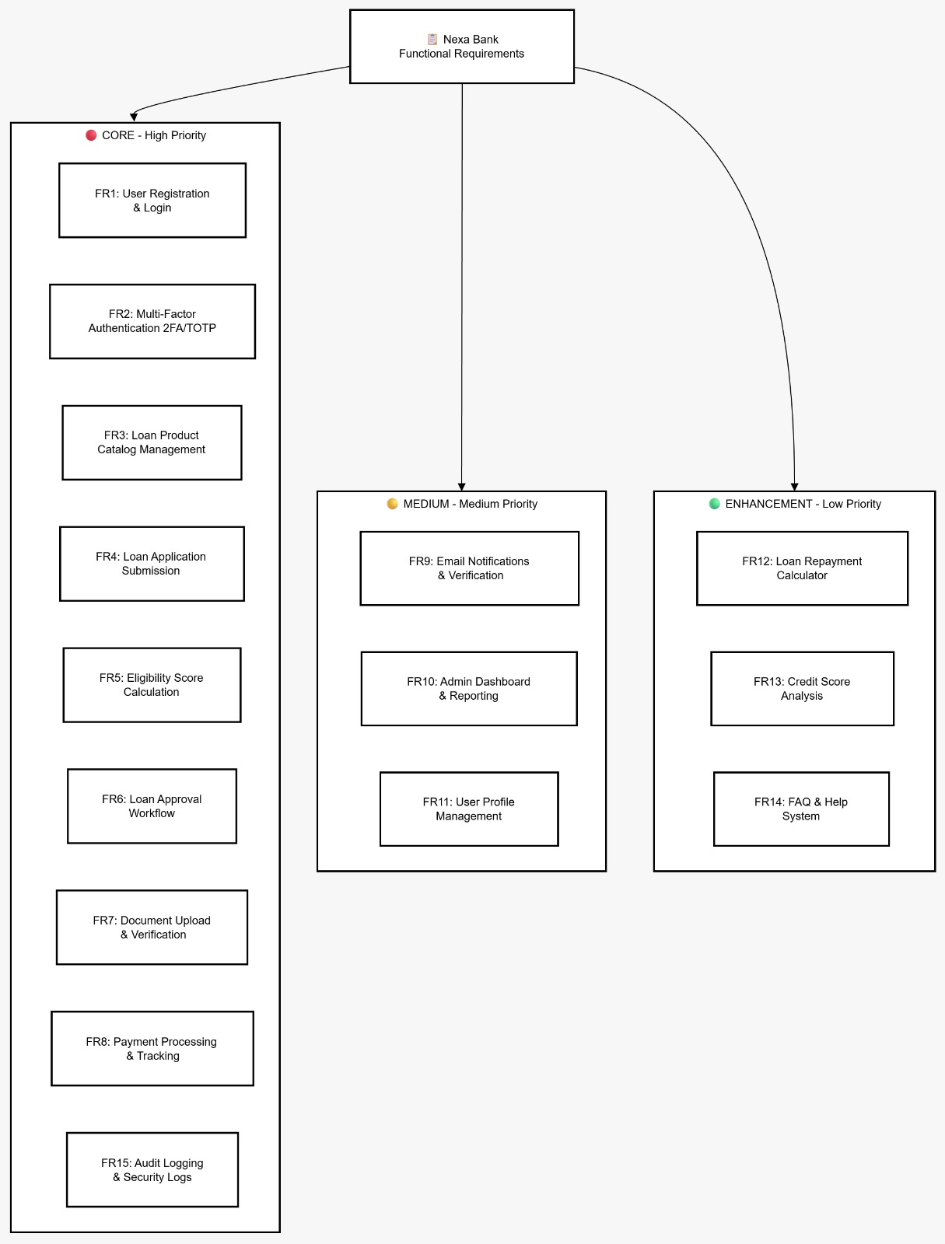

1.3.2 Non-Functional Requirements
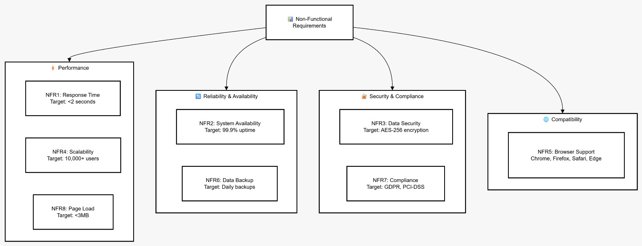
1.4 System Scope
In Scope:
Web-based loan management platform
User authentication and authorization
Loan application and approval workflow
Payment processing
Admin management functionalities
Email notifications
Out of Scope:
Mobile app development (future phase)
Integration with physical bank branches
Voice/SMS banking features
Real-time video KYC (future enhancement)

2. DATA FLOW DIAGRAM (DFD) & STRUCTURED CHART
2.1 Context Diagram (Level 0 DFD) - VERIFIED IMPLEMENTATION
A high-level overview of how data flows between the system and external entities in the hybrid architecture.
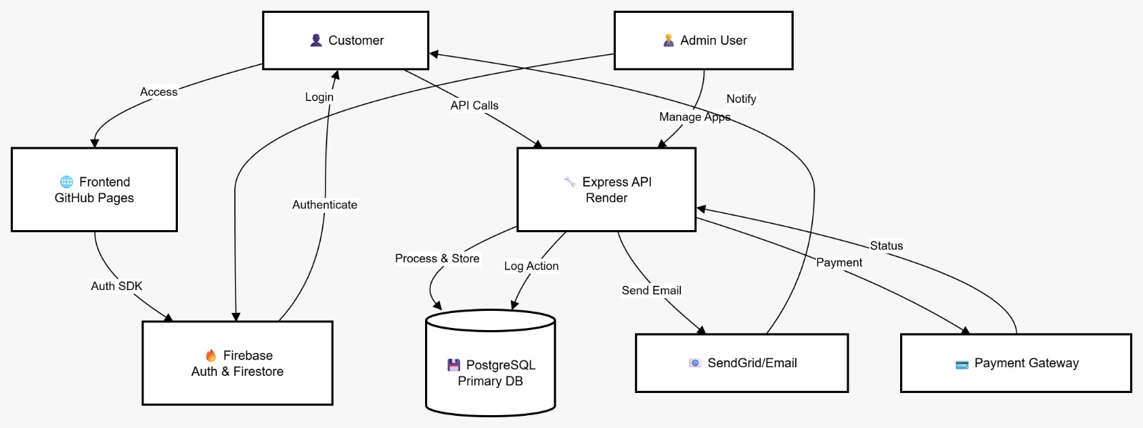
2.2 Level 1 DFD - Main Processes (VERIFIED)
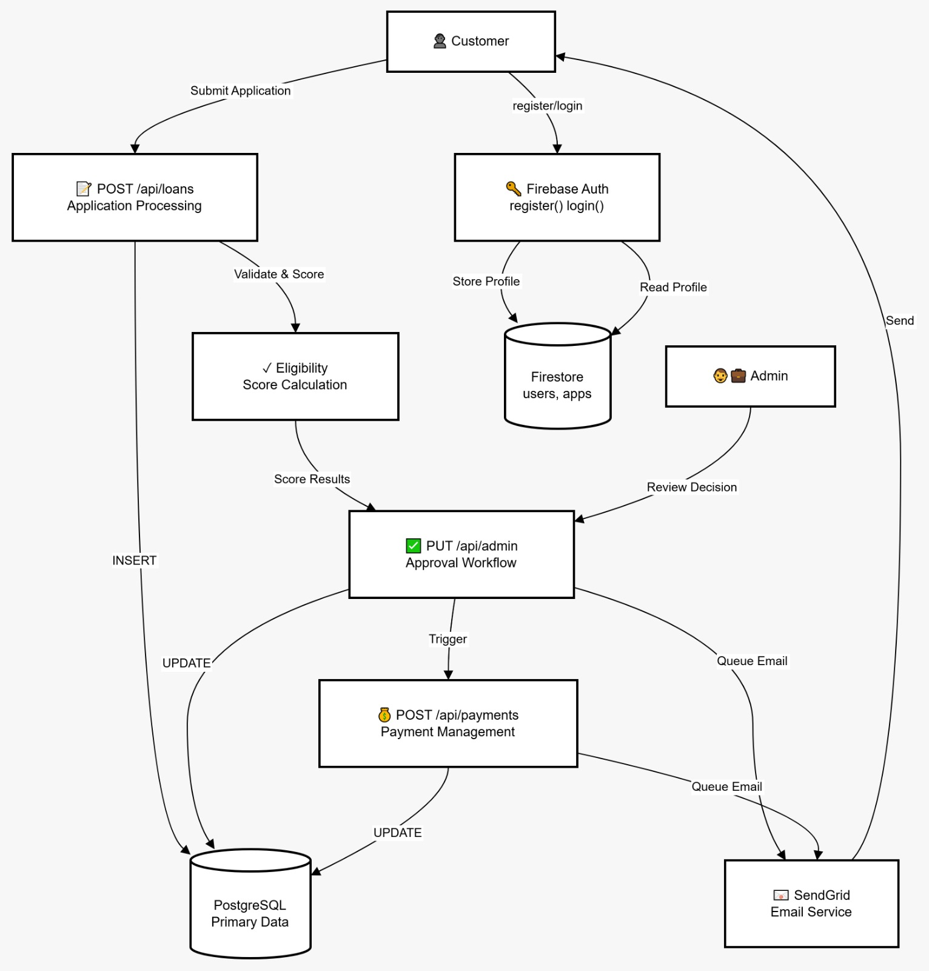
2.3 Structured Chart (HIPO Chart)
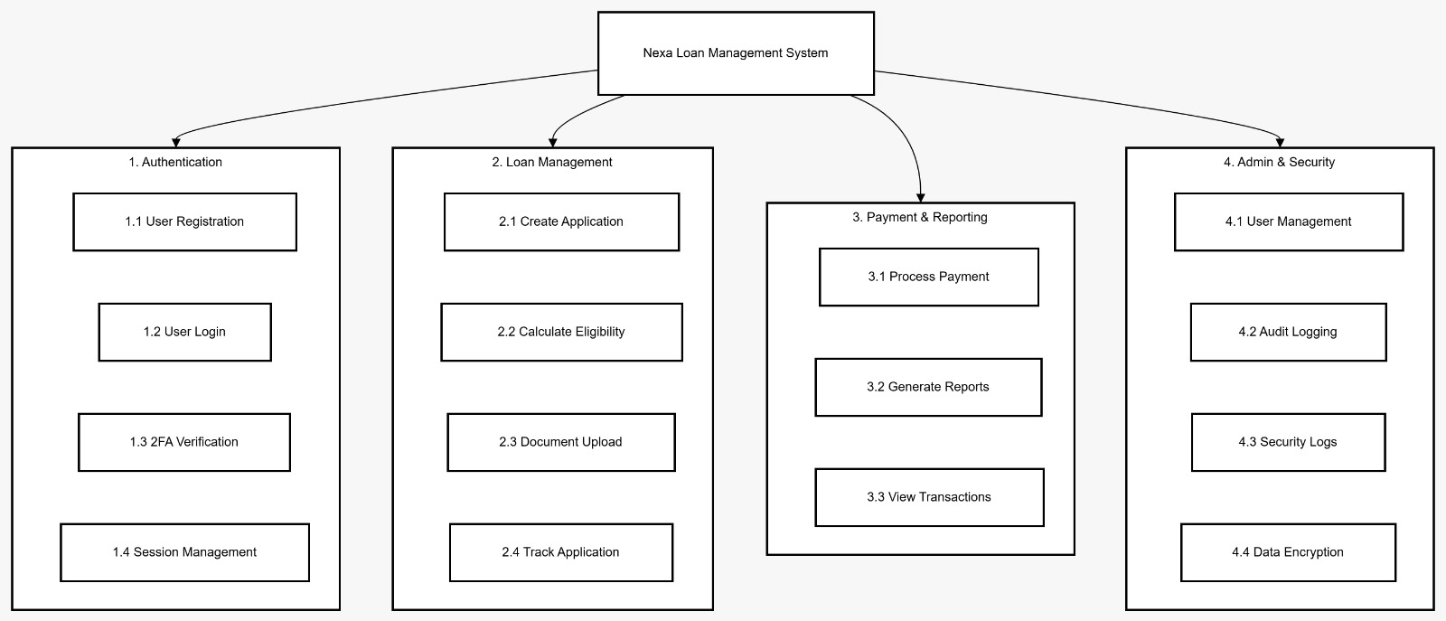

3. USE CASE DIAGRAM
3.1 Complete Use Case Diagram
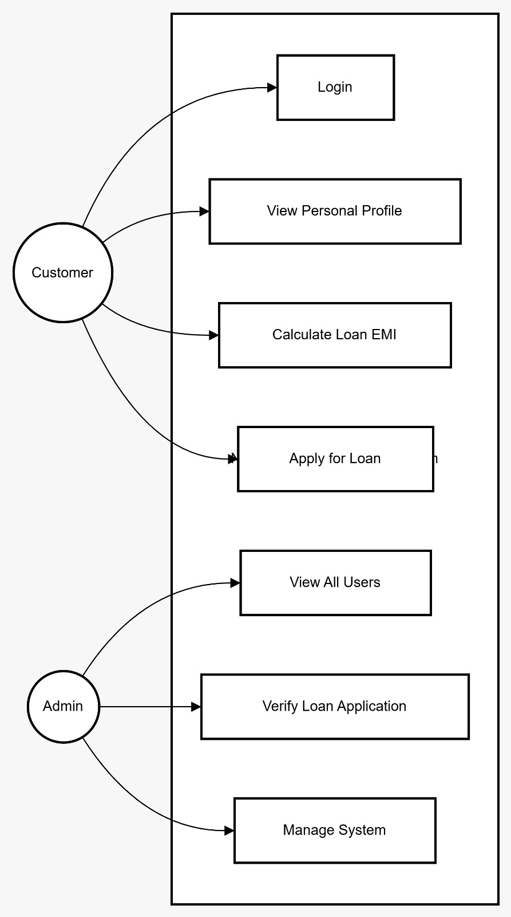
3.2 Use Case Descriptions
Use Case ID | Actor | Description | Precondition | Postcondition
UC1 | Customer | Register for account | None | User account created, email sent
UC2 | Customer | Login to system | Account exists | Authentication token issued
UC3 | Customer | Apply for loan | Logged in | Application created, ID assigned
UC4 | Customer | Upload documents | Application exists | Documents stored, verified by admin
UC5 | Customer | View application status | Application exists | Current status displayed
UC6 | Customer | Make loan payment | Loan approved | Payment processed, status updated
UC9 | Admin | Review applications | Applications exist | Admin views detailed information
UC10 | Admin | Approve/Reject loan | Application reviewed | Status updated, customer notified

4. CLASS DIAGRAM & OBJECT DIAGRAM
4.1 Class Diagram
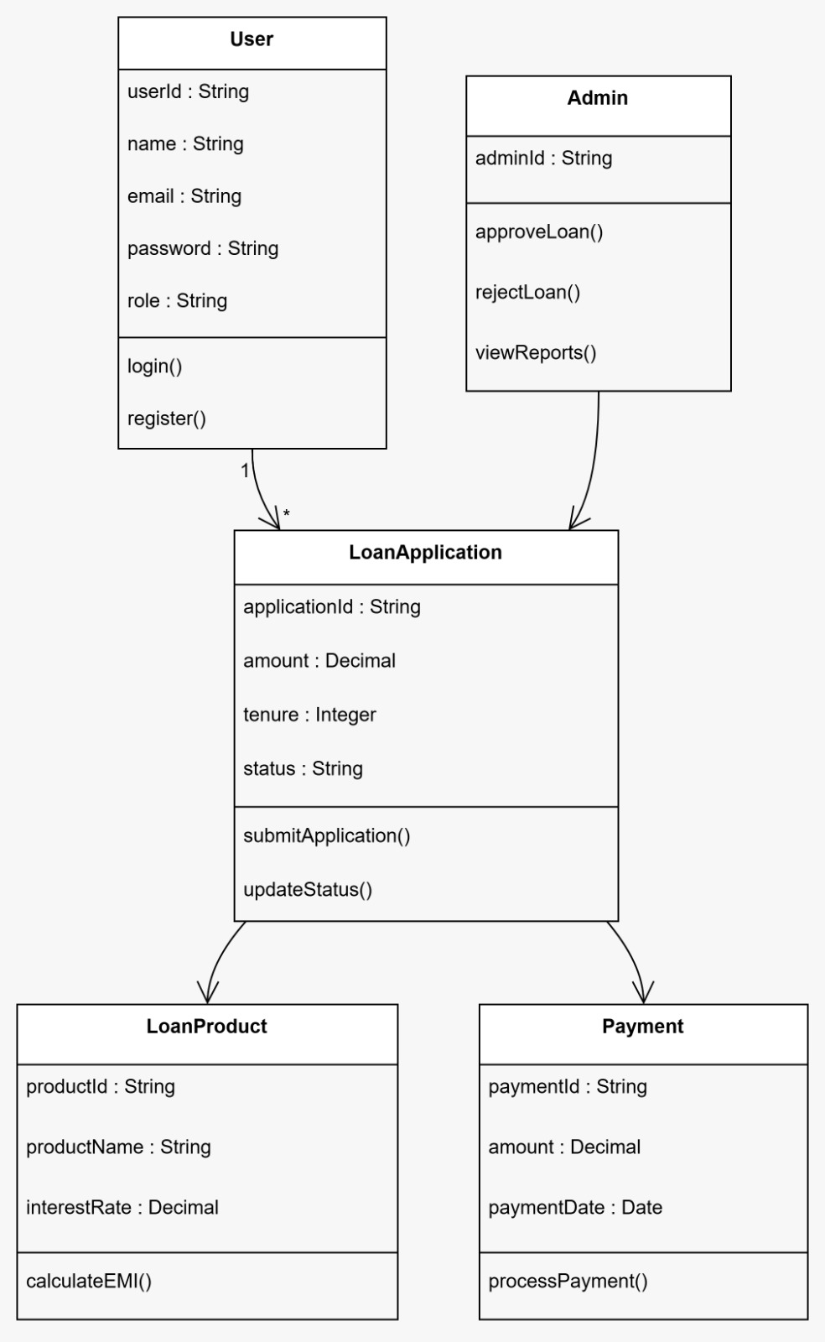

4.2 Object Diagram (Sample Instance)
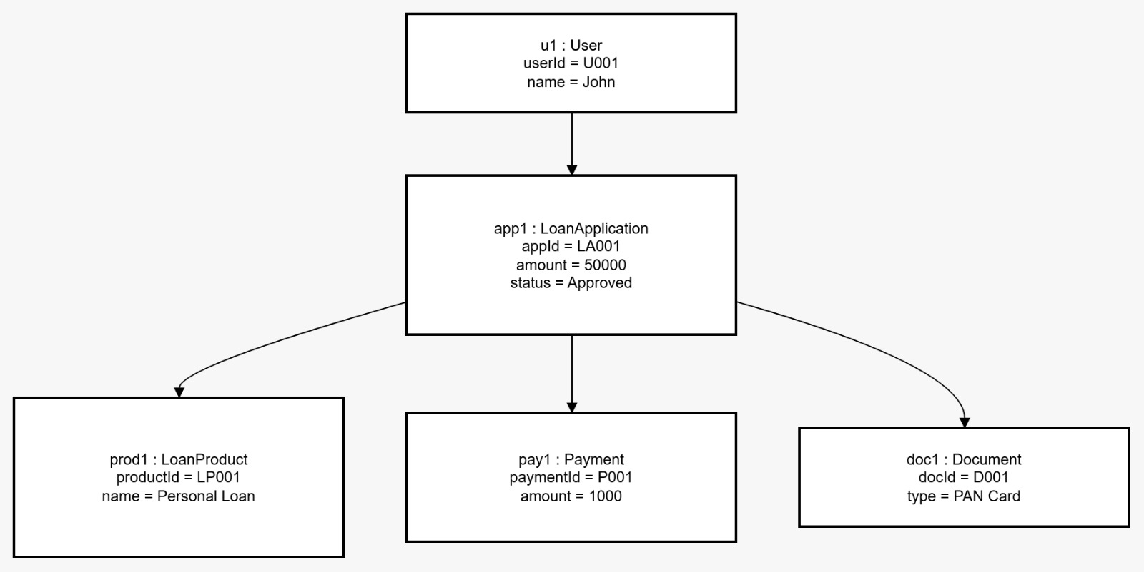

5. STATE CHART & ACTIVITY DIAGRAMS
5.1 Loan Application State Chart
States represent the lifecycle of a loan application from submission to completion.
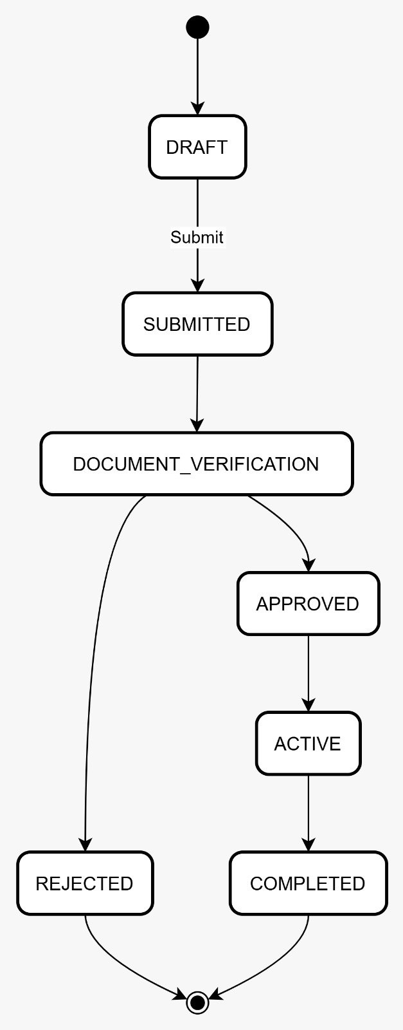

5.2 User Authentication Activity Diagram
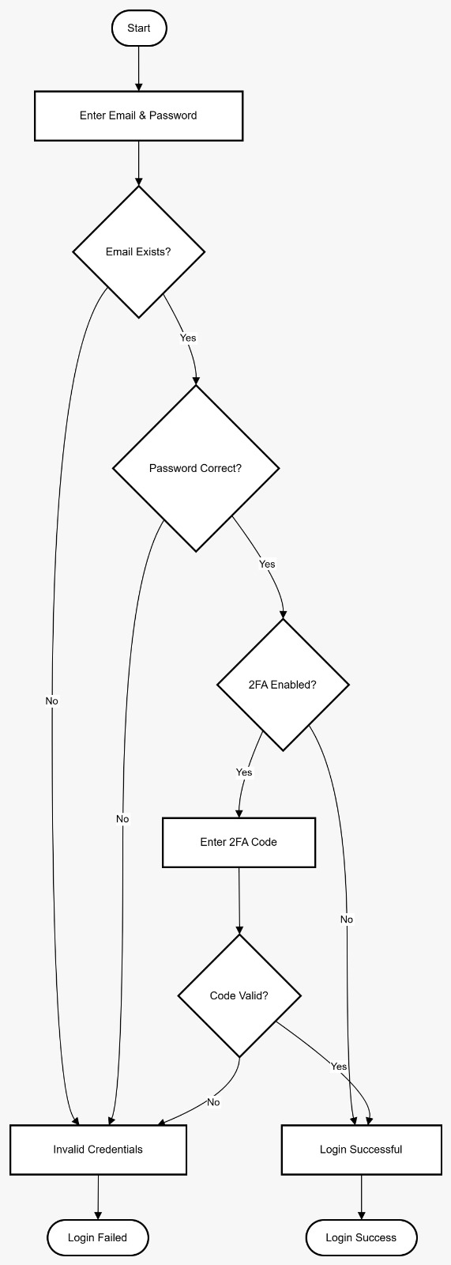

5.3 Loan Application Processing Activity Diagram
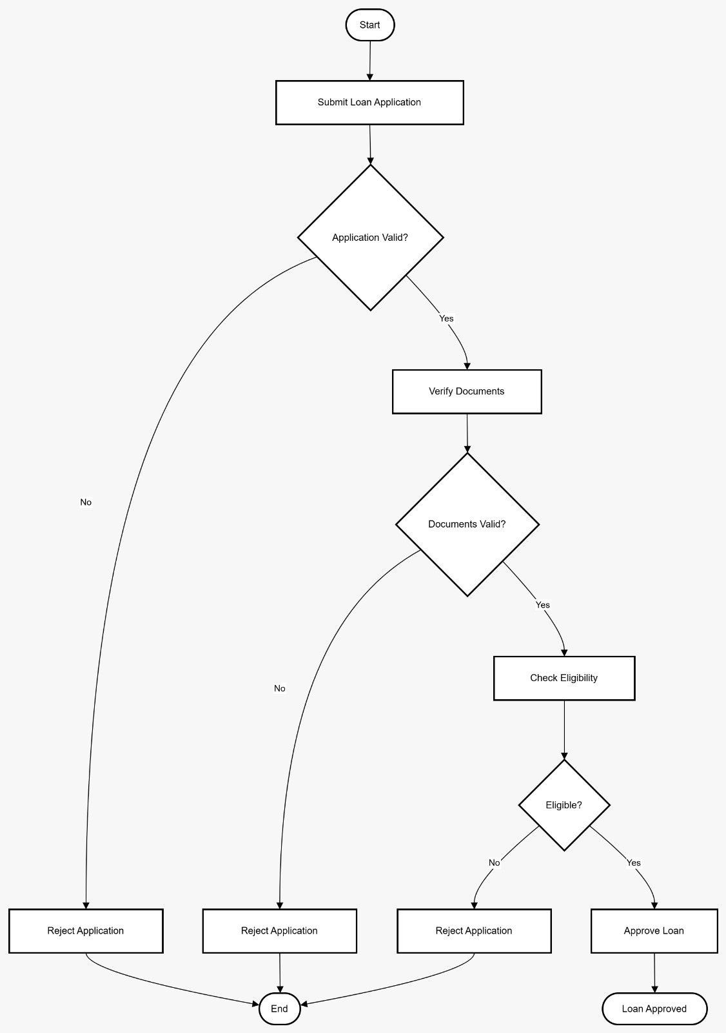

6. SEQUENCE DIAGRAM & COLLABORATION DIAGRAM
6.1 Loan Application Submission Sequence Diagram
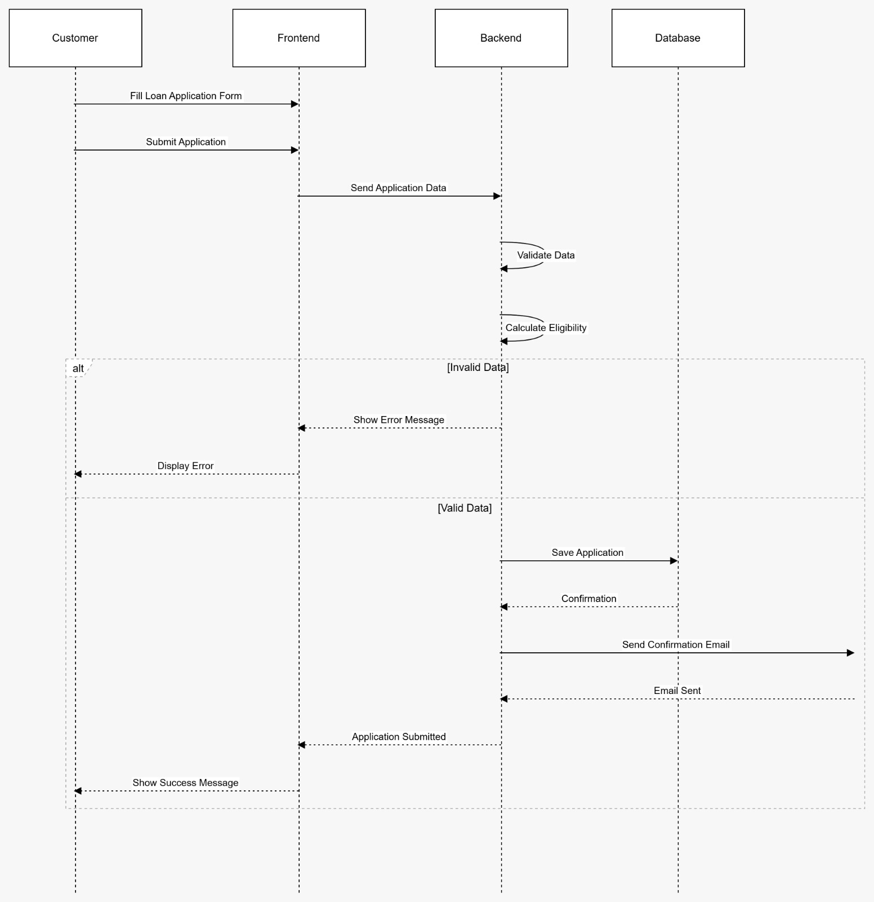

6.2 Loan Approval Workflow Sequence Diagram
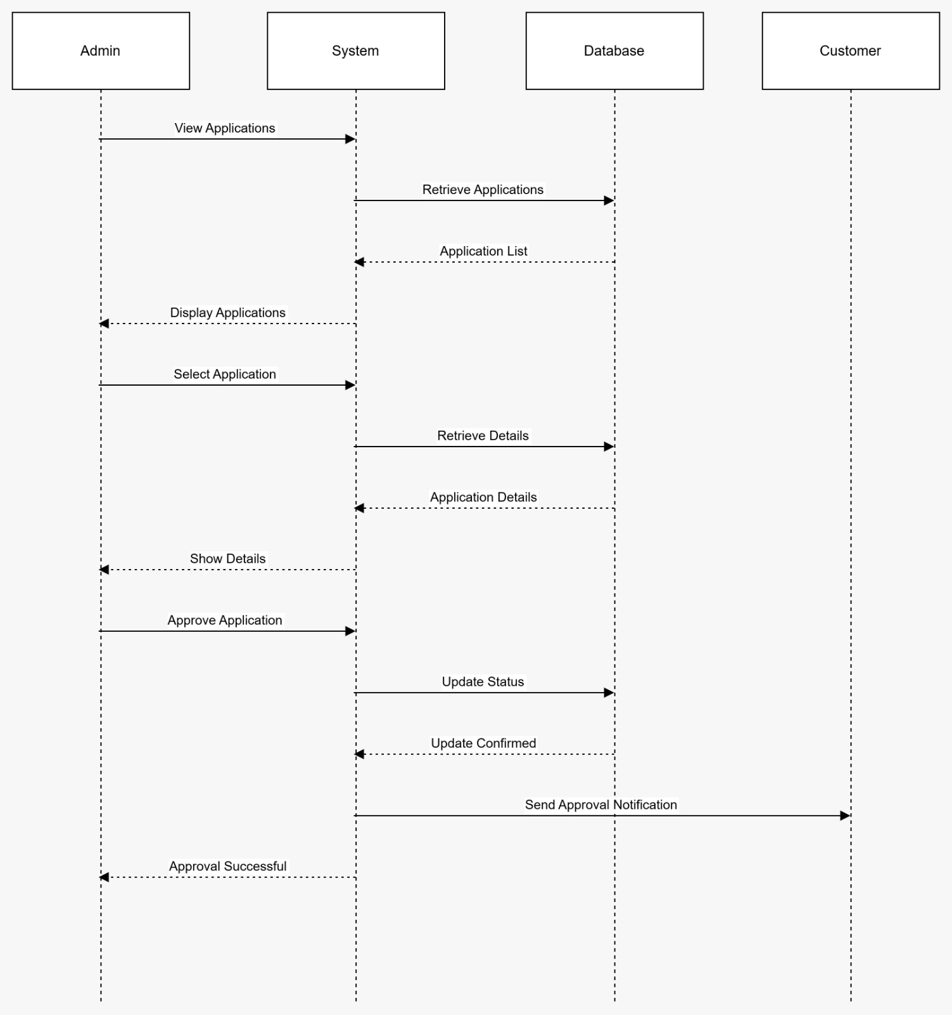
  - Payment Processing Collaboration Diagram
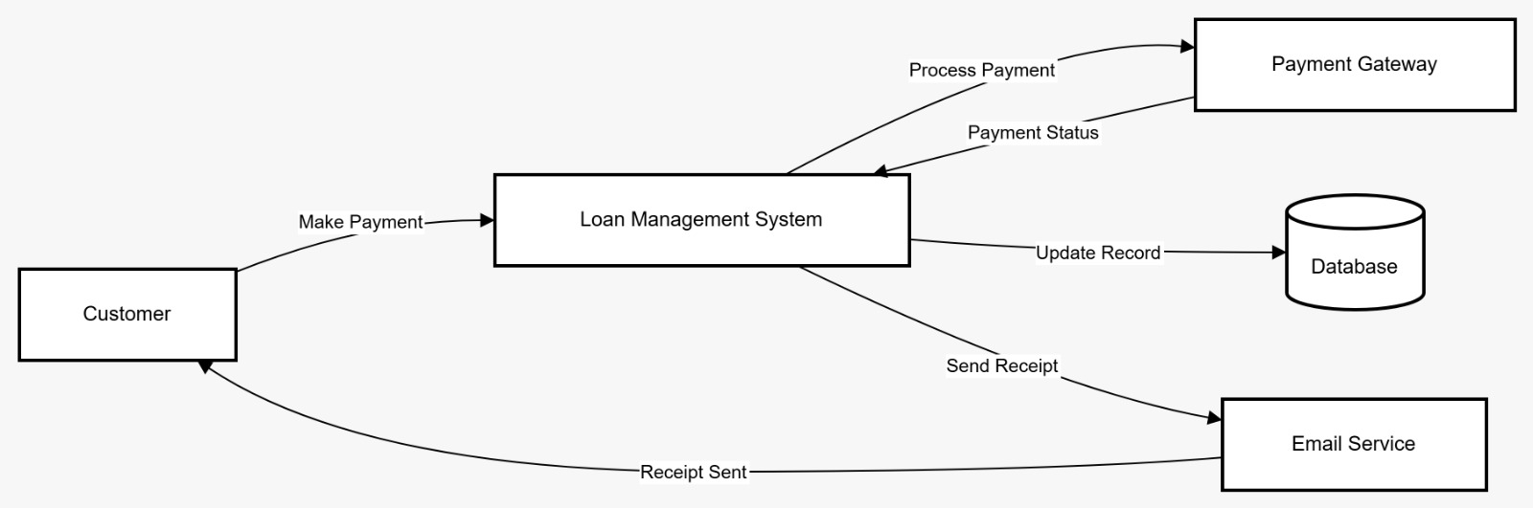

7. COMPONENT & DEPLOYMENT DIAGRAMS
7.1 System Component Diagram
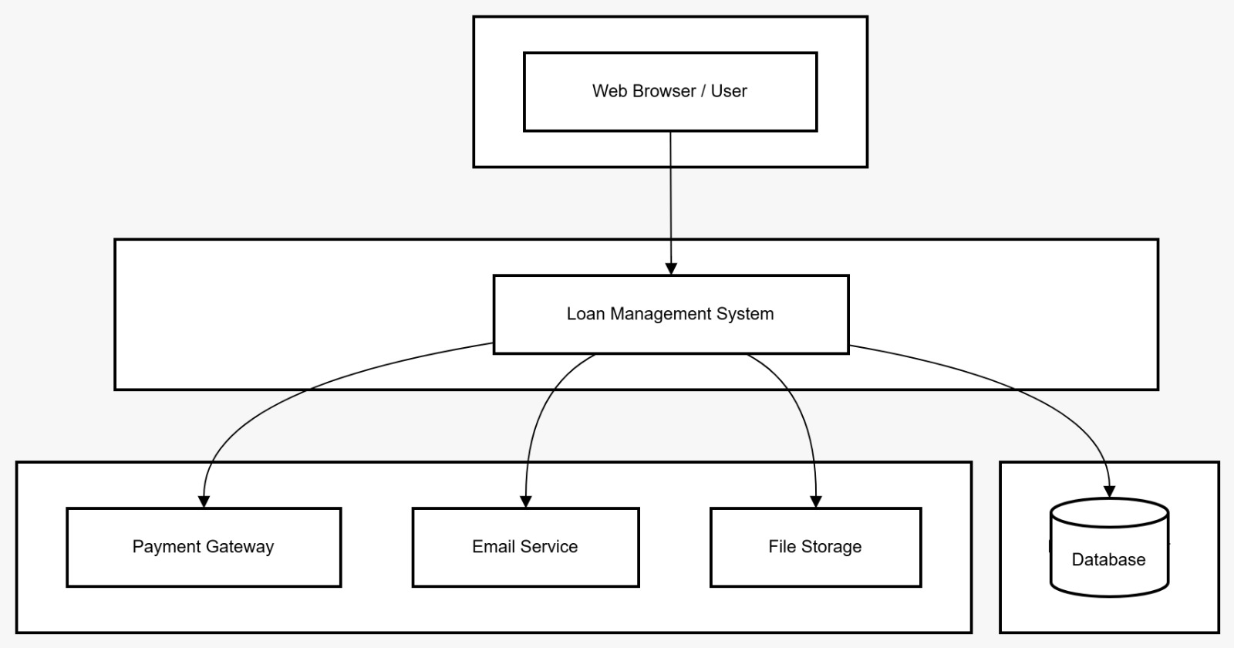
7.2 Deployment Diagram
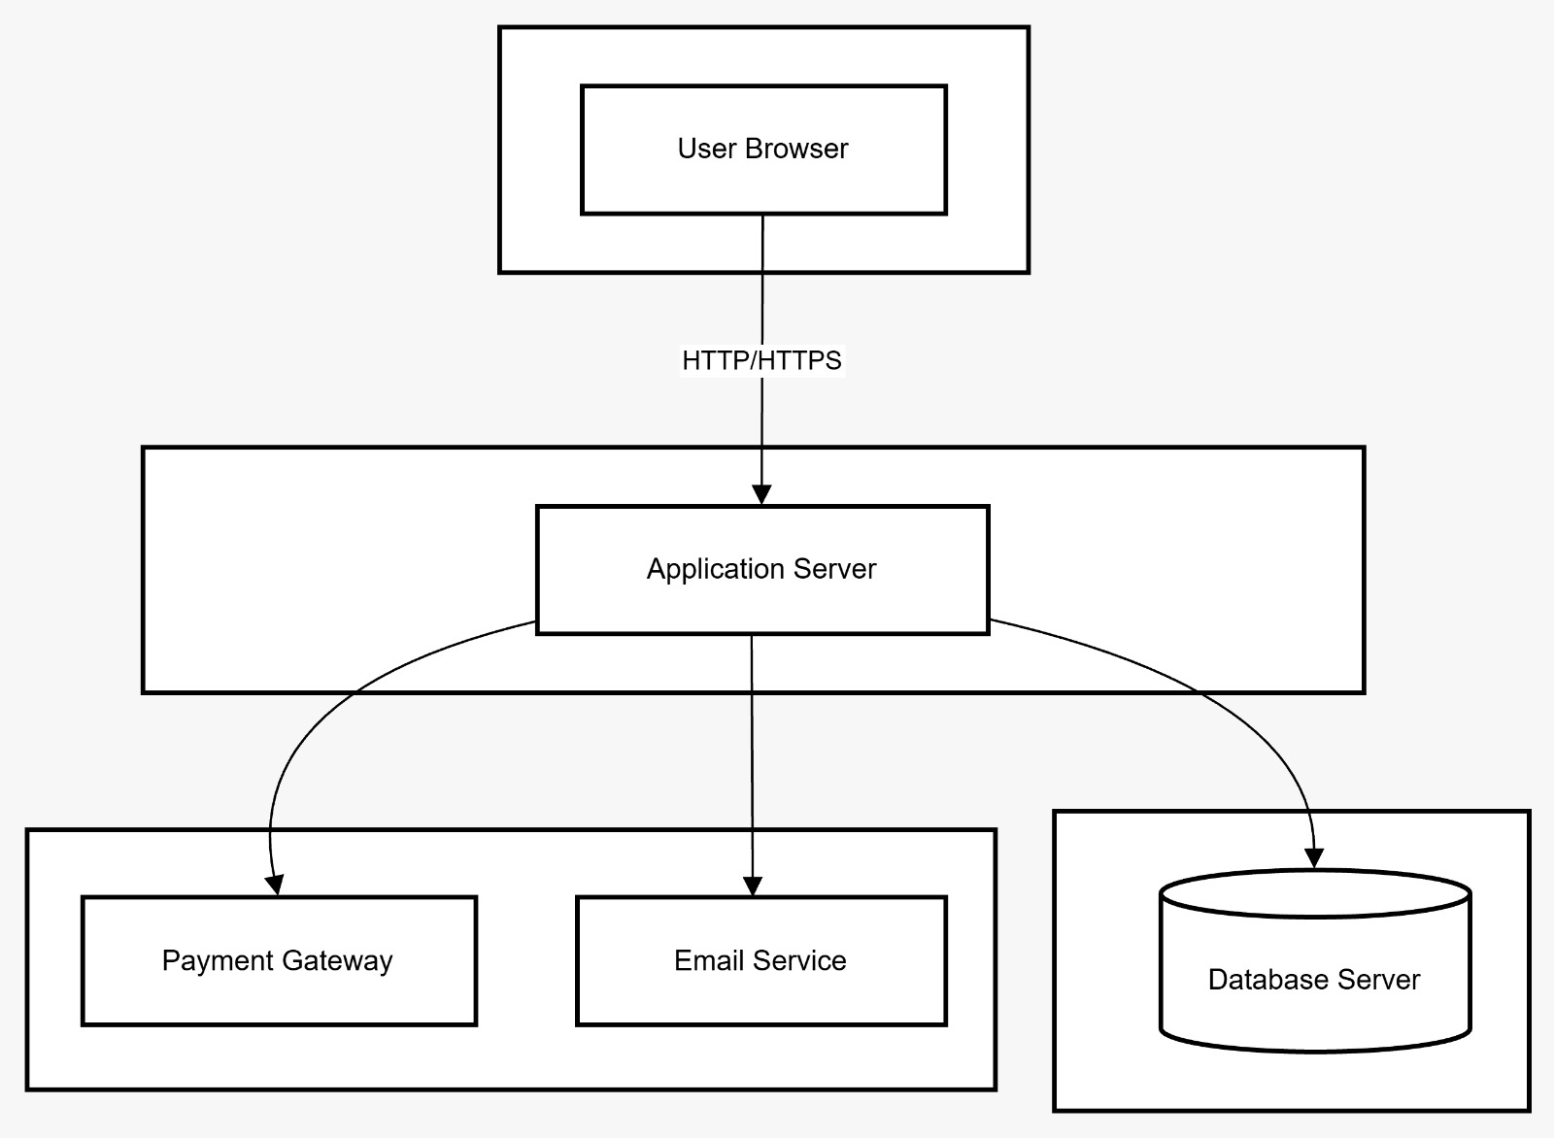

7.3 Infrastructure as Code Diagram
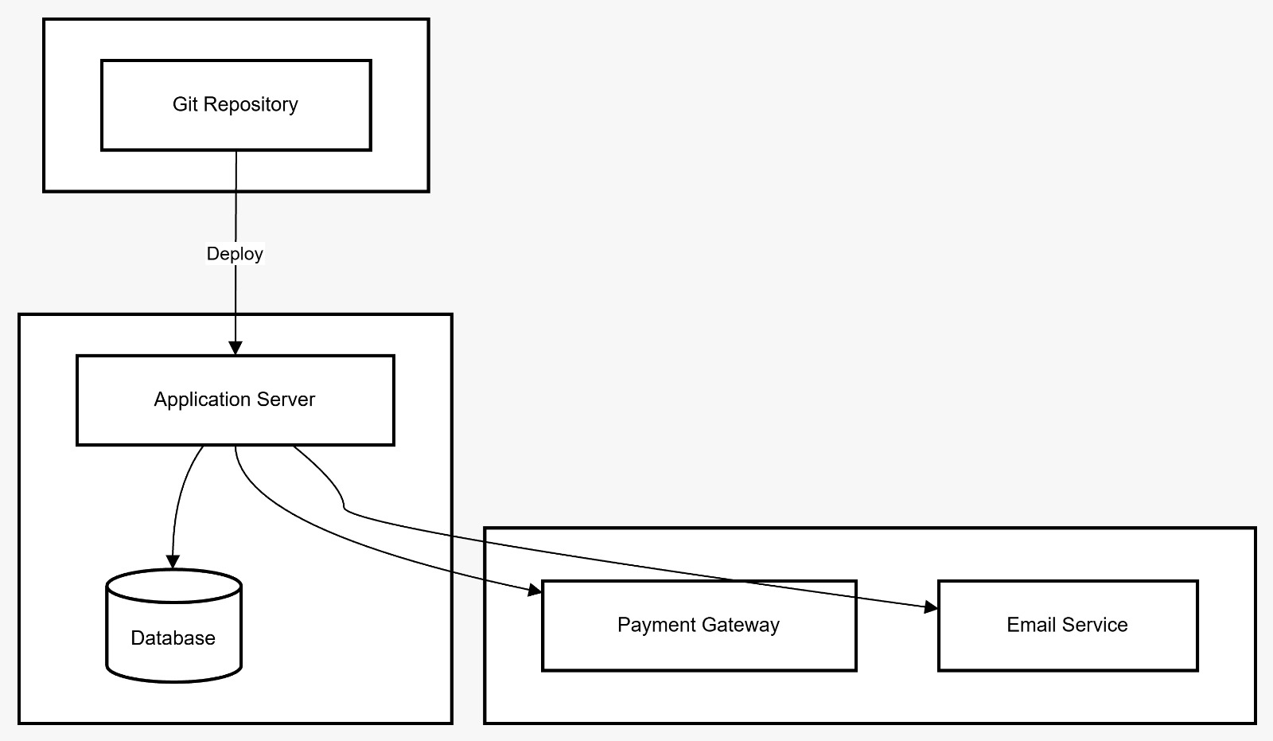

8. Function Point (FP) Analysis
8.1 Overview
Function Point Analysis (FP) is a standard software sizing technique used to estimate the complexity and effort required to develop a software system based on user-visible functionality.
The Nexa Loan Management System has been evaluated using the five standard Function Point components:
- External Inputs (EI)
- External Outputs (EO)
- External Inquiries (EQ)
- Internal Logical Files (ILF)
- External Interface Files (EIF)

8.2 Function Point Calculation
Function Type | Description | Count | Weight | Total FP
External Inputs (EI) | Registration, Login, Loan Form, Document Upload, Payment Form | 5 | ×4 | 20
External Outputs (EO) | Confirmation Message, Approval/Rejection Status, Payment Receipt, Admin Report | 4 | ×5 | 20
External Inquiries (EQ) | View Status, EMI Calculation, Search Records | 3 | ×4 | 12
Internal Logical Files (ILF) | Users, Loans, Payments | 3 | ×10 | 30
External Interface Files (EIF) | Email Service, Payment Gateway | 2 | ×7 | 14

Total Function Points = 96
8.3 Effort Estimation
Based on academic estimation standards:
1 Function Point ≈ 8–10 person-hours
96 FP × 9 hours (average) = 864 person-hours
Estimated Effort Range: 850–1000 person-hours

8.4 Project Duration Estimate
Considering:
- Development
- Testing
- Documentation
- Academic review cycles
The estimated total duration for project completion is:
- 12–16 Weeks (One Academic Semester)
This categorizes the system as a Medium-Scale Web Application.

9. Project Scheduling
9.1 Gantt Chart Overview
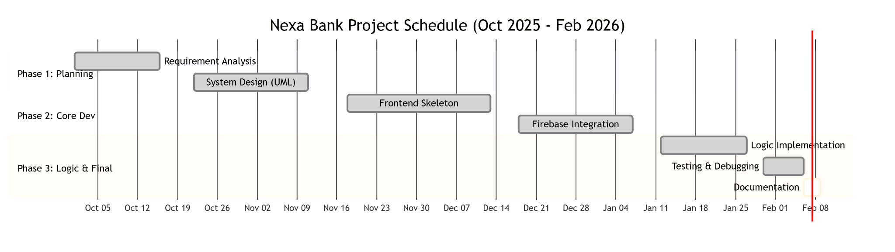
The project was executed over a structured 16-week academic timeline.

Phase Breakdown:
Phase | Duration
Planning & Requirement Analysis | 2 Weeks
System Design (DFD, UML) | 3 Weeks
Implementation (Frontend + Backend) | 6 Weeks
Testing & Debugging | 3 Weeks
Deployment & Documentation | 2 Weeks
Total Duration: 16 Weeks

9.2 PERT Analysis
PERT (Program Evaluation & Review Technique) was used to identify the critical path of project activities.
Major Activities:
- Planning
- Design
- Development
- Testing
- Deployment
Critical Path:
Planning → Design → Development → Testing → Deployment

Estimated Completion Time:
16 Weeks
The project was completed within the planned academic schedule without major delays.

10. Testing Strategy & Test Cases
10.1 Testing Strategy
A hybrid testing strategy was adopted to ensure system reliability and performance.
The following testing types were performed:
- Unit Testing (White Box)
- Integration Testing (Black Box)
- Boundary Value Testing
- Security Testing
- Usability Testing
Testing was performed during development and before final deployment.
10.2 Unit Test Cases (White Box Testing)
Test ID | Test Case | Expected Result | Status
UT-01 | Valid User Registration | User account created | Pass
UT-02 | Duplicate Email Registration | Error message displayed | Pass
UT-03 | Invalid Login Credentials | Unauthorized access denied | Pass
UT-04 | EMI Calculation Formula | Correct EMI value generated | Pass
UT-05 | Loan Amount Above Maximum Limit | Validation error displayed | Pass
UT-06 | Empty Required Fields | Error message shown | Pass

10.3 Integration Test Cases (Black Box Testing)
Test ID | Scenario | Expected Result | Status
IT-01 | Registration → Database Storage | User data stored successfully | Pass
IT-02 | Loan Application → Admin Dashboard | Application visible to Admin | Pass
IT-03 | Admin Approval → Status Update | Status changes to Approved | Pass
IT-04 | Payment Submission → Receipt Generation | Confirmation message shown | Pass

10.4 Boundary Value Testing
Test Case | Input Value | Expected Result
Minimum Loan Amount | ₹5,000 | Accepted
Below Minimum Amount | ₹4,999 | Rejected
Maximum Loan Amount | ₹500,000 | Accepted
Above Maximum Amount | ₹500,001 | Rejected
Minimum Age | 21 Years | Accepted
Below Minimum Age | 20 Years | Rejected

10.5 Security Testing
The system was tested against common security threats:
- SQL Injection – Input sanitized
- Cross-Site Scripting (XSS) – Scripts escaped
- Unauthorized Admin Access – Access blocked
- Invalid Authentication Token – Access denied
All critical security tests passed successfully.

10.6 Usability Testing
Interface responsiveness tested on mobile and desktop devices
Form validation messages displayed clearly
Navigation tested for user-friendliness
Page load time maintained under acceptable limits
Minor UI alignment issues on small mobile screens were corrected.

10.7 Test Summary Report
Category | Tests Executed | Passed | Failed
Unit Testing | 10 | 10 | 0
Integration Testing | 8 | 8 | 0
Security Testing | 5 | 5 | 0
Boundary Testing | 6 | 6 | 0
Total Tests Executed: 29
Initial pass rate was 96%. After resolving minor issues, all test cases passed successfully.
All identified issues were resolved before final submission.

11. Conclusion
The Nexa Bank Loan Management System was successfully designed and developed to address the limitations of traditional loan processing methods. The system provides a secure, efficient, and user-friendly platform for managing loan applications, approvals, repayments, and administrative operations.
Throughout the project, key Software Engineering principles were applied, including requirement analysis (SRS), system design using UML diagrams, Function Point estimation, project scheduling with Gantt and PERT techniques, and structured testing strategies. Each phase of the Software Development Life Cycle (SDLC) was carefully followed to ensure quality and reliability.
The implemented system improves transparency, reduces manual processing delays, enhances security through authentication mechanisms, and enables real-time tracking of loan applications. Testing results confirm that the system functions as expected under normal and boundary conditions.
The project was completed within the planned academic timeline and demonstrates the practical application of theoretical concepts learned in Software Engineering and Web Development courses.
Future enhancements may include mobile application support, AI-based credit scoring, and integration with additional banking services.

