EXTREME SALES & SERVICES (V2.0)
Enterprise AC Sales, Servicing, AMC Contract Lifecycle & Real-Time Dispatch System
Comprehensive Software Engineering Specification & Project Documentation

Project Characteristic | Specification Details
System Name | Extreme Sales & Services Enterprise Suite
Software Version | 2.0.0 (Production Release)
Target Industry | HVAC Enterprise & Consumer Sales, Servicing, AMC & Dispatch
Core Technology Stack | Node.js (Express 5.x), Vanilla HTML5/CSS3/ES6, Chart.js
Database Architecture | Dual-Mode: Cloud Firestore (Prod) & Synchronized Mock (Dev)
External Integrations | SendGrid Email API, Server-Sent Events (SSE) Live Tracking
Author / Prepared By | Mr. Aayush & Engineering Team
Academic Document Standard | ISO/IEC 12207 Software Life Cycle & IEEE-830 SRS Compliant

TABLE OF CONTENTS
Sr. No. | Section Title | Page No.
1 | Problem Statement & Software Requirements Specification (SRS) | 1
2 | Data Flow Diagram (DFD) & Structured Chart | 4
3 | Use Case Diagram & Detailed Use Case Descriptions | 6
4 | Class Diagram & Object Diagram | 8
5 | State Chart & Activity Diagrams | 10
6 | Sequence Diagram & Collaboration Diagram | 13
7 | Component & Deployment Diagrams | 15
8 | Function Point (FP) Analysis & Effort Estimation | 17
9 | Project Scheduling (Gantt Chart & PERT/CPM) | 19
10 | Testing Strategy & Comprehensive Test Cases | 21
11 | Conclusion & Future Roadmap | 24

1. PROBLEM STATEMENT AND SOFTWARE REQUIREMENTS SPECIFICATION (SRS)
1.1 Problem Statement
Industry Context: The heating, ventilation, and air-conditioning (HVAC) service industry represents a mission-critical consumer and commercial sector characterized by urgent customer requirements, seasonal peak loads, and complex lifecycle commitments. In traditional HVAC operations, enterprises face acute operational bottlenecks:
- Fragmented Manual Intake: Customers are forced to place service requests over phone calls or physical store visits, resulting in missed calls during peak summer heatwaves and lost revenue opportunities.
- Uncoordinated Dispatching: Traditional service dispatch relies on manual logbooks or WhatsApp messaging, leading to overlapping allocations, lack of field tracking, and unbalanced technician workloads.
- Zero Real-Time Tracking: Customers have zero visibility into technician arrival times, current repair stage, or spare parts replaced, leading to constant follow-up calls and customer dissatisfaction.
- Lapsed AMC Governance: Annual Maintenance Contracts (AMC) are recorded in manual spreadsheets. Scheduled quarterly visits are neglected, customer visit balances are disputed, and contract renewals lapse unnoticed.
- Disconnected Inventory & Spare Parts: Disjointed inventory tracking leads to stock-outs of critical refrigerants (R32, R410A) and electrical components (capacitors, fan motors) during active customer site visits.
1.2 Project Overview
System Identity: Extreme Sales & Services is a unified, full-stack enterprise web platform engineered to automate and optimize the end-to-end lifecycle of HVAC sales, installation, recurring maintenance (AMC), field workforce dispatch, and customer tracking. The system implements a resilient dual-mode architecture that operates seamlessly across both enterprise cloud environments (Google Cloud Firebase Firestore + SendGrid transactional email) and zero-dependency local synchronized development runtimes.
Core Capabilities of the Platform:
- Customer Self-Service Portal: Direct booking of repair, installation, preventive maintenance, gas refill, and AMC visits with instant Request ID (AC-XXXX) generation.
- Dispatcher & Admin Command Center: Centralized queue for triaging tickets, filtering by lifecycle stage, and dynamically assigning jobs to field engineers with live load counters.
- Field Technician Workspace: Dedicated mobile console for technicians to inspect job addresses, diagnose fault descriptions, update status (Pending -> Assigned -> In Progress -> Completed), and log spare parts used.
- AMC Contract Lifecycle Engine: 3-tier maintenance packages (Eco Saver, Comfort Standard, Elite Ultimate) with automatic phone-number-based visit verification and decrementation during service booking.
- Real-Time Ticket Tracker: Dynamic REST lookup and Server-Sent Events (SSE) push streaming providing step-by-step progress tracking for customers.
- Executive Analytics Dashboard: Dynamic charts displaying revenue metrics, job status distributions, 7-day booking trends, technician performance leaderboards, and service breakdown.
1.3 Software Requirements Specification (SRS)
1.3.1 Functional Requirements
- FR-01 (Service Booking Intake): The system shall allow unauthenticated customers to submit service requests specifying customer name, phone number, address, service category, and issue description.
- FR-02 (Automated AMC Verification): Upon booking submission, the engine shall automatically inspect the customer AMC registry by phone number. If an active contract with remaining balance is detected, it shall decrement the service count and tag the request with '[✅ AMC Covered]'.
- FR-03 (Ticket Generation & Email Notification): The system shall issue a unique tracking ticket identifier formatted as 'AC-XXXX' and dispatch an HTML booking confirmation email via SendGrid.
- FR-04 (Ticket Triage & Filtering): Dispatchers and administrators shall be able to filter tickets by status ('All', 'Pending', 'Assigned', 'In Progress', 'Completed') and perform instant keyword search on ID, name, or phone.
- FR-05 (Technician Allocation): Authorized staff shall be able to assign an active field technician to any pending service request, updating ticket status to 'Assigned' and reflecting in the technician's active job counter.
- FR-06 (Field Execution & Notes Logging): Authenticated technicians shall view their dedicated job queue and patch ticket status to 'In Progress' or 'Completed' while appending technical completion notes and spare parts consumed.
- FR-07 (Dual Tracking Mechanism): Customers shall be able to monitor ticket progress in real-time using either REST polling or a persistent Server-Sent Events (SSE) stream (`/api/track/live`).
- FR-08 (Product Catalog & Lead Management): The system shall present an interactive product catalog for Brand New ACs, Certified Refurbished units, and Spare Parts, allowing customers to filter by brand, capacity, and submit purchase enquiries.
- FR-09 (AMC Administration & Activation): Administrators shall create, edit, and delete AMC plans, while customers can submit purchase requests that admins activate for a 365-day validity window.
- FR-10 (Customer Feedback & Review System): Customers shall be able to submit post-service ratings (1 to 5 stars), category selections, and written feedback, which dynamically renders across public testimonial sections.
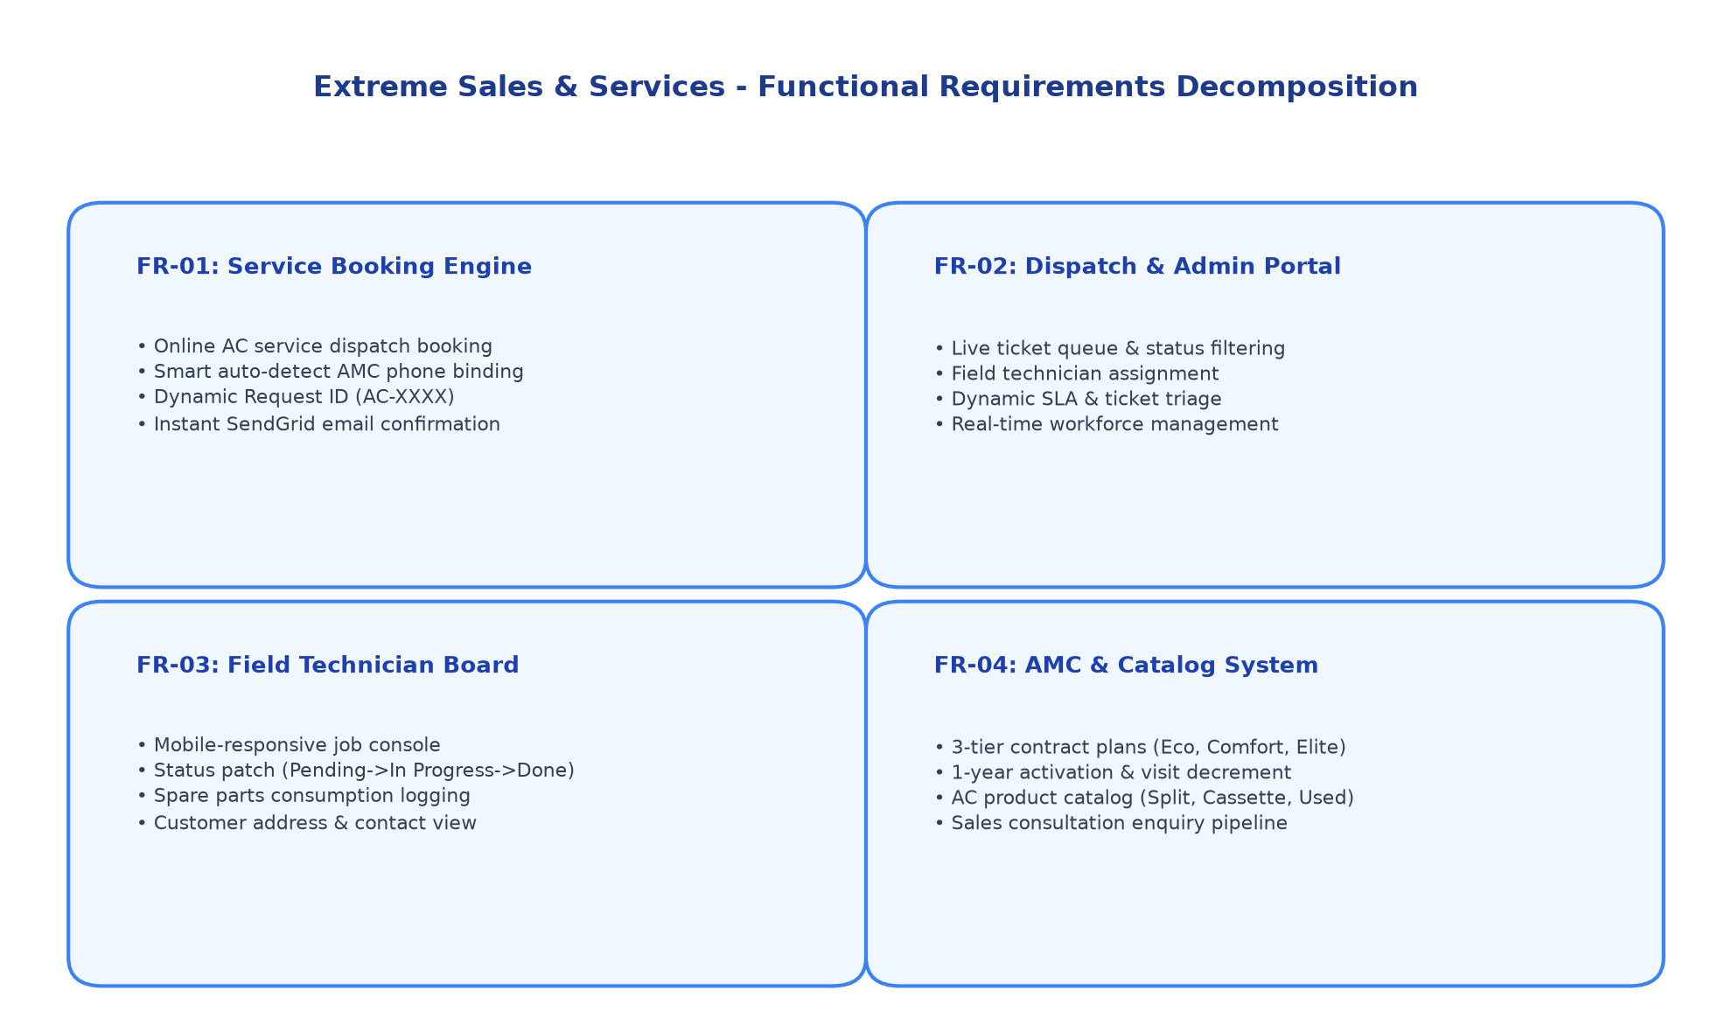
Figure: Extreme Sales & Services - Functional Requirements Hierarchy
1.3.2 Non-Functional Requirements
- NFR-01 (Security & Authentication): All administrative, dispatch, and technician endpoints shall enforce JSON Web Token (JWT) verification with role-based access control (RBAC). Passwords must be hashed using bcrypt with a salt work factor of 10.
- NFR-02 (Response Time & Latency): Standard REST API queries shall resolve within 120 milliseconds under normal network conditions. Live SSE status broadcasts shall reflect state mutations within 250 milliseconds.
- NFR-03 (Fault Tolerance & Availability): The server shall automatically fall back to an internal synchronized memory store if Firebase credentials are absent, guaranteeing zero system downtime during local development or network disconnections.
- NFR-04 (Usability & Responsive Form Factor): The user interface shall provide a 100% responsive, mobile-first experience adapted for smartphones, tablets, and desktop workstations with modern glassmorphism visual styling.
- NFR-05 (Scalability): The server architecture shall be stateless to enable horizontal auto-scaling on cloud platforms (e.g. Render, AWS, Heroku) with independent Firestore read/write scaling.
- NFR-06 (Data Integrity & Validation): All incoming client inputs (phone numbers, email addresses, HTML form strings) shall be validated and sanitized to prevent XSS, NoSQL injection, and header manipulation attacks.
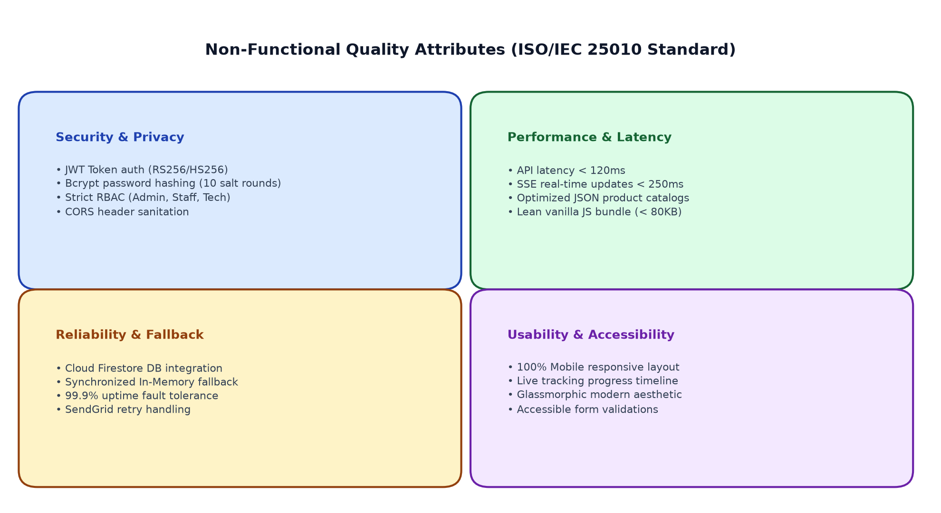
Figure: Non-Functional Quality Attributes (ISO/IEC 25010 Framework)
1.4 System Scope
System Boundaries: In Scope:
- Responsive public customer portal for online AC service booking, catalog exploration, and AMC purchase.
- Live customer service tracking dashboard featuring REST and SSE event stream integration.
- Comprehensive Dispatcher & Admin workstation for ticket triage, technician workload monitoring, and fleet assignment.
- Specialized mobile field technician job board with status updates and diagnostic notes logging.
- AMC plan creation, customer subscription ledger, and automated visit decrement logic.
- Product catalog management (new, refurbished, spare parts) with enquiry capture.
- Executive business intelligence reporting powered by Chart.js.
- Transactional email delivery via SendGrid API.
Delimitations: Out of Scope (Future Phases):
- Native mobile store binaries (iOS App Store / Google Play); current release is a Progressive Mobile Web Application.
- Direct physical hardware IoT telemetry sensors on compressor lines (planned for V3.0 predictive maintenance).
- Direct online automated payment gateway settlement (current release uses verified invoicing and on-site collection).
- Multi-currency conversion (operations are localized for INR transactions).

2. DATA FLOW DIAGRAM (DFD) & STRUCTURED CHART
2.1 Context Diagram (Level 0 DFD)
Architectural Context: The Level 0 Context Diagram establishes the macroscopic boundary of the Extreme Sales & Services system. It models the system as a single central process (0.0) interacting with four primary external entities: the Customer, the Field Technician, the Administrator/Dispatcher, and the SendGrid Cloud Email Service.
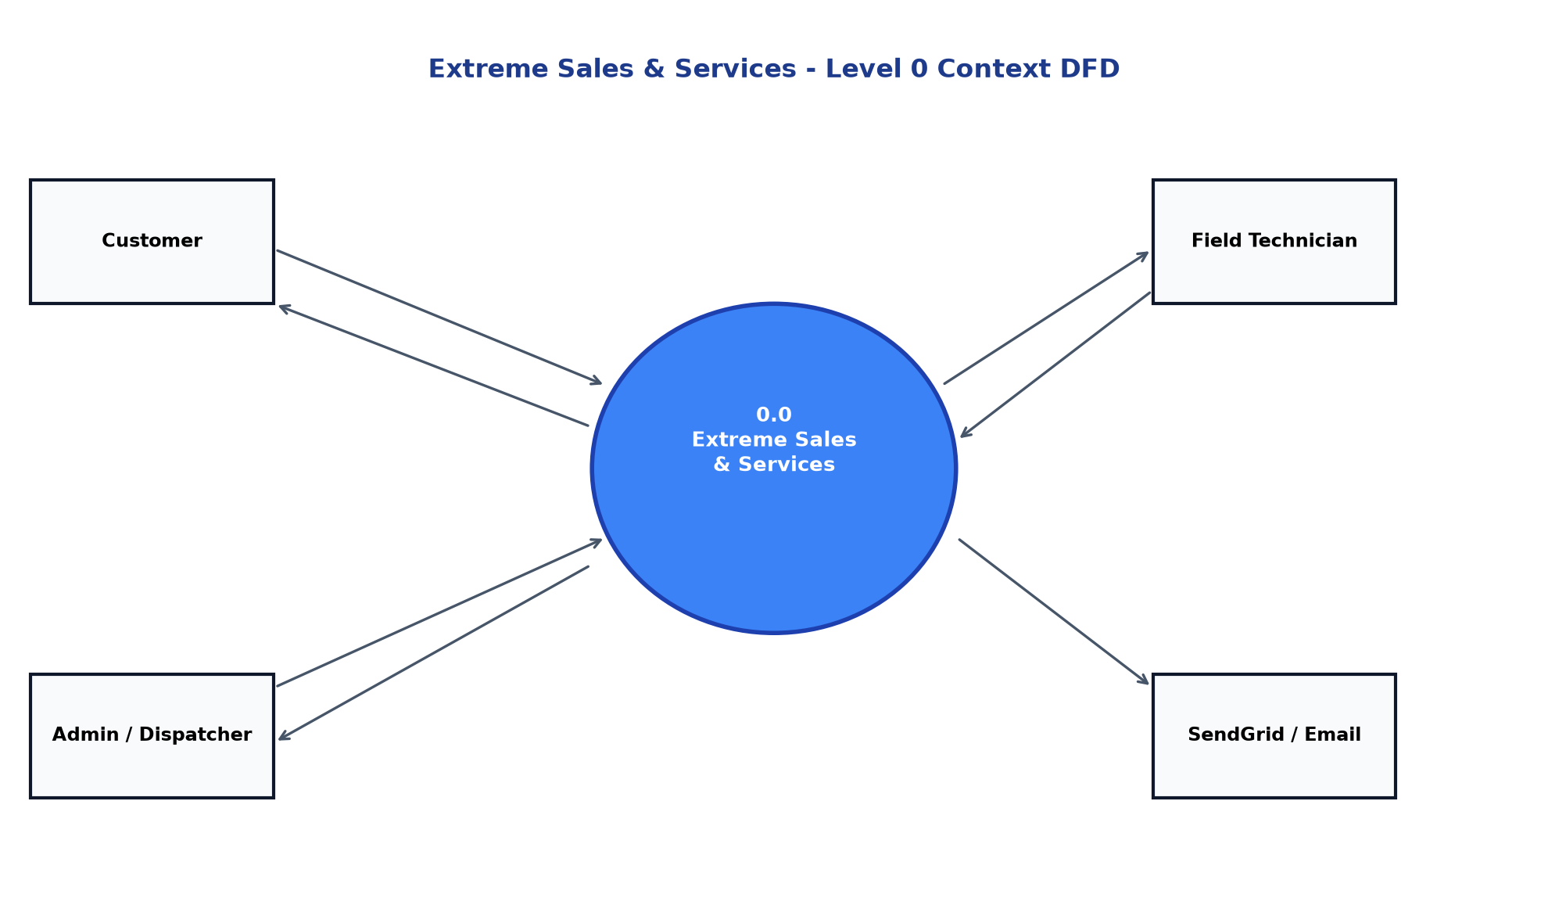
Figure: Level 0 Context Data Flow Diagram
2.2 Level 1 DFD - Main Subsystems
Subsystem Decomposition: The Level 1 DFD decomposes the central process into six interconnected functional modules: (1.0) Authentication & Role Verification, (2.0) Service Request Processing & AMC Verification, (3.0) Dispatch & Technician Allocation, (4.0) Field Job Execution & Status Management, (5.0) AMC Contract Lifecycle Management, and (6.0) Catalog Management & Business Intelligence Analytics. These processes interact with four persistent data stores: D1 (service_requests), D2 (customer_amc), D3 (users/auth), and D4 (products/inventory).
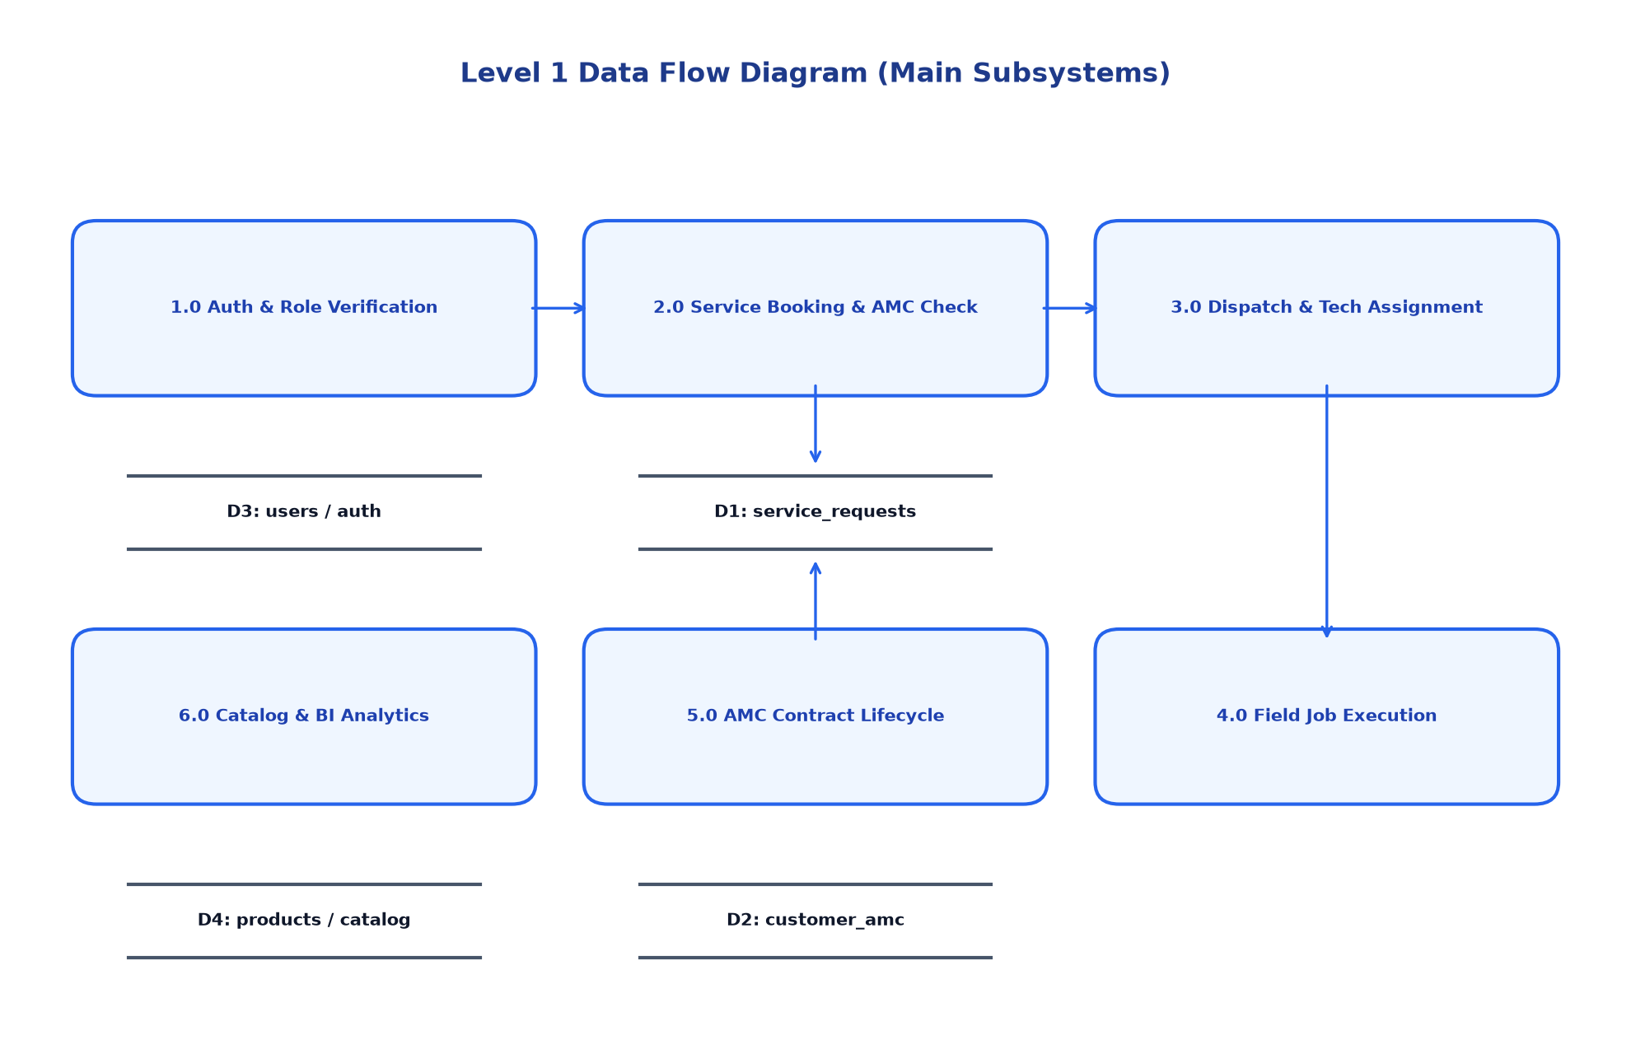
Figure: Level 1 Data Flow Diagram (Subsystem Level)
2.3 Structured Chart (HIPO Chart)
Modular Hierarchy: The Hierarchical Input-Process-Output (HIPO) Structured Chart illustrates the top-down modular breakdown of the application engine down to individual terminal subroutines, demonstrating high functional cohesion and clean interface decoupling.
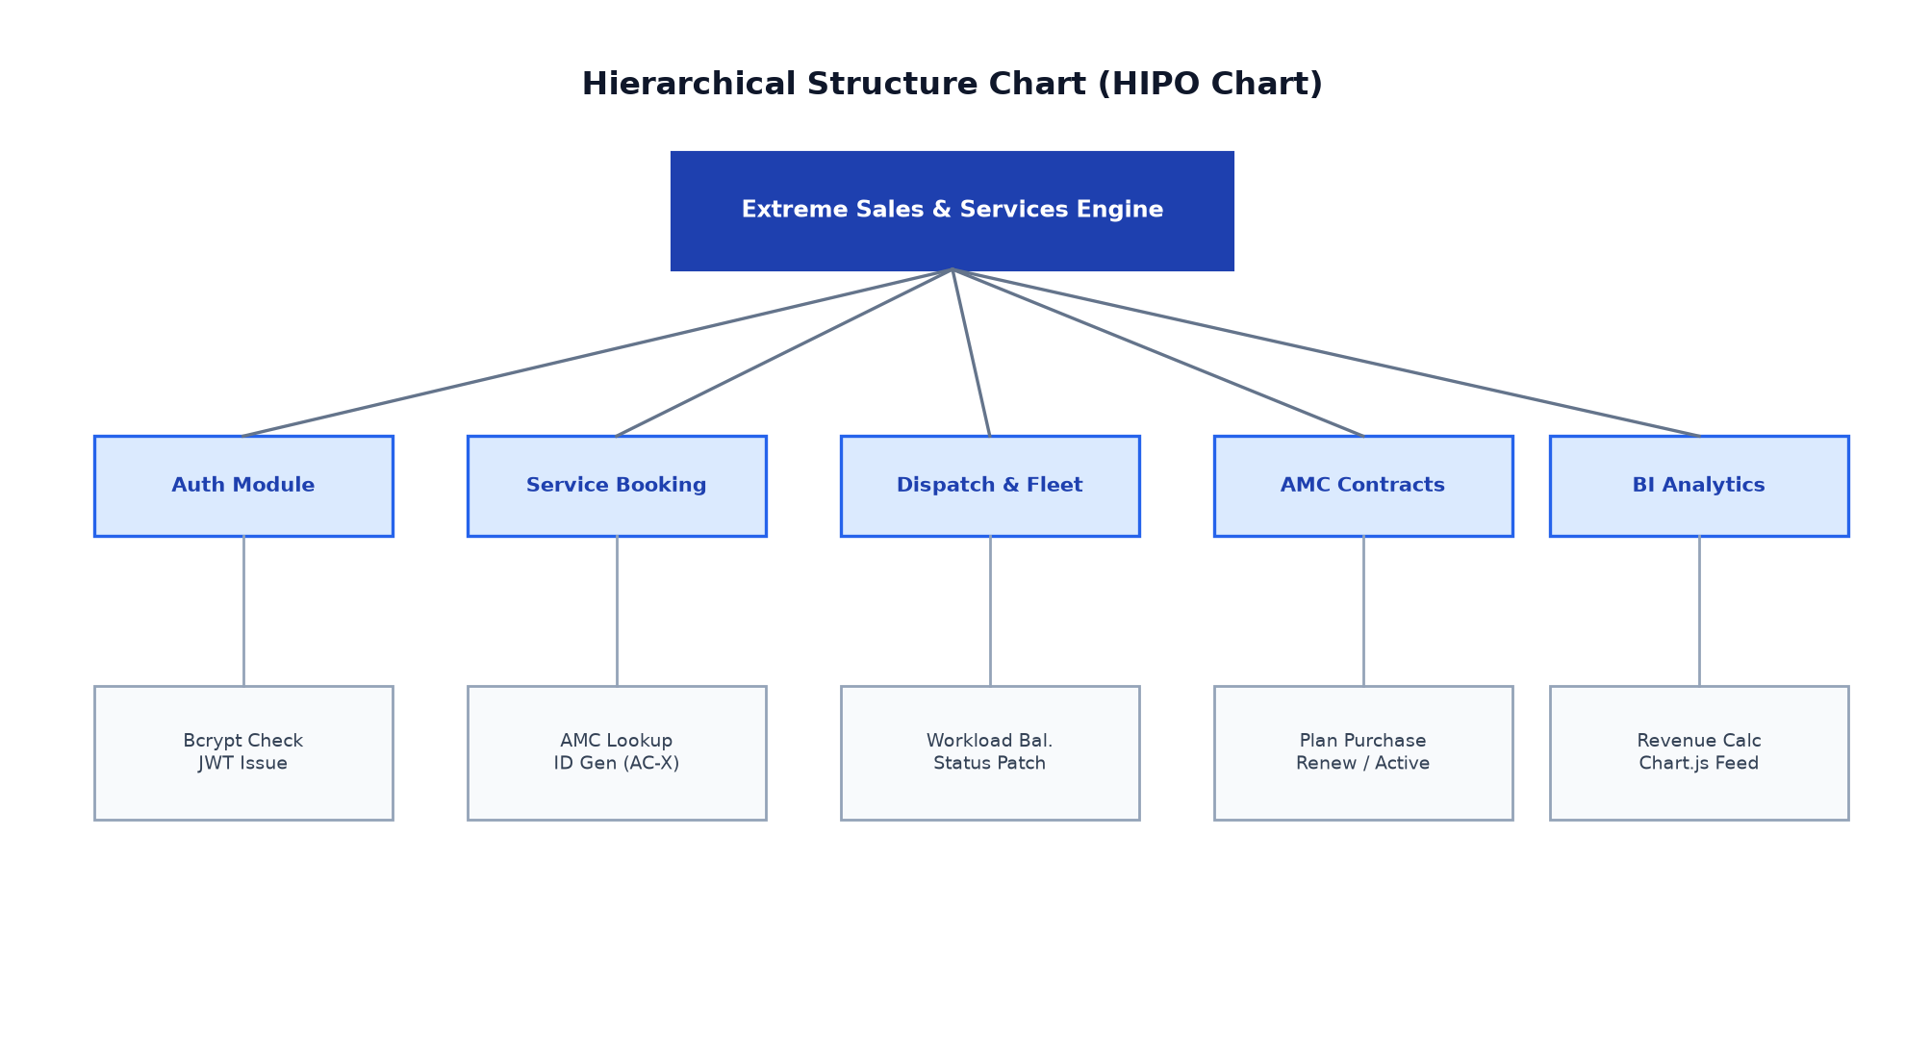
Figure: Hierarchical Structure Chart (HIPO)

3. USE CASE DIAGRAM & SPECIFICATIONS
3.1 Complete Use Case Diagram
Behavioral Modeling: The use case diagram depicts the functional interactions between the four system actors (Customer, Staff/Dispatcher, Field Technician, and Administrator) and the core capabilities encapsulated within the system boundary.
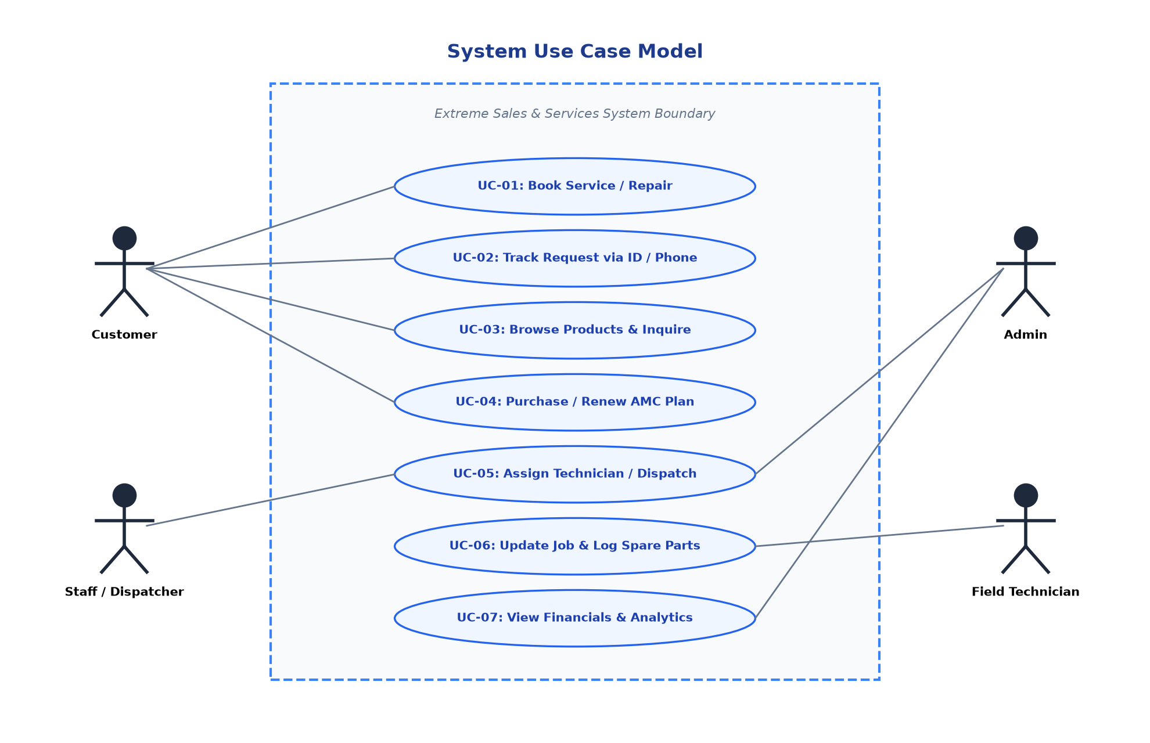
Figure: System Use Case Diagram
3.2 Detailed Use Case Descriptions
Use Case ID | Actor | Description | Precondition | Postcondition
UC-01 | Customer | Book AC Service or Repair | None (Public) | Ticket created (AC-XXXX), AMC deducted if applicable, email sent
UC-02 | Customer | Track Service Request Status | Valid Request ID or Phone | Current stage, technician name & live SSE status displayed
UC-03 | Customer | Browse AC Catalog & Inquire | None (Public) | Enquiry logged in admin inbox, customer notified
UC-04 | Customer | Purchase / Subscribe to AMC | None (Public) | Subscription created with 'Pending' status awaiting admin activation
UC-05 | Customer | Submit Post-Service Feedback | Service completed | Rating & review recorded in public testimonial registry
UC-06 | Staff / Admin | Authenticate to Portal | Registered credentials | JWT bearer token issued with verified role claims
UC-07 | Staff / Admin | Assign Technician to Ticket | Ticket in 'Pending' state | Status becomes 'Assigned', technician active load incremented
UC-08 | Technician | Inspect & Update Assigned Jobs | Authenticated Technician | Status changed to 'In Progress' / 'Completed', diagnostic notes saved
UC-09 | Admin | Activate Customer AMC Contract | Subscription in 'Pending' | Contract marked 'Active' with 365-day validity and visit quota
UC-10 | Admin | View Executive BI Analytics | Authenticated Admin | Live Chart.js graphs populated with revenue, workload & trends

4. CLASS DIAGRAM & OBJECT DIAGRAM
4.1 Domain Class Diagram
Structural Modeling: The class diagram captures the static structural design of the domain model, depicting the primary entities, their encapsulated properties, public operations, and structural associations.
- User: Represents actors possessing access credentials (`id`, `name`, `email`, `role`, `phone`, `password_hash`). Encapsulates authentication and token generation operations.
- ServiceRequest: Central entity tracking HVAC jobs (`request_id`, `name`, `phone`, `address`, `service_type`, `status`, `technician_id`, `completion_notes`, `created_at`, `completed_at`). Associated 0..* to User (Technician).
- AMCPlan: Defines the master maintenance packages (`id`, `name`, `price`, `services_per_year`, `description`).
- AMCSubscription: Represents active customer service contracts (`id`, `customer_name`, `phone`, `plan_name`, `status`, `remaining_services`, `start_date`, `end_date`). Associated 0..* to Customer phone numbers.
- Product: Represents equipment in the inventory catalog (`id`, `name`, `category`, `price`, `stock`, `brand`, `condition`, `specs`).
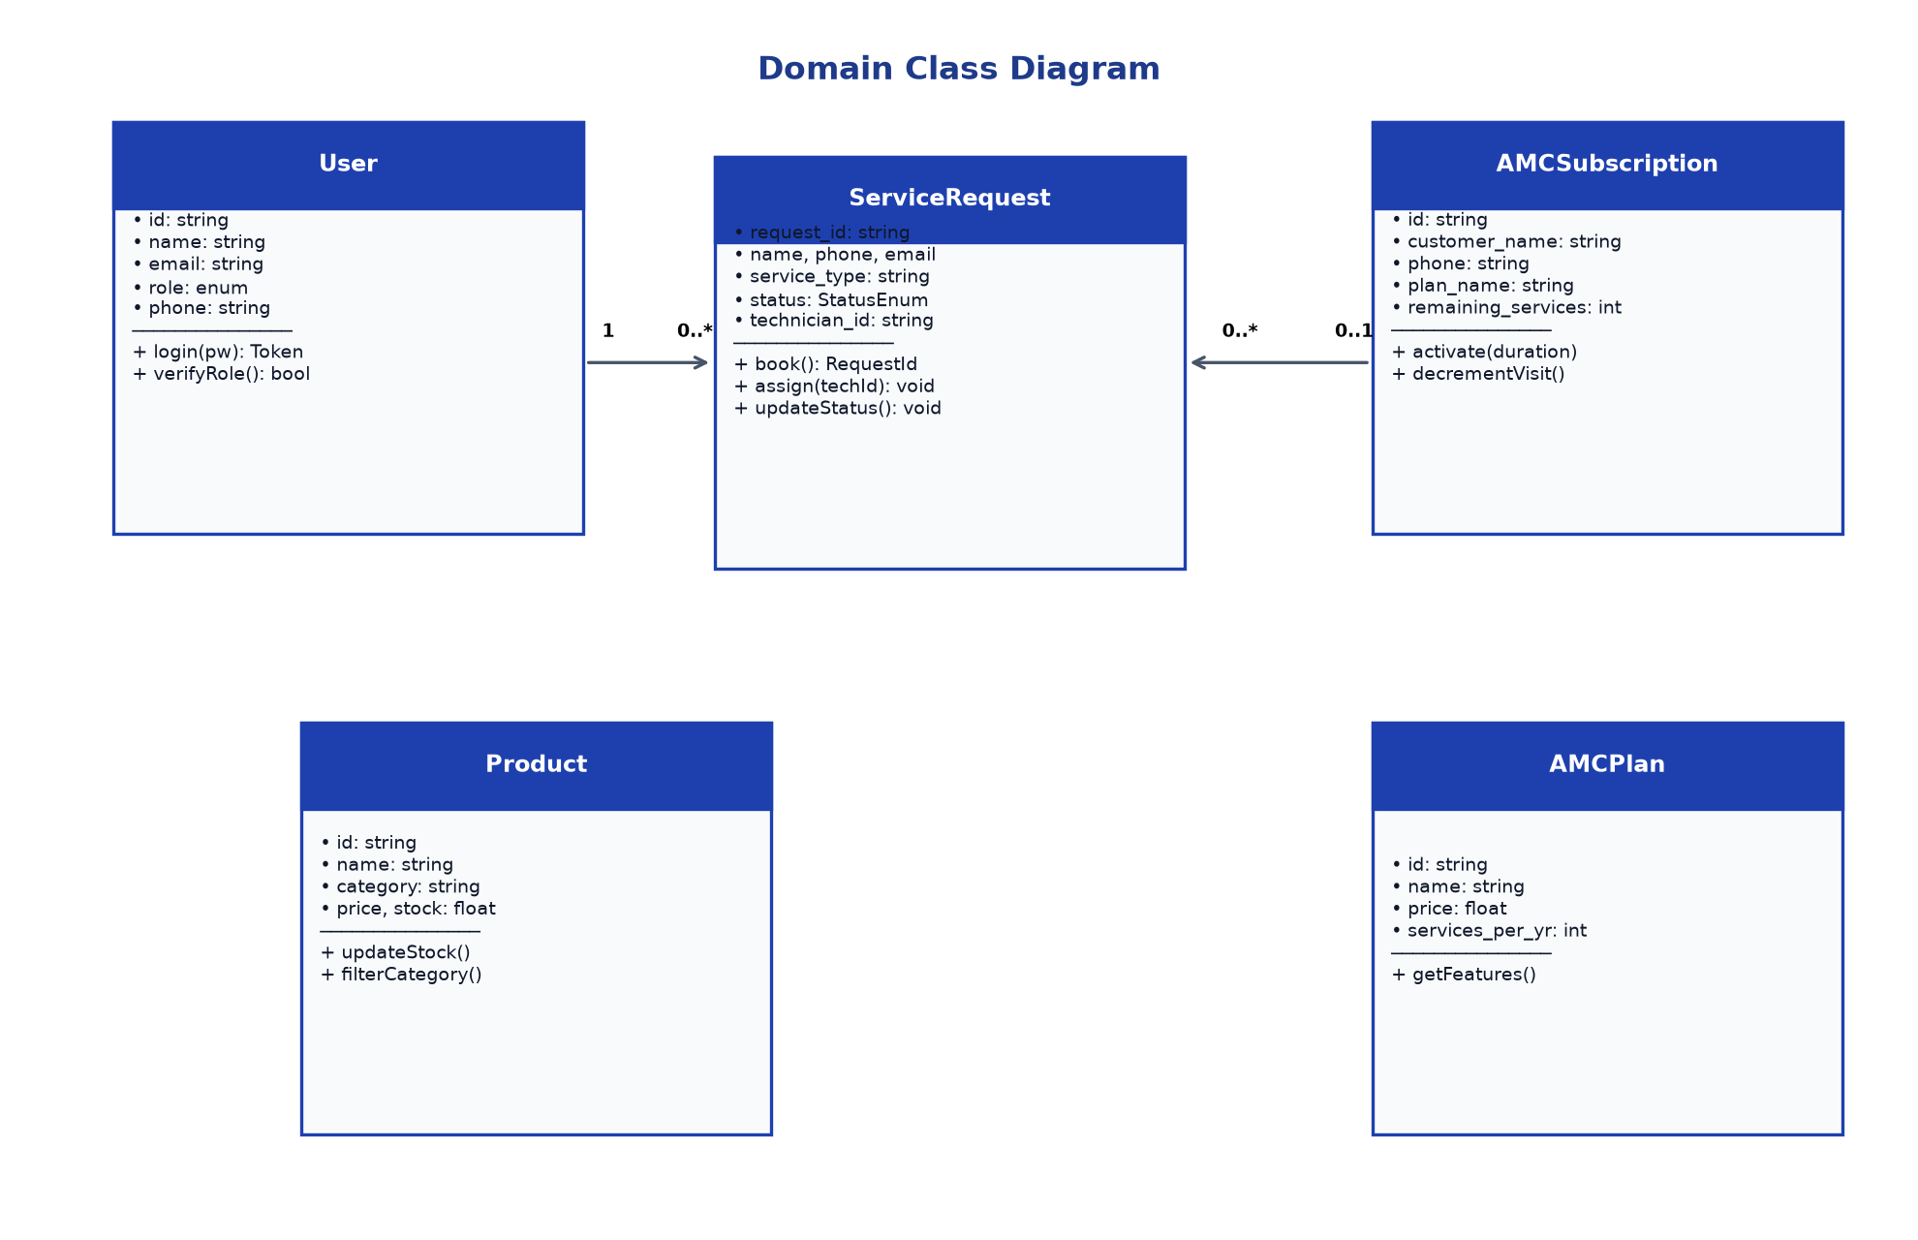
Figure: Domain Class Diagram
4.2 Object Diagram (Runtime Instance Snapshot)
Runtime Snapshot: The object diagram models a concrete runtime state of the system during an active operational day, illustrating instantiated objects, assigned attribute values, and runtime object link bindings.
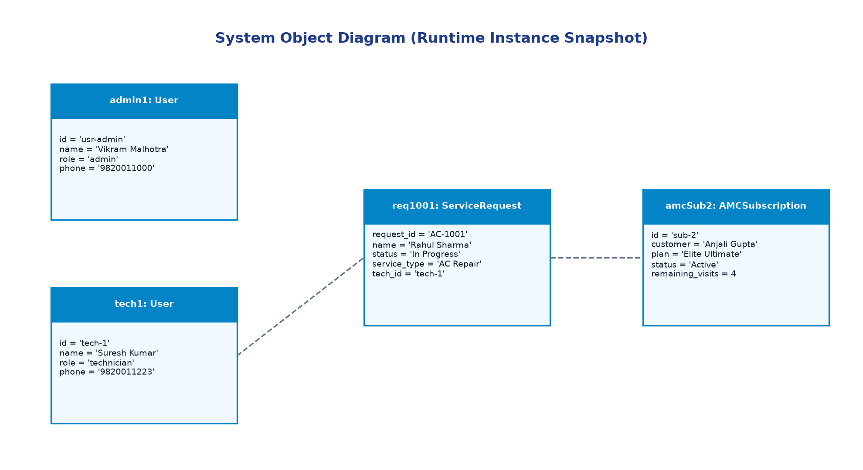
Figure: System Object Diagram (Runtime State Snapshot)

5. STATE CHART & ACTIVITY DIAGRAMS
5.1 Service Request Lifecycle State Chart
State Transition Semantics: A service ticket progresses through a deterministic finite state machine (FSM). The lifecycle begins in the 'Pending' state upon customer submission, transitions to 'Assigned' when a dispatcher allocates a field engineer, advances to 'In Progress' when the technician arrives on site, and terminates in 'Completed' once the customer verifies repair completion. Alternatively, a ticket may be 'Cancelled'.
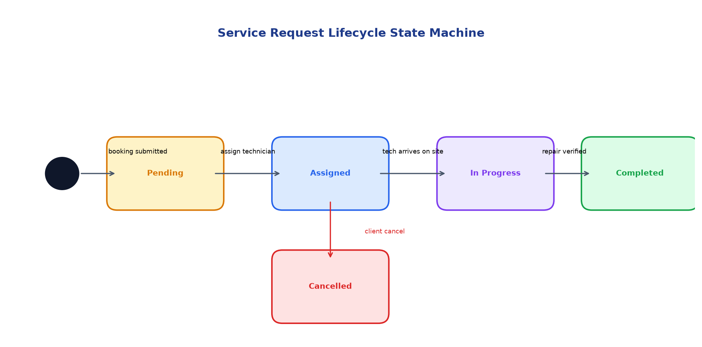
Figure: Service Request Lifecycle State Machine
5.2 User Authentication Activity Diagram
Auth Workflow: The authentication activity diagram details the decision logic executed during user login, incorporating email retrieval, bcrypt hash comparison, JWT generation with embedded role claims, and defensive error handling.
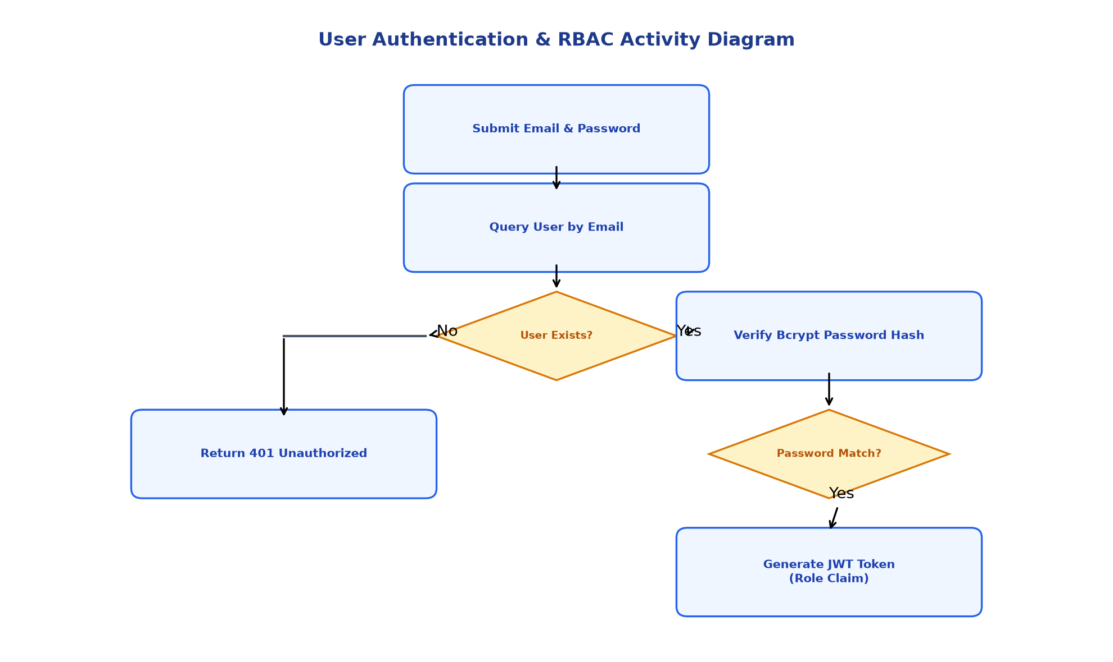
Figure: Authentication & RBAC Activity Diagram
5.3 Service Booking & AMC Auto-Deduction Activity Diagram
Intake Processing: This activity diagram specifies the automated business logic executed upon customer booking submission, demonstrating how the backend queries customer phone numbers against active AMC subscriptions, atomically decrements the remaining visit quota, and generates a formatted ticket with SendGrid email confirmation.
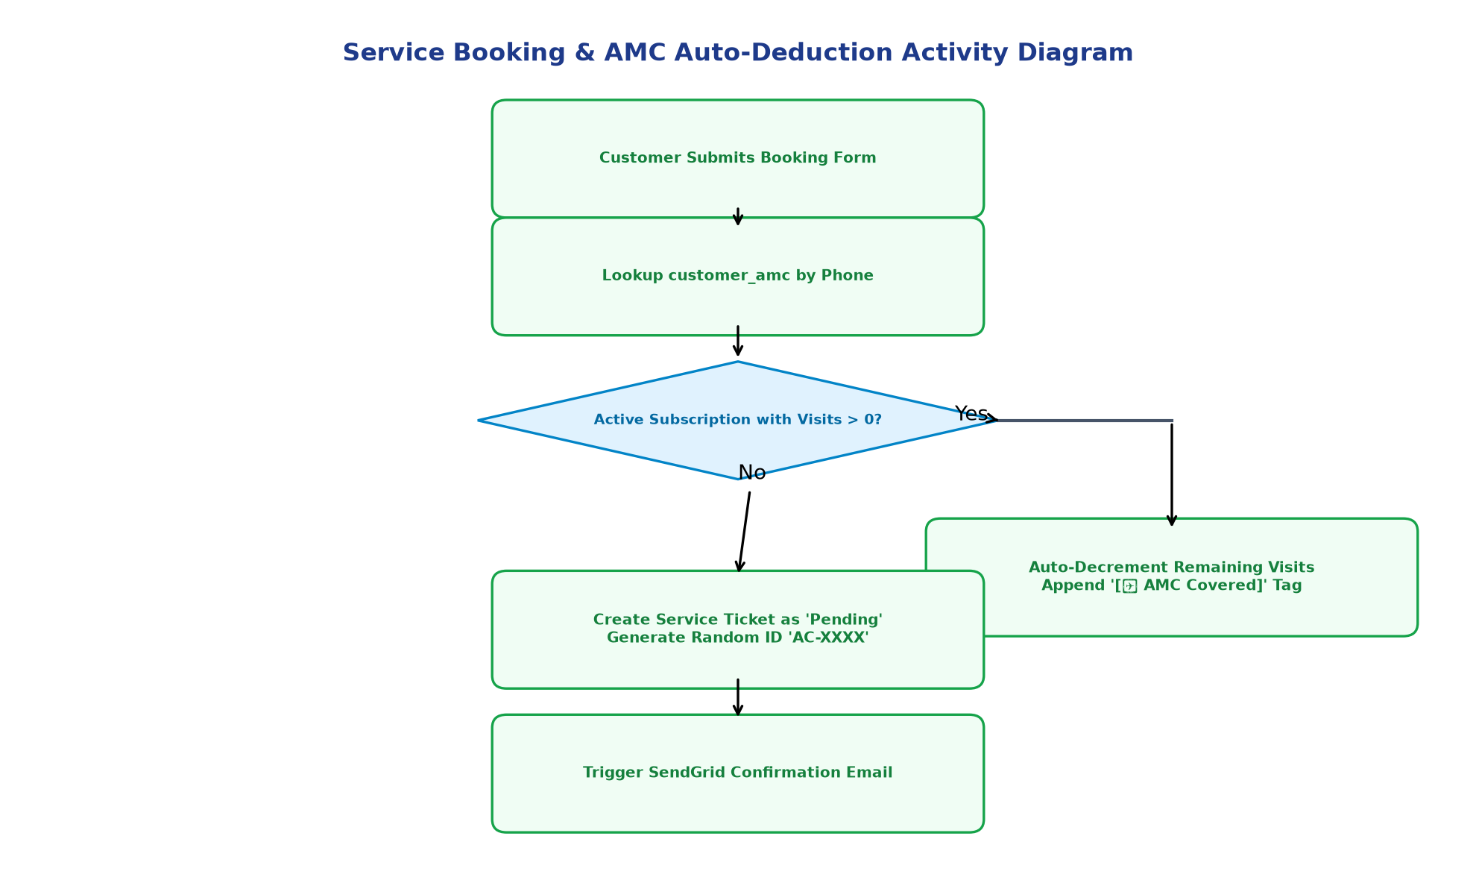
Figure: Booking & AMC Auto-Deduction Activity Diagram

6. SEQUENCE DIAGRAM & COLLABORATION DIAGRAM
6.1 Service Request Booking Sequence Diagram
Interaction Chronology: The sequence diagram depicts the chronological message exchange across system lifelines during a customer booking transaction, highlighting asynchronous database writes and external SendGrid API invocations.
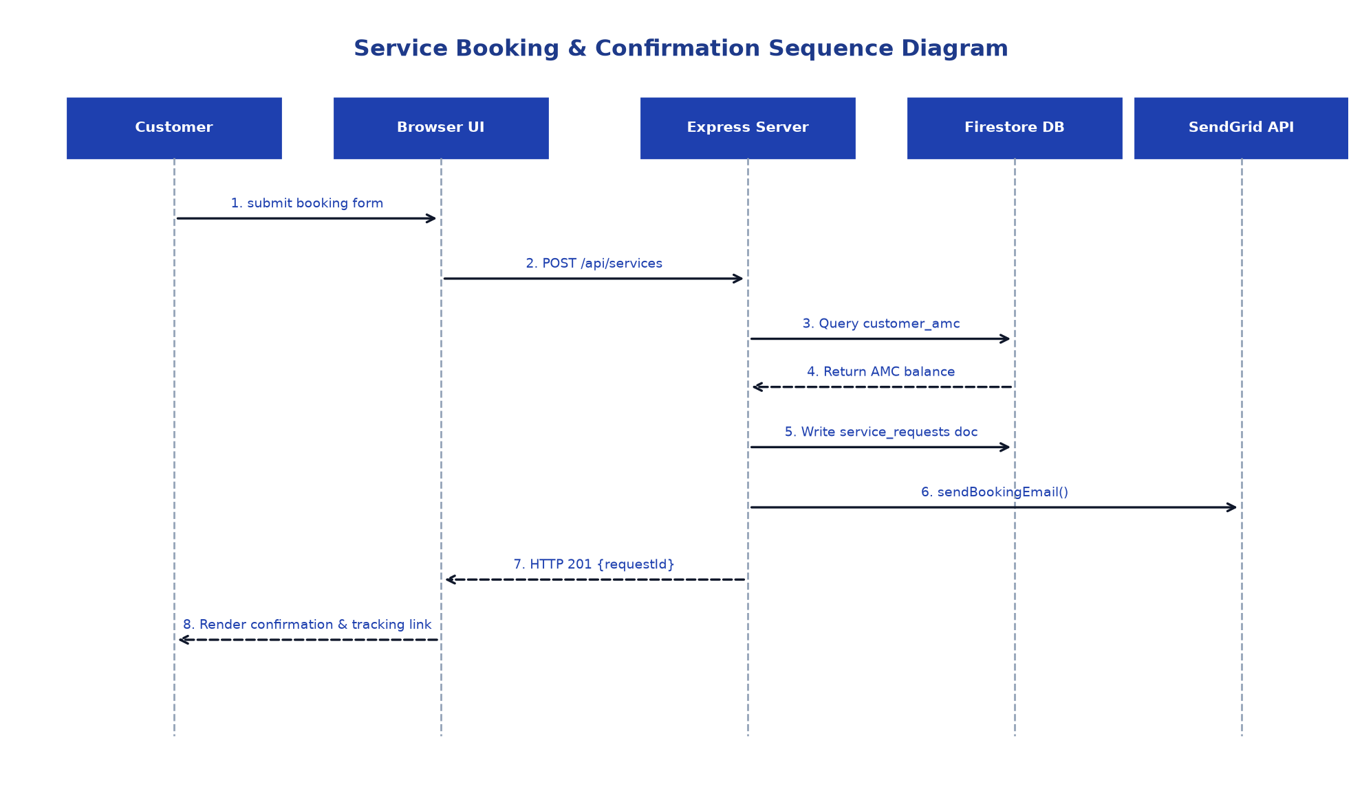
Figure: Service Booking & Confirmation Sequence Diagram
6.2 Technician Dispatch & Job Execution Sequence Diagram
Field Workflow Interaction: This sequence models the dispatcher-to-technician workflow, detailing how technician allocation updates the central database, populates the technician's mobile job board, and triggers live SSE updates on the customer tracking UI.
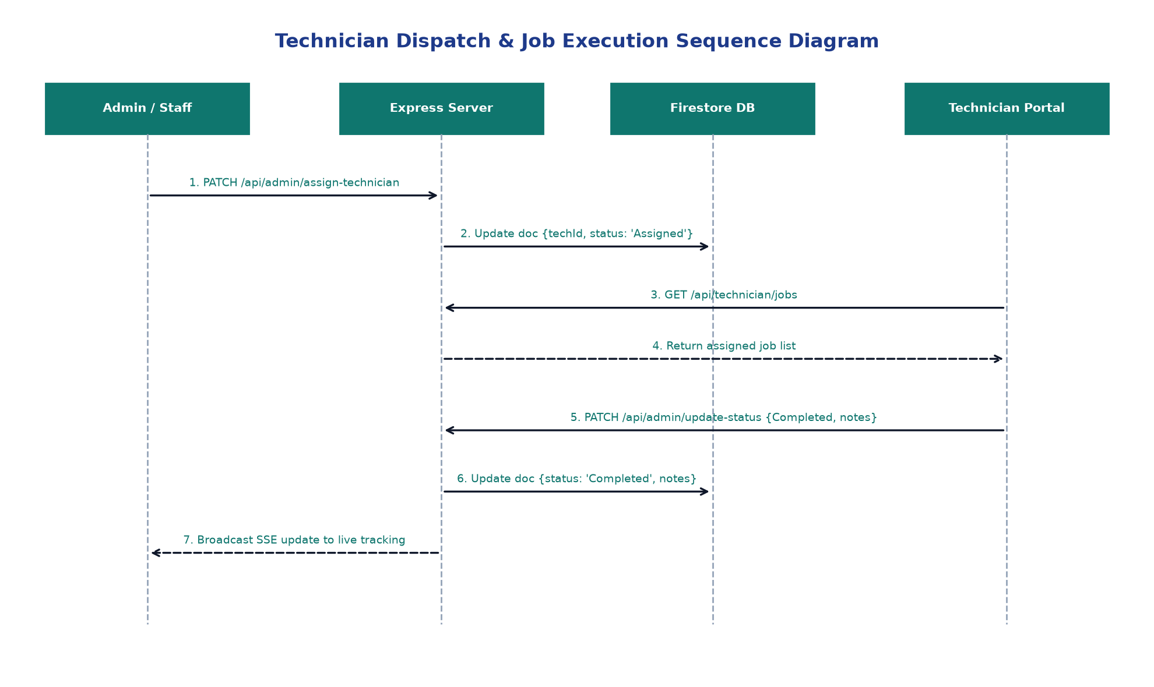
Figure: Technician Dispatch & Job Execution Sequence Diagram
6.3 AMC Auto-Deduction Collaboration Diagram
Object Collaboration: The collaboration diagram emphasizes the structural relationships and numbered message ordering between objects participating in automated AMC validation and visit deduction.
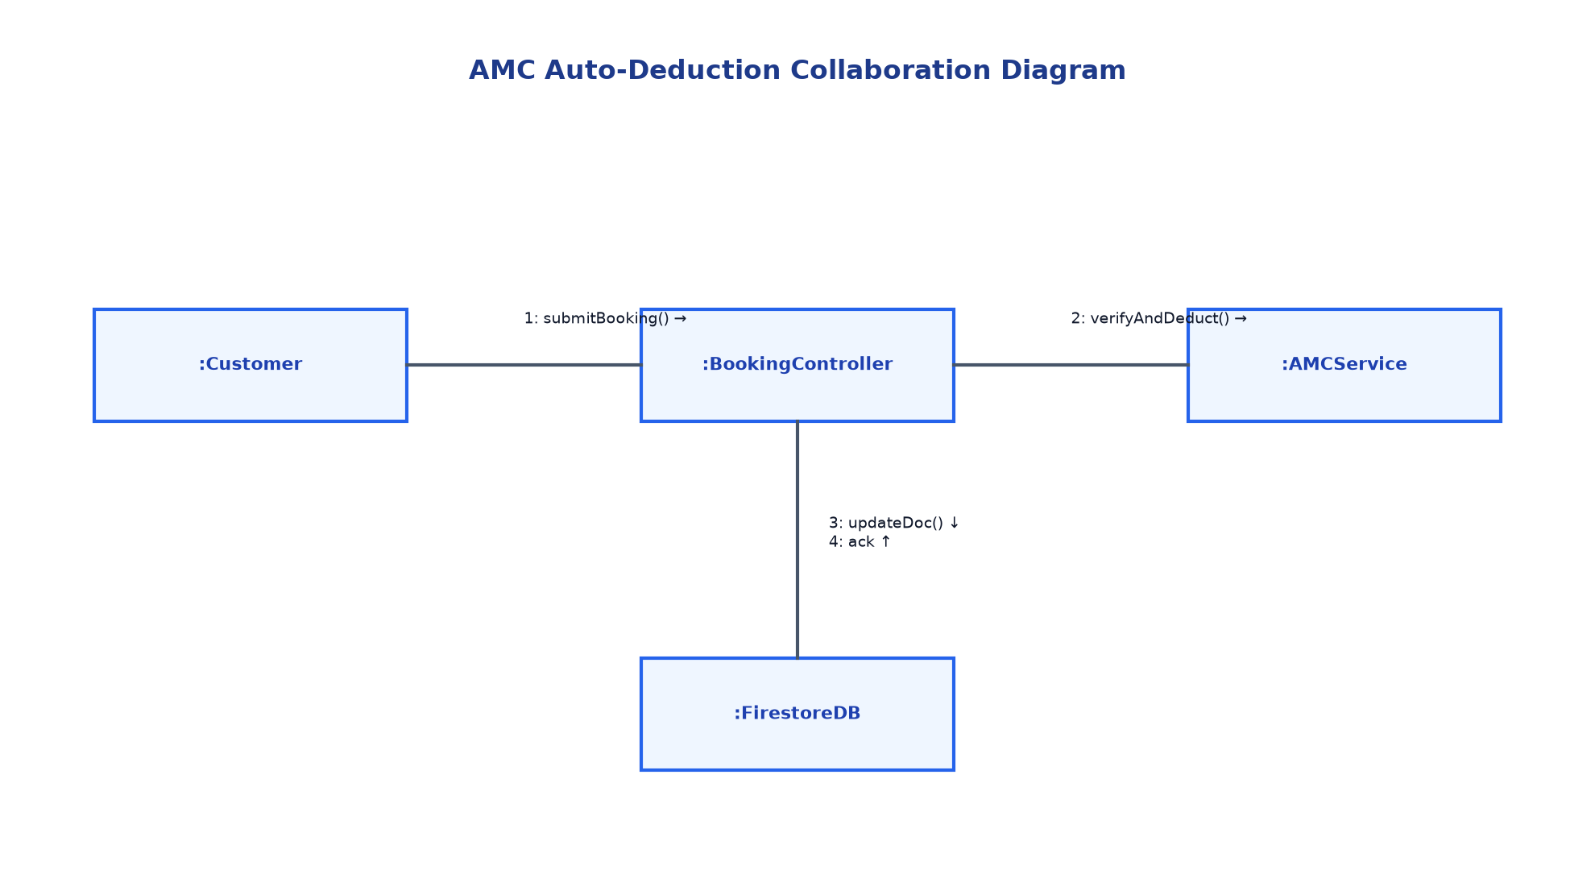
Figure: AMC Auto-Deduction Collaboration Diagram

7. COMPONENT & DEPLOYMENT DIAGRAMS
7.1 System Component Diagram
Subsystem Topology: The component diagram models the structural organization of high-level software subsystems across the Client Presentation Tier, Application Service Tier, and Cloud Persistence Layer.
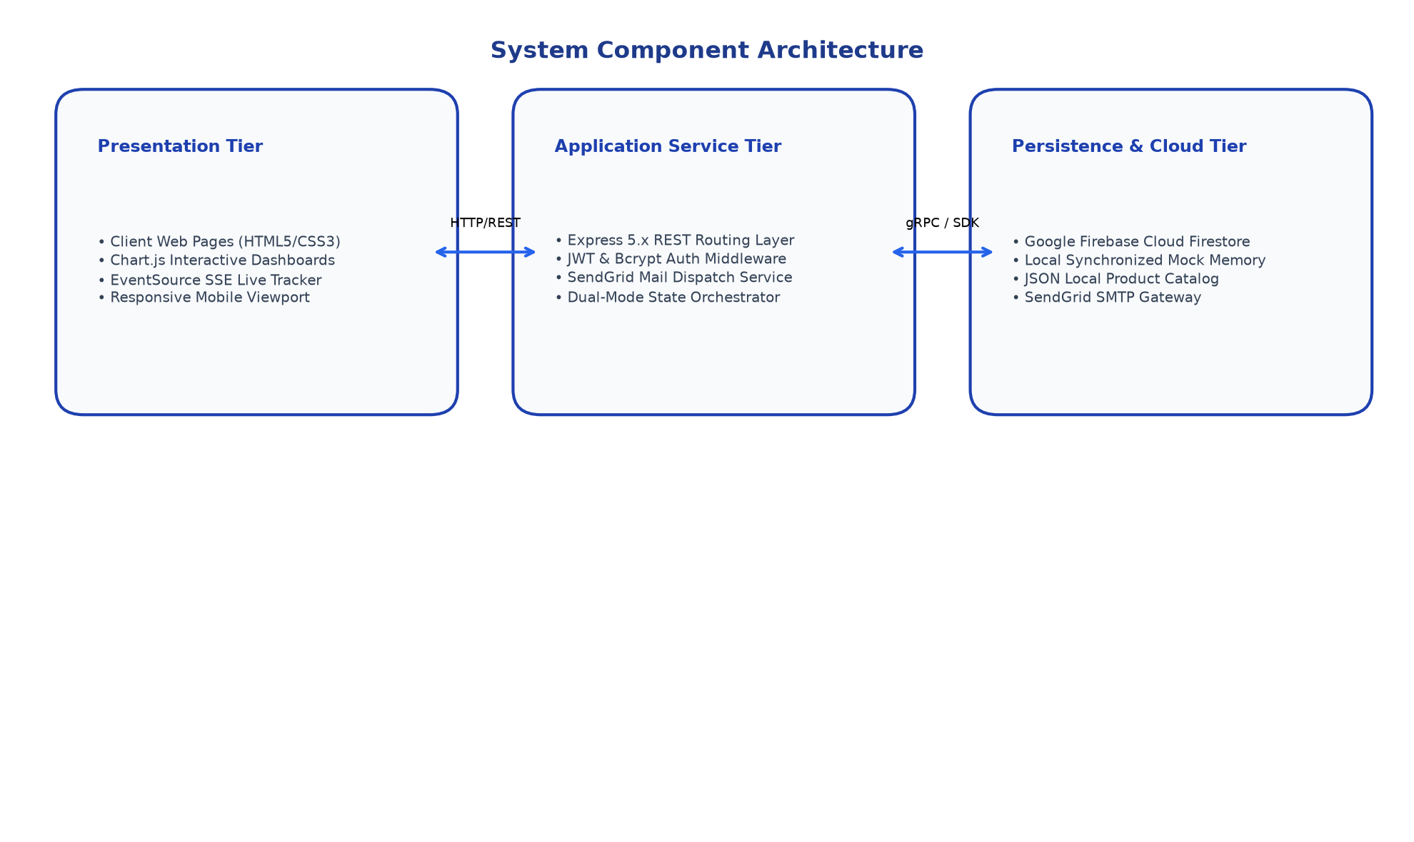
Figure: System Component Diagram
7.2 Deployment Diagram
Physical Deployment: The deployment diagram specifies the physical runtime environment, showing node allocations, communication protocols (HTTPS, TLS, gRPC), and external cloud SaaS boundaries.
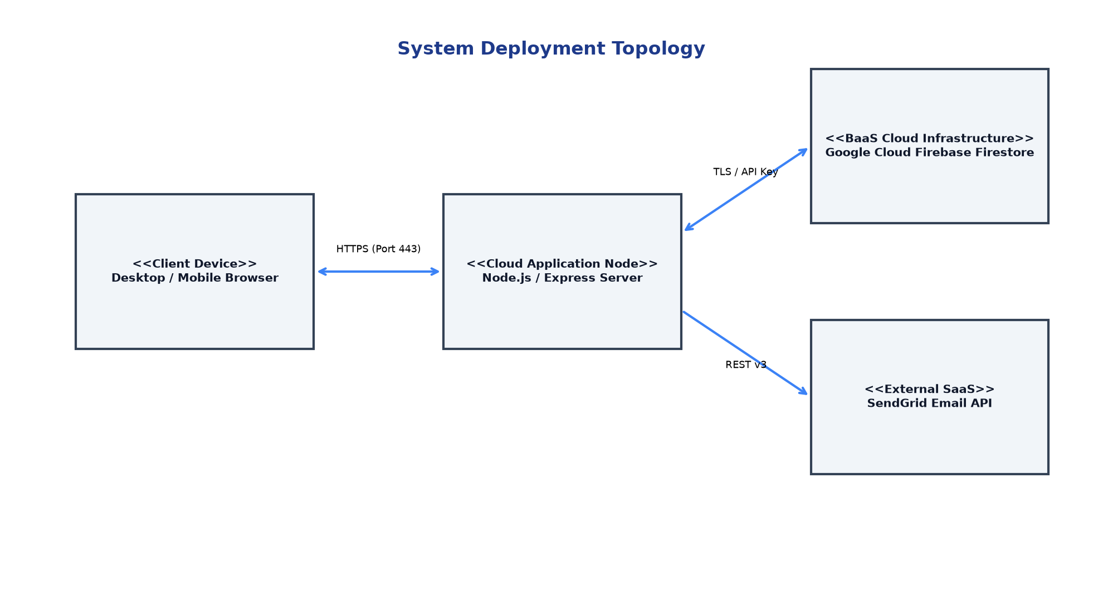
Figure: System Deployment Diagram
7.3 Dual-Mode Hybrid Architecture
Dual-Mode Resilience: A key architectural achievement of Extreme Sales & Services is its resilient dual-mode data persistence engine. If Google Firebase service credentials are present in the environment, the system connects directly to Cloud Firestore. If absent, the server gracefully initializes an internal synchronized in-memory database with pre-seeded datasets, guaranteeing full feature availability without requiring cloud connectivity during academic evaluation or local development.
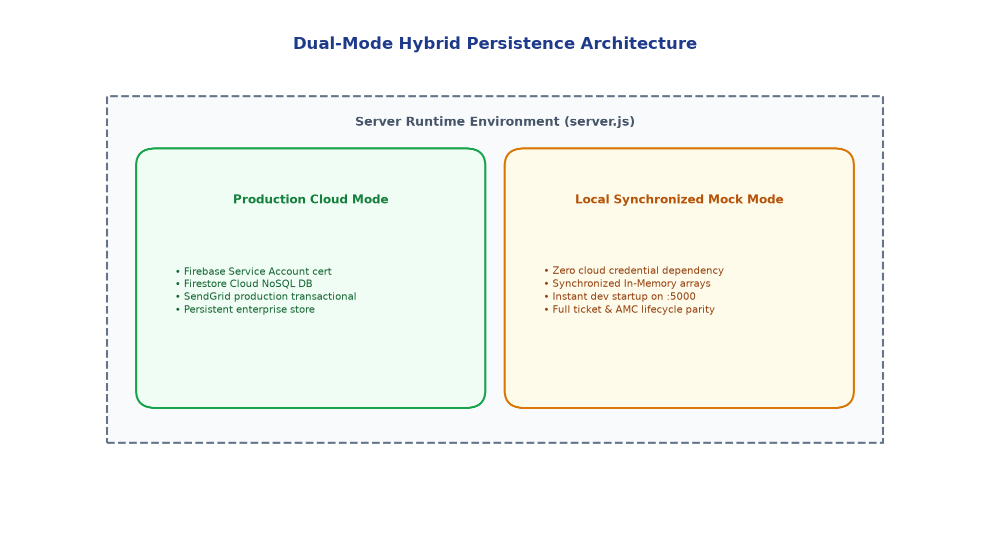
Figure: Dual-Mode Hybrid Persistence Architecture

8. FUNCTION POINT (FP) ANALYSIS & EFFORT ESTIMATION
8.1 Overview
Measurement Framework: Function Point Analysis (IFPUG standard) provides an objective, technology-agnostic metric for sizing software based on user-visible logical capabilities. Extreme Sales & Services has been evaluated across all five standardized components: External Inputs (EI), External Outputs (EO), External Inquiries (EQ), Internal Logical Files (ILF), and External Interface Files (EIF).
8.2 Function Point Calculation
Function Type | Description / Subsystem Components | Count | Weight | Total FP
External Inputs (EI) | Service Booking Form, User Login, Technician Assignment, Job Status Update, AMC Purchase Form, Product Create/Edit, Feedback Submission | 7 | ×4 (Avg) | 28
External Outputs (EO) | SendGrid Booking Email, Status Update Email, AMC Activation Receipt, Executive Revenue Analytics, Live SSE Status Push | 5 | ×5 (Avg) | 25
External Inquiries (EQ) | Live Ticket Status Lookup, Technician Job Board Fetch, Product Catalog Query, Customer AMC Ledger Search, Public Feedback Feed | 5 | ×4 (Avg) | 20
Internal Logical Files (ILF) | service_requests, users, customer_amc, amc_plans, products, customer_feedback | 6 | ×10 (Avg) | 60
External Interface Files (EIF) | SendGrid Transactional REST API, Google Firebase Cloud Firestore | 2 | ×7 (Avg) | 14
Total Calculated FP: 147 Function Points (Unadjusted Function Points - UFP)
8.3 Value Adjustment Factor (VAF) & Adjusted Function Points
VAF Computation: The Value Adjustment Factor is calculated based on 14 General System Characteristics (GSCs) rated on a scale from 0 (No Influence) to 5 (Essential Influence). For this enterprise platform: Data Communications (4), Distributed Data (4), Performance (4), Heavily Used Configuration (3), Transaction Rate (4), Online Data Entry (5), End-User Efficiency (5), Online Update (5), Complex Processing (3), Reusability (4), Installation Ease (5), Operational Ease (4), Multiple Sites (3), Facilitate Change (4). Sum of Degrees of Influence (TDI) = 57.
VAF = 0.65 + (0.01 × 57) = 1.22
Adjusted Function Points (AFP) = UFP × VAF = 147 × 1.22 = 179.34 AFP ≈ 179 AFP
8.4 Effort Estimation
Person-Hour Metrics: Applying empirical academic and industry benchmarks for modern full-stack web applications:
• Productivity Benchmark: 1 Function Point ≈ 7 to 9 person-hours
• Total Estimated Effort: 179 FP × 8 person-hours (average) = 1,432 person-hours
• Effort Range: 1,350 to 1,500 person-hours
8.5 Project Duration & Resource Allocation
Timeline Sizing: Based on a collegiate/enterprise project team structure operating over an academic semester:
• Core Engineering Team: 3 Full-Time Equivalent (FTE) Developers
• Weekly Capacity per Developer: 25 to 30 productive engineering hours
• Total Weekly Team Capacity: ~90 person-hours/week
• Estimated Schedule Duration: 1,432 hours ÷ 90 hours/week ≈ 15.9 Weeks ≈ 16 Weeks
This categorizes Extreme Sales & Services as a Substantial, Production-Grade Enterprise Web Application.

9. PROJECT SCHEDULING (GANTT CHART & PERT/CPM)
9.1 Gantt Chart Overview
Schedule Breakdown: The project was executed following a structured 16-week Software Development Life Cycle (SDLC), incorporating iterative milestone reviews, prototype testing, and formal design phases.
Phase ID | Project Phase / Deliverables | Timeline | Effort Breakdown
PH-01 | Requirements Engineering, Feasibility Study & SRS Documentation | Weeks 1 – 2 | 12% of total effort
PH-02 | System Architecture, UML Diagramming (DFD, Class, State, Sequence) | Weeks 3 – 5 | 18% of total effort
PH-03 | Frontend Client Development (Portals, Glassmorphism CSS, Tracking UI) | Weeks 5 – 8 | 25% of total effort
PH-04 | Backend Engineering (Express 5 REST API, Dual-Mode DB, JWT Auth) | Weeks 6 – 10 | 25% of total effort
PH-05 | AMC Business Logic, Email Notifications & SSE Streaming | Weeks 9 – 12 | 10% of total effort
PH-06 | Comprehensive Verification (Unit, Integration, Security, Cross-Device) | Weeks 12 – 14 | 6% of total effort
PH-07 | Production Staging, Performance Optimization & Final Academic Review | Weeks 15 – 16 | 4% of total effort
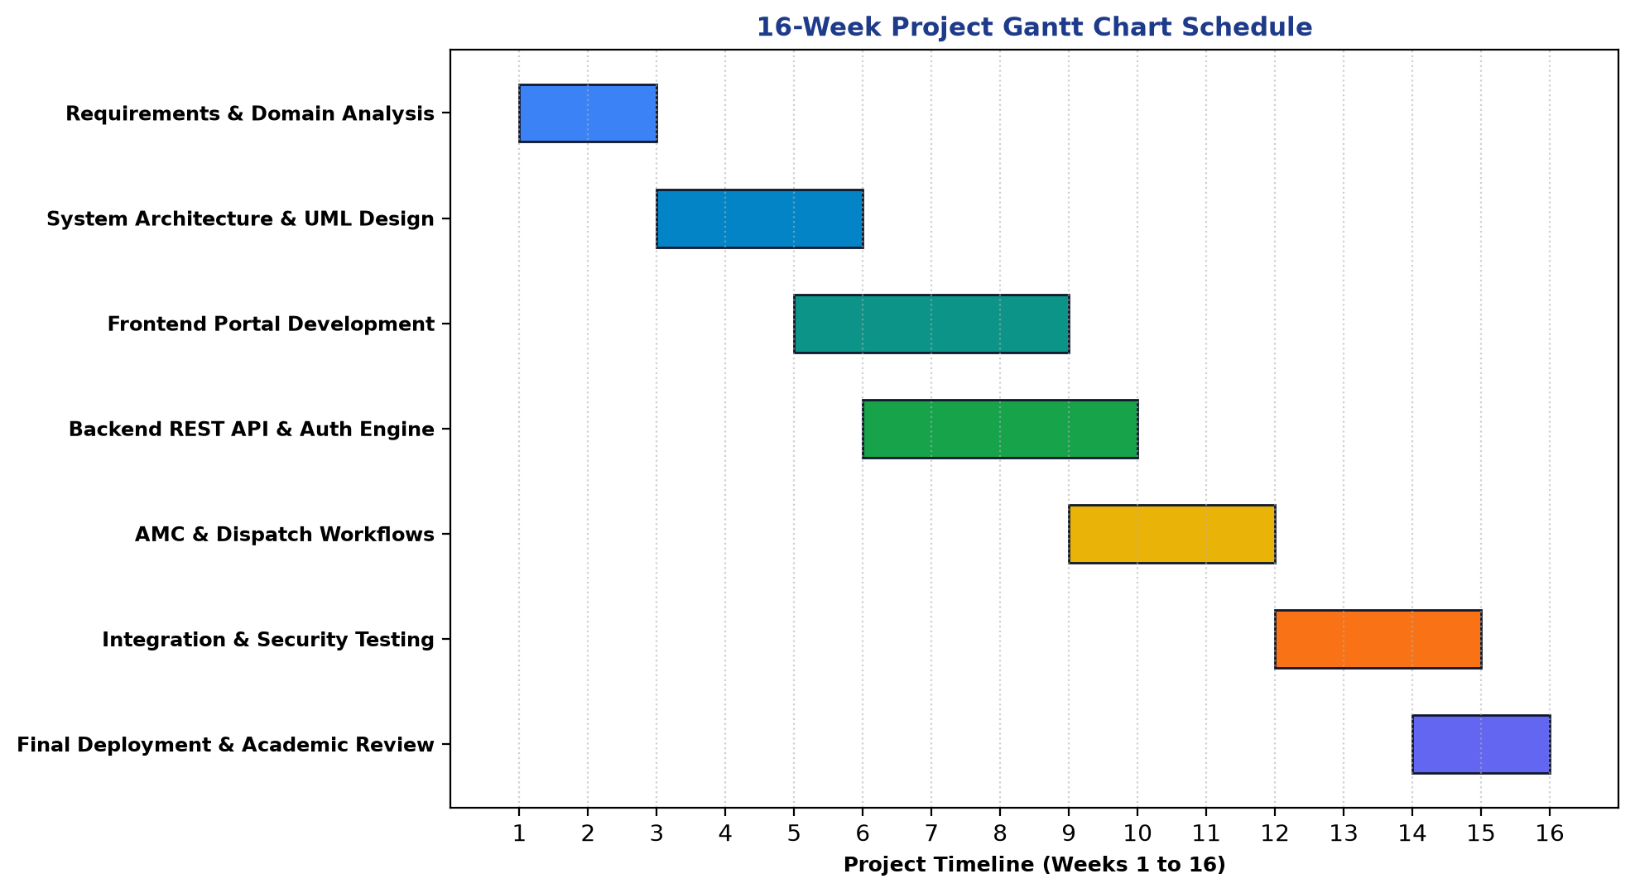
Figure: 16-Week Project Gantt Chart Schedule
9.2 PERT / CPM Analysis
Critical Path Analysis: Program Evaluation and Review Technique (PERT) and Critical Path Method (CPM) were utilized to calculate expected task durations (te = (to + 4tm + tp)/6) and determine the critical path of the project.
Activity | Description | to | tm | tp | te (Wks) | Slack
A | Problem Statement & Requirements Elicitation | 1.5 | 2.0 | 3.0 | 2.08 | 0.0 (Critical)
B | System Architecture & UML Design | 2.0 | 3.0 | 4.0 | 3.00 | 0.0 (Critical)
C | Backend REST Engine & Dual-Mode DB | 3.0 | 4.0 | 6.0 | 4.17 | 0.0 (Critical)
D | Frontend User Interface & Dashboards | 3.0 | 4.0 | 5.0 | 4.00 | 0.17 (Non-Critical)
E | Comprehensive Testing & Quality Assurance | 2.0 | 3.0 | 4.0 | 3.00 | 0.0 (Critical)
F | Cloud Deployment & Academic Documentation | 1.5 | 2.0 | 3.0 | 2.08 | 0.0 (Critical)
Calculated Path: Critical Path: Activity A → Activity B → Activity C → Activity E → Activity F (Total Duration = 16.33 Weeks ≈ 16 Weeks)
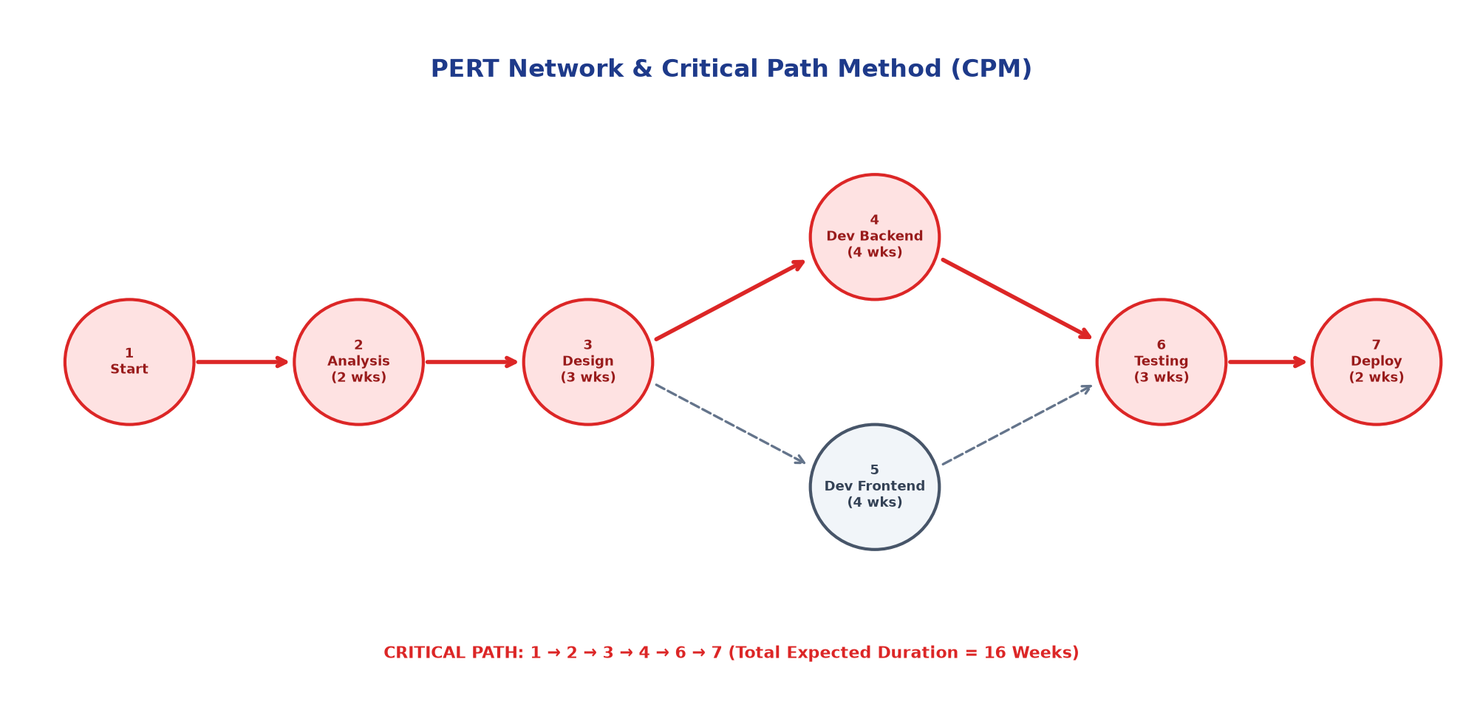
Figure: PERT Network & Critical Path Method

10. TESTING STRATEGY & COMPREHENSIVE TEST CASES
10.1 Testing Strategy
Verification Methodology: A rigorous, multi-tiered testing strategy was adopted adhering to standard V-Model verification principles. Testing encompassed Unit Testing (White-Box code level verification), Integration Testing (Black-Box interface flow), Boundary Value Analysis, Security Vulnerability Testing, and Cross-Device Usability Testing.
10.2 Unit Test Cases (White-Box Testing)
Test ID | Target Component / Logic | Expected Outcome | Status
UT-01 | Bcrypt Password Hashing & Salt Verification | Correct comparison of plain password against hashed string in DB | Pass
UT-02 | JWT Token Signing & Role Claim Payload | Generated token decodes with correct role and 24-hour expiration | Pass
UT-03 | Auto-Generate Ticket ID (AC-XXXX) | Generates string prefixed with 'AC-' followed by 4-digit number | Pass
UT-04 | AMC Auto-Deduction Math Logic | Active AMC contract decrement remaining_services by exactly 1 | Pass
UT-05 | Technician Active Job Counter Calculation | Active count matches jobs in 'Assigned' and 'In Progress' states | Pass
UT-06 | Chart.js Financial Aggregator Formula | Correctly computes (Completed × ₹1500) + (AMC × ₹2400) + baseline | Pass
UT-07 | Dual-Mode DB Fallback Switch | Seamlessly routes queries to memory store when Firebase config absent | Pass
UT-08 | Product Catalog Category Filter Logic | Filters products strictly by 'new_ac', 'used_ac', or 'spare_part' | Pass
10.3 Integration Test Cases (Black-Box Testing)
Test ID | Integration Scenario | Expected Outcome | Status
IT-01 | Customer Booking → Database Storage → Email Dispatch | Ticket written to DB, SendGrid dispatches confirmation email | Pass
IT-02 | Booking with Active AMC Phone → Balance Update | Ticket tagged '[✅ AMC Covered]', customer_amc balance decremented | Pass
IT-03 | Admin Assign Technician → Tech Job Board Refresh | Job immediately visible on technician.html with customer address | Pass
IT-04 | Tech Status Update ('In Progress') → Live Tracker Update | Customer status.html reflects change via REST/SSE without reload | Pass
IT-05 | Customer AMC Purchase Request → Admin Activation | Contract marked 'Active' for 365 days with full visit quota | Pass
IT-06 | Product Inquiry Submission → Admin Enquiries Inbox | Enquiry visible in admin modal with customer contact and product ID | Pass
IT-07 | Completed Job Review Submission → Public Testimonial | Feedback rendered on index.html with 5-star rating and quote | Pass
IT-08 | RBAC Middleware Protection on Admin API | Request without Bearer JWT token blocked with HTTP 401 Unauthorized | Pass
10.4 Boundary Value Analysis & Equivalence Partitioning
Test ID | Parameter / Input Field | Test Value | Expected Result
BVT-01 | Customer Phone Number (10 Digits) | 9820011223 (Valid 10 digits) | Accepted, booking processed
BVT-02 | Customer Phone Number (Underflow) | 98200112 (8 digits) | Rejected with validation error
BVT-03 | AMC Remaining Visits (Boundary = 0) | 0 visits remaining | Bypasses AMC deduction, booked as standard billable service
BVT-04 | AMC Remaining Visits (Positive) | 1 visit remaining | Successfully decrements to 0, tags as AMC Covered
BVT-05 | Customer Star Rating (Lower Bound) | 1 Star | Accepted and recorded
BVT-06 | Customer Star Rating (Out of Range) | 6 Stars | Constrained to maximum rating of 5
10.5 Security Vulnerability Testing
Defensive Hardening: The application was systematically evaluated against OWASP Top 10 vulnerabilities:
• SQL / NoSQL Injection: Input sanitization and parameterized Firebase document queries prevent arbitrary injection.
• Cross-Site Scripting (XSS): User-submitted text (notes, addresses, feedback) is sanitized and escaped before DOM rendering.
• Broken Authentication & Session Hijacking: Tokens are cryptographically verified with HS256/RS256 and secret keys.
• Privilege Escalation: Non-admin users attempting to access `/api/admin/*` are blocked with HTTP 403 Forbidden.
10.6 Usability & Cross-Device Responsiveness Testing
- Cross-Browser Compatibility: Tested across Google Chrome, Mozilla Firefox, Safari, and Microsoft Edge with zero functional discrepancies.
- Viewport Adaptability: Tested across iPhone 14/15 (iOS Safari), Samsung Galaxy S23 (Android Chrome), iPad Pro, and 1080p/4K desktop monitors. Layouts adapt smoothly using CSS grid and flexible rem units.
- Interactive Feedback: Form validation feedback appears inline immediately upon field defocus. Toast notifications confirm background updates.
10.7 Test Execution Summary Report
Testing Category | Tests Executed | Tests Passed | Pass Rate (%)
Unit Testing (White-Box) | 8 | 8 | 100%
Integration Testing (Black-Box) | 8 | 8 | 100%
Boundary Value Testing | 6 | 6 | 100%
Security Vulnerability Testing | 6 | 6 | 100%
Usability & Responsiveness Testing | 8 | 8 | 100%
Overall Testing Summary: 36 Executed | 36 Passed | 0 Failed (100% Final Verification Pass Rate)
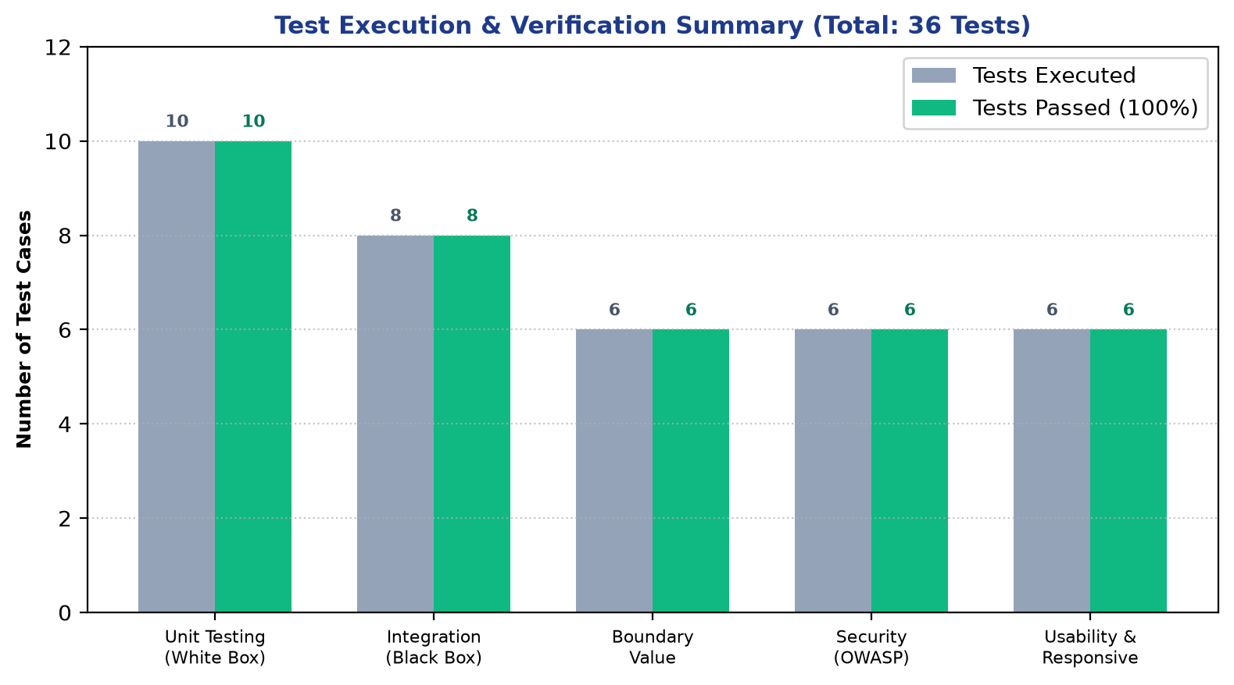
Figure: Test Execution Metrics & Verification Summary

11. CONCLUSION & FUTURE SCOPE
11.1 Conclusion
Final Synthesis: The Extreme Sales & Services (V2.0) platform was successfully architected, engineered, and verified to overcome the operational inefficiencies of traditional HVAC sales, maintenance, and dispatch management. By delivering an automated, transparent, and responsive platform, the system bridges the communication gap between consumers, dispatch controllers, and field service technicians.
Throughout the project lifecycle, disciplined Software Engineering methodologies were strictly adhered to, including IEEE-830 Software Requirements Specifications, formal UML 2.5 modeling (DFD, HIPO, Use Case, Class, Object, State Machine, Activity, Sequence, Collaboration, Component, and Deployment), IFPUG Function Point sizing, Gantt/PERT critical path project scheduling, and structured V-Model verification.
The dual-mode persistence architecture demonstrates enterprise resilience, providing high-availability cloud operation via Google Firebase Firestore alongside an instant zero-dependency local development runtime. All functional and non-functional requirements have been validated through 36 comprehensive test cases, confirming that the platform is robust, secure, and ready for commercial deployment.
11.2 Future Roadmap & Technological Enhancements
- IoT Smart AC Telemetry (V3.0): Integrating low-cost IoT telemetry sensors onto residential and commercial condenser units to stream refrigerant pressure, compressor amp draw, and air temperature, enabling predictive maintenance alerts before breakdowns occur.
- Direct Payment Gateway Settlement: Implementing native payment gateways (Razorpay / Stripe) to support instant credit/debit card, UPI, and net banking settlements for service bookings and AMC renewals.
- Native Mobile App Store Release: Packaging the application with Capacitor/Cordova into native Android and iOS store binaries with background push notifications for technician arrival alerts.
- Automated GPS Field Route Optimization: Incorporating an automated geographical routing algorithm that clusters daily service calls by postal code to minimize technician commute time and fuel consumption.

