“SMART SHOES FOR VISUALLY AND HEARING-IMPAIRED INDIVIDUALS”

A smart shoe for visually impaired and hearing-impaired individuals which will detect the still or moving object by using the ultrasonic sensors and alert the user by making sound using a buzzer or creating vibration patterns on foot by using the vibration motor.
¹Asst. Prof. S.S. Bawankule, ²Ayush Kuttarmare,³Aman Shahare, ⁴Mohammad Faijan Mohammad Shafi Sheikh, ⁴Rainali Ramteke, ⁵Aditi Dewalkar

¹Project Guide, ²Project Member, ³Project Member, ⁴Project Member, ⁵Project Member, ⁶Project Member,
¹Department of Computer Science & Engineering,
¹Priyadarshini J.L College of Engineering, Nagpur, Maharashtra, India
______________________________________________________________________________________________

Abstract: This research paper presents the design, development, and evaluation of a novel smart shoe system aimed at enhancing accessibility and safety for visually and hearing-impaired individuals. The smart shoe system integrates advanced sensor technologies, including ultrasonic sensors and a vibration sensor, along with an Arduino microcontroller and buzzer alert system. The sensors detect obstacles and hazards in the wearer's path, while the buzzer provides auditory alerts for obstacle avoidance and navigation guidance. Additionally, a vibration sensor offers tactile feedback for hearing impaired users, ensuring inclusivity in alert mechanisms. Results indicate that the smart shoe system effectively enhances mobility and independence for users, providing timely alerts and navigation assistance in various environments. Feedback from user trials demonstrates high levels of satisfaction and confidence in navigating unfamiliar surroundings. Furthermore, the system's adaptability and customization options cater to individual user preferences and needs.

Index Terms - Smart Shoes, Internet of Things, Hardware, Arduino UNO, Ultrasonic Sensor HC- SR04,
Vibration Motor, Object Detection, Embedded-C.

Introduction

The eyes are identified as the soul's window, which is the meaning of the eyes. The eye is a critical part of the human body that helps a person to learn about it. Blindness hampers a person's ability to do their survivor's everyday tasks and earn salaries. According to a recent World Health survey, The Organization (WHO) of India is home to approximately 30 percent of the world's total blind. India's population of visually disabled individuals has now crossed 12 million, which will rise in the coming days. From the numbers, it is clear how big the blindness problem in India.
In an era marked by remarkable technological advancements, the quest for inclusivity remains a driving force, particularly in the domain of assistive technology. Among the forefront of these innovations lies the development of Smart Shoes tailored to address the unique needs of visually and hearing-impaired individuals. This research paper delves into the conception, design, and implementation of such a revolutionary Smart Shoe System, aimed at enhancing the mobility and safety of users through the seamless integration of ultrasonic sensors, a buzzer, and a vibration motor.
Navigating the world poses significant challenges for individuals with visual and hearing impairments, as they often encounter obstacles and hazards that impede their mobility and independence. The Smart Shoe System presented in this paper serves as a beacon of innovation, harnessing the power of sensor technology to detect objects in the wearer's path. Through the use of ultrasonic sensors strategically embedded within the shoe, the system provides real-time feedback on the proximity of obstacles, enabling users to navigate with increased awareness and confidence.
Central to the functionality of the Smart Shoe System are the auditory and tactile feedback mechanisms integrated into the design. Upon detecting an obstacle, a buzzer emits a distinct sound, alerting the wearer to the presence of the obstruction. Simultaneously, a vibration motor embedded within the shoe initiates vibrations, providing tactile feedback to further enhance the user's awareness of their surroundings. This multi-sensory approach ensures that individuals with both visual and hearing impairments can navigate their environment with heightened safety and autonomy.
This paper offers a comprehensive exploration of the Smart Shoe System, delving into its design principles, technological components, and usability considerations. Through rigorous testing and evaluation, the effectiveness and user acceptance of the system are assessed, highlighting its potential to revolutionize the lives of visually and hearing-impaired individuals.

Literature review

2.1) International Journal of Creative Research and Thoughts @2021|Volume 9 “Smart Shoes for Blind Using Internet of Things: A Review” by Pradeepa R, Dr. R. Porkodi*2 “Department of Computer Science”, Bharathihar University, Coimbatore [ February 2021]
This paper introduces a thought regarding managing the issues looked by blind people through smart shoes. Due to the blind people face many challenges especially when moving in public places. 285 million people are estimated to be visually impaired worldwide out of which 39 million people are blind and 246 have low vision. Smart shoes will help a blind person to mover on independently with help of ultrasonic sensor to detect obstacles. In this paper presents various smart shoes for blind technology using Internet of Things.

2.2) Technology “Development of Smart Shoes for Visually Impaired using Arduino Uno and Ultrasonic Sensors” by Wannarat Khamduang*1, Sarun Intakosum*2, and Boonchieng*3 “Department Telecommunication”, Hilinski University [ March 2018]
This survey paper provides an overview of assistive shoe technologies developed to aid navigation and mobility for visually impaired individuals. The authors review existing research on sensor based navigation systems integrated into shoes, discussing their design principles, sensor configurations, and navigation algorithms. They examine the effectiveness of different sensor modalities, such as ultrasonic sensors, infrared sensors, and pressure sensors, in detecting obstacles and guiding users along predefined paths. Furthermore, the survey discusses challenges related to sensor accuracy, power consumption, and user acceptance, offering insights into potential solutions and future research directions in the field of assistive shoe technology for the visually impaired.
This survey paper provides an overview of assistive shoe technologies developed to aid navigation and mobility for visually impaired individuals. The authors review existing research on sensor-based navigation systems integrated into shoes, discussing their design principles, sensor configurations, and navigation algorithms. They examine the effectiveness of different sensor modalities, such as ultrasonic sensors, infrared sensors, and pressure sensors, in detecting obstacles and guiding users along predefined paths. Furthermore, the survey discusses challenges related to sensor accuracy, power consumption, and user acceptance, offering insights into potential solutions and future research directions in the field of assistive shoe technology for the visually impaired.

2.3) Open International Conference on Innovations in Electrical Engineering and Computational Technologies @2017|Volume 7| “Design and Implementation of Intelligent Navigation Shoes for Visually Impaired Individuals” by M.Z, Uddin*1, Sadia Zafar*2, Mahammad Asif*3, Taher M. Ghazal*4 “College of Computing and Information Science”, KIET, Karachi [March 2017]
This comprehensive review paper offers a detailed examination of smart shoe technologies developed to assist visually impaired individuals in navigation and mobility tasks. The authors analyze the design principles, sensor configurations, and navigation algorithms employed in existing smart shoe systems. They discuss the advantages and limitations of different sensor modalities, such as ultrasonic sensors, infrared sensors, and pressure sensors, in detecting obstacles and guiding users. Furthermore, the review explores user-centered design considerations, including comfort, durability, and aesthetics, in the development of effective and user-friendly smart shoe solutions for the visually impaired. Additionally, the review explores emerging trends, such as the integration of machine learning algorithms and haptic feedback mechanisms, in enhancing the 4 functionality and usability of smart shoes for the visually impaired.

2.4) IEEE International Conference on Signal and Image Processing @2016|Volume 4| “A Wearable Obstacle Detection Device for the Visually Impaired” by S. S. M. Ghazali*1, S. A. M. Alias*2, and N. H. S. Mohd
Noor*3, “Department of Computer Science and Engineering, University of Cambridge” [April 2016]
This review paper provides an overview of smart shoe technologies developed for assisting visually impaired individuals in navigation and mobility. The authors survey existing research on sensor-based navigation systems integrated into shoes, examining their sensing modalities, data processing techniques, and user interface designs. They discuss the challenges associated with sensor calibration, environmental variability, and user acceptance, highlighting the importance of robustness and reliability in smart shoe systems.

- OBJECTIVES

3.1) Develop Sensor Integration: The primary objective is to integrate advanced sensors into the design of smart shoes to facilitate real-time object detection. These sensors, including ultrasonic and infrared sensors, will provide accurate distance measurements, enabling users to navigate their surroundings with increased awareness. By leveraging state-of-the-art technology, the system aims to detect obstacles, curbs, and other potential hazards to enhance safety and mobility for visually impaired individuals.

3.2) Implement Arduino Technology: Another key objective is to incorporate Arduino technology into the smart shoe design. Arduino microcontrollers will serve as the central processing units, orchestrating data collection from the integrated sensors and executing algorithms for object detection. This allows for customizable and adaptable functionality, enabling the system to evolve with user feedback and technological advancements. Moreover, Arduino's open-source platform fosters innovation and collaboration, facilitating future enhancements and widespread adoption of the smart shoe technology.

3.3) Integrate Buzzer Alert System: The project also aims to integrate a buzzer alert system into the smart shoes, providing auditory feedback to users in response to detected obstacles. The buzzer will emit distinct sounds or patterns to indicate the proximity and nature of obstacles, enabling users to react promptly and navigate safely. This auditory feedback mechanism enhances the accessibility of the system, catering to individuals with visual impairments who may rely on sound cues for navigation.

3.4) Incorporate Vibration Sensor for Deaf Individuals: Additionally, the project seeks to incorporate a vibration sensor into the smart shoe design to cater to the needs of deaf individuals. The vibration sensor will translate alerts into tactile feedback, providing users with a discreet yet effective means of obstacle detection. By harnessing vibrations, this feature ensures inclusivity and accessibility for individuals with diverse sensory needs, empowering them to navigate their environment confidently and independently.

- METHODOLOGY

4.1) Methodology for Objective 1: The methodology for developing sensor integration within the context of smart shoes for enhancing safety and mobility for visually impaired individuals involves a systematic approach encompassing several key stages. Firstly, comprehensive research is conducted to identify suitable sensor technologies, such as ultrasonic and infrared sensors, known for their accuracy and applicability in real-time object detection. Following sensor selection, a meticulous design phase ensues where the integration of these sensors into the smart shoe architecture is carefully planned, considering factors like sensor placement, power consumption, and communication protocols. Next, the hardware and software components are developed and integrated, with firmware/software tailored to interface with the sensors and process the collected data effectively.

4.2) Methodology for Objective 2: The methodology for implementing Arduino technology within the context of developing sensor integration for smart shoes targeting enhanced safety and mobility for visually impaired individuals involves a structured process designed to maximize efficiency and effectiveness. Subsequently, hardware components are assembled, including the Arduino boards, sensors, and necessary peripherals, following appropriate wiring diagrams and connections. Concurrently, software development takes place, with code being written to interface with the sensors, process the collected data, and provide actionable feedback to the user in real-time. Throughout this process, extensive testing is conducted to ensure the functionality and reliability of the Arduino-based sensor integration system, both in controlled environments and real-world scenarios. User feedback is also solicited and incorporated to refine the system's design and user interface, ensuring optimal usability and effectiveness for visually impaired individuals. This iterative approach ensures the successful implementation of Arduino technology for developing sensor integration within smart shoes, ultimately leading to enhanced safety and mobility for the target user group.

4.3) Methodology for Objective 3: The methodology for integrating a buzzer alert system into smart shoes, aimed at enhancing safety and mobility for visually impaired individuals, follows a structured approach to ensure effectiveness and reliability. Initially, comprehensive research is conducted to understand the functionalities and capabilities of buzzer modules compatible with the smart shoe architecture. This research includes evaluating factors such as sound intensity, power requirements, and compatibility with the existing hardware and software components. Following the selection of suitable buzzer modules, a detailed design phase ensues, where the integration of these modules into the smart shoe system is carefully planned. This involves determining the optimal placement of the buzzer units within the shoe design to ensure effective sound projection and user awareness.

4.4) Methodology for Objective 4: The methodology for incorporating a vibration sensor into smart shoes, tailored to cater to the needs of deaf individuals and aimed at enhancing safety and mobility, follows a systematic and structured approach. Initially, comprehensive research is conducted to identify suitable vibration sensors known for their sensitivity, reliability, and compatibility with the smart shoe architecture. This research encompasses understanding various types of vibration sensors, their specifications, and their integration capabilities with microcontrollers such as Arduino. Following sensor selection, a detailed design phase ensues, wherein the integration of the vibration sensor into the smart shoe system is carefully planned Ultimately, this iterative approach ensures the successful incorporation of a vibration sensor into smart shoes, providing deaf individuals with enhanced safety and mobility through real-time tactile alerts to potential obstacles or hazards in their surroundings.

- MAJOR HARDWARE REQUIREMENTS

5.1) Arduino UNO: The heart of the Arduino Uno is the ATmega328P microcontroller, which runs at 16 MHz’s It has 32 KB of Flash memory for storing code (of which 0.5 KB is used by the bootloader), 2 KB of SRAM, and 1 KB of EEPROM.

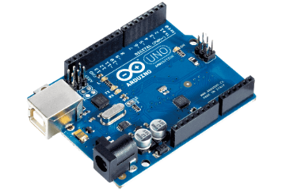

fig.5.1 Arduino uno

5.2) Ultrasonic Sensors: The HC-SR04 sensor works on the principle of ultrasonic waves. It emits an ultrasonic pulse and measures the time it takes for the pulse to bounce back after hitting an object. This time measurement is used to calculate the distance between the sensor and the object.
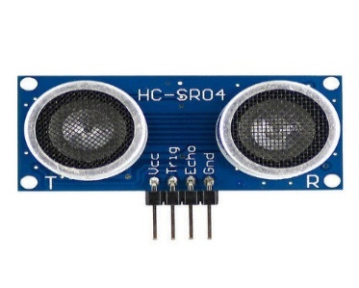

fig-5.2 Ultrasonic sensor

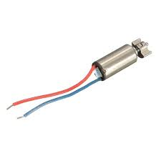
5.3) Vibration Motor: A vibration motor is a compact, electrically-powered device that generates vibrations when powered. These motors are commonly used in various electronic devices, including smartphones, game controllers, wearables, and other gadgets, to provide haptic feedback to users. Haptic feedback enhances user experience by providing tactile sensations in response to interactions with the device such as alerts, or touch commands.

fig-5.3 Vibration motor

5.4) Buzzer: Arduino buzzer serves as a crucial component for providing auditory alerts and notifications. When the sensors embedded within the smart shoes detect an obstacle in the user's path, the Arduino microcontroller processes this information. If an obstacle is detected within a certain range, the Arduino activates the buzzer to emit an alert sound, notifying the wearer of the obstacle's presence.
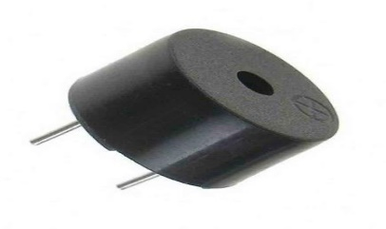
Fig-5.4 Buzzer

- MAJOR SOFTWARE REQUIREMENTS

6.1) Arduino IDE: The Arduino Integrated Development Environment - or Arduino Software (IDE) - contains a text editor for writing code, a message area, a text console, a toolbar with code for common functions and a series of menus. It connects to the Arduino hardware to upload programs and communicate with them.[

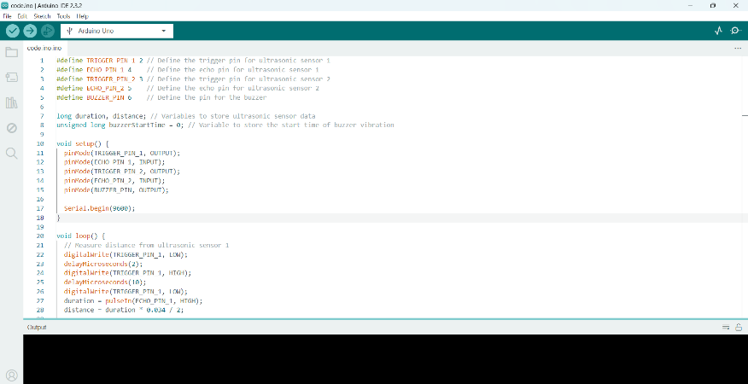

fig-6.1 Arduino IDE

- Wirings and Connections
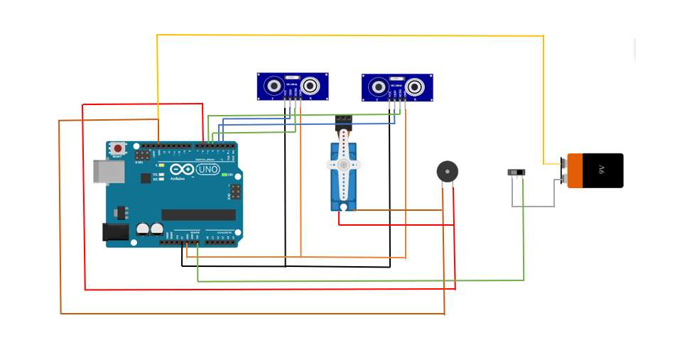
Fig-6.1 Wiring and connections

Connections

Ultrasonic Sensor-
VCC: Connect VCC pin of both sensors to Arduinos VCC pin.
GND: Connect GND pin of both Sensors to Arduinos GND pin.
Triger: Connect one sensor’s trigger pin to Arduino’s digital pin 2, and the other sensor’s trigger pin to Arduinos Digital pin 3.
Echo: Connect one sensors Echo pin to Arduino’s digital pin 4, and another sensor’s Echo pin to digital pin 5.
Buzzer-
VCC: Connect positive terminal of buzzer to Arduino’s digital pin 6.
GND: Connect negative terminal of buzzer to Arduino’s GND pin.
Vibration Motor-
VCC: Connect one terminal of vibration motor to Arduino’s digital pin 7.
GND: Connect the other terminal of vibration motor to Arduino’s GND pin.
Power Supply:
Battery: Connect the positive terminal of battery to one terminal of switch.
Arduino: Connect the other terminal of battery to Arduino’s VIN pin.
GND: Connect the negative terminal of battery directly to Arduino’s GND pin.

FLOWCHART

Start

Initialize the Arduino Board and connect the required
sensors and modules

Set up the ultrasonic sensor to detect the distance between the user and the object in the environment.

Use an algorithm to detect objects by using a sensor.

If an object is detected, determine its distance
From the user using ultrasonic sensor.

If the object is within a certain range,
Notify the user by beeping an audio sound using buzzer and give sensing feedback by using the vibration motor which are attached to the shoe.

If no object is detected or the object is outside the user’s range, continue detecting the environment with sensor.

Stop

- WORKING PRINCIPLES

Implementation: After connecting all of the parts in accordance with the circuit diagram and programming the Arduino boards. We're prepared to us the smart shoe.
The smart shoe is capable of detecting object in two angles:
1) 180 degrees (Horizontally)
2) 45 degrees (Facing Upwards)

Setting up Vibration motor module:
You can directly use the Vibration Motor module after purchasing from market, because there is no need to change any setting of Vibration Motor module. The expected rate of movement of vibration motor is 25ms/rotation. You just need to connect both the terminals to Arduino UNO by jumper wires and install a code for working. This Vibration motor works collaboratively with the buzzer as, whenever the object is detected by the ultrasonic sensors, the buzzer starts alerting by sound and vibration motor start vibrating.
When a Visually impaired person starts moving forward, he can now also track the objects coming in the range of ultrasonic sensors, and if the object is present upward at some angle up to 45 degrees, they can also be detected easily.

- CONCLUSION AND FUTURE SCOPE

9.1) Future Scope: The future of smart shoes holds significant potential for further innovation and advancement. Some potential areas for future development include:

9.1.1) Enhanced Performance Tracking: Continued advancements in sensor technology and data analytics can lead to more accurate performance tracking, including metrics such as balance, stride length, and foot pressure distribution. This could benefit athletes, physical therapy patients, and individuals seeking to optimize their exercise routines.

9.1.2) Health Monitoring and Diagnosis: Smart shoes equipped with advanced biometric sensors could monitor vital signs such as heart rate, blood pressure, and oxygen saturation levels. Integration with AI-powered algorithms could enable early detection of health conditions such as cardiovascular diseases or respiratory disorders, providing users with valuable insights into their overall well-being.

9.1.3) Adaptive Comfort and Support: Future smart shoes could feature dynamic adjustments in cushioning, arch support, and shoe structure based on real-time feedback from sensors. This adaptive functionality could enhance comfort and reduce the risk of foot-related injuries by providing personalized support tailored to each user's unique biomechanics and activity levels.

9.2) Conclusion: Smart shoes have emerged as a promising innovation in the footwear industry, integrating technology to enhance functionality, comfort, and user experience. The integration of sensors, connectivity features, and data analysis capabilities in footwear has opened up new avenues for various applications ranging from fitness tracking to healthcare monitoring and beyond.

The benefits offered by smart shoes include real-time activity tracking, gait analysis, injury prevention, and personalized coaching. These features cater to the evolving needs of consumers who are increasingly prioritizing health and fitness in their lifestyles. Moreover, smart shoes have the potential to address specific requirements such as diabetic foot care and elderly fall detection, thereby contributing to improved healthcare outcomes.

- REFERENCES

- 2022 IEEE Delhi Section Conference (DELCON) “Internet of Things- Enabled Smart Shoes for Blind People” by Pratik Bhongade*1, Sanyukta Girhay*2, Abdul Moeid Sheikh*3, Rahul Ghata*4, Sakshi Ambadkar*5, Chitra Dunase*6 from IIIT Delhi (February 2022).

- International Journal for Research in Applied Science and Engineering Technology (IJRASET) “Smart Shoes for Blind People” by Anita Dombale*1 Published in November 2023.

- Tech Science Press, DOI: 10.32604/cmc.2023.036266 “Smart Shoes Safety for Blind People based on (IOT) Technology, by AmmarAlmomani1,2,*, Mohammad Alauthman*3,Amal Malkawi*4, Hadeel Shwaihet*5, Batool Aldigide*6, Donia Aldabeek*7 and Karmen Abu Hamoodeh*8 from 1*Research and Innovation Department, Skyline University College, P. O. Box 1797, Sharjah, UAE, 3Department of Information Security, Faculty of Information Technology, University of Petra, Amman, Jordan, Received: 23 September 2022; Accepted: 20 March 2023; Published: 09 June 2023.

- 2019 IEEE 4th International Conference on Computer and Communication Systems “Smart Assistive Navigation Devices for Visually impaired people” by Arjun Pardasani Aditya kamal*1, Prithviraj N Indi*2, Sashwata Banerjee*3, Vaibhav Garg*4 from Vellore Institute of Technology (December 2019)

- “New Trend in Computational Vision and Bio-Inspired Computing” a book by Springer Publications, Chapter- Smart Assistive Shoes for Blind, PP 619-625 by N. Shohan*1, S. Urs Ruthuja*2, H.S. Sai Rishabh*3 and R. Sashidhar*4.

