JOINS in SQL :

Types of Joins in SQL -

- Inner Join or ‘Join’ - Needs two tables to perform ‘Join’ operation , tries to match only those records which are present in both the tables.

- Left Join – Needs two tables , first it will perform a ‘Join’ and then will look out for values in the left table who failed the join condition . After finding respective ones , they will be added into the result.

LEFT JOIN = INNER JOIN + Unmatched records in LEFT TABLE.

- Right Join - Needs two tables , first it will perform a ‘Join’ and then will look out for values in the right table who failed the join condition . After finding respective ones , they will be added into the result.

RIGHT JOIN = INNER JOIN + Unmatched records in RIGHT TABLE.

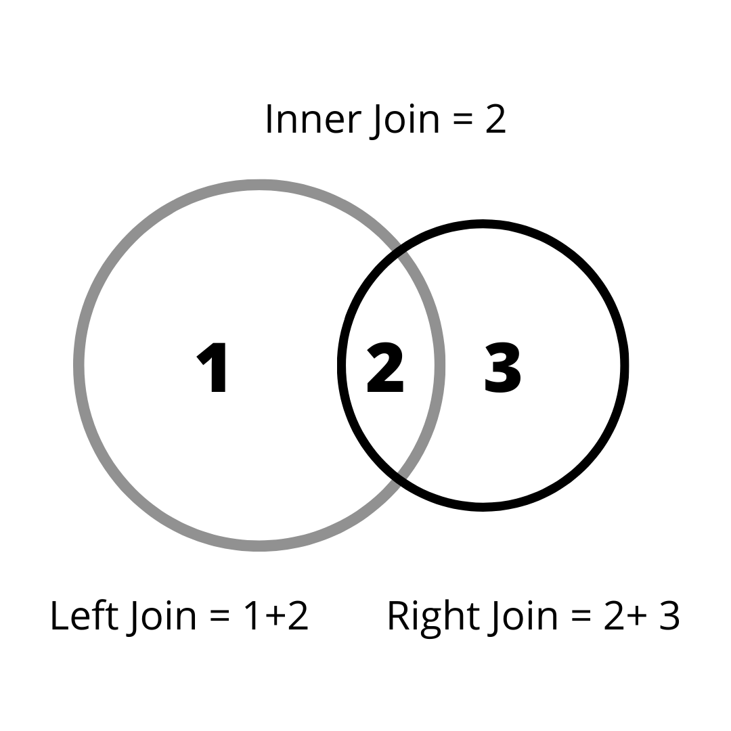

-- Create Database -

CREATE DATABASE office;
USE office;

-- Create Tables -

CREATE TABLE employees (id VARCHAR (4) NOT NULL PRIMARY KEY , name VARCHAR(30) , salary INT , dept_id VARCHAR(4) , manager_id VARCHAR (4)) ;

CREATE TABLE departments (id VARCHAR(4) NOT NULL PRIMARY KEY , name VARCHAR(20));

CREATE TABLE managers (id VARCHAR(4) NOT NULL PRIMARY KEY , name VARCHAR(30) , dept_id VARCHAR(4), FOREIGN KEY (dept_id) REFERENCES departments(id));

CREATE TABLE projects (id VARCHAR (4) , name VARCHAR(30) , member_id VARCHAR(4) , FOREIGN KEY (member_id) REFERENCES employees(id));

-- Insert into Tables -

INSERT INTO departments VALUES ('D1', 'IT'), ('D2', 'HR'), ('D3', 'Finance'), ('D4', 'Admin');

INSERT INTO managers VALUES ('M1', 'Prem', 'D3'), ('M2', 'Andrew', 'D4'), ('M3', 'Nick', 'D1'), ('M4', 'Anderson', 'D1');

INSERT INTO employees VALUES ('E1', 'Shubham', 15000, 'D1', 'M1'), ('E2', 'Jaiki', 18000, 'D2', 'M1'), ('E3', 'Akhand', 20000, 'D1', 'M2'), ('E4', 'Rahul', 55000, 'D2', 'M2'),('E5', 'Aayush', 22000, 'D10', 'M3'), ('E6', 'Shubham', 18000, 'D10', 'M3');

INSERT INTO Projects VALUES ('P1', 'Data Migration', 'E1'),('P1', 'Data Migration', 'E2'),('P1', 'Data Migration', 'M3'),('P2', 'ETL Tool', 'E1'),('P2', 'ETL Tool', 'M4');

-- Fetch Employee name and department they belong too -

SELECT e.name , d.name
FROM employees e
INNER JOIN departments d ON e.dept_id = d.id
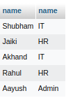

-- Fetch Manager and their respective department

SELECT m.name AS Manager, d.name AS Department
FROM managers m
JOIN departments d on m.dept_id = d.id

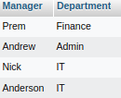

-- Fetch all managers along with their respective emplpoyees -

SELECT m.name , e.name
FROM managers m
LEFT JOIN employees e ON m.id = e.manager_id
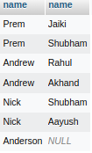

- Fetch all the departments with their managers

SELECT d.name , m.name
FROM departments d
LEFT JOIN managers m ON d.id = m.dept_id

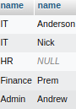

-- Fetch all the departments with their managers

SELECT d.name , m.name
FROM managers m
RIGHT JOIN departments d ON m.dept_id = d.id
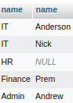

-- Fetch employee name , his/her manager and department

SELECT e.name AS Employee , d.name AS Department , m.name AS Manager
FROM employees e
LEFT JOIN departments d ON e.dept_id = d.id
JOIN managers m ON e.manager_id = m.id

