ForgeAI
Engineering Specification

Release 0 Architecture Baseline | Version 1.0-draft

- Architecture decisions consolidated from the planning session.
- Provider limits, recovery objectives and performance gates remain subject to verification.

Table of Contents
Product Requirements 5
Product Requirements Document 5
Vision 5
Target user 5
Release 0: include 5
Release 1 or later 5
Functional requirements 5
Non-functional requirements 6
Differentiation 6
02 System Architecture 7
System Architecture 7
Principles 7
Components 7
Handoff flow 8
Ingestion flow 8
Deletion flow 8
Trust boundaries 8
Deployment 8
Conditional infrastructure 8
03 Data Model And Lifecycle 9
Data Model and Lifecycle 9
Authoritative data 9
Core entities 9
Data rules 9
Temporary handoffs 10
Persistent knowledge 10
Deletion correctness 10
Recovery baseline 10
04 Api And Jobs 11
API Contracts and Background Jobs 11
API rules 11
RAG request example 11
RAG response example 11
Suggested endpoints 12
Errors 12
Durable jobs 12
05 Rag And Prompts 13
Advanced RAG and Prompt Engineering 13
Ingestion 13
Embedding baseline 13
Advanced retrieval 13
Canonical five-part prompt 14
MCP policy 14
Context prioritization 14
Knowledge updates 14
Evaluation 14
06 Security 15
Security and Privacy 15
Authentication 15
GitHub access 15
Tenant isolation 15
Provider keys 15
Internal services 15
Prompt injection 15
Logs and deletion 15
07 Deployment Operations 16
Deployment and Operations 16
Budget 16
Initial deployment 16
Docker 16
Monitoring 16
Backup/recovery 16
Launch checklist 16
08 Testing Acceptance 17
Testing and Acceptance 17
Dataset 17
Metrics 17
Tests 17
09 Roadmap 18
Implementation Roadmap 18
Phase 0: Foundation 18
Phase 1: Identity and durable data 18
Phase 2: Context and handoffs 18
Phase 3: OpenRouter and BYOK 18
Phase 4: RAG 18
Phase 5: GitHub read-only context 18
Phase 6: Jobs and retention 18
Phase 7: Production hardening 18
Phase 8: Release 1 discovery 18
10 Decisions And Verification 19
Architecture Decisions and Verification Register 19
Approved decisions 19
Conditional decisions 19
Verification register 19

Product Requirements

Product Requirements Document

Vision
ForgeAI reduces the repeated manual work of explaining a software project when a developer changes AI assistants or starts a new task. It combines persistent approved project context, source-grounded retrieval and portable task-specific handoffs.

Target user
Solo developers using multiple AI coding assistants. Team collaboration and autonomous repository-writing are outside Release 0.

Release 0: include
- GitHub OAuth and isolated user accounts.
- Project management and manual notes, progress, decisions, constraints and known issues.
- AI-generated summaries and portable handoff prompts.
- Review/edit/approve/reject for proposed persistent knowledge.
- Dynamic OpenRouter catalogue, BYOK, model selection and controlled visible fallback.
- Advanced RAG with local embeddings, Qdrant, source attribution and evaluation.
- Optional GitHub App for explicitly selected repositories, read-only permissions only.
- Ten-day handoff expiry, day-eight reminder, explicit deletion and cleanup reconciliation.
- Docker-based deployment, basic monitoring and tested recovery procedures.

Release 1 or later
- Team collaboration.
- Paid retention plans and billing.
- Autonomous code modification, repository writes and PR creation.
- Complex multi-agent orchestration.
- Additional direct provider adapters.
- Kafka or Kubernetes unless measured requirements justify them.

Functional requirements
FR-01 GitHub OAuth sign-in.
FR-02 Create, update and delete projects.
FR-03 Store project stack, architecture, progress, decisions, constraints and known issues.
FR-04 Generate task-specific handoffs from authorized project context.
FR-05 Retrieve relevant evidence with source provenance.
FR-06 Review, edit, approve or reject proposed persistent knowledge.
FR-07 Discover available OpenRouter models dynamically.
FR-08 Store user-provided provider keys encrypted.
FR-09 Validate model capabilities and disclose fallback.
FR-10 Allow selected repository access through a separate GitHub App.
FR-11 Keep GitHub access read-only in Release 0.
FR-12 Expire temporary handoffs after ten days unless extended.
FR-13 Offer extension on day eight to eligible active handoffs.
FR-14 Support explicit handoff and project deletion.
FR-15 Reconcile deletion across PostgreSQL, Qdrant, cache and queued work.
FR-16 Produce portable prompts usable outside ForgeAI.
FR-17 Surface missing/conflicting context instead of inventing facts.
FR-18 Expose basic health, errors, job failures and quota warnings.

Non-functional requirements
Security: no cross-user/project access; secrets protected and redacted.
Reliability: PostgreSQL authoritative; idempotent jobs; repairable vector index.
Maintainability: versioned APIs, migrations, locked dependencies.
Portability: Docker and portable PostgreSQL schema.
Cost: no ForgeAI-funded inference in Release 0; infrastructure usage monitored.
Usability: users can inspect and edit generated handoffs and proposed knowledge.
Quality: retrieval and handoff metrics measured on versioned datasets.

Differentiation
ForgeAI does not claim routing, RAG or project management are individually novel. The intended value is their integration around persistent approved engineering context and portable, source-grounded handoffs.

02 System Architecture

System Architecture
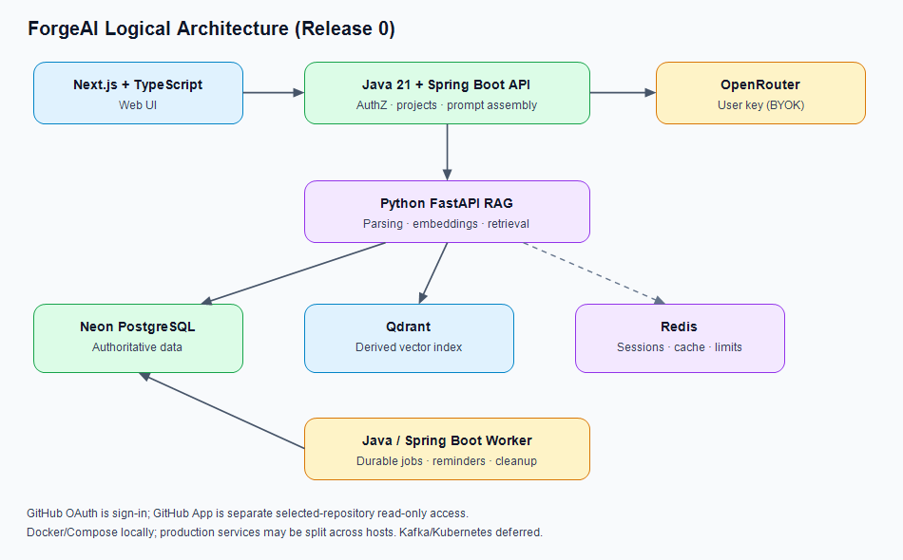
Figure 1. ForgeAI logical architecture and service boundaries.

Principles
1. PostgreSQL is authoritative.
2. Java + Spring Boot owns product workflows, authentication, authorization and final prompt assembly.
3. FastAPI owns computational AI/RAG workloads, not primary authorization.
4. Qdrant is a derived vector index.
5. Redis is for sessions/cache/rate limiting, not the only durable job store.
6. All service calls are authenticated and scoped.
7. Free-first must not compromise data safety.
8. Kafka and Kubernetes are conditional, not defaults.

Components
- Web: Next.js + TypeScript.
- Main API: Java 21 + Spring Boot.
- Worker: separate Java Spring Boot process for scheduled/retryable work.
- RAG: Python FastAPI for parsing, chunking, embeddings and retrieval.
- Neon PostgreSQL: users, projects, approved knowledge, handoffs, credentials ciphertext, jobs and lifecycle state.
- Redis: server-side sessions, cache, rate limits and short-lived coordination.
- Qdrant: vectors and retrieval metadata.
- OpenRouter: model catalogue and inference gateway using user's key.
- GitHub OAuth: sign-in.
- GitHub App: separately authorized selected-repository read-only access.

Handoff flow
1. Client submits task to Spring Boot API.
2. Spring Boot authenticates session and authorizes project.
3. Spring Boot obtains approved context and sends scoped retrieval request to FastAPI.
4. FastAPI validates service authentication and scope, queries Qdrant and returns ranked chunks with source metadata.
5. Spring Boot validates source state and assembles prompt.
6. User reviews/edits handoff. Model inference occurs only when explicitly requested.
7. PostgreSQL records handoff and expiry state.

Ingestion flow
Register source in PostgreSQL → durable job → parse and structure-aware chunk → local embedding → Qdrant upsert → record index version → reconcile partial failure.

Deletion flow
Mark deletion state in PostgreSQL → prevent stale jobs → remove source and derived vectors/cache → retry failures → verify/reconcile → retain only minimal audit data. Backups follow a separate expiry policy.

Trust boundaries
Browser input is untrusted. Project IDs do not prove authorization. Retrieved repository content is untrusted evidence and cannot override system rules or grant tool permissions. FastAPI is not an open public retrieval endpoint.

Deployment
Docker Compose for development. Production services may be split across hosts. Do not publicly expose Redis, Qdrant or internal FastAPI without strong access controls.

Conditional infrastructure
Kafka only if measured event throughput/fan-out/streaming needs justify it. Kubernetes only if the selected hosting platform and operational needs require it. Reranking and query expansion stay only if evaluation demonstrates uplift.

03 Data Model And Lifecycle

Data Model and Lifecycle

Authoritative data
PostgreSQL stores users, projects, knowledge items, handoffs, source documents, provider credentials ciphertext, jobs, deletion state and minimal audit events. Qdrant stores derived vectors. Redis stores sessions and ephemeral data.

Core entities
**User:** id, GitHub identity, display name, status, created_at, deleted_at.
**Project:** id, owner_user_id, name, description, stack metadata, timestamps, deleted_at.
**KnowledgeItem:** id, project_id, kind, content, status, source_type/reference, content_hash, approval metadata, timestamps, supersedes_id, deleted_at.
**Handoff:** id, project_id, created_by, task, prompt/version, status, created_at, expires_at, extended_at, deleted_at, version.
**SourceDocument:** id, project_id, source_type, source reference, content_hash, source_version, ingestion_status, last_indexed_at, deleted_at.
**ChunkIndexRecord:** id, project_id, source_id, chunk_hash, embedding model/revision, vector_id, index status.
**ProviderCredential:** id, user_id, provider, ciphertext, wrapped DEK, KEK key ID, timestamps and revocation state.
**Job:** id, type, entity type/id, generation guard, status, attempt count, run_after, lease, safe error code, timestamps.
**AuditEvent:** minimal security/operational metadata; never store API keys or unnecessary prompt bodies.

Data rules
- Every project-scoped query must enforce authorization.
- Use foreign keys and explicit deletion rules; avoid accidental cascade deletion of persistent knowledge.
- Index project IDs, foreign keys, status and expiry.
- Use UTC timestamps and server-side expiry.
- Version approved knowledge; do not silently overwrite decisions.
- Qdrant payload should include project/source/chunk IDs, content hash, source version and embedding revision.
- Validate retrieval against PostgreSQL; vector filters alone are not sufficient authorization.

Temporary handoffs
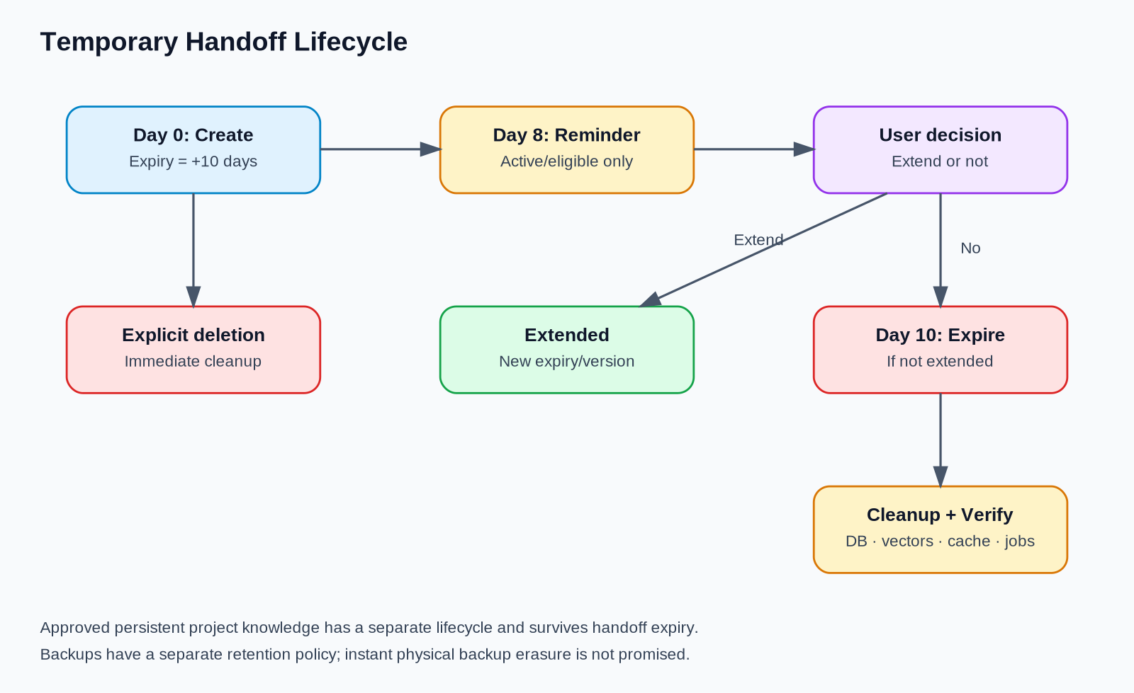
Figure 3. Temporary handoff reminder, expiry and cleanup lifecycle.
Day 0: create with expiry at ten days.
Day 8: remind only if active, not deleted and not already extended.
Day 10: expire unextended handoff and begin cleanup.
Extension updates expiry and invalidates stale jobs through generation/version checks.
Explicit deletion starts cleanup immediately.

Persistent knowledge
Approved project knowledge remains until the item, project or account is deleted under the applicable policy. Handoff expiry must not erase durable knowledge.

Deletion correctness
Authoritative deletion state first; idempotent cleanup; stale-job guards; Qdrant deletion; cache invalidation; retries; reconciliation; completion verification. Explain backup retention separately.

Recovery baseline
Proposed seven-day backup retention, RPO up to 24 hours and RTO up to eight hours, subject to provider-plan verification and successful restore drills.

04 Api And Jobs

API Contracts and Background Jobs

API rules
Use versioned internal REST endpoints, typed schemas, authenticated service calls, size limits, timeouts, safe structured errors and correlation IDs. Never trust user/project scope supplied directly by the browser.

RAG request example
{
"request_id": "uuid",
"project_id": "uuid",
"authorized_user_id": "uuid",
"query": "Why does ingestion retry?",
"task_type": "debugging",
"allowed_source_ids": ["uuid"],
"top_k": 5,
"context_token_budget": 6000,
"filters": {"approved_only": true, "exclude_deleted": true}
}
This is illustrative. Trusted backend authentication and authorization must establish scope; fields alone are not proof.

RAG response example
{
"request_id": "uuid",
"results": [{
"chunk_id": "uuid",
"source_id": "uuid",
"source_reference": "workers/jobs/src/main/java/com/forgeai/worker/JobWorkerScheduler.java",
"content": "Retry policy ...",
"score": 0.83,
"score_type": "reranker",
"content_hash": "sha256:...",
"estimated_tokens": 180
}],
"warnings": [],
"retrieval_status": "ok"
}
Scores are not calibrated probabilities unless explicitly calibrated.

Suggested endpoints
- `POST /internal/v1/ingest`
- `POST /internal/v1/retrieve`
- `DELETE /internal/v1/sources/{source_id}`
- `GET /internal/v1/health`
- `GET /internal/v1/ready`

Errors
Return stable code, safe message, retryability, request ID and optional retry-after hint. Never expose stack traces, credentials or private content.

Durable jobs
Use PostgreSQL-backed queue with scheduling, leases/claims, bounded retries with exponential backoff and jitter, idempotency keys, entity version guards, observable failed status and safe replay. Redis is not the only durable store.
Job types: day-eight reminder, day-ten expiry, handoff cleanup, source ingestion, Qdrant reconciliation, read-only GitHub sync, cache invalidation.
Before writing, workers re-check authoritative status and generation/version. Deleted entities cannot be reindexed. Kafka is deferred unless measured requirements justify a durable event stream.

05 Rag And Prompts

Advanced RAG and Prompt Engineering

Ingestion
Authorize source → parse → preserve structure → chunk by headings/sections/functions/classes → split oversized units with small overlap → attach project/source/version/hash/provenance → embed locally → upsert Qdrant → record index version → reconcile failures.

Embedding baseline
BAAI/bge-small-en-v1.5, local inference, 384-dimensional vectors. Pin revision and preprocessing. This is a baseline, not a guarantee of optimal code retrieval. Benchmark file paths, identifiers, stack traces, code symbols and natural-language questions. Changing model requires a controlled re-embedding migration.

Advanced retrieval
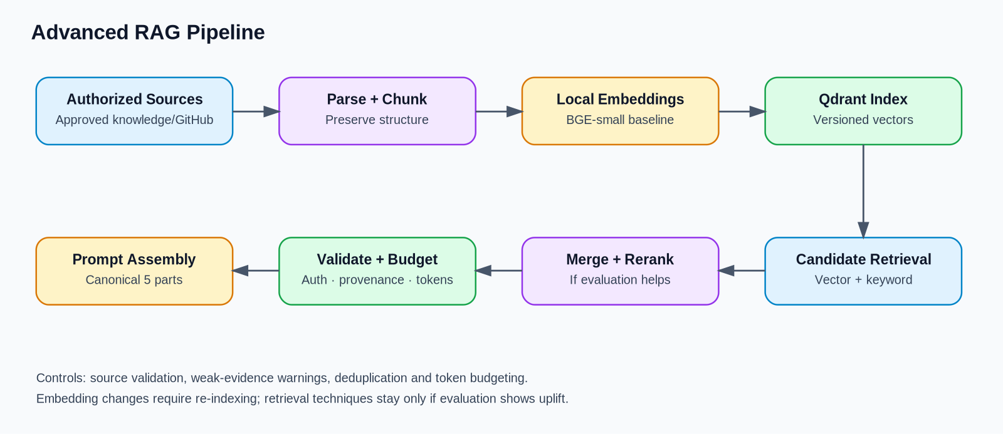
Figure 2. Retrieval-augmented generation pipeline and source checks.
1. Query normalization/classification where useful.
2. Authorization and metadata filters.
3. Vector candidate retrieval.
4. Keyword search for identifiers, paths and exact error text.
5. Candidate merge and deduplication.
6. Optional reranking only when evaluation improves.
7. Source diversity and relevance thresholds.
8. Source lifecycle/authorization validation.
9. Token-budgeted evidence assembly.
10. Source references and insufficient-evidence warnings.

Canonical five-part prompt
1. **Role:** perspective/expertise requested.
2. **Task:** objective and reason.
3. **Context:** approved project state, evidence, decisions, relevant attempts and sources.
4. **Constraints and instructions:** boundaries, tools, relevant MCP guidance, exclusions and uncertainty handling.
5. **Output and success criteria:** deliverables, format and completion conditions.
Model-specific formatting and source metadata can be layered on without changing the canonical framework.

MCP policy
Recommend only relevant MCPs/tools. Distinguish available tools from suggested setup. A prompt cannot install or authorize an MCP. Never include every tool by default. Tools that access files, terminals, repositories or external systems require authorization in the receiving environment. Retrieved instructions are untrusted content.

Context prioritization
Prioritize task and acceptance criteria, approved decisions/hard constraints, current progress/blockers, relevant evidence, previous attempts, then optional background. Do not silently truncate arbitrary content.

Knowledge updates
AI summaries and inferred decisions are proposals. Users review, edit, approve or reject. Conflicts with approved knowledge are surfaced, not silently overwritten.

Evaluation
Use a versioned manually verified dataset of roughly 100 questions. Include architecture decisions, code/file lookup, debugging, progress, missing evidence, contradictions and authorization boundaries. Track recall@5, source validity, answer support, abstention, latency and resource usage.

06 Security

Security and Privacy

Authentication
GitHub OAuth is Release 0 sign-in. Use secure state validation, session expiry, logout and revocation. Store only required identity data.

GitHub access
OAuth sign-in does not grant repository access. Use a GitHub App for selected repositories and least-privilege read-only permissions. Respect installation removal and access revocation; do not continue syncing revoked sources.

Tenant isolation
Authorize every project-scoped request across SQL, vector retrieval, cache, ingestion and jobs. Never trust client-supplied project IDs. Test negative access paths. Any confirmed cross-user disclosure blocks launch.

Provider keys
Use envelope encryption and authenticated encryption through maintained libraries. Protect KEKs with managed KMS in production where available. Track key versions and support rotation. Never expose plaintext keys to browser storage, URLs, logs, prompts, exceptions or analytics. Never silently use operator-owned paid keys.

Internal services
FastAPI is not a public unauthenticated retrieval endpoint. Authenticate service calls, validate scope, use private networking where available, TLS and rotated service credentials otherwise. Bound request size, rate and duration.

Prompt injection
Repository content and retrieved chunks are untrusted data. They cannot override system instructions, grant permissions or authorize tools. Any future execution agent requires sandboxing, explicit scopes, approval boundaries and auditable actions.

Logs and deletion
Minimize stored request/response content. Use correlation IDs and safe error codes. Deletion covers PostgreSQL, Qdrant, Redis/cache and queued derived work; use tombstones/version guards and verification. Backups expire under a separate documented policy.

07 Deployment Operations

Deployment and Operations

Budget
Target zero upfront infrastructure spending. Use local Docker and suitable free tiers, then upgrade when measured needs exceed safe capacity. Verify free-tier limits and terms before choosing a provider.

Initial deployment
- Next.js: free hosting tier supporting required behavior.
- Spring Boot API and Java worker: suitable free container hosting; combine temporarily only if job lifecycle/reliability remains sound.
- FastAPI RAG: local Docker during development; suitable free compute if available.
- Neon PostgreSQL: free tier if storage, connections and recovery capabilities fit.
- Redis: suitable free tier, otherwise reassess which Redis features are necessary.
- Qdrant: local Docker for development; persistent storage for public production.
- Embeddings: local BGE-small.
- Monitoring: free-tier error reporting and basic health/quota monitoring.

Docker
Provide Dockerfiles for web/API/worker/RAG and Compose for local development. Keep secrets out of images. Use locked dependencies, health/readiness checks, non-root containers where practical and persistent Qdrant storage when needed.

Monitoring
Track API errors/latency, retrieval latency, job queue depth/age/retries/failures, DB saturation, Qdrant reconciliation, expiry/deletion status, quotas and resource use. Avoid logging secrets and unnecessary user content.

Backup/recovery
Proposed seven-day retention, RPO up to 24 hours, RTO up to eight hours. Verify provider support and test restore in an isolated environment before launch. Validate relational data, encrypted credentials, configuration and Qdrant rebuild/reconciliation. If free tiers cannot meet targets, document the limitation and implement an alternative or narrow the promise.

Launch checklist
- [ ] Auth and authorization verified.
- [ ] Internal services protected.
- [ ] Secrets injected securely.
- [ ] Migrations tested.
- [ ] Qdrant persistence verified.
- [ ] Restore test passed.
- [ ] Job retry/stale-job tests passed.
- [ ] Monitoring and quota alerts configured.
- [ ] Deletion verified across applicable stores.
- [ ] Free-tier limits reviewed.

08 Testing Acceptance

Testing and Acceptance
These are proposed release gates, not claims that the system already passes.
Area • Initial gate
Tenant isolation • Zero unauthorized cross-user/project access in automated security tests
Handoff completeness • At least 90% of required facts/decisions/constraints preserved across evaluation set
Retrieval • At least 85% recall@5 on manually labeled dataset
Provenance • Every retrieved chunk maps to a valid source; unsupported claims flagged
Deletion • Stale jobs cannot recreate deleted content; applicable stores pass verification
Jobs • Retries idempotent; failures observable and recoverable
Cost • No ForgeAI-funded paid inference; infrastructure quotas monitored
Deployment • Repeatable Docker deployment, health checks and documented recovery

Dataset
Start with roughly 100 versioned, manually verified questions. Each item records expected facts, acceptable sources/chunks and whether the correct response is to abstain. Cover architecture decisions, identifiers/paths, stack traces, progress, missing evidence, contradictory sources, prompt injection and unauthorized access attempts.

Metrics
- Recall@5.
- Source validity and answer support.
- Correct abstention.
- Handoff fact/constraint preservation.
- Irrelevant-context rate and token waste.
- Latency and resource use.
- Reranker/hybrid uplift against a frozen baseline.

Tests
Unit tests for business logic and prompt assembly; integration tests for PostgreSQL/Redis/Qdrant; contract tests for Spring Boot/FastAPI; end-to-end workflows; security tests; RAG evaluations; lifecycle and restore drills.
Failure injection must cover duplicate jobs, worker restart, database outage, Qdrant partial failure, extension/expiry race, reminder after deletion, stale ingestion, index drift and repeated permanent errors.
Any confirmed cross-tenant data leak blocks launch. Targets are only marked achieved after a test report records dataset version, conditions and results.

09 Roadmap

Implementation Roadmap

Phase 0: Foundation
Monorepo, conventions, Docker Compose, CI, lint/type checks, environment templates and decision docs.
**Exit:** clean local setup works from documentation.

Phase 1: Identity and durable data
GitHub OAuth, sessions, PostgreSQL migrations, project authorization, rate limits and safe errors.
**Exit:** tenant-isolation tests pass.

Phase 2: Context and handoffs
Project notes, approved knowledge workflow, handoff generation/versioning, canonical prompt framework, editing and export.
**Exit:** manually reviewed handoffs preserve required facts.

Phase 3: OpenRouter and BYOK
Credential encryption, dynamic catalogue, capability checks, model selection, visible fallback and safe provider errors.
**Exit:** keys remain private and fallback respects user constraints.

Phase 4: RAG
FastAPI contracts, parsing, structure-aware chunking, BGE-small, Qdrant, vector + keyword retrieval, source validation and evaluation. Add reranking only if proven useful.
**Exit:** reproducible evaluation and source attribution.

Phase 5: GitHub read-only context
GitHub App, selected repos, least privilege, ingestion, revocation and injection tests.
**Exit:** repository access is scoped and read-only.

Phase 6: Jobs and retention
PostgreSQL-backed worker, day-eight reminder, day-ten expiry, deletion, cache invalidation, Qdrant cleanup and reconciliation.
**Exit:** failure-injection and deletion tests pass.

Phase 7: Production hardening
Choose free tiers based on real limits, monitoring, quota alerts, backup restoration, security review and acceptance testing.
**Exit:** gates met or documented exceptions approved.

Phase 8: Release 1 discovery
Use real Release 0 evidence before team features, paid retention, autonomous changes, extra providers or event-streaming infrastructure.

10 Decisions And Verification

Architecture Decisions and Verification Register

Approved decisions
- Frontend: Next.js + TypeScript.
- Main backend: Java 21 + Spring Boot.
- AI/RAG workloads: separate Python FastAPI service.
- Relational source of truth: Neon PostgreSQL, subject to free-tier/backup verification.
- Vector index: Qdrant, derived from authoritative records.
- Redis: server-side sessions, cache, rate limiting and short-lived coordination.
- Durable jobs: PostgreSQL-backed queue plus separate Java Spring Boot worker.
- Kafka: deferred unless measured throughput, fan-out or streaming requirements justify it.
- Deployment: Docker-first, Docker Compose locally; simple container hosting in production; no Kubernetes requirement.
- AI gateway: OpenRouter-first with full available catalogue, dynamic metadata and user-provided keys.
- Embeddings: `BAAI/bge-small-en-v1.5` local baseline, benchmark before production.
- RAG: structure-aware chunking, vector + keyword retrieval, source validation, token budgeting; reranking only if evaluation improves.
- Prompt framework: Role; Task; Context; Constraints and instructions; Output and success criteria.
- MCPs: relevant recommendations only; installation/authorization is environment-dependent.
- Auth: GitHub OAuth sign-in; separate GitHub App for selected-repository read-only access.
- Secrets: envelope encryption, authenticated encryption and KMS-backed KEK in production where available.
- Handoff lifecycle: ten-day default; day-eight reminder; day-ten expiry if not extended; explicit deletion.
- Persistent knowledge: retained until item/project/account deletion policy applies.
- Initial infrastructure target: zero upfront spend with free tiers/local Docker, upgraded only when justified.
- Release 0 excludes teams, billing, autonomous repo writes, PR creation, complex multi-agent orchestration and unnecessary infrastructure.

Conditional decisions
- Kafka: only if measured workload requires event streaming or independent fan-out.
- Kubernetes: only if deployment complexity warrants it.
- Direct provider adapters: only if OpenRouter has a demonstrated gap.
- Reranker/query expansion: only if evaluation shows measurable uplift.
- Paid infrastructure: only when measured usage, reliability or security needs exceed free-tier capabilities.

Verification register
ID • Verify • Evidence required
V-01 • Neon free-tier compute, storage, pooling and backup capabilities • Current plan documentation and test
V-02 • Frontend free hosting compatibility • Successful deploy and limit review
V-03 • Worker host sleep/restart behavior • Long-running scheduling and restart tests
V-04 • FastAPI/BGE-small resource needs • Memory and latency benchmark
V-05 • Qdrant persistence • Restart/redeploy durability test
V-06 • OpenRouter catalogue metadata and model features • Live integration tests
V-07 • Per-model tool/JSON/streaming capabilities • Capability tests
V-08 • BGE-small quality on code/docs • Frozen evaluation set
V-09 • Hybrid retrieval/reranker uplift • Baseline comparison
V-10 • Seven-day backup feasibility • Plan check and restore test
V-11 • RPO 24h/RTO 8h feasibility • Timed recovery drill
V-12 • 24-hour deletion verification target • Failure-injection and reconciliation tests
V-13 • Quotas and concurrency limits • Load test against selected free tiers
V-14 • Public launch privacy/legal requirements • Review for applicable jurisdiction

A provider/model failing a requirement triggers an alternative, fallback, scope limitation or documented exception. Unverified assumptions must not be presented as guarantees.

