**Experiment 2.1**

**Student Name: Shivam Keshri UID: 20BCS9337**

**Branch: C.S.E. Section/Group: 906B**

**Semester: 5th Date of Performance: 15th September’2022**

**Subject Name: ML Lab Subject Code: 20CSP-317**

**1. Aim/Overview of the practical:**

Classifying data using Logistic Regression in Python

**2. Steps for experiment/practical/Code:**

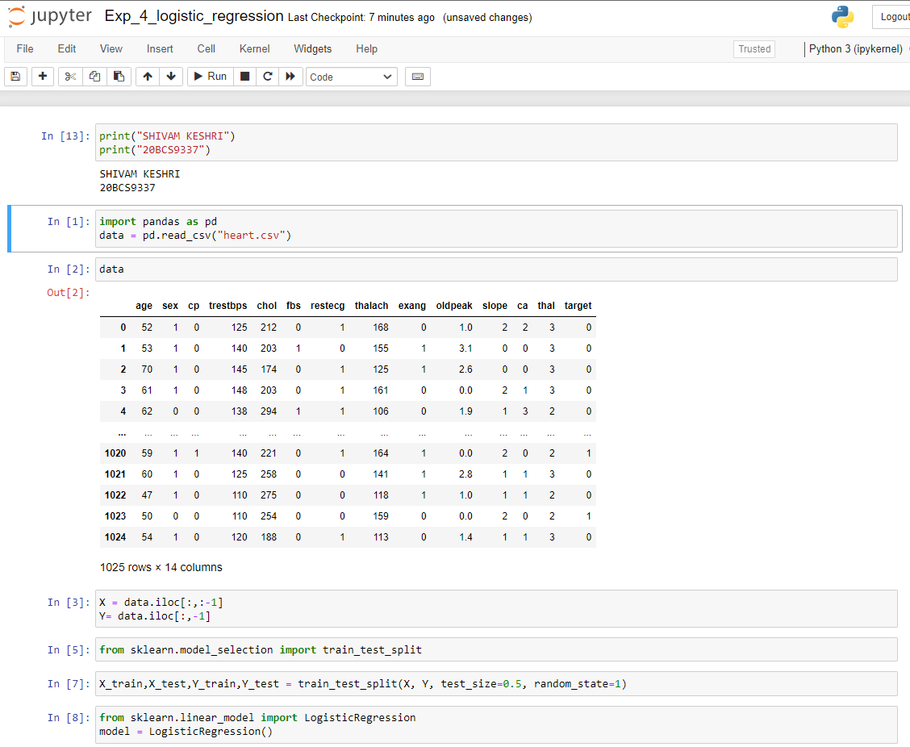

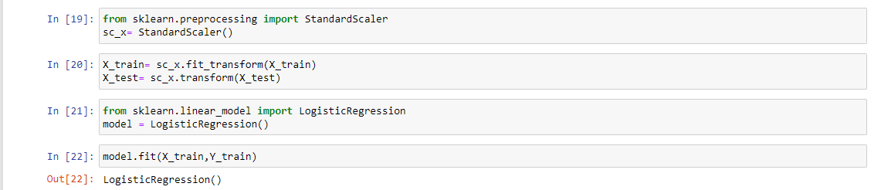

**3. Output:**

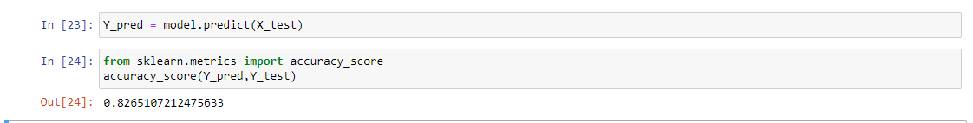

**4. Learning Outcomes**

Learnt to train and test dataset

Learnt logistic regression

Learnt accuracy score from predicted and test values