DEPARTMENT OF

COMPUTER SCIENCE & ENGINEERING



**Experiment 2.2**

**Student Name: Shivam Keshri UID: 20BCS9337**

**Branch: C.S.E Section/Group: 20BCS_WM 906B**

**Semester: 3rd Date of Performance: 29th Sept 2022**

**Subject Name: Machine Learning Subject Code: 20CSP-317**

1. **Aim:** Implement Naïve Bayes on any dataset.

1. **Objective:**

Gaussian Naïve Bayes is used when we assume all the continuous variables associated with each feature to be distributed according to Gaussian Distribution. Gaussian Distribution is also called Normal distribution.

1. **Result and Output:**

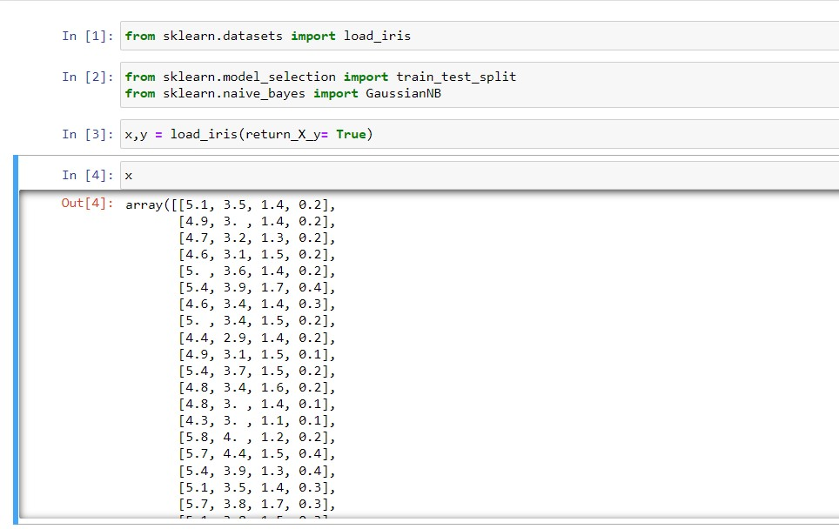



DEPARTMENT OF

COMPUTER SCIENCE

&

ENGINEERING

