ENSF-381: Full Stack Web Development Laboratory
Lab04

GitHub Link: https://github.com/Aayush-Karthikeyan/ENSF381-Lab4

Group Information:
Name 1: Aayush Karthikeyan (UCID# 30189743)
Name 2: Sarvesh Vettrivelan (UCID# 30242015)

Exercise 1:
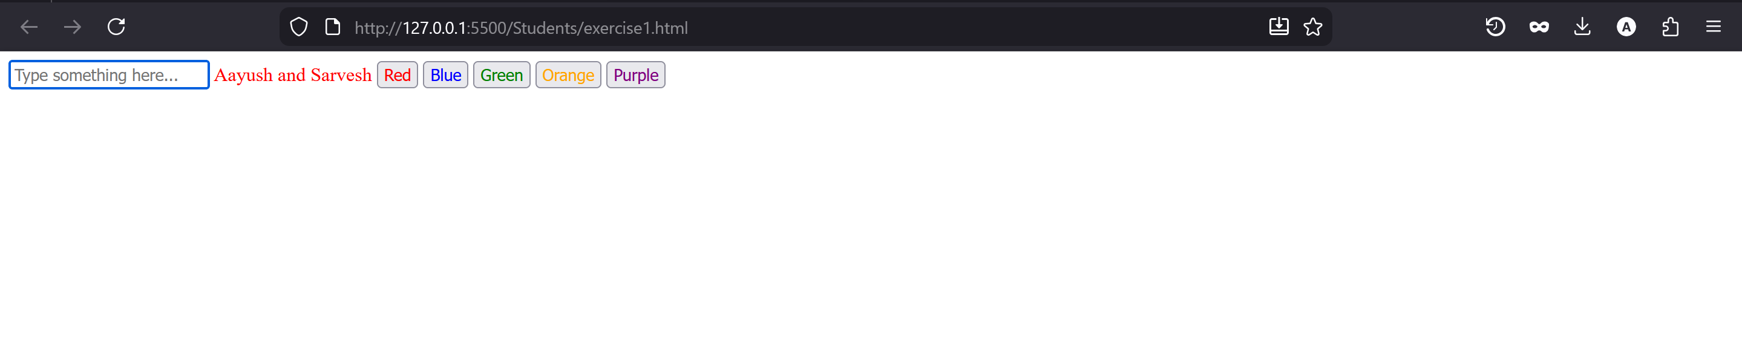

Exercise 2:

Screenshot from Step 9:
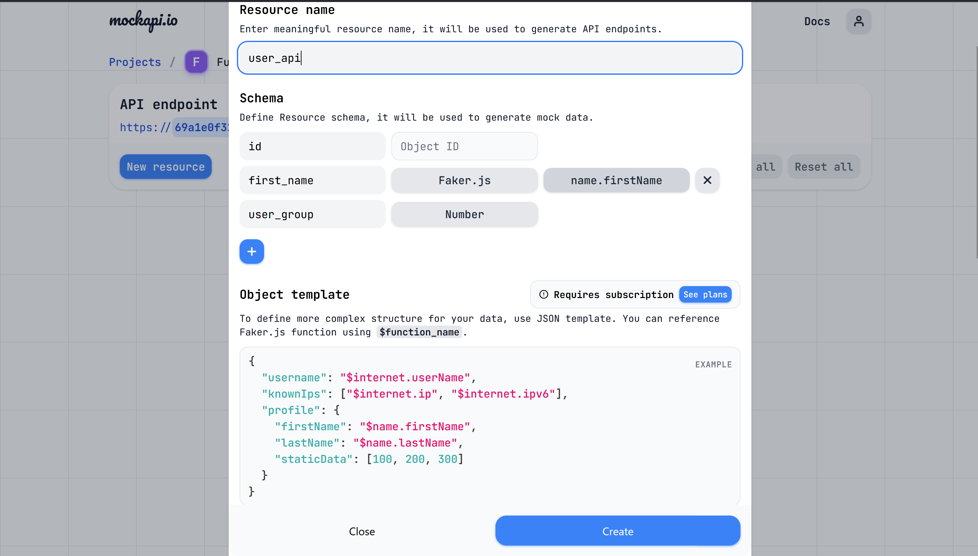

Screenshot from Step 12:
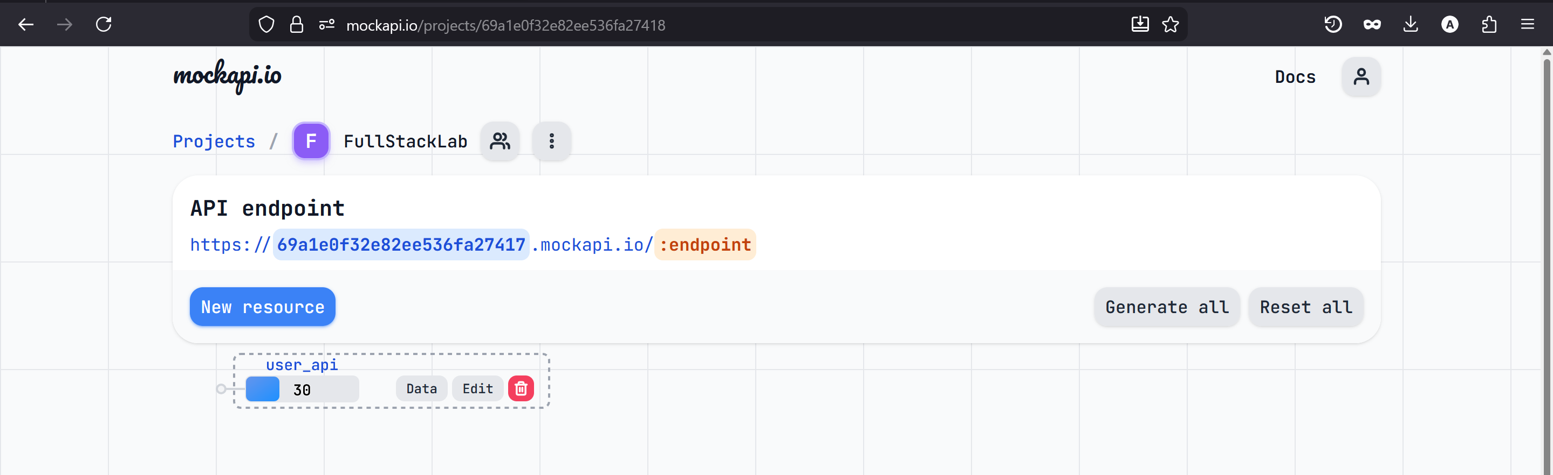

Screenshot from Step 14:
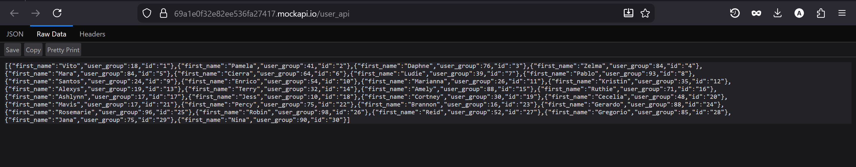

Exercise 3:

Screenshot A:
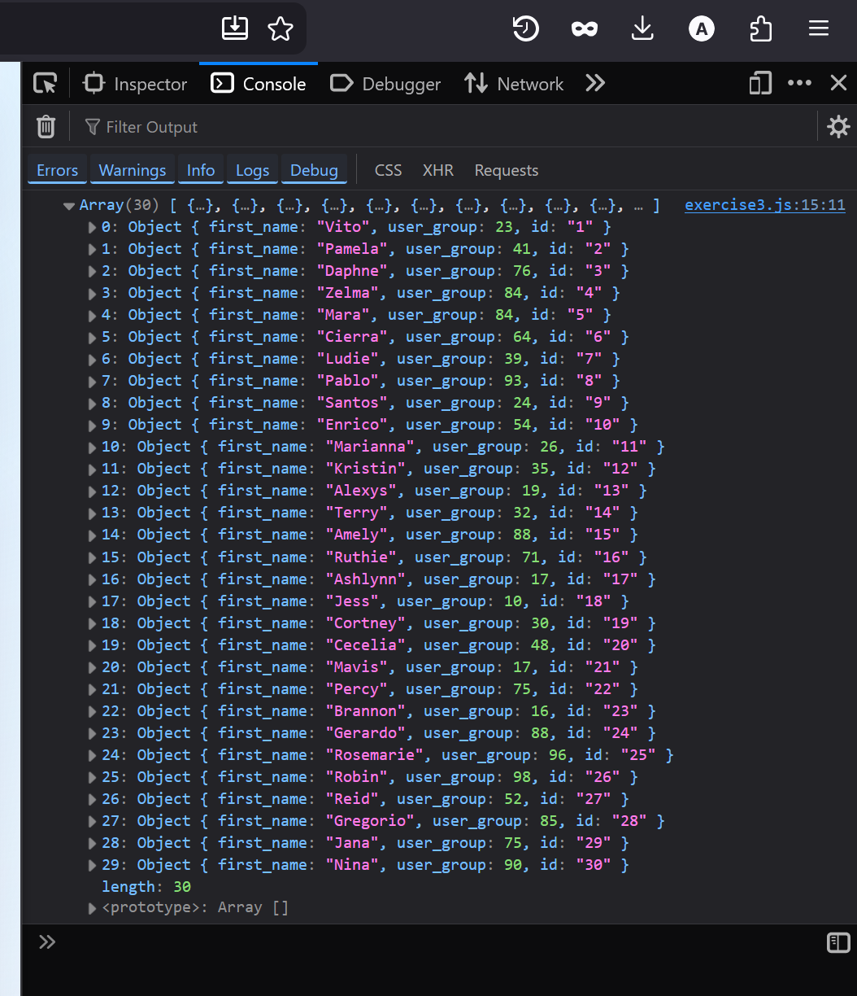

Screenshot B:
