ENSF-381: Full Stack Web Development Laboratory
Lab04

GitHub Link: https://github.com/Aayush-Karthikeyan/Ensf381_Lab3

Group information:
Name 1: Aayush Karthikeyan (UCID# 30189743)
Name 2: Sarvesh Vettrivelan (UCID# 30242015)

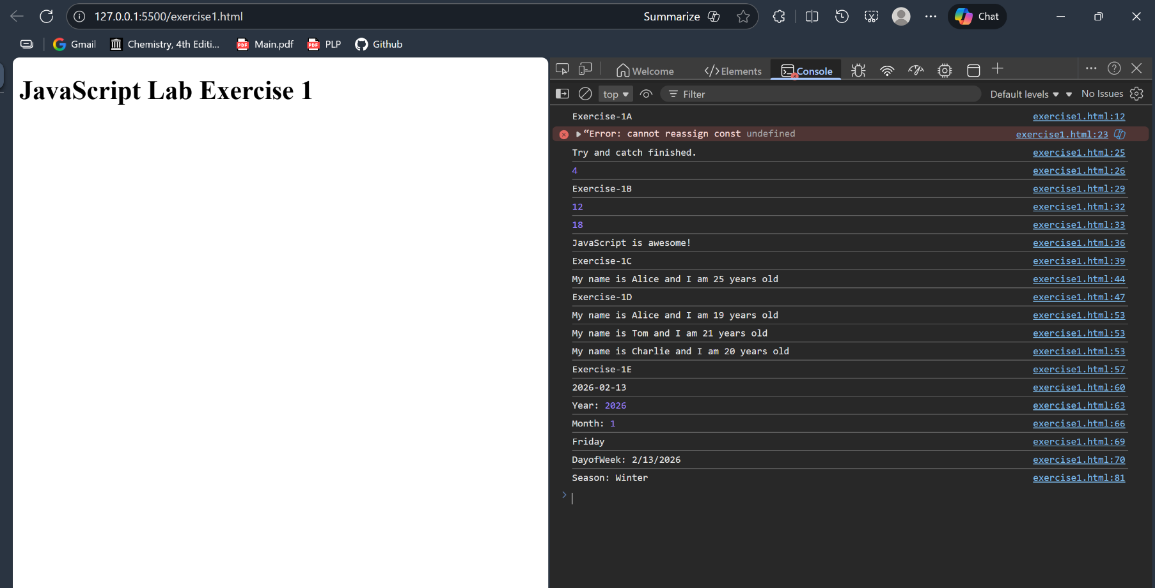
Exercise1: Output

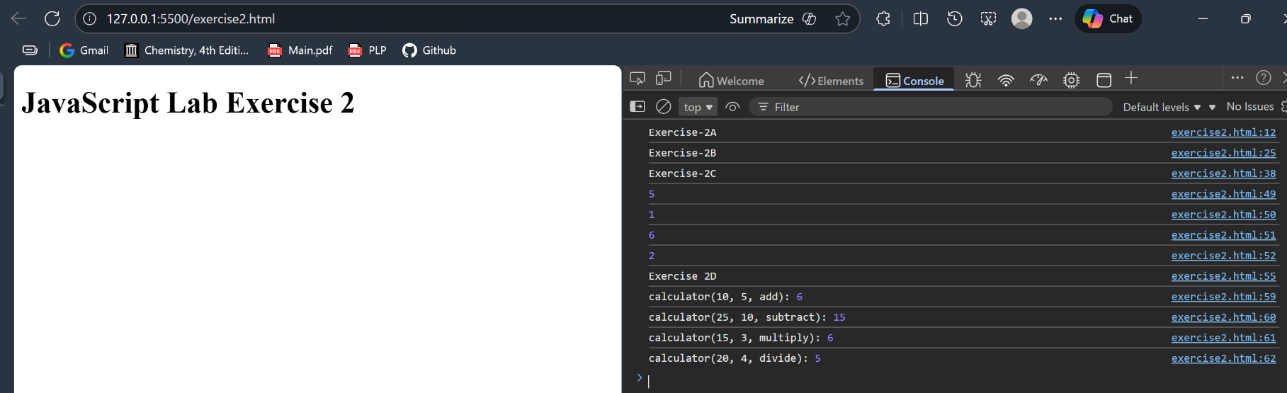
Exercise2: Output

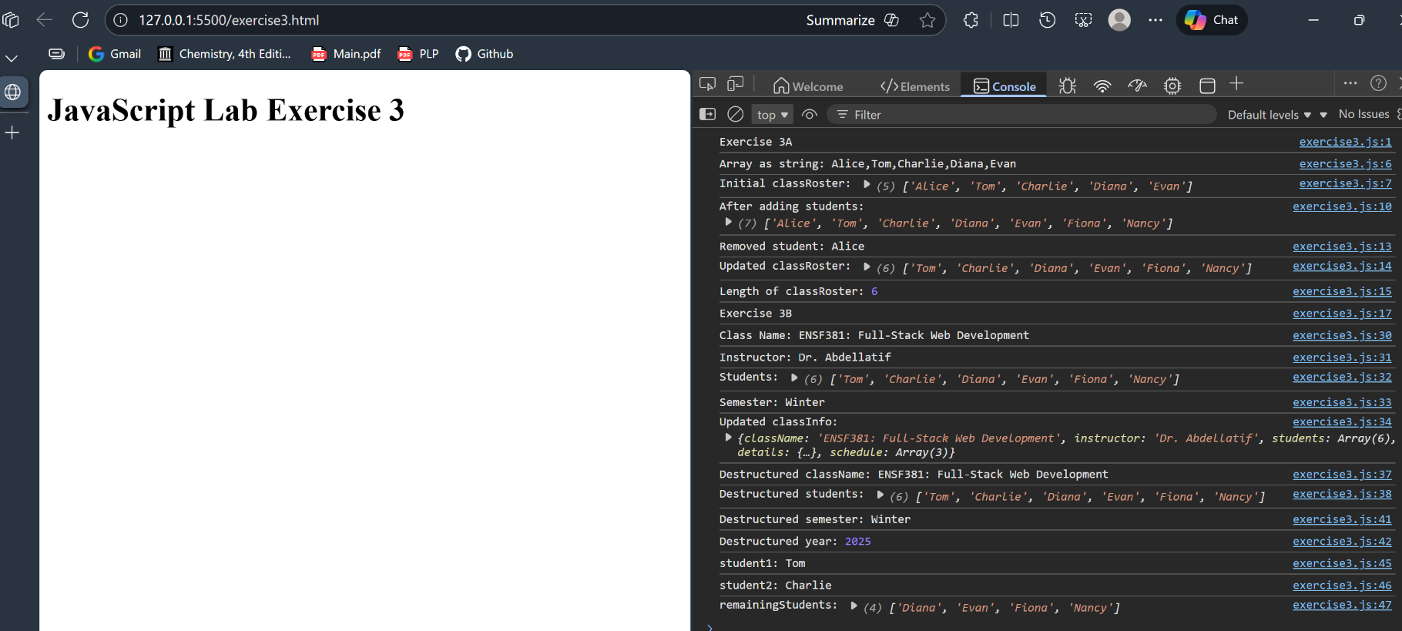
Exercise3: Output

