Mobile: 9964990536
E-mail: mahadevm10@gmail.com

MAHADEVA.M B.E., M.Tech, MISTE,MNG,MIRED,AMIE

National Advisory Board Member for International Conference

Conference convener for international conference

Editorial member for international conference

INDIAN INSTITUTE OF REMOTE SENSING Outreach program Institute coordinator

Objective
To work with an organization where enthusiasm and professionalism are recognized. I am self motivated, looking for challenging position that would enable me to contribute to an organization by utilizing my practical and educational experience.

experience

Currently working as a Assistant Professor in Shri Pillappa College of Engineering from

30-7-15 to till date, Bangalore.
- Have one semester teaching experience in KSIT and Dr.SMCE, Bangalore.
- 1.5 Year worked as guest faculty in BCE, Bangalore.
- One semester teaching experience in shanthinikethana polytechnic ramanagara.
- Junior research fellow and project fellow in Hindustan aeronautics limited Bangalore

Academics
School/College | Course | % of Marks | Year of passing
Shridevi Institute of Engineering and Technology,  Tumkur | M.Tech  (Computer Aided Design of Structures) | 83 | June 2014
Government Engineering College  K.R.Pet | B.E  (Civil Engineering) | 69 | June 2012
Govt. Polytechnic, Channapatna | Diploma  (Civil Engineering) | 65 | June 2009

COMPUTER SKILLS:
- AUTOCAD
- FORTRAN
- E- tabs
- NASTRAN
- PATRAN
- PRO STAD
- SAP-2000

EXTRA CURRICULAR ACTIVITIES & ACHIEVEMENTS:
- Participated in 3 days workshop on “ARTIFICIAL INTELLIGENCE AND EXPERT SYSTEM” conducted by MCE Hassan.
- Participated in 3 days Faculty development program and I S T E program in k s institute of technology Bangalore.
- I guided project to UG and PG students.
- Publish a paper in international journals and attend international conference held in Delhi.
- Publish a paper in international journals and attend international conference held in Goa.
- Secured a “Active Young Research Award” in international conference for continues contribution in research work.
- “NATIONAL ADVISORY BORAD MEMBER”for International Conference and Journals.
- “ CONFERENCE CONVENER” for International Conference and Journals
- “EDITORIAL MEMBER” for International Conference till 2020.oornitor
- “INAIAN INSTITUTE OF RENMOTE SENSING Outreach program Institute Coordinator.
- Participating As a Session chair person for “13th International Conference On Recent Trends In Engineering Science And Management” held at REVA University, yelhahanka, Bengaluru.
- As a IIRS Institute Coordinator Organizing Indian Institute of remote Sensing Outreach program on “Geospatial Modeling for Watershed Management” from 01-May-2018 to 05-May-2018 in SPCE Seminar all.
- As a IIRS Institute Coordinator Organizing Indian Institute of remote Sensing Outreach program on “RS and GIS Applications in Hydro meteorological Disaster Management” from 15-May-2018 to 15-May-2018 in SPCE Seminar all.
- As a IIRS Institute Coordinator Organizing Indian Institute of remote Sensing Outreach program on “RS and GIS Applications in Water Resources” from 16-Apr-2018 to 27-Apr-2018 in SPCE Seminar all.

Strengths
- Hard worker and proper time management.
- Ability to take responsibility and fulfill them.

subject thoughts
- Elements Of Civil Engineering
- Fluid Mechanics
- Hydraulic And Hydraulics Machines
- Building Planning And Drawing
- Structural Analysis I
- Pre Stressed Concrete Structures
- Hydraulic structures and Irrigation and design drawing
- Transpiration engineering 2
- Design of steel structures 1 and 2
- Construction Planning and management

project work
- Design and analysis of Transmission Deck for an utility helicopter held at HAL, Bangalore.

research and publication
Sl no | Title | ISSN & ISSBN Number
1 | RESPONSE OF RC FRAME STRUCURES RESTING ON RAFT FOUNDATION USING E TABS | ISSN(O)-2319-8359  ISSN(P)-2319-8359  ISBN-978-93-86171-51-1
2 | RESPONSE OF RC FRAME STRUCURES RESTING ON RAFT FOUNDATION USING STAAD PRO | ISSN(O)-2319-8354  ISSN(P)-2319-8354  ISBN-978-93-86171-43-6
3 | SOIL STRUCTURE INTERACTION OF RC FRAME BUILDING RESTING ON RAFT FOUNDATION USING STAAD PRO AND E TABS | ISSN(O)-2319-8354  ISSN(P)-2319-8346  ISBN-978-93-86171-54-2
4 | ENERGY RESOURCES FOR SUSTAINABLE GROWTH AND DEVELOPMENT | ISSN(O)-2319-8354  ISSN(P)-2319-8346  ISBN-978-93-86171-54-2
5 | COMPARISON OF REGULAR BUILDINGS WITH AND WITHOUT CORE WALL | ISSN-2348-7550  ISBN-978-93-86171-54-2
6 | RAIN WATER HARVESTING FOR GOVT ENGG COLLEGE K R PET | ISSN(O)-2320-8352  ISSN(P)-2320-8342  ISBN-978-93-86171-56-7
7 | DESIGN AND ANALYSIS OF MULTI STOREY BUILDING RESTING ON DIFFERENT FOUNDATION | ISSN(O)-2320-8352  ISSN(P)-2320-8342  ISBN-978-93-86171-56-7
8 | DESIGN AND ANALYSIS OF RC STRUCTRES | ISSN(O)-2320-8352  ISSN(P)-2320-8342  ISBN-978-93-86171-56-7
9 | SOIL STABILIZATION USING RICE HUSK | ISSN(O)-2320-8352  ISSN(P)-2320-8342  ISBN-978-93-86171-57-8
10 | EFFECT OF ECCENTRICITY ON THE PERFORMANCE OF RC STRUCTURES SUBJECTED TO NONLINEAR STATIC ANALYSIS | ISSN(O)-2323-8352  ISSN(P)-2323-8342  ISBN-978-93-86171-57-8
11 | COMPARITIVE STUDY OF COMPRESSIVE STRENGTH OF MORTOR CUBES USING RIVER SAND AND M SAND | ISSN(O)-2319-8354  ISSN(P)-2319-8346  ISBN-978-93-87793-13-2
12 | NET ZERO ENERGY BUILDING | ISSN(O)-2319-8354  ISSN(P)-2319-8346  ISBN-978-93-87793-13-2
13 | GREEN HOUSE LIGHTING USING OPTICAL FIBERS | ISSN(O)-2319-8354  ISSN(P)-2319-8346  ISBN-978-93-87793-13-2

Conference attended
- Attended one day international conference in IETE goa.
- Attended one day international conference in IETE Delhi.
- Attended one day international conference in IETE Bangalore.
- Attended one day workshop on Dynamic Analysis on Shake Table and Scaled Model in ACS College of engineering.
- Participated in 3 days national conference in J S S Academy of technical education in Bangalore.
- Participated in one day workshop on “Seismic Performance Assessment of Structures” on 20th april 2018 @ Alpa College of Engineering.

Personal details

Name : MAHADEVA.M

Father’s Name : MADEGOWDA.M

Gender : Male

Nationality : Indian

Date of Birth : 04/07/1987

Languages Known : English, Kannada, Thelugu.

Contact Details : Mahadeva M
Assistant Professor
Shri Pillappa College of Engineering, Bangalore

references
- Dr. P M Ravindra, Professor,BIT,Banaglore.
- Dr. D L Venkatesh Babu, JSSATE,Bangalore.
- Mr.R. Ramachandran, General Manager, RWR&DC, HAL, Bangalore.
- Dr. Parameshachari, professor & head,GSSSIETW,Mysuru

declaration
I hereby declare that information furnished above is true to best of my knowledge.

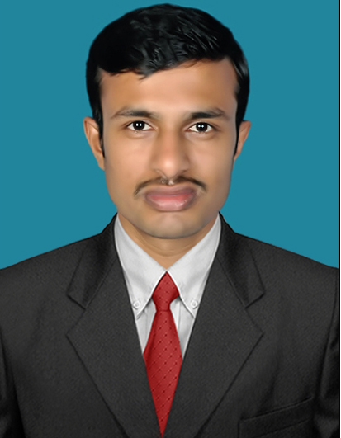
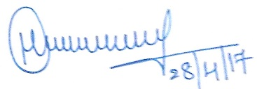
(Mahadeva.M)

