**CURRICULUM VITAE**

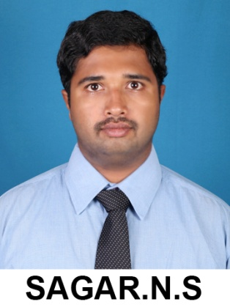**Sagar N S**B E (Civil); M TECH (Structures); AMIE (I)

S/o Sailendra Reddy A V

#24, 4th Main 1st Cross

I U D P Layout, Chitradurga-577501

**Email** : sagarns.nss@gmail.com

**Contact** : +919738804430

**Date of Birth** : 25th April 1991

**Gender** : Male

EDUCATION QUALIFICATIONS:

|  |  |  |  |
| --- | --- | --- | --- |
| **DEGREE** | **UNIVERSITY / BOARD** | **YEAR OF PASSING** | **MARKS %** |
| Post graduation | VisvesvarayaTechnolagical University | 2014 | **75.41** |
| Under graduation | VisvesvarayaTechnolagical University | 2012 | **67.82** |
| Intermediate (12th) | Karnataka PU Board | 2008 | **63.83** |
| High school (10th) | Karnataka SSLC Board | 2006 | **79.04** |

PROFESSIONAL EXPERIENCE:

Working as Asst. Prof. in Dept. of Civil Engineering, S J M I T, Chitradurga since October 2014.

ACADEMIC PROJECTS:

**BLDEACET, Visvesvaraya Technological University, India, Master’s Projects:**

Topic: A Fuzzy approach in the seismic analysis of long span suspension bridges.

* Develop and integrate structural bridge model implemented in eTabs to MATLAB to perform the seismic Geo-technical analysis.
* Prepared the theoretical test cases under various atmospheric conditions for the bridge statistical parameters
* Successfully simulated the bridge model from mat lab under harsh earth quake conditions with a 11 % of error with respect to theoretical analysis.
* Prepared a report in mat lab representing all the simulated load, seismic, and displacement parameters.

**SJMIT, Visvesvaraya Technological University, India, Bachelor’s Projects:**

Topic: Planning, Analysis and Design of Hostel Building

* Block diagram of the building is prepared which gives the necessary elements of building and Plan of the building is prepared by Auto CAD.
* The structural elements are analysed by Kani’s Rotation Method and Moment Distribution Method and designed by using e-Tabs.

**SJMIT, Visvesvaraya Technological University, India, Bachelor (Minor Projects):**

* Extensive Survey Project
* Design of a Residential Building

SUBJECTS HANDLED:

|  |  |
| --- | --- |
| **For B.E.:**   * Building, Planning and Drawing * Design of Prestressed Concrete Structures * Structural Analysis II * Elements of Civil Engineering & Engineering Mechanics * Hydraulics and Hydraulics Machinery Laboratory * Computer Aided Design Laboratory | **For M Tech.:**   * Mechanics of Deformable Bodies * Advanced Design of RC Structures * Design of Plates and Shells * Design of Tall Structures |

TECHNICAL EXPERTISE:

Languages: C.

Operating Systems: Windows.

Softwares: Auto CAD, SAP 2000, e-Tabs, Matlab.

LANGUAGE SKILLS:

Fluent in reading, listening, writing and speaking English.

PAPER PRESENTATION:

* Presented a paper on Fire Resistant Buildings.
* Presented a paper on Bearings in Bridges.
* Presented a paper on Arch Bridges.

STRENGTHS:

* Positive Attitude.
* Leadership and Organizing skills.
* Can lead an organisation in the best and positive way.
* Adaptable and Flexible.
* Team Facilitator and Self-confident.

DECLARATION:

I hereby assure you that the information furnished above is true to the best of my knowledge.

PLACE: Chitradurga **SAGAR N S**