**Result Processing System**

***Documentation of Java Project***

**Project by- Project submitted to-**

Chetan Chamlagai RK Singh sir

Engineering 11 Batch 2078 Co-ordinator and teacher

Roll no- 11 of Tech. depart

**Contents**

Introduction 1

Existing system 1

Proposed system 1

Minimum Requirements 1

Hardware Requirements 1

Software Requirements 2

Source Code 2

Interface 12

Conclusion 13

# Introduction

This is Java project done by Chetan Chamlagai, student of Himalaya Secondary School, studying in class 11 of Technical stream. In this project, demonstration of result processing system is done.

This is not a heavy project. Being liter one, there is availability of some important features enlisted below:

* Keeps record of student name, class and marks
* Calculates total marks obtained and percentages
* Based on grading system
* Ability to update entered data
* Easy data manipulation and deletion

# Existing system

This processing system is built from some other already developed and existing systems. The features of existing systems are:

* Keeps record of student details
* In result processing, calculates total and percentage
* Containing payroll details

# Proposed system

After the modification of the existing system, the following new features will be added,

* It will be based on grading system
* Enabled data updating feature when needed
* Enhanced data manipulation and deletion feature

Some of the existing features will be removed, they are,

* Payroll details of student
* Keeping only record of student name and class and other data are uncared

# Minimum Requirements

## Hardware Requirements

* Requires i3 10th generation processor
* Requires 4 GB RAM
* Requires 256 GB SSD
* About 150 MB space needed in storage device

## Software Requirements

* Requires JDK (Java Development Kit)
* Any Operating System should be installed
* Terminal such as command prompt is needed to run java program

# Source Code

//This is the Java project for result processing system

import java.util.*;

class ResultProcessingSystem

{

int count=0;

Scanner sc= new Scanner(System.in);

String name, stdclass;

int maths, physics, chemistry, computer, nepali, roll;

float total, percentage;

double gpm, gpp, gpc, gp, gpn, gpa;

void inputDetails() // For taking input of student details and marks

{

System.out.print("\t\t\t\t\t\t\t\tEnter name of student: ");

name= sc.next();

System.out.print("\t\t\t\t\t\t\t\tEnter roll number of student: ");

roll= sc.nextInt();

System.out.print("\t\t\t\t\t\t\t\tEnter student's class: ");

stdclass= sc.next();

System.out.print("\t\t\t\t\t\t\t\tEnter marks in Maths: ");

maths= sc.nextInt();

System.out.print("\t\t\t\t\t\t\t\tEnter marks in Physics: ");

physics= sc.nextInt();

System.out.print("\t\t\t\t\t\t\t\tEnter marks in Chemistry: ");

chemistry= sc.nextInt();

System.out.print("\t\t\t\t\t\t\t\tEnter marks in Nepali: ");

nepali= sc.nextInt();

System.out.print("\t\t\t\t\t\t\t\tEnter marks in Computer: ");

computer= sc.nextInt();

System.out.print("\n\n");

}

void processResult() //For processing this input to result

{

total=maths+physics+chemistry+nepali+computer;

percentage= total/5;

//Status Checker

if(maths>=40 && physics>=40 && chemistry>=40 &&nepali>=40 && computer>=40)

count= 1;

else

count= 0;

// Calculating Grade Points

if(maths>=90)

gpm=4.0;

else if(maths>=80 &&maths<=90)

gpm=3.6;

else if(maths>=70 &&maths<=80)

gpm=3.2;

else if(maths>=60 &&maths<=70)

gpm=2.8;

else if(maths>=50 &&maths<=60)

gpm=2.4;

else if(maths>=40 &&maths<=50)

gpm=2.0;

else

gpm=0;

if(physics>=90)

gpp=4.0;

else if(physics>=80 && physics<=90)

gpp=3.6;

else if(physics>=70 && physics<=80)

gpp=3.2;

else if(physics>=60 && physics<=70)

gpp=2.8;

else if(physics>=50 && physics<=60)

gpp=2.4;

else if(physics>=40 && physics<=50)

gpp=2.0;

else

gpp=0;

if(chemistry>=90)

gpc=4.0;

else if(chemistry>=80 && chemistry<=90)

gpc=3.6;

else if(chemistry>=70 && chemistry<=80)

gpc=3.2;

else if(chemistry>=60 && chemistry<=70)

gpc=2.8;

else if(chemistry>=50 && chemistry<=60)

gpc=2.4;

else if(chemistry>=40 && chemistry<=50)

gpc=2.0;

else

gpc=0;

if(computer>=90)

gp=4.0;

else if(computer>=80 && computer<=90)

gp=3.6;

else if(computer>=70 && computer<=80)

gp=3.2;

else if(computer>=60 && computer<=70)

gp=2.8;

else if(computer>=50 && computer<=60)

gp=2.4;

else if(computer>=40 && computer<=50)

gp=2.0;

else

gp=0;

if(nepali>=90)

gpn=4.0;

else if(nepali>=80 &&nepali<=90)

gpn=3.6;

else if(nepali>=70 &&nepali<=80)

gpn=3.2;

else if(nepali>=60 &&nepali<=70)

gpn=2.8;

else if(nepali>=50 &&nepali<=60)

gpn=2.4;

else if(nepali>=40 &&nepali<=50)

gpn=2.0;

else

gpn=0;

gpa= (gpm+gpp+gpc+gp+gpn)/5;

}

void getResultStat()

{

if(maths>=40 && physics>=40 && chemistry>=40 &&nepali>=40 && computer>=40)

{

System.out.println("\t\t\t\t\t\t\t\tCongrats! You passed \n");

count=1;

}

else

{

System.out.println("\t\t\t\t\t\t\t\tOops! You failed\n");

count=0;

}

}

void displayResult() //Displays the result

{

System.out.print("\t\t\t\t\t\tThe marks secured by "+name+" of class "+stdclass+" is below:");

System.out.print("\n\t\t\t\t\t\t\tSubject\t Marks Obtained\tGrade Point");

System.out.print("\n\t\t\t\t\t\t\tPhysics\t\t"+physics+"\t\t"+gpp);

System.out.print("\n\t\t\t\t\t\t\tChemistry\t"+chemistry+"\t\t"+gpc);

System.out.print("\n\t\t\t\t\t\t\tMaths\t\t"+maths+"\t\t"+gpm);

System.out.print("\n\t\t\t\t\t\t\tComputer\t"+computer+"\t\t"+gp);

System.out.print("\n\t\t\t\t\t\t\tNepali\t\t"+nepali+"\t\t"+gpn);

System.out.print("\n\t\t\t\t\t\t\t Total Marks: "+total+"\t Percentage: "+percentage);

System.out.print("\n\t\t\t\t\t\t\t Grade: ");

if(gpa>=3.6)

System.out.print("A+");

else if(gpa>=3.2 &&gpa<=3.6)

System.out.print("A");

else if(gpa>=2.8 &&gpa<=3.2)

System.out.print("B+");

else if(gpa>=2.4 &&gpa<=2.8)

System.out.print("B");

else if(gpa>=2.0 &&gpa<=2.4)

System.out.print("C+");

else if(gpa>=1.6 &&gpa<=2.0)

System.out.print("C");

else

System.out.print("NG");

System.out.print("\t\t\tGPA: "+String.format("%.2f", gpa));

System.out.print("\n\t\t\t\t\t\t\t Remarks: ");

if(count==1)

System.out.println("Passed");

else

System.out.println("Failed");

System.out.println();

}

}

class Main

{

public static void main(String args[]) throws NullPointerException

{

int i,j,n=0,found=0;

String tempname;

Scanner in= new Scanner(System.in);

ResultProcessingSystem record[]= new ResultProcessingSystem[100];

while(true)

{

System.out.println("\t\t\t\t\t\t\t====Result Processing System====");

System.out.println("\t\t\t\t\t\t\t\t1. Insert Data");

System.out.println("\t\t\t\t\t\t\t\t2. Process Result");

System.out.println("\t\t\t\t\t\t\t\t3. Check Result");

System.out.println("\t\t\t\t\t\t\t\t4. Display Result");

System.out.println("\t\t\t\t\t\t\t\t5. Update Data");

System.out.println("\t\t\t\t\t\t\t\t6. Delete Data");

System.out.println("\t\t\t\t\t\t\t\t7. Exit");

System.out.print("\t\t\t\t\t\t\t\t Make your choice: ");

int ch=in.nextInt();

switch (ch) {

case 1:

{

System.out.println();

System.out.println();

System.out.print("\t\t\t\t\t\t\t\tEnter number of students(Max-100): ");

n= in.nextInt();

System.out.println();

for(i=0; i<n; i++)

record[i]= new ResultProcessingSystem();

for(i=0; i<n; i++)

record[i].inputDetails();

}

break;

case 2:

{

System.out.println();

for(i=0; i<n; i++)

record[i].processResult();

}

break;

case 3:

{

System.out.println();

System.out.print("\t\t\t\t\t\t\t\tEnter student's name whose status you're checking: ");

tempname= in.next();

for(i=0; i<n; i++)

{

if(tempname.equalsIgnoreCase(record[i].name))

{

record[i].getResultStat();

found=1;

break;

}

else

found=0;

}

if(found == 0)

System.out.println("\t\t\t\t\t\t\t\tStudent Not Found");

}

break;

case 4:

{

System.out.println();

for(i=0; i<n; i++)

record[i].displayResult();

}

break;

case 5:

{

found=0;

System.out.println();

System.out.print("\t\t\t\t\t\t\t\tEnter student's name: ");

tempname= in.next();

for(i=0; i<n; i++)

{

if(tempname.equalsIgnoreCase(record[i].name))

{

record[i].inputDetails();

found= 2;

}

}

if(found == 0)

System.out.println("\t\t\t\t\t\t\t\tStudent Not Found");

found= 1;

}

break;

case 6:

{

int cnt= 0;

System.out.println();

System.out.print("\t\t\t\t\t\t\t\tEnter roll number of student: ");

int del= in.nextInt();

for(i=0; i<n; i++)

{

if(record[i].roll == del)

{

cnt = 6;

for(j=i+1; j<n; j++)

{

record[i].name = record[j].name;

record[i].roll = record[j].roll;

record[i].stdclass = record[j].stdclass;

record[i].physics = record[j].physics;

record[i].chemistry = record[j].chemistry;

record[i].maths = record[j].maths;

record[i].computer = record[j].computer;

record[i].nepali = record[j].nepali;

}

n--;

}

}

if(cnt==0)

System.out.println("\t\t\t\t\t\t\t\t Data is not found");

System.out.println("\t\t\t\t\t\t\t\tNote: Must Process before checking and displaying");

}

break;

case 7:

{

System.exit(0);

}

default:

System.out.println("Invalid Option");

}

}

}

}

# Interface

* ***Startup menu:***

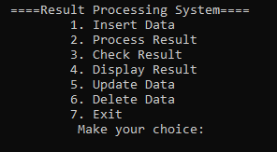

* ***First option interface:***

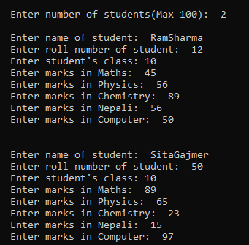

* ***Second option interface:***

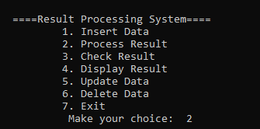

* ***Third option interface:***

1. ***For data present in the program***



1. ***For data absent in the program***



* ***Fourth option interface:***

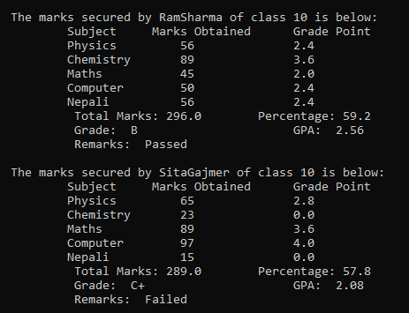

* ***Fifth option interface:***

1. ***For absent record***



1. ***For present record***

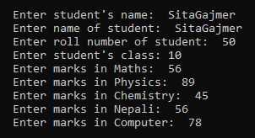

* ***Sixth option interface:***



***After record deletion, the marksheet displayed is,***

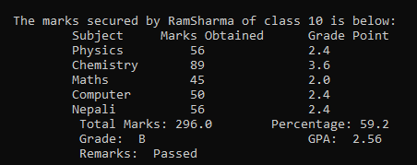

# Conclusion

The program is developed and demonstrated. The program is successfully executed, processed and manipulated student’s result on grading system without any faults in calculations.